Visual Summary: Cultural and Creative Activity in Australia, 2015–16 to 2024–25

September 2026

The Department of Infrastructure, Transport, Regional Development, Communications, Sport and the Arts acknowledges the Traditional Custodians of Country throughout Australia and their continuing connection to land, sea and community. We pay our respects to them, their cultures and to their Elders, past, present and emerging.
© Commonwealth of Australia 2026 ISBN: 978-1-923111-30-1 / BCARR reference: 2026-103

Ownership of intellectual property rights in this publication
Unless otherwise noted, copyright (and any other intellectual property rights, if any) in this publication is owned by the Commonwealth of Australia (referred to below as the Commonwealth).

Disclaimer
The material contained in this publication is made available on the understanding that the Commonwealth is not providing professional advice, and that users exercise their own skill and care with respect to its use, and seek independent advice if necessary. The Commonwealth makes no representations or warranties as to the contents or accuracy of the information contained in this publication. To the extent permitted by law, the Commonwealth disclaims liability to any person or organisation in respect of anything done, or omitted to be done, in reliance upon information contained in this publication.
Creative Commons licence

With the exception of (a) the Coat of Arms; (b) the Department of Infrastructure, Transport, Regional Development, Communications, Sport and the Arts photos and graphics; (c) content supplied by third parties; (d) content otherwise labelled; copyright in this publication is licensed under a Creative Commons BY Attribution 4.0 International Licence.

Use of the Coat of Arms
The Department of the Prime Minister and Cabinet (PM&C) sets the terms under which the Coat of Arms is used. Please refer to the Commonwealth Coat of Arms Information and Guidelines | PM&C.

Contact us
This publication is available in PDF format. All other rights are reserved, including in relation to any departmental logos or trademarks which may exist. For enquiries regarding the licence and any use of this publication, please contact:
Email: BCARR@infrastructure.gov.au
Website: https://www.bitre.gov.au/resource/arts/cultural-and-creative-activity

Contents
About this document 6
Table 1: Cultural and creative activity 2015–16 and 2024–25 7
Table 2: Cultural and creative activity components and share of GDP, 2015–16 to 2024–25 8
Figure 1: Relative to nominal Gross Domestic Product (GDP) 9
Figure 2: Cultural and creative GVA and industry share of total economy, 2024–25 10
Figure 3: GVA average annual growth rate by industry division, 2015–16 to 2024–25 11
Figure 4: Cultural and creative activity, GDP by domain, 2024–25 12
Figure 5: Contribution to cultural and creative activity, GDP by domain, 2015–16 and 2024–25 13
Figure 6: Nominal GDP growth by domain, between 2015–16 and 2024–25 14
Figure 7: GDP average annual growth rate by domain, between 2015–16 and 2024–25 15
Table 3: Literature, creative and performing arts, 2015–16 to 2024–25 16
Figure 8: Literature, creative and performing arts, GDP and as a share of overall economy 17
Table 4: Visual arts and crafts, 2015–16 to 2024–25 18
Figure 9: Visual arts and crafts, GDP and as a share of overall economy 19
Table 5: Music production and distribution, 2015–16 to 2024–25 20
Figure 10: Music production and distribution, GDP and as a share of overall economy 21
Table 6: Museums and galleries, 2015–16 to 2024–25 22
Figure 11: Museums and galleries, GDP and as a share of overall economy 23
Table 7: Film and television activities, 2015–16 to 2024–25 24
Figure 12: Film and television activities, GDP and as a share of overall economy 25
Table 8: Radio broadcasting, 2015–16 to 2024–25 26
Figure 13: Radio broadcasting, GDP and as a share of overall economy 27
Table 9: Internet publishing and broadcasting, 2015–16 to 2024–25 28
Figure 14: Internet publishing and broadcasting, GDP and as a share of overall economy 29
Table 10: Libraries and archives, 2015–16 to 2024–25 30
Figure 15: Libraries and archives, GDP and as a share of overall economy 31
Table 11: Print media and publishing (excl. internet), 2015–16 to 2024–25 32
Figure 16: Print media and publishing (excl. internet), GDP and as a share of overall economy 33
Table 12: Architecture services, 2015–16 to 2024–25 34
Figure 17: Architecture services, GDP and as a share of overall economy 35
Table 13: Design and fashion, 2015–16 to 2024–25 36
Figure 18: Design and fashion, GDP and as a share of overall economy 37
Table 14: Advertising and promotion, 2015–16 to 2024–25 38
Figure 19: Advertising and promotion, GDP and as a share of overall economy 39
Table 15: Events (arts), 2015–16 to 2024–25 40
Figure 20: Events (arts), GDP and as a share of overall economy 41
Table 16: Arts education, 2015–16 to 2024–25 42
Figure 21: Arts education, GDP and as a share of overall economy 43
Table 17: Digital games development, 2015–16 to 2024–25 44
Figure 22: Digital games development, GDP and as a share of overall economy 45
Table 18: Cultural and creative activity, GVA by industry division ($m), 2015–16 to 2024–25 46
Figure 23: Cultural and creative GVA change by division, 2015–16 to 2024–25 47
Figure 24: Industry contributors to specialised, support and embedded activities, 2015–16 to 2024–25 48
Table 19: Specialised activity, 2015–16 to 2024–25 ($m) 49
Table 20: Support activity, 2015–16 to 2024–25 ($m) 50
Table 21: In-scope cultural and creative industry subdivisions ($m) 51
Table 22: Embedded activity, 2015–16 to 2024–25 ($m) 52
Table 23: Revisions from 2015–16 to 2023–24 53
Appendix: Scope of cultural and creative domains 54

About this document
The Bureau of Communications, Arts and Regional Research (BCARR) within the Department of Infrastructure, Transport, Regional Development, Communications, Sport and the Arts has estimated the economic contribution of cultural and creative activity in Australia over a 10-year period, from 2015–16 to 2024–25.
This publication provides an update to the BCARR annual report: Cultural and Creative Activity in Australia, 2014–15 to 2023–24 released in September 2025. The updated estimates are presented as a visual summary. Each table and figure corresponds to those used in the BCARR working paper: Cultural and Creative Activity in Australia, 2008–09 to 2022–23 (Methodology Refresh).
This annual update applies the same methodological approach established in BCARR’s 2024 statistical working paper. The tables and figures align with those in the original publication to support comparability over time.
Note that data is subject to revisions in the Australian Bureau of Statistics’ (ABS) national accounts datasets. Estimates in this release vary from those published previously. This document also includes a table of revisions to the data, covering the period from 2015–16 to 2023–24.
Estimates and their components in this document have been rounded and discrepancies may occur between sums of component items and totals. Analysis featured in this release is based on unrounded data. Calculations based on rounded data may differ to those published.
Further information on these updates can be found in the FAQ: Cultural and creative activity in Australia, 2015–16 to 2024–25.

Table 1: Cultural and creative activity 2015–16 and 2024–25

Cultural and Creative Activity | 2015–16 | 2024–25 | Change | Movement (%)
Gross Value Added ($m) | 45,357 | 66,767 | 21,409 | 47.2
plus Net taxes on products ($m) | 2,444 | 3,519 | 1,076 | 44.0
equals Total Cultural and Creative GDP ($m) | 47,801 | 70,286 | 22,485 | 47.0
As a proportion of GDP (%) | 2.9 | 2.5 | -0.3

Source: ABS Australian System of National Accounts, Australian National Accounts: Input-Output Tables (Product Details); Australian National Accounts: Supply Use Tables; BCARR calculations. Corresponding reference: Cultural and Creative Activity in Australia, 2008–09 to 2022–23 (Methodology Refresh), Table 1.

Explanatory notes
New estimates show cultural and creative activity contributed $47.8 billion to GDP in 2015–16. By 2024–25, this had increased to $70.3 billion, up $22.5 billion, or 47.0%. While this activity is growing in absolute terms, as a share of GDP, it declined by 0.3% points, from 2.9% in 2015–16 to 2.5% in 2024–25.

Table 2: Cultural and creative activity components and share of GDP, 2015–16 to 2024–25
Period | Cultural and creative activity gross value added (GVA) ($m) | Net taxes on products of cultural and creative activity ($m) | Cultural and creative activity GDP ($m) | Cultural and creative activity as a share of GDP (%)
2015–16 | 45,357 | 2,444 | 47,801 | 2.9
2016–17 | 46,597 | 2,223 | 48,819 | 2.8
2017–18 | 47,620 | 2,272 | 49,892 | 2.7
2018–19 | 48,123 | 2,259 | 50,382 | 2.6
2019–20 | 47,592 | 2,239 | 49,831 | 2.5
2020–21 | 49,290 | 2,441 | 51,731 | 2.5
2021–22 | 54,689 | 2,891 | 57,580 | 2.5
2022–23 | 60,066 | 3,106 | 63,172 | 2.5
2023–24 | 64,272 | 3,345 | 67,617 | 2.5
2024–25 | 66,767 | 3,519 | 70,286 | 2.5
Source: ABS Australian System of National Accounts, Australian National Accounts: Input-Output Tables (Product Details); Australian National Accounts: Supply Use Tables; BCARR calculations. Corresponding reference: Cultural and Creative Activity in Australia, 2008–09 to 2022–23 (Methodology Refresh), Table 3.

Explanatory notes
Cultural and creative activity in Australia grew to $70.3 billion in nominal terms in 2024–25, up $22.5 billion, or 47.0%, since 2015–16. This growth included an increase of $21.4 billion in cultural and creative gross value added from 2015–16 to 2024–25, which was primarily from the Professional, Scientific and Technical Services industry, which rose by $11.7 billion. This industry division includes activities that generally require a high level of expertise and training and formal (usually tertiary level) qualifications. Cultural and creative activities captured within this division primarily include advertising, architecture, management services for artists, and professional photography. Net taxes on products of cultural and creative activity have increased by $1.1 billion, or 44.0%, from $2.4 billion in 2015–16 to $3.5 billion in 2024–25.
While cultural and creative activity is growing in nominal terms, as a share of GDP it declined by 0.3 percentage points over the period – from 2.9% in 2015–16 to 2.5% in 2024–25.

Figure 1: Relative to nominal Gross Domestic Product (GDP)
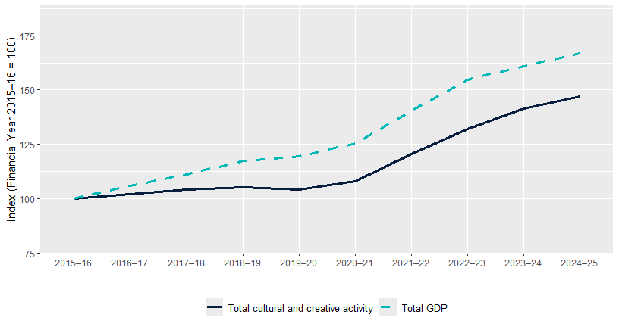
Source: ABS Australian System of National Accounts, Australian National Accounts: Input-Output Tables (Product Details); Australian National Accounts: Supply Use Tables; BCARR calculations. Corresponding reference: Cultural and Creative Activity in Australia, 2008–09 to 2022–23 (Methodology Refresh), Figure 8.

Explanatory notes
Cultural and creative activity has grown more slowly than the Australian economy overall. In Figure 1, the index value of 100 represents the 2015–16 base year. The dashed line represents GDP growth for the entire Australian economy relative to the base year. Since 2015–16, cultural and creative activity has increased at a slower rate than total GDP, reflecting stronger growth in industries such as Mining and Health care and social assistance that are almost entirely outside cultural and creative activity (explained further in Figures 2 and 3).

Figure 2: Cultural and creative activity GVA and industry share of total economy, 2024–25
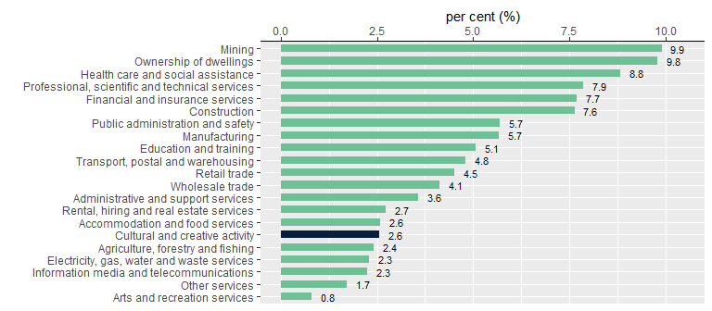
Source: ABS Australian System of National Accounts, Australian National Accounts: Input-Output Tables (Product Details); Australian National Accounts: Supply Use Tables; BCARR calculations. Corresponding reference: Cultural and Creative Activity in Australia, 2008–09 to 2022–23 (Methodology Refresh), Figure 9.

Explanatory notes
The Australian System of National Accounts lists 19 industries in the Australian economy. When added together with Ownership of Dwellings, the activity in these industries equals the total amount of final goods and services produced in the economy in a given period. Cultural and creative activity is not an industry division, but rather includes output produced by many industries across the economy. Cultural and creative activity is therefore not additional to the industry shares shown in Figure 2 but is provided here to indicate its size relative to other industry divisions.

Figure 2 shows that cultural and creative activity accounted for 2.6% of GVA¹ in the economy in 2024–25, comparable to the size of the Accommodation and food services industry.

¹ GVA is a measure of the contribution to domestic production made by an individual producer, industry or sector. This is the value of output less the value of the goods and services used up in the process of production. By excluding net taxes, GVA provides a more accurate measure of economic activity by industry than gross domestic product (GDP).

Figure 3: GVA average annual growth rate by industry division, 2015–16 to 2024–25
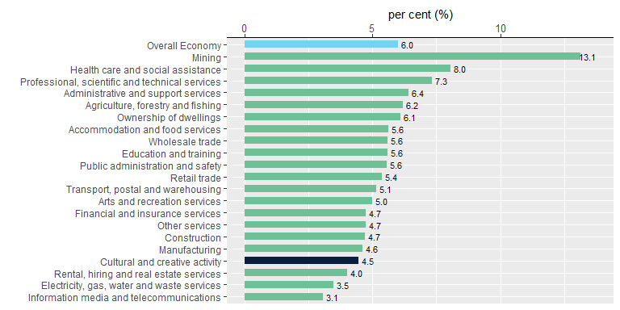
Source: ABS Australian System of National Accounts, Australian National Accounts: Input-Output Tables (Product Details); Australian National Accounts: Supply Use Tables; BCARR calculations. Corresponding reference: Cultural and Creative Activity in Australia, 2008–09 to 2022–23 (Methodology Refresh), Figure 10.

Explanatory notes
From 2015–16 to 2024–25, the Australian economy has been supported by strong growth in Mining, buoyed by high commodity prices, and Health care and social assistance, supported by an ageing population. Average annual GVA growth was 13.1% in Mining, 8.0% in Health care and social assistance, 6.0% for the overall economy, and 4.5% in cultural and creative activity.

Figure 4: Cultural and creative activity, GDP by domain, 2024–25
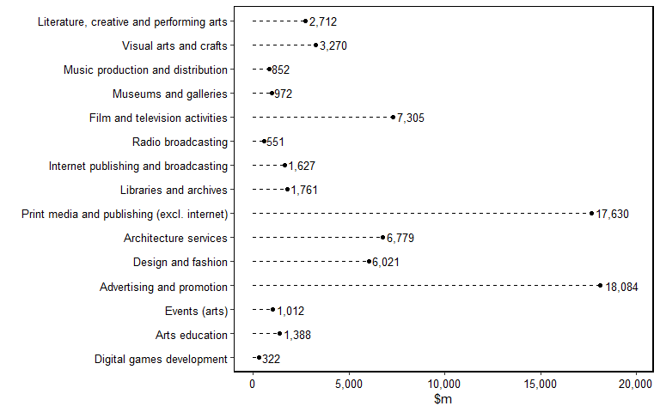
Source: ABS Australian System of National Accounts, Australian National Accounts: Input-Output Tables (Product Details); Australian National Accounts: Supply Use Tables; BCARR calculations. Corresponding reference: Cultural and Creative Activity in Australia, 2008–09 to 2022–23 (Methodology Refresh), Figure 11.

Explanatory notes
Cultural and creative activity is grouped into 15 domains. In 2024–25, advertising and promotion was the largest contributor, at $18.1 billion.

Figure 5: Contribution to cultural and creative activity, GDP by domain, 2015–16 and 2024–25
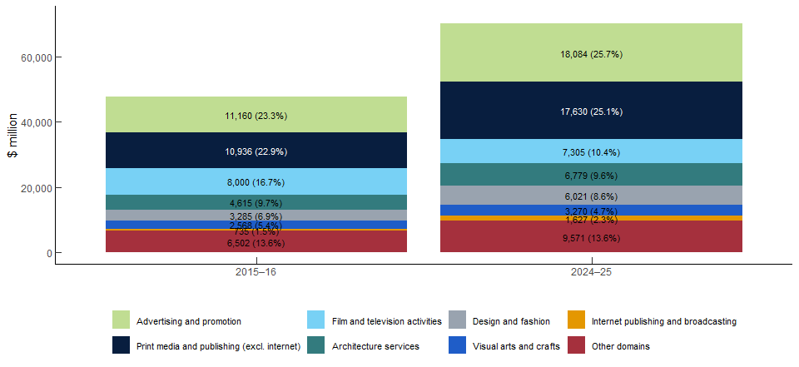
Source: ABS Australian System of National Accounts, Australian National Accounts: Input-Output Tables (Product Details); Australian National Accounts: Supply Use Tables; BCARR calculations. Corresponding reference: Cultural and Creative Activity in Australia, 2008–09 to 2022–23 (Methodology Refresh), Figure 12.

Explanatory notes
Advertising and promotion was the largest domain, with its share of cultural and creative activity increasing from 23.3% in 2015–16 to 25.7% in 2024–25. Print media and publishing (excl. internet) was the second largest, up from $10.9 billion, or 22.9%, in 2015–16 to $17.6 billion, or 25.1%, in 2024–25. Film and television activities was valued at $7.3 billion, although its share fell from 16.7% to 10.4%. Architecture services contributed $6.8 billion and remained broadly stable as a share, decreasing slightly from 9.7% to 9.6%. Together, these four domains represented over 70% of cultural and creative activity in 2024–25.

Figure 6: Nominal GDP growth by domain, between 2015–16 and 2024–25
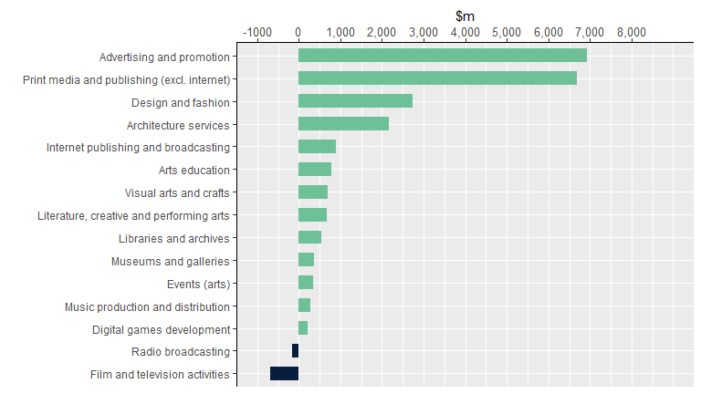
Source: ABS Australian System of National Accounts, Australian National Accounts: Input-Output Tables (Product Details); Australian National Accounts: Supply Use Tables; BCARR calculations. Corresponding reference: Cultural and Creative Activity in Australia, 2008–09 to 2022–23 (Methodology Refresh), Figure 13.

Explanatory notes
Thirteen of the 15 domains experienced growth in nominal terms from 2015–16 to 2024–25. Advertising and promotion recorded the strongest growth of $6.9 billion. The only domains to record a decline over the period were Film and television activities and Radio broadcasting, which fell by $696 million and $172 million respectively. These declines were likely influenced by rising competition from online and cloud-based media platforms and falling demand from advertisers.

Figure 7: GDP average annual growth rate by domain, between 2015–16 and 2024–25
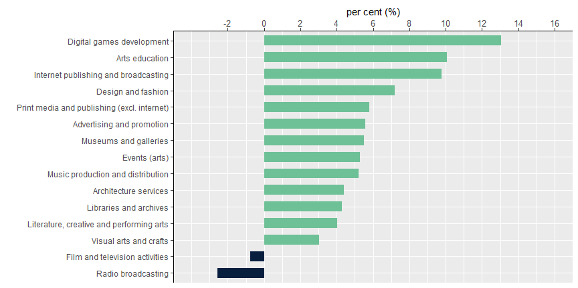
Source: ABS Australian System of National Accounts, Australian National Accounts: Input-Output Tables (Product Details); Australian National Accounts: Supply Use Tables; BCARR calculations.

Explanatory notes
Digital games development experienced the strongest growth rate over the period. From its small base of initial activity, digital games development increased by an average annual growth rate of 13.1% from 2015–16 to 2024–25.

Table 3: Literature, creative and performing arts, 2015–16 to 2024–25
Period | Output ($m) | GVA ($m) | Net taxes on products ($m) | GDP ($m) | As a share of GDP (%)
2015–16 | 4,042 | 1,955 | 75 | 2,030 | 0.12
2016–17 | 4,203 | 2,028 | 76 | 2,104 | 0.12
2017–18 | 4,313 | 2,020 | 72 | 2,092 | 0.11
2018–19 | 4,915 | 2,316 | 77 | 2,392 | 0.12
2019–20 | 4,267 | 2,073 | 57 | 2,130 | 0.11
2020–21 | 3,367 | 1,733 | 27 | 1,760 | 0.08
2021–22 | 4,244 | 2,028 | 44 | 2,072 | 0.09
2022–23 | 5,487 | 2,471 | 75 | 2,546 | 0.10
2023–24 | 5,713 | 2,479 | 88 | 2,567 | 0.10
2024–25 | 6,054 | 2,627 | 85 | 2,712 | 0.10
Source: ABS Australian System of National Accounts, Australian National Accounts: Input-Output Tables (Product Details); Australian National Accounts: Supply Use Tables; BCARR calculations. Corresponding reference: Cultural and Creative Activity in Australia, 2008–09 to 2022–23 (Methodology Refresh), Table 5.

Explanatory notes
Cultural and creative activity GDP in literature, creative and performing arts increased by $0.7 billion, or 33.6%, from $2.0 billion in 2015–16 to $2.7 billion in 2024–25. Activity declined in 2019–20 and 2020–21, reflecting COVID-19 restrictions and the suspension of live performances.² Conditions have improved in recent years, supported by strong demand for international contemporary music performances and higher ticket sales.³ As a share of the overall economy, the domain decreased to 0.10% over the period.

² IBISWorld industry report (2021), R9001 Music and Theatre Production in Australia, June 2021, p. 3
³ IBISWorld industry report (2024), R9001 Music and Theatre Production in Australia, July 2024, p. 12

Figure 8: Literature, creative and performing arts, GDP and as a share of overall economy
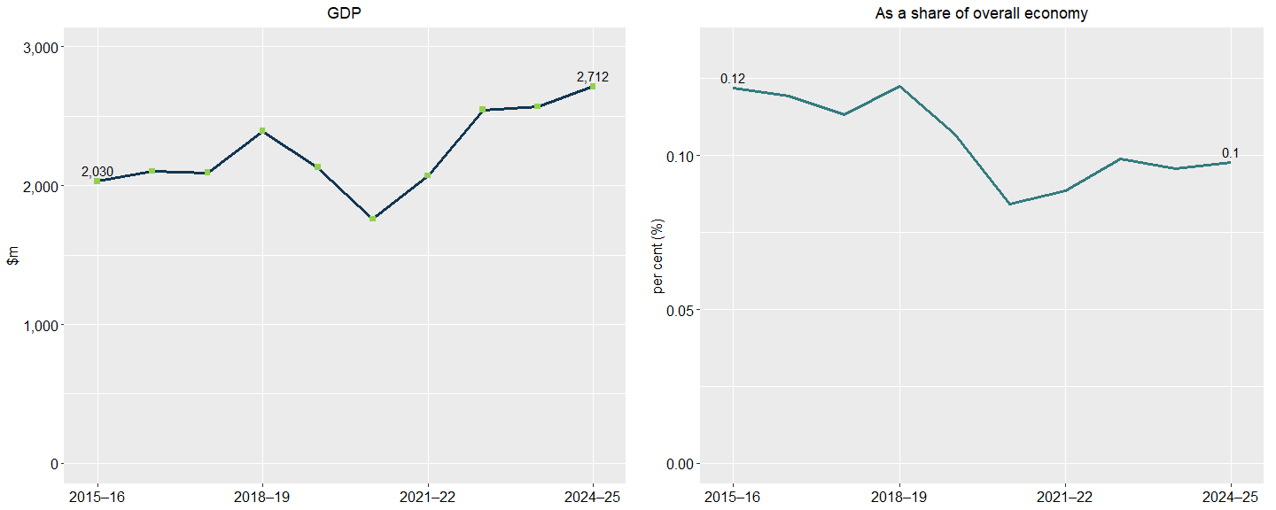
Source: ABS Australian System of National Accounts, Australian National Accounts: Input-Output Tables (Product Details); Australian National Accounts: Supply Use Tables; BCARR calculations. Corresponding reference: Cultural and Creative Activity in Australia, 2008–09 to 2022–23 (Methodology Refresh), Figure 14.

Explanatory notes
See notes of Table 3.

Table 4: Visual arts and crafts, 2015–16 to 2024–25
Period | Output ($m) | GVA ($m) | Net taxes on products ($m) | GDP ($m) | As a share of GDP (%)
2015–16 | 4,335 | 1,937 | 631 | 2,568 | 0.15
2016–17 | 3,531 | 1,664 | 553 | 2,217 | 0.13
2017–18 | 3,901 | 1,729 | 566 | 2,295 | 0.12
2018–19 | 4,249 | 1,949 | 593 | 2,542 | 0.13
2019–20 | 3,954 | 1,822 | 571 | 2,393 | 0.12
2020–21 | 4,072 | 1,876 | 678 | 2,554 | 0.12
2021–22 | 4,584 | 2,049 | 853 | 2,901 | 0.12
2022–23 | 4,914 | 2,177 | 844 | 3,021 | 0.12
2023–24 | 5,162 | 2,352 | 797 | 3,149 | 0.12
2024–25 | 5,334 | 2,431 | 839 | 3,270 | 0.12
Source: ABS Australian System of National Accounts, Australian National Accounts: Input-Output Tables (Product Details); Australian National Accounts: Supply Use Tables; BCARR calculations. Corresponding reference: Cultural and Creative Activity in Australia, 2008–09 to 2022–23 (Methodology Refresh), Table 6.

Explanatory notes
Cultural and creative activity GDP in visual arts and crafts increased by $702 million, from $2.6 billion in 2015–16 to $3.3 billion in 2024–25. As a share of the overall economy, the domain declined from 0.15% to 0.12% over the period.

Figure 9: Visual arts and crafts, GDP and as a share of overall economy
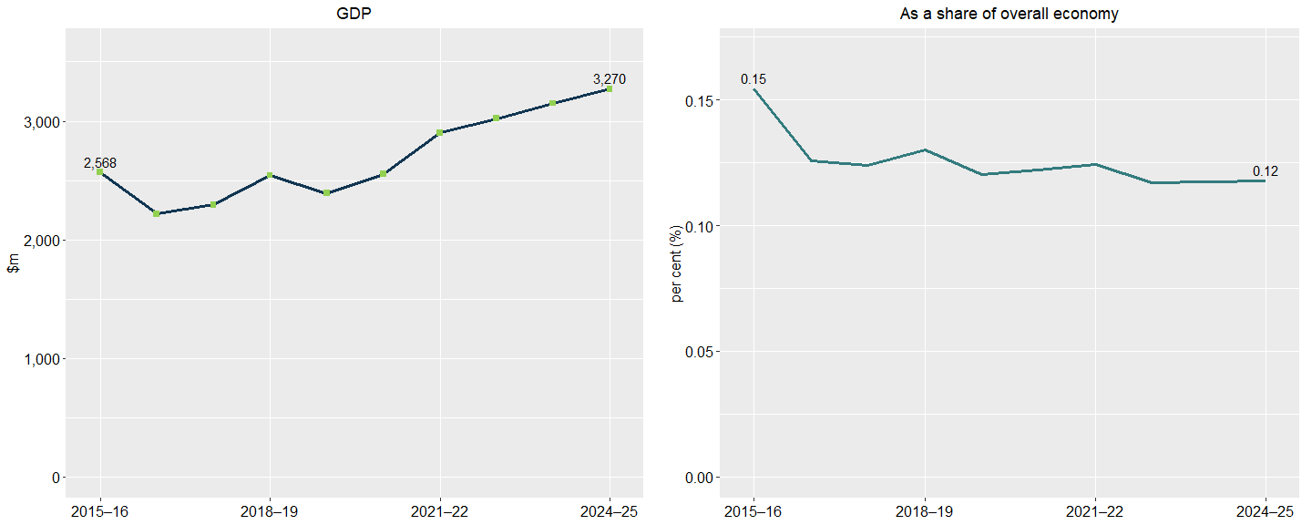
Source: ABS Australian System of National Accounts, Australian National Accounts: Input-Output Tables (Product Details); Australian National Accounts: Supply Use Tables; BCARR calculations. Corresponding reference: Cultural and Creative Activity in Australia, 2008–09 to 2022–23 (Methodology Refresh), Figure 15.

Explanatory notes
See notes of Table 4.

Table 5: Music production and distribution, 2015–16 to 2024–25
Period | Output ($m) | GVA ($m) | Net taxes on products ($m) | GDP ($m) | As a share of GDP (%)
2015–16 | 1,258 | 455 | 109 | 565 | 0.03
2016–17 | 1,295 | 466 | 107 | 573 | 0.03
2017–18 | 1,347 | 493 | 113 | 606 | 0.03
2018–19 | 1,311 | 474 | 112 | 586 | 0.03
2019–20 | 1,339 | 477 | 113 | 590 | 0.03
2020–21 | 1,328 | 392 | 128 | 520 | 0.02
2021–22 | 1,381 | 413 | 135 | 549 | 0.02
2022–23 | 1,749 | 551 | 140 | 691 | 0.03
2023–24 | 1,917 | 687 | 131 | 818 | 0.03
2024–25 | 1,990 | 714 | 138 | 852 | 0.03
Source: ABS Australian System of National Accounts, Australian National Accounts: Input-Output Tables (Product Details); Australian National Accounts: Supply Use Tables; BCARR calculations. Corresponding reference: Cultural and Creative Activity in Australia, 2008–09 to 2022–23 (Methodology Refresh), Table 7.

Explanatory notes
Cultural and creative activity GDP in music production and distribution increased by $287 million, from $565 million in 2015–16 to $852 million in 2024–25. Music production and distribution is a small domain comprising around 0.03% of the overall economy.

Figure 10: Music production and distribution, GDP and as a share of overall economy
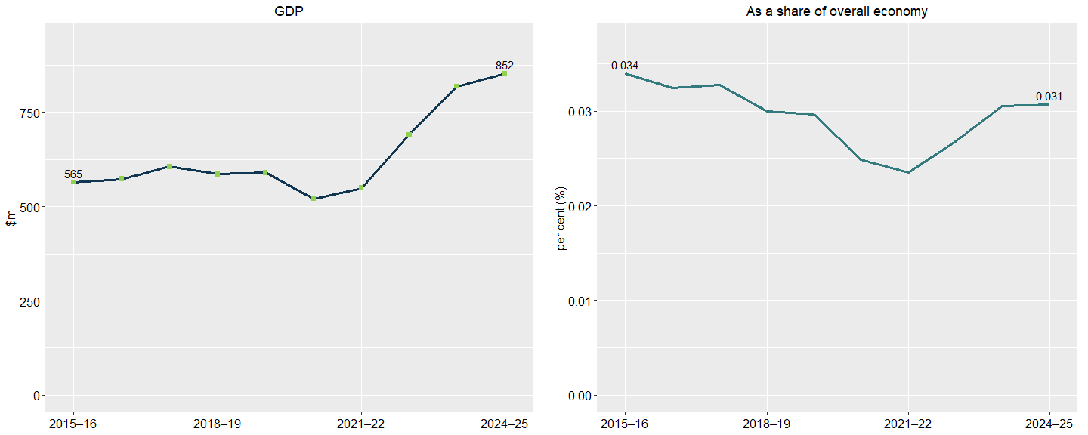
Source: ABS Australian System of National Accounts, Australian National Accounts: Input-Output Tables (Product Details); Australian National Accounts: Supply Use Tables; BCARR calculations. Corresponding reference: Cultural and Creative Activity in Australia, 2008–09 to 2022–23 (Methodology Refresh), Figure 16.

Explanatory notes
See notes of Table 5.

Table 6: Museums and galleries, 2015–16 to 2024–25
Period | Output ($m) | GVA ($m) | Net taxes on products ($m) | GDP ($m) | As a share of GDP (%)
2015–16 | 1,189 | 574 | 28 | 602 | 0.04
2016–17 | 1,277 | 616 | 27 | 643 | 0.04
2017–18 | 1,341 | 626 | 33 | 660 | 0.04
2018–19 | 1,464 | 687 | 31 | 718 | 0.04
2019–20 | 1,460 | 708 | 28 | 736 | 0.04
2020–21 | 1,422 | 731 | 17 | 747 | 0.04
2021–22 | 1,565 | 748 | 23 | 771 | 0.03
2022–23 | 1,861 | 838 | 26 | 864 | 0.03
2023–24 | 2,042 | 886 | 31 | 917 | 0.03
2024–25 | 2,164 | 939 | 33 | 972 | 0.03
Source: ABS Australian System of National Accounts, Australian National Accounts: Input-Output Tables (Product Details); Australian National Accounts: Supply Use Tables; BCARR calculations. Corresponding reference: Cultural and Creative Activity in Australia, 2008–09 to 2022–23 (Methodology Refresh), Table 8.

Explanatory notes
Cultural and creative activity GDP in museums and galleries increased by $370 million, from $602 million in 2015–16 to $972 million in 2024–25. As a share of the overall economy, it decreased slightly over the period.

Figure 11: Museums and galleries, GDP and as a share of overall economy
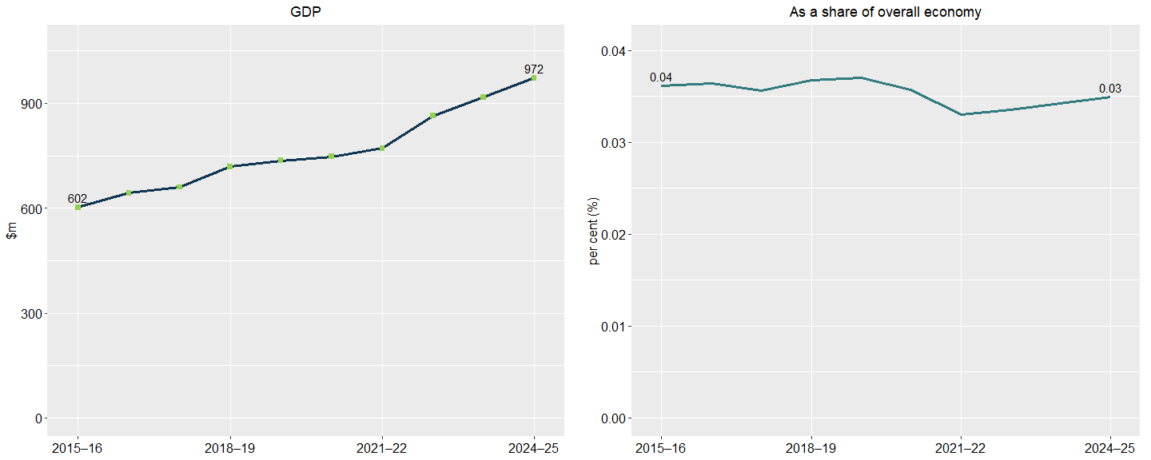
Source: ABS Australian System of National Accounts, Australian National Accounts: Input-Output Tables (Product Details); Australian National Accounts: Supply Use Tables; BCARR calculations. Corresponding reference: Cultural and Creative Activity in Australia, 2008–09 to 2022–23 (Methodology Refresh), Figure 17.

Explanatory notes
See notes of Table 6.

Table 7: Film and television activities, 2015–16 to 2024–25
Period | Output ($m) | GVA ($m) | Net taxes on products ($m) | GDP ($m) | As a share of GDP (%)
2015–16 | 17,456 | 7,542 | 458 | 8,000 | 0.48
2016–17 | 17,049 | 7,252 | 343 | 7,595 | 0.43
2017–18 | 16,718 | 7,157 | 381 | 7,538 | 0.41
2018–19 | 16,499 | 6,413 | 302 | 6,715 | 0.34
2019–20 | 15,139 | 5,669 | 276 | 5,945 | 0.30
2020–21 | 14,947 | 5,550 | 306 | 5,855 | 0.28
2021–22 | 16,656 | 5,856 | 387 | 6,243 | 0.27
2022–23 | 18,528 | 6,386 | 423 | 6,808 | 0.26
2023–24 | 18,101 | 6,613 | 411 | 7,024 | 0.26
2024–25 | 18,807 | 6,871 | 433 | 7,305 | 0.26
Source: ABS Australian System of National Accounts, Australian National Accounts: Input-Output Tables (Product Details); Australian National Accounts: Supply Use Tables; BCARR calculations. Corresponding reference: Cultural and Creative Activity in Australia, 2008–09 to 2022–23 (Methodology Refresh), Table 9.

Explanatory notes
Film and television activities decreased by $696 million, or 8.7%, from 2015–16 to 2024–25. As a share of GDP, it declined from 0.48% to 0.26% over the period.
This decline was mainly driven by decreases in free-to-air television broadcasting, and cable and other subscription broadcasting. These segments have faced several challenges over the period as more Australians have turned to online content. This shift has precipitated a trend where advertising budgets gravitate more towards online platforms.⁴

⁴ IBISWorld industry report (2025), J5621 Free-to-Air Television Broadcasting in Australia, August 2025, p. 8.

Figure 12: Film and television activities, GDP and as a share of overall economy
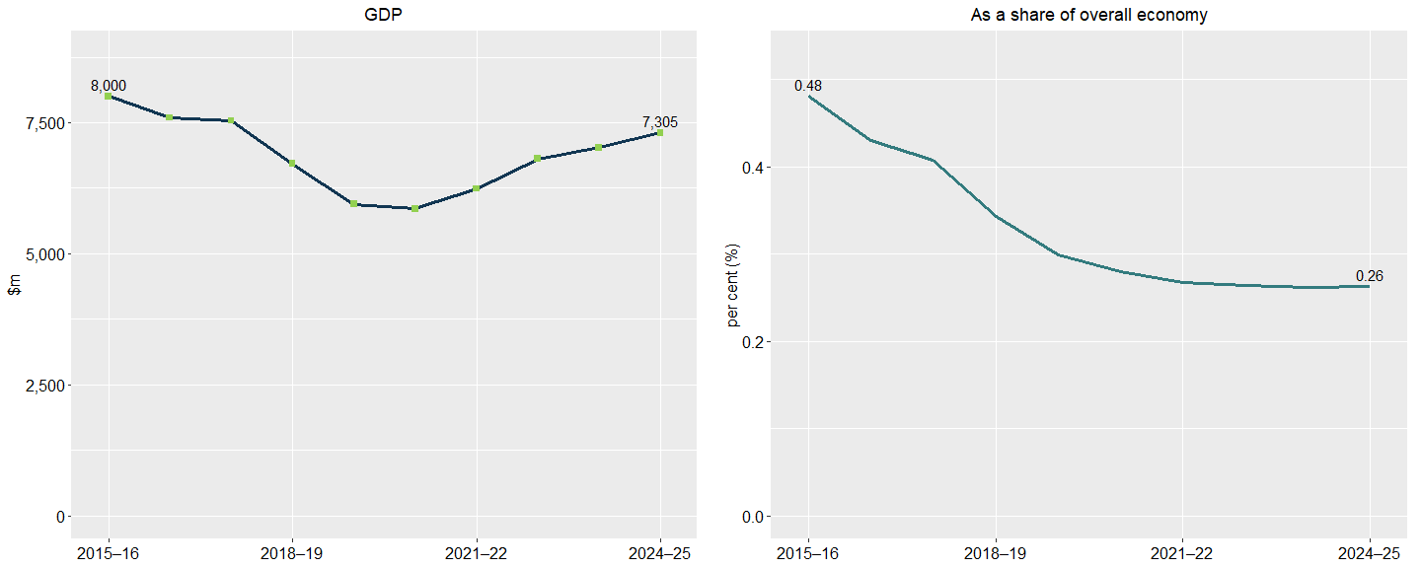
Source: ABS Australian System of National Accounts, Australian National Accounts: Input-Output Tables (Product Details); Australian National Accounts: Supply Use Tables; BCARR calculations. Corresponding reference: Cultural and Creative Activity in Australia, 2008–09 to 2022–23 (Methodology Refresh), Figure 18.

Explanatory notes
See notes of Table 7.

Table 8: Radio broadcasting, 2015–16 to 2024–25
Period | Output ($m) | GVA ($m) | Net taxes on products ($m) | GDP ($m) | As a share of GDP (%)
2015–16 | 1,438 | 713 | 9 | 722 | 0.04
2016–17 | 1,381 | 670 | 8 | 678 | 0.04
2017–18 | 1,451 | 701 | 10 | 711 | 0.04
2018–19 | 1,331 | 562 | 5 | 567 | 0.03
2019–20 | 1,265 | 508 | 5 | 513 | 0.03
2020–21 | 1,321 | 584 | -12 | 572 | 0.03
2021–22 | 1,391 | 578 | 2 | 580 | 0.02
2022–23 | 1,421 | 555 | 2 | 557 | 0.02
2023–24 | 1,371 | 529 | 1 | 530 | 0.02
2024–25 | 1,425 | 550 | 1 | 551 | 0.02
Source: ABS Australian System of National Accounts, Australian National Accounts: Input-Output Tables (Product Details); Australian National Accounts: Supply Use Tables; BCARR calculations. Corresponding reference: Cultural and Creative Activity in Australia, 2008–09 to 2022–23 (Methodology Refresh), Table 10.

Explanatory notes
Radio broadcasting GDP decreased by $172 million, or 23.8%, from 2015–16 to 2024–25.
The industry has experienced declining listener numbers as smartphones and tablets have made alternative audio and entertainment options more accessible. However, radio’s popular personalities and signature interactivity retain a loyal listener base, maintaining some advertising revenue.⁵

⁵ IBISWorld industry report (2024), J5610 Radio Broadcasting in Australia, April 2025, p. 9.

Figure 13: Radio broadcasting, GDP and as a share of overall economy
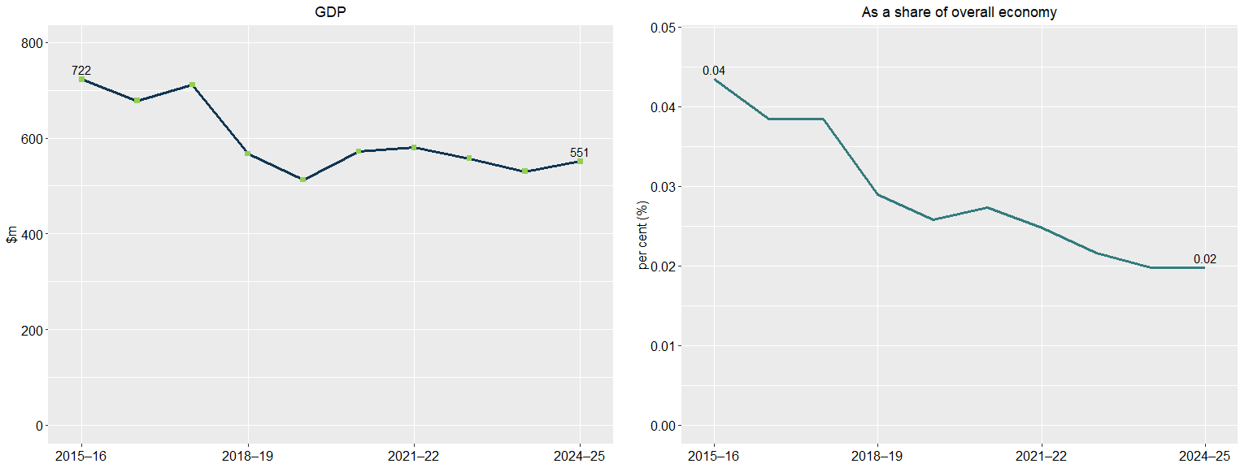
Source: ABS Australian System of National Accounts, Australian National Accounts: Input-Output Tables (Product Details); Australian National Accounts: Supply Use Tables; BCARR calculations. Corresponding reference: Cultural and Creative Activity in Australia, 2008–09 to 2022–23 (Methodology Refresh), Figure 19.

Explanatory notes
See notes of Table 8.

Table 9: Internet publishing and broadcasting, 2015–16 to 2024–25
Period | Output ($m) | GVA ($m) | Net taxes on products ($m) | GDP ($m) | As a share of GDP (%)
2015–16 | 1,635 | 735 | 0 | 735 | 0.04
2016–17 | 2,033 | 967 | 7 | 974 | 0.06
2017–18 | 2,337 | 1,121 | 7 | 1,128 | 0.06
2018–19 | 2,324 | 1,144 | 8 | 1,152 | 0.06
2019–20 | 2,513 | 1,183 | 9 | 1,192 | 0.06
2020–21 | 2,386 | 1,100 | 10 | 1,110 | 0.05
2021–22 | 2,695 | 1,152 | 11 | 1,163 | 0.05
2022–23 | 3,271 | 1,368 | 13 | 1,381 | 0.05
2023–24 | 3,706 | 1,550 | 15 | 1,565 | 0.06
2024–25 | 3,850 | 1,611 | 16 | 1,627 | 0.06
Source: ABS Australian System of National Accounts, Australian National Accounts: Input-Output Tables (Product Details); Australian National Accounts: Supply Use Tables; BCARR calculations. Corresponding reference: Cultural and Creative Activity in Australia, 2008–09 to 2022–23 (Methodology Refresh), Table 11.

Explanatory notes
Internet publishing and broadcasting GDP increased by $891 million from 2015–16 to 2024–25. This domain has grown strongly. Improved digital connectivity has made internet publishing and broadcasting services more accessible to consumers, elevating demand.⁶ As a share of the overall economy, this domain increased from 0.04% to 0.06% over the period.

⁶ IBISWorld industry report (2025), J5700 Internet Publishing and Broadcasting in Australia, October 2025, p. 8.

Figure 14: Internet publishing and broadcasting, GDP and as a share of overall economy
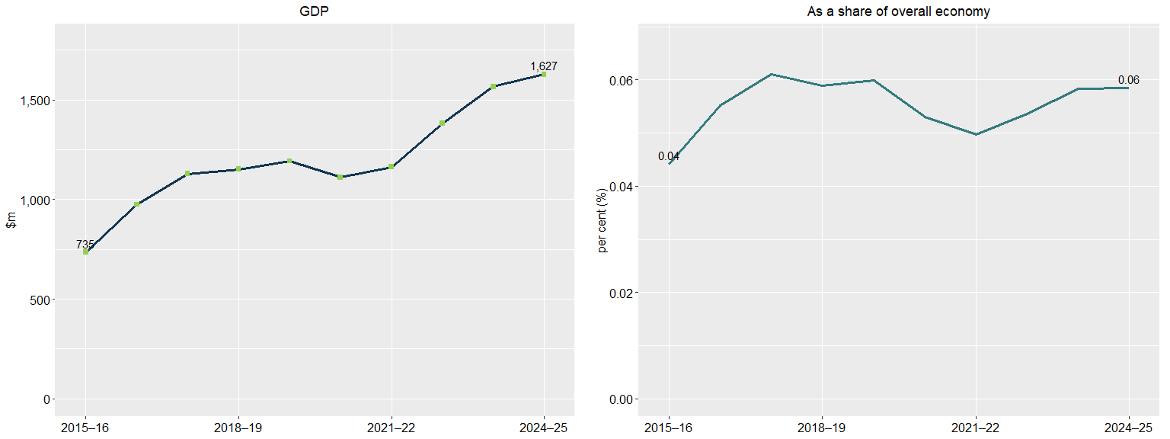
Source: ABS Australian System of National Accounts, Australian National Accounts: Input-Output Tables (Product Details); Australian National Accounts: Supply Use Tables; BCARR calculations. Corresponding reference: Cultural and Creative Activity in Australia, 2008–09 to 2022–23 (Methodology Refresh), Figure 20.

Explanatory notes
See notes of Table 9.

Table 10: Libraries and archives, 2015–16 to 2024–25
Period | Output ($m) | GVA ($m) | Net taxes on products ($m) | GDP ($m) | As a share of GDP (%)
2015–16 | 1,539 | 1,181 | 30 | 1,211 | 0.07
2016–17 | 1,624 | 1,197 | 32 | 1,229 | 0.07
2017–18 | 1,806 | 1,320 | 33 | 1,353 | 0.07
2018–19 | 1,809 | 1,339 | 37 | 1,376 | 0.07
2019–20 | 1,783 | 1,345 | 34 | 1,379 | 0.07
2020–21 | 1,737 | 1,351 | 42 | 1,393 | 0.07
2021–22 | 1,833 | 1,414 | 48 | 1,462 | 0.06
2022–23 | 2,007 | 1,531 | 51 | 1,582 | 0.06
2023–24 | 2,126 | 1,635 | 60 | 1,695 | 0.06
2024–25 | 2,209 | 1,698 | 63 | 1,761 | 0.06
Source: ABS Australian System of National Accounts, Australian National Accounts: Input-Output Tables (Product Details); Australian National Accounts: Supply Use Tables; BCARR calculations. Corresponding reference: Cultural and Creative Activity in Australia, 2008–09 to 2022–23 (Methodology Refresh), Table 12.

Explanatory notes
Cultural and creative activity GDP in libraries and archives increased by $550 million from 2015–16 to 2024–25. As a share of overall economy, the domain has declined slightly over the period.

Figure 15: Libraries and archives, GDP and as a share of overall economy
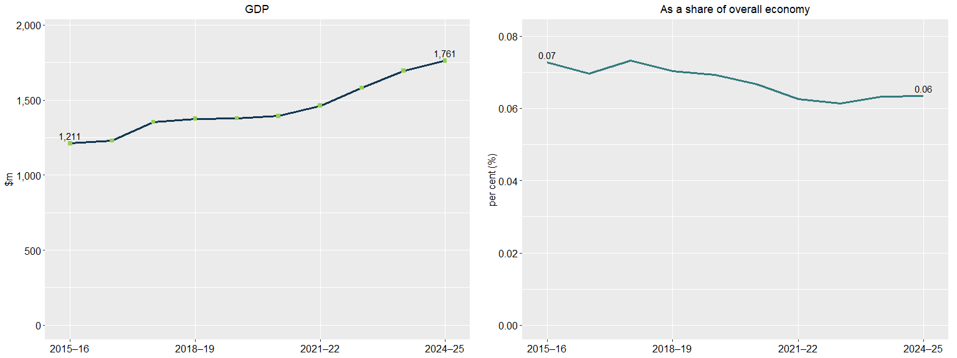
Source: ABS Australian System of National Accounts, Australian National Accounts: Input-Output Tables (Product Details); Australian National Accounts: Supply Use Tables; BCARR calculations. Corresponding reference: Cultural and Creative Activity in Australia, 2008–09 to 2022–23 (Methodology Refresh), Figure 21.

Explanatory notes
See notes of Table 10.

Table 11: Print media and publishing (excl. internet), 2015–16 to 2024–25
Period | Output ($m) | GVA ($m) | Net taxes on products ($m) | GDP ($m) | As a share of GDP (%)
2015–16 | 18,833 | 10,017 | 919 | 10,936 | 0.66
2016–17 | 18,439 | 9,356 | 885 | 10,241 | 0.58
2017–18 | 17,142 | 9,033 | 879 | 9,913 | 0.54
2018–19 | 18,948 | 9,004 | 899 | 9,903 | 0.51
2019–20 | 20,713 | 9,141 | 935 | 10,076 | 0.51
2020–21 | 22,609 | 10,257 | 1,018 | 11,275 | 0.54
2021–22 | 27,657 | 12,432 | 1,141 | 13,573 | 0.58
2022–23 | 34,770 | 13,492 | 1,263 | 14,755 | 0.57
2023–24 | 38,544 | 15,446 | 1,547 | 16,993 | 0.63
2024–25 | 39,924 | 15,998 | 1,631 | 17,630 | 0.63
Source: ABS Australian System of National Accounts, Australian National Accounts: Input-Output Tables (Product Details); Australian National Accounts: Supply Use Tables; BCARR calculations. Corresponding reference: Cultural and Creative Activity in Australia, 2008–09 to 2022–23 (Methodology Refresh), Table 13.

Explanatory notes
Cultural and creative activity GDP in print media and publishing (excl. internet) increased by $6.7 billion, or 61.2%, from 2015–16 to 2024–25. The increase was mainly driven by software publishing, which has experienced strong growth in recent years. Remote working trends have supported software adoption, lifting the sector to new heights.⁷ However, the domain’s share of GDP declined from 0.66% to 0.63% over the period. This was mainly driven by the decrease in newspaper, magazine and other periodic publishing activity, reflecting declining demand for printed publications.⁸

⁷ IBISWorld industry report (2025), J5420 Software Publishing in Australia, January 2025, p. 5.
⁸ IBISWorld industry report (2025), J5411 Newspaper Publishing in Australia, September 2025, p. 4.

Figure 16: Print media and publishing (excl. internet), GDP and as a share of overall economy
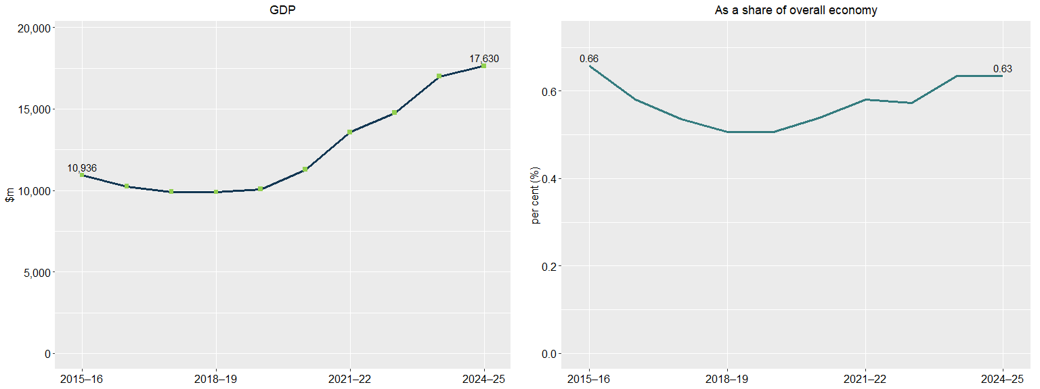
Source: ABS Australian System of National Accounts, Australian National Accounts: Input-Output Tables (Product Details); Australian National Accounts: Supply Use Tables; BCARR calculations. Corresponding reference: Cultural and Creative Activity in Australia, 2008–09 to 2022–23 (Methodology Refresh), Figure 22.

Explanatory notes
See notes of Table 11.

Table 12: Architecture services, 2015–16 to 2024–25
Period | Output ($m) | GVA ($m) | Net taxes on products ($m) | GDP ($m) | As a share of GDP (%)
2015–16 | 10,297 | 4,610 | 6 | 4,615 | 0.28
2016–17 | 10,051 | 4,600 | 4 | 4,604 | 0.26
2017–18 | 11,022 | 4,800 | 5 | 4,805 | 0.26
2018–19 | 11,292 | 4,870 | 5 | 4,875 | 0.25
2019–20 | 11,707 | 5,172 | 5 | 5,177 | 0.26
2020–21 | 11,918 | 5,323 | 5 | 5,328 | 0.25
2021–22 | 12,702 | 5,555 | 6 | 5,561 | 0.24
2022–23 | 13,778 | 5,987 | 7 | 5,994 | 0.23
2023–24 | 14,879 | 6,512 | 7 | 6,519 | 0.24
2024–25 | 15,473 | 6,772 | 7 | 6,779 | 0.24
Source: ABS Australian System of National Accounts, Australian National Accounts: Input-Output Tables (Product Details); Australian National Accounts: Supply Use Tables; BCARR calculations. Corresponding reference: Cultural and Creative Activity in Australia, 2008–09 to 2022–23 (Methodology Refresh), Table 14.

Explanatory notes
Cultural and creative activity GDP in architecture services increased by $2.2 billion, or 46.9%, from 2015–16 to 2024–25. Despite recent challenges in the construction sector, profitability in architecture services is increasing as firms expand into higher‑value offerings such as sustainable design consulting, project management and specialised services.⁹ However, as a share of the overall economy, this domain has declined from 0.28% to 0.24% over the period.

⁹ IBISWorld industry report (2025), M6921 Architectural Services in Australia, June 2025, p. 4.

Figure 17: Architecture services, GDP and as a share of overall economy
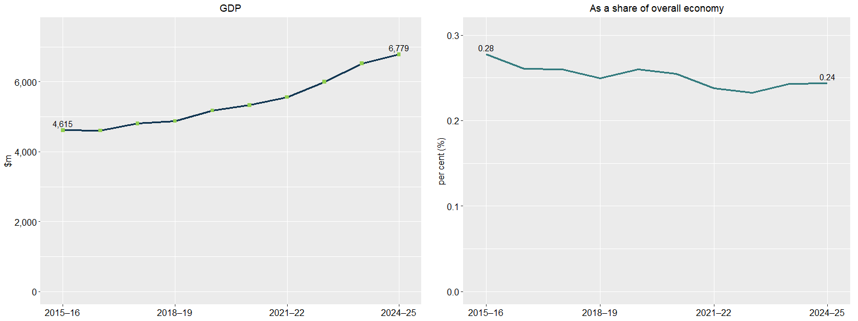
Source: ABS Australian System of National Accounts, Australian National Accounts: Input-Output Tables (Product Details); Australian National Accounts: Supply Use Tables; BCARR calculations. Corresponding reference: Cultural and Creative Activity in Australia, 2008–09 to 2022–23 (Methodology Refresh), Figure 23.

Explanatory notes
See notes of Table 12.

Table 13: Design and fashion, 2015–16 to 2024–25
Period | Output ($m) | GVA ($m) | Net taxes on products ($m) | GDP ($m) | As a share of GDP (%)
2015–16 | 6,928 | 3,281 | 4 | 3,285 | 0.20
2016–17 | 8,621 | 4,159 | 7 | 4,166 | 0.24
2017–18 | 9,162 | 4,440 | 6 | 4,446 | 0.24
2018–19 | 9,221 | 4,373 | 6 | 4,379 | 0.22
2019–20 | 9,349 | 4,532 | 7 | 4,539 | 0.23
2020–21 | 9,718 | 4,815 | 7 | 4,822 | 0.23
2021–22 | 10,023 | 4,956 | 6 | 4,962 | 0.21
2022–23 | 10,756 | 5,406 | 5 | 5,411 | 0.21
2023–24 | 11,530 | 5,811 | 5 | 5,816 | 0.22
2024–25 | 11,938 | 6,016 | 5 | 6,021 | 0.22
Source: ABS Australian System of National Accounts, Australian National Accounts: Input-Output Tables (Product Details); Australian National Accounts: Supply Use Tables; BCARR calculations. Corresponding reference: Cultural and Creative Activity in Australia, 2008–09 to 2022–23 (Methodology Refresh), Table 15.

Explanatory notes
Cultural and creative activity GDP in design and fashion increased by $2.7 billion from 2015–16 to 2024–25. Growth was mainly driven by specialised design service providers that have integrated new design innovations and have capitalised on the widespread adoption of digital technology. More businesses have taken their operations online and onto social media platforms, lifting demand for website design services.¹⁰ As a share of the overall economy, the domain increased from 0.20% in 2015–16 to 0.22% in 2024–25.

¹⁰ IBISWorld industry report (2024), M6924 Specialised Design Services in Australia, October 2024, p. 12.

Figure 18: Design and fashion, GDP and as a share of overall economy
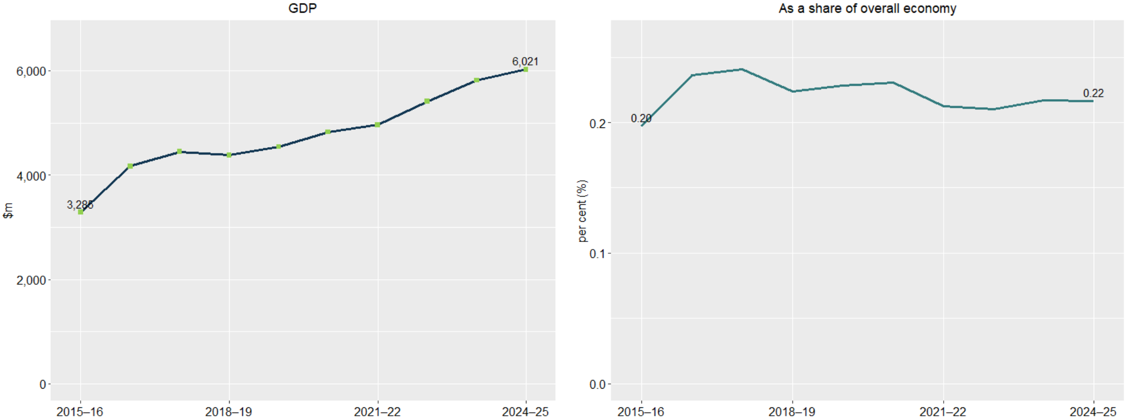
Source: ABS Australian System of National Accounts, Australian National Accounts: Input-Output Tables (Product Details); Australian National Accounts: Supply Use Tables; BCARR calculations. Corresponding reference: Cultural and Creative Activity in Australia, 2008–09 to 2022–23 (Methodology Refresh), Figure 24.

Explanatory notes
See notes of Table 13.

Table 14: Advertising and promotion, 2015–16 to 2024–25
Period | Output ($m) | GVA ($m) | Net taxes on products ($m) | GDP ($m) | As a share of GDP (%)
2015–16 | 22,735 | 11,059 | 101 | 11,160 | 0.67
2016–17 | 24,826 | 12,294 | 91 | 12,385 | 0.70
2017–18 | 25,950 | 12,752 | 94 | 12,846 | 0.69
2018–19 | 27,717 | 13,410 | 102 | 13,512 | 0.69
2019–20 | 26,989 | 13,384 | 100 | 13,484 | 0.68
2020–21 | 27,590 | 13,851 | 103 | 13,954 | 0.67
2021–22 | 30,575 | 15,410 | 102 | 15,512 | 0.66
2022–23 | 33,414 | 17,056 | 101 | 17,157 | 0.67
2023–24 | 33,996 | 17,356 | 83 | 17,439 | 0.65
2024–25 | 35,251 | 17,996 | 88 | 18,084 | 0.65
Source: ABS Australian System of National Accounts, Australian National Accounts: Input-Output Tables (Product Details); Australian National Accounts: Supply Use Tables; BCARR calculations. Corresponding reference: Cultural and Creative Activity in Australia, 2008–09 to 2022–23 (Methodology Refresh), Table 16.

Explanatory notes
Advertising and promotion was the largest cultural and creative domain in 2024–25, accounting for 25.7% of total cultural and creative activity. GDP in this domain increased by $6.9 billion, from $11.2 billion in 2015–16 to $18.1 billion in 2024–25. Growth was supported by technology investment and digital transformation, which have improved profitability by increasing digital advertising uptake and lowering operating costs through tools such as AI-driven campaigns and digital billboards.¹¹ As a share of the overall economy, the domain declined slightly from 0.67% to 0.65% over the period.

¹¹ IBISWorld industry report (2025), M6941 Advertising Agencies in Australia, May 2025, p. 3.

Figure 19: Advertising and promotion, GDP and as a share of overall economy
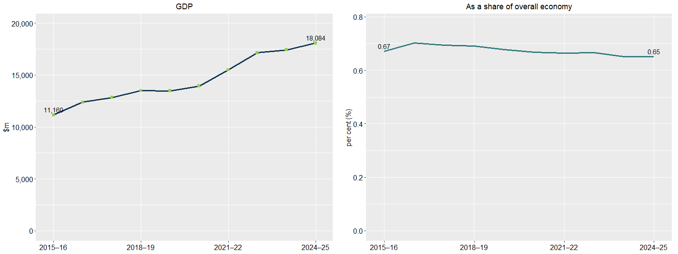
Source: ABS Australian System of National Accounts, Australian National Accounts: Input-Output Tables (Product Details); Australian National Accounts: Supply Use Tables; BCARR calculations. Corresponding reference: Cultural and Creative Activity in Australia, 2008–09 to 2022–23 (Methodology Refresh), Figure 25.

Explanatory notes
See notes of Table 14.

Table 15: Events (arts), 2015–16 to 2024–25
Period | Output ($m) | GVA ($m) | Net taxes on products ($m) | GDP ($m) | As a share of GDP (%)
2015–16 | 1,017 | 638 | 25 | 663 | 0.04
2016–17 | 1,064 | 662 | 14 | 676 | 0.04
2017–18 | 1,144 | 744 | 12 | 756 | 0.04
2018–19 | 1,215 | 804 | 12 | 816 | 0.04
2019–20 | 1,105 | 751 | 9 | 760 | 0.04
2020–21 | 1,095 | 743 | 11 | 753 | 0.04
2021–22 | 1,440 | 968 | 11 | 979 | 0.04
2022–23 | 1,437 | 950 | 12 | 962 | 0.04
2023–24 | 1,483 | 957 | 13 | 970 | 0.04
2024–25 | 1,547 | 998 | 14 | 1,012 | 0.04
Source: ABS Australian System of National Accounts, Australian National Accounts: Input-Output Tables (Product Details); Australian National Accounts: Supply Use Tables; BCARR calculations. Corresponding reference: Cultural and Creative Activity in Australia, 2008–09 to 2022–23 (Methodology Refresh), Table 17.

Explanatory notes
Cultural and creative activity GDP in arts-related events increased by $349 million, or 52.7%, from 2015–16 to 2024–25. Event promotion and management activities was significantly affected by COVID-19, with lockdowns restricting conferences, events and other industry services over this period.¹² As a restrictions eased, GVA rebounded in 2021–22, supported by the return of major events including music concerts. As a share of the overall economy, the domain remained relative flat at 0.04% over the period.¹³

¹² IBISWorld industry report (2022), N7299 Event Promotion and Management Services in Australia, August 2022, p. 9.
¹³ IBISWorld industry report (2023), N7299 Event Promotion and Management Services in Australia, August 2023, p. 15.

Figure 20: Events (arts), GDP and as a share of overall economy
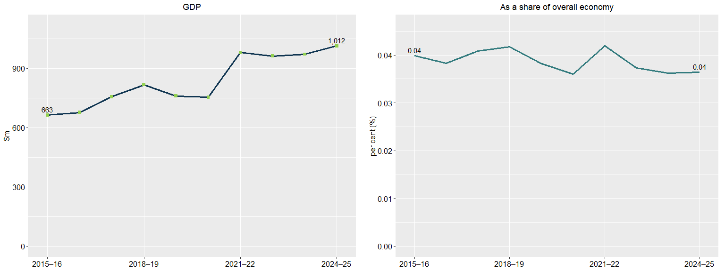
Source: ABS Australian System of National Accounts, Australian National Accounts: Input-Output Tables (Product Details); Australian National Accounts: Supply Use Tables; BCARR calculations. Corresponding reference: Cultural and Creative Activity in Australia, 2008–09 to 2022–23 (Methodology Refresh), Table 17.

Explanatory notes
See notes of Table 15.

Table 16: Arts education, 2015–16 to 2024–25
Period | Output ($m) | GVA ($m) | Net taxes on products ($m) | GDP ($m) | As a share of GDP (%)
2015–16 | 954 | 552 | 45 | 597 | 0.04
2016–17 | 963 | 538 | 63 | 601 | 0.03
2017–18 | 960 | 533 | 54 | 587 | 0.03
2018–19 | 1,089 | 617 | 63 | 680 | 0.03
2019–20 | 1,087 | 659 | 79 | 738 | 0.04
2020–21 | 1,201 | 766 | 88 | 853 | 0.04
2021–22 | 1,311 | 844 | 103 | 948 | 0.04
2022–23 | 1,561 | 998 | 126 | 1,124 | 0.04
2023–24 | 1,709 | 1,164 | 140 | 1,304 | 0.05
2024–25 | 1,820 | 1,240 | 148 | 1,388 | 0.05
Source: ABS Australian System of National Accounts, Australian National Accounts: Input-Output Tables (Product Details); Australian National Accounts: Supply Use Tables; BCARR calculations. Corresponding reference: Cultural and Creative Activity in Australia, 2008–09 to 2022–23 (Methodology Refresh), Table 18.

Explanatory notes
Cultural and creative activity GDP in arts education increased by $791 million from 2015–16 to 2024–25. As a share of overall economy, the domain increased slightly, from 0.04% to 0.05% over the period.

Figure 21: Arts education, GDP and as a share of overall economy
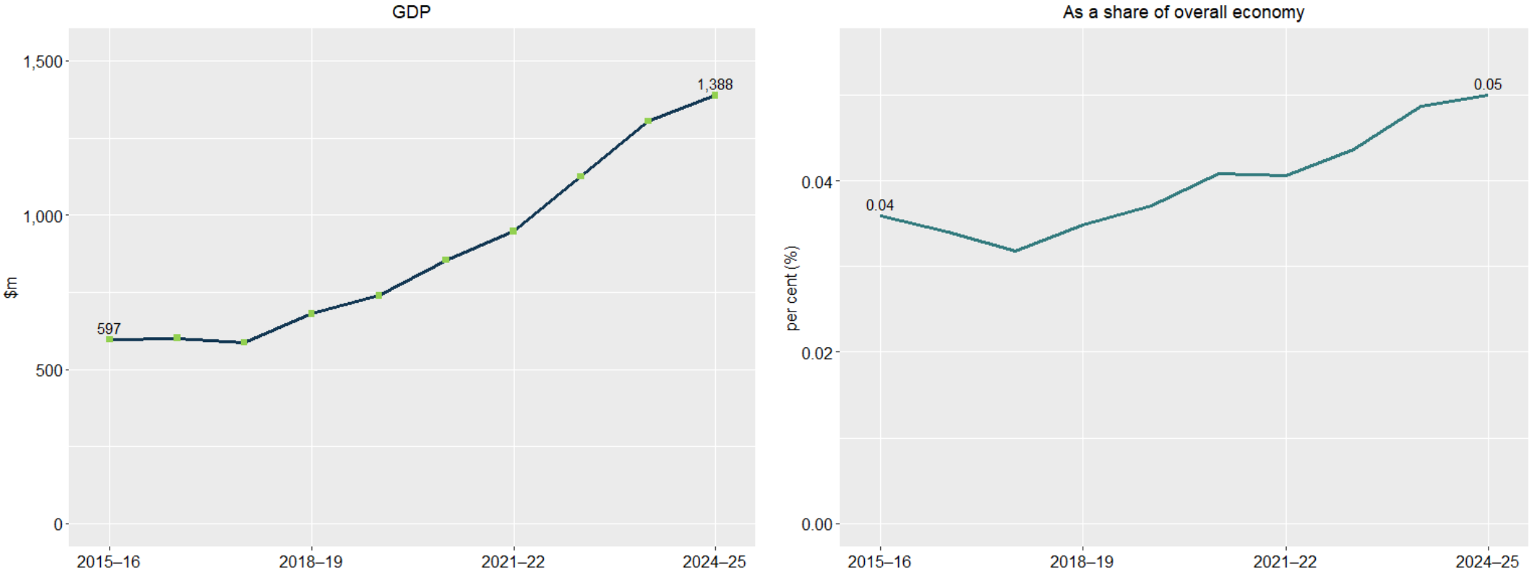
Source: ABS Australian System of National Accounts, Australian National Accounts: Input-Output Tables (Product Details); Australian National Accounts: Supply Use Tables; BCARR calculations. Corresponding reference: Cultural and Creative Activity in Australia, 2008–09 to 2022–23 (Methodology Refresh), Figure 27.

Explanatory notes
See notes of Table 16.

Table 17: Digital games development, 2015–16 to 2024–25
Period | Output ($m) | GVA ($m) | Net taxes on products ($m) | GDP ($m) | As a share of GDP (%)
2015–16 | 277 | 109 | 3 | 111 | 0.007
2016–17 | 281 | 126 | 6 | 132 | 0.008
2017–18 | 269 | 150 | 7 | 158 | 0.009
2018–19 | 280 | 160 | 9 | 169 | 0.009
2019–20 | 256 | 169 | 12 | 180 | 0.009
2020–21 | 261 | 219 | 15 | 233 | 0.011
2021–22 | 287 | 286 | 18 | 304 | 0.013
2022–23 | 320 | 299 | 19 | 318 | 0.012
2023–24 | 354 | 295 | 16 | 310 | 0.012
2024–25 | 418 | 306 | 16 | 322 | 0.012
Source: ABS Australian System of National Accounts, Australian National Accounts: Input-Output Tables (Product Details); Australian National Accounts: Supply Use Tables; BCARR calculations. Corresponding reference: Cultural and Creative Activity in Australia, 2008–09 to 2022–23 (Methodology Refresh), Table 19.

Explanatory notes
Cultural and creative GDP in digital games development increased significantly, rising from $111 million in 2015–16 to $322 million in 2024–25. Growth has been supported by strong consumer uptake of video games over the past decade. As a share of the overall economy, this domain has increased from 0.007% to 0.012% over the period.

Figure 22: Digital games development, GDP and as a share of overall economy
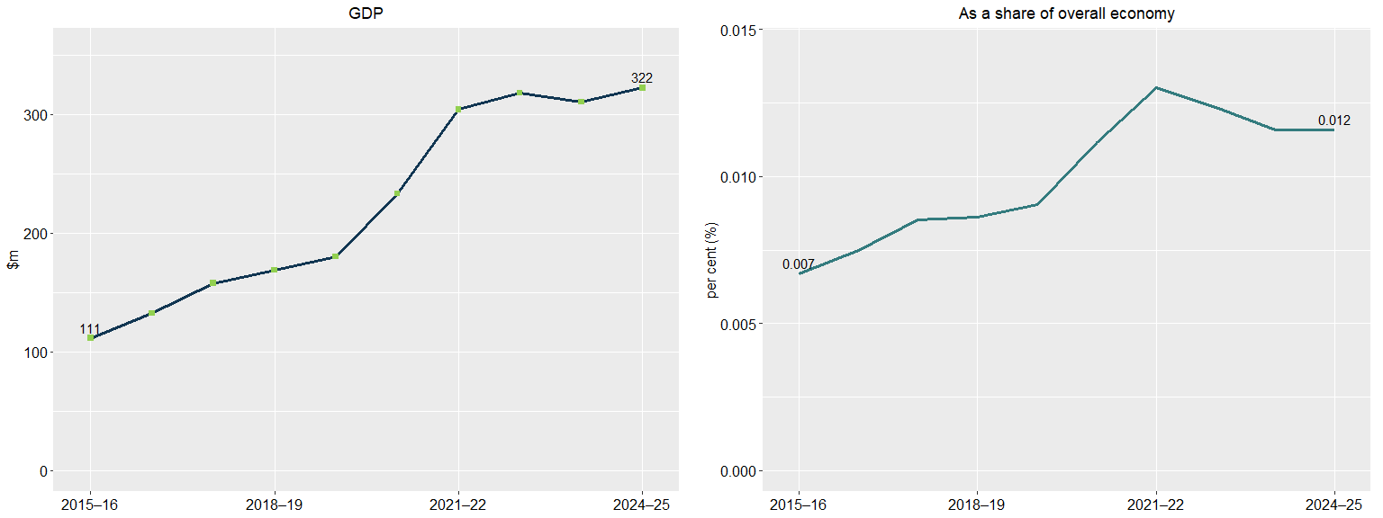
Source: ABS Australian System of National Accounts, Australian National Accounts: Input-Output Tables (Product Details); Australian National Accounts: Supply Use Tables; BCARR calculations. Corresponding reference: Cultural and Creative Activity in Australia, 2008–09 to 2022–23 (Methodology Refresh), Figure 28.

Explanatory notes
See notes of Table 17.

Table 18: Cultural and creative activity, GVA by industry division ($m), 2015–16 to 2024–25
Period | Manufacturing | Construction | Wholesale Trade | Retail Trade | Information Media and Telecommunications | Professional, Scientific and Technical Services | Administrative and Support Services | Education and Training | Arts and Recreation Services | Other Services | Total
2015–16 | 2,925 | 1,032 | 1,631 | 338 | 18,315 | 16,952 | 638 | 552 | 2,727 | 248 | 45,357
2016–17 | 2,825 | 1,045 | 1,713 | 298 | 17,342 | 19,018 | 662 | 538 | 2,894 | 260 | 46,597
2017–18 | 2,728 | 1,347 | 1,365 | 298 | 17,674 | 19,811 | 744 | 533 | 2,874 | 246 | 47,620
2018–19 | 2,936 | 1,325 | 1,268 | 250 | 16,875 | 20,505 | 804 | 617 | 3,275 | 267 | 48,123
2019–20 | 2,628 | 1,354 | 1,192 | 221 | 16,518 | 21,035 | 751 | 659 | 3,022 | 212 | 47,592
2020–21 | 2,759 | 1,384 | 1,253 | 232 | 17,331 | 21,951 | 743 | 766 | 2,669 | 203 | 49,290
2021–22 | 2,778 | 1,440 | 1,294 | 241 | 19,822 | 24,069 | 968 | 844 | 3,008 | 225 | 54,689
2022–23 | 2,940 | 1,625 | 1,464 | 296 | 21,507 | 26,468 | 950 | 998 | 3,570 | 249 | 60,066
2023–24 | 2,951 | 1,750 | 1,520 | 332 | 24,022 | 27,611 | 957 | 1,164 | 3,599 | 365 | 64,272
2024–25 | 3,027 | 1,839 | 1,540 | 341 | 24,958 | 28,628 | 998 | 1,240 | 3,814 | 382 | 66,767
Source: ABS Australian System of National Accounts, Australian National Accounts: Input-Output Tables (Product Details); Australian National Accounts: Supply Use Tables; BCARR calculations. Corresponding reference: Cultural and Creative Activity in Australia, 2008–09 to 2022–23 (Methodology Refresh), Table 20.

Explanatory notes
Cultural and creative activity occurs across several industry divisions. Professional, Scientific and Technical Services was the largest contributor to growth over the period, with cultural and creative GVA increasing by $11.7 billion, or 68.9%, from 2015–16 to 2024–25. This growth was driven primarily by advertising services due to increases in total business profit, reduced operational expenses and further digital advertising growth buttressing demand for advertising services.¹⁴ Information Media and Telecommunications was the second-largest contributor, with cultural and creative GVA increasing by $6.6 billion, or 36.3%, over the period. Growth was mainly driven by software publishing, which has experienced significant growth in recent years due to increased internet access and adoption of new technologies. Arts and Recreation Services was the third-largest contributor, increasing by $1.1 billion, or 39.9%, over the period, mainly driven by creative artists, musicians, writers and performers.

¹⁴ IBISWorld industry report (2025), M6941 Advertising Agencies in Australia, May 2025, p. 5.

Figure 23: Cultural and creative GVA change by division, 2015–16 to 2024–25
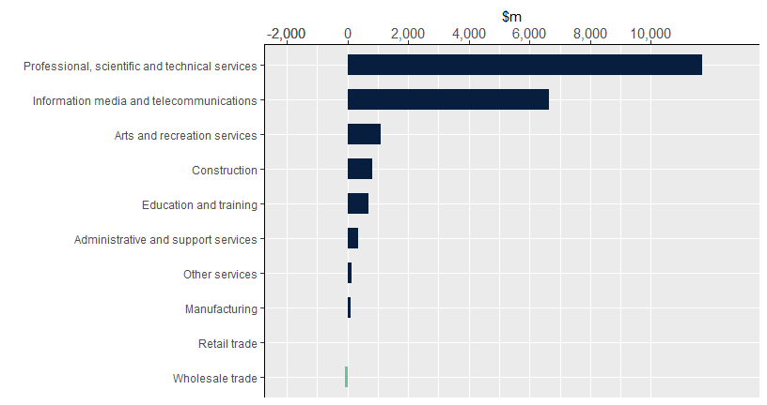
Source: ABS Australian System of National Accounts, Australian National Accounts: Input-Output Tables (Product Details); Australian National Accounts: Supply Use Tables; BCARR calculations. Corresponding reference: Cultural and Creative Activity in Australia, 2008–09 to 2022–23 (Methodology Refresh), Figure 29.

Explanatory notes
See notes of Table 18.

Figure 24: Industry contributors to specialised, support and embedded activities, 2015–16 to 2024–25
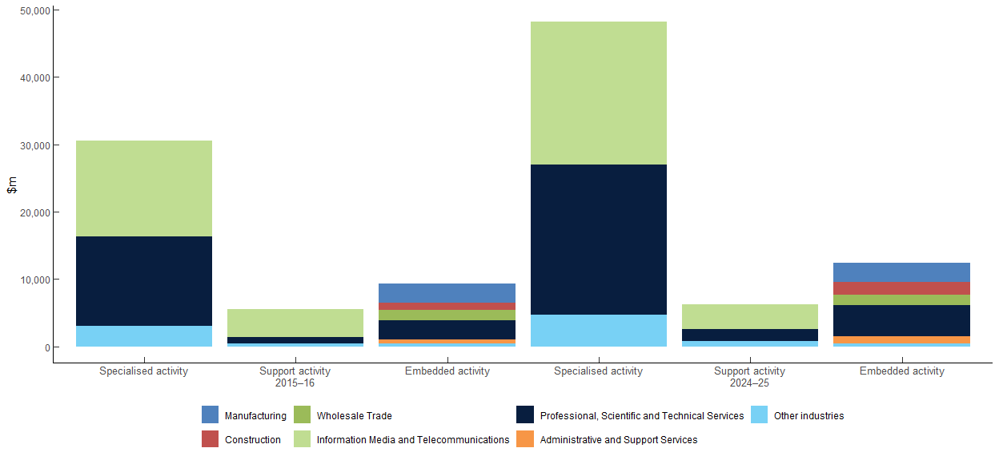
Source: ABS Australian System of National Accounts, Australian National Accounts: Input-Output Tables (Product Details); Australian National Accounts: Supply Use Tables; BCARR calculations. Corresponding reference: Cultural and Creative Activity in Australia, 2008–09 to 2022–23 (Methodology Refresh), Figures 30–32.

Explanatory notes
See notes of Table 19, 20 and 23.

Table 19: Specialised activity, 2015–16 to 2024–25 ($m)
Period | Manufacturing | Information Media and Telecommunications | Professional, Scientific and Technical Services | Education and Training | Arts and Recreation Services | Other Services | Total
2015–16 | 113 | 14,164 | 13,240 | 517 | 2,277 | 214 | 30,525
2016–17 | 130 | 13,087 | 14,680 | 506 | 2,413 | 226 | 31,042
2017–18 | 131 | 13,406 | 15,368 | 503 | 2,439 | 212 | 32,059
2018–19 | 141 | 12,663 | 15,889 | 584 | 2,723 | 230 | 32,231
2019–20 | 91 | 12,548 | 16,431 | 619 | 2,503 | 182 | 32,373
2020–21 | 113 | 13,630 | 17,182 | 723 | 2,172 | 176 | 33,996
2021–22 | 129 | 16,684 | 18,754 | 796 | 2,429 | 195 | 38,987
2022–23 | 169 | 18,087 | 20,581 | 946 | 2,923 | 218 | 42,922
2023–24 | 165 | 20,372 | 21,422 | 1,104 | 2,926 | 319 | 46,308
2024–25 | 169 | 21,166 | 22,211 | 1,176 | 3,100 | 334 | 48,156
Source: ABS Australian System of National Accounts, Australian National Accounts: Input-Output Tables (Product Details); Australian National Accounts: Supply Use Tables; BCARR calculations. Corresponding reference: Cultural and Creative Activity in Australia, 2008–09 to 2022–23 (Methodology Refresh), Table 21.

Explanatory notes
Specialised activity refers to cultural and creative products being produced within cultural and creative industries. This activity increased by $17.6 billion, or 57.8%, from $30.5 billion in 2015–16 to $48.2 billion in 2024–25. Specialised activity accounted for 72.1% of total cultural and creative activity GVA in 2024–25, indicating that most cultural and creative products were produced within cultural and creative industries. Professional, Scientific and Technical Services and Information Media and Telecommunications together accounted for around 90% of specialised activity in 2024–25.

Table 20: Support activity, 2015–16 to 2024–25 ($m)
Period | Manufacturing | Information Media and Telecommunications | Professional, Scientific and Technical Services | Education and Training | Arts and Recreation Services | Other Services | Total
2015–16 | 35 | 4,077 | 966 | 35 | 399 | 33 | 5,545
2016–17 | 34 | 4,176 | 1,106 | 32 | 411 | 35 | 5,793
2017–18 | 34 | 4,183 | 1,176 | 29 | 386 | 34 | 5,843
2018–19 | 37 | 4,127 | 1,180 | 34 | 494 | 37 | 5,908
2019–20 | 24 | 3,905 | 1,273 | 40 | 463 | 30 | 5,736
2020–21 | 32 | 3,645 | 1,297 | 43 | 442 | 27 | 5,485
2021–22 | 40 | 3,049 | 1,381 | 48 | 524 | 29 | 5,071
2022–23 | 49 | 3,314 | 1,535 | 51 | 600 | 31 | 5,581
2023–24 | 47 | 3,549 | 1,673 | 60 | 618 | 46 | 5,993
2024–25 | 49 | 3,687 | 1,734 | 64 | 655 | 48 | 6,237
Source: ABS Australian System of National Accounts, Australian National Accounts: Input-Output Tables (Product Details); Australian National Accounts: Supply Use Tables; BCARR calculations. Corresponding reference: Cultural and Creative Activity in Australia, 2008–09 to 2022–23 (Methodology Refresh), Table 22.

Explanatory notes
Support activity refers to products that fall outside the scope of cultural and creative products but are produced by industries classified as cultural and creative. This activity accounted for $6.2 billion, or 9.3%, of cultural and creative activity GVA in 2024–25. Support activity increased by $692 million, or 12.5%, from $5.5 billion in 2015–16 to $6.2 billion in 2024–25. The main contributors were non-cultural and non-creative products relating to advertising services, including advertising space in newspapers, magazines and other periodicals, books, and internet publishing. As a result, most support activity was concentrated in the Information, Media and Telecommunications industry. Growth in support activity was mainly driven by increased advertising services in internet publishing and broadcasting, as providers such as subscription video-on-demand services introduced more advertising to generate additional revenue.¹⁵

¹⁵ IBISWorld industry report (2025), J5700 Internet Publishing and Broadcasting in Australia, October 2025, p. 3.

Table 21: In-scope cultural and creative industry subdivisions ($m)
Period | Printing (including Reproduction of Recorded Media) | Publishing (except Internet and Music Publishing) | Motion Picture and Sound Recording Activities | Broadcasting (except Internet) | Internet Publishing and Broadcasting | Library and Other Information Services | Professional, Scientific and Technical Services (except Computer System Design and Related Services) | Adult, Community and Other Education | Heritage Activities | Creative and Performing Arts Activities | Personal and Other Services | Total
2015–16 | 147 | 7,512 | 2,887 | 5,745 | 733 | 1,364 | 14,206 | 552 | 571 | 2,105 | 248 | 36,070
2016–17 | 164 | 6,638 | 2,922 | 5,393 | 965 | 1,345 | 15,786 | 538 | 616 | 2,208 | 260 | 36,835
2017–18 | 165 | 6,752 | 2,886 | 5,391 | 1,120 | 1,440 | 16,544 | 533 | 625 | 2,201 | 246 | 37,902
2018–19 | 178 | 6,824 | 2,973 | 4,401 | 1,138 | 1,454 | 17,069 | 617 | 684 | 2,533 | 267 | 38,139
2019–20 | 115 | 7,232 | 2,719 | 3,853 | 1,179 | 1,470 | 17,704 | 659 | 705 | 2,261 | 212 | 38,109
2020–21 | 145 | 8,272 | 1,982 | 4,455 | 1,097 | 1,469 | 18,479 | 766 | 729 | 1,886 | 203 | 39,481
2021–22 | 169 | 10,272 | 2,420 | 4,334 | 1,147 | 1,560 | 20,135 | 844 | 747 | 2,205 | 225 | 44,058
2022–23 | 218 | 10,952 | 3,234 | 4,169 | 1,364 | 1,682 | 22,116 | 998 | 837 | 2,686 | 249 | 48,504
2023–24 | 213 | 12,852 | 3,704 | 4,029 | 1,546 | 1,790 | 23,094 | 1,164 | 884 | 2,660 | 365 | 52,301
2024–25 | 218 | 13,352 | 3,848 | 4,186 | 1,606 | 1,860 | 23,945 | 1,240 | 937 | 2,818 | 382 | 54,393
Source: ABS Australian System of National Accounts, Australian National Accounts: Input-Output Tables (Product Details); Australian National Accounts: Supply Use Tables; BCARR calculations. Corresponding reference: Cultural and Creative Activity in Australia, 2008–09 to 2022–23 (Methodology Refresh), Table 23.

Explanatory notes
Both specialised and support activity are captured within cultural and creative industries, with in-scope industries further broken down into 11 subdivisions at the 2-digit ANZSIC level.

Table 22: Embedded activity, 2015–16 to 2024–25 ($m)
Period | Manufacturing | Construction | Wholesale Trade | Retail Trade | Information Media and Telecommunications | Professional, Scientific and Technical Services | Administrative and Support Services | Arts and Recreation Services | Total
2015–16 | 2,778 | 1,032 | 1,631 | 338 | 73 | 2,746 | 638 | 51 | 9,287
2016–17 | 2,661 | 1,045 | 1,713 | 298 | 79 | 3,233 | 662 | 70 | 9,761
2017–18 | 2,563 | 1,347 | 1,365 | 298 | 85 | 3,267 | 744 | 48 | 9,718
2018–19 | 2,758 | 1,325 | 1,268 | 250 | 85 | 3,436 | 804 | 58 | 9,984
2019–20 | 2,513 | 1,354 | 1,192 | 221 | 65 | 3,331 | 751 | 57 | 9,483
2020–21 | 2,614 | 1,384 | 1,253 | 232 | 56 | 3,473 | 743 | 54 | 9,809
2021–22 | 2,609 | 1,440 | 1,294 | 241 | 89 | 3,934 | 968 | 56 | 10,631
2022–23 | 2,722 | 1,625 | 1,464 | 296 | 106 | 4,352 | 950 | 47 | 11,563
2023–24 | 2,739 | 1,750 | 1,520 | 332 | 101 | 4,516 | 957 | 56 | 11,971
2024–25 | 2,809 | 1,839 | 1,540 | 341 | 105 | 4,683 | 998 | 59 | 12,374
Source: ABS Australian System of National Accounts, Australian National Accounts: Input-Output Tables (Product Details); Australian National Accounts: Supply Use Tables; BCARR calculations. Corresponding reference: Cultural and Creative Activity in Australia, 2008–09 to 2022–23 (Methodology Refresh), Table 24.

Explanatory notes
Embedded activity contributed $12.4 billion of cultural and creative activity GVA in 2024–25, accounting for 18.5% of total cultural and creative activity. Most embedded activity was produced from Professional, Scientific and Technical Services and Manufacturing industries. This was because some cultural and creative activities – such as management services (including business, artists, entertainers and sporting professionals), manufacturing products of printing materials and crafts – have only been identified as in-scope activities through their product levels rather than industry levels. As a result, the economic value produced by these activities was only estimated as embedded activity.

Table 23: Revisions from 2015–16 to 2023–24
Period | Cultural and creative activity gross value added (GVA) ($m) | Net taxes on products of cultural and creative activity ($m) | Cultural and creative activity GDP ($m) | Cultural and creative activity as a share of GDP (%)
2015–16 | 149 | 0 | 149 | -0.0
2016–17 | 193 | 0 | 194 | -0.0
2017–18 | 181 | -0 | 181 | -0.0
2018–19 | 157 | 0 | 157 | -0.0
2019–20 | 137 | 0 | 138 | -0.0
2020–21 | -143 | 3 | -140 | -0.0
2021–22 | -92 | -6 | -98 | -0.0
2022–23 | -55 | 1 | -54 | -0.0
2023–24 | 117 | 125 | 242 | 0.0
Source: ABS Australian System of National Accounts, Australian National Accounts: Input-Output Tables (Product Details); Australian National Accounts: Supply Use Tables; BCARR calculations.

Explanatory notes
The estimates of cultural and creative activity from 2015–16 to 2023–24 are derived from the ABS National Accounts data: Australian System of National Accounts, 2024–25, Australian National Accounts: Supply Use Tables, 2023–24, and Australian National Accounts: Input-Output Tables, 2023–24. As a result of revisions to these data sources, BCARR’s updated estimates of cultural and creative activity differ from those published in previous releases. The revised estimates cover 2015–16 to 2023–24 and are compared with BCARR’s previous estimates published in Cultural and Creative Activity in Australia, 2014–15 to 2023–24 (shown in nominal values).

Appendix: Scope of cultural and creative domains
Cultural and creative activities are grouped by 15 domains. The activities within the domains are grouped in terms of the input-output product classification (IOPC) codes, and the Australian and New Zealand Standard Industrial Classification 2006 (ANZSIC 06) class codes.
No | Domain name | Domain scope
1 | Literature, creative and performing arts | This domain includes:  • Performing arts operations which provide or produce live theatrical or musical presentations or performances.  • Creative artists, musicians, writers and performers who are independent individuals or groups mainly engaged in the regular creation of original artistic or cultural works.  • Performing arts venue operations that operate venues for the presentation and rehearsal of performing arts.  Visual arts creation activities are excluded from this domain.
2 | Visual arts and crafts | This domain includes:  • Activities of independent artists, e.g. sculptors, painters, etc.  • Manufacturing products of crafts including tableware, ornamental pottery, glassware, jewellery and silverware.  • Professional photographic services.  • Photographic film processing activities.
3 | Music production and distribution | This domain includes:  • Musical instruments (including parts and accessories).  • Music publishing activities.  • Music and other sound recording activities, including studios and distribution.
4 | Museums and galleries | This domain consists of museum operations such as the preservation and exhibition of heritage objects and artefacts, including activities in historical places and sites.
5 | Film and television activities | This domain consists of:  • Motion picture and video production.  • Distribution and exhibition activities.  • Post-production services.  • Free-to-air and subscription television broadcasting.
6 | Radio broadcasting | Radio broadcasting is mainly engaged in broadcasting audio signals using radio broadcasting studios and facilities.
7 | Internet publishing and broadcasting | Internet publishing and broadcasting consists of activities engaged in publishing and/or broadcasting content on the internet.
8 | Libraries and archives | Libraries and archives include activities such as maintaining collections of documents and facilitating their use.
9 | Print media and publishing (excl. internet) | This domain includes:  • Printing products and printing support services.  • Newspaper, magazine and book publishing.  • Other publishing activities (excluding software, music and internet).  • Software publishing and other information services.
10 | Architecture services | Architecture services consist of planning and designing buildings, structures, and land development.
11 | Design and fashion | This domain consists of specialised design services including commercial art, display services, and fashion, interior and jewellery design.
12 | Advertising and promotion | This domain includes:  • Advertising campaign creation and media planning.  • Management services for businesses, artists and entertainers.
13 | Events (arts) | This domain includes:  • Theatre, concert ticketing and booking services.  • Event management or promotion and fund-raising services.
14 | Arts education | Arts education provides non-vocational instruction in art, dance, drama and music.
15 | Digital games development | This domain consists of computer systems, hardware and software design and development services relating to digital games.

