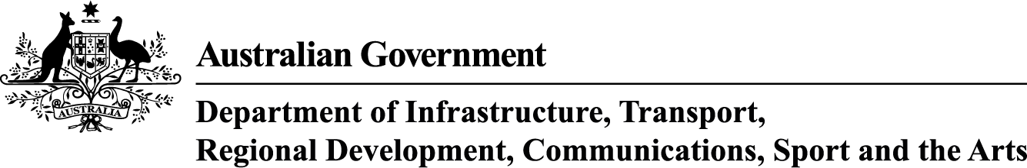
BUREAU OF COMMUNICATIONS, ARTS AND REGIONAL RESEARCH

Visual Summary: Cultural and Creative Activity in Australia, 2014–15 to 2023–24
September 2025

The Department of Infrastructure, Transport, Regional Development, Communications, Sport and the Arts acknowledges the Traditional Custodians of Country throughout Australia and their continuing connection to land, sea and community. We pay our respects to them, their cultures and to their Elders, past, present and emerging.

© Commonwealth of Australia 2025
ISBN: 978-1-922879-97-4/ BCARR reference: 2025-103

Ownership of intellectual property rights in this publication
Unless otherwise noted, copyright (and any other intellectual property rights, if any) in this publication is owned by the Commonwealth of Australia (referred to below as the Commonwealth).

Disclaimer
The material contained in this publication is made available on the understanding that the Commonwealth is not providing professional advice, and that users exercise their own skill and care with respect to its use, and seek independent advice if necessary.
The Commonwealth makes no representations or warranties as to the contents or accuracy of the information contained in this publication. To the extent permitted by law, the Commonwealth disclaims liability to any person or organisation in respect of anything done, or omitted to be done, in reliance upon information contained in this publication.
Creative Commons licence


With the exception of (a) the Coat of Arms; (b) the Department of Infrastructure, Transport, Regional Development, Communications, Sport and the Arts photos and graphics; (c) content supplied by third parties; (d) content otherwise labelled; copyright in this publication is licensed under a Creative Commons BY Attribution 4.0 International Licence.

Use of the Coat of Arms
The Department of the Prime Minister and Cabinet (PM&C) sets the terms under which the Coat of Arms is used. Please refer to the Commonwealth Coat of Arms Information and Guidelines | PM&C.

Contact us
This publication is available in PDF format. All other rights are reserved, including in relation to any departmental logos or trademarks which may exist. For enquiries regarding the licence and any use of this publication, please contact:
Email: BCARR@infrastructure.gov.au
Website: https://www.infrastructure.gov.au/research-data/bureau-communications-arts-and-regional-research

Content
About this document 6
Table 1: Cultural and creative activity 2014–15 and 2023–24 7
Table 2: Cultural and creative activity components and share of GDP, 2014–15 to 2023–24 8
Figure 1: Relative to nominal Gross Domestic Product (GDP) 9
Figure 2: Cultural and creative GVA and industry share of total economy, 2023–24 10
Figure 3: GVA average annual growth rate by industry division, 2014–15 to 2023–24 11
Figure 4: Cultural and creative activity, GDP by domain, 2023–24 12
Figure 5: Contribution to cultural and creative activity, GDP by domain, 2014–15 and 2023–24 13
Figure 6: Nominal GDP growth by domain, between 2014–15 and 2023–24 14
Figure 7: GDP average annual growth rate by domain, between 2014–15 and 2023–24 15
Table 3: Literature, creative and performing arts, 2014–15 to 2023–24 16
Figure 8: Literature, creative and performing arts, GDP and as a share of overall economy 17
Table 4: Visual arts and crafts, 2014–15 to 2023–24 18
Figure 9: Visual arts and crafts, GDP and as a share of overall economy 19
Table 5: Music production and distribution, 2014–15 to 2023–24 20
Figure 10: Music production and distribution, GDP and as a share of overall economy 21
Table 6: Museums and galleries, 2014–15 to 2023–24 22
Figure 11: Museums and galleries, GDP and as a share of overall economy 23
Table 7: Film and television activities, 2014–15 to 2023–24 24
Figure 12: Film and television activities, GDP and as a share of overall economy 25
Table 8: Radio broadcasting, 2014–15 to 2023–24 26
Figure 13: Radio broadcasting, GDP and as a share of overall economy 27
Table 9: Internet publishing and broadcasting, 2014–15 to 2023–24 28
Figure 14: Internet publishing and broadcasting, GDP and as a share of overall economy 29
Table 10: Libraries and archives, 2014–15 to 2023–24 30
Figure 15: Libraries and archives, GDP and as a share of overall economy 31
Table 11: Print media and publishing (excl. internet), 2014–15 to 2023–24 32
Figure 16: Print media and publishing (excl. internet), GDP and as a share of overall economy 33
Table 12: Architecture services, 2014–15 to 2023–24 34
Figure 17: Architecture services, GDP and as a share of overall economy 35
Table 13: Design and fashion, 2014–15 to 2023–24 36
Figure 18: Design and fashion, GDP and as a share of overall economy 37
Table 14: Advertising and promotion, 2014–15 to 2023–24 38
Figure 19: Advertising and promotion, GDP and as a share of overall economy 39
Table 15: Events (arts), 2014–15 to 2023–24 40
Figure 20: Events (arts), GDP and as a share of overall economy 41
Table 16: Arts education, 2014–15 to 2023–24 42
Figure 21: Arts education, GDP and as a share of overall economy 43
Table 17: Digital games development, 2014–15 to 2023–24 44
Figure 22: Digital games development, GDP and as a share of overall economy 45
Table 18: Cultural and creative activity, GVA by industry division, 2014–15 to 2023–24 46
Figure 23: Cultural and creative GVA change by division, 2014–15 to 2023–24 47
Figure 24: Industry contributors to specialised, support and embedded activities, 2014–15 to 2023–24 48
Table 19: Specialised activity, 2014–15 to 2023–24 49
Table 20: Support activity, 2014–15 to 2023–24 50
Table 21: In-scope cultural and creative industry subdivisions 51
Table 22: Embedded activity, 2014–15 to 2023–24 52
Table 23: Revisions from 2014–15 to 2022–23 53
Appendix: Scope of cultural and creative domains 54

About this document
The Bureau of Communications, Arts and Regional Research (BCARR) within the Department of Infrastructure, Transport, Regional Development, Communications, Sport and the Arts has estimated the economic contribution of cultural and creative activity in Australia over a 10-year period, from 2014–15 to 2023–24.
This publication provides an update to the BCARR working paper: Cultural and Creative Activity in Australia, 2008–09 to 2022–23 (Methodology Refresh)—Statistical Working Paper released in December 2024. The updated estimates are presented as a visual summary. Each table and figure corresponds to those used in the BCARR working paper.
This publication follows the same approach taken in the statistical working paper.
Note that data is subject to revisions in the Australian Bureau of Statistics’ (ABS) national accounts datasets. Estimates in this release vary from those published previously. This document also includes a table of revisions to the data, covering the period from 2014–15 to 2022–23.
Estimates and their components in this document have been rounded and discrepancies may occur between sums of component items and totals. Analysis featured in this release is based on un-rounded data. Calculations based on rounded data may differ to those published.
Further information on these updates can be found in the FAQ: Cultural and creative activity in Australia, 2014–15 to 2023–24.

Table 1: Cultural and creative activity 2014–15 and 2023–24
Cultural and Creative Activity | 2014–15 | 2023–24 | Change | Movement (%)
Gross Value Added ($m) | 43,931 | 64,155 | 20,224 | 46.0
plus Net taxes on products ($m) | 2,514 | 3,220 | 707 | 28.1
equals Total Cultural and Creative GDP ($m) | 46,445 | 67,376 | 20,931 | 45.1
As a proportion of GDP (%) | 2.9 | 2.5 | -0.3
Source: ABS Australian System of National Accounts, Australian National Accounts: Input-Output Tables (Product Details); Australian National Accounts: Supply Use Tables; BCARR calculations.
Corresponding reference: Cultural and Creative Activity in Australia, 2008–09 to 2022–23 (Methodology Refresh), Table 1.

Explanatory notes

New estimates of the economic contribution from cultural and creative activity to Australia’s GDP was $46.4 billion in 2014–15. Between 2014–15 and 2023–24, cultural and creative activity in Australia grew to $67.4 billion, an increase of $20.9 billion (or 45.1%). While this activity is growing in absolute terms, as a share of GDP, it declined by 0.3 percentage points from 2.9% in 2014-15 to 2.5% in 2023–24. The slower growth of cultural and creative activity during this period relative to the Australian economy overall reflects the expansion of activities such as mining and healthcare that are almost entirely outside cultural and creative activity (see Figure 2 and 3).

Table 2: Cultural and creative activity components and share of GDP, 2014–15 to 2023–24
Period | Cultural and creative activity gross value added (GVA)  $m | Net taxes on products of cultural and creative activity  $m | Cultural and creative activity GDP  $m | Cultural and creative activity as a share of GDP  %
2014–15 | 43,931 | 2,514 | 46,445 | 2.9
2015–16 | 45,208 | 2,444 | 47,652 | 2.9
2016–17 | 46,403 | 2,223 | 48,626 | 2.8
2017–18 | 47,439 | 2,272 | 49,711 | 2.7
2018–19 | 47,965 | 2,259 | 50,224 | 2.6
2019–20 | 47,455 | 2,239 | 49,694 | 2.5
2020–21 | 49,433 | 2,437 | 51,870 | 2.5
2021–22 | 54,781 | 2,897 | 57,678 | 2.5
2022–23 | 60,121 | 3,105 | 63,226 | 2.5
2023–24 | 64,155 | 3,220 | 67,376 | 2.5
Source: ABS Australian System of National Accounts, Australian National Accounts: Input-Output Tables (Product Details); Australian National Accounts: Supply Use Tables; BCARR calculations.
Corresponding reference: Cultural and Creative Activity in Australia, 2008–09 to 2022–23 (Methodology Refresh), Table 3.

Explanatory notes
Cultural and creative activity in Australia grew to $67.4 billion in nominal terms in 2023-24, an increase of $20.9 billion or 45.1% since 2014-15. This growth included an increase of $20.2 billion in cultural and creative gross value added from 2014–15 to 2023–24, which was primarily from the Professional, Scientific and Technical Services industry with an increase of $11.4 billion over the period. This industry division includes activities that mainly provide professional, scientific and technical services that generally require a high level of expertise and training and formal (usually tertiary level) qualifications. Cultural and creative activities captured within this division primarily include advertising, architecture, management services for artists, and professional photography.
Net taxes on products of cultural and creative activity have increased by $707 million or 28.1%, from $2.5 billion in 2014–15 to $3.2 billion in 2023–24.
While cultural and creative activity is growing in nominal terms, as a share of GDP it declined by 0.3 percentage points over the period – from 2.9% in 2014–15 to 2.5% in 2023–24.

Figure 1: Relative to nominal Gross Domestic Product (GDP)
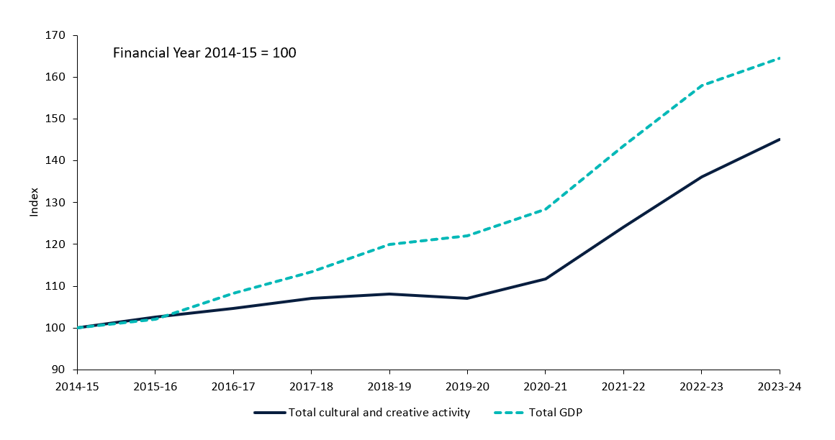
Source: ABS Australian System of National Accounts, Australian National Accounts: Input-Output Tables (Product Details); Australian National Accounts: Supply Use Tables; BCARR calculations.
Corresponding reference: Cultural and Creative Activity in Australia, 2008–09 to 2022–23 (Methodology Refresh), Figure 8.

Explanatory notes
The pace of growth in cultural and creative activity has been slower than the pace of growth in the Australian economy overall.
In Figure 1, the index at 100 represents the base year of 2014–15. The dashed line represents GDP growth for the entire Australian economy relative to the base year. Cultural and creative activity has grown slower than the overall economy since 2016–17. The slower growth of cultural and creative activity during this period relative to the Australian economy overall reflects the expansion of activities such as mining and healthcare that are almost entirely outside cultural and creative activity (explained further in Figure 2 and 3).

Figure 2: Cultural and creative GVA and industry share of total economy, 2023–24
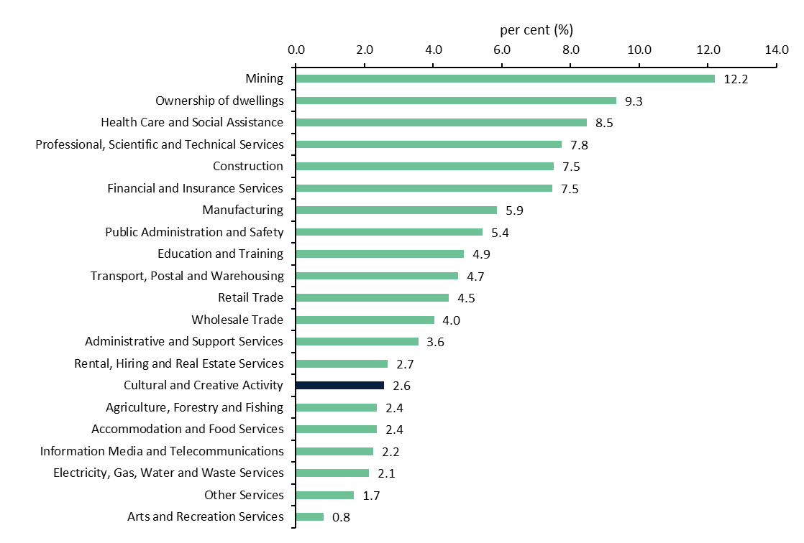
Source: ABS Australian System of National Accounts, Australian National Accounts: Input-Output Tables (Product Details); Australian National Accounts: Supply Use Tables; BCARR calculations.
Corresponding reference: Cultural and Creative Activity in Australia, 2008–09 to 2022–23 (Methodology Refresh), Figure 9.

Explanatory notes
The Australian System of National Accounts lists 19 industries in the Australian economy. When added together with Ownership of Dwellings, the activity in these industries equals the total amount of final goods and services produced in the economy in a given period. Cultural and creative activity is not an industry division, but rather includes output produced by many industries across the economy. Cultural and creative activity is therefore not additional to the industry shares shown in Figure 2 but is provided here to indicate its size relative to other industry divisions.
Figure 2 shows that cultural and creative activity accounted for 2.6% of GVA in the economy in 2023–24. This is comparable to the size of the Rental, Hiring and Real Estate Services industry at 2.7%.

Figure 3: GVA average annual growth rate by industry division, 2014–15 to 2023–24
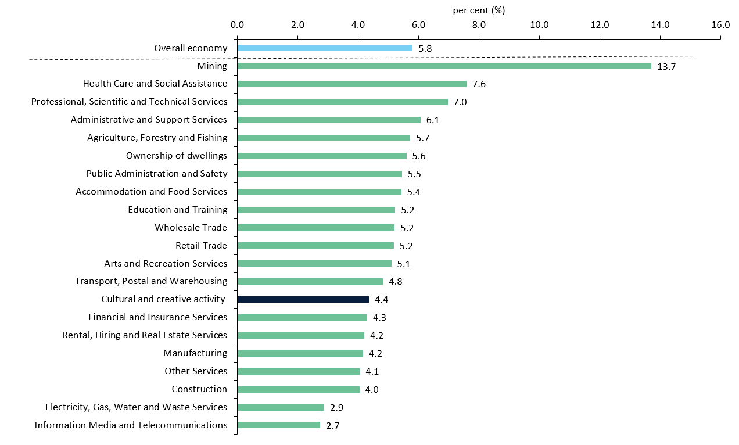
Source: ABS Australian System of National Accounts, Australian National Accounts: Input-Output Tables (Product Details); Australian National Accounts: Supply Use Tables; BCARR calculations.
Corresponding reference: Cultural and Creative Activity in Australia, 2008–09 to 2022–23 (Methodology Refresh), Figure 10.

Explanatory notes
The Australian economy has been supported by strong growth in Mining (buoyed by high commodity prices) and the Health Care and Social Assistance industry (supported by an ageing population). From 2014–15 to 2023–24, the average annual GVA growth was 13.7% for mining, 7.6% for health care and social assistance, 5.8% for the overall economy, and 4.4% for cultural and creative activities.

Figure 4: Cultural and creative activity, GDP by domain, 2023–24
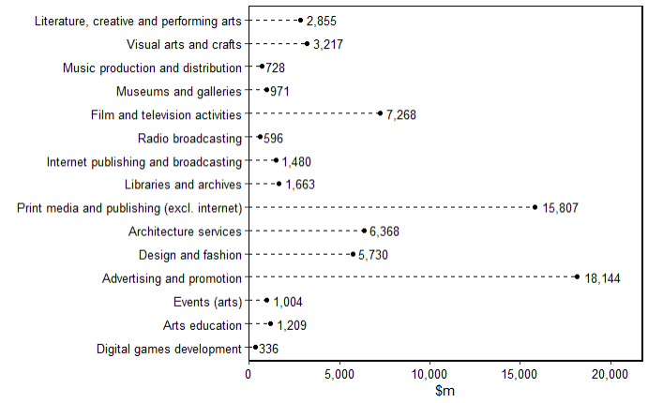
Source: ABS Australian System of National Accounts, Australian National Accounts: Input-Output Tables (Product Details); Australian National Accounts: Supply Use Tables; BCARR calculations.
Corresponding reference: Cultural and Creative Activity in Australia, 2008–09 to 2022–23 (Methodology Refresh), Figure 11.

Explanatory notes
Cultural and creative activities are grouped into 15 domains. In 2023–24, advertising and promotion contributed the most to cultural and creative activity, at $18.1 billion.

Figure 5: Contribution to cultural and creative activity, GDP by domain, 2014–15 and 2023–24
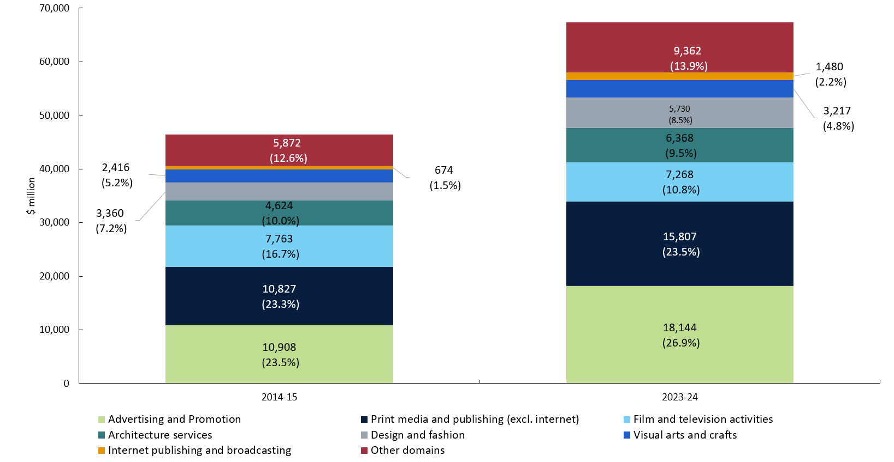
Source: ABS Australian System of National Accounts, Australian National Accounts: Input-Output Tables (Product Details); Australian National Accounts: Supply Use Tables; BCARR calculations.
Corresponding reference: Cultural and Creative Activity in Australia, 2008–09 to 2022–23 (Methodology Refresh), Figure 12.

Explanatory notes
Advertising and promotion was the largest domain, with its share of total cultural and creative activity growing from $10.9 billion or 23.5% in 2014–15 to $18.1 billion or 26.9% in 2023–24. Print media and publishing (excl. internet) followed, growing from $10.8 billion or 23.3% in 2014–15 to $15.8 billion or 23.5% in 2023–24. Film and television activities decreased from $7.8 billion or 16.7% in 2014–15 to $7.3 billion or 10.8% in 2023–24. Architecture services represented $4.6 billion or 10.0% in 2014–15 and $6.4 billion or 9.5% in 2023–24. These four domains represented over 70% of cultural and creative activity in 2023–24.

Figure 6: Nominal GDP growth by domain, between 2014–15 and 2023–24
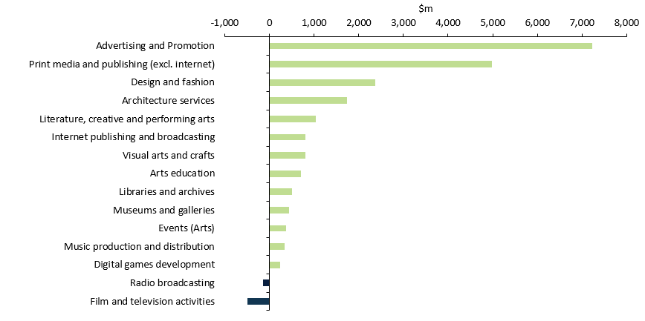
Source: ABS Australian System of National Accounts, Australian National Accounts: Input-Output Tables (Product Details); Australian National Accounts: Supply Use Tables; BCARR calculations.
Corresponding reference: Cultural and Creative Activity in Australia, 2008–09 to 2022–23 (Methodology Refresh), Figure 13.

Explanatory notes
Thirteen of the 15 domains experienced growth in nominal terms from 2014–15 to 2023–24. Advertising and promotion recorded the strongest growth of $7.2 billion. The only two domains that declined were film and television activities, and radio broadcasting which decreased by $496 million and $150 million, respectively, driven by rising competition from online and cloud-based media platforms and falling demand from advertisers.

Figure 7: GDP average annual growth rate by domain, between 2014–15 and 2023–24
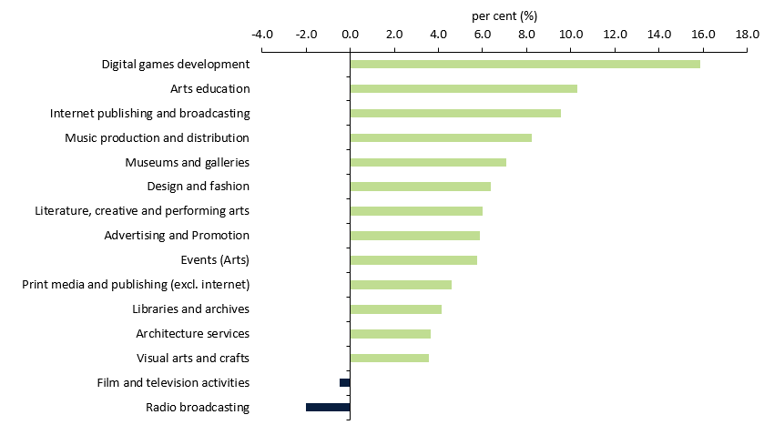
Source: ABS Australian System of National Accounts, Australian National Accounts: Input-Output Tables (Product Details); Australian National Accounts: Supply Use Tables; BCARR calculations.

Explanatory notes
Digital games development has experienced the strongest growth rate over the period. From its small base of initial activity, digital games development increased by an average annual growth rate of 15.9% from 2014–15 to 2023–24.

Table 3: Literature, creative and performing arts, 2014–15 to 2023–24
Literature, creative and performing arts  Period | Output  $m | GVA  $m | Net taxes on products  $m | GDP  $m | As a share of overall economy  %
2014–15 | 3,750 | 1,732 | 84 | 1,816 | 0.11
2015–16 | 4,042 | 1,950 | 75 | 2,025 | 0.12
2016–17 | 4,203 | 2,023 | 76 | 2,099 | 0.12
2017–18 | 4,313 | 2,013 | 72 | 2,086 | 0.11
2018–19 | 4,914 | 2,310 | 77 | 2,386 | 0.12
2019–20 | 4,266 | 2,069 | 57 | 2,126 | 0.11
2020–21 | 3,368 | 1,731 | 27 | 1,757 | 0.08
2021–22 | 4,240 | 2,027 | 44 | 2,071 | 0.09
2022–23 | 5,377 | 2,531 | 75 | 2,605 | 0.10
2023–24 | 5,916 | 2,784 | 71 | 2,855 | 0.11
Source: ABS Australian System of National Accounts, Australian National Accounts: Input-Output Tables (Product Details); Australian National Accounts: Supply Use Tables; BCARR calculations.
Corresponding reference: Cultural and Creative Activity in Australia, 2008–09 to 2022–23 (Methodology Refresh), Table 5.

Explanatory notes
Cultural and creative activity GDP in Literature, creative and performing arts increased by $1.0 billion or 57.2% from $1.8 billion in 2014–15 to $2.9 billion in 2023–24.
Declines in activity occurred in 2019–20 and 2020–21 due to COVID-19 and the inability to hold performances. However, this domain has experienced more favourable conditions in recent years. Strong demand for international artist performances in the contemporary music segment, coupled with improved ticket sales, has bolstered the industry's performance.
As a share of the overall economy, this domain consistently accounted for around 0.11%, dipping to 0.08% in 2020–21 and 0.09% in 2021–22 before returning to 0.11% in 2023–24.

Figure 8: Literature, creative and performing arts, GDP and as a share of overall economy
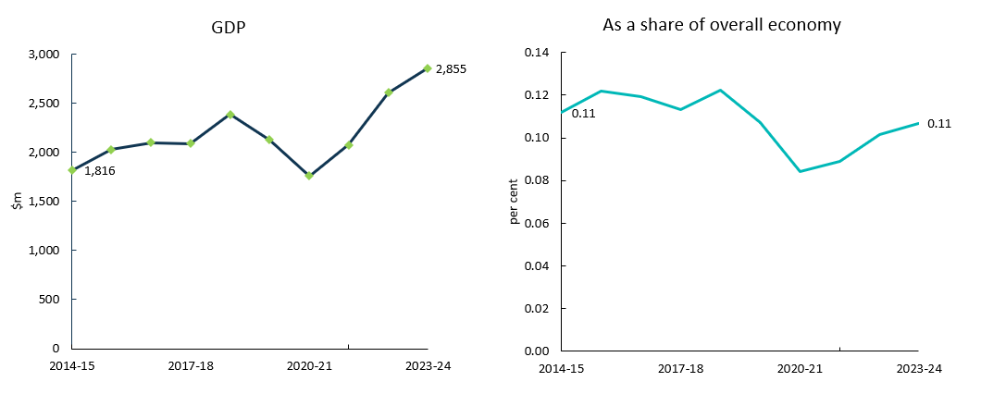
Source: ABS Australian System of National Accounts, Australian National Accounts: Input-Output Tables (Product Details); Australian National Accounts: Supply Use Tables; BCARR calculations.
Corresponding reference: Cultural and Creative Activity in Australia, 2008–09 to 2022–23 (Methodology Refresh), Figure 14.

Explanatory notes
See notes of Table 3.

Table 4: Visual arts and crafts, 2014–15 to 2023–24
Visual arts and crafts  Period | Output  $m | GVA  $m | Net taxes on products  $m | GDP  $m | As a share of overall economy  %
2014–15 | 3,839 | 1,753 | 663 | 2,416 | 0.15
2015–16 | 4,333 | 1,931 | 631 | 2,562 | 0.15
2016–17 | 3,528 | 1,656 | 553 | 2,209 | 0.13
2017–18 | 3,897 | 1,721 | 566 | 2,287 | 0.12
2018–19 | 4,245 | 1,941 | 593 | 2,534 | 0.13
2019–20 | 3,949 | 1,815 | 570 | 2,384 | 0.12
2020–21 | 4,069 | 1,870 | 678 | 2,549 | 0.12
2021–22 | 4,593 | 2,049 | 854 | 2,902 | 0.12
2022–23 | 4,890 | 2,194 | 844 | 3,038 | 0.12
2023–24 | 5,218 | 2,341 | 877 | 3,217 | 0.12
Source: ABS Australian System of National Accounts, Australian National Accounts: Input-Output Tables (Product Details); Australian National Accounts: Supply Use Tables; BCARR calculations.
Corresponding reference: Cultural and Creative Activity in Australia, 2008–09 to 2022–23 (Methodology Refresh), Table 6.

Explanatory notes
Cultural and creative activity GDP in Visual arts and crafts increased by $801 million, from $2.4 billion in 2014–15 to $3.2 billion in 2023–24.
As a share of the overall economy, this domain declined from 0.15% to 0.12% over the period.

Figure 9: Visual arts and crafts, GDP and as a share of overall economy
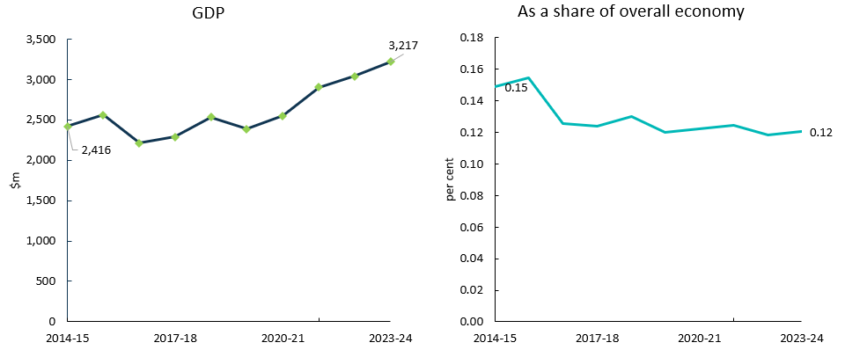
Source: ABS Australian System of National Accounts, Australian National Accounts: Input-Output Tables (Product Details); Australian National Accounts: Supply Use Tables; BCARR calculations.
Corresponding reference: Cultural and Creative Activity in Australia, 2008–09 to 2022–23 (Methodology Refresh), Figure 15.

Explanatory notes
See notes of Table 4.

Table 5: Music production and distribution, 2014–15 to 2023–24
Music production and distribution  Period | Output  $m | GVA  $m | Net taxes on products  $m | GDP  $m | As a share of overall economy  %
2014–15 | 970 | 321 | 69 | 390 | 0.024
2015–16 | 1,258 | 454 | 109 | 564 | 0.034
2016–17 | 1,296 | 465 | 107 | 572 | 0.033
2017–18 | 1,348 | 492 | 113 | 605 | 0.033
2018–19 | 1,311 | 474 | 112 | 585 | 0.030
2019–20 | 1,339 | 476 | 113 | 589 | 0.030
2020–21 | 1,328 | 392 | 127 | 519 | 0.025
2021–22 | 1,381 | 414 | 136 | 549 | 0.024
2022–23 | 1,746 | 545 | 138 | 684 | 0.027
2023–24 | 1,869 | 584 | 144 | 728 | 0.027
Source: ABS Australian System of National Accounts, Australian National Accounts: Input-Output Tables (Product Details); Australian National Accounts: Supply Use Tables; BCARR calculations.
Corresponding reference: Cultural and Creative Activity in Australia, 2008–09 to 2022–23 (Methodology Refresh), Table 7.

Explanatory notes
Cultural and creative activity GDP in Music production and distribution increased by $338 million, from $390 million in 2014–15 to $728 million 2023–24.
Music production and distribution is a small domain, comprising around 0.03% of the overall economy.

Figure 10: Music production and distribution, GDP and as a share of overall economy
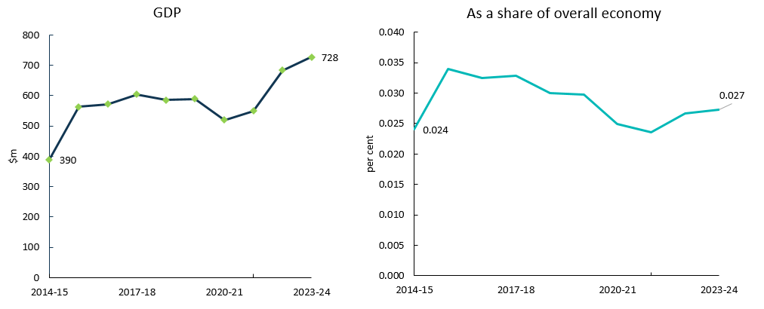
Source: ABS Australian System of National Accounts, Australian National Accounts: Input-Output Tables (Product Details); Australian National Accounts: Supply Use Tables; BCARR calculations.
Corresponding reference: Cultural and Creative Activity in Australia, 2008–09 to 2022–23 (Methodology Refresh), Figure 16.

Explanatory notes
See notes of Table 5.

Table 6: Museums and galleries, 2014–15 to 2023–24
Museums and galleries  Period | Output  $m | GVA  $m | Net taxes on products  $m | GDP  $m | As a share of overall economy  %
2014–15 | 1,098 | 507 | 23 | 530 | 0.03
2015–16 | 1,189 | 573 | 28 | 601 | 0.04
2016–17 | 1,277 | 615 | 27 | 642 | 0.04
2017–18 | 1,341 | 624 | 33 | 658 | 0.04
2018–19 | 1,464 | 686 | 31 | 717 | 0.04
2019–20 | 1,460 | 706 | 28 | 735 | 0.04
2020–21 | 1,423 | 730 | 17 | 746 | 0.04
2021–22 | 1,564 | 748 | 23 | 771 | 0.03
2022–23 | 1,824 | 858 | 26 | 884 | 0.03
2023–24 | 2,007 | 944 | 27 | 971 | 0.04
Source: ABS Australian System of National Accounts, Australian National Accounts: Input-Output Tables (Product Details); Australian National Accounts: Supply Use Tables; BCARR calculations.
Corresponding reference: Cultural and Creative Activity in Australia, 2008–09 to 2022–23 (Methodology Refresh), Table 8.

Explanatory notes
Cultural and creative activity GDP in Museums and galleries increased by $442 million, from $530 million in 2014–15 to $971 million in 2023–24. As a share of the overall economy, it has increased slightly over the period.

Figure 11: Museums and galleries, GDP and as a share of overall economy
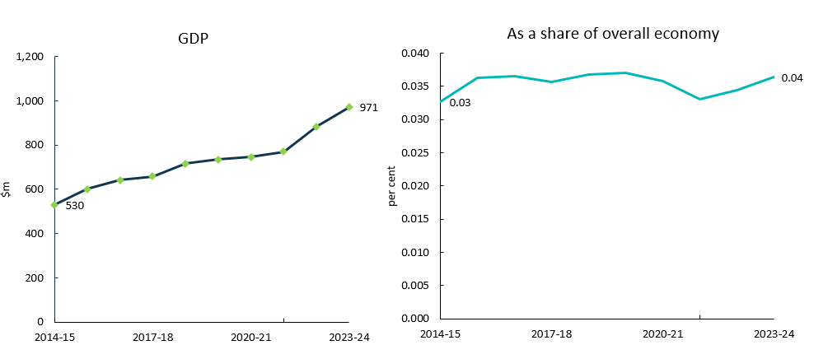
Source: ABS Australian System of National Accounts, Australian National Accounts: Input-Output Tables (Product Details); Australian National Accounts: Supply Use Tables; BCARR calculations.
Corresponding reference: Cultural and Creative Activity in Australia, 2008–09 to 2022–23 (Methodology Refresh), Figure 17.

Explanatory notes
See notes of Table 6.

Table 7: Film and television activities, 2014–15 to 2023–24
Film and television activities  Period | Output  $m | GVA  $m | Net taxes on products  $m | GDP  $m | As a share of overall economy  %
2014–15 | 17,259 | 7,354 | 410 | 7,763 | 0.48
2015–16 | 17,456 | 7,513 | 458 | 7,971 | 0.48
2016–17 | 17,049 | 7,218 | 343 | 7,560 | 0.43
2017–18 | 16,718 | 7,124 | 381 | 7,505 | 0.41
2018–19 | 16,499 | 6,394 | 302 | 6,695 | 0.34
2019–20 | 15,139 | 5,656 | 276 | 5,932 | 0.30
2020–21 | 14,947 | 5,542 | 304 | 5,846 | 0.28
2021–22 | 16,652 | 5,848 | 389 | 6,237 | 0.27
2022–23 | 18,570 | 6,371 | 423 | 6,793 | 0.26
2023–24 | 19,904 | 6,828 | 439 | 7,268 | 0.27
Source: ABS Australian System of National Accounts, Australian National Accounts: Input-Output Tables (Product Details); Australian National Accounts: Supply Use Tables; BCARR calculations.
Corresponding reference: Cultural and Creative Activity in Australia, 2008–09 to 2022–23 (Methodology Refresh), Table 9.

Explanatory notes
Cultural and creative activity GDP in Film and television activities decreased by $496 million or 6.4% from 2014–15 to 2023–24. As a share of GDP, it has declined from 0.48% to 0.27% during the period. This decline was mainly driven by decreases in free-to-air television broadcasting, and cable and other subscription broadcasting. These broadcasting activities have faced several challenges over the period as more Australians have turned to online content. This shift has precipitated a trend where advertising budgets gravitate more towards online platforms.

Figure 12: Film and television activities, GDP and as a share of overall economy
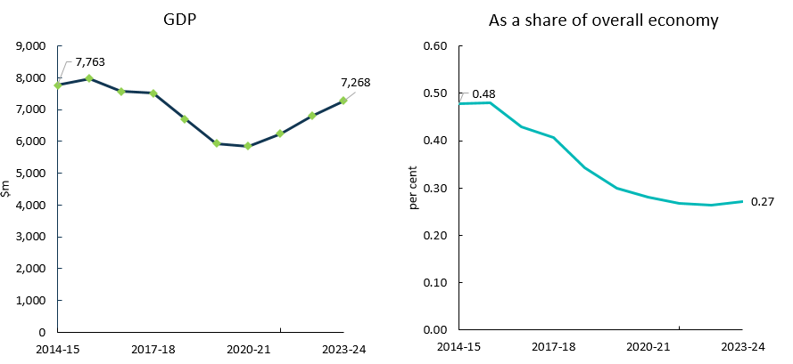
Source: ABS Australian System of National Accounts, Australian National Accounts: Input-Output Tables (Product Details); Australian National Accounts: Supply Use Tables; BCARR calculations.
Corresponding reference: Cultural and Creative Activity in Australia, 2008–09 to 2022–23 (Methodology Refresh), Figure 18.

Explanatory notes
See notes of Table 7.

Table 8: Radio broadcasting, 2014–15 to 2023–24
Radio broadcasting  Period | Output  $m | GVA  $m | Net taxes on products  $m | GDP  $m | As a share of overall economy  %
2014–15 | 1,181 | 599 | 147 | 746 | 0.05
2015–16 | 1,438 | 710 | 9 | 719 | 0.04
2016–17 | 1,381 | 666 | 8 | 674 | 0.04
2017–18 | 1,451 | 697 | 10 | 707 | 0.04
2018–19 | 1,331 | 560 | 5 | 565 | 0.03
2019–20 | 1,265 | 507 | 5 | 511 | 0.03
2020–21 | 1,321 | 583 | -12 | 571 | 0.03
2021–22 | 1,390 | 576 | 2 | 578 | 0.02
2022–23 | 1,421 | 554 | 2 | 556 | 0.02
2023–24 | 1,523 | 594 | 2 | 596 | 0.02
Source: ABS Australian System of National Accounts, Australian National Accounts: Input-Output Tables (Product Details); Australian National Accounts: Supply Use Tables; BCARR calculations.
Corresponding reference: Cultural and Creative Activity in Australia, 2008–09 to 2022–23 (Methodology Refresh), Table 10.

Explanatory notes
Cultural and creative activity GDP in radio broadcasting decreased by $150 million or 20.1% from 2014–15 to 2023–24. Radio listener numbers have reduced as alternative online listening options have become more accessible. However, radio’s popular personalities and signature interactivity retain a loyal listener base, maintaining some advertising revenue.
As a share of the overall economy, radio broadcasting fell from 0.05% to 0.02% over the period.

Figure 13: Radio broadcasting, GDP and as a share of overall economy
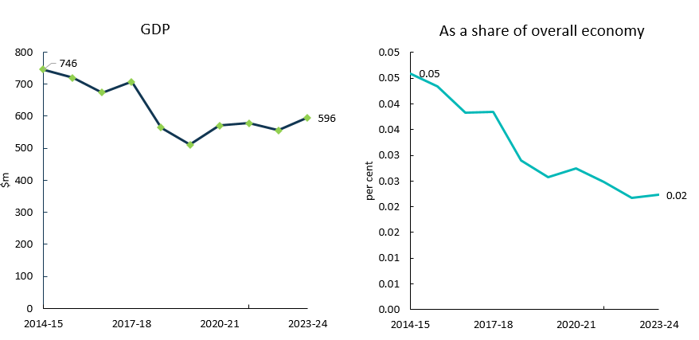
Source: ABS Australian System of National Accounts, Australian National Accounts: Input-Output Tables (Product Details); Australian National Accounts: Supply Use Tables; BCARR calculations.
Corresponding reference: Cultural and Creative Activity in Australia, 2008–09 to 2022–23 (Methodology Refresh), Figure 19.

Explanatory notes
See notes of Table 8.

Table 9: Internet publishing and broadcasting, 2014–15 to 2023–24
Internet publishing and broadcasting  Period | Output  $m | GVA  $m | Net taxes on products  $m | GDP  $m | As a share of overall economy  %
2014–15 | 1,478 | 665 | 9 | 674 | 0.04
2015–16 | 1,635 | 732 | 0 | 732 | 0.04
2016–17 | 2,033 | 960 | 7 | 967 | 0.06
2017–18 | 2,337 | 1,115 | 7 | 1,122 | 0.06
2018–19 | 2,324 | 1,138 | 8 | 1,146 | 0.06
2019–20 | 2,513 | 1,179 | 9 | 1,188 | 0.06
2020–21 | 2,386 | 1,352 | 10 | 1,362 | 0.07
2021–22 | 2,690 | 1,430 | 11 | 1,441 | 0.06
2022–23 | 3,278 | 1,368 | 13 | 1,381 | 0.05
2023–24 | 3,513 | 1,466 | 14 | 1,480 | 0.06
Source: ABS Australian System of National Accounts, Australian National Accounts: Input-Output Tables (Product Details); Australian National Accounts: Supply Use Tables; BCARR calculations.
Corresponding reference: Cultural and Creative Activity in Australia, 2008–09 to 2022–23 (Methodology Refresh), Table 11.

Explanatory notes
Cultural and creative activity GDP in Internet publishing and broadcasting increased by $806 million from 2014–15 to 2023–24. This domain has grown strongly. Improved digital connectivity has made internet publishing and broadcasting services more accessible to consumers, elevating demand. During COVID-19 lockdowns, consumers also sought entertainment which accelerated the demand for streaming services and online content.
As a share of the overall economy, this domain increased from 0.04% to 0.06% over the period.

Figure 14: Internet publishing and broadcasting, GDP and as a share of overall economy
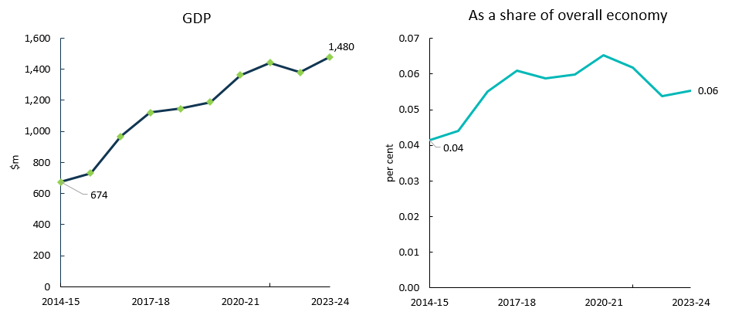
Source: ABS Australian System of National Accounts, Australian National Accounts: Input-Output Tables (Product Details); Australian National Accounts: Supply Use Tables; BCARR calculations.
Corresponding reference: Cultural and Creative Activity in Australia, 2008–09 to 2022–23 (Methodology Refresh), Figure 20.

Explanatory notes
See notes of Table 9.

Table 10: Libraries and archives, 2014–15 to 2023–24
Libraries and archives  Period | Output  $m | GVA  $m | Net taxes on products  $m | GDP  $m | As a share of overall economy  %
2014–15 | 1,475 | 1,115 | 45 | 1,160 | 0.07
2015–16 | 1,539 | 1,181 | 30 | 1,211 | 0.07
2016–17 | 1,624 | 1,196 | 32 | 1,228 | 0.07
2017–18 | 1,806 | 1,319 | 33 | 1,352 | 0.07
2018–19 | 1,809 | 1,339 | 37 | 1,376 | 0.07
2019–20 | 1,783 | 1,345 | 34 | 1,379 | 0.07
2020–21 | 1,737 | 1,351 | 42 | 1,393 | 0.07
2021–22 | 1,810 | 1,382 | 48 | 1,430 | 0.06
2022–23 | 1,982 | 1,501 | 52 | 1,553 | 0.06
2023–24 | 2,125 | 1,609 | 54 | 1,663 | 0.06
Source: ABS Australian System of National Accounts, Australian National Accounts: Input-Output Tables (Product Details); Australian National Accounts: Supply Use Tables; BCARR calculations.
Corresponding reference: Cultural and Creative Activity in Australia, 2008–09 to 2022–23 (Methodology Refresh), Table 12.

Explanatory notes
Cultural and creative activity GDP in Libraries and archives increased by $503 million from 2014–15 to 2023–24.
As a share of the overall economy, this domain has declined slightly over the period.

Figure 15: Libraries and archives, GDP and as a share of overall economy
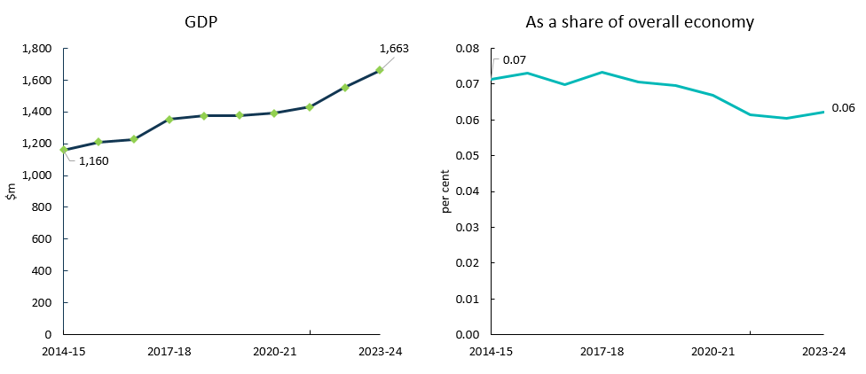
Source: ABS Australian System of National Accounts, Australian National Accounts: Input-Output Tables (Product Details); Australian National Accounts: Supply Use Tables; BCARR calculations.
Corresponding reference: Cultural and Creative Activity in Australia, 2008–09 to 2022–23 (Methodology Refresh), Figure 21.

Explanatory notes
See notes of Table 10.

Table 11: Print media and publishing (excl. internet), 2014–15 to 2023–24
Print media and publishing (excl. internet)  Period | Output  $m | GVA  $m | Net taxes on products  $m | GDP  $m | As a share of overall economy  %
2014–15 | 18,703 | 9,918 | 909 | 10,827 | 0.67
2015–16 | 18,837 | 9,983 | 919 | 10,902 | 0.66
2016–17 | 18,446 | 9,320 | 885 | 10,205 | 0.58
2017–18 | 17,145 | 9,001 | 879 | 9,880 | 0.54
2018–19 | 18,950 | 8,978 | 899 | 9,877 | 0.51
2019–20 | 20,713 | 9,118 | 935 | 10,053 | 0.51
2020–21 | 22,610 | 10,241 | 1,017 | 11,257 | 0.54
2021–22 | 27,570 | 12,384 | 1,143 | 13,526 | 0.58
2022–23 | 34,782 | 13,602 | 1,263 | 14,865 | 0.58
2023–24 | 37,061 | 14,493 | 1,313 | 15,807 | 0.59
Source: ABS Australian System of National Accounts, Australian National Accounts: Input-Output Tables (Product Details); Australian National Accounts: Supply Use Tables; BCARR calculations.
Corresponding reference: Cultural and Creative Activity in Australia, 2008–09 to 2022–23 (Methodology Refresh), Table 13.

Explanatory notes
Cultural and creative activity GDP in Print media and publishing (excl. internet) increased by $5.0 billion or 46.0% from 2014–15 to 2023–24. The increase was mainly driven by software publishing activities that have experienced strong growth in recent years. Despite the challenges posed by COVID-19, growth in software publishing has remained steady, buoyed by the increased demand for remote working software counterbalancing cutbacks by businesses facing financial constraints.
However, as a share of GDP, print media and publishing (excl. internet) has declined from 0.67% to 0.59% during this period. This was mainly driven by the decrease in newspaper, magazine and other periodic publishing activity, as consumers purchase fewer printed publications and use digital media to access content.

Figure 16: Print media and publishing (excl. internet), GDP and as a share of overall economy
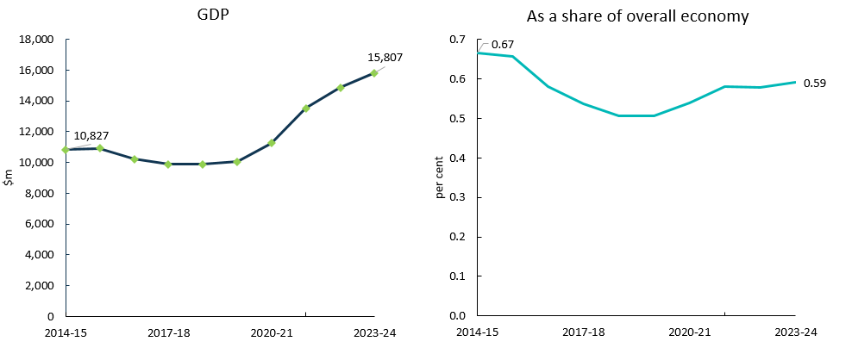
Source: ABS Australian System of National Accounts, Australian National Accounts: Input-Output Tables (Product Details); Australian National Accounts: Supply Use Tables; BCARR calculations.
Corresponding reference: Cultural and Creative Activity in Australia, 2008–09 to 2022–23 (Methodology Refresh), Figure 22.

Explanatory notes
See notes of Table 11.

Table 12: Architecture services, 2014–15 to 2023–24
Architecture services  Period | Output  $m | GVA  $m | Net taxes on products  $m | GDP  $m | As a share of overall economy  %
2014–15 | 10,187 | 4,624 | 0 | 4,624 | 0.28
2015–16 | 10,300 | 4,588 | 6 | 4,594 | 0.28
2016–17 | 10,056 | 4,573 | 4 | 4,577 | 0.26
2017–18 | 11,023 | 4,771 | 5 | 4,776 | 0.26
2018–19 | 11,291 | 4,839 | 5 | 4,844 | 0.25
2019–20 | 11,700 | 5,138 | 5 | 5,143 | 0.26
2020–21 | 11,913 | 5,289 | 5 | 5,294 | 0.25
2021–22 | 12,692 | 5,525 | 6 | 5,531 | 0.24
2022–23 | 13,751 | 5,960 | 7 | 5,967 | 0.23
2023–24 | 14,675 | 6,360 | 7 | 6,368 | 0.24
Source: ABS Australian System of National Accounts, Australian National Accounts: Input-Output Tables (Product Details); Australian National Accounts: Supply Use Tables; BCARR calculations.
Corresponding reference: Cultural and Creative Activity in Australia, 2008–09 to 2022–23 (Methodology Refresh), Table 14.

Explanatory notes
Cultural and creative activity GDP in Architecture services increased by $1.7 billion or 37.7%, from 2014–15 to 2023–24.
Architecture firms have benefitted from a period of high population growth which has also increased property prices. These trends have provided a significant source of industry demand, particularly for small-scale architects.
However, as a share of the overall economy, this domain has declined from 0.28% to 0.24% over the period.

Figure 17: Architecture services, GDP and as a share of overall economy
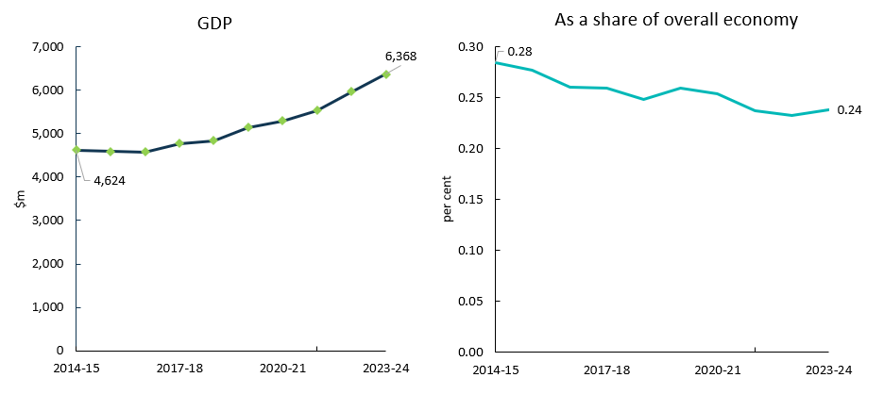
Source: ABS Australian System of National Accounts, Australian National Accounts: Input-Output Tables (Product Details); Australian National Accounts: Supply Use Tables; BCARR calculations.
Corresponding reference: Cultural and Creative Activity in Australia, 2008–09 to 2022–23 (Methodology Refresh), Figure 23.

Explanatory notes
See notes of Table 12.

Table 13: Design and fashion, 2014–15 to 2023–24
Design and fashion  Period | Output  $m | GVA  $m | Net taxes on products  $m | GDP  $m | As a share of overall economy  %
2014–15 | 6,942 | 3,352 | 7 | 3,360 | 0.21
2015–16 | 6,931 | 3,273 | 4 | 3,277 | 0.20
2016–17 | 8,624 | 4,145 | 7 | 4,152 | 0.24
2017–18 | 9,163 | 4,427 | 6 | 4,433 | 0.24
2018–19 | 9,223 | 4,361 | 6 | 4,367 | 0.22
2019–20 | 9,350 | 4,522 | 7 | 4,529 | 0.23
2020–21 | 9,719 | 4,806 | 7 | 4,813 | 0.23
2021–22 | 10,018 | 4,947 | 6 | 4,953 | 0.21
2022–23 | 10,759 | 5,395 | 5 | 5,400 | 0.21
2023–24 | 11,417 | 5,725 | 5 | 5,730 | 0.21
Source: ABS Australian System of National Accounts, Australian National Accounts: Input-Output Tables (Product Details); Australian National Accounts: Supply Use Tables; BCARR calculations.
Corresponding reference: Cultural and Creative Activity in Australia, 2008–09 to 2022–23 (Methodology Refresh), Table 15.

Explanatory notes
Cultural and creative activity GDP in Design and fashion has experienced a growth of $2.4 billion from 2014–15 to 2023–24.
Specialised design service providers that have integrated new design innovations have capitalised on the widespread adoption of digital technology. More businesses have taken their operations online and onto social media platforms, lifting demand for website design services.
As a share of the overall economy, this domain has remained relatively flat at 0.21% over the period.

Figure 18: Design and fashion, GDP and as a share of overall economy
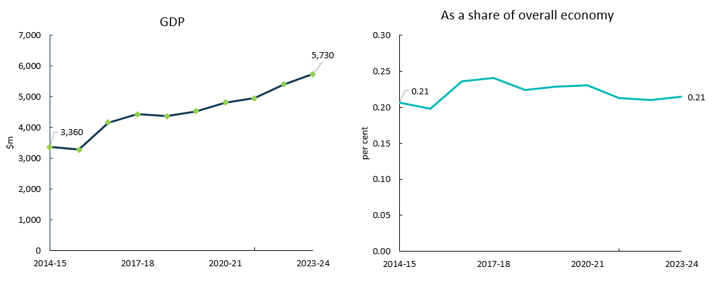
Source: ABS Australian System of National Accounts, Australian National Accounts: Input-Output Tables (Product Details); Australian National Accounts: Supply Use Tables; BCARR calculations.
Corresponding reference: Cultural and Creative Activity in Australia, 2008–09 to 2022–23 (Methodology Refresh), Figure 24.

Explanatory notes
See notes of Table 13.

Table 14: Advertising and promotion, 2014–15 to 2023–24
Advertising and promotion  Period | Output  $m | GVA  $m | Net taxes on products  $m | GDP  $m | As a share of overall economy  %
2014–15 | 21,759 | 10,791 | 117 | 10,908 | 0.67
2015–16 | 22,736 | 11,026 | 101 | 11,127 | 0.67
2016–17 | 24,829 | 12,244 | 91 | 12,335 | 0.70
2017–18 | 25,950 | 12,711 | 94 | 12,805 | 0.70
2018–19 | 27,717 | 13,369 | 102 | 13,470 | 0.69
2019–20 | 26,988 | 13,350 | 100 | 13,450 | 0.68
2020–21 | 27,589 | 13,823 | 103 | 13,925 | 0.67
2021–22 | 30,549 | 15,360 | 102 | 15,462 | 0.66
2022–23 | 33,403 | 17,008 | 101 | 17,109 | 0.67
2023–24 | 35,429 | 18,039 | 105 | 18,144 | 0.68
Source: ABS Australian System of National Accounts, Australian National Accounts: Input-Output Tables (Product Details); Australian National Accounts: Supply Use Tables; BCARR calculations.
Corresponding reference: Cultural and Creative Activity in Australia, 2008–09 to 2022–23 (Methodology Refresh), Table 16.

Explanatory notes
Advertising and promotion is the largest domain, accounting for 26.9% of cultural and creative activity in 2023–24. Cultural and creative activity GDP in this domain increased by $7.2 billion, from $10.9 billion in 2014–15 to $18.1 billion in 2023–24.
As a share of the overall economy, this domain increased slightly from 0.67% to 0.68% over the period. People are increasingly consuming content on internet-based platforms, which is bolstering demand for online advertising at the expense of print and broadcast advertising.

Figure 19: Advertising and promotion, GDP and as a share of overall economy
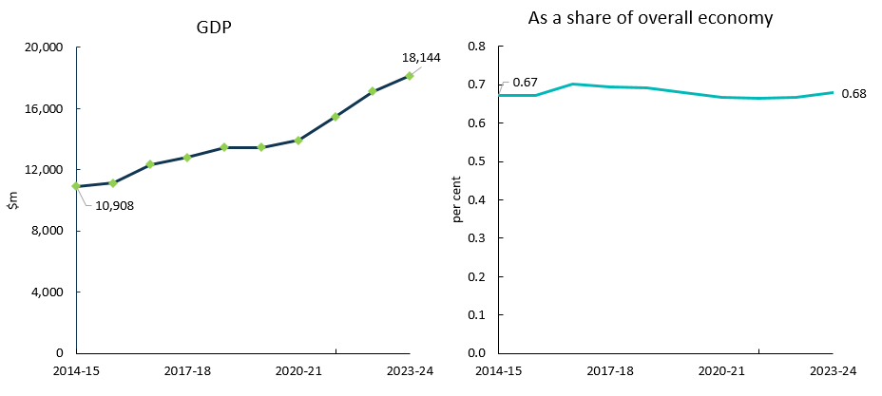
Source: ABS Australian System of National Accounts, Australian National Accounts: Input-Output Tables (Product Details); Australian National Accounts: Supply Use Tables; BCARR calculations.
Corresponding reference: Cultural and Creative Activity in Australia, 2008–09 to 2022–23 (Methodology Refresh), Figure 25.

Explanatory notes
See notes of Table 14.

Table 15: Events (arts), 2014–15 to 2023–24
Events (arts)  Period | Output  $m | GVA  $m | Net taxes on products  $m | GDP  $m | As a share of overall economy  %
2014–15 | 953 | 608 | 21 | 629 | 0.04
2015–16 | 1,017 | 637 | 25 | 662 | 0.04
2016–17 | 1,064 | 661 | 14 | 675 | 0.04
2017–18 | 1,144 | 743 | 12 | 755 | 0.04
2018–19 | 1,215 | 803 | 12 | 814 | 0.04
2019–20 | 1,105 | 750 | 9 | 759 | 0.04
2020–21 | 1,095 | 742 | 11 | 752 | 0.04
2021–22 | 1,435 | 963 | 11 | 975 | 0.04
2022–23 | 1,426 | 940 | 12 | 951 | 0.04
2023–24 | 1,504 | 991 | 12 | 1,004 | 0.04
Source: ABS Australian System of National Accounts, Australian National Accounts: Input-Output Tables (Product Details); Australian National Accounts: Supply Use Tables; BCARR calculations.
Corresponding reference: Cultural and Creative Activity in Australia, 2008–09 to 2022–23 (Methodology Refresh), Table 17.

Explanatory notes
Cultural and creative activity GDP in arts-related events increased by $375 million or 59.6% from 2014–15 to 2023–24.
Event promotion and management activities performed poorly during COVID-19. Pandemic-induced lockdowns led to major restrictions on a range of conferences, events and other industry services over this period. As a result, the GVA of events declined before rebounding in 2021–22 when restrictions eased. There has been a marked improvement in activity for this domain since 2021–22 as restrictions have ended, and major events like music concerts have resumed.
As a share of the overall economy, events has remained relatively flat at 0.04% during the period.

Figure 20: Events (arts), GDP and as a share of overall economy
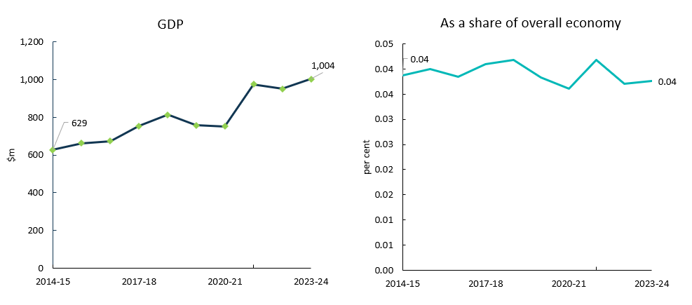
Source: ABS Australian System of National Accounts, Australian National Accounts: Input-Output Tables (Product Details); Australian National Accounts: Supply Use Tables; BCARR calculations.
Corresponding reference: Cultural and Creative Activity in Australia, 2008–09 to 2022–23 (Methodology Refresh), Figure 26.

Explanatory notes
See notes of Table 15.

Table 16: Arts education, 2014–15 to 2023–24
Arts education  Period | Output  $m | GVA  $m | Net taxes on products  $m | GDP  $m | As a share of overall economy  %
2014–15 | 857 | 500 | 9 | 510 | 0.03
2015–16 | 955 | 550 | 45 | 595 | 0.04
2016–17 | 965 | 536 | 63 | 599 | 0.03
2017–18 | 961 | 531 | 54 | 585 | 0.03
2018–19 | 1,090 | 616 | 63 | 679 | 0.03
2019–20 | 1,088 | 658 | 79 | 737 | 0.04
2020–21 | 1,202 | 764 | 88 | 852 | 0.04
2021–22 | 1,319 | 844 | 103 | 947 | 0.04
2022–23 | 1,578 | 996 | 125 | 1,121 | 0.04
2023–24 | 1,709 | 1,079 | 130 | 1,209 | 0.05
Source: ABS Australian System of National Accounts, Australian National Accounts: Input-Output Tables (Product Details); Australian National Accounts: Supply Use Tables; BCARR calculations.
Corresponding reference: Cultural and Creative Activity in Australia, 2008–09 to 2022–23 (Methodology Refresh), Table 18.

Explanatory notes
Cultural and creative activity GDP in Arts education increased by $699 million from 2014–15 to 2023–24. As a share of the overall economy, arts education has increased slightly, from 0.03% to 0.05% over the period.

Figure 21: Arts education, GDP and as a share of overall economy
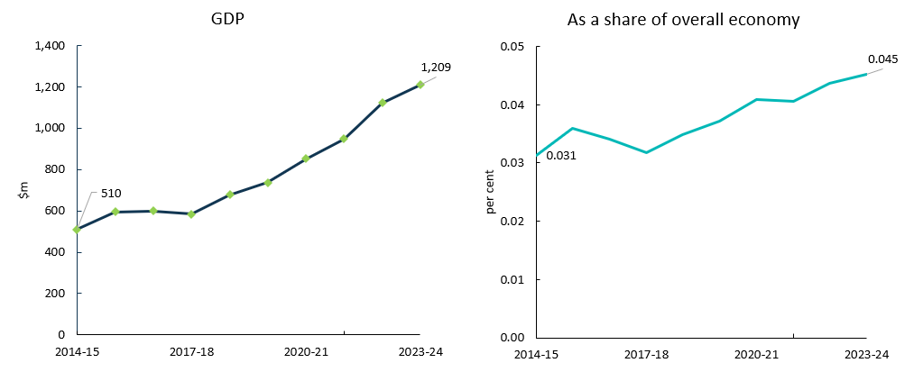
Source: ABS Australian System of National Accounts, Australian National Accounts: Input-Output Tables (Product Details); Australian National Accounts: Supply Use Tables; BCARR calculations.
Corresponding reference: Cultural and Creative Activity in Australia, 2008–09 to 2022–23 (Methodology Refresh), Figure 27.

Explanatory notes
See notes of Table 16.

Table 17: Digital games development, 2014–15 to 2023–24
Digital games development  Period | Output  $m | GVA  $m | Net taxes on products  $m | GDP  $m | As a share of overall economy  %
2014–15 | 199 | 90 | 2 | 92 | 0.006
2015–16 | 239 | 108 | 3 | 111 | 0.007
2016–17 | 284 | 126 | 6 | 132 | 0.007
2017–18 | 336 | 150 | 7 | 157 | 0.009
2018–19 | 400 | 159 | 9 | 168 | 0.009
2019–20 | 441 | 168 | 12 | 180 | 0.009
2020–21 | 562 | 218 | 14 | 233 | 0.011
2021–22 | 782 | 285 | 19 | 304 | 0.013
2022–23 | 848 | 299 | 19 | 318 | 0.012
2023–24 | 899 | 317 | 20 | 336 | 0.013
Source: ABS Australian System of National Accounts, Australian National Accounts: Input-Output Tables (Product Details); Australian National Accounts: Supply Use Tables; BCARR calculations.
Corresponding reference: Cultural and Creative Activity in Australia, 2008–09 to 2022–23 (Methodology Refresh), Table 19.

Explanatory notes
Cultural and creative activity GDP in Digital games development has increased significantly – from $92 million in 2014–15 to $336 million in 2023–24.
Consumer uptake of video games has been strong over the past decade. As a share of the overall economy, this domain has increased from 0.006% to 0.013% over the period.

Figure 22: Digital games development, GDP and as a share of overall economy
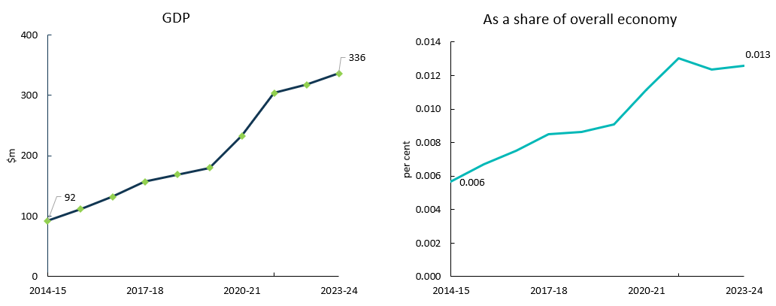
Source: ABS Australian System of National Accounts, Australian National Accounts: Input-Output Tables (Product Details); Australian National Accounts: Supply Use Tables; BCARR calculations.
Corresponding reference: Cultural and Creative Activity in Australia, 2008–09 to 2022–23 (Methodology Refresh), Figure 28.

Explanatory notes
See notes of Table 17.

Table 18: Cultural and creative activity, GVA by industry division, 2014–15 to 2023–24
Period | Manufacturing  $m | Construction  $m | Wholesale Trade  $m | Retail Trade  $m | Information Media and Telecommunications  $m | Professional, Scientific and Technical Services  $m | Administrative and Support Services  $m | Education and Training  $m | Arts and Recreation Services  $m | Other Services  $m | Total  $m
2014–15 | 2,952 | 1,094 | 1,574 | 296 | 17,666 | 16,588 | 608 | 500 | 2,371 | 282 | 43,931
2015–16 | 2,920 | 1,020 | 1,625 | 338 | 18,252 | 16,901 | 637 | 550 | 2,719 | 246 | 45,208
2016–17 | 2,817 | 1,031 | 1,705 | 298 | 17,269 | 18,940 | 661 | 536 | 2,887 | 259 | 46,403
2017–18 | 2,719 | 1,329 | 1,358 | 298 | 17,606 | 19,746 | 743 | 531 | 2,865 | 244 | 47,439
2018–19 | 2,928 | 1,305 | 1,263 | 250 | 16,828 | 20,441 | 803 | 616 | 3,266 | 266 | 47,965
2019–20 | 2,619 | 1,328 | 1,187 | 221 | 16,482 | 20,983 | 750 | 658 | 3,016 | 211 | 47,455
2020–21 | 2,752 | 1,357 | 1,250 | 232 | 17,561 | 21,908 | 742 | 764 | 2,665 | 202 | 49,433
2021–22 | 2,765 | 1,423 | 1,306 | 227 | 20,035 | 23,988 | 963 | 844 | 3,007 | 224 | 54,781
2022–23 | 2,918 | 1,609 | 1,477 | 276 | 21,615 | 26,392 | 940 | 996 | 3,641 | 257 | 60,121
2023–24 | 3,111 | 1,757 | 1,499 | 289 | 23,167 | 27,978 | 991 | 1,079 | 4,006 | 278 | 64,155
Source: ABS Australian System of National Accounts, Australian National Accounts: Input-Output Tables (Product Details); Australian National Accounts: Supply Use Tables; BCARR calculations.
Corresponding reference: Cultural and Creative Activity in Australia, 2008–09 to 2022–23 (Methodology Refresh), Table 20.

Explanatory notes

Cultural and creative activity occurs across several industry divisions, as shown in Table 18.
Professional, Scientific and Technical Services was the largest contributor to cultural and creative activity GVA growth over the period. Cultural and creative activity GVA in this industry experienced significant growth of $11.4 billion or 68.7% from 2014–15 to 2023–24. The growth was driven primarily by advertising services due to increases in total business profit, positive business confidence and further digital advertising growth buttressing demand for advertising services.
After Professional, Scientific and Technical Services, Information Media and Telecommunications was the second largest contributor to the increase in cultural and creative activity. Cultural and creative activity GVA in Information Media and Telecommunications rose by $5.5 billion or 31.1% from 2014–15 to 2023–24, mainly driven by software publishing, which has experienced significant growth in recent years due to increased internet access and adoption of new technology. Arts and Recreation Services was the third largest contributor, and increased by $1.6 billion or 69.0% over the period, mainly driven by activities by creative artists, musicians, writers and performers.

Figure 23: Cultural and creative GVA change by division, 2014–15 to 2023–24
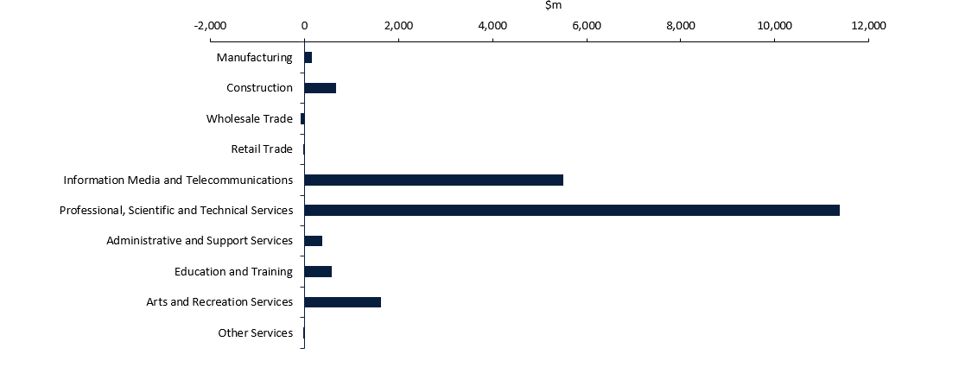
Source: ABS Australian System of National Accounts, Australian National Accounts: Input-Output Tables (Product Details); Australian National Accounts: Supply Use Tables; BCARR calculations.
Corresponding reference: Cultural and Creative Activity in Australia, 2008–09 to 2022–23 (Methodology Refresh), Figure 29.

Explanatory notes
See notes of Table 18.

Figure 24: Industry contributors to specialised, support and embedded activities, 2014–15 to 2023–24
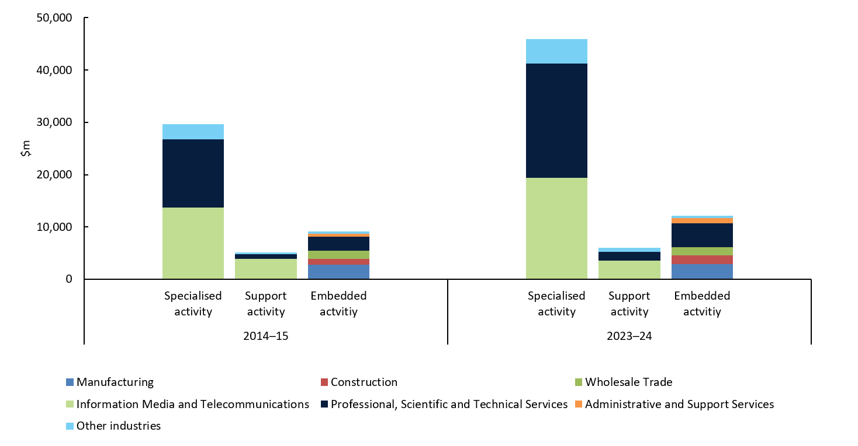
Source: ABS Australian System of National Accounts, Australian National Accounts: Input-Output Tables (Product Details); Australian National Accounts: Supply Use Tables; BCARR calculations.
Corresponding reference: Cultural and Creative Activity in Australia, 2008–09 to 2022–23 (Methodology Refresh), Figure 30-32.

Explanatory notes
See notes of Table 19, 20 and 23.

Table 19: Specialised activity, 2014–15 to 2023–24
Period | Manufacturing  $m | Information Media and Telecommunications  $m | Professional, Scientific and Technical Services  $m | Education and Training  $m | Arts and Recreation Services  $m | Other Services  $m | Total Specialised Activity  $m
2014–15 | 125 | 13,692 | 13,024 | 484 | 2,051 | 238 | 29,615
2015–16 | 112 | 14,115 | 13,200 | 515 | 2,271 | 213 | 30,427
2016–17 | 129 | 13,031 | 14,619 | 504 | 2,407 | 224 | 30,915
2017–18 | 131 | 13,353 | 15,319 | 501 | 2,432 | 210 | 31,946
2018–19 | 141 | 12,628 | 15,840 | 581 | 2,717 | 229 | 32,137
2019–20 | 91 | 12,521 | 16,390 | 617 | 2,498 | 181 | 32,297
2020–21 | 113 | 13,758 | 17,147 | 721 | 2,169 | 175 | 34,083
2021–22 | 129 | 16,804 | 18,688 | 795 | 2,426 | 194 | 39,037
2022–23 | 168 | 18,137 | 20,518 | 944 | 2,988 | 224 | 42,979
2023–24 | 179 | 19,438 | 21,752 | 1,023 | 3,287 | 243 | 45,922
Source: ABS Australian System of National Accounts, Australian National Accounts: Input-Output Tables (Product Details); Australian National Accounts: Supply Use Tables; BCARR calculations.
Corresponding reference: Cultural and Creative Activity in Australia, 2008–09 to 2022–23 (Methodology Refresh), Table 21.

Explanatory notes
Specialised activity refers to cultural and creative products produced within cultural and creative industries. This activity increased by $16.3 billion or 55.1%, from $29.6 billion in 2014–15 to $45.9 billion in 2023–24. Specialised activity accounted for 71.6% of total cultural and creative activity GVA in 2023–24, which indicates that most cultural and creative products were produced primarily within cultural and creative industries. Professional, Scientific and Technical Services and Information Media and Telecommunications combined represented around 90% of this specialised activity in 2023–24.

Table 20: Support activity, 2014–15 to 2023–24
Period | Manufacturing  $m | Information Media and Telecommunications  $m | Professional, Scientific and Technical Services  $m | Education and Training  $m | Arts and Recreation Services  $m | Other Services  $m | Total Support Activity  $m
2014–15 | 45 | 3,883 | 879 | 16 | 304 | 43 | 5,171
2015–16 | 35 | 4,064 | 963 | 35 | 398 | 33 | 5,528
2016–17 | 34 | 4,159 | 1,101 | 33 | 410 | 35 | 5,772
2017–18 | 34 | 4,169 | 1,171 | 30 | 385 | 34 | 5,822
2018–19 | 37 | 4,115 | 1,175 | 34 | 492 | 36 | 5,889
2019–20 | 24 | 3,897 | 1,271 | 40 | 462 | 30 | 5,724
2020–21 | 32 | 3,748 | 1,295 | 43 | 442 | 27 | 5,587
2021–22 | 40 | 3,157 | 1,379 | 48 | 525 | 29 | 5,178
2022–23 | 50 | 3,360 | 1,534 | 52 | 620 | 32 | 5,648
2023–24 | 53 | 3,601 | 1,626 | 56 | 682 | 35 | 6,053
Source: ABS Australian System of National Accounts, Australian National Accounts: Input-Output Tables (Product Details); Australian National Accounts: Supply Use Tables; BCARR calculations.
Corresponding reference: Cultural and Creative Activity in Australia, 2008–09 to 2022–23 (Methodology Refresh), Table 22.

Explanatory notes
Support activity refers to any other products outside the scope of cultural and creative products within cultural and creative industries. This activity accounted for $6.1 billion or 9.4% of cultural and creative activity GVA in 2023–24.
Support activity increased by $882 million or 17.1%, from $5.2 billion to $6.1 billion from 2014–15 to 2023–24.
The main contributors of support activity were from various non-cultural-or-creative products relating to advertising services (advertising space) on newspapers, magazines and other periodicals, books, and internet publishing. Most support activity was therefore found in the Information Media and Telecommunications industry. The growth in support activity was mainly driven by the increased advertising services on internet publishing and broadcasting, due to providers, such as SVOD services, within this industry introducing more advertising to bring in additional revenue.

Table 21: In-scope cultural and creative industry subdivisions
Period | Printing (including Reproduction of Recorded Media)  $m | Publishing (except Internet and Music Publishing)  $m | Motion Picture and Sound Recording Activities  $m | Broadcasting (except Internet)  $m | Internet Publishing and Broadcasting  $m | Library and Other Information Services  $m | Professional, Scientific and Technical Services (except Computer System Design and Related Services)  $m | Adult, Community and Other Education  $m | Heritage Activities  $m | Creative and Performing Arts Activities  $m | Personal and Other Services  $m | Total  $m
2014–15 | 171 | 7,374 | 2,495 | 5,735 | 645 | 1,326 | 13,904 | 500 | 507 | 1,848 | 282 | 34,786
2015–16 | 147 | 7,486 | 2,880 | 5,719 | 730 | 1,364 | 14,163 | 550 | 570 | 2,099 | 246 | 35,955
2016–17 | 163 | 6,612 | 2,914 | 5,361 | 958 | 1,344 | 15,721 | 536 | 615 | 2,203 | 259 | 36,687
2017–18 | 165 | 6,729 | 2,879 | 5,360 | 1,114 | 1,439 | 16,490 | 531 | 623 | 2,193 | 244 | 37,768
2018–19 | 178 | 6,805 | 2,968 | 4,384 | 1,132 | 1,454 | 17,016 | 616 | 683 | 2,526 | 266 | 38,027
2019–20 | 115 | 7,216 | 2,714 | 3,843 | 1,175 | 1,470 | 17,660 | 658 | 704 | 2,256 | 211 | 38,022
2020–21 | 145 | 8,260 | 1,982 | 4,446 | 1,348 | 1,469 | 18,442 | 764 | 728 | 1,883 | 202 | 39,669
2021–22 | 169 | 10,266 | 2,421 | 4,323 | 1,426 | 1,525 | 20,067 | 844 | 747 | 2,204 | 224 | 44,215
2022–23 | 218 | 11,087 | 3,232 | 4,163 | 1,364 | 1,650 | 22,052 | 996 | 858 | 2,750 | 257 | 48,627
2023–24 | 233 | 11,883 | 3,464 | 4,462 | 1,462 | 1,768 | 23,378 | 1,079 | 943 | 3,026 | 278 | 51,975
Source: ABS Australian System of National Accounts, Australian National Accounts: Input-Output Tables (Product Details); Australian National Accounts: Supply Use Tables; BCARR calculations.
Corresponding reference: Cultural and Creative Activity in Australia, 2008–09 to 2022–23 (Methodology Refresh), Table 23.

Explanatory notes
Both specialised and support activities are captured by the cultural and creative industries, and Table 21 provides a further breakdown of the in-scope cultural and creative industries by 11 subdivisions (2-digit ANZSIC).

Table 22: Embedded activity, 2014–15 to 2023–24
Period | Manufacturing | Construction | Wholesale Trade | Retail Trade | Information Media and Telecommunications | Professional, Scientific and Technical Services | Administrative and Support Services | Arts and Recreation Services | Total
 | $m | $m | $m | $m | $m | $m | $m | $m | $m
2014–15 | 2,781 | 1,094 | 1,574 | 296 | 91 | 2,685 | 608 | 16 | 9,145
2015–16 | 2,773 | 1,020 | 1,625 | 338 | 73 | 2,737 | 637 | 51 | 9,253
2016–17 | 2,653 | 1,031 | 1,705 | 298 | 79 | 3,219 | 661 | 70 | 9,717
2017–18 | 2,554 | 1,329 | 1,358 | 298 | 85 | 3,256 | 743 | 48 | 9,671
2018–19 | 2,750 | 1,305 | 1,263 | 250 | 85 | 3,426 | 803 | 57 | 9,939
2019–20 | 2,504 | 1,328 | 1,187 | 221 | 65 | 3,322 | 750 | 56 | 9,433
2020–21 | 2,607 | 1,357 | 1,250 | 232 | 56 | 3,466 | 742 | 54 | 9,763
2021–22 | 2,596 | 1,423 | 1,306 | 227 | 74 | 3,921 | 963 | 56 | 10,566
2022–23 | 2,700 | 1,609 | 1,477 | 276 | 119 | 4,339 | 940 | 34 | 11,494
2023–24 | 2,878 | 1,757 | 1,499 | 289 | 128 | 4,600 | 991 | 37 | 12,180
Source: ABS Australian System of National Accounts, Australian National Accounts: Input-Output Tables (Product Details); Australian National Accounts: Supply Use Tables; BCARR calculations.
Corresponding reference: Cultural and Creative Activity in Australia, 2008–09 to 2022–23 (Methodology Refresh), Table 24.

Explanatory notes
Embedded activity contributed $12.2 billion to cultural and creative activity GVA in 2023–24, and accounted for 19.0% of total cultural and creative activity.
Most embedded activity was produced from Professional, Scientific and Technical Services and Manufacturing industries. This was because some cultural and creative activities – such as management services (including business, artists, entertainers and sporting professionals), and manufacturing products of printing materials and crafts – have only been identified as in-scope activities through their product levels rather than industry levels. As a result, the economic value produced by these activities was only estimated as embedded activity.

Table 23: Revisions from 2014–15 to 2022–23
Period | Cultural and creative activity gross value added (GVA)  $m | Net taxes on products of cultural and creative activity  $m | Cultural and creative activity GDP  $m | Cultural and creative activity as a share of GDP  %
2014–15 | -157 | 0 | -157 | 0.0
2015–16 | -182 | 0 | -182 | 0.0
2016–17 | -137 | 0 | -137 | 0.0
2017–18 | -98 | 0 | -98 | 0.0
2018–19 | -180 | 0 | -180 | 0.0
2019–20 | -283 | 0 | -283 | 0.0
2020–21 | -374 | -21 | -395 | 0.0
2021–22 | -572 | -21 | -594 | 0.0
2022–23 | -603 | 117 | -485 | 0.0
Source: ABS Australian System of National Accounts, Australian National Accounts: Input-Output Tables (Product Details); Australian National Accounts: Supply Use Tables; BCARR calculations.

Explanatory notes
The estimates of cultural and creative activity from 2014–15 to 2023–24 are derived from the ABS National Accounts data: Australian System of National Accounts, 2023–24, Australian National Accounts: Supply Use Tables, 2022–23, and Australian National Accounts: Input-Output Tables, 2022–23. The 2024 Annual National Accounts historical revisions process included improvements to the measurement of digital services and updated Film and Television capital data from the ABS 2021-22 Flexible Survey.
As a result of these revisions, BCARR’s updated estimates of cultural and creative activity vary from those presented in previous releases. Table 23 shows the overall revisions of the new estimates of cultural and creative activity from 2014–15 to 2022–23, compared to BCARR’s previous estimates in Cultural and Creative Activity in Australia, 2008–09 to 2022–23 (Methodology Refresh) in nominal values. These changes mainly reflect the revised estimates of cultural and creative activity in information, media and telecommunications, as well as professional, scientific and technical services. There were no changes in cultural and creative activity as a share of GDP over the period.

Appendix: Scope of cultural and creative domains
Cultural and creative activities are grouped by 15 domains. The activities within the domains are grouped in terms of the input-output product classification (IOPC) codes, and the Australian and New Zealand Standard Industrial Classification 2006 (ANZSIC 06) class codes.
No. | Domain name | Domain scope
1 | Literature, creative and performing arts | This domain includes:  - Performing arts operations which provide or produce live theatrical or musical presentations or performances.  - Creative artists, musicians, writers and performers who are independent individuals or groups mainly engaged in the regular creation of original artistic or cultural works who may or may not produce and perform their works. Also includes activities providing independent technical expertise necessary for these productions, and celebrities mainly engaged in endorsing products or making speeches or public appearances for which they receive a fee; and  - Performing arts venue operations that operates venues for the presentation and rehearsal of performing arts.  Visual arts creation activities are excluded from this domain.
2 | Visual arts and crafts | This domain includes:  - Activities of independent artists, e.g. sculptors, painters, etc.  - Manufacturing products of crafts including tableware, ornamental pottery and domestic ware not elsewhere classified; glass containers, bottles or jars; glass stoppers; glass inners for vacuum vessels; jewellery and silverware; and imitation jewellery (excl incorporating precious metal except as plating or as minor constituents) (excl watch straps); bags of leather or leather substitute.  - Professional photographic services that are mainly engaged in providing still, video or computer photography services, including the recording of special events such as weddings.  - Photographic film processing activity such as developing film and/or making photographic slides, prints and enlargements.
3 | Music production and distribution | This domain includes:  - Musical instruments (including parts and accessories).  - Music publishing which is the acquisition and registration of copyright for musical compositions and the promotion and authorisation of the use of these compositions in recordings, radio, television, motion pictures, live performances, print, or other media.  - Music and other sound recording activities which is the production of original (sound) master recordings and the release and distribution of them to wholesalers, retailers or directly to the public. This also includes the operation of sound recording studios and in the production of pre-recorded radio programs.
4 | Museums and galleries | This domain consists of museum operations such as the preservation and exhibition of heritage objects and artefacts as well as visual arts and crafts with aesthetic, historical, cultural, and educational value. This also includes activities related to entities operating in historical places, sites or houses
5 | Film and television activities | This domain consists of:  - Motion picture and video production activities that mainly engaged in producing motion pictures, videos and television programs or commercials.  - Motion picture and video distribution activities that mainly engaged in acquiring distribution rights and distributing motion pictures and videos.  - Motion picture exhibition activities that mainly engaged in screening motion pictures using a variety of visual media.  - Post-production services and other motion picture and video activities that mainly engaged in providing post-production services and other motion picture and video activities such as editing, film/tape transfers, titling, subtitling, credits, closed captioning and computer-produced graphics, animation and special effects, as well as developing and processing motion picture film.  - Free-to-air television broadcasting of visual content, in the form of electronic images together with sound, through broadcasting studios and facilities.  - Cable and other subscription broadcasting of broadcasting television programs on a subscription or fee basis to viewers.
6 | Radio broadcasting | Radio broadcasting is mainly engaged in broadcasting audio signals, using radio broadcasting studios and facilities to transmit aerial programming.
7 | Internet publishing and broadcasting | Internet publishing and broadcasting consists of activities engaged in publishing and/or broadcasting content on the internet.
8 | Libraries and archives | Libraries and archives include activities such as maintaining the collections of documents and facilitating the use of such documents.
9 | Print media and publishing (excl. internet) | This domain includes:  - Printing products such as books, newspapers, journals and periodicals printed but not published by the business.  - Printing Support Services such as pre-press (e.g. typesetting, colour separation or platemaking), post-press or finishing (e.g. laminating, embossing or book binding) services.  - Newspaper Publishing activities creating and disseminating newspapers.  - Magazine and Other Periodical Publishing activities creating and disseminating magazines, journals and other periodicals.  - Book Publishing activities creating and disseminating books including atlases, textbooks and travel guides.  - Other Publishing (except software, music and internet) activities such as greeting card, postcard and art print publishing.  - Software Publishing activities mainly engaged in creating and disseminating ready-made (non-customised) computer software.  - Other information services (including radio and television news collection and telephone based recorded information services).
10 | Architecture Services | Architecture services consists of activity in providing services such as planning and designing buildings and structures; or planning and designing the development of land.
11 | Design and fashion | This domain consists of other specialised design services, including commercial art and display services; and specialised design service not elsewhere classified (such as fashion, interior and jewellery design).
12 | Advertising and promotion | This domain includes:  - Advertising services such as the creation of advertising campaigns and materials; and media planning and buying (i.e. placing advertisements);  - Management services (including business, artists, entertainers and sporting professionals).
13 | Events (arts) | This domain includes:  - Theatre, concert ticketing and booking services; and  - Event management or promotion (including art or similar); fund raising services (fee based) or administration services not elsewhere classified.
14 | Arts education | Arts education provides non-vocational instruction in the arts, including art, dance, drama and music.
15 | Digital games development | This domain consists of computer systems, hardware and software design and development services relating to digital games.

GVA is a measure of the contribution to domestic production made by an individual producer, industry or sector. This is the value of output less the value of the goods and services used up in the process of production. By excluding net taxes, GVA provides a more accurate measure of economic activity by industry than gross domestic product (GDP).
IBISWorld industry report (2021), R9001 Music and Theatre Production in Australia, June 2021, p. 3
IBISWorld industry report (2024), R9001 Music and theatre production in Australia, July 2024, p. 12.
IBISWorld industry report (2024), J5621 Free-to-Air Television Broadcasting in Australia, July 2024, p. 8.
IBISWorld industry report (2024), J5610 Radio Broadcasting in Australia, June 2024, p. 8.
IBISWorld industry report (2024), J5700 Internet Publishing and Broadcasting in Australia, April 2024, p. 12.
IBISWorld industry report (2024), J5420 Software Publishing in Australia, June 2024, p. 13.
IBISWorld industry report (2023), J5412 Magazine and Directory Publishing in Australia, May 2023, p. 7.
IBISWorld industry report (2024), M6921 Architectural Services in Australia, June 2024, p. 19.
IBISWorld industry report (2024), M6924 Specialised Design Services in Australia, October 2024, p. 12.
IBISWorld industry report (2023), M6941 Advertising Agencies in Australia, July 2024, p. 20.
IBISWorld industry report (2022), N7299 Event Promotion and Management Services in Australia, August 2022, p. 9.
IBISWorld industry report (2023), N7299 Event Promotion and Management Services in Australia, August 2023, p. 15.
IBISWorld industry report (2024), M6941 Advertising Agencies in Australia, June 2024, p. 13
IBISWorld industry report (2024), J5700 Internet Publishing and Broadcasting in Australia, April 2024, p. 8.
Australian Bureau of Statistics (2024), Impacts from the 2024 Annual National Accounts historical revisions, October 2024.

