

Use of digital technologies among First Nations children
November 2024

 | The Bureau of Communications, Arts and Regional Research (BCARR) research paper ‘Use of digital technologies among First Nations children: Findings from the Longitudinal Study of Indigenous Children’ examines how First Nations children’s use of digital technologies has changed over time, and how it differs by socioeconomic background.

The Longitudinal Study of Indigenous Children (LSIC)
LSIC aims to improve the understanding of the lives of First Nations children. The survey follows the same group of First Nations children and their families over an extended period and collects information each year. LSIC has a large sample of First Nations families from urban, regional, remote and very remote areas. Due to its sample design, LSIC is not nationally representative of First Nations families. The research findings reflect the LSIC sample only and should not be generalised to represent the wider population of First Nations children in Australia. While this research relates to the Australian Government’s Closing the Gap targets, LSIC findings should not be used to directly measure Closing the Gap targets.

Children’s internet use has increased over time
 | Children in the LSIC sample grow older over the time period analysed. The ageing of children in the sample plays a significant role in their increased use of digital technology over time.

Almost all surveyed children used the internet by 2019
The share of children using the internet increased from 39% in 2011 to 92% in 2019 (when the children sampled were older). Children most commonly accessed the internet at home (79% in 2019) or at school (74% in 2019).
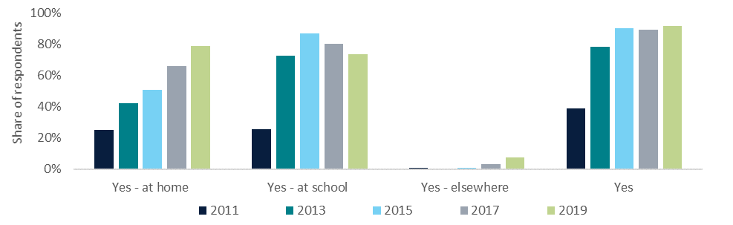

The majority of parents have rules around their child’s online activities
As children increasingly use the internet it is important to consider their safety online. In 2019, almost three-quarters of primary caregivers had one or more rules about their child’s internet access.
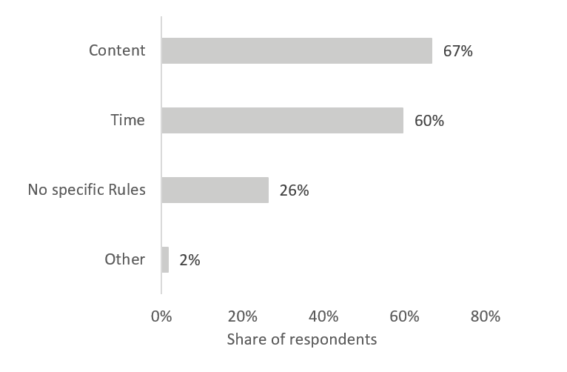

Socioeconomic factors impact digital technology use and ownership

Children in remote and very remote areas are less likely to use or own digital technologies
Children’s location was a strong factor for their computer and internet use at home, as well as their mobile phone ownership. A child in a very remote area was 56% less likely to own their own phone, 45% less likely to use internet at home and 44% less likely to use computer at home compared to a child in a metropolitan area.
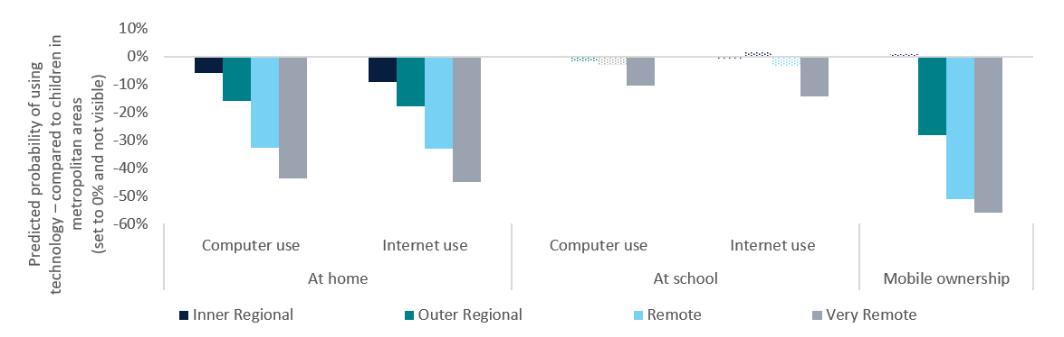

Other factors also play a role
Age was a leading factor impacting children’s uptake of digital technologies. Older children were more likely to use the internet and a computer (at home and at school), and were more likely to own a mobile phone.
Children were also more likely to use and own digital technologies if their primary caregiver:
earned an income over $800 per week
was employed
lived with a partner
 had a post-secondary school qualification.
The gap in the use of digital technologies from children of differing backgrounds has narrowed over time.
Reference number 2024-1189

Closing the Gap Target 17: By 2026, Aboriginal and Torres Strait Islander people have equal levels of digital inclusion; Closing the Gap Target 5: By 2031, increase the proportion of Aboriginal and Torres Strait Islander people (aged 20–24) attaining year 12 or equivalent qualification to 96%.

