

Use of digital technologies among First Nations children
  - Findings from the Longitudinal Study of Indigenous Children
November 2024

The Department of Infrastructure, Transport, Regional Development, Communications and the Arts acknowledges the Traditional Custodians of Country throughout Australia and their continuing connection to land, sea and community. We pay our respects to them, their cultures and to their Elders, past, present and emerging.
© Commonwealth of Australia 2024
ISBN 978-1-922879-52-3
November 2024
BCARR reference: 2024-1189

Ownership of intellectual property rights in this publication
Unless otherwise noted, copyright (and any other intellectual property rights, if any) in this publication is owned by the Commonwealth of Australia (referred to below as the Commonwealth).

Disclaimer
The material contained in this publication is made available on the understanding that the Commonwealth is not providing professional advice, and that users exercise their own skill and care with respect to its use, and seek independent advice if necessary.
The Commonwealth makes no representations or warranties as to the contents or accuracy of the information contained in this publication. To the extent permitted by law, the Commonwealth disclaims liability to any person or organisation in respect of anything done, or omitted to be done, in reliance upon information contained in this publication.

Use of the Coat of Arms
The Department of the Prime Minister and Cabinet sets the terms under which the Coat of Arms is used. Please refer to the Commonwealth Coat of Arms - Information and Guidelines publication available at http://www.pmc.gov.au.

Use of the Coat of Arms
The Department of the Prime Minister and Cabinet sets the terms under which the Coat of Arms is used. Please refer to the Commonwealth Coat of Arms - Information and Guidelines publication available at http://www.pmc.gov.au.

Contact us
This publication is available in PDF and Word format. All other rights are reserved, including in relation to any departmental logos or trademarks which may exist. For enquiries regarding the licence and any use of this publication, please contact:
Director – Creative Services
Communication Branch
Department of Infrastructure, Transport, Regional Development and Communications and the Arts
GPO Box 594 Canberra ACT 2601 Australia
Email: publishing@infrastructure.gov.au
Website: www.infrastructure.gov.au

Table of contents
1. Introduction 6
2. Data 6
Limitations of the data 8
The information available on digital connectivity varies across the survey 8
Non-random purposive sample design 8
3. Internet use 9
Use of the internet has increased significantly over time 9
Most children access the internet from their own mobile phone 10
Online safety 10
4. Computer use 12
The majority of children used a computer 12
Computers are an important enabler of children’s education 13
5. Mobile use 14
Children are increasingly using and owning mobile phones 14
Mobile phones provide entertainment and social interaction 15
6. Socioeconomic factors impacting children’s use and ownership of digital technologies 16
The ageing of children in the survey contributes to their increased use of digital technologies 16
Children in metropolitan areas are more likely to use digital technologies 17
Use of computers and internet at schools 18
Children of employed primary caregivers are more likely to use digital technologies 19
Children in low income households are less likely to use the internet and computers at home, but the gap has narrowed 20
Children living with parents and their partners are more likely to use digital technologies 22
Children of primary caregivers with higher education are more likely to use digital technologies at home 23
7. Conclusion 24
8. References 26
Appendix A—Availability of LSIC data on children’s use of digital technologies 27
Appendix B—LSIC sample distribution 29
B.1. Overview of sample 29
B.2. Comparison to Census First Nations children and families 30
Appendix C—Logistic regression 31

List of figures and tables
Table 1: Average age of each child cohort across LSIC 6
Table 2: LSIC sample sizes by respondent type 7
Figure 1: Children’s use of internet (primary caregiver respondents) 9
Figure 2: Children’s use of devices to access the internet (study child respondents), 2019 10
Figure 3: Rules about children’s internet access (primary caregiver respondents), 2019 11
Figure 4: Actions taken by children for their own online safety (study child respondents), 2019 12
Figure 5: Children’s computer use (primary caregiver respondents) 13
Figure 6: Six most common uses of computers (study children respondents), 2019 13
Figure 7: Children’s use and ownership of mobile phones (primary caregiver respondents) 14
Figure 8: Children’s use of mobile phones (study child respondents) 15
Figure 9: Most common uses for mobile phones (study child respondents), 2019 15
Figure 10: Predicted probability of using digital technologies as children’s age increases by one year 17
Figure 11: Predicted probability of using digital technologies by location (relative to the ‘metropolitan’ reference category) 18
Figure 12: Children’s use of digital technologies by location 19
Figure 13: Children’s use of digital technologies by caregiver employment status 19
Figure 14: Predicted probability of using digital technologies for children of employed primary caregivers (relative to the ‘non-employed’ reference category) 20
Figure 15: Predicted probability of using digital technologies for children in households with income of $800 or more per week (relative to the ‘income less than $800 per week’ reference category) 21
Figure 16: Children’s use of digital technologies by weekly household income 21
Figure 17: Predicted probability of using digital technology by household type (relative to the ‘parent and partner household’ reference category) 22
Figure 18: Predicted probability of using digital technologies by the primary caregiver’s highest level of education (relative to the ‘Year 11 or below (including no school)’ reference category) 23
Figure 19: Children’s use of digital technologies by primary caregiver’s highest level of education 24
Table 3: The availability of LSIC data on children’s use of digital technologies across waves 27
Figure 20: LSIC sample distribution, site of primary caregiver interviews in Wave 1 29
Figure 21: Footprints in Time sample compared to all First Nations peoples, share of total, waves 9 to 13, Release 13, compared to 2021 Census of Population and Housing 30
Table 4: Logistic regression results - internet use at home 32
Table 5: Logistic regression results - internet use at school 34
Table 6: Logistic regression results – computer use at home 35
Table 7: Logistic regression results – computer use at school 37
Table 8: Logistic regression results – mobile ownership 39

Key Findings
• Nearly all First Nations children surveyed use the internet and/or a computer.
- Over 90% of children surveyed used the internet and/or a computer in 2017 and 2019. These usage rates were significantly higher than those recorded in 2011 – when the children surveyed were younger and when less than 40% had used the internet and nearly 70% had used a computer.
• Just over two thirds of primary caregivers felt that their child was safe online in 2019, however their perception of their child’s online safety has lessened over time. Almost one-fifth of primary caregivers did not know if their child was safe online.
• First Nations children’s ownership and use of mobile phones is growing. Between 2015 and 2017, there was a 25-percentage point increase in the share of children who used and owned a mobile phone.
• Socioeconomic factors play a key role in First Nations children’s use of digital technologies.
- Age was a leading factor impacting children’s uptake of digital technologies. Older children were more likely to use the internet and a computer at home and at school, and more likely to own a mobile phone.
- The more remote the area, the less digitally connected were the children. Children were more likely to use digital technologies at home and at school if they lived in a metropolitan area.
- A child was more likely to access the internet and/or a computer at home if their primary caregiver was employed, earned a high income, had a post-secondary qualification, or if their primary caregiver lived with a partner.
- The gap in the use of digital technologies between children of differing socioeconomic backgrounds has narrowed over time.
• School appears to play a key role in providing access to digital technologies for children who make limited use of the internet and computers at home. Household and primary caregiver characteristics were less important drivers of children’s computer and internet usage at school, relative to their usage at home.
• Access to the internet and computers in remote schools appears to provide opportunities for digital connectivity that otherwise might not be possible for children living in these areas.
This paper has been written by non-First Nations data analysts. While every effort has been made to interpret the data within First Nations contexts, there may be instances in which a greater understanding of First Nations cultures might aid this interpretation.
We would like to express our gratitude to Professor Belinda Hewitt, a member of the Steering Committee for the Longitudinal Study of Indigenous Children (LSIC), and to the First Nations Digital Inclusion Advisory Group for their valuable review of the research presented in this paper.
The findings and views reported in this document are those of the authors and do not necessarily represent the views of First Nations people and their communities involved in LSIC or the Australian Government Department of Social Services (DSS) which initiated, funds and manages LSIC.

1. Introduction
Access to reliable, quality digital technology is integral to Australians’ everyday life. For children, it is particularly important as it facilitates their digital learning, social connectedness and builds the skills to participate in an increasingly digital economy.
Despite its importance, not everyone in Australia accesses digital technology. The Australian Digital Inclusion Index (ADII) showed that in 2022, digital access for First Nations people was 8 points lower than the Australian average (at 72 compared to 64). The access gap between First Nations households and the average for Australian households overall was widest in remote and very remote areas (Thomas, McCosker, Parkinson, Hegarty, Featherstone, Kennedy, Holcombe-James, Ormond-Parker and Ganley 2023). Reducing this gap is a key focus of the Australian Government and its efforts to meet Target 17 of the National Agreement on Closing the Gap (NIAA, 2023).
This research contributes to the evidence base for policies aimed at improving digital inclusion for First Nations children to enable them to reach their full learning potential. The analysis considers the use of digital technologies by First Nations children, including the internet, mobile phones and computers. We examine how First Nations children’s use of digital technologies has changed over time, and how it differs by socioeconomic background.
The paper is set out as follows:
- section 2 outlines the data used and its limitations
- section 3 examines First Nations children’s use of the internet and their online safety
- section 4 examines use of computers
- section 5 examines use and ownership of a mobile phone
- section 6 identifies socioeconomic factors which relate to children’s use of digital technologies
- section 7 concludes and discusses the limitations of this research.

2. Data
This analysis uses data from the Longitudinal Study of Indigenous Children (LSIC). As a longitudinal survey, LSIC follows the same group of First Nations children over an extended period, collecting survey information each year (or ‘wave’).
LSIC started in 2008 (wave 1) when 1,671 primary caregivers were interviewed. The survey expanded in the following year (wave 2) with an additional 88 new interviews. No new additions to the survey sample have been made since 2009 (DSS, 2020).
LSIC includes two cohorts of First Nations children (Table 1):
- the child cohort (K) – born between December 2003 and November 2004
- the baby cohort (B) – born between December 2006 and November 2007.
Table 1: Average age of each child cohort across LSIC
Wave | Year | Baby (B) cohort age  (in years) | Child (K) cohort age  (in years)
Wave 1 | 2008 | 0.5–2 | 3.5–5
Wave 2 | 2009 | 1.5–3 | 4.5–6
Wave 3 | 2010 | 2.5–4 | 5.5–7
Wave 4 | 2011 | 3.5–5 | 6.5–8
Wave 5 | 2012 | 4.5–6 | 7.5–9
Wave 6 | 2013 | 5.5–7 | 8.5–10
Wave 7 | 2014 | 6.5–8 | 9.5–11
Wave 8 | 2015 | 7.5–9 | 10.5–12
Wave 9 | 2016 | 8.5–10 | 11.5–13
Wave 10 | 2017 | 9.5–11 | 12.5–14
Wave 11 | 2018 | 10.5–12 | 13.5–15
Wave 12 | 2019 | 11.5–13 | 14.5–16
Wave 13 | 2020 | 12.5–14 | 15.5–17
Source: LSIC, Release 13.
LSIC collects information from those with a relationship to the child, including:
- parent 1 (referred to as the primary caregiver in this report) – defined as the primary caregiver who knew the study child best
- parent 2 – parent 1’s partner or another adult with a parent or carer relationship to the study child, in most cases the child’s biological father
- study child – the child surveyed (referred to as children)
- teacher/carer – the teachers/carers of study children
- school principal – surveyed in wave 12 only.
The LSIC sample was selected to ensure approximately equal representation of urban, regional and remote areas (for more on this, see: Appendix B—LSIC sample distribution). As shown in Table 2, the largest number of observations (16,756 across 13 waves) has been collected from each child’s primary caregiver, second largest (16,168 observations) from study children themselves, and third largest from teachers/carers (5,396 observations). The sample size in wave 13 was significantly lower than previous waves, reflecting challenges in data collection during COVID-19.
This report primarily makes use of data collected from primary caregivers and study children.
Table 2: LSIC sample sizes by respondent type
Wave | Year | Primary caregiver | Parent 2/dad | Teacher/carer | Principal | Study child
Wave 1 | 2008 | 1,671 | 257 | 44 | 0 | 1,469
Wave 2 | 2009 | 1,530 | 268 | 163 | 0 | 1,472
Wave 3 | 2010 | 1,429 | 0 | 326 | 0 | 1,394
Wave 4 | 2011 | 1,290 | 213 | 442 | 0 | 1,269
Wave 5 | 2012 | 1,267 | 180 | 473 | 0 | 1,244
Wave 6 | 2013 | 1,255 | 0 | 543 | 0 | 1,241
Wave 7 | 2014 | 1,258 | 222 | 549 | 0 | 1,244
Wave 8 | 2015 | 1,265 | 215 | 517 | 0 | 1,240
Wave 9 | 2016 | 1,273 | 175 | 583 | 0 | 1,247
Wave 10 | 2017 | 1,276 | 110 | 631 | 0 | 1,254
Wave 11 | 2018 | 1,256 | 222 | 519 | 0 | 1,218
Wave 12 | 2019 | 1,212 | 269 | 606 | 358 | 1,165
Wave 13 | 2020 | 774 | 116 | 0 | 0 | 711
Total |  | 16,756 | 2,247 | 5,396 | 358 | 16,168
Source: LSIC, Release 13; BCARR calculations.

Limitations of the data

The information available on digital connectivity varies across the survey
The availability and quality of LSIC information on children’s use of the internet, computer and mobile phones – the focus of this study – varies across survey waves.
- Children’s internet use is the most comprehensive survey topic that relates to digital connectivity. Primary caregivers were asked related questions in waves 4, 6, 8, 10 and 12, and children were also asked related questions in wave 12.
- The information on children’s computer use was collected from the primary caregivers in waves 4, 6, 8 and 10, and also from children in wave 12.
- The information on children’s mobile phone use was collected from the primary caregivers in waves 8 and 10 only, and also from children in waves 8, 10 and 12.
More information on the questions asked across LSIC waves can be found in Appendix A—Availability of LSIC data on children’s use of digital technologies.
Many of the LSIC questions analysed allowed for multiple responses to be provided. As a result, responses generally sum to a value greater than 100%.

Non-random purposive sample design
LSIC uses non-random purposive sampling. This sampling method selects respondents based on 11 specific survey sites rather than sampling at random (see Appendix B—LSIC sample distribution).
Non-random sampling means that the LSIC sample does not represent the total population of First Nations children in Australia. The survey also does not include survey weights which would enable population inference. For this reason, the descriptive analysis presented in this paper should not be generalised to the entire population of First Nations children in Australia. LSIC data should also not be directly compared to the nationally-representative Longitudinal Study of Australian Children (LSAC) to measure any potential ‘gap’ in the use of digital technologies between First Nations and non-First Nations children. The LSIC sample and the Census First Nations population are compared in Appendix B—LSIC sample distribution.
In contrast, the regression analysis presented in this paper adjusts for the LSIC sampling method by using multilevel modelling – an approach recommended by Hewitt (2012) (see Appendix C—Logistic regression).
Despite its limitations for population inference, LSIC does include a large sample of First Nations children and their families from urban, regional, remote and very remote areas. LSIC offers a unique opportunity to investigate the trends and factors affecting digital connectivity, particularly for First Nations children in the most remote parts of Australia. Findings from this study are therefore instructive for the Australian Government’s Closing the Gap targets as there is an acute lack of data to support policy choices in this area.
Unless specifically stated, the percentages provided in this paper are based on completed responses and exclude ‘don’t know’ and ‘refused’ responses.

3. Internet use

Use of the internet has increased significantly over time
The share of children in LSIC who used the internet has risen significantly over time. Of the 75% of children that did not have access to the internet at home in 2011, 58% had started using it at home by 2019. The growth in internet use at home was strongest among children living in metropolitan areas, where 75% of children who did not use the internet at home in 2011 did so by 2019. This compares to 72% of children in inner regional, 60% in outer regional, 49% in remote, and 34% in very remote areas.
The share of children using the internet across various locations increased from 39% in 2011 to 92% in 2019. The internet was most commonly accessed by children at home (79% in 2019) or at school (74% in 2019). School use of the internet increased rapidly between 2011 and 2013 and has remained high, while home use of the internet grew more steadily over the same period (Figure 1). While this increased internet use could be from improved access among the children surveyed, it could also reflect the fact that the children in the sample were growing older. Section 6 discusses how age impacts internet use.
Children accessed the internet from several locations. Between 2011 and 2019, the share of children who used the internet at both home and school grew from 12.2% in 2011 to 61.5% in 2019.
Figure 1: Children’s use of internet (primary caregiver respondents)
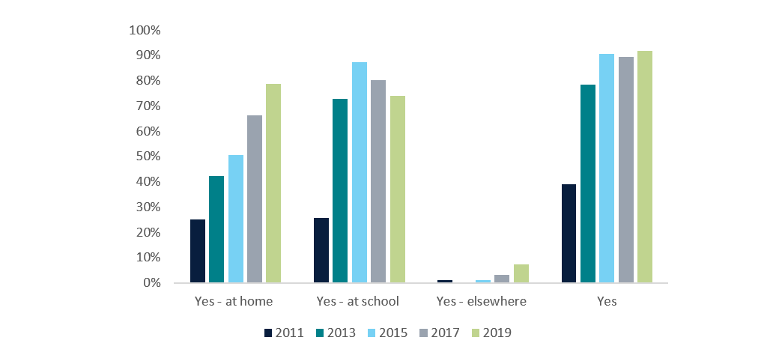
Source: LSIC, Release 13; BCARR calculations.

Most children access the internet from their own mobile phone
In 2019, the most common method children used to access the internet was through their own mobile phone, with over two-thirds of children accessing the internet in this way. Other common methods for accessing the internet included a computer or tablet at school, the child’s own computer and/or the family computer (Figure 2). LSIC did not collect information on the type of internet connection that was used by the study child in 2019 (e.g. mobile broadband, fixed wireless).
Figure 2: Children’s use of devices to access the internet (study child respondents), 2019
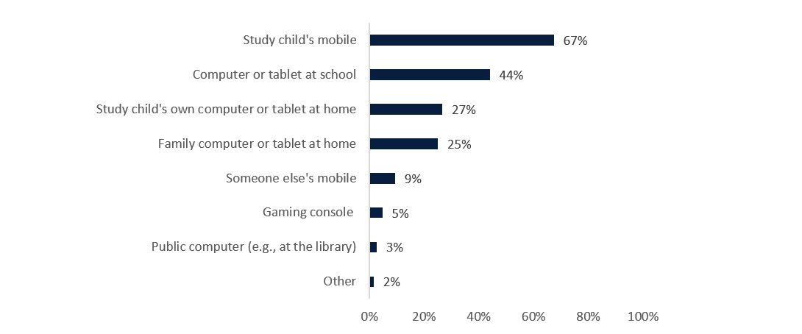
Source: LSIC, Release 13; BCARR calculations.

Online safety
Just over two-thirds of primary caregivers felt that their child was safe online in 2019 (69%); however, their perception of their child’s online safety has lessened over time (down 5 percentage points from 74% in 2017). Almost one-fifth of primary caregivers did not know if their child was safe online (19% in 2017 and 18% in 2019).
Most primary caregivers who did feel their children were safe online indicated they did so because they talked to their children about cyber safety and effectively monitored their child’s internet access through parental controls. In 2019, the majority of surveyed primary caregivers had rules regarding their child’s access to the internet at home. Two-thirds of primary caregivers whose children used the internet had rules regarding content and 57% had rules regarding their child’s time spent on the internet (Figure 3).
Figure 3: Rules about children’s internet access (primary caregiver respondents), 2019
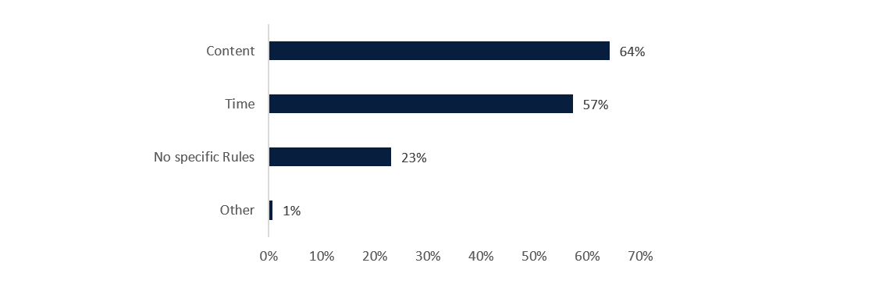
Source: LSIC, Release 13; BCARR calculations.
Between 2015 and 2017, the proportion of children using the internet without supervision almost doubled, from 36% to 64%. This proportion was even higher among children who owned a mobile, at 48% in 2015 and 72% in 2017. These responses correspond with reduced knowledge of cyber safety amongst primary caregivers, with the share of primary caregivers ‘not [knowing] much’ or knowing only a ‘little bit’ about cyber safety increasing by 10 percentage points from 24% in 2015 to 34% in 2019. It also reflects the ageing of the sample as children transition into high school.
Children were less likely to think they were unsafe online compared to their primary caregivers. Only 4% of children felt as though they were not safe on the internet in 2019, compared to 13% of primary caregivers. In 2019, nearly 70% of children considered themselves to be safe online. Most children who said that they felt safe on the internet did so because they:
- were convinced that their schools and homes had appropriate protections in place
- were taught about cyber safety at school
- talked only to people they knew on the internet
- visited only ‘safe websites’.
Children who used the internet were asked about the actions they had taken for their own online safety. The most common actions included blocking other people (18%), hiding or unfollowing people (13%) and deleting posts about themselves (11%). Only 14% of children had not undertaken any of the provided options for online safety (Figure 4).
Figure 4: Actions taken by children for their own online safety (study child respondents), 2019
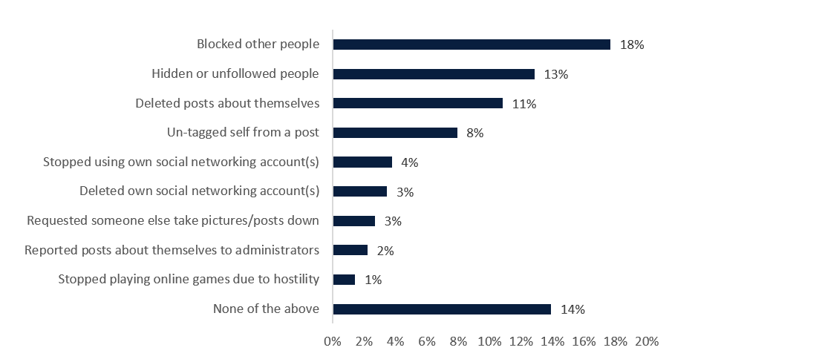
Source: LSIC, Release 13; BCARR calculations.

4. Computer use

The majority of children used a computer
Computer usage is an important enabler of digital inclusion. Between 2011 and 2017, the share of surveyed children who used a computer increased from 67% to 91% (Figure 5). This growth was supported by computer use at both home and school, but schools were the primary location for using a computer.
Computer use at school rose from 48% to 85% between 2011 and 2013, as the baby cohort (aged 5 to 6 years in 2013) entered primary school. However, between 2015 and 2017, the share of children using a computer at school actually decreased from 94% to 80%. The decline may be related to an increase in bring-your-own-device policies in schools, where children bring devices from home to school, reducing the need for access to a school-owned device (DEC, 2013).
The longitudinal nature of LSIC can show how children’s use of computers has changed over time. In 2011 around 53% of children did not use a computer at home. By 2017, over 50% of these children who had not used a computer at home in 2011 had now done so, with strong growth recorded across both the baby and child cohorts of the survey. The increase in computer use was particularly strong among children living in outer regional areas where, by 2017, 74% of children who did not use a computer at home in 2011 were using one. The lowest growth in computer use at home was among children residing in very remote areas where, by 2017, only 30% of children who did not use computer at home in 2011 were using one.
Figure 5: Children’s computer use (primary caregiver respondents)
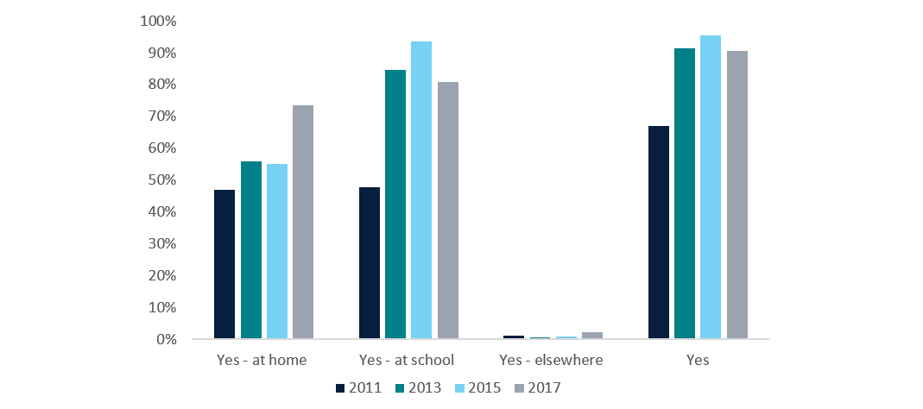
Source: LSIC, Release 13; BCARR calculations.

Computers are an important enabler of children’s education
In 2019, when this information was first collected, 64% of surveyed children used a computer primarily to do their school work, 59% to use Microsoft Office software, and 52% to search for information online (Figure 6). Children’s use of computers and the internet at home was found to be correlated with higher reading scores. Children who used the internet at home also had higher maths scores (DSS, 2020). For these reasons, further improving the availability of computers for First Nations children at home, especially in remote areas, appears to tie in with Closing the Gap Target 5 which is aimed at First Nations children achieving their full learning potential.
Figure 6: Six most common uses of computers (study children respondents), 2019
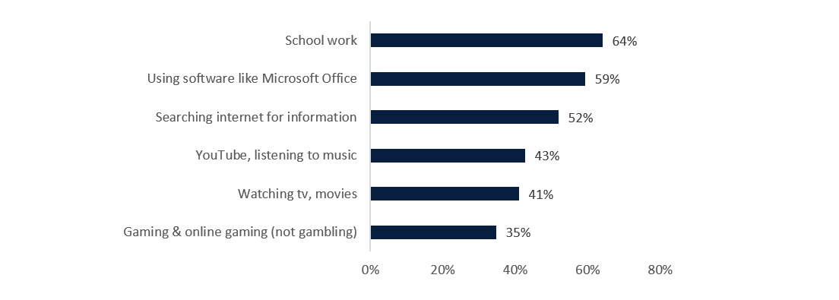
Source: LSIC, Release 13; BCARR calculations.

5. Mobile use

Children are increasingly using and owning mobile phones
Primary caregivers were asked whether their child used or owned a mobile phone in 2015 and 2017. Both children’s use and ownership of mobile phones grew significantly over this period. Reported mobile phone use grew from 45% in 2015 to 65% in 2017, while mobile phone ownership grew from 16% in 2015 to 42% in 2017 (Figure 7). Much of this growth in use is likely due to the ageing of the children surveyed. It corresponds with a decrease in the share of children using their primary caregiver’s phone, and growth in the share of primary caregivers indicating their child used someone else’s phone from the same residence. The vast majority of children (97% in 2017) who owned their own phone were on a pre-paid plan. Pre-paid mobile plans were particularly common in remote areas where, in 2017, 99% of children that owned a mobile were on a pre-paid plan (compared with 85% of children living in metropolitan areas).
Figure 7: Children’s use and ownership of mobile phones (primary caregiver respondents)
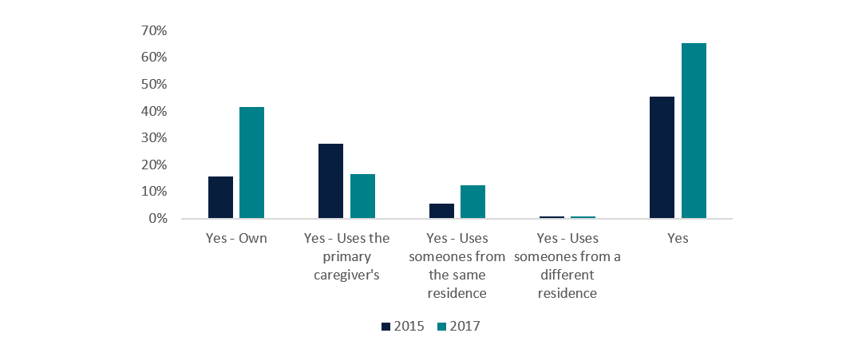
Source: LSIC, Release 13; BCARR calculations.
Surveyed children were also asked the same questions about mobile use and ownership in 2015, 2017 and 2019. Children reported much higher rates of phone ownership than was reported by their primary caregivers in 2015 (at 39%), but responses in 2017 were consistent with primary caregiver responses (at 42%). In 2019, over two-thirds of children surveyed reported that they owned their own mobile phone (Figure 8).
Figure 8: Children’s use of mobile phones (study child respondents)
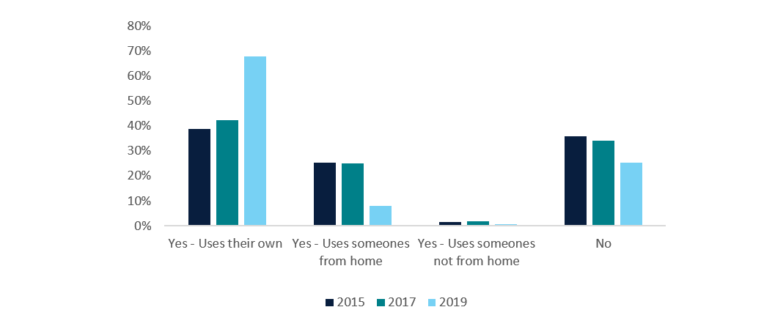
Source: LSIC, Release 13; BCARR calculations.

Mobile phones provide entertainment and social interaction
In 2019, children who used a mobile phone were asked for the first time what they used it for (Figure 9). Children used their mobiles most commonly to:
- listen to music and watch YouTube (91%)
- keep in contact with family and friends (84%)
- play games (60%)
- keep themselves organised (59%).
Figure 9: Most common uses for mobile phones (study child respondents), 2019
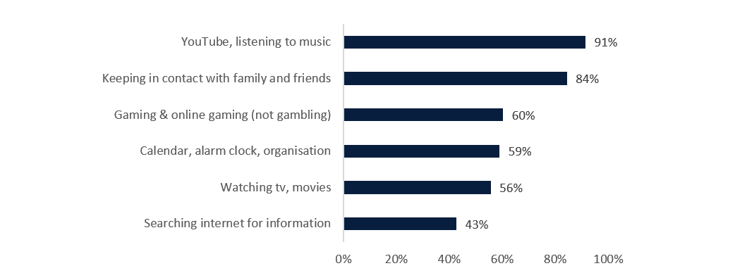
Source: LSIC, Release 13; BCARR calculations.

6. Socioeconomic factors impacting children’s use and ownership of digital technologies
This section examines whether children’s use of digital technologies differs by:
- location
- employment and education status of the primary caregiver
- household income
- living arrangements.
Multilevel logistic regression is used to estimate the relationship between each of the above characteristics and the likelihood of the children using the internet or a computer, or owning a mobile phone (while holding all other characteristics constant). For example, we estimate whether children with employed caregivers are more likely to use the internet than children whose caregivers are not employed, while holding all other characteristics constant (such as the child’s age, household income and caregivers’ highest level of education).
We estimate separate logistic regression models for each of the 5 dependent variables of interest:
- children’s use of the internet at home
- children’s use of the internet at school
- children’s use of a computer at home
- children’s use of a computer at school
- children’s ownership and use of a mobile phone.
The dependent variables used in the regressions are coded 1 if the child used the internet/computer/mobile phone, and 0 otherwise. With the exception of age, which is a continuous variable, all explanatory variables used are grouped into categorical variables. Some of these categorical variables are binary – for example, employment status of the caregiver is coded 1 if a caregiver was employed, and 0 otherwise. Similarly, household income is set to 1 if it was $800 or more per week, and 0 if below this threshold. For non-binary categorical variables, we set the following as reference categories:
- ‘metropolitan’ for the remoteness variable
- ‘parent and partner’ for the household type variable
- ‘completed year 11 or lower (including no education)’ for the highest level of education attained.
Regression estimates for these categorical variables are reported in comparison to these reference categories.
Detailed regression results are presented in Appendix C—Logistic regression. Here, we report the average marginal effects to show the factors impacting the likelihood of children having used the internet, a computer and a mobile phone. Marginal effects refer to the percentage change in the probability of accessing the internet, a computer or a mobile phone, respectively, if a given variable is changed by one unit, holding all the other variables constant.

The ageing of children in the survey contributes to their increased use of digital technologies
The age of the children involved in the study played a key role in their use of digital technologies. Research from the Department of Social Services using LSIC identified that both computer and internet use tended to increase with the child’s school year level (DSS, 2020). As children age, the nature of their school work changes and they are more likely to require a computer/internet to complete their study.
Older children were much more likely to own a mobile and access digital technologies – particularly at school, but also at home. As shown in Figure 10, the ageing of children by one year increased the likelihood of them owning a mobile by 52% and using a computer by between 4% (at home) and 9% (at school). Similarly, a one-year increase in a child’s age increased their probability of using the internet by between 5% (at home) and 9% (at school).
The stronger effect of age on mobile ownership is partially the result of the timing of the analysis period for regression modelling. Estimates for mobile ownership were analysed for the period from 2015 to 2019 when the sample cohorts were aged between 7 and 13 years old, and 10 and 16 years old. In contrast, estimates for computer and internet use were analysed for the period from 2011 to 2015, when the sample cohorts were younger – aged between 3 and 9 years old, and 6 and 12 years old.
Figure 10: Predicted probability of using digital technologies as children’s age increases by one year
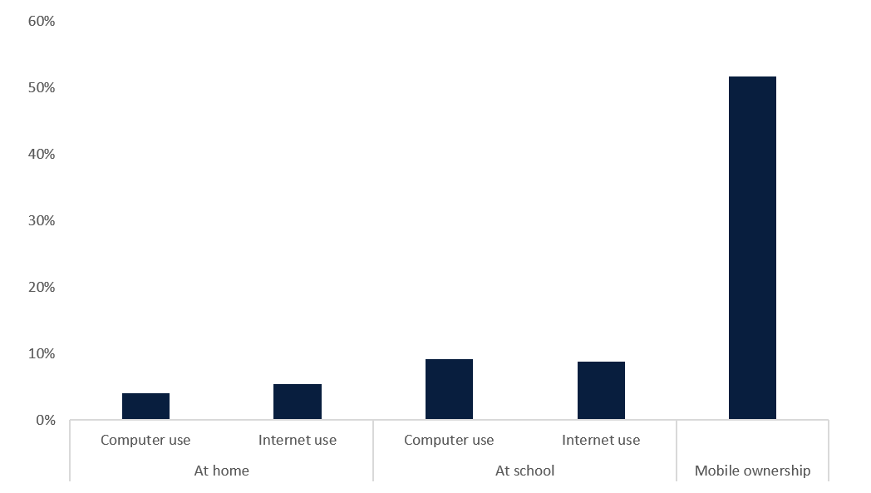
Source: LSIC, Release 13; BCARR calculations.
Note: The estimates for computer and internet use refer to the 2011–15 period. Estimates for mobile ownership refer to the 2015–19 period.

Children in metropolitan areas are more likely to use digital technologies
The LSIC data shows that, across most digital connectivity types, children in metropolitan areas record higher levels of digital technology use than their peers in regional and remote areas. In general, the more remote the area, the less digitally connected the children.
Children living in very remote areas are especially disadvantaged in their use of digital technology. As shown in Figure 11, compared to children living in metropolitan areas, children in very remote communities are, on average, 45% less likely to use the internet at home, 44% less likely to use a computer at home, 14% less likely to use the internet at school, 11% less likely to use a computer at school, and 56% less likely to own their own mobile. Figure 11 also shows that children in remote or regional areas are less digitally connected than children in metropolitan areas. Compared to children living in metropolitan regions, children in remote areas were 33% less likely to use the internet or a computer at home and 51% less likely to own a mobile. Children living in outer regional areas were also less likely than children in metropolitan areas to use digital technologies, but to a lesser extent.
Figure 11: Predicted probability of using digital technologies by location (relative to the ‘metropolitan’ reference category)
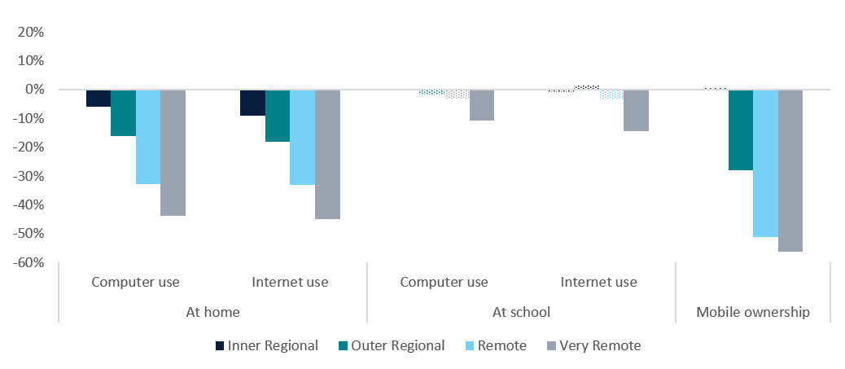
Source: LSIC, Release 13; BCARR calculations.
Notes: Results should be interpreted with respect to the ‘metropolitan’ reference category set to 0% and not visible in the above graph. Shaded areas refer to results that were not statistically significant (p-values were above 10%). The estimates for computer and internet use refer to the 2011–15 period. Estimates for mobile ownership refer to the 2015–19 period.

Use of computers and internet at schools
The use of computers and the internet at school is not statistically different between children located in metropolitan areas, and those located in regional and remote areas. Children in very remote areas still have lower usage at school, but these geographic differences are narrower than the differences in digital technology use at home. Though it is not explicit in the data, these findings may suggest access to the internet and computers in remote schools provides opportunities for digital connectivity that might not otherwise be possible for children living in these areas.
Over time, use of the internet, computers and mobile phones increased for LSIC children across all geographical boundaries (Figure 12). Children in remote areas recorded lower levels of use than their peers in non-remote areas, but this gap has narrowed over time. Between 2011 and 2019, the share of remotely-located study children using the internet increased by 66.9 percentage points (from 25% to 92%). Between 2011 and 2017, the share of remotely-located children using a computer increased by 31 percentage points (from 52% to 90%).
Figure 12: Children’s use of digital technologies by location
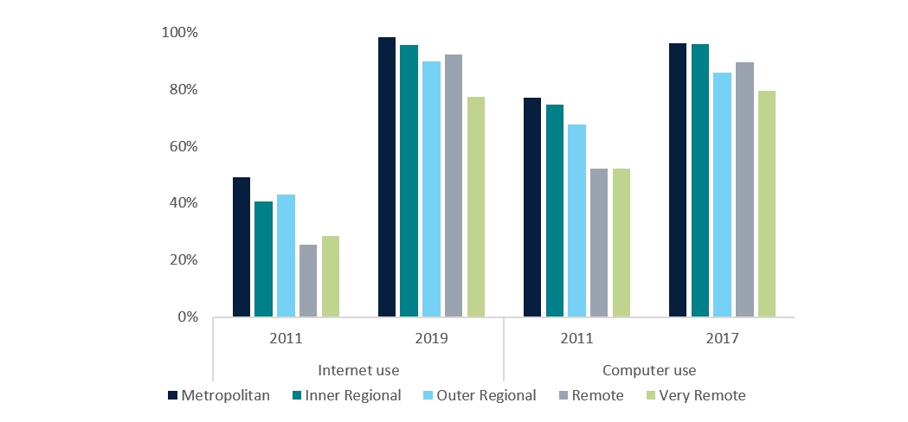
Source: LSIC, Release 13; BCARR calculations.

Children of employed primary caregivers are more likely to use digital technologies
The employment status of the child’s parent/primary caregiver is another important factor impacting children’s use of digital technologies. The rates of use of digital technologies for children of both employed and not employed parent/primary caregivers are presented in Figure 13. This figure shows children of primary caregivers who were not employed had consistently lower rates of use of digital technologies compared to children whose caregivers were employed. This gap in internet/computer use between a child with an employed primary caregiver and a child with a non-employed primary caregiver has narrowed over time. The opposite was true for mobile ownership, where the gap between a child with an employed primary caregiver and a child with a non-employed primary caregiver increased by 10 percentage points between 2015 and 2019.
Figure 13: Children’s use of digital technologies by caregiver employment status
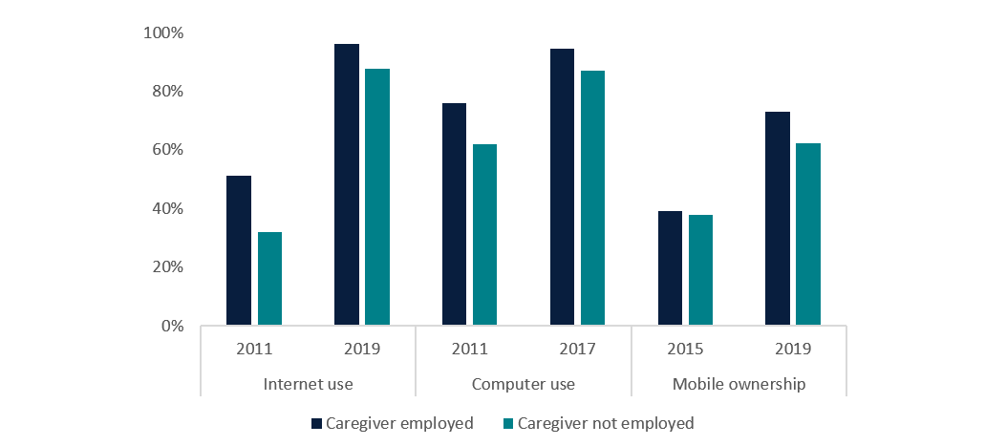
Source: LSIC, Release 13; BCARR calculations.
We tested these differences using logistic regression modelling and found that they were statistically significant. Children of employed parents/carers were 11% more likely to use a computer at home; 8% more likely to use the internet at home; about 3% more likely to use the internet and/or a computer at school, and 35% more likely to own a mobile phone, compared to children of non-employed parents/carers (Figure 14).
Figure 14: Predicted probability of using digital technologies for children of employed primary caregivers (relative to the ‘non-employed’ reference category)
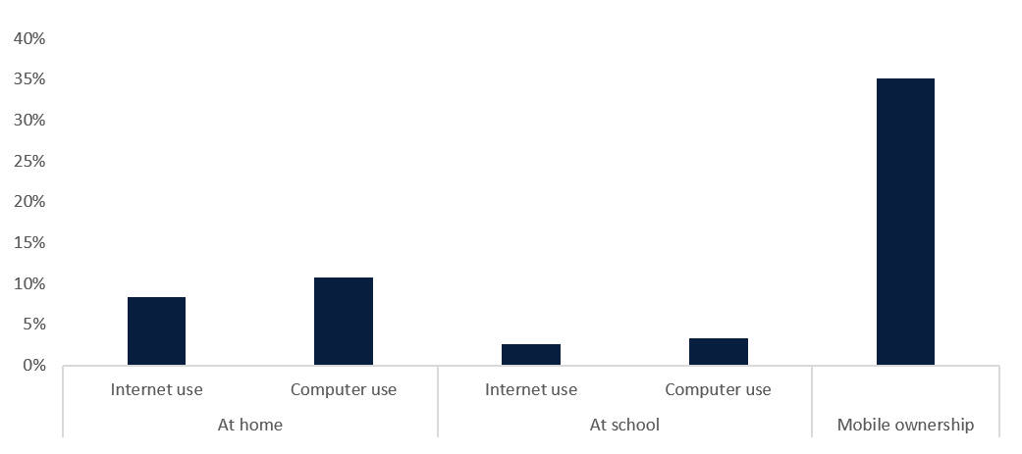
Source: LSIC, Release 13; BCARR calculations.
Note: Results should be interpreted with respect to the ‘non-employed’ reference category set to 0% and not visible in the above graph. The estimates for computer and internet use refer to the 2011–15 period. Estimates for mobile ownership refer to the 2015–19 period.

Children in low income households are less likely to use the internet and computers at home, but the gap has narrowed
This study examined whether children’s use of digital technologies varied by household weekly income. We divided households into two income groups:
- households with income of less than $800 per week, and
- households with income of $800 per week or more.
Children in households with higher income recorded higher levels of computer and internet use at home. Children residing in these households were on average 9% more likely to use a computer and/or internet at home, compared to children from households with weekly income below $800 per week (Figure 15).
Figure 15: Predicted probability of using digital technologies for children in households with income of $800 or more per week (relative to the ‘income less than $800 per week’ reference category)
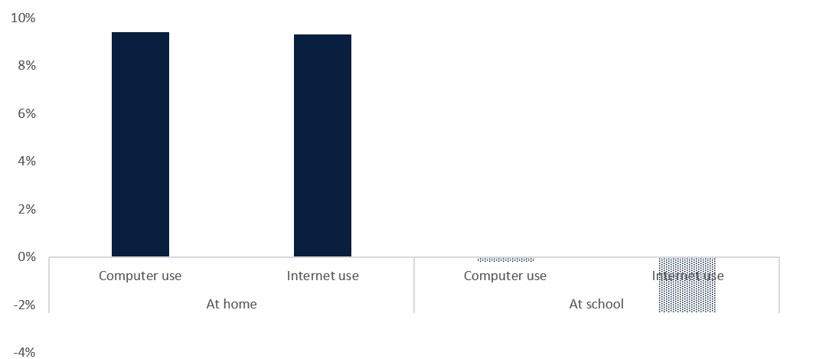
Source: LSIC, Release 13; BCARR calculations.
Notes: Results should be interpreted with respect to the ‘households with income below $800 per week’ reference category set to 0% and not visible in the above graph. Shaded areas refer to results that were not statistically significant (p-values were above 10%). Estimates refer to the 2011–15 period.
We could not establish a statistically significant relationship between household income and children’s use of digital technologies at school. Children’s use of digital technologies at school might relate to other non-household related factors such as school funding or the digital literacy of teachers. Also, a statistically significant relationship was not found between household income and children’s mobile ownership, perhaps owing to the small number of respondents to these questions.
Despite being less likely, on average, to use a computer or the internet at home, children in households with income below $800 per week recorded strong increases in their use of the internet and computers between 2011 and 2015. The shares of these children using a computer and the internet over this timeframe increased by 31 percentage points and 54 percentage points, respectively (Figure 16).
Figure 16: Children’s use of digital technologies by weekly household income
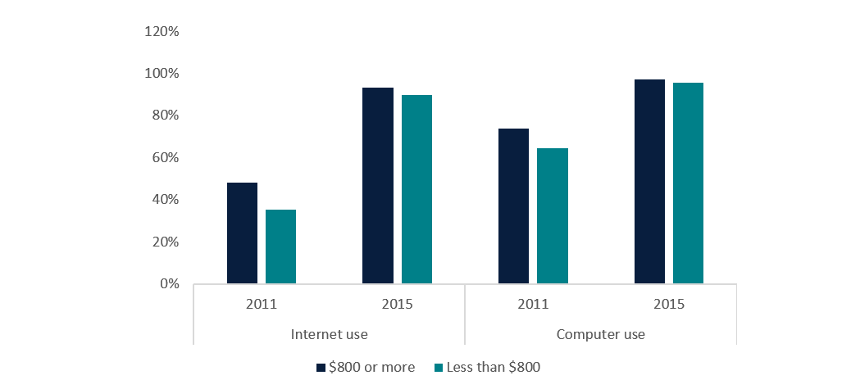
Source: LSIC, Release 13; BCARR calculations.

Children living with parents and their partners are more likely to use digital technologies
Our analysis also considered how children’s use of digital technologies varied by household living arrangements. Most of the surveyed children lived with their parents, in either lone parent or partnered households.
With the exception of mobile ownership, children who lived with parents and their partners recorded the highest levels of use of digital technologies at home. Compared to children who lived in households with a parent and partner, internet use at home was 7% lower in lone parent households, 9% lower in carer and partner households, and 19% lower in lone carer households. Similarly, children living with lone parents and lone carers were on average 6% and 18% less likely than partnered households to use a computer at home, respectively (Figure 17).
The very low usage of digital technologies by children in lone carer households may, in part, be explained by differences in age between carers and parents. In the LSIC sample, primary caregivers who were carers tended to be older than parents, with the average carer age in LSIC being over 50 years, compared to mid-30s for parents. Carers possibly represent grandparents or aunties/uncles/other elders who may be less likely to have a computer or the internet at home. There is a body of research that points to older people being more likely to be digitally excluded and being less able to afford telecommunications (Thomas et al 2023; BCARR 2023).
Finally, we again see that household type is generally not a significant driver of school internet and computer use. However, due to the lower probabilities of these children using the internet or a computer at home, their access to these technologies at school could be an important facilitator of these children’s overall use of digital technology. This is particularly true for children living with a lone carer whose primary location for accessing the internet was at school, across all relevant waves of the survey.
Figure 17: Predicted probability of using digital technology by household type (relative to the ‘parent and partner household’ reference category)
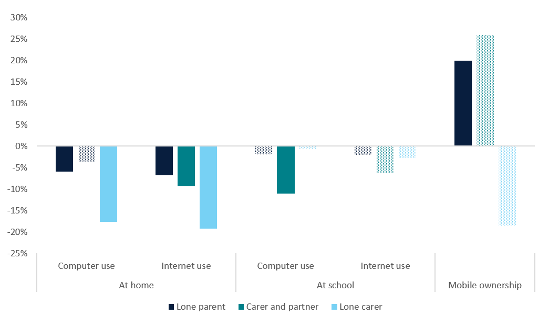
Source: LSIC, Release 13; BCARR calculations.
Notes: Results should be interpreted with respect to the ‘parent and partner household’ reference category set to 0%. Shaded areas refer to results that were not statistically significant (p-values were above 10%). Estimates for computer and internet use refer to the 2011–15 period, mobile ownership estimates refer to the 2015–19 period.

Children of primary caregivers with higher education are more likely to use digital technologies at home
Children’s use of internet and computers also varied by the primary caregiver’s highest level of education. Generally, children whose caregivers were more educated had higher rates of internet and computer use at home.
Children of parents/caregivers with post-secondary qualification were on average 9% more likely to use the internet at home and 8% more likely to use a computer at home (Figure 18). Parent’s educational attainment was not a statistically significant predictor of children’s mobile ownership and their use of digital technologies at school.
Figure 18: Predicted probability of using digital technologies by the primary caregiver’s highest level of education (relative to the ‘Year 11 or below (including no school)’ reference category)
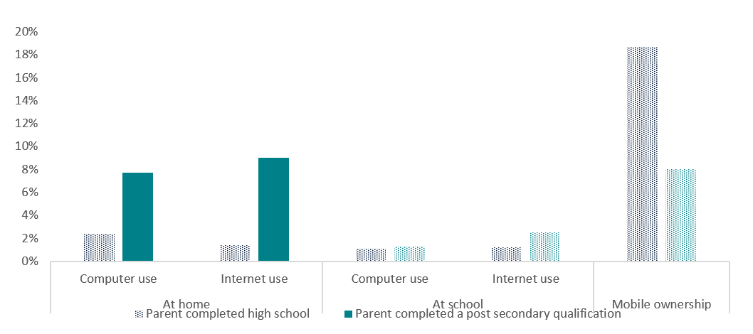
Source: LSIC, Release 13; BCARR calculations.
Notes: Results should be interpreted with respect to the ‘Year 11 or below (including no school)’ reference category set to 0% and not visible in the above graph. Shaded areas refer to results that were not statistically significant (p-values were above 10%). The estimates for computer and internet use refer to the 2011–15 period. The estimates for mobile ownership refer to the 2015–19 period.
The gap in use rates for children of primary caregivers with high and low educational attainment has narrowed, particularly regarding the use of technology at home. In 2011, a gap of 13 percentage points in internet use at home was observed between children of primary caregivers with a post-secondary qualification and children of primary caregivers with educational attainment below year 12. By 2019, this same gap was only 2 percentage points (Figure 19).
Figure 19: Children’s use of digital technologies by primary caregiver’s highest level of education
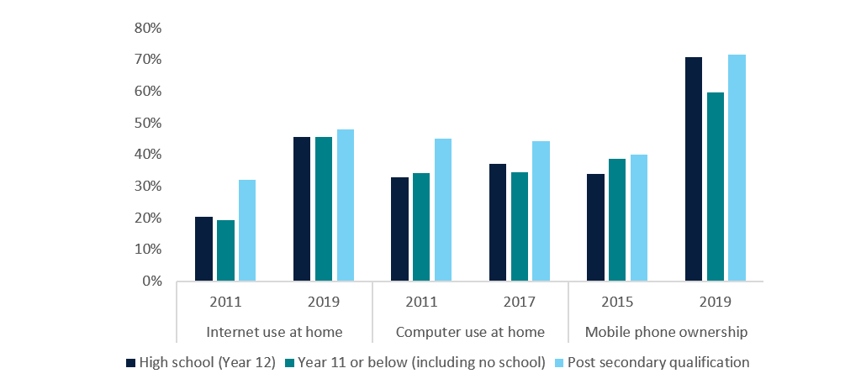
Source: LSIC, Release 13; BCARR calculations.

7. Conclusion
This paper examines the use of digital technologies by First Nations children in LSIC. Findings show that:
- Nearly all First Nations children use the internet. Over 90% of children in the study had used the internet in 2019.
- First Nations children’s internet, mobile and computer use is growing.
- Socioeconomic factors play a key role in First Nations children’s use of digital technologies.
- Age was a leading factor impacting children’s uptake of digital technologies at home and at school. Older children were more likely to use the internet and computers, at home and at school, and to own a mobile.
- Children were more likely to use digital technologies at school and at home if they lived in a metropolitan area or if their parent/caregiver was employed.
- A child was more likely to use the internet or a computer at home if their caregiver earned a higher income, had a post-secondary qualification or was living with a partner.
- The gap in the use of digital technologies between children of differing socioeconomic backgrounds has narrowed over time.
- The household and primary caregiver characteristics analysed were more likely to influence a child’s use of digital technologies at home, rather than at school.
- For children who are less likely to use digital technologies at home, school may play a key role in facilitating access to digital technologies.
A strength of the LSIC data is its ability to provide good sample representation of First Nations households across urban, regional and remote areas of Australia, enabling the use of digital technologies to be compared across these geographical boundaries.
That said, our analysis does have some limitations. Firstly, LSIC uses non-random purposive sampling which means that the probability of being selected for participation in LSIC is not random across all First Nations children in Australia, but rather clustered around 11 specific survey sites selected for sampling. As explained in more detail in Appendix C—Logistic regression, in our analysis, we use statistical techniques that allow us to control for this sampling design.
Secondly, as described in Appendix B—LSIC sample distribution, the non-random purposive sampling results in a dataset that is not nationally-representative. We were not able to control for this in our analysis and so the statistical inferences made in this study can only be made with regard to the sample collected through LSIC. These findings should not be generalised.
BCARR plans to explore children’s usage of digital technologies using the Longitudinal Study of Australian Children (LSAC). Such research would enable drawing nationally-representative inferences about children’s use of digital technologies. In doing so, it will provide a complementary analysis to this paper.
The research presented in this paper would also benefit from a better understanding of the role of digital connectivity in classrooms, particularly in remote areas, and how this has changed over time.

8. References
ACARA. (2023). Retrieved from Student Attendance: https://www.acara.edu.au/reporting/national-report-on-schooling-in-australia/student-attendance
ACMA. (2020). Kids and mobiles: how Australian children are using mobile phones. Retrieved from https://www.acma.gov.au/publications/2020-12/report/kids-and-mobiles-how-australian-children-are-using-mobile-phones
ACMA. (2023). Communications and media in Australia: How we use internet. Retrieved from https://www.acma.gov.au/sites/default/files/2023-12/ACMA_How%20we%20use%20the%20internet_Executive%20summary%20and%20key%20findings.pdf
AIFS. (2012). Footprints in Time: The Longitudinal Study of Indigenous Children. A guide for the uninitiated. Retrieved from https://aifs.gov.au/research/family-matters/no-91/footprints-time-longitudinal-study-indigenous-children
BCARR. (2023). Australian households and the affordability of telecommunications. Evidence from Household Income and Labour Dynamics in Australia (HILDA) data. Retrieved from https://www.infrastructure.gov.au/sites/default/files/documents/australian-households_-affordability-telecommunications-evidence-household-income-labour-dynamics-australia-hilda-data-working-paper-november2023.pdf
DEC. (2013). Bring your own device (BYOD) in Schools - 2013 Literature review. Retrieved from https://westryde-p.schools.nsw.gov.au/content/dam/doe/sws/schools/w/westryde-p/localcontent/byod_2013_literaturereview.pdf
DSS. (2020). A Decade of Data: Findings from the first 10 years of Footprints in Time. Retrieved from https://www.dss.gov.au/sites/default/files/documents/05_2021/19667-dss-footprints-time.pdf
DSS. (2023). Footprints in Time: The Longitudinal Study of Indigenous Children - Data User Guide, Release 13.0.
Hewitt, B. (2012). The longitudinal Study of Indigenous Children. Implications of the study design for analysis and results. Retrieved from https://www.dss.gov.au/sites/default/files/files/about-fahcsia/publication-articles/footprints/Implications%20of%20the%20study%20design%20for%20analysis%20and%20results.pdf
Holodinsky J. K., A. P. (2020). An introduction to clustered data and mutlilevel analyses. Family Practice, volume 37, issue 5, 719-722.
Mohal, J. L. (2023). Growing Up in Australia: The Longitudinal Study of Australian Children – Data User Guide, Release 9.1C2. Melbourne: Australian Institute of Family Studies.
NIAA. (2023). 2023 Commonwealth Closing the Gap Implementation Plan. Retrieved from https://www.niaa.gov.au/2023-commonwealth-closing-gap-implementation-plan/delivering-outcomes-and-targets/outcome-17-aboriginal-and-torres-strait-islander-people-have-access-information-and-services-enabling-participation-informed-decision-making-regardin
Thomas J., M. A.-J.-P. (2023). Measuring Australia's Digital Divide: Australian Digital Inlcusion Index 2023. Retrieved from https://www.digitalinclusionindex.org.au/wp-content/uploads/2023/07/ADII-2023-Summary_FINAL-Remediated.pdf

Appendix A—Availability of LSIC data on children’s use of digital technologies
Questions on internet access and computer use were asked in the technology section of LSIC. The technology section was included in waves 4, 6, 8, 10, and 12 of the survey. These survey waves were the focus of our analysis.
Table 3: The availability of LSIC data on children’s use of digital technologies across waves
Question | Respondent | 1 | 2 | 3 | 4 | 5 | 6 | 7 | 8 | 9 | 10 | 11 | 12 | 13
Does SC use the internet? | P1 |  |  |  | Y* |  | Y* |  | Y* |  | Y* |  | Y
Does SC use a computer? | P1 |  |  |  | Y |  | Y |  | Y |  | Y
Do you (P1) have internet access at home? / What types of internet access do you (P1) have at home? | P1 |  |  |  |  |  |  |  | Y
Does SC own or use a mobile phone? | P1 |  |  |  |  |  |  |  | Y |  | Y
What kind of plan is SC's mobile phone on? | P1 |  |  |  |  |  |  |  | Y |  | Y
Do you (P1) use the internet on your phone or computer to do….? (MCQ of activities) | P1 |  |  |  |  |  |  |  | Y* |  |  |  | Y
Does SC look at the internet without supervision (e.g. in their bedroom)? | P1 |  |  |  |  |  |  |  | Y |  | Y
Do you (P1) know about cyber safety (being safe on the internet)? | P1 |  |  |  |  |  |  |  | Y |  | Y |  | Y
Do you (P1) think SC is safe on the internet? | P1 |  |  |  |  |  |  |  |  |  | Y |  | Y
Do you have rules about what (SC) is allowed to access on the internet at home? | P1 |  |  |  |  |  |  |  | Y |  | Y |  | Y
Do you (SC) use a mobile phone? | SC |  |  |  |  |  |  |  | Y# |  | Y |  | Y
What do you (SC) use the mobile phone for? | SC |  |  |  |  |  |  |  |  |  |  |  | Y
Do you (SC) use a computer, laptop, tablet/iPad, smartphone or Chromebook? | SC |  |  |  |  |  |  |  |  |  |  |  | Y
Do you (SC) use the internet? | SC |  |  |  |  |  |  |  |  |  |  |  | Y
What do you (SC) use the tablet/computer for? | SC |  |  |  |  |  |  |  |  |  |  |  | Y
What do (SC) you use to get onto the internet? | SC |  |  |  |  |  |  |  |  |  |  |  | Y
Do you (SC) feel safe on the internet? | SC |  |  |  |  |  |  |  |  |  |  |  | Y#
What SC did for online safety. Have you (SC) ever done any of the following online? (MCQ of actions) | SC |  |  |  |  |  |  |  |  |  |  |  | Y#
Source: LSIC, Release 13.
Notes: * Limited responses were collected in this wave. # Not all cohorts asked. P1 = Primary caregiver, SC = Study child.

Appendix B—LSIC sample distribution

B.1. Overview of sample
The LSIC sample was selected from 11 sites located across Australia which cover diverse socioeconomic and community environments where Aboriginal and Torres Strait Islander children live. The sites were chosen to:
- ensure approximately equal representation of urban, regional and remote areas
- represent the concentration of Aboriginal and Torres Strait Islander people around Australia
- contain a substantial Aboriginal and Torres Strait Islander population
- include locations engaged in the pilot of the study where existing relationships could be built upon (DSS, 2023).
LSIC was designed to sample approximately 150 children in each site. The study sites are represented graphically in Figure 20.
Figure 20: LSIC sample distribution, site of primary caregiver interviews in Wave 1
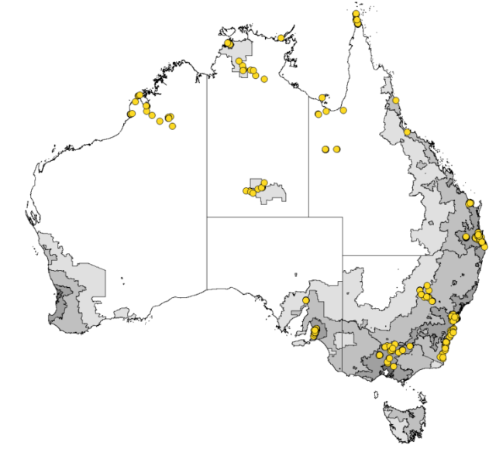
Source: LSIC User Guide Wave 13.

B.2. Comparison to Census First Nations children and families
We compared the LSIC sample with the wider First Nations population to better understand the representativeness of the LSIC sample. We examined average characteristics of the LSIC sample (between the years of 2016 and 2021) against similar characteristics found in the 2021 Census of Population and Housing for First Nations peoples (Figure 21). Where equivalent data for 2016 was able to be captured, we have presented an average of the two Census periods data. Our analysis indicates that the LSIC sample has some key differences compared to the wider First Nations population, including:
- higher proportions of children living in remote locations
- lower levels of family income
- lower rates of high school and post-school completion.
The share of children whose primary carer is a parent is relatively consistent with that of wider First Nations children populations.
Given the differences between the LSIC sample and the Census population – and especially the high share of the LSIC sample sourced from remote Australia, the findings of this report should not be used to draw population inferences for all First Nations children in Australia.
Figure 21: Footprints in Time sample compared to all First Nations peoples, share of total, waves 9 to 13, Release 13, compared to 2021 Census of Population and Housing
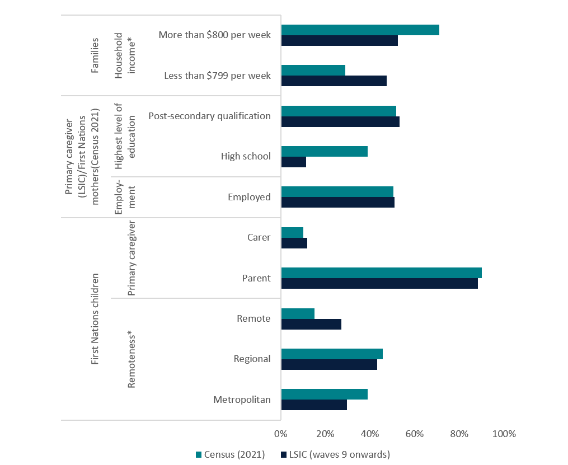
Source: LSIC, Release 13; Census of Population and Housing, 2016; Census of Population and Housing, 2021; BCARR calculations
Notes: *Household income and remoteness shares presented for First Nations peoples are an average of both the 2016 and 2021 Census.

Appendix C—Logistic regression
As outlined in Appendix B—LSIC sample distribution, LSIC surveyed children and families located in and around 11 geographic sites in Australia. Families living close to a survey site had a higher probability of being a survey participant than families that lived further away from the survey site. This impacts the data as there are greater similarities in the responses and characteristics of respondents located near each other than if respondents were selected randomly from across the total population. If unaccounted for, the clustering of the sample may understate the variability that exists and could also lead to incorrect estimates and conclusions. To reduce this problem, we follow the approach of Hewitt (2012) and estimate LSIC data using 3 logistic regression models on each of our 5 dependent variables to account for clustering in LSIC.
We run our models on multiple waves of LSIC data collected over a period of time for the same groups of individuals which inevitably leads to clustering of observations around them. Since this kind of clustering has the same potential for underestimating the variability of the sample as the geographic clustering our final models adjust for both types of clustering.
The 5 dependent variables are: child internet use at home; child internet use at school; child computer use at home; child computer use at school; and child mobile ownership. These variables were coded 1 if a child had used the internet/computer/mobile, and 0 if they did not.
The 3 models include:
- Model 1: A standard logistic regression, which does not account for any clustering of the survey data. It is also referred to as our base model.
- Model 2: A logistic regression with clustered standard errors. The standard errors are adjusted only for clustering of individuals (leading to their higher values). The coefficients of the models are not adjusted.
- Model 3: A mixed effects multilevel logistic regression. This model specifies random intercepts for both geographic and individual clustering, adjusting both the regression coefficients and their standard errors.
The regression results for each of the 5 dependent variables are presented in separate tables. In each table we compare the results of models 1, 2 and 3 in separate columns. We tested the interactions between the explanatory variables in our models. None of them were statistically significant so we did not include them in our models.
To determine which model fits our data best we compare the values of their log likelihoods, and the results of the Akaike Information Criteria (AIC) and Bayesian Information Criteria (BIC) tests. The log-likelihood value for a given model can range from negative to positive infinity. The higher the value of log-likelihood the better a model fits a dataset. AIC and BIC tests are designed to assist in selecting the best fitting model. The smaller the AIC or BIC, the better the model specification.
For model 3, in addition to the AIC and BIC, we report the value of the intraclass correlation coefficients for both clustering variables (ICC). The ICC measures the proportion of the variation in the dependent variable that can be attributed to systematic differences in the dependent variable between clusters. In other words, the ICC tells us the degree of similarity between individuals belonging to the same cluster. ICC can take values from 0 to 1. The ICC of 0 indicates that there is no clustering present in the data; 1 shows that the clustering accounts for all the variation in the dependent variable (Holodinsky, Austin and Williamson 2020).
We use the ICC to determine whether the explanatory variables included in our multilevel logistic regression models increase the proportion of the variation explained by the dependent variable. To do so, we compare the ICC of our models without any explanatory variables to the ICC of models with the explanatory variables included. If the ICC of our models with explanatory variables included is lower compared to the ICC of the models without explanatory variables we conclude that the inclusion of the explanatory variables improves the predictive power of the model.
Under these criteria, the multilevel logistic regressions (model 3) fit our data best. We report the marginal effects for these models in section 6 of the report.
Table 4: Logistic regression results - internet use at home
Does the study child use internet at home? | Model 1  (Logistic)  Odds Ratio | Std Error | Model 2  (Logistic with standard errors adjusted for clustering of individuals)  Odds Ratio | Std Error | Model 3  (Multilevel logistic adjusting for both geographic and individual clustering)  Odds Ratio | Std Error
Wave (relative to
wave 4)
Wave 6 | 1.044 | 0.131 | 1.044 | 0.127 | 1.135 | 0.187
Wave 8 | 0.915 | 0.138 | 0.915 | 0.148 | 1.058 | 0.228
Age
Age (in years) | 2.667*** | 0.368 | 2.667*** | 0.360 | 3.977*** | 0.737
Age-squared | 0.959*** | 0.008 | 0.959*** | 0.008 | 0.94*** | 0.011
Remoteness (relative to ‘Metropolitan’)
Inner Regional | 0.532*** | 0.058 | 0.532*** | 0.067 | 0.527*** | 0.126
Outer Regional | 0.406*** | 0.053 | 0.406*** | 0.061 | 0.279*** | 0.067
Remote | 0.179*** | 0.030 | 0.179*** | 0.035 | 0.085*** | 0.029
Very Remote | 0.057*** | 0.010 | 0.057*** | 0.011 | 0.023*** | 0.007
Caregiver Education (relative to ‘Completed year 11/No educ’)
High school | 1.143 | 0.146 | 1.143 | 0.165 | 1.117 | 0.213
Post-secondary  qualification | 1.746*** | 0.177 | 1.746*** | 0.200 | 2.035*** | 0.307
Caregiver Employment (relative to ‘Not employed’)
Employed | 1.698*** | 0.169 | 1.698*** | 0.182 | 1.978*** | 0.284
Income (relative to ‘<$800 pw’)
$800+ pw | 1.753*** | 0.173 | 1.753*** | 0.179 | 2.125*** | 0.298
Household type (relative to ‘Parent and partner’)
Lone parent | 0.66*** | 0.064 | 0.66*** | 0.070 | 0.58*** | 0.083
Carer and partner | 0.586* | 0.172 | 0.586* | 0.178 | 0.468* | 0.208
Lone carer | 0.28*** | 0.076 | 0.28*** | 0.094 | 0.199*** | 0.078
_cons | 0.008*** | 0.004 | 0.008*** | 0.004 | 0.001*** | 0.001
N Obs | 3118 |  | 3118 |  | 3118
(Pseudo) R2 | 0.257 |  | 0.257 |  | n.a.
Log (Pseudo) likelihood | -1573 |  | -1573 |  | -1520
AIC | 3178 |  | 3178 |  | 3076
BIC | 3275 |  | 3275 |  | 3185
ICC geographic cluster | n.a. |  | n.a. |  | 0.046 | 0.022
ICC individual cluster | n.a. |  | n.a. |  | 0.428 | 0.044
Source: LSIC, Release 13; BCARR calculations.
Notes: *Significant at 10% level; **Significant at 5% level; ***Significant at 1% level; n.a. – not available.

Table 5: Logistic regression results - internet use at school
Does the study child use internet at home? | Model 1  (Logistic)  Odds Ratio | Std Error | Model 2  (Logistic with standard errors adjusted for clustering of individuals)  Odds Ratio | Std Error | Model 3  (Multilevel logistic adjusting for both geographic and individual clustering)  Odds Ratio | Std Error
Wave (relative to wave 4)
Wave 6 | 3.502*** | 0.412 | 3.502*** | 0.412 | 4.953*** | 0.794
Wave 8 | 3.176*** | 0.525 | 3.176*** | 0.555 | 4.679*** | 1.036
Age | 0.000 | 0.000 | 0.000 | 0.000 | 0.000 | 0.000
Age (in years) | 7.855*** | 1.420 | 7.855*** | 1.201 | 13.615*** | 3.331
Age-squared | 0.909*** | 0.011 | 0.909*** | 0.009 | 0.885*** | 0.013
Remoteness (relative to ‘Metropolitan’)
Inner Regional | 0.616*** | 0.084 | 0.616*** | 0.086 | 0.922 | 0.297
Outer Regional | 1.112 | 0.189 | 1.112 | 0.203 | 1.175 | 0.359
Remote | 0.612*** | 0.111 | 0.612*** | 0.111 | 0.701 | 0.295
Very Remote | 0.339*** | 0.053 | 0.339*** | 0.058 | 0.268*** | 0.087
Caregiver Education (relative to ‘Completed year 11/No educ’’)
High school | 0.984 | 0.140 | 0.984 | 0.160 | 1.129 | 0.207
Post-secondary  qualification | 1.233* | 0.152 | 1.233 | 0.159 | 1.285 | 0.199
Caregiver Employment (relative to ‘Not employed’)
Employed | 1.251* | 0.148 | 1.251* | 0.157 | 1.302* | 0.194
Income (relative to ‘<$800 pw’)
$800+ pw | 0.822* | 0.098 | 0.822 | 0.100 | 0.794 | 0.118
Household type (relative to ‘Parent and partner’)
Lone parent | 0.825* | 0.092 | 0.825 | 0.099 | 0.816 | 0.115
Carer and partner | 0.678 | 0.206 | 0.678 | 0.221 | 0.543 | 0.213
Lone carer | 0.757 | 0.206 | 0.757 | 0.209 | 0.755 | 0.255
_cons | 0.000*** | 0.000 | 0.000*** | 0.000 | 0.000*** | 0.000
N Obs | 3118 |  | 3118 |  | 3118
(Pseudo) R2 | 0.385 |  | 0.385 |  | n.a.
Log (Pseudo) likelihood | -1262.301 |  | -1262.301 |  | -1184.717
AIC | 2556.602 |  | 2556.602 |  | 2405
BIC | 2653.322 |  | 2653.322 |  | 2514
ICC geographic cluster | n.a. |  | n.a. |  | 0.196 | 0.035
ICC individual cluster | n.a. |  | n.a. |  | 0.356 | 0.059
Source: LSIC, Release 13; BCARR calculations.
Notes: *Significant at 10% level; **Significant at 5% level; ***Significant at 1% level; n.a. – not available.
Table 6: Logistic regression results – computer use at home
Does the study child use internet at home? | Model 1  (Logistic)  Odds Ratio | Std Error | Model 2  (Logistic with standard errors adjusted for clustering of individuals)  Odds Ratio | Std Error | Model 3  (Multilevel logistic adjusting for both geographic and individual clustering)  Odds Ratio | Std Error
Wave (relative to wave 4)
Wave 6 | 0.812* | 0.095 | 0.812* | 0.091 | 0.78* | 0.115
Wave 8 | 0.558*** | 0.081 | 0.558*** | 0.084 | 0.491*** | 0.096
Age
Age (in years) | 1.725*** | 0.205 | 1.725*** | 0.202 | 2.108*** | 0.315
Age-squared | 0.978*** | 0.008 | 0.978*** | 0.007 | 0.968*** | 0.009
Remoteness (relative to ‘Metropolitan’)
Inner Regional | 0.654*** | 0.070 | 0.654*** | 0.081 | 0.683* | 0.149
Outer Regional | 0.474*** | 0.059 | 0.474*** | 0.068 | 0.361*** | 0.077
Remote | 0.229*** | 0.033 | 0.229*** | 0.038 | 0.131*** | 0.037
Very Remote | 0.111*** | 0.015 | 0.111*** | 0.017 | 0.062*** | 0.015
Caregiver Education (relative to ‘Completed year 11/No educ’’)
High school | 1.177 | 0.136 | 1.177 | 0.152 | 1.172 | 0.192
Post-secondary  qualification | 1.581*** | 0.153 | 1.581*** | 0.170 | 1.677*** | 0.226
Caregiver Employment (relative to ‘Not employed’)
Employed | 1.772*** | 0.167 | 1.772*** | 0.175 | 2.088*** | 0.269
Income (relative to ‘<$800 pw’)
$800+ pw | 1.69*** | 0.157 | 1.69*** | 0.159 | 1.894*** | 0.235
Household type (relative to ‘Parent and partner’)
Lone parent | 0.762*** | 0.068 | 0.762*** | 0.076 | 0.675*** | 0.083
Carer and partner | 0.886 | 0.225 | 0.886 | 0.210 | 0.785 | 0.278
Lone carer | 0.387*** | 0.087 | 0.387*** | 0.106 | 0.309*** | 0.098
_cons | 0.147*** | 0.061 | 0.147*** | 0.062 | 0.076*** | 0.041
N Obs | 3213 |  | 3213 |  | 3213
(Pseudo) R2 | 0.178 |  | 0.178 |  | n.a.
Log (Pseudo) likelihood | -1816.903 |  | -1816.903 |  | -1766.850
AIC | 3665.805 |  | 3665.805 |  | 3570
BIC | 3763.005 |  | 3763.005 |  | 3679
ICC geographic cluster | n.a. |  | n.a. |  | 0.038 | 0.018
ICC individual cluster | n.a. |  | n.a. |  | 0.363 | 0.040
Source: LSIC, Release 13; BCARR calculations.
Notes: *Significant at 10% level; **Significant at 5% level; ***Significant at 1% level; n.a. – not available.
Table 7: Logistic regression results – computer use at school
Does the study child use internet at home? | Model 1  (Logistic)  Odds Ratio | Std Error | Model 2  (Logistic with standard errors adjusted for clustering of individuals)  Odds Ratio | Std Error | Model 3  (Multilevel logistic adjusting for both geographic and individual clustering)  Odds Ratio | Std Error
Wave (relative to wave 4)
Wave 6 | 1.769*** | 0.248 | 1.769*** | 0.229 | 2.069*** | 0.364
Wave 8 | 1.572** | 0.359 | 1.572* | 0.373 | 1.835** | 0.517
Age
Age (in years) | 10.956*** | 1.965 | 10.956*** | 1.710 | 24.674*** | 6.878
Age-squared | 0.888*** | 0.011 | 0.888*** | 0.010 | 0.85*** | 0.015
Remoteness (relative to ‘Metropolitan’)
Inner Regional | 0.713** | 0.111 | 0.713** | 0.120 | 0.985 | 0.344
Outer Regional | 0.852 | 0.158 | 0.852 | 0.169 | 0.812 | 0.259
Remote | 0.733 | 0.149 | 0.733 | 0.140 | 0.674 | 0.294
Very Remote | 0.426*** | 0.074 | 0.426*** | 0.080 | 0.298*** | 0.100
Caregiver Education (relative to ‘Completed year 11/No educ’’)
High school | 0.977 | 0.154 | 0.977 | 0.173 | 1.143 | 0.231
Post-secondary  qualification | 1.123 | 0.159 | 1.123 | 0.167 | 1.178 | 0.209
Caregiver Employment (relative to ‘Not employed’)
Employed | 1.398** | 0.188 | 1.398** | 0.199 | 1.503** | 0.253
Income (relative to ‘<$800 pw’)
$800+ pw | 0.954 | 0.128 | 0.954 | 0.128 | 0.971 | 0.162
Household type (relative to ‘Parent and partner’)
Lone parent | 0.828 | 0.104 | 0.828 | 0.105 | 0.785 | 0.124
Carer and partner | 0.394*** | 0.123 | 0.394*** | 0.126 | 0.296*** | 0.121
Lone carer | 0.952 | 0.309 | 0.952 | 0.344 | 0.925 | 0.372
_cons | 0.000*** | 0.000 | 0.000*** | 0.000 | 0.000*** | 0.000
N Obs | 3213 |  | 3213 |  | 3213
(Pseudo) R2 | 0.3894 |  | 0.3894 |  | n.a.
Log (Pseudo) likelihood | -1067.517 |  | -1067.517 |  | -1012.210
AIC | 2167.034 |  | 2167.034 |  | 2060.42
BIC | 2264.233 |  | 2264.233 |  | 2169.769
ICC geographic cluster | n.a. |  | n.a. |  | 0.184 | 0.039
ICC individual cluster | n.a. |  | n.a. |  | 0.377 | 0.068
Source: LSIC, Release 13; BCARR calculations.
Notes: *Significant at 10% level; **Significant at 5% level; ***Significant at 1% level; n.a. – not available.

Table 8: Logistic regression results – mobile ownership
Does the study child use internet at home? | Model 1  (Logistic)  Odds Ratio | Std Error | Model 2  (Logistic with standard errors adjusted for clustering of individuals)  Odds Ratio | Std Error | Model 3  (Multilevel logistic adjusting for both geographic and individual clustering)  Odds Ratio | Std Error
Wave (relative to wave 8)
Wave 10 | 1.035 | 0.123 | 1.035 | 0.121 | 1.06 | 0.144
Wave 12 | 1.474*** | 0.195 | 1.474*** | 0.203 | 1.567*** | 0.264
Age
Age (in years) | 1.558*** | 0.050 | 1.558*** | 0.053 | 1.676*** | 0.083
Remoteness (relative to ‘Metropolitan’)
Inner Regional | 1.013 | 0.115 | 1.013 | 0.122 | 1.007 | 0.156
Outer Regional | 0.771** | 0.100 | 0.771* | 0.107 | 0.755* | 0.125
Remote | 0.657*** | 0.102 | 0.657** | 0.110 | 0.6** | 0.129
Very Remote | 0.633*** | 0.083 | 0.633*** | 0.088 | 0.571*** | 0.099
Caregiver Education (relative to ‘Completed year 11/No educ’’)
High school | 1.181 | 0.167 | 1.181 | 0.172 | 1.205 | 0.202
Post-secondary  qualification | 1.082 | 0.106 | 1.082 | 0.109 | 1.083 | 0.124
Caregiver Employment (relative to ‘Not employed’)
Employed | 1.349*** | 0.122 | 1.349*** | 0.127 | 1.42*** | 0.154
Household type (relative to ‘Parent and partner’)
Lone parent | 1.2** | 0.110 | 1.2* | 0.117 | 1.221* | 0.132
Carer and partner | 1.266 | 0.277 | 1.266 | 0.313 | 1.296 | 0.334
Lone carer | 0.857 | 0.162 | 0.857 | 0.174 | 0.831 | 0.183
_cons | 0.004*** | 0.002 | 0.004*** | 0.002 | 0.002*** | 0.001
N Obs | 2,673 |  | 2,673 |  | 2,673
(Pseudo) R2 | 0.122 |  | 0.122 |  | n.a.
Log (Pseudo) likelihood | -1624.188 |  | -1624.188 |  | -1618.680
AIC | 3276.376 |  | 3276.376 |  | 3269.359
BIC | 3358.849 |  | 3358.849 |  | 3363.614
ICC geographic cluster | n.a. |  | n.a. |  | 0.024 | 0.014
ICC individual cluster | n.a. |  | n.a. |  | 0.202 | 0.084
Source: LSIC, Release 13; BCARR calculations.
Notes: *Significant at 10% level; **Significant at 5% level; ***Significant at 1% level; n.a. – not available.

Closing the Gap Target 17: ‘By 2026, Aboriginal and Torres Strait Islander people have equal levels of digital inclusion.’
Closing the Gap Target 5: ‘By 2031, increase the proportion of Aboriginal and Torres Strait Islander people (aged 20–24) attaining year 12 or equivalent qualification to 96%.’
More information on the LSAC sample can be found in Mohal, Lansangan, Gasser, Howell, Hockey, Duffy, Renda, Scovelle, Jessup, Daraganova, Mundy, 2023.
In 2019, LSIC also collected this information directly from the children surveyed. The distribution of the children’s responses was very similar to that of their primary caregivers. In 2019, 79% of children self-reported having used the internet at home (primary caregiver respondents gave the same figure), while 69% self-reported using the internet at school (primary caregiver respondents reported 74%). Only 8% of surveyed children reported not using the internet in 2019.
The information on the type of internet access was collected from primary carers in 2015. In this year, 36% of respondents used 3G, 31% broadband and 26% other wireless (WiFi) connection.
In 2019, the primary caregivers who considered their children to be safe on online were asked a follow-up open-ended question to specify why they considered their child to be safe. The conclusions included in this paper are based on the most frequent responses provided.
In wave 12 (2019), children who considered themselves safe on the internet were asked a follow-up open-ended question regarding why they considered themselves to be safe. This paper summarises the most frequent responses.
In wave 12 (2019), children who used internet were asked to select actions they had taken for their own online safety from a given list. Answers to this question are summarised in Figure 4.
The question asked to primary caregivers referred to any kind of computer. In waves 4 (2011), 6 (2013) and 8 (2015) primary caregivers were asked whether a study child used a computer. In wave 10, primary caregivers were asked whether a child used a computer, laptop, iPad, smartphone or chromebook.
This is one potential explanation; however, it is not clear whether this LSIC question refers to the study child’s use of school-owned computers or all computers.
Our findings align with research from ACMA which found that mobile phone ownership increases significantly as children enter adolescence. In 2020, only 15% of 8–9-year olds owned a mobile phone, increasing to 76% phone ownership for 12–13-year olds (ACMA, 2020).
LSIC collected information on household disposable income from the primary caregiver in waves 1, 2, 4, 5, 6, 7, 8, 9 and 11 using the following question: ‘How much money do you usually get from all of your sources of income in total, (including your partner) after deductions are taken out, such as tax, quarantined payments etc?’. Household income was coded as a categorical (not continuous) variable in the LSIC data. The income thresholds chosen for this analysis split the LSIC respondents into two groups of similar size, (i.e., respondents with household income of less than $800 per week represented 53% of the sample and respondents with household income of $800 per week or more represented 47% in wave 1).
The total LSIC sample on children’s mobile ownership and household income was only 432 observations.
This category comprises of all certificate level qualifications and all postgraduate diploma, bachelor degrees and diplomas.

