Bureau of
Communications
and Arts Research


Private sector support for the arts in Australia
June 2017
Background statistical paper


Disclaimer
The material in this paper is of a general nature and should not be regarded as legal advice or relied on for assistance in any particular circumstance or emergency situation. In any important matter, you should seek appropriate independent professional advice in relation to your own circumstances.
The Commonwealth accepts no responsibility or liability for any damage, loss or expense incurred as a result of the reliance on information contained in this discussion paper.
This paper has been prepared for consultation purposes only and does not indicate the Commonwealth’s commitment to a particular course of action. Additionally, any third party views or recommendations included in this discussion paper do not reflect the views of the Commonwealth, or indicate its commitment to a particular course of action.

Copyright
© Commonwealth of Australia 2017
The material in this discussion paper is licensed under a Creative Commons Attribution—3.0 Australia license, with the exception of:
- the Commonwealth Coat of Arms
- this Department’s logo
- any third party material
- any material protected by a trademark, and
- any images and/or photographs.
More information on this CC BY license is set out at the creative commons website: www.creativecommons.org/licenses/by/3.0/au/. Enquiries about this license and any use of this paper can be sent to: National Security and International Branch, Department of Communications and the Arts, GPO Box 2154, Canberra, ACT, 2601.

Attribution
Use of all or part of this discussion paper must include the following attribution:
© Commonwealth of Australia 2017

Using the Commonwealth Coat of Arms
The terms of use for the Coat of Arms are available from the It’s an Honour website (see www.itsanhonour.gov.au and click ‘Commonwealth Coat of Arms’).

Contents
Glossary iv
Introduction 1
Key findings 1
Estimates of total support 1
Donations estimates 2
Sponsorship estimates 2
International comparisons 2
Notes on data and modelling 3
Chapter 1. Total support estimates: results and findings 4
Model 1. AbaF lowest historical growth of 4.0 per cent 4
Model 2. AMPAG data projections of AbaF estimates 5
Model 3. GOS data projections of AbaF estimates 7
Models 1–3. Contrasting total support estimates 9
Chapter 2. Donations estimates: results and findings 11
Model 4. AbaF donations lowest positive historical growth of 6.2 per cent 11
Model 5. AMPAG donations data projections of AbaF donations estimates 12
Model 6. GOS data projections of AbaF donations estimates 14
Models 4–6. Contrasting donations estimates 16
Chapter 3. Sponsorship estimates: results and findings 17
Model 7. AbaF sponsorship lowest positive historical growth of 1.6 per cent 17
Model 8. AMPAG sponsorship data projections of AbaF sponsorship estimates 19
Model 9. GOS sponsorship data projections of AbaF sponsorship estimates 21
Models 7–9. Contrasting sponsorships estimates 23
Appendix 1. Research boundaries 25
Appendix 2. Methodology 26
Defining private sector support for the arts 26
Data collection 26
Data representativeness 27
Previous estimates of survey results 27
Modelling on AbaF figures 28
Appendix 3. Philanthropy and support expenditure 30
Australian arts and culture population diagram of potential data sources 30
Appendix 4. Philanthropy and support income 31
Australian arts and culture population diagram of potential data sources 31
Appendix 5. Model 2—AMPAG on AbaF regression 32
Appendix 6. Model 3—GOS on AbaF regression 35
Appendix 7. Model 5—AMPAG donations on AbaF giving regression 37
Appendix 8. Model 6—GOS on AbaF giving regression 39
Appendix 9. Model 8—AMPAG sponsorship on AbaF sponsorship regression 41
Appendix 10. Model 9—GOS on AbaF sponsorship regression 44
Endnotes 47

Glossary
Australia Business Arts Foundation (AbaF): a wholly owned Commonwealth company with the objective of promoting private sector support for the arts, merged with the Australia Council’s Artsupport Australia program in 2013 to form Creative Partnerships Australia.
Australian Bureau of Statistics (ABS): Australia’s national statistical agency, which provides official statistics on a wide range of economic, social, population and environmental matters of importance to Australia.
Australian Cultural Fund (ACF): a fundraising platform for Australian artists that encourages donations to the arts. The ACF is managed by Creative Partnerships Australia.
Australian Charities and Not-for-profits Commission (ACNC): the independent national regulator of charities.
Australian Major Performing Arts Group (AMPAG): the representative body of Australia’s 28 major performing arts companies.
Bureau of Communications and Arts Research (BCAR): the Department of Communications and the Arts’ in-house economic and statistical research unit whose work supports fact-based policy development and advice.
Confidence interval: a range of values, surrounding a calculated estimate of the population, within which one can be reasonably certain that the unknown population estimate is located.
Creative Partnerships Australia (Creative Partnerships): a Commonwealth company established following the merger of the Australia Business Arts Foundation (AbaF) and the Australia Council’s Artsupport Australia program in 2013. Creative Partnerships aims to foster a culture of private sector support for the arts in Australia to grow a more sustainable, vibrant and ambitious cultural sector for the benefit of all Australians.
Data confrontation: bringing together data for examination or comparison.
Extrapolation: estimate of a statistical quantity, which depends on one or more variables, by extending the variables beyond their established ranges.
Gross operating surplus (GOS): in general terms, the income of a business generated from its operating activities in Australia, net of its input costs. GOS is measured as the firm’s gross output less its intermediate consumption, wages and taxes and includes any production and import subsidies. It is measured before deducting depreciation, dividends, interest, royalties and land rent, and direct taxes payable, but after deducting any adjustment for the value of inventories (ABS definition).
Historical growth rate: a growth rate selected across multiple year-on-year growth rates.
Simple linear regression: a straight line model containing one independent variable.
Mature data: a data set absent of volatile fluctuations stemming from the recency of its establishment.
Non-earned income: income that is not provided in exchange for goods or services, such as government grants or philanthropic donations.
Philanthropy and support expenditure: contributions to non-earned income from sources such as business entities, individuals and ancillary funds, trusts and foundations.
Philanthropy and support income: non-earned income received from private sources.
Population of interest: the entire and complete group of all items that are of research interest for a particular question.
Prediction divergence: estimations not similar in value but undergoing a significant separation that may be increasing.
Prediction levels: a descriptive indication of prediction power.
Prediction power for regression (r-squared): a measure indicating the proportion of variation that is explained by the regression model.
Private sector support: support provided by non-government sources.
R2 adjusted: see ‘prediction power’ above.
Simpson’s paradox: when two groups considered separately provide for the opposite conclusion compared to the joint result of the two groups combined.
Year-on-year growth: percentage change between successive years.

List of figures
Figure 1. AMPAG—AbaF linear model with confidence and prediction intervals 6
Figure 2. GOS—AbaF linear model with confidence and prediction intervals 8
Figure 3. Private sector total support estimates for the arts in Australia 10
Figure 4. AMPAG donations—AbaF donations linear model with confidence and prediction intervals 13
Figure 5. GOS—AbaF donations linear model with confidence and prediction interval 15
Figure 6. Private sector estimated donations for arts in Australia 17
Figure 7. AMPAG sponsorship—AbaF sponsorship linear model with confidence and prediction intervals 20
Figure 8. GOS—AbaF sponsorship linear model with confidence and prediction intervals 22
Figure 9. Private sector estimated sponsorship for arts in Australia 24
Figure 10. Data set availability and relative time spans 27

List of tables
Table 1. AbaF total support estimate with 4.0 per cent growth projection 4
Table 2. AMPAG data projections of AbaF estimates 5
Table 3. GOS data projections of AbaF estimates 7
Table 4. Summary of total estimated private sector support for the arts in Australia 9
Table 5. AbaF donations estimates with 6.2 per cent growth projection 11
Table 6. AMPAG donations data projections of AbaF donations estimates 12
Table 7. GOS data projections of AbaF donations estimates 14
Table 8. Summary of estimated private sector donations to the arts in Australia 16
Table 9. AbaF sponsorship estimates with 1.6 per cent growth projection 17
Table 10. AMPAG sponsorship data projections of AbaF sponsorship estimates 19
Table 11. GOS data projections of AbaF sponsorship estimates 21
Table 12. Summary of estimated private sector sponsorship 23
Table 13. Survey-based estimates of total private sector support for arts: AbaF and ABS 28

Introduction
Australians engage with a variety of forms of arts and culture (the arts) through a range of mediums. The arts are integral to our individual and community wellbeing and a vital catalyst for positive change and innovation. Ongoing public and private sector support, each through their own means, cultivates a vibrant and a sustainable arts sector benefiting all Australians.
Private sector support for the arts—whether from individuals or business entities—plays an important role in providing a supportive environment in which the arts can thrive. Such support is achieved through giving, investing, partnerships and volunteering. In many areas of the arts, and for many arts organisations, private sector support is essential for providing funding stability.
Creating a culture of private sector support for the arts, which includes developing a culture of giving, investment, partnership and volunteering as well as bringing donors, businesses, artists and arts organisations together is essential. Creative Partnerships Australia—the Australian Government’s primary body for encouraging and facilitating greater private sector support for the arts—proposed and commissioned this paper, which is a product of collaboration between the Bureau of Communications and Arts Research and Creative Partnerships Australia.
This paper is a first step in estimating the size of that support over time using currently available data sourced from the Australia Business Arts Foundation (AbaF, merged with the Australia Council’s Artsupport Australia program in 2013 to form Creative Partnerships Australia), the Australian Bureau of Statistics (ABS) and the Australian Major Performing Arts Group (AMPAG). In doing so, this paper also seeks to identify the scope of private sector support and map this to available data.
The projections outlined in this paper suggest that private sector support for the arts in Australia continues to grow and flourish. However, it also highlights the need for more robust and comprehensive data in this area.
Looking to the future, the collection of ongoing data in a consistent manner and the linking of existing data sets across jurisdictions would enable more reliable and sophisticated analysis and unlock the potential toward greater insights on arts support in Australia.

Key findings

Estimates of total support
Overall private sector support for the arts in Australia is estimated to have grown over a period of six years, from $221.1 million in 2009–10 to between $268.5 million and $279.8 million in 2015–16. Three models were used to produce estimates for each given year (see Table 4).
The models immediately start to diverge once they exit the range of the AbaF data. This is most notable for the AMPAG model which is based on Australia’s 28 major performing arts companies. As such, the AMPAG estimates are likely to overstate the overall trend for the sector due to the significant variation in the size, and the nature of activity, of arts organisations in Australia. These range from very small volunteer-run organisations, to considerably larger organisations with significant financial turnover and dedicated fundraising staff. All estimates are significantly higher than the ABS 2014–15 survey based estimate of $204 million.
The Gross Operating Surplus (GOS) estimates would incorporate the structural impact on business income arising from the Global Financial Crisis (GFC) in 2007–08, and are more likely than the AMPAG estimates to represent the overall trend for the sector. Following the GFC, both business and household income growth slowed in Australia.
While the two linear models (AbaF and AMPAG) had significant good fit and strong prediction levels, the GOS model is the best fit (R2 adjusted = 0.9704) and is therefore the most reliable estimate. However, this is likely an effect of a separate factor, such as the state of the economy, impacting on both business profitability and the level of private sector support for the arts.
The AbaF projections are based on its lowest historical growth rate of four per cent, which for a period of two years (2014–15 and 2015–16) aligns relatively closely with that modelled from the GOS data, and suggests that private sector support has continued to grow in real terms over the past six years.

Donations estimates
Overall private sector donations to the arts in Australia are estimated to have grown over a period of six years, from $123.1 million in 2009–10 to between $149.9 million and $176.6 million in 2015–16.
While the two linear models have significant good fit and strong prediction levels, the variation in the representativeness of the data means no single estimate is comprehensive.
The AMPAG model, which is based on donations made to Australia’s 28 major performing arts companies had the greatest divergence.

Sponsorship estimates
Overall private sector arts sponsorships in Australia are estimated to have grown over a period of six years, from $98.0 million in 2009-10 to between $107.8 million and $118.6 million in 2015–16.
The models used to produce the sponsorship component of the total support also provided a broad range of estimates for each given year. The two linear models are significant and had medium to strong prediction levels, with GOS having significantly stronger prediction power. Given the divergence between the model outcomes, these estimates should be treated with caution.

International comparisons
To gauge where Australia’s private sector support for the arts sits relative to other comparable economies, the BCAR has used the estimates in this paper to determine Australia’s per-capita private sector support for the arts.
Australia is a unique environment with distinct cultural characteristics underpinning our approach to philanthropy. This makes cross-country comparison challenging as other countries, in particular the United States, have differing cultures around philanthropy and giving. There are also differences in the frameworks each country has in place to encourage and facilitate private sector support, as well as variations in the definitions and methodologies used to compile data.
With this in mind, the BCAR estimates broadly indicate that Australian per-capita private sector support for the arts is above that for Canada, similar to England, but below that for the United States, noting that comparable estimates are not available for Canada and England in the same year.
The BCAR estimates that in 2013 per capita private sector support for the arts was:
- between AUD$11 and AUD$14 in Australia (based on the total estimates in this paper)
- AUD$5 in Canada (based on individual contributions)
- AUD$46 in the United States (noting that this figure relates to contributions to the humanities as well as arts and culture).
Based on 2014–15 figures, per capita private sector support for arts estimates in England and Australia are broadly similar, with AUD$16 in England and between AUD$11 and AUD$16 in Australia.

Notes on data and modelling
There are a range of estimates for each year (see Tables 4, 8, and 12). While the models used to produce the estimates have a good fit and strong prediction levels, the variation in the representativeness of the data means no single estimate is comprehensive. The divergence in estimates is most notable for the AMPAG model (see Figures 3, 6, and 9).
The linking of existing data sets across jurisdictions (where there are no legal restrictions) as well as taking steps toward consistent data structure, would unlock the potential toward greater insights on arts support in Australia.
Future estimates of private sector support for the arts could take the following into account:
- The AbaF survey historically provides the most complete data given the population of interest.
- Existing data sets could be better linked to provide a more comprehensive coverage of the entities and organisations that would represent the arts population. This would include linking and combining Commonwealth, state and territory government data sets, along with coordinating the type, quality, granularity and reporting periods of the data collected.
- Such data aggregation would require a responsible entity, such as Creative Partnerships Australia, to coordinate the data collection, storage, care and maintenance.
- The value of data sets could be further strengthened through harmonised reporting methods to create better sources of quality and consistent data.

Chapter 1. Total support estimates: results and findings

Model 1. AbaF lowest historical growth of 4.0 per cent
Private sector support for the arts in Australia was estimated by AbaF, based on surveys starting in 2001–02 and ending in 2009–10. In that time, year to year estimates were volatile, registering growth rates ranging between 4.0 per cent (2007–08 to 2008–09) and 22.2 per cent (2004–05 to 2005–06). For the final two surveys estimated annual growth was 4.0 and 4.2 per cent, respectively.
For the purpose of obtaining an arbitrary conservative projection rate of private contributions this model is based on its lowest historical growth rate of 4.0 per cent, which provided figures as outlined in Table 1.
Table 1. AbaF total support estimate with 4.0 per cent growth projection
Financial year | AbaF ($ million) | Aba F 4.0% growth projection  ($ million)
2001–02 | 111.6 | -
2002–03 | 120.7 | -
2003–04 | 127.0 | -
2004–05 | 138.2 | -
2005–06 | 168.8 | -
2006–07 | 178.7 | -
2007–08 | 204.0 | -
2008–09 | 212.1 | -
2009–10 | 221.1 | -
2010–11 | - | 229.9
2011–12 | - | 239.1
2012–13 | - | 248.7
2013–14 | - | 258.7
2014–15 | - | 269.0
2015–16 | - | 279.8

Model 2. AMPAG data projections of AbaF estimates
The AMPAG data set is mature (see the ‘data collection’ section in Appendix 2) and extends from 2001 to 2015. However, the reporting period used in the AMPAG report is on a calendar year basis. For the purpose of this paper, the data has been transformed to financial years by halving each calendar year and summing the adjacent halves. While it may be the case that there could be an increase in donations towards the end of the financial year, without any data on this, the most straightforward approach has been adopted. The AMPAG data is an aggregate of the private sector support received by Australia’s 28 major performing arts companies. This is approximately a quarter of the support provided to the arts sector from 2001–02 to 2009–10, when compared to AbaF estimates.
Using AMPAG data as a predictor in a linear relationship model was found to be significant (p < 0.001), with strong prediction levels (R2 adjusted = 0.9557) (see Appendix 5). This provided average total estimates as outlined in Table 2.
Table 2. AMPAG data projections of AbaF estimates
Financial year | AbaF ($ million) | AMPAG ($ million) | AbaF average projections on AMPAG ($ million)
2001–02 | 111.6 | 30.3 | -
2002–03 | 120.7 | 32.1 | -
2003–04 | 127.0 | 35.9 | -
2004–05 | 138.2 | 39.5 | -
2005–06 | 168.8 | 40.8 | -
2006–07 | 178.7 | 43.4 | -
2007–08 | 204.0 | 47.6 | -
2008–09 | 212.1 | 48.7 | -
2009–10 | 221.1 | 51.5 | -
2010–11 | - | 59.8 | 268.3
2011–12 | - | 64.7 | 295.4
2012–13 | - | 67.9 | 313.2
2013–14 | - | 75.1 | 353.0
2014–15 | - | 80.5 | 383.0
2015–16 | - | - | -

Figure 1 shows the relationship between AMPAG and AbaF values (red dots) and the linear model based on this relationship (dark blue line). The 95 per cent confidence and prediction intervals (inner green dashed and outer orange dotted lines, respectively) fan out illustrating where the true results may lie with 95 per cent certainty.
Figure 1. AMPAG—AbaF linear model with confidence and prediction intervals
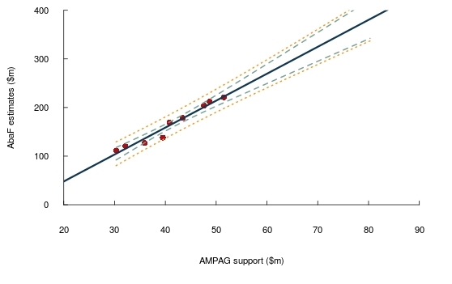

Model 3. GOS data projections of AbaF estimates
Historically, it has been suggested that literature investigating business giving for artistic and cultural activities is sparse. In this context, some articles posit that business giving is linked to profits,. This paper includes GOS, a measure of business profitability, as one of the potential determinants in estimating overall contributions of the private sector to the arts. GOS is reported by the ABS in the Australian System of National Accounts (cat. no. 5204.0 Table 7).
GOS used as a predictor in a linear relationship model was found to be significant (p < 0.001), with strong prediction levels (R2 adjusted = 0.9704) (see Appendix 6). This provided average total estimates as outlined in Table 3.
Table 3. GOS data projections of AbaF estimates
Financial year | AbaF ($ million) | GOS ($ million) | AbaF average projections on GOS  ($ million)
2001–02 | 111.6 | 235,035 | -
2002–03 | 120.7 | 257,010 | -
2003–04 | 127.0 | 274,911 | -
2004–05 | 138.2 | 292,590 | -
2005–06 | 168.8 | 328,520 | -
2006–07 | 178.7 | 366,058 | -
2007–08 | 204.0 | 388,857 | -
2008–09 | 212.1 | 446,531 | -
2009–10 | 221.1 | 447,590 | -
2010–11 | - | 490,748 | 244.6
2011–12 | - | 519,067 | 259.3
2012–13 | - | 521,165 | 260.4
2013–14 | - | 542,112 | 271.3
2014–15 | - | 536,862 | 268.6
2015–16 | - | 536,695 | 268.5

Figure 2 shows the relationship between GOS and AbaF values (red dots) and the linear model based on this relationship (grey line). The 95 per cent confidence and prediction intervals (inner green dashed and outer orange dotted lines, respectively) show where the true results may lie with 95 per cent certainty.
Figure 2. GOS—AbaF linear model with confidence and prediction intervals
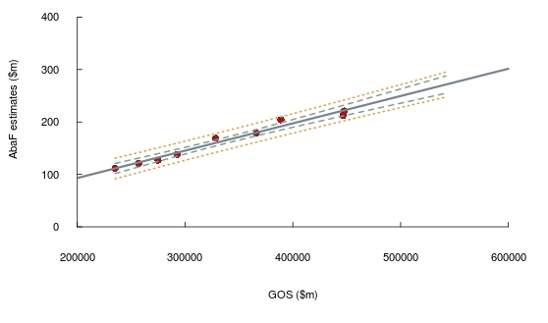

Models 1–3. Contrasting total support estimates
The three models used to produce estimates of the total private sector support for the arts have provided a broad range of values for each given year (Table 4).
While both linear models had significant good fit and strong prediction levels, the GOS model is the best fit (R2 adjusted = 0.9704) and therefore the most likely estimate. However, this is likely an effect of a separate factor, such as the state of the economy, impacting on both business profitability and the level of private sector support for the arts. The GOS estimates would incorporate the structural impact on business income arising from the Global Financial Crisis (GFC) in 2007–08, and are more likely than the AMPAG estimates to represent the overall trend for the sector. Following the GFC, both business and household income growth has slowed in Australia.
The AbaF projections are based on its lowest historical growth rate, which in the past two years aligns relatively closely with that modelled from the GOS data, and suggests that private sector support has continued to grow in real terms over the past six years.
All estimates are significantly higher than the ABS 2014–15 survey based estimate of $204 million.
Table 4. Summary of total estimated private sector support for the arts in Australia
Financial year | Model 1:  AbaF 4%  ($ million) | Model 2:  AMPAG  ($ million) | Model 3:  GOS  ($ million)
2010–11 | 229.9 | 268.3 | 244.6
2011–12 | 239.1 | 295.4 | 259.3
2012–13 | 248.7 | 313.2 | 260.4
2013–14 | 258.7 | 353.0 | 271.3
2014–15 | 269.0 | 383.0 | 268.6
2015–16 | 279.8 | - | 268.5

Figure 3 below presents the average prediction for each model. The models immediately start to diverge once they exit the range of the AbaF data. This is most notable for the AMPAG model, which is based on Australia’s 28 major performing arts companies. As such, the AMPAG estimates are likely to overstate the overall trend for the sector, due to the significant variation in the size, and the nature of activity, of arts organisations in Australia.
Figure 3. Private sector total support estimates for the arts in Australia
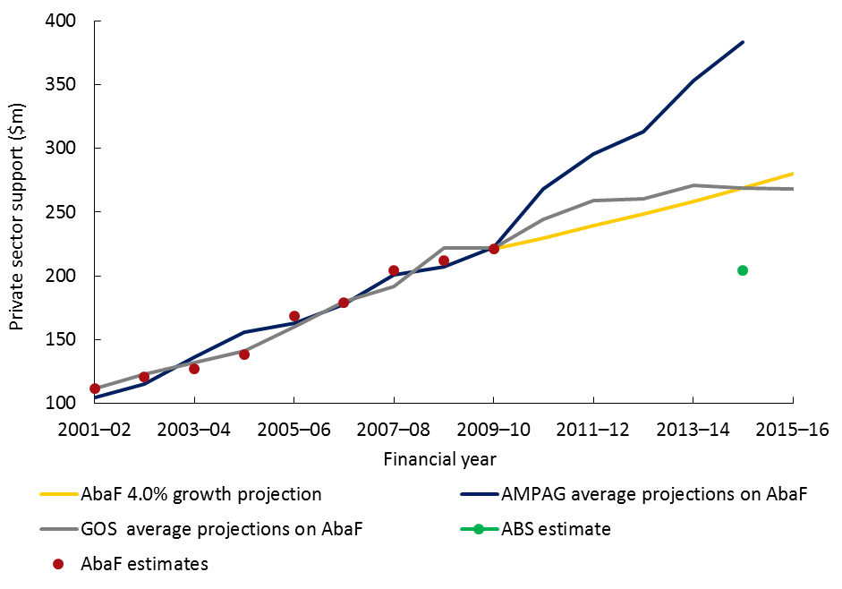

Chapter 2. Donations estimates: results and findings

Model 4. AbaF donations lowest positive historical growth of 6.2 per cent
Private sector donations data was provided by AbaF survey-based estimates, between 2001–02 and 2009–10. In that time, year to year growth estimates were volatile, with growth rates that ranged from -0.3 per cent (2005–06 to 2006–07) to 38.6 per cent (2004–05 to 2005–06). For the final two surveys, estimated growth was 10.5 and 6.2 per cent respectively. With such variation in the growth rates, the estimates presented in Table 5 should be treated with caution.
For the purpose of obtaining a conservative projection rate, this model is based on the AbaF donations lowest positive historical growth rate of 6.2 per cent, with projected figures as outlined in Table 5.
Table 5. AbaF donations estimates with 6.2 per cent growth projection
Financial year | AbaF donations estimates  ($ million) | AbaF 6.2 % growth projection  ($ million)
2001–02 | 47.1 | -
2002–03 | 57.0 | -
2003–04 | 50.9 | -
2004–05 | 62.7 | -
2005–06 | 86.9 | -
2006–07 | 86.6 | -
2007–08 | 104.9 | -
2008–09 | 111.4 | -
2009–10 | 123.1 | -
2010–11 | - | 130.7
2011–12 | - | 138.8
2012–13 | - | 147.4
2013–14 | - | 156.6
2014–15 | - | 166.3
2015–16 | - | 176.6

Model 5. AMPAG donations data projections of AbaF donations estimates
AMPAG donations data used as a predictor in a linear relationship model was found to be significant (p < 0.001), with strong prediction levels (R2 adjusted = 0.9618) (see Appendix 7). This provided average donations estimates as outlined in Table 6.
Table 6. AMPAG donations data projections of AbaF donations estimates
Financial year | AbaF donations estimates ($ million) | AMPAG donations  ($ million) | AbaF donations average projections on AMPAG donations  ($ million)
2001–02 | 47.1 | 7.5 | -
2002–03 | 57.0 | 7.8 | -
2003–04 | 50.9 | 8.7 | -
2004–05 | 62.7 | 11.1 | -
2005–06 | 86.9 | 12.9 | -
2006–07 | 86.6 | 15.5 | -
2007–08 | 104.9 | 19.2 | -
2008–09 | 111.4 | 19.9 | -
2009–10 | 123.1 | 22.3 | -
2010–11 | - | 30.1 | 160.8
2011–12 | - | 33.2 | 176.1
2012–13 | - | 35.3 | 186.6
2013–14 | - | 40.7 | 213.2
2014–15 | - | 43.2 | 225.3

Figure 4 illustrates the relationship between AMPAG donations and AbaF donations values (red dots) and the linear model based on this relationship (dark blue line). The 95 per cent confidence and prediction intervals (inner green dashed and outer orange dotted lines, respectively) fan out illustrating where the true results may lie with 95 per cent certainty.
Figure 4. AMPAG donations—AbaF donations linear model with confidence and prediction intervals
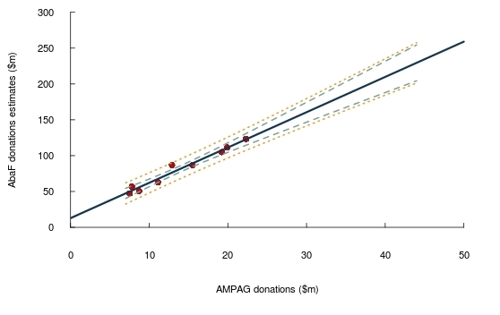

Model 6. GOS data projections of AbaF donations estimates
GOS data used as a predictor in a linear relationship model was found to be significant (p < 0.001), with strong prediction levels (R2 adjusted = 0.9451) (see Appendix 8). This provided average donations estimates as outlined in Table 7.
Table 7. GOS data projections of AbaF donations estimates
Financial year | AbaF donations estimates ($ million) | GOS ($ million) | AbaF donations average projections on GOS  ($ million)
2001–02 | 47.1 | 235,035 | -
2002–03 | 57.0 | 257,010 | -
2003–04 | 50.9 | 274,911 | -
2004–05 | 62.7 | 292,590 | -
2005–06 | 86.9 | 328,520 | -
2006–07 | 86.6 | 366,058 | -
2007–08 | 104.9 | 388,857 | -
2008–09 | 111.4 | 446,531 | -
2009–10 | 123.1 | 447,590 | -
2010–11 | - | 490,748 | 134.0
2011–12 | - | 519,067 | 143.8
2012–13 | - | 521,165 | 144.5
2013–14 | - | 542,112 | 151.8
2014–15 | - | 536,862 | 149.9
2015–16 | - | 536,695 | 149.9

Figure 5 illustrates the relationship between GOS and AbaF donations values (red dots) and the linear model based on this relationship (grey line). The 95 per cent confidence and prediction intervals (inner green dashed and outer orange dotted lines, respectively) show where the true results may lie with 95 per cent certainty.
Figure 5. GOS—AbaF donations linear model with confidence and prediction interval
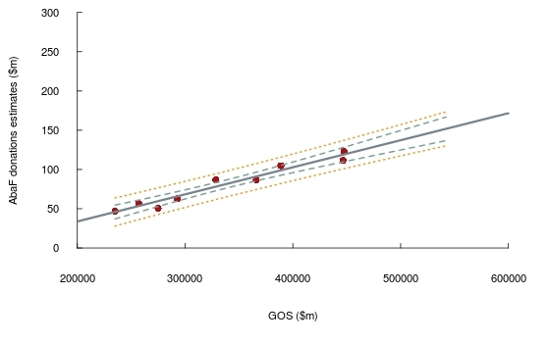

Models 4–6. Contrasting donations estimates
Overall private sector donations to the arts in Australia are estimated to have grown over a period of six years, from $123.1 million in 2009-10 to between $149.9 million and $176.6 million in 2015–16.
The estimates produced by the three models for the private sector donations component are outlined in Table 8.
While the two linear models have significant good fit and strong prediction levels, the variation in the representativeness of the data means no single estimate is comprehensive.
Table 8. Summary of estimated private sector donations to the arts in Australia
Financial year | Model 4:  AbaF 6.2%  ($ million) | Model 5:  AMPAG donations  ($ million) | Model 6:  GOS  ($ million)
2010–11 | 130.7 | 160.8 | 134.0
2011–12 | 138.8 | 176.1 | 143.8
2012–13 | 147.4 | 186.6 | 144.5
2013–14 | 156.6 | 213.2 | 151.8
2014–15 | 166.3 | 225.3 | 149.9
2015–16 | 176.6 | - | 149.9

Figure 6 shows movements of each of the three models’ predictions. The AMPAG model, which is based on donations made to Australia’s 28 major performing arts companies, had the greatest divergence.
Figure 6. Private sector estimated donations for arts in Australia
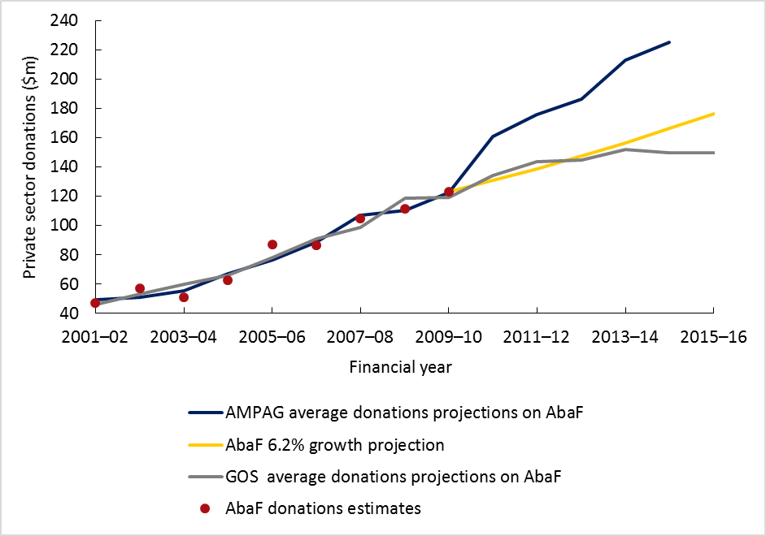

Chapter 3. Sponsorship estimates: results and findings

Model 7. AbaF sponsorship lowest positive historical growth of 1.6 per cent
Private sector sponsorship data was provided by AbaF survey-based estimates, in relation to the period covering 2001–02 and 2009–10. In that time, year-to-year growth estimates were volatile, with growth rates that ranged from -2.7 per cent (2009–10) to 19.5 per cent (2003–04). For the final two surveys, estimated growth was 1.6 and -2.7 per cent, respectively. With such variation in the growth rates, the estimates presented in Table 9 should be treated with caution.
For the purpose of obtaining a conservative projection rate, this model is based on the AbaF sponsorship lowest positive historical growth rate of 1.6 per cent, with projected figures as outlined in Table 9.
Table 9. AbaF sponsorship estimates with 1.6 per cent growth projection
Financial year | AbaF sponsorship estimates  ($ million) | AbaF 1.6% growth projection  ($ million)
2001–02 | 64.5 | -
2002–03 | 63.7 | -
2003–04 | 76.1 | -
2004–05 | 75.5 | -
2005–06 | 81.9 | -
2006–07 | 92.1 | -
2007–08 | 99.1 | -
2008–09 | 100.7 | -
2009–10 | 98.0 | -
2010–11 | - | 99.6
2011–12 | - | 101.2
2012–13 | - | 102.8
2013–14 | - | 104.4
2014–15 | - | 106.1
2015–16 | - | 107.8

Model 8. AMPAG sponsorship data projections of AbaF sponsorship estimates
AMPAG sponsorship data used as a predictor in a linear relationship model was found to be significant (p = 0.007), with medium prediction levels (R2 adjusted = 0.6277) suitable for use within the data range but poor for forward estimates (Appendix 9). This provided average sponsorship estimates as outlined in Table 10.
Table 10. AMPAG sponsorship data projections of AbaF sponsorship estimates
Financial year | AbaF sponsorship estimates ($ million) | AMPAG sponsorship  ($ million) | AbaF sponsorship average projections on AMPAG sponsorship  ($ million)
2001–02 | 64.5 | 21.6 | -
2002–03 | 63.7 | 22.8 | -
2003–04 | 76.1 | 24.8 | -
2004–05 | 75.5 | 25.4 | -
2005–06 | 81.9 | 25.0 | -
2006–07 | 92.1 | 24.6 | -
2007–08 | 99.1 | 25.2 | -
2008–09 | 100.7 | 26.4 | -
2009–10 | 98.0 | 26.7 | -
2010–11 | - | 27.4 | 102.9
2011–12 | - | 29.1 | 115.9
2012–13 | - | 30.0 | 122.5
2013–14 | - | 31.6 | 134.0
2014–15 | - | 34.5 | 155.8
2015–16 | - | - | -

Figure 7 illustrates the relationship between AMPAG sponsorship and AbaF sponsorship values (red dots) and the linear model based on this relationship (dark blue line). The 95 per cent confidence and prediction intervals (inner green dashed and outer orange dotted lines, respectively) fan out illustrating where the true results may lie with 95 per cent certainty.
Figure 7. AMPAG sponsorship—AbaF sponsorship linear model with confidence and prediction intervals
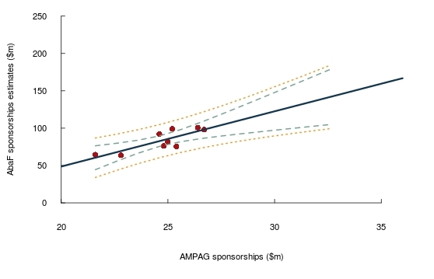

Model 9. GOS sponsorship data projections of AbaF sponsorship estimates
GOS data used as a predictor in a linear relationship model was found to be significant (p < 0.001), with strong prediction levels (R2 adjusted = 0.913) (see Appendix 10). This provided average sponsorship estimates as outlined in Table 11.
Table 11. GOS data projections of AbaF sponsorship estimates
Financial year | AbaF sponsorship estimate ($ million) | GOS ($ million) | AbaF sponsorship average projections on GOS ($ million)
2001–02 | 64.5 | 235,035 | -
2002–03 | 63.7 | 257,010 | -
2003–04 | 76.1 | 274,911 | -
2004–05 | 75.5 | 292,590 | -
2005–06 | 81.9 | 328,520 | -
2006–07 | 92.1 | 366,058 | -
2007–08 | 99.1 | 388,857 | -
2008–09 | 100.7 | 446,531 | -
2009–10 | 98.0 | 447,590 | -
2010–11 | - | 490,748 | 110.5
2011–12 | - | 519,067 | 115.5
2012–13 | - | 521,165 | 115.9
2013–14 | - | 542,112 | 119.6
2014–15 | - | 536,862 | 118.7
2015–16 | - | 536,695 | 118.6

Figure 8 illustrates the relationship between GOS and AbaF sponsorship values (red dots) and the linear model based on this relationship (grey line). The 95 per cent confidence and prediction intervals (inner green dashed and outer orange dotted lines, respectively) show where the true results may lie with 95 per cent certainty.
Figure 8. GOS—AbaF sponsorship linear model with confidence and prediction intervals
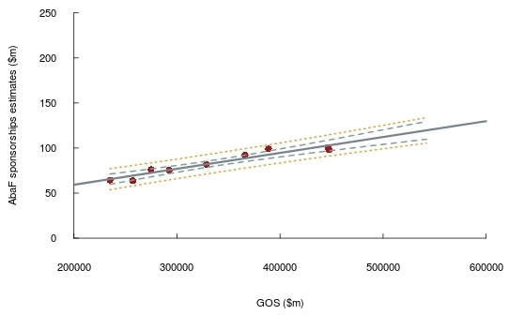

Models 7–9. Contrasting sponsorships estimates
Overall private sector arts sponsorships in Australia are estimated to have grown over a period of six years, from $98.0 million in 2009–10 to between $107.8 million and $118.6 million in 2015–16.
The models used to produce the sponsorship component of the total support also provided a broad range of estimates for each given year (Table 12). The two linear models are significant and had medium to strong prediction levels, with GOS having significantly stronger prediction power. Given the divergence between the model outcomes, the estimates should be treated with caution.
Table 12. Summary of estimated private sector sponsorship
Financial year | Model 9: AbaF 1.6%  ($ million) | Model 10: AMPAG  sponsorship ($ million) | Model 11: GOS  ($ million)
2010-11 | 99.6 | 102.9 | 110.5
2011-12 | 101.2 | 115.9 | 115.5
2012-13 | 102.8 | 122.5 | 115.9
2013-14 | 104.4 | 134.0 | 119.6
2014-15 | 106.1 | 155.8 | 118.7
2015-16 | 107.8 | - | 118.6

Figure 9 illustrates movements of the three models’ predictions with AMPAG again having significant divergence.
Figure 9. Private sector estimated sponsorship for arts in Australia
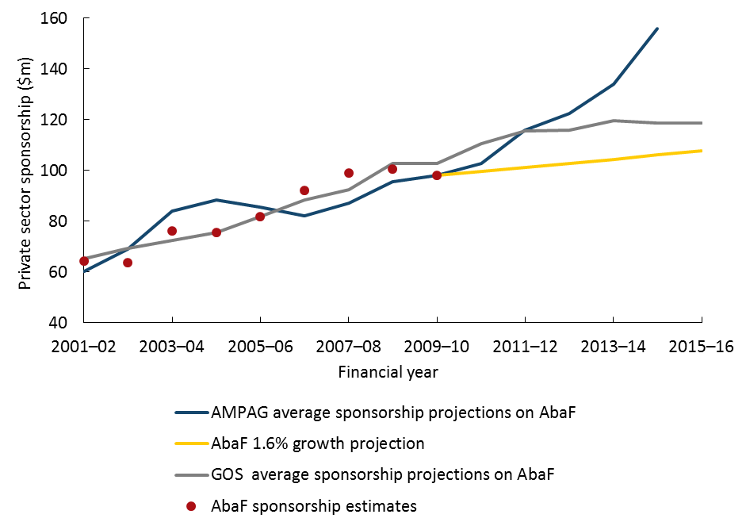

Appendix 1. Research boundaries
The estimates provided in this background statistical paper are based on a range of data sources, none of which map completely to overall private sector support for the arts. Consequently, the estimates should be considered as indicative only.
Two challenges needed to be addressed in order to provide these estimates. The first was determining the population to be estimated and whether it should be based on expenditure by contributors or income received from contributors. The second was that the data collection undertaken for this paper has identified some gaps in data availability on both the donor and recipient sides.
A number of data sets were considered in developing this paper (see the ‘data collection’ section in Appendix 2). No single data set is representative of the total arts organisations population (see Appendices 3 and 4) and could not be used on its own to estimate the private sector support for the arts sector at a national level.
The Australia Business Arts Foundation (AbaF) and the Australian Bureau of Statistics (ABS) prior survey-based results, estimating total private sector support for the arts, were also obtained. AbaF survey results were used in concert with the available data sets to produce some limited extrapolations of the total support in the non-surveyed years.
Additionally, the same methods were used to produce limited extrapolations of the donations and sponsorship segments of the total support. While these independent estimates fall within the confidence interval of the total support, the numbers should not be summed to determine the overall level of support.
The exploration of data availability and useability confirmed an absence of a single available database that can be used for a direct estimation of total yearly private sector support for the arts in Australia. Likewise, the sponsorship and donations components of the support could not be directly estimated.
Extrapolating from data produced by past AbaF surveys has enabled estimates to be provided for total support for the non-surveyed years through the use of a regression method using AbaF, AMPAG and business profitability (gross operating surplus (GOS) data). The same method was applied for extrapolating donations and sponsorship components.
By regressing estimated support outside of the data range and with a small number of data points, estimated results are inevitably indicative. The arbitrary nature of the models dealing with the lowest growth rate, pertaining to the donations and sponsorship sections, should be taken with a degree of caution due to the unevenness in the historical growth rates.

Appendix 2. Methodology

Defining private sector support for the arts
The population estimated in this paper comprises support to arts organisations from private sector sources:
- philanthropy and support expenditure that comprises arts and culture contributions to ‘non-earned’ income from business sources, individuals and ancillary funds, trusts and foundations; or
- philanthropy and support ‘non-earned’ income received from private sources.
Both populations are set out in further detail in Appendices 3 and 4.

Data collection
Data sets that we were in a position to consider, besides the AbaF and ABS figures outlined below (see the ‘previous estimates of surveys section’) include (see Figure 10):
- Australian Charities and Not-for-profits Commission (ACNC), 2012–13 to 2014–15: ACNC commenced operations in December 2012 and collects data supplied by charities and not-for-profit organisations. Registered organisations supply information via their annual information statement, with publically available data published on data.gov.au. Data collected includes name, charity size, number of responsible persons, operating states and charity purpose. The data considered was open data as provided through data.gov.au.
- Australian Cultural Fund (ACF), 2003–04 to 2014–15: ACF is a fundraising platform for Australian artists established by the Australian Government to encourage donations to the arts. It is currently managed by Creative Partnerships Australia and provides data containing aggregate donations received state by state. The data considered were aggregated totals per year.
- Australian Major Performing Arts Group (AMPAG), 2001–02 to 2014–15: AMPAG is the representative body of Australia’s 28 major performing arts companies. AMPAG publishes annual sponsorship and philanthropy survey results outlining aggregate sponsorships and donations given to its members. The data considered were aggregated totals by year.

Figure 10. Data set availability and relative time spans
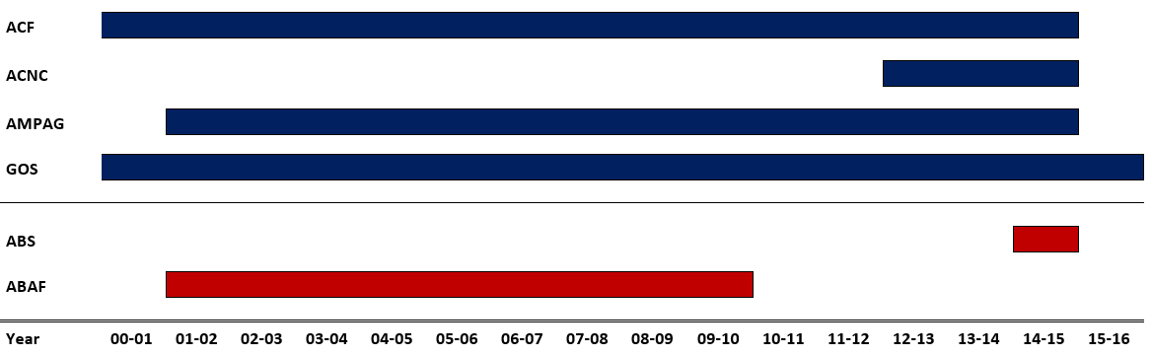
Not all data collected was necessarily mature and complete. That is, each data set reflected the life of the program it was linked to. In general, when a program or an agency is in its commencing stages, initial utilisation of the scheme and its reporting may take a period of time to reach potential and stabilise. Until then, data may be sporadic and aggregate changes may be lumpy, which is the case with the early periods of data from ACF and ACNC. In this regard, BCAR has only used mature data that could be consistently used for modelling from 2001–02 onwards, which in this case is AMPAG data.
Due to the nature of the arts-specific data, an additional data confrontation was required. The ABS measure of GOS was used for this purpose (see model 3 below).

Data representativeness
The data sets could not be used to estimate the population of interest, private sector support for the arts sector across Australia, as they are not representative of the arts sector as a whole. ACNC pertains only to organisations that are registered as charities and not-for-profits with the ACNC. AMPAG represents the 28 major performing arts organisations also funded by the Australian and state governments. ACF data relates only to organisations and individuals that have used the scheme. However, these data sets could be used in the future, as additional data sets become available and their proportional relationships is established with respect to the population of interest as a whole.

Previous estimates of survey results
In the past, surveys have been undertaken by AbaF (2001–02 to 2009–10) and the ABS (2014–15) to estimate private sector support to the arts. Both AbaF and ABS survey-based estimates were designed to capture the arts sector as a whole and can be considered as representative, with AbaF geared toward organisations that are eligible tax deductible gift recipients.
AbaF and ABS survey-based estimates are outlined in Table 13 below.

Table 13. Survey-based estimates of total private sector support for arts: AbaF and ABS
Financial year | AbaF ($ million) | ABS ($ million)
2001–02 | 111.6 | -
2002–03 | 120.7 | -
2003–04 | 127.0 | -
2004–05 | 138.2 | -
2005–06 | 168.8 | -
2006–07 | 178.7 | -
2007–08 | 204.0 | -
2008–09 | 212.1 | -
2009–10 | 221.1 | -
2010–11 | - | -
2011–12 | - | -
2012–13 | - | -
2013–14 | - | -
2014–15 | - | 204.0
2015–16 | - | -

Modelling on AbaF figures
The BCAR did not identify and locate raw data sets that are representative of the population of interest, so prior survey estimates of the population have been used to produce overall estimates of private sector support for the arts.
The only ABS estimate available is for 2014–15, so it is unsuited for estimating trends over time, or for reconciling the various estimates derived from other sources. As such, the ABS 2014–15 data point has been used only to provide a high-level check of the projected estimates.
Nine years of data, representing AbaF survey-based estimates of private sector support for the arts, and its donations and sponsorship components, have been used to produce projections based on prior growth rates and simple linear regression. As the models are based on nine data points only, there is increased potential for issues with the fit of the models that may affect the precision of the estimates and create divergence in the models’ estimates. For example, the period includes the Global Financial Crisis, which affected individual and business incomes and therefore potentially the level of private sector support for the arts.
This approach produced the following models estimating total support (chapter 3):
- Model 1: AbaF total support projected with its lowest historical growth of 4.0 per cent.
- Model 2: AbaF total support projected with AMPAG data.
- Model 3: AbaF total support projected with GOS data.
AbaF survey-based estimates were used as the dependent variables that were regressed on potential predictor data sets (AMPAG and GOS). Model 1 estimations were produced by calculating year-on-year positive 4 per cent growth, which was the lowest historical growth level recorded. Models 2 and 3 have average estimations produced by using a simple linear regression.
A similar approach was used to model donations estimates (chapter 4), producing the following models:
- Model 4: AbaF donations projected with its lowest positive historical growth of 6.2 per cent.
- Model 5: AbaF donations estimates projected with AMPAG data.
- Model 6: AbaF donations estimates projected with GOS data.
Model 4 projections were produced by calculating year-on-year growth, which was 6.2 per cent for donations (its lowest growth). The negative growth figures, which were present in the donations estimates, were not considered as it would create a chain of estimated figures that are falling. This would be in direct contrast to the overall result for the total support that was estimated as positive, which would lead to Simpson’s paradox. This judgement was made mindful of the fact that AbaF sponsorship and donation estimates were deduced out of the total support, not the other way around.
Models 5 and 6 average projections were produced using a simple linear regression. AbaF survey-based donations estimates were used as the outcome variables that were regressed on the predictor data sets of AMPAG donations and GOS.
This approach was also used to model sponsorship estimates (chapter 5), producing the following models:
- Model 7: AbaF sponsorship projected with its lowest positive historical growth of 1.6 per cent.
- Model 8: AbaF sponsorship estimates projected with AMPAG data.
- Model 9: AbaF sponsorship estimates projected with GOS data.
As in chapters 1 and 2, model 7 estimations were produced by calculating year-on-year growth, which was 1.6 per cent for sponsorships (its lowest growth level). Again, the negative growth figures, which were present in the sponsorships estimates, were not considered as this would be in direct contrast to the overall result for total support, which was estimated as positive.
Models 8 and 9 have average estimations produced by using a simple linear regression. AbaF survey-based sponsorship estimates were used as the outcome variables that were regressed on the predictor data sets of AMPAG sponsorship and GOS.
Simple linear regression is a logical starting point for any study of this nature. Multiple regression models were investigated but these models did not provide additional statistical prediction power in this instance. While other modelling options could have been explored (i.e. non-linear), the good modelling fit of simple linear regression rendered it unnecessary. Nonetheless, should additional data become available, these options could be explored.

Appendix 3. Philanthropy and support expenditure

Australian arts and culture population diagram of potential data sources
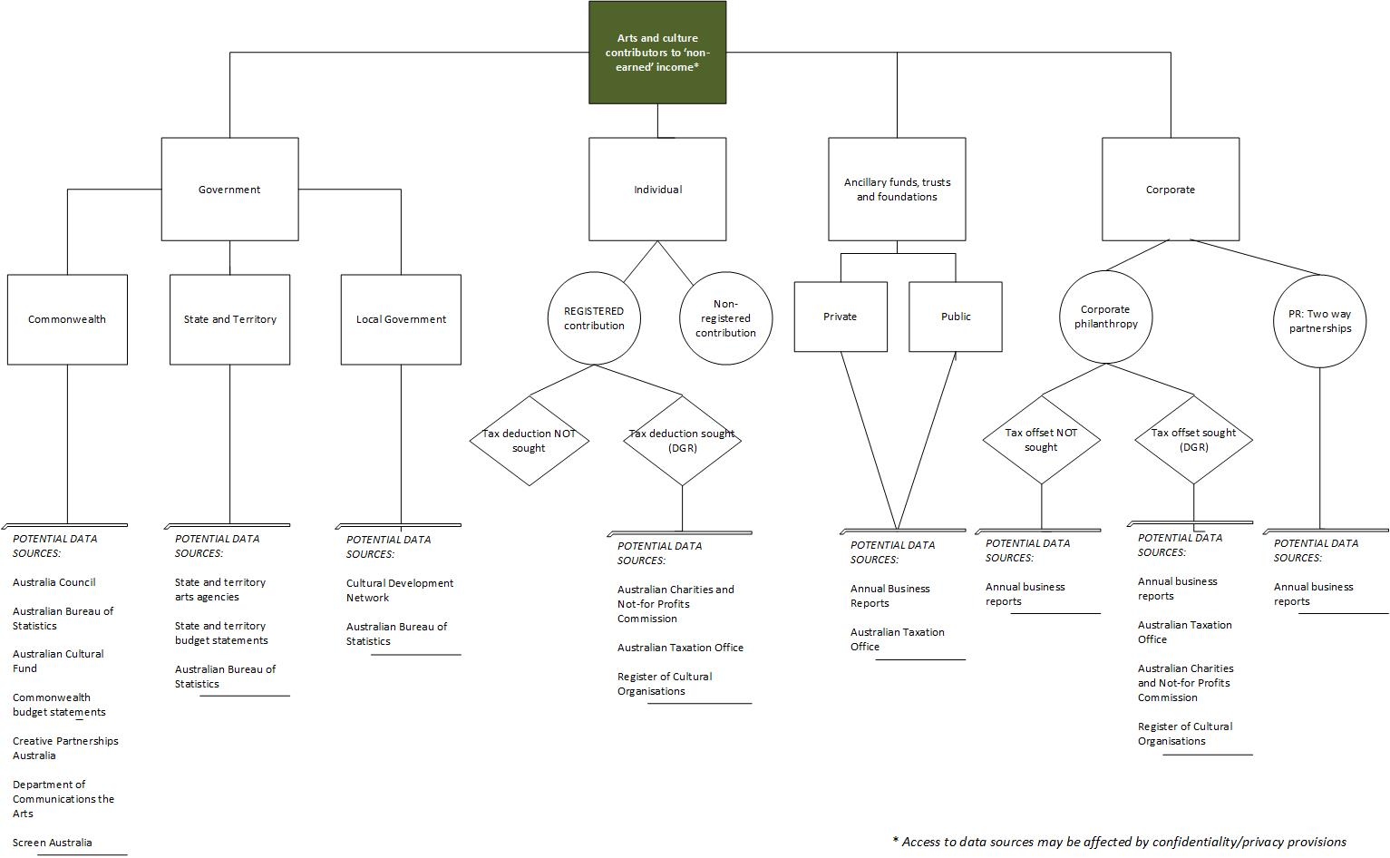

Appendix 4. Philanthropy and support income

Australian arts and culture population diagram of potential data sources
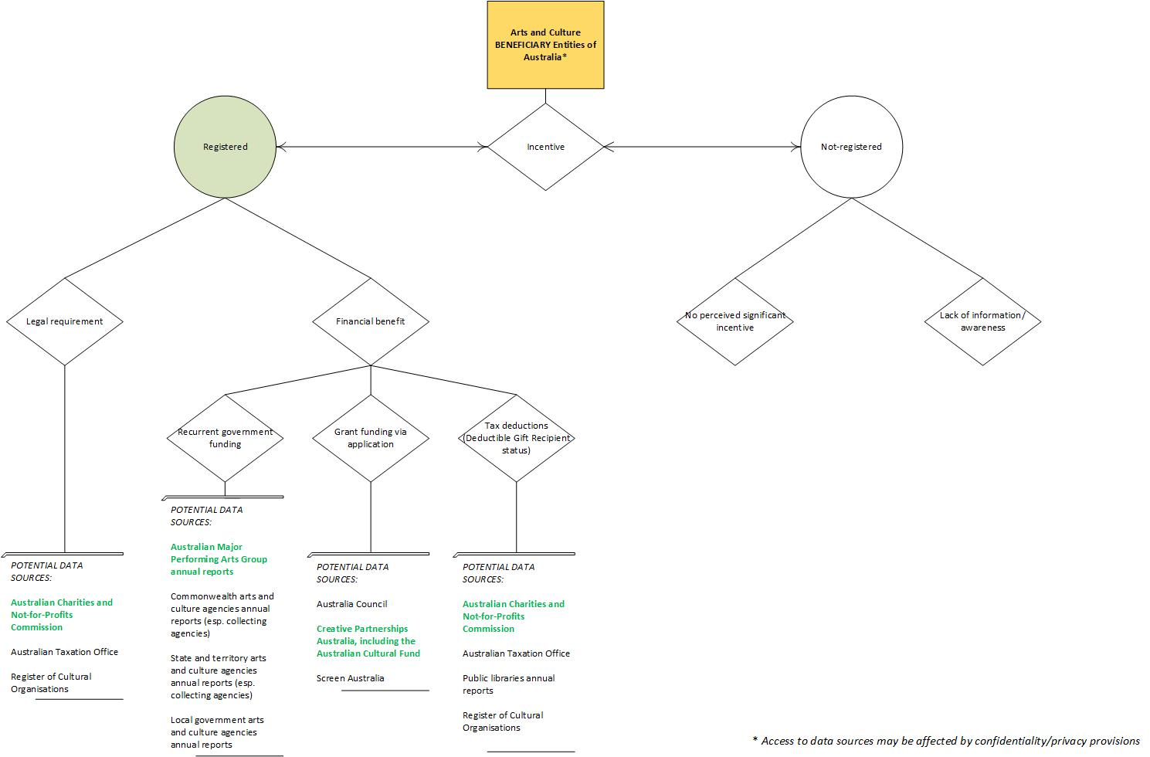

Appendix 5. Model 2—AMPAG on AbaF regression
Summary R output below indicates that the linear regression model of AMPAG total private sector support on estimated AbaF support is found to be significant (t = 13.179, p < 0.001). The model suggests strong prediction levels (R2 adjusted = 0.9557).
However, diagnostic charts (Residuals vs Fitted, Normal Q–Q, Cook’s distance) indicate some potential issues with the fit of the model, which may affect the precision of estimates. This is to be expected considering that the regression was produced on nine data points.
Summary R output of the model:
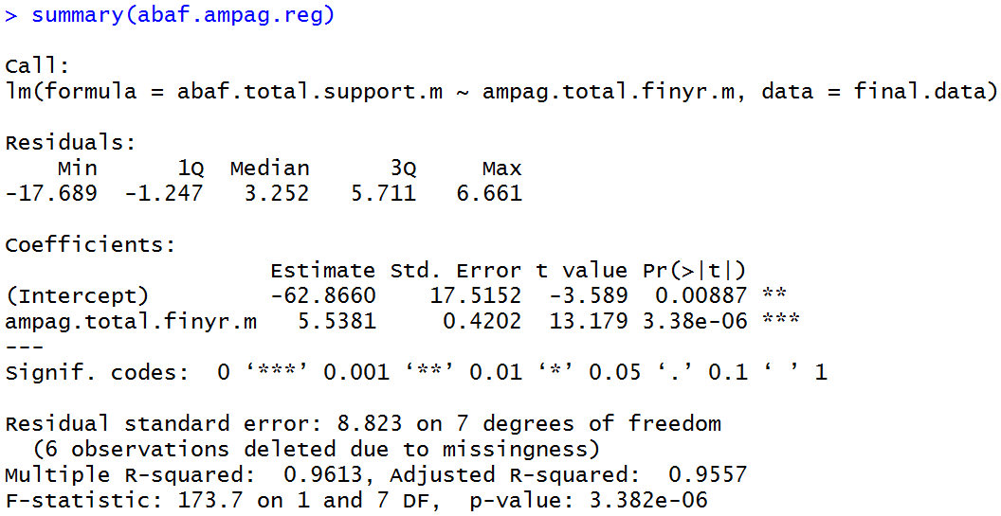
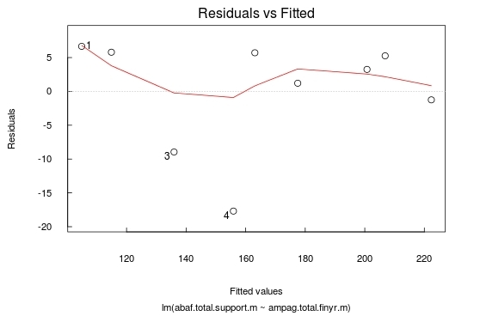

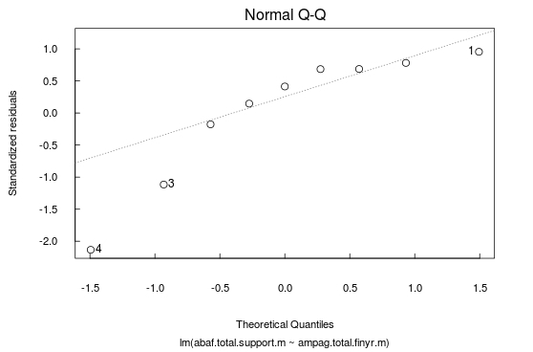

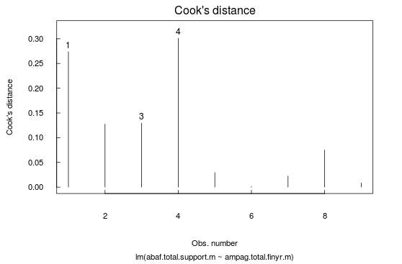

Appendix 6. Model 3—GOS on AbaF regression
Summary R output below indicates that the linear regression model of GOS on estimated AbaF total support is found to be significant (t = 16.222, p < 0.001). The model suggests strong prediction levels (R2 adjusted = 0.9704).
However, diagnostic charts (Residuals vs Fitted, Normal Q–Q, Cook’s distance) indicate some potential issues with the fit of the model, which may affect the precision of estimates. This is to be expected considering that the regression was produced on nine data points.
Summary R output of the model:
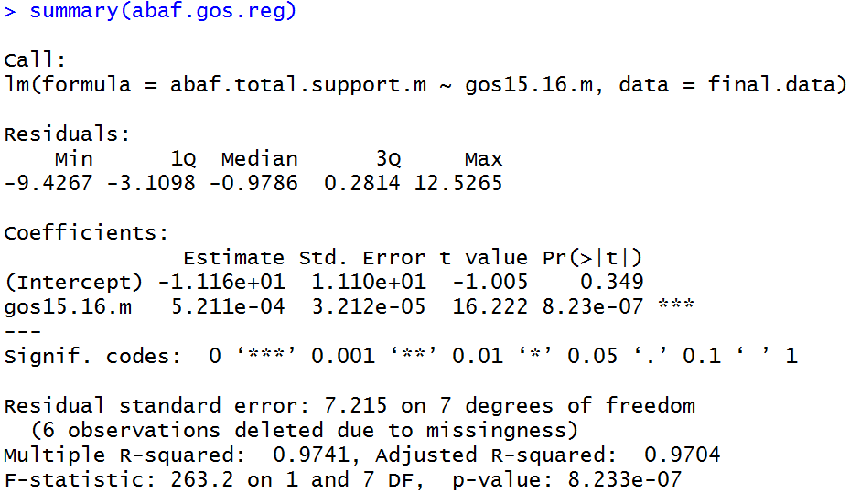
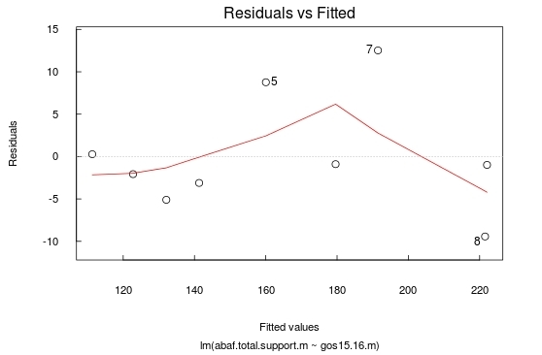
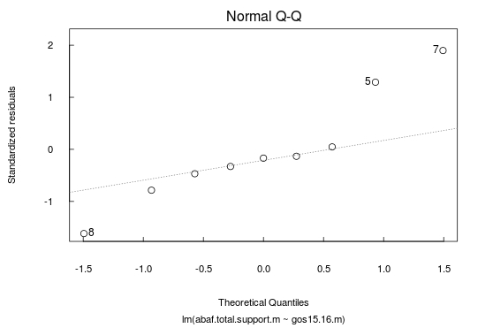

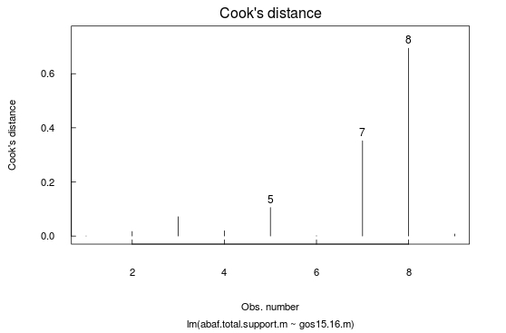

Appendix 7. Model 5—AMPAG donations on AbaF giving regression
Summary R output below indicates that the linear regression model of AMPAG donations on estimated AbaF giving (donations) is found to be significant (t = 14.233, p < 0.001). The model suggests strong prediction levels (R2 adjusted = 0.9618).
However, diagnostic charts (Residuals vs Fitted, Normal Q–Q, Cook’s distance) indicate some potential issues with the fit of the model, which may affect the precision of estimates. This is to be expected considering that the regression was produced on nine data points.
Summary R output of the model:
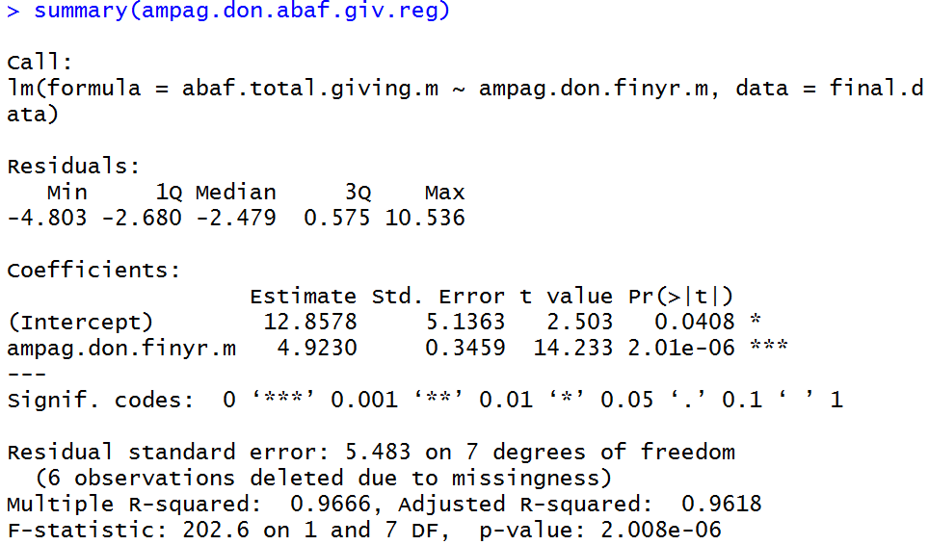
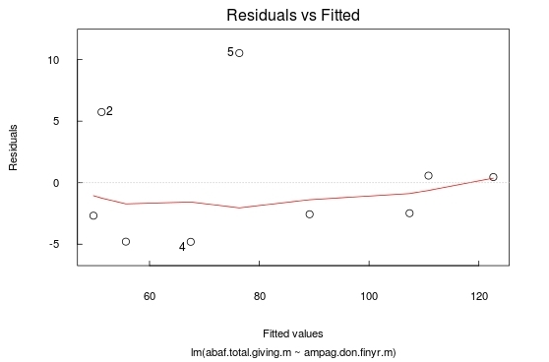

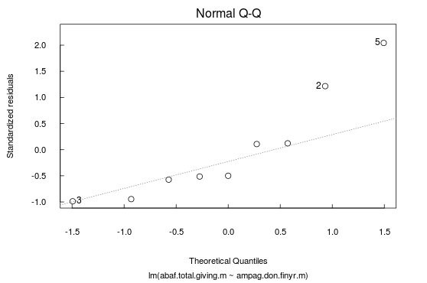

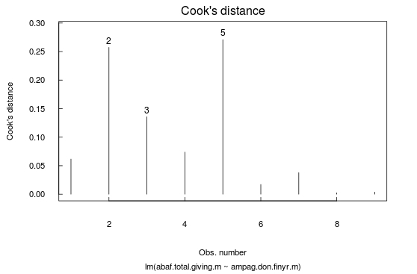

Appendix 8. Model 6—GOS on AbaF giving regression
Summary R output below indicates that the linear regression model of GOS on estimated AbaF giving (donations) is found to be significant (t = 11.780, p < 0.001). The model suggests strong prediction levels (R2 adjusted = 0.9451).
However, diagnostic charts (Residuals vs Fitted, Normal Q–Q, Cook’s distance) indicate some potential issues with the fit of the model, which may affect the precision of estimates. This is to be expected considering that the regression was produced on nine data points.
Summary R output of the model:
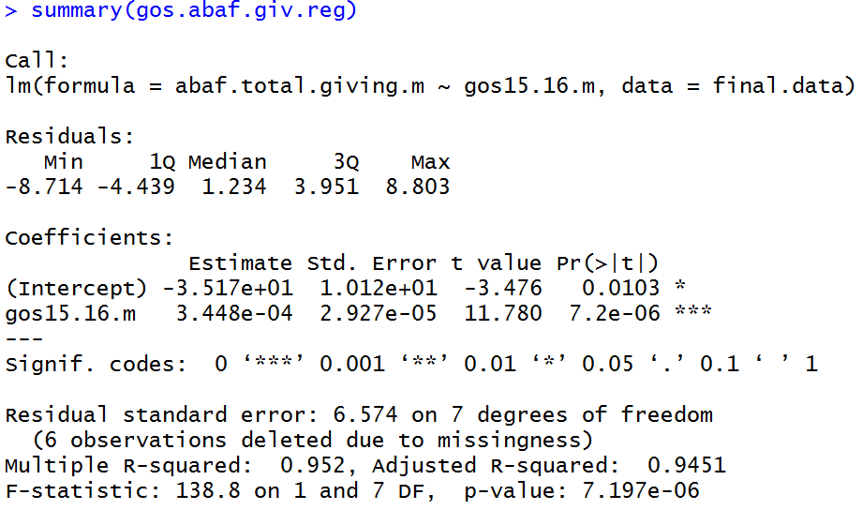
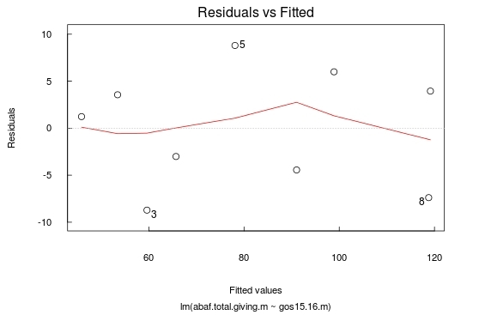

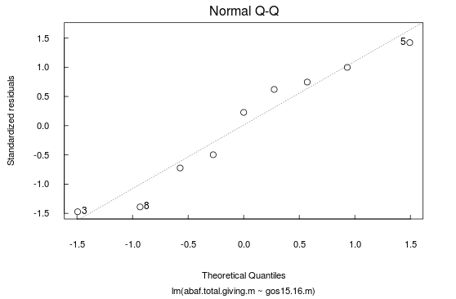

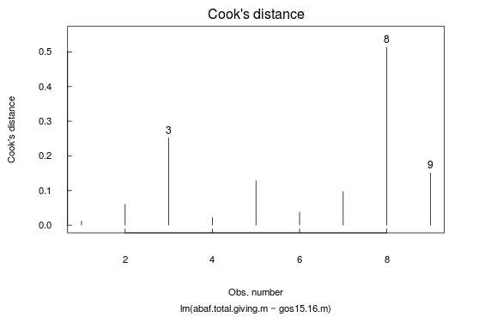

Appendix 9. Model 8—AMPAG sponsorship on AbaF sponsorship regression
Summary R output below indicates that the linear regression model of AMPAG sponsorship on estimated AbaF sponsorship is found to be significant (t = 3.806, p = 0.007). The model suggests medium prediction levels (R2 adjusted = 0.6277).
However, diagnostic charts (Residuals vs Fitted, Normal Q–Q, Cook’s distance) indicate some potential issues with the fit of the model, which may affect the precision of estimates. This is to be expected considering that the regression was produced on nine data points.
Summary R output of the model:
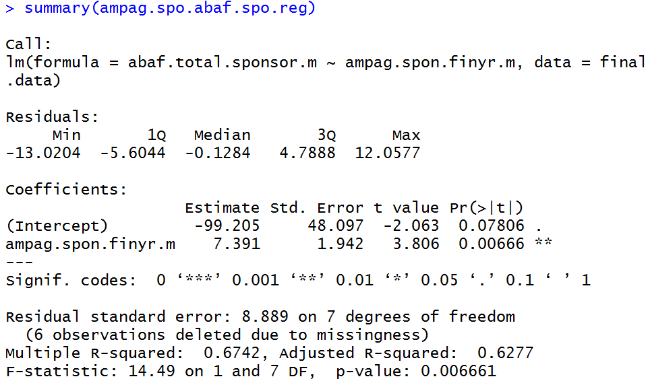

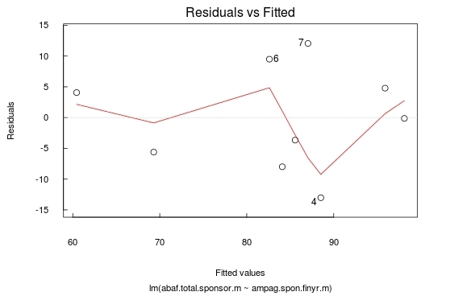

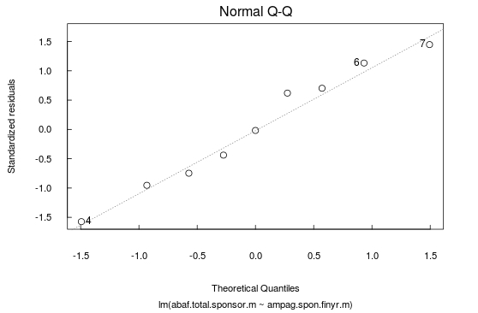

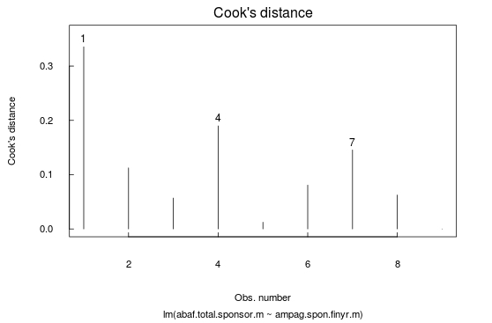

Appendix 10. Model 9—GOS on AbaF sponsorship regression
Summary R output below indicates that the linear regression model of GOS on estimated AbaF sponsorship is found to be significant (t = 9.215, p < 0.001). The model suggests strong prediction levels (R2 adjusted = 0.913).
However, diagnostic charts (Residuals vs Fitted, Normal Q–Q, Cook’s distance) indicate some potential issues with the fit of the model, which may affect the precision of estimates. This is to be expected considering that the regression was produced on nine data points.
Summary R output of the model:
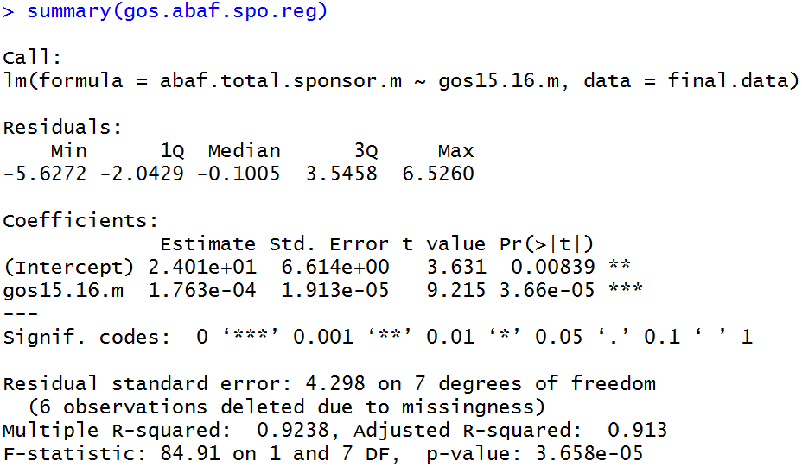

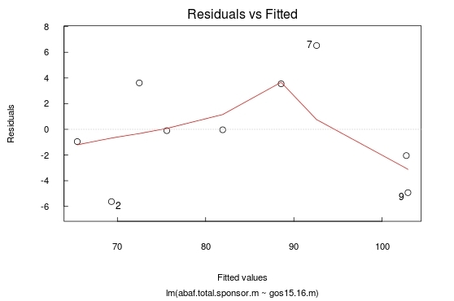
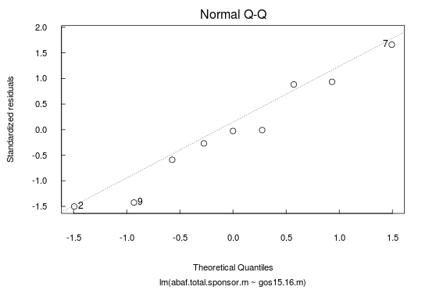
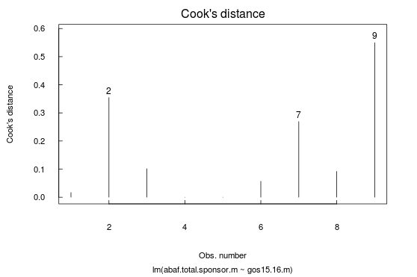

Endnotes

Per capita calculations are based on: private sector contribution figures as per the sources indicated in the endnotes; using currency conversion rates available at the Reserve Bank of Australia web site (median rate for the year); and the population figures accessed through OECD, ABS, and UK Office for National Statistics. The United States figures are also adjusted for inflation for their respective years.
Mitchell, Harold (Chair) (2011), Building Support: Report of the Review of Private Sector Support for the Arts in Australia, Canberra. Accessed 27 September 2016, available at https://www.arts.gov.au/file/2861/download?token=jupQq7uK
Ibid.
Statistics Canada (2013), Charitable Giving in Canada: 2013, General Social Survey – Giving, Volunteering and Participating. Accessed 23 May 2017, available at http://www.statcan.gc.ca/pub/89-652-x/2015008/t/tbl03-eng.htm
Giving USA Foundation (2016), Data Tables for Charts in the Numbers, Contributions by type of recipient organisation, 1975-2015. Accessed 9 May 2017, available at https://store.givingusa.org/collections/data-tables
Giving USA Foundation (2016), Giving USA 2016: The Annual Report on Philanthropy for the Year 2015 Digital Package, p.133. Accessed 9 May 2017, available at https://store.givingusa.org/collections/older-versions/products/giving-usa-2016-the-annual-report-on-philanthropy-for-the-year-2015-digital-package?variant=34373342281
Arts Council England (2016), Private Investment in Culture Survey. Accessed 25 May 2017, available at http://www.artscouncil.org.uk/publication/private-investment-culture-survey
Australian Major Performing Arts Group (2016), Tracking Changes in Corporate Sponsorship and Donations 2015. Accessed 19 October 2016, available at http://www.ampag.com.au/article/Surveys
LeClair, Mark S., and Kelly Gordon (2000), ‘Corporate Support for Artistic and Cultural Activities: What Determines the Distribution of Corporate Giving?’, Journal of Cultural Economics, vol. 24, pp. 225–241.
Johnson, Orace (1966), ‘Corporate Philanthropy: An Analysis of Corporate Contributions’, The Journal of Business, vol. 39, no.4, pp. 489–504.
Useem, Michael (1988), ‘Market and Institutional Factors in Corporate Contributions’, California Management Review, vol. 30, no. 2, pp. 77–88.
Australian Major Performing Arts Group (2016), Tracking Changes in Corporate Sponsorship and Donations 2015. Accessed 19 October 2016, available at http://www.ampag.com.au/article/Surveys
Australian Bureau of Statistics (2016), 8155.0 – Australian Industry 2014-15, data cube: Arts and recreations services 2014-15, Table 2: Sources of income, Cultural activities. Sum of Sponsorship and fundraising income and Donations and bequests for ‘891 Museum operation’ and ‘900 Creative and performing arts activities’.
Simpson’s paradox, Oxford Reference definition. Available at http://www.oxfordreference.com/view/10.1093/oi/authority.20110803100507464

