

Measuring Australia’s fixed broadband performance
November 2020

The context for this work
Fixed broadband plays a vital role in connecting Australians, and significant public investment has been made to develop fixed broadband infrastructure with the rollout of the NBN. Fixed broadband is and will remain an important part of Australia’s broadband infrastructure, particularly given the high proportion of traffic it carries (just under 90% of all downloads) and is expected to continue carrying. It is therefore important that the performance of Australia’s fixed broadband infrastructure is known and comparable to our international peers, especially in the COVID-19 environment.
While existing international comparisons provide useful insights, data availability and challenges in comparing like for like indicators across countries mean that they do not always provide an accurate picture of Australia’s relative performance. In particular, existing measures fall short in enabling comparisons between countries with similar economic compositions, technology, population and geographic features.
‘Speed test’ comparisons are often cited as a key measure of fixed broadband performance. However using speed tests based on experienced download speed as the only metric for comparison can be misleading as they do not account for many of the factors that can influence internet performance.
In light of the above and to provide transparency on Australia’s relative performance, the Department of Infrastructure, Transport, Regional Development and Communications (the Department) will monitor indicators that are relevant to fixed broadband in Australia, and make comparisons to countries with similar economies and geography. The methodology has been developed by PricewaterhouseCoopers Australia (PwC), which provided an independent assessment of the strengths and limitations of existing measures and proposed a transparent and robust basis for ongoing monitoring.
The findings from the new methodology will be published by the Department’s Bureau of Communications, Arts and Regional Research (BCARR) in a series of fact sheets, with the indicators able to be updated over time.

Issues with commonly used broadband comparisons
Existing measures do not provide like-for-like comparisons
No country is easily comparable to another. For example, by global standards, Australia is wealthy and highly urbanised, but our population is also spread across a vast landmass. Our income and geography mean that Australia is more readily comparable with Canada than with city states like Singapore, or densely-populated countries such as the United Kingdom.

Existing international comparisons are generally not able to make meaningful like-for-like comparisons between countries. They do not take into account that differences in performance observed between countries may reflect differences in the characteristics of countries (such as geography or population density). This means that performance differences offer very limited measures of actual country performance.
There are limitations to existing speed tests
International comparisons of broadband performance tend to focus on comparing countries based on tests of ‘average experienced download speed’. Speed tests, which measure the speed experienced, have a number of limitations that affect how they are interpreted.
First, the results are affected by a range of factors including congestion, the speed of a user’s broadband subscription plan and the technical configuration of the test itself.
Methodological factors also impact a user’s experienced speed. These include collection factors such as the time and frequency of measurement, location of measurement (such as the customer’s premises, or at another point in the network), how the user has configured their access to the network, and how the measurement itself has been designed.
Cross-country comparisons can also be limited by sampling differences, such as the size and cohort of users sampled in broadband performance measures. For example, in some countries there are several million speed tests conducted every month, whereas in other countries there may only be a few hundred speed tests conducted over the same period. Further, some speed tests allow the inclusion of results even from quite small samples. This means the results are not able to be compared consistently as smaller sample sizes are less likely to be representative of whole-of-country results.
Speed alone is not a sufficiently useful measure to assess fixed broadband performance
The term broadband performance can be used to refer to many aspects of broadband experience—from the speeds possible on broadband infrastructure to the real-world speeds experienced by users.
Broadband performance can also refer to network coverage, population uptake, data usage and reliability within a country.
Experienced speed measures, on their own, have limited relevance for understanding and assessing fixed broadband performance. Other elements of broadband performance include the speeds users subscribe to, network coverage, uptake of broadband services, network congestion at the test time and the quality of in-home networks.

A new approach to compare Australia’s broadband performance
The new suite of measures developed by PwC address the shortcomings with existing measures and provide a more robust way to compare Australia’s broadband performance against similar countries. The measures were developed following a review of existing international comparisons and consultation with key sector regulators and industry experts in Australia and internationally.
The new suite of measures enables more like-for-like comparisons across countries, and provide a broader range of relevant measures for assessing fixed broadband performance.
Like-for-like comparisons
The new methodology incorporates countries against which Australia can most usefully be compared. In developing the list of comparable countries, a range of factors were considered, including economic composition, geographical distribution of population, and population size.
- Economic composition: A country’s ability to replicate policies/practices that promote improved broadband performance will be driven in part by the similarity of that economy to others. A similar economic composition is also correlated with similar regulatory constraints, decision-making processes and trade-offs around investment. GDP per capita is used to capture a country’s economic composition.
- Geographic distribution of population: The spread of people has important implications for the costs and complexity required to build and maintain a fixed broadband network, and therefore the ability to replicate policies/practices related to broadband performance. This is particularly relevant for Australia, which has a sparse population in parts of the country. Population density is used to capture a country’s geographic distribution of population.
- Population size: The size of a country’s population is also likely to contribute to the relative cost and resources required to build and maintain a fixed broadband network, and therefore the ability to replicate policies/practices around broadband performance. Population is used to capture a country’s size.
Based on the above approach, a list of 20 comparable countries has been developed. These are listed at
Appendix A.
Fixed broadband performance measures
In the context of the issues described above, the following have been identified as indicators for fixed broadband performance:
- Coverage measures—these indicate the opportunity for citizens to access the benefits facilitated by a broadband connection. Accessibility is expected to be particularly important in the context of the digital divide—widespread access to fixed broadband can be considered to represent good broadband performance, given it is a key requirement to enabling all citizens to experience the social and economic benefits of the digital economy.
- Minimum speed measures—this indicates whether the overall user experience is improving. Where consumers have reliable access to higher subscription speed tiers, this will represent a positive outcome where speed brings improvements to the quality of experience.
- Uptake of higher speed plans measures—this is another measure of user experience, but also indicates that citizens are aware of the social and economic benefits of fixed broadband. Actual uptake of broadband is also important to understanding coverage—it is fundamentally linked to citizens realising the social and economic benefits of fixed broadband. Therefore, good broadband performance may be associated with high levels of broadband utilisation.
- Data usage—this is an outcome measure that conveys the overall extent to which citizens are realising the benefits of fixed broadband, and how the network is being utilised. As one indicator for how much broadband is being used, greater levels of usage may reflect greater realisation of broadband’s benefits and therefore be an indication of good performance.

Appendix A: List of countries for international comparison of broadband performance
Country | GDP per capita | Population | Population Density
Switzerland | $82,839 | 8,516,543 | 215.5
Norway | $81,807 | 5,314,336 | 14.6
Ireland | $78,806 | 4,853,506 | 70.5
Qatar | $69,026 | 2,781,677 | 239.6
United States | $62,641 | 327,167,434 | 35.8
Denmark | $60,726 | 5,797,446 | 138.1
Australia | $57,305 | 24,992,369 | 3.2
Sweden | $54,112 | 10,183,175 | 25.0
Austria | $51,513 | 8,847,037 | 107.2
Finland | $49,648 | 5,518,050 | 18.2
Germany | $48,196 | 82,927,922 | 237.4
Belgium | $46,556 | 11,422,068 | 377.2
Canada | $46,211 | 37,058,856 | 4.1
United Arab Emirates | $43,005 | 9,630,959 | 135.6
United Kingdom | $42,491 | 66,488,991 | 274.8
New Zealand | $41,966 | 4,885,500 | 18.6
Israel | $41,614 | 8,883,800 | 410.5
France | $41,464 | 66,987,244 | 122.3
Japan | $39,287 | 126,529,100 | 347.1
Italy | $34,318 | 60,431,283 | 205.5

Ownership of intellectual property rights in this publication
Unless otherwise noted, copyright (and any other intellectual property rights, if any) in this publication is owned by the Commonwealth of Australia (referred to below as the Commonwealth).
Disclaimer
The material contained in this publication is made available on the understanding that the Commonwealth is not providing professional advice, and that users exercise their own skill and care with respect to its use, and seek independent advice if necessary.
The Commonwealth makes no representations or warranties as to the contents or accuracy of the information contained in this publication. To the extent permitted by law, the Commonwealth disclaims liability to any person or organisation in respect of anything done, or omitted to be done, in reliance upon information contained in this publication.
Creative Commons licence
With the exception of (a) the Coat of Arms; (b) the Department of Infrastructure, Transport, Regional Development and Communications photos and graphics; and (c) [OTHER], copyright in this publication is licensed under a Creative Commons Attribution 4.0 Australia Licence.
Creative Commons Attribution 4.0 Australia Licence is a standard form licence agreement that allows you to copy, communicate and adapt this publication provided that you attribute the work to the Commonwealth and abide by the other licence terms.
Further information on the licence terms is available from https://creativecommons.org/licenses/by/4.0/. This publication should be attributed in the following way: © Commonwealth of Australia 2020.
Use of the Coat of Arms
The Department of the Prime Minister and Cabinet sets the terms under which the Coat of Arms is used. Please refer to the Commonwealth Coat of Arms—Information and Guidelines publication available at www.pmc.gov.au.
Contact us
This publication is available in hard copy or PDF format. All other rights are reserved, including in relation to any Departmental logos or trademarks which may exist. For enquiries regarding the licence and any use of this publication, please contact:
Director—Publishing and Communications Communication Branch
Department of Infrastructure, Transport, Regional Development and Communications GPO Box 594
Canberra ACT 2601 Australia
Email: publishing@communications.gov.au
Websites: www.infrastructure.gov.au | www.communications.gov.au | www.arts.gov.au.



International comparison of fixed broadband performance

Coverage and minimum speeds
November 2020
________________________________________________________________________________________________________

Role of fixed broadband
Fixed broadband plays a vital role in connecting Australians, and it is important that the performance of Australia’s fixed broadband infrastructure is known and comparable to our international peers.
Fixed broadband, including both fixed-line and wireless connections to fixed locations, plays a vital role in connecting Australians. There has been significant public investment to develop fixed broadband infrastructure with the rollout of the NBN. Therefore it is important that the performance of Australia’s fixed broadband infrastructure is known and can be compared to our international peers, especially in the COVID-19 environment.
This fact sheet describes Australia’s performance on coverage and minimum speed for fixed broadband services.^{i} Further information on the indicators and how the comparison countries were selected is provided in the paper Measuring Australia’s fixed broadband performance.

Australia performs strongly on coverage
As at September 2020, 99.3 per cent of premises could connect to the NBN.^{ii} Relative to the household coverage estimated in other countries, this ranks Australia 8th out of 17 comparable countries (chart 1).

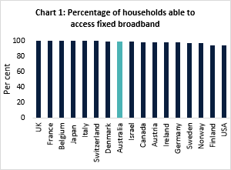
Source: Various, PwC analysis.
Coverage based on the percentage of premises able to access fixed broadband download speeds of at least 25Mbps is approximately 99.3 per cent,^{iii} ranking Australia 1st out of 15 comparable countries (chart 2).
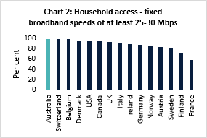
Source: Various, PwC analysis. NBN data used for Australia.

The percentage of premises able to access fixed broadband services with download speeds greater than or equal to 100Mbps is around 66 per cent,^{iv} which ranks Australia 10th out of 16 comparable countries.
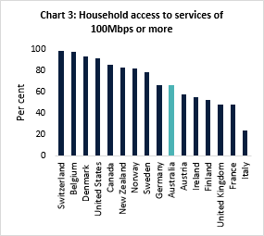
Source: Various, PwC analysis. NBN data used for Australia.

Australians are tapped into the digital economy
The most recent data on the total number of fixed broadband subscriptions and households shows that approximately 88 per cent of households in Australia had a fixed broadband subscription by December 2019.^{v} This ranked Australia 8th out of 18 comparable countries, as shown in chart 4.
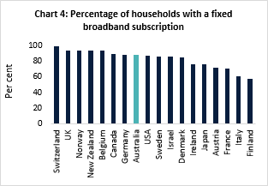
Source: Various, PwC analysis.
Australia’s uptake has grown by more than 50 per cent over the period of the NBN rollout. Chart 5 shows that the percentage of households with a fixed broadband subscription in Australia has increased from around 56 per cent to 88 per cent over the period from 2010 to 2019.
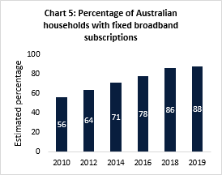
Source: PwC analysis, World Bank, UN, OECD. Includes both NBN and non-NBN subscriptions.

_____________________________________________________________________________________

^{i} Information presented in this fact sheet draws on the most recent data available for countries analysed, and may not always relate to the same period. ‘Speeds’ refer to wholesale speeds. Limitations on the availability of appropriate data means that for some measures, analysis of different subsets of countries from the list of identified peer countries was required.
^{ii} Data provided by NBNCo. Some premises are not yet ready to connect due to having complex connection requirements or being premises added to the fixed-line network in the final year of the build – comprising some new developments and
premises previously designated to receive fixed wireless that were reallocated to fixed-line technology. The small proportion of premises defined as ‘complex connections’ includes those that are difficult to access or are in culturally significant areas and heritage sites. NBN Co expects to address 80% of these not yet ready to connect premises by the end of 2020.
^{iii} Based on data available to the Department, NBNCo. ^{iv} Based on data available to the Department, NBNCo. ^{v} Includes NBN and non-NBN subscriptions.

International comparison of fixed broadband performance

Migration to higher speed plans
December 2020
________________________________________________________________________________________________________

Role of fixed broadband

Fixed broadband plays a vital role in connecting Australians, and it is important that the performance of Australia’s fixed broadband infrastructure is known and comparable to our international peers.
Fixed broadband, including both fixed-line and wireless connections to fixed locations, plays a vital role in connecting Australians. There has been significant public investment to develop fixed broadband infrastructure with the rollout of the NBN. Therefore it is important that the performance of Australia’s fixed broadband infrastructure is known and can be compared to our international peers, especially in the COVID-19 environment.
This fact sheet outlines Australia’s fixed broadband performance on access to higher speeds and migration to higher speed services.¹ Further information on this and other broadband performance indicators, including how the comparison countries identified in the analysis were selected is provided in the paper Measuring Australia’s fixed broadband performance.²

Australians’ appetite for fixed broadband
Australians have demonstrated a strong appetite for fixed broadband services. From 2010 to 2019 household uptake of all types of fixed broadband services grew from 56 per cent to 88 per cent. Additionally, as the number of premises activated on the NBN has increased over the period 2013 to 2020, average speeds have increased threefold.
Coverage based on the percentage of premises able to access fixed broadband download speeds of at least 25 Mbps is approximately 99.3 per cent.³ Australia is ranked 1st out of 15 comparable countries on this measure (chart 1).
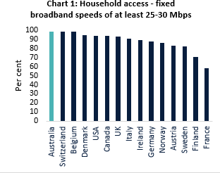Source: Various, PwC analysis. NBN data used for Australia. Speed tiers differ by country. To enable international comparison this statistic reports the level of coverage based on a minimum speed of 25 Mbps or 30 Mbps.

A shift to higher speeds
Australians are embracing higher speed plans over time, which is reflected in increases in wholesale and retail subscriptions. As at June 2020, almost 70 per cent of NBN fixed subscriptions were for plans with download speeds of at least 50 Mbps, up from around 16 per cent in June 2016 (chart 2).
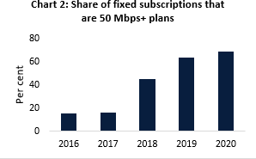
Source: ACCC Wholesale Market Indicators reports.
Similarly, at September 2020 around 70 per cent of all NBN wholesale subscriptions were for plans with download speeds of at least 50 Mbps, up from less than 40 per cent in early 2018. There has been a corresponding decline in the share of households subscribing to comparatively lower speed plans, indicating a pattern of migration to higher speed services (chart 3).⁴
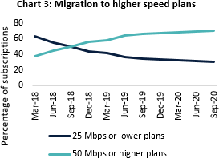
Source: NBN Co. Monthly progress reports.
_____________________________________________________________________
¹ Information in this fact sheet draws on data available as at September 2020 for countries analysed, and may not always relate to the same period. ‘Speeds’ refer to wholesale speeds. ² Limitations on the availability of appropriate data means that for some measures, analysis of different subsets of countries from the list of identified peer countries was required.

This change has been in part due to NBN Co’s introduction of discounted bundled products which have allowed retailers to offer more affordable 50 Mbps and above products.
Other factors include increased demand for higher speeds due to the increasing popularity of video streaming services, a greater number of internet- connected household devices and the increased importance of home internet due to the impact of the COVID-19 pandemic.
Australia ranks 6th amongst peer countries in terms of the proportion of households on speeds equal to or greater than 25 Mbps. Around 84 per cent of households have subscriptions that fall within this speed range in Australia (chart 4).⁵
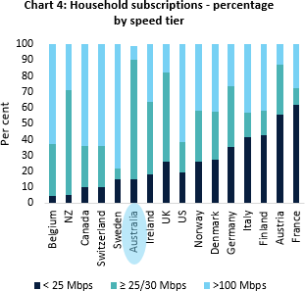

Source: ACCC, OECD (2019 data) PwC analysis. Australia’s data is based on speed tiers using NBN services only, using the ACCC’s NBN Services in Operation RKR data (June 2020).
³Based on data available to the Department, NBN Co. ⁴Note this captures NBN wholesale plans only and includes both fixed and wireless connections.
⁵Refers to NBN subscriptions only.

International comparison of fixed broadband performance

Data consumption
December 2020
________________________________________________________________________________________________________

Role of fixed
broadband
Fixed broadband plays a vital role in connecting Australians, and it is important that the performance of Australia’s fixed broadband infrastructure is known and comparable to our international peers.

Fixed broadband, including both fixed-line and wireless connections to fixed locations, plays a vital role in connecting Australians. There has been significant public investment to develop fixed broadband infrastructure with the rollout of the NBN. Therefore it is important that the performance of Australia’s fixed broadband infrastructure is known and can be compared to our international peers, especially in the COVID-19 environment.
This fact sheet outlines Australia’s fixed broadband performance on access to higher speeds and migration to higher speed services.¹ Further information on this and other broadband performance indicators, including how the comparison countries identified in the analysis were selected is provided in the paper Measuring Australia’s fixed broadband performance.²

Insights from data usage metrics
Data usage shows the extent to which broadband and broadband networks are being used, providing policy insights. Greater usage is one indicator that a broadband network is realising the benefits of connectivity to Australians.

Australians are hungry for data
Australia is a leading country for fixed data usage with per capita data consumption of around 61GB in 2018.
This ranks Australia equal third out of nine comparable countries, with only the United Kingdom and United States ranking higher in terms of the amount of data consumed (chart 1)
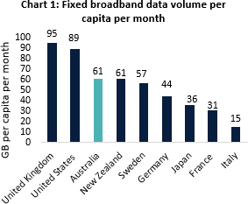
Source: Ofcom International Broadband Scorecard. Including upload and download data.
Australians’ average monthly data usage per user over the year from June 2019 to June 2020 was 295GB over the NBN (or around 88GB when measured on a per capita basis for the Australian population that has NBN coverage). This takes into account the COVID-19 pandemic on data consumption (see below).

Australia is also a high performer for growth in data consumption compared to our international peers. From 2017 to 2018 Australia’s data consumption per capita grew 42 per cent over the 12 month period. This is the 3rd highest growth amongst the nine countries for which data is available (chart 2).
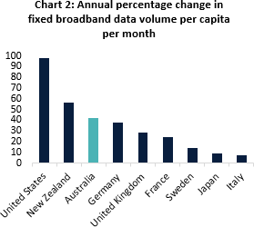
Source: Ofcom International Broadband Scorecard. Including upload and download data.
Data use has also grown over the period of the NBN rollout. Average monthly data downloaded per fixed- line subscription was over 310GB in June 2020, compared to almost 100GB in 2016 and around 35GB in June 2013 (chart 3).
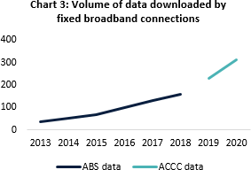
_____________________________________________________
¹ Information in this fact sheet draws on data available as at September 2020 for countries analysed, and may not always relate to the same period. ‘Speeds’ refer to wholesale speeds. ² Limitations on the availability of appropriate data means that for some measures, analysis of different subsets of countries from the list of identified peer countries was required.
Source: BCARR analysis; ABS, Internet Activity Survey; ACCC Internet Activity Report3
The COVID-19 pandemic has seen a greater demand for data on the back of working and schooling from home, as well as increased usage of video gaming and streaming services.
Data collected by the ACCC shows that for the June 2020 quarter, the volume of data downloaded over NBN services had almost doubled compared to the same period in 2019, increasing from 3.48 million terabytes (TB) to around 6.28 million TB of data downloaded on these services.
The total volume of data downloaded over all fixed services also increased from 5.29 million TB over the June 2019 quarter to 7.42 million TB over the June 2020 quarter (chart 4).
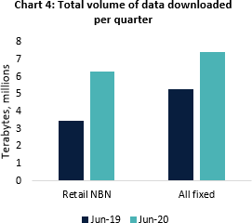
Source: ACCC, Internet Activity Report June 2020.
Similar to the drivers of increased demand for higher speed internet services, described in International comparison of fixed broadband performance: migration to higher speed plans, factors contributing to increased data consumption are likely to include the increasing popularity of video streaming services, a greater number of internet-connected household devices and the increased importance of home internet due to the impact of the COVID-19 pandemic
³ Prior to June 2018 this data was collected by the ABS. From December 2018 and onwards this data is being collected by the ACCC and uses a different methodology.

The ‘digital divide’ refers to gaps in access to information and communication technology contributing to poorer outcomes amongst some cohorts.

