

BUREAU OF COMMUNICATIONS, ARTS AND REGIONAL RESEARCH

Measuring Australia’s Cultural and Creative Workforce, 2008–09 to 2023–24
  - Interim report
December 2025

The Department of Infrastructure, Transport, Regional Development, Communications, Sport and the Arts acknowledges the Traditional Custodians of Country throughout Australia and their continuing connection to land, sea and community. We pay our respects to them, their cultures and to their Elders, past, present and emerging.
© Commonwealth of Australia 2025
ISBN 978-1-923111-05-9/ BCARR reference: 2025-140

Ownership of intellectual property rights in this publication
Unless otherwise noted, copyright (and any other intellectual property rights, if any) in this publication is owned by the Commonwealth of Australia (referred to below as the Commonwealth).

Disclaimer
The material contained in this publication is made available on the understanding that the Commonwealth is not providing professional advice, and that users exercise their own skill and care with respect to its use, and seek independent advice if necessary.
The Commonwealth makes no representations or warranties as to the contents or accuracy of the information contained in this publication. To the extent permitted by law, the Commonwealth disclaims liability to any person or organisation in respect of anything done, or omitted to be done, in reliance upon information contained in this publication.
Creative Commons licence


With the exception of (a) the Coat of Arms; (b) the Department of Infrastructure, Transport, Regional Development, Communications, Sport and the Arts photos and graphics; (c) content supplied by third parties; (d) content otherwise labelled; copyright in this publication is licensed under a Creative Commons BY Attribution 4.0 International Licence.

Use of the Coat of Arms
The Department of the Prime Minister and Cabinet (PM&C) sets the terms under which the Coat of Arms is used. Please refer to the Commonwealth Coat of Arms Information and Guidelines | PM&C.

Contact us
This publication is available in PDF format. All other rights are reserved, including in relation to any departmental logos or trademarks which may exist. For enquiries regarding the licence and any use of this publication, please contact:
Email: BCARR@infrastructure.gov.au
Website: https://www.infrastructure.gov.au/research-data/bureau-communications-arts-and-regional-research

Table of contents
Executive summary 5
Why this matters for policy 5
Key interim findings 6
Cultural and creative employment is significant 6
Secondary jobs play an important role in the cultural and creative sector 6
Cultural and creative employment varies by states and territories 6
Limitations 6
Next steps 6
Background 7
Focus of Phase 2 7
Methodology 8
Framework 8
Scope of cultural and creative occupations 9
Approach and data sources 10
Quality statement 10
Labour force concepts adopted in this paper 11
Treatment of occupations across multiple domains 11
Limitations and caveats 13
Using new occupational classifications 13
Estimation of secondary jobs 14
Interim estimates 15
Employment (for main job) 15
Total cultural and creative employment, 2008–09 to 2023–24 15
Comparison with overall employment and Australian industries 16
Distribution by states and territories 17
Demographics 19
First Nations employment in the cultural and creative sector 22
Detailed analysis of cultural and creative employment by domain 24
1. Literature, creative and performing arts 25
2. Visual arts and crafts 29
3. Music production and distribution 34
4. Museums and galleries 38
5. Film and television activities 43
6. Radio broadcasting 47
7. Internet publishing and broadcasting 52
8. Libraries and archives 57
9. Print media and publishing (excl. internet) 61
10. Architecture services 66
11. Design and fashion 70
12. Advertising and promotion 75
13. Events (arts) 79
14. Arts education 83
15. Digital games development 87
16. Arts health and wellbeing 90
Secondary jobs 94
Appendix A—Detailed review of the scope of cultural and creative occupations by domain 98
A.1 Literature, creative and performing arts 98
A.2 Visual arts and crafts 101
A.3 Music production and distribution 102
A.4 Museums and galleries 103
A.5 Film and television activities 104
A.6 Radio broadcasting 106
A.7 Internet publishing and broadcasting 107
A.8 Libraries and archives 108
A.9 Print media and publishing (excl. internet) 108
A.10 Architecture services 111
A.11 Design and fashion 112
A.12 Advertising and promotion 113
A.13 Events (arts) 113
A.14 Arts education (and Health) 114
A.15 Digital games development 114
A.16 Arts health and wellbeing 115
Appendix B—Data sources summary table 116
Appendix C—Industry coverage and classifications 117
Appendix D—Product coverage and classifications 118
Appendix E—Occupation coverage, classifications and correspondence 120
Occupations in the previous ABS cultural and creative occupation list but out-of-scope in the methodology refresh 135
Appendix F—Domain-Industry based mapping occupation list 140
Appendix G—Glossary 148
References 150

Executive summary
Australia’s cultural and creative workforce makes a significant contribution to Australia’s social and economic wellbeing. This report provides interim estimates using a refreshed methodology for measuring cultural and creative employment from 2008–09 to 2023–24, aligning with the objectives set out in the National Cultural Policy – Revive.
After completing Phase 1 of the Cultural and Creative Account Methodology Refresh, which quantified the direct economic contribution of cultural and creative activity, Phase 2 now shifts attention to the workforce conducting these activities — artists, designers, educators, technicians, and other support workers who work within the cultural and creative sector.
This paper sets out a robust methodology for estimating cultural and creative employment using various data sources published by the Australian Bureau of Statistics (ABS). It also includes a detailed review of the new Occupational Standard Classification for Australia (OSCA) to determine the in-scope cultural and creative occupations.
Interim findings show that the cultural and creative sector is a significant and resilient part of Australia’s economy. In 2023–24, over 591,000 people were employed in this sector as their main job—comparable to major industries like transport, postal and warehousing and wholesale trade—with nearly 50,000 secondary jobs highlighting the flexible, multi-job nature of the workforce. Employment has grown by 33% since 2008–09, driven by architecture services, events (arts), and advertising and promotion, with most domains rebounding strongly post-COVID. While concentrated in New South Wales and Victoria, cultural and creative employment contributes across all states and territories, with women making up 56% of the workforce and First Nations employment increasing by more than 80% since 2008–09.
Data limitations are evident in the analysis due to the transition from the previous occupational framework—the Australian and New Zealand Standard Classification of Occupations (ANZSCO)—to the new occupational framework—Occupational Standard Classification for Australia (OSCA). The analysis uses an interim solution to bridge classifications until the official OSCA statistics become widely available from 2027.

Why this matters for policy
Understanding the cultural and creative workforce helps inform policies for sustainable careers, equity, and sector growth. These insights guide funding, workforce development, and collaboration to ensure Australia’s talent is recognised and supported.

Key interim findings

Cultural and creative employment is significant
- An estimated 591,302 people worked in a cultural and creative industry or occupation as their main job in 2023–24. This is an increase of 7.1% from 2022–23.
- As a share of total employment, cultural and creative employment (4.1%) is comparable to the employment share of transport, postal and warehousing (4.6%), and wholesale trade (3.8%).
- In 2023–24, the most prominent domains of cultural and creative employment were architecture services, advertising and promotion, and visual arts and crafts.

Secondary jobs play an important role in the cultural and creative sector
- Secondary jobs play an important role in the cultural and creative sector, supplementing the employment of main jobs by offering additional income, opportunities for skill development, and networking options.
- In 2023–24, an estimated 49,214 secondary jobs were related to the cultural and creative sector. The number of secondary jobs within the cultural and creative sector was 4.5% of all secondary jobs, higher than the sector’s share of main job employment in the economy (4.1%).
- The largest domains of cultural and creative secondary jobs in 2023–24 are film and television activities; literature, creative and performing arts; and advertising and promotion.
- Secondary jobs are partially estimated in this analysis.

Cultural and creative employment varies by states and territories
- In relative terms, cultural and creative employment is higher in New South Wales and Victoria, with these states having higher shares of their respective total workforces in cultural and creative employment.
- Different patterns of cultural and creative employment are evident across Australia. New South Wales leads across nearly all domains particularly in advertising and promotion and architecture services, while Victoria shows strong representation in print media and publishing (excl. internet) and design and fashion.
- Queensland has a large cultural and creative presence supported by tourism yet it remains under-represented across all domains compared to its population size.
- South Australia and Western Australia also make significant contributions, though on a smaller scale, such as in visual arts and crafts; radio broadcasting, and events (arts).
- Tasmania, Northern Territory, and the Australian Capital Territory exhibit niche strengths in museums and galleries; events (arts); and radio broadcasting.
- Emerging fields such as digital games development are experiencing growth, mainly in New South Wales and Victoria, indicating potential areas for future industry expansion.

Limitations
- While the new occupational framework – Occupational Standard Classification for Australia (OSCA) – is now available, it will not be reported in official labour market statistics until September 2026 and in the 2026 Census data outputs. As a result, this report uses an interim solution to bridge the two classifications (see ‘Limitations and caveats’ section for further detail).

Next steps
- A final report is expected for release in 2027–28, following the publication of 2026 Census data and labour market statistics which incorporate updated occupational classifications.

Background
In December 2024, the Bureau of Communications, Arts and Regional Research (BCARR) released the statistical working paper Cultural and Creative Activity in Australia, 2008–09 to 2022–23 (Methodology Refresh). This paper marked an important step in re-examining how Australia’s cultural and creative activity is measured, an action of Revive: a place for every story, a story for every place—Australia’s cultural policy for the next five years.
The initial phase of this research focused on the economic contribution of cultural and creative activity – using gross value added (GVA). However, we recognise that cultural and creative activity can also be viewed from the perspective of workers and occupations. Understanding the composition of the cultural and creative workforce is essential to gaining a more comprehensive picture of the sector’s contribution.
This report sets out ways to measure Australia’s cultural and creative workforce – which forms ‘Phase 2’ of BCARR’s cultural and creative research. This report details the measurement approach and scope of the cultural and creative occupation list.
Interim estimates of the cultural and creative workforce are also provided for each domain. This approach aims to approximate workforce estimates in the absence of data using the new occupational classification framework – which will only become widely available from 2027. As such, these interim estimates should be interpreted with caution. Once new data becomes available, a new occupational distribution will be developed to improve the accuracy of the cultural and creative employment estimates.
The methodology and scope used in this paper was reviewed internally across the department and the Australian Bureau of Statistics. We thank the reviewers for their valuable input and expertise.

Focus of Phase 2
Building on the foundation of Phase 1 (economic activity), Phase 2 shifts focus to cultural and creative employment. The methodology and scope to measure the cultural and creative workforce is developed and incorporates new analytical dimensions, such as state and territory breakdowns, demographic characteristics, and representation of First Nations people.
The methodology draws on several Australian Bureau of Statistics (ABS) data sources to enable more granular analysis. For example, data from the Labour Account is utilised for benchmarking, while the Labour Force Survey, Jobs in Australia, and the Census of Population and Housing supports further data disaggregation. These diverse data sources allow for a detailed analysis of the cultural and creative workforce and offers a more comprehensive understanding of Australia’s cultural and creative sector.
Figure 1. Focus for Phase 2
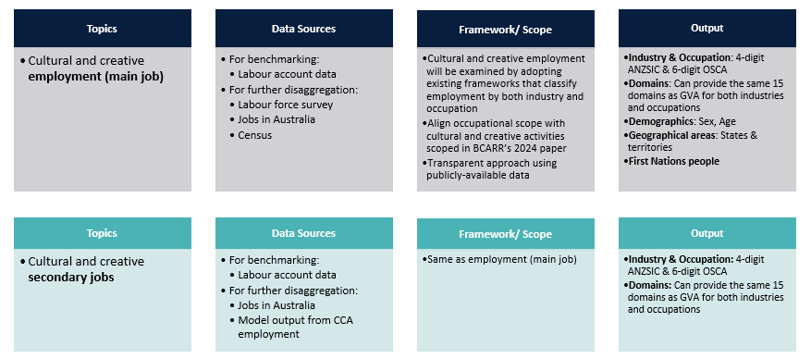
Source: BCARR.

Methodology

Framework
There is no universally-accepted definition for cultural and creative activity, and there is similarly not a consistent definition for the cultural and creative workforce. However, there is a broadly consistent approach used to categorise the cultural and creative workforce. This approach applies across international frameworks, regardless of whether the sector is scoped broadly or narrowly, or how the framework is named in academic and public debates.
For example, in Bernard Casey’s 1995 article Employment in the Cultural Sector, the cultural sector is defined as follows:
The cultural sector is taken to consist of people working in a cultural industry or in a cultural occupation. Thus employment in the cultural sector includes people working in a cultural industry but not having a cultural occupation, and people having a cultural occupation but not working in a cultural industry. An example of the former has already been given; an example of the latter is a librarian working in an industrial company's library.
A similar structure to Casey’s classification was used in the European Commission’s Cultural Employment in Europe in 2002 report, which defined cultural employment as ‘the total of active workers having either a cultural profession, or working with an economic unit within the cultural sector’ and distinctly identified cultural employment into three situations: (1) workers with a cultural profession working in a cultural sector; (2) workers having a cultural profession but working outside the cultural sector; and (3) workers having a non-cultural profession and working in the cultural sector (e.g. a secretary in a film production company).
These three aspects of employment were further formalised by Higgs and Cunningham (2008) by introducing a ‘Creative Trident’ table, which shows creative occupations in core creative industries (specialist workers), creative roles in other industries (embedded workers), and non-creative roles in creative industries (support workers).
Similarly, the 2009 UNESCO Framework for Cultural Statistics (FCS) defines cultural employment as including all individuals engaged in cultural or non-cultural occupations within the cultural sector, as well as those involved in cultural occupations within non-cultural sectors. These classifications have been widely adopted in both academic and statistical contexts.
To measure the cultural and creative workforce, BCARR adopts these existing frameworks that classify employment by both industry and occupation. For clarity, the labels ‘specialised’, ‘embedded’, and ‘support’ are used for employment categories (Figure 2), which are defined as follows:
- workers in cultural and creative industries are classified as ‘specialised’ if they work in cultural and creative occupations
- workers in cultural and creative industries are classified as ‘support’ if they work in other occupations
- workers in other (non-cultural and creative) industries are classified as ‘embedded’ if they work in cultural and creative occupations.
Figure 2 shows that, while specialised and support workers are both identified within cultural and creative industries, embedded workers – those employed in cultural and creative occupations but working outside of cultural and creative industries – are essential to the broader cultural and creative workforce. For example, a graphic designer who works in a healthcare organisation or an architect who works in a construction company would both be considered ‘embedded’ workers.
Within the cultural and creative employment trident framework, these workers represent a third category (alongside specialised and support workers), highlighting the importance of cultural and creative expertise within industries that are not considered cultural or creative. BCARR’s methodology identifies these workers by cross-referencing occupation and industry classifications from Census data. Model outputs separately report on specialised, support and embedded workers, allowing for greater insights on cultural and creative employment.
Figure 2. The cultural and creative employment trident
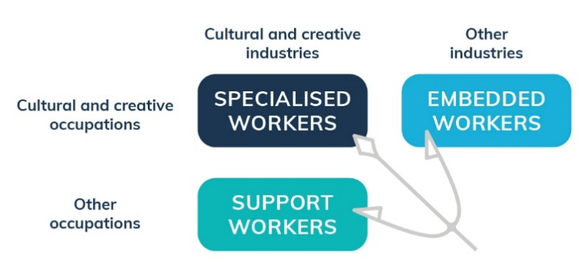
Source: S. Cunningham and P. Higgs (2010).
However, it is important to note that while we follow the same labelling convention as the Creative Trident framework, the scope of what constitutes cultural and creative industries and occupations differs from those defined in previous frameworks, including the Creative Trident.

Scope of cultural and creative occupations
The release of the statistical working paper Cultural and Creative Activity in Australia, 2008–09 to 2022–23 (Methodology Refresh) quantified the size of cultural and creative activity in Australia based on a new scope for measuring this activity. In-scope activities were informed by a decision-making framework used to determine which industry and product lists were included as cultural and creative activity. Compared to the earlier measure of cultural and creative activity developed by the ABS, most activities continued to be in-scope, however, several main sources of ‘creative only’ activity from the previous industry scope were removed. These included computer system design and related services; clothing and footwear manufacturing, wholesaling and retailing.
Cultural and creative occupations are aimed to align with the scope of cultural and creative activities produced by the sector – refer to Cultural and Creative Activity in Australia, 2008–09 to 2022–23 (Methodology Refresh). This alignment ensures consistency between the measurement of cultural and creative output and classification of the cultural and creative workforce.
The Occupation Standard Classification for Australia (OSCA) has been reviewed to determine the in-scope cultural and creative occupations for Phase 2. OSCA was established by the ABS following an extensive review of the Australian and New Zealand Standard Classification of Occupations (ANZSCO) conducted between July 2022 and December 2024. OSCA officially replaced ANZSCO in Australia in December 2024.
Appendix A provides a detailed review of the scope of occupations for each cultural and creative domain. Further information is provided in Appendix E.

Approach and data sources
Employment and secondary job estimates are developed using a top-down approach (Figure 3), ensuring alignment with national employment and jobs benchmarks. The estimation process starts with aggregating data from the ABS Labour Account, which provides time-series estimates in 4 areas: the number of people employed, jobs, hours worked, and income earned, for each industry within a single framework. These estimates align conceptually with the Australian System of National Accounts (ASNA), and its coherent framework aims to improve macroeconomic analysis and forecasting.
To derive industry-specific estimates, these aggregates are initially broken down to the ANZSIC industry subdivision (2-digit) level. By incorporating data from labour force and jobs data, more detailed estimates are then developed by industry group (3-digit) and class (4-digit) level, as well as by state and territory. The combination of these datasets supports a comprehensive industry-based disaggregation that aligns with the structural composition of the workforce.
Following this disaggregation, estimates are further split by applying the workforce occupation structure of each ANZSIC class obtained from Census data. Workforce composition within each ANZSIC industry class is determined using data from the Census, which captures detailed occupation-by-industry employment patterns and other dimensions. This allows for the mapping of occupations across industries in line with the ‘creative trident’ categories—specialised, support, and embedded workers—resulting in a detailed and representative view of cultural and creative employment across the Australian labour market. Data sources used in the model are detailed in Appendix B.
Figure 3. Approach for measuring cultural and creative workforce
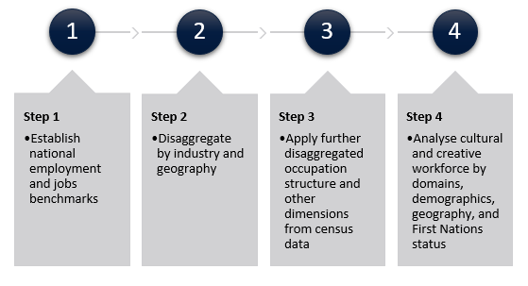
Source: BCARR.

Quality statement
This paper uses lower-level Labour Force Survey (LFS), Jobs in Australia (JIA) and Census of Population and Housing classifications (and categories) to model and enhance the granularity of employment and job estimates for the cultural and creative sector. By utilising these detailed classifications, this method provides a more comprehensive view of the cultural and creative workforce composition. However, data at these detailed levels will be less reliable than data reported at the broader aggregates.
The Labour Account, when combined with detailed industry-occupation and other disaggregated variables from various ABS data sources, provides sufficient granularity to analyse the cultural and creative workforce without the added complexity of integrating unit-level administrative data. This methodology is broadly consistent with approaches used in other Australian thematic accounts, such as the Tourism Satellite account, and aims to provide a robust foundation for producing timely and policy-relevant estimates of cultural and creative employment.

Labour force concepts adopted in this paper
Key labour force concepts – such as employed people, main job, and secondary jobs – are defined in ABS data sources in various ways, affecting their comparability, integration and interpretation. For example, in the ABS Labour Account, a main job is defined as the main activity carried out by an employed person – specifically, the job in which most hours are usually worked. In contrast, Jobs in Australia defines a main job as the job in which they received the highest employment income.,
This paper aims to produce consistent estimates aligned with national benchmarks. The Labour Account definitions are therefore used as the conceptual basis for estimating employment and secondary jobs. The Labour Account provides an integrated framework that reconciles various household, business, and administrative data sources. These sources are combined and analysed to address gaps and resolve inconsistencies in the data by drawing on the differing strengths of the data sources.
A glossary of terms used in this paper is available in Appendix G.

Treatment of occupations across multiple domains
There are important interconnections between people employed in different cultural and creative fields. Many workers within these sectors have similar education pathways, possess related skills, and move back-and-forth between domains throughout their careers. People across these fields share common networks and communities, and many are linked by a shared sense of identity and professional association.
Certain cultural and creative occupations span multiple domains. For example, OSCA 231435 Production Manager (Screen or Live Performance) and 231437 Screen or Live Performance Designer fall under both ‘Literature, creative and performing arts’ and ‘Film and television activities’. To address this complexity, a ‘domain-industry' based mapping and estimation approach is applied to more accurately capture the distribution of cultural and creative workers across multiple domains (Figure 4).
Figure 4. Domain-Industry based mapping and weight approach
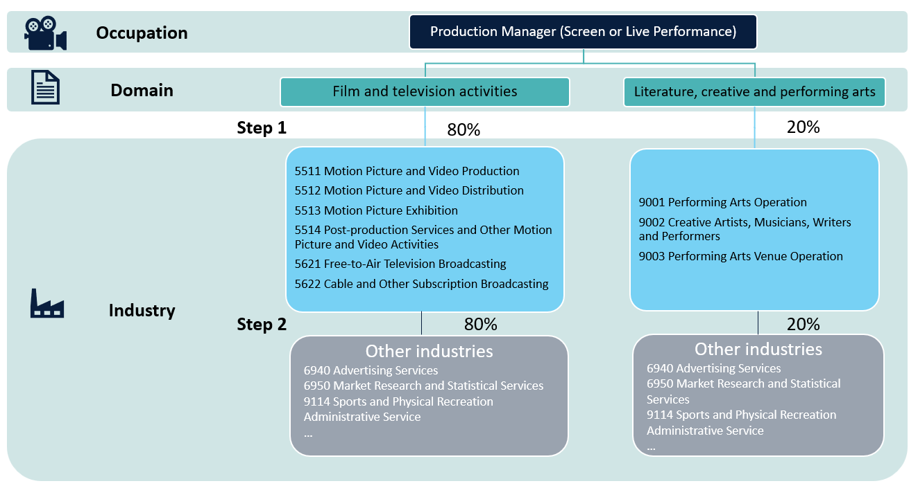
Source: BCARR.
As shown in Figure 4, the occupation Production Manager (Screen or Live Performance) encompasses two domains: Film and television activities and Literature, creative and performing arts. Individuals employed in industries associated with motion picture and video activities (ANZSIC 5511, 5512, 5513 and 5514) and television broadcasting (ANZSIC 5621 and 5622) are allocated to the Film and television activities domain. Conversely, individuals working in industries related to creative and performing arts activities (ANZSIC 9001, 9002 and 9003) are classified under the Literature, creative and performing arts domain.
However, a Production Manager could also work in another industry that is not directly classified under either of the above domains. This could include an industry within the broader cultural and creative sector – such as ANZSIC 6940 Advertising Services, or it may fall entirely outside of the cultural and creative sector, such as ANZSIC 9114 Sports and Physical Recreation Administrative Service. To address this, a domain-industry specific weight approach is applied to estimate the most likely domain distribution for workers whose industry classification does not allow for direct domain allocation through two steps:
Step 1: Calculate the domain weights based on known industry-domain mapping.
First, identify the domain of employed individuals based on industry classifications and calculate the weights for each domain. For a production manager in screen or live performance, if 800 individuals are employed in film and television (FTV) industries and 200 are in literature, creative, and performing arts (LCP) industries for 2020–21, the corresponding weights are:
$${Weight}_{FTV}=0.80, { Weight}_{LCP }=0.20$$
Step 2: Apply the weights to cultural and creative occupations employed in other industries.
For a production manager who is working in other industries, the weights for each year calculated in step 1 are used to proportionally distribute these industries across the two relevant domains. For example, if there were 300 such individuals without a domain classification in 2020–21, 240 workers would be attributed to Film and television activities, while 60 workers would be allocated to Literature, creative and performing arts.
A detailed ‘Domain-Industry based mapping’ list of occupations used to systematically identify and process all relevant cases is provided in Appendix F.

Limitations and caveats

Using new occupational classifications
While the new occupational framework – Occupational Standard Classification for Australia (OSCA) – is now available, it will not be reported in official labour market statistics until September 2026 and in the 2026 Census data outputs. In the interim, any analysis that seeks to align with the new classification must rely on a correspondence framework to bridge the two classifications. One challenge in doing this is that ANZSCO and OSCA do not always have a one-to-one correspondence. Occupations in ANZSCO can be:
- split into multiple detailed OSCA codes (one-to-many): for example, ANZSCO 212112 Media Producer (excluding Video) was further disaggregated into four OSCA codes: OSCA 231435 Production Manager (Screen or Live Performance), 231531 Audio Producer, 231532 Live Performance Producer, and 231533 Screen Producer.
- merged into broader OSCA categories (many-to-one): for example, ANZSCO 212413 Print Journalist, 212414 Radio Journalist, 212416 Television Journalist, and (part of) 212499 Journalists and Other Writers nec were merged into OSCA 231332 Journalist. However, if an old ANZSCO code was fully merged into OSCA, this scenario could also be considered as one-to-one correspondence.
- no correspondence: for example, there is no correspondence for some of the new OSCA occupations such as 341133 Track Rider, 343137 Vineyard Supervisor, etc. However, the impact of these classifications for estimating the cultural and creative workforce is expected to be minimal.
The lack of equivalence requires a ‘weighted allocation method’ to be applied to the interim analysis to estimate how ANZSCO-coded labour data can be translated into OSCA classifications. The estimates of occupational analysis used in this paper are based on the mapping between ANZSCO and OSCA provided by the OSCA correspondence tables. For occupations with direct one-to-one matches, a weight of 1 is assigned:
$$w_{ij}=1 if occupation i ∈ANZSCO maps uniquely to j∈OSCA$$
For occupations with one-to-many mappings, an ‘equal-weighted’ rule is applied by default, distributing weights evenly across all linked OSCA codes:
$$w_{ij}=\frac{1}{n_{i}} if occupation i∈ANZSCO maps to n_{i}>1 j∈OSCA codes$$
This produces weights in such a way that:
$$\sum_{j}^{n}{w_{ij}}=1 for all i∈ANZSCO$$
This method presumes an equal distribution of employment figures between the mapped ANZSCO and OSCA codes, given the current absence of data for more precise proportions. For instance, the ANZSCO occupation 224611 Librarian is mapped to both OSCA 149132 Library Services Manager and 232131 Librarian. Considering the lack of detailed distribution data, each OSCA code is provisionally assigned a weight of 0.5 for interim analysis purposes, acknowledging that these weights are not reflective of actual distributions.
While such cases are unlikely to affect the overall estimates – since both resulting occupations (Library Services Manager and Librarian) remain within the cultural and creative scope, some other one-to-many mappings may have a substantial impact on the overall employment estimates. For example, the ANZSCO occupation 139999 Specialist Manager nec is disaggregated into ten distinct OSCA occupations. Under an equal-weighted approach, each receives a weight of 0.1, and only one of them – 149199 Arts, Culture, and Sports Administrators nec falls within the cultural and creative scope. This would mean that 10% of the employment previously attributed to broader Specialist Managers nec category would now be counted toward cultural and creative employment, which may under- or over-estimate its true share. In such scenarios, the distribution of weights can materially affect the final employment estimates which are attributed to the cultural and creative sectors.
Minor adjustments were made to these weights if other data sources were available for data confrontation. For example, the weight applied to OSCA 273131 Digital Game Developer, which was partially derived from ANZSCO 232413 Multimedia Designer and ANZSCO 261211 Multimedia Specialist, was further adjusted to ensure that the employment estimation aligns more closely with the data published by the ABS’s Film, Television and Digital Games, Australia.
Appendix E provides detailed information on occupational mapping and the corresponding default weights applied. This approach serves as an interim proxy in the absence of OSCA-based labour force and Census data by assuming equal probability across new classifications and provides a transparent and replicable solution. This approach is particularly suitable where no empirical evidence currently exists to support an alternative distribution. However, estimates based on this method should be interpreted with caution. Once detailed data using OSCA becomes available, the weights can be replaced using the actual occupational data distributions to improve the accuracy of cultural and creative employment estimation.

Estimation of secondary jobs
Secondary jobs play an important role in the cultural and creative sector. These jobs often supplement the employment of main jobs by offering additional income, opportunities for skill development, and networking options for those who work in cultural and creative fields.
Secondary jobs can be partially estimated in this analysis. The coverage of secondary jobs which relate to the cultural and creative sector includes:
- Individuals whose main job is in a cultural and creative occupation and take on secondary jobs in a cultural and creative industry. For example, a singer employed by a music company who also acts in the film sector.
- Individuals whose main job is in a cultural and creative occupation but take on secondary jobs in a non-cultural or creative industry. For example, a visual artist who teaches part-time at a (non-arts) school.
- Individuals whose main job is outside the cultural and creative occupation but take on secondary jobs within cultural and creative industries. For example, an administrative assistant who takes on a secondary job at a performing arts venue.
Due to data limitations, the analysis cannot capture the full occupational profile of secondary jobs, particularly in the following cases:
- Where a person’s main job is in a cultural and creative occupation, but their secondary job is neither in a cultural and creative occupation nor in a cultural and creative industry. For example, a singer who also works in a club – the estimates can identify that their secondary job is in the pub/club industry but cannot further identify whether the role is still as a singer (a cultural and creative occupation) or as a waiter (a non-cultural or creative occupation).
- When a person’s main job is in a non-cultural or creative occupation, but their secondary job is in a cultural and creative industry. For example, a cleaner whose secondary job is in a museum – the estimates can identify the industry as cultural and creative, but not whether the role itself is cultural and creative (e.g. a museum guide) or not (e.g. a cleaner).
The current estimation focuses on observable linkages between main job occupations and the industries of secondary jobs, rather than further identify the occupation of the secondary job itself.

Interim estimates
This section provides interim estimates of the cultural and creative workforce from 2008–09 to 2023–24.

Employment (for main job)

Total cultural and creative employment, 2008–09 to 2023–24
An estimated 591,302 people were employed in a cultural and creative industry or occupation as their main job in 2023–24, an increase of 146,816 or 33.0% since 2008–09. Of this total:
- 252,506 (42.7%) were in cultural and creative occupations within the cultural and creative industries (specialised workers)
- 107,341 (18.2%) were in other occupations within the cultural and creative industries (support workers)
- 231,455 (39.1%) were in cultural and creative occupations in other industries (embedded workers).
Table 1. Total cultural and creative employment by trident types, 2008–09 to 2023–24
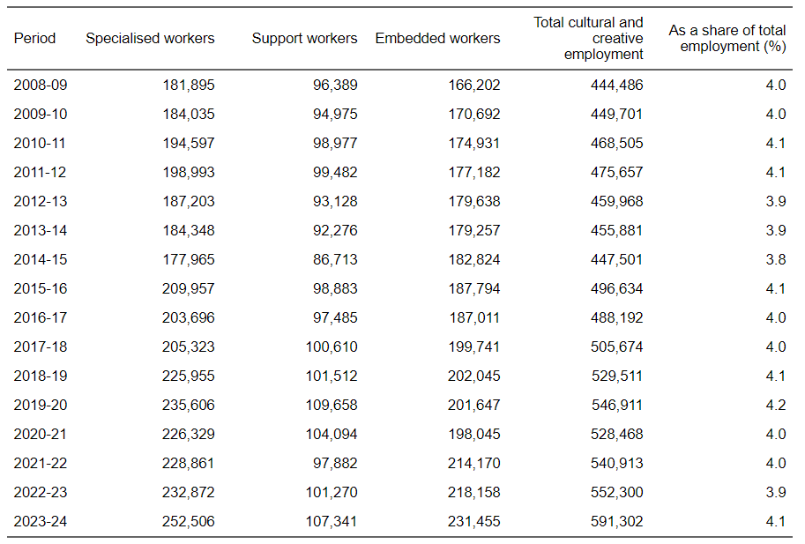
Source: ABS Labour Account Australia, Labour Force, Australia, Detailed, Quarterly; Jobs in Australia; Census of Population and Housing; BCARR calculations.
This table shows that – while much cultural and creative talent is concentrated within the cultural and creative sector – a significant share of cultural and creative workers is employed in other industries. These embedded workers spread their cultural and creative skills and innovation throughout the broader labour market.

Figure 5. Total cultural and creative employment by trident types, 2008–09 to 2023–24
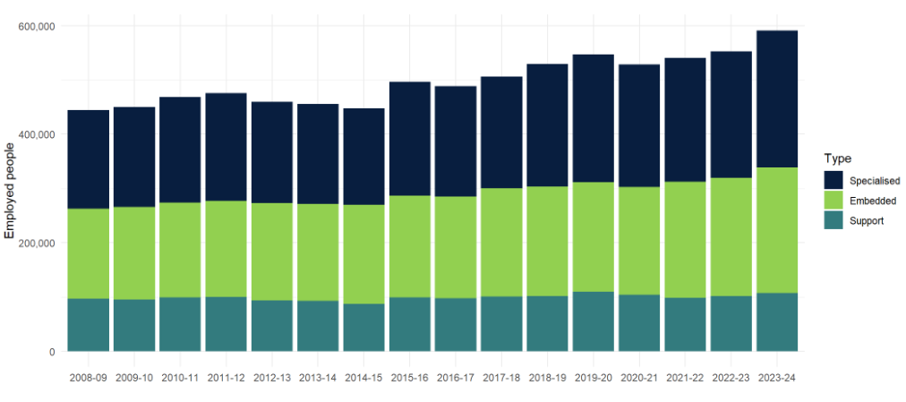
Source: ABS Labour Account Australia, Labour Force, Australia, Detailed, Quarterly; Jobs in Australia; Census of Population and Housing; BCARR calculations.

Comparison with overall employment and Australian industries
As a share of total employment, cultural and creative employment has remained relatively stable over the analysis period. After peaking at 4.2% in 2019–20, the share of cultural and creative employment decreased during the pandemic, down to 3.9% of total employment in 2022–23, while rebounding to 4.1% in 2023–24.
Figure 6. As a share of total employment
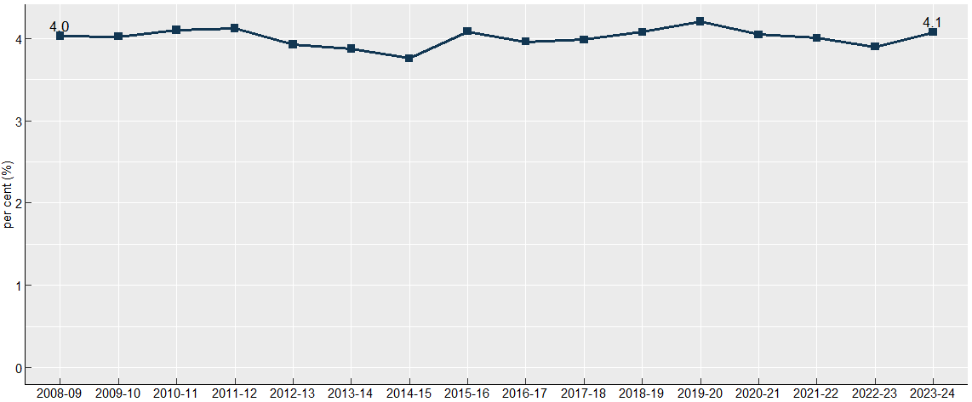
Source: ABS Labour Account Australia, Labour Force, Australia, Detailed, Quarterly; Jobs in Australia; Census of Population and Housing; BCARR calculations.
Figure 7 indicates that the share of cultural and creative employment in 2023–24 (4.1%) is comparable to the employment share of transport, postal and warehousing (4.6%), and wholesale trade (3.8%).
Figure 7. Cultural and creative employment and industry share of total employment, 2023–24
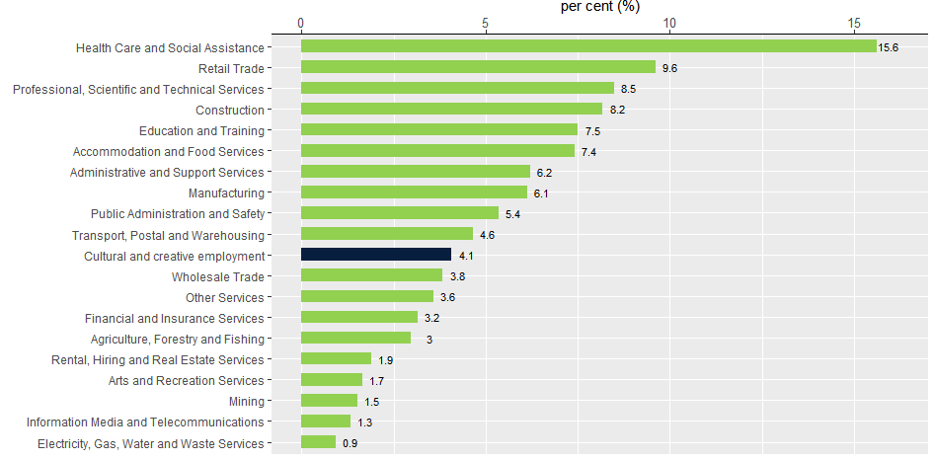
Source: ABS Labour Account Australia, Labour Force, Australia, Detailed, Quarterly; Jobs in Australia; Census of Population and Housing; BCARR calculations.
Note: Cultural and creative employment is not an industry division, but rather includes employment from many industries across the economy.

Distribution by states and territories
The estimates indicate that over 80% of cultural and creative employment is concentrated in the most populous states of New South Wales, Victoria, and Queensland.
Figure 8. Cultural and creative employment by states and territories, 2023–24
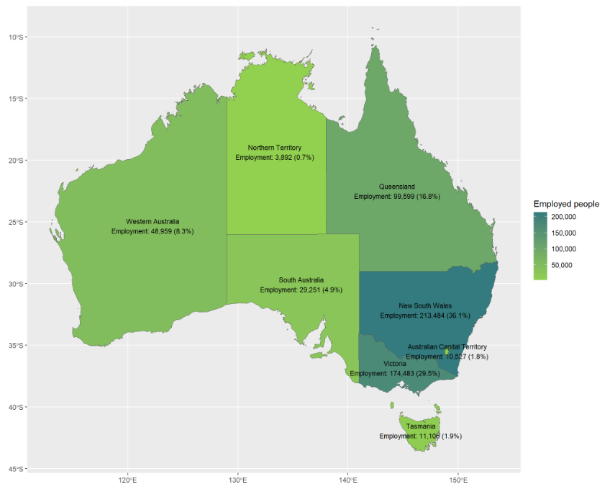
Source: ABS Labour Account Australia, Labour Force, Australia, Detailed, Quarterly; Jobs in Australia; Census of Population and Housing; BCARR calculations.
In relative terms, cultural and creative employment is higher in New South Wales and Victoria – with these states having higher shares of their respective total workforces in cultural and creative employment. Tasmania and the Australian Capital Territory show cultural and creative employment shares that are broadly consistent with their total employment shares.
Figure 9. Cultural and creative employment shares by states and territories compared to total employment distribution, 2023–24
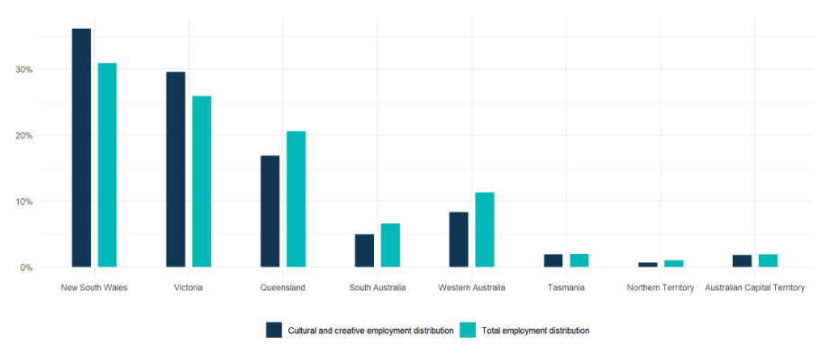
Source: ABS Labour Account Australia, Labour Force, Australia, Detailed, Quarterly; Jobs in Australia; Census of Population and Housing; BCARR calculations.
In contrast, other states and territories—particularly Queensland and Western Australia—recorded lower shares of cultural and creative employment relative to their total employment shares.
Table 2. Cultural and creative employment by states and territories, 2008–09 to 2023–24
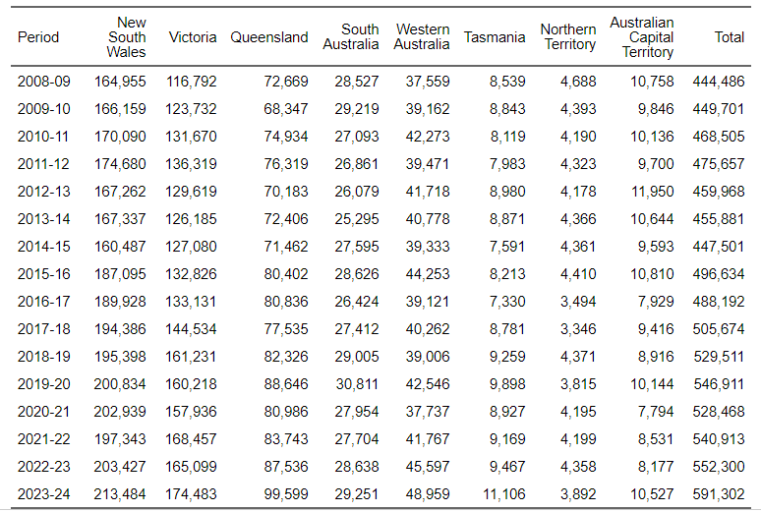
Source: ABS Labour Account Australia, Labour Force, Australia, Detailed, Quarterly; Jobs in Australia; Census of Population and Housing; BCARR calculations.
Cultural and creative employment in New South Wales was higher across nearly all domains – particularly in advertising and promotion and architecture services, while Victoria was highly represented in print media and publishing (excl. internet) and design and fashion employment but less represented in domains such as museum and galleries. Queensland has a large cultural and creative presence supported by tourism, yet its cultural and creative employment remained lower across all domains compared to its population share. South Australia and Western Australia also make significant contributions, though on a smaller scale, particularly in visual arts and crafts; radio broadcasting, and events (arts). Tasmania, Northern Territory, and the Australian Capital Territory exhibit niche strengths in museums and galleries; events (arts); and radio broadcasting. Emerging fields such as digital games development is experiencing growth, mainly in New South Wales and Victoria, indicating potential areas for future industry expansion.
Between 2008–09 and 2023–24, cultural and creative employment in Victoria saw the strongest growth rate, increasing by 49.4%, which equates to an additional 57,692 individuals employed in this sector.
Figure 10. Cultural and creative employment growth rate, by states and territories, 2008–09 to 2023–24
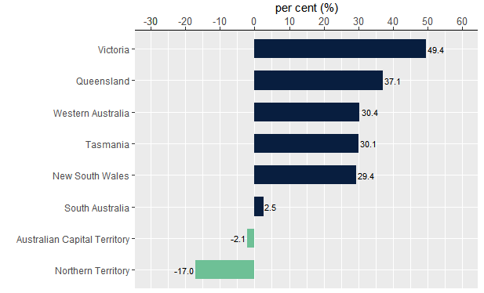
Source: ABS Labour Account Australia, Labour Force, Australia, Detailed, Quarterly; Jobs in Australia; Census of Population and Housing; BCARR calculations.
Further information about the distribution of states and territories by each cultural and creative domain can be found in the ‘Detailed analysis of cultural and creative employment by domain’ section.

Demographics
In 2023–24, women made up 56% (331,130) of cultural and creative employment, while men accounted for 44% (260,172). This contrasts with overall employment figures for the same period, in which men accounted for 52.2% and women for 47.8%.
Figure 11. Cultural and creative employment by sex and age group, 2023–24
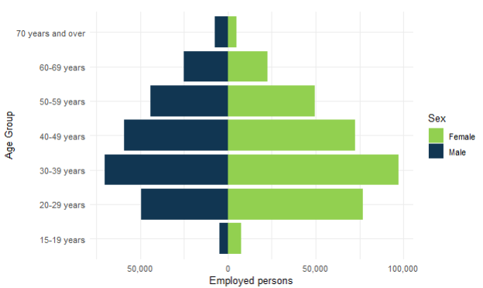
Source: ABS Labour Account Australia, Labour Force, Australia, Detailed, Quarterly; Jobs in Australia; Census of Population and Housing; BCARR calculations.
Figure 12 also shows that individuals working in the cultural and creative sector were predominantly between the ages of 20 and 49 years.
Figure 12. Cultural and creative employment by sex and age group, 2008–09 to 2023–24
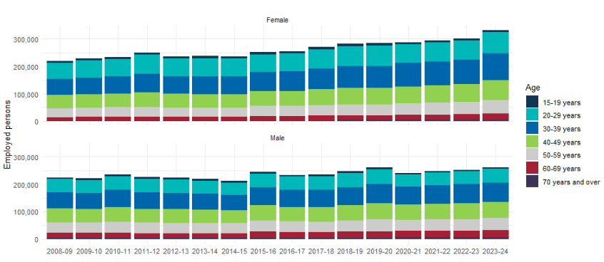
Source: ABS Labour Account Australia, Labour Force, Australia, Detailed, Quarterly; Jobs in Australia; Census of Population and Housing; BCARR calculations.
The mean age of the cultural and creative workforce increased from 39.5 years in 2008–09 to 40.6 years in 2023–24, while the median age changed from 38 years to 39 years over the same period. The median age of those employed within the cultural and creative sector was in line with total employment in Australia – also 39 years in 2023–24.
Figure 13. Mean and median age of cultural and creative employment, 2008–09 to 2023–24
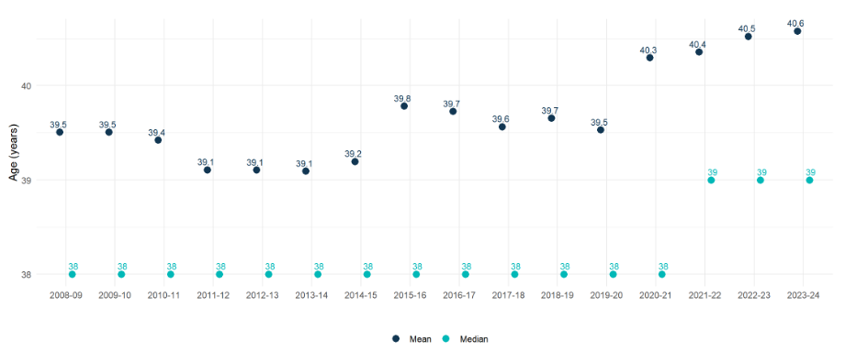
Source: ABS Labour Account Australia, Labour Force, Australia, Detailed, Quarterly; Jobs in Australia; Census of Population and Housing; BCARR calculations.
Figure 14 presents the mean and median ages of cultural and creative workers across different domains for 2023–24. The libraries and archives domain had the oldest workers on average, with a mean age of 48.6 years and a median age of 50 years. Conversely, the digital games development domain had the youngest workers on average, with a mean age of 36.9 years and a median age of 36 years.
Figure 14. Mean and median age of cultural and creative employment by domain, 2023–24
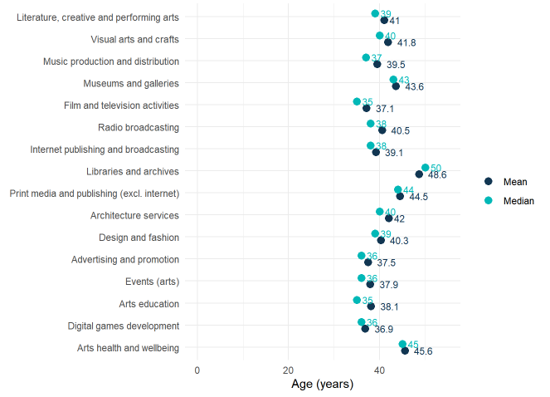
Source: ABS Labour Account Australia, Labour Force, Australia, Detailed, Quarterly; Jobs in Australia; Census of Population and Housing; BCARR calculations.
Women have been prominent in cultural and creative domains, particularly in libraries and archives, arts health and wellbeing, and arts education. Conversely, men represent a larger share of roles in music production and distribution, architecture services, digital games development, and film and television activities.
Figure 15. Cultural and creative employment by domain and sex, 2023–24
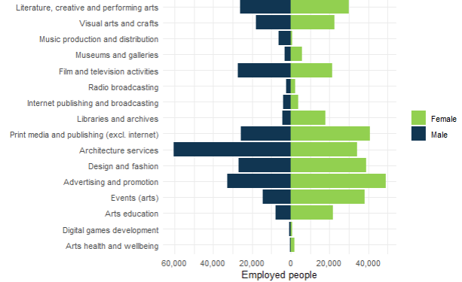
Source: ABS Labour Account Australia, Labour Force, Australia, Detailed, Quarterly; Jobs in Australia; Census of Population and Housing; BCARR calculations.

First Nations employment in the cultural and creative sector
According to the 2021 census, 259,754 First Nations individuals were employed. First Nations employment in the cultural and creative sector has grown significantly. In 2023–24, an estimated 4,955 First Nations people were employed in the cultural and creative sector, an increase of 82.5% from 2,716 in 2008–09. First Nations share of total cultural and creative employment rose from 0.6% to 0.8% during this period.
Figure 16. First Nations employment in the cultural and creative sector
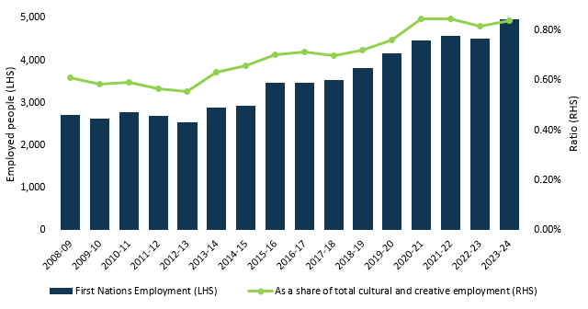
Source: ABS Labour Account Australia, Labour Force, Australia, Detailed, Quarterly; Jobs in Australia; Census of Population and Housing; BCARR calculations.
Most First Nations workers were employed in the domains of visual arts and crafts; events (arts); literature, creative and performing arts; and advertising and promotion. These four domains constituted approximately 52% of total First Nations employment within the cultural and creative sector in 2023–24.
Figure 17. First Nations cultural and creative employed people by domain, 2023–24
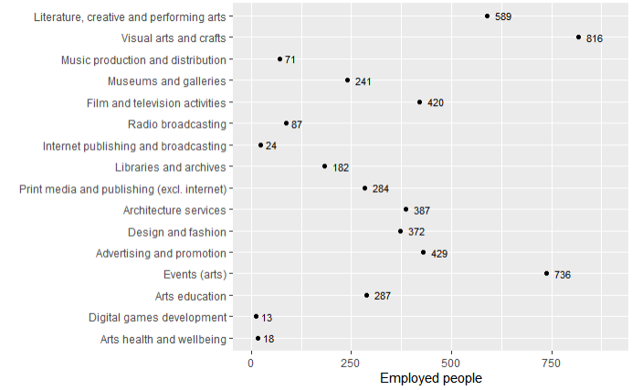
Source: ABS Labour Account Australia, Labour Force, Australia, Detailed, Quarterly; Jobs in Australia; Census of Population and Housing; BCARR calculations.
First Nations employment in the cultural and creative sector was high in New South Wales, Victoria, and the Australian Capital Territory compared to their respective (projected) population shares for 2023–24. In contrast, other states and territories had lower relative shares of First Nations cultural and creative employment compared to their respective (projected) population shares.
Figure 18. First Nations cultural and creative employment shares by states and territories, 2023–24
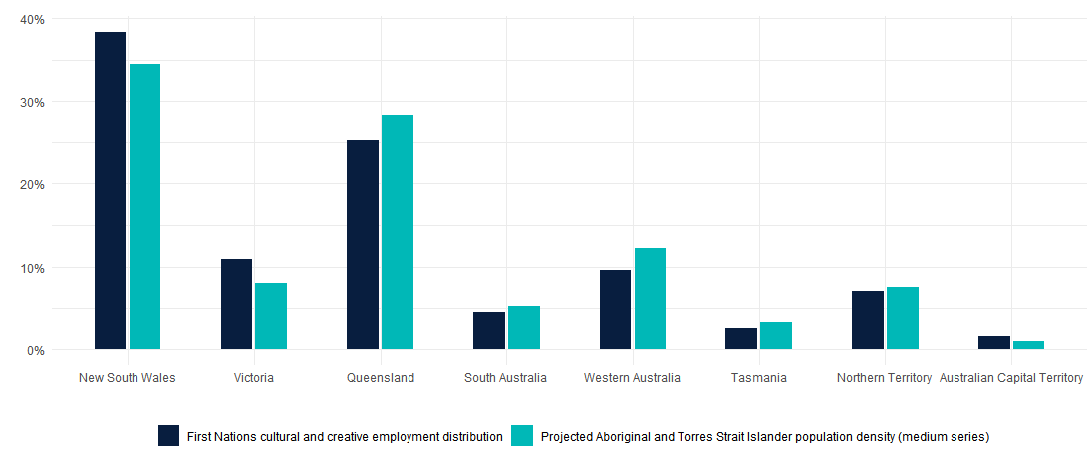
Source: ABS Labour Account Australia, Labour Force, Australia, Detailed, Quarterly; Jobs in Australia; Census of Population and Housing; Estimates and projections, Australian Aboriginal and Torres Strait Islander population; BCARR calculations.

Detailed analysis of cultural and creative employment by domain
In 2023–24, the most prominent domains of cultural and creative employment were architecture services, advertising and promotion, and visual arts and crafts.
Figure 19. Cultural and creative employment by domain, 2023–24
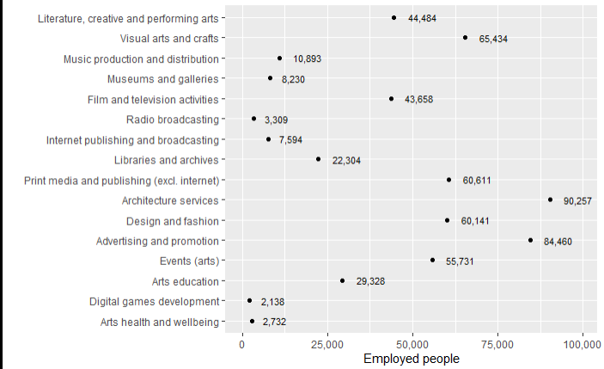
Source: ABS Labour Account Australia, Labour Force, Australia, Detailed, Quarterly; Jobs in Australia; Census of Population and Housing; BCARR calculations.
Architecture services experienced the strongest growth between 2008–09 and 2023–24, increasing by 32,408 or 56.0%. In contrast, other domains such as libraries and archives, radio broadcasting, and print media and publishing (excl. internet) showed declines. Libraries and archives saw the largest decrease, with a reduction of 5,234 or 19.0% over the period.
Figure 20. Cultural and creative employment by domain, change between 2008–09 and 2023–24
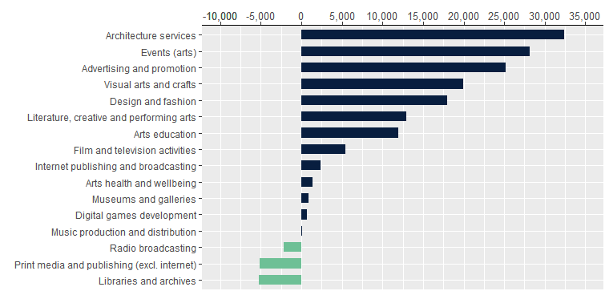
Source: ABS Labour Account Australia, Labour Force, Australia, Detailed, Quarterly; Jobs in Australia; Census of Population and Housing; BCARR calculations.

1. Literature, creative and performing arts
Literature, creative, and performing arts includes creating and presenting original works, live performances, and running supporting venues, with contributions from both individuals and organisations. Key occupations in this domain include arts and media professionals (who communicate ideas through various media, produce and present content, and write or perform music and literature), performing arts technicians (who assist in production and broadcasting), as well as arts administrators, managers, make-up artists, and live performance coordinators.
In 2023–24, employment in literature, creative, and performing arts was estimated at 44,484 individuals. The largest occupational groups were musicians (instrumental), authors, and arts administrators and managers, together comprising nearly 50% of total employment in this domain.
Figure 21. Literature, creative and performing arts employment share by main occupations, 2023–24
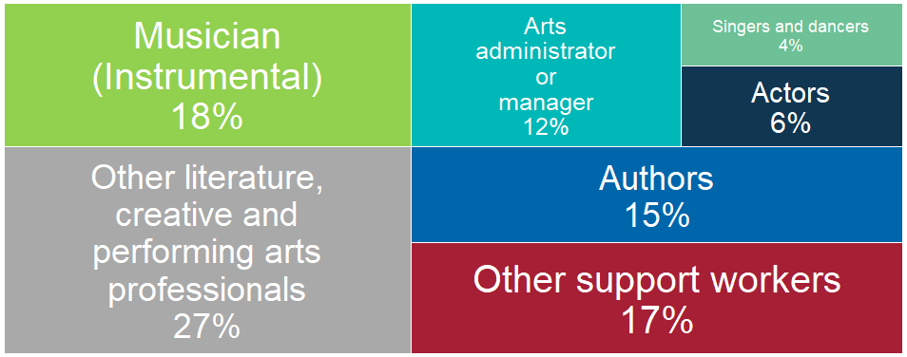
Source: ABS Labour Account Australia, Labour Force, Australia, Detailed, Quarterly; Jobs in Australia; Census of Population and Housing; BCARR calculations.
Literature, creative and performing arts employment increased by 41.1% (12,957 people) in 2023–24, from 31,527 employed persons in 2008–09. The sector experienced a significant decline in 2020–21 due to the impact of COVID-19 and restrictions on live performance. However, it demonstrated a strong recovery from 2021–22 as border reopening led to increased demand, particularly in the contemporary music segment, with improved ticket sales for the sector.
Figure 22. Literature, creative and performing arts employment, 2008–09 to 2023–24
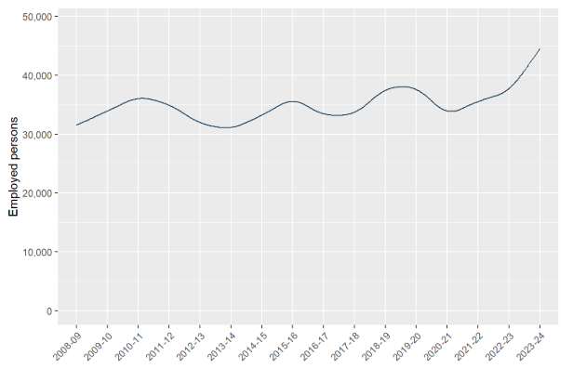
Source: ABS Labour Account Australia, Labour Force, Australia, Detailed, Quarterly; Jobs in Australia; Census of Population and Housing; BCARR calculations.
The geographic distribution of employment in literature, creative, and performing arts sectors is closely linked to patterns of tourism, government funding, and the overall dispersion of the Australian population. New South Wales comprised the largest proportion of employment for these sectors, primarily reflecting its status as the most populous state and a major centre for tourism.
Table 3. Literature, creative and performing arts employment by states, 2008–09 to 2023–24
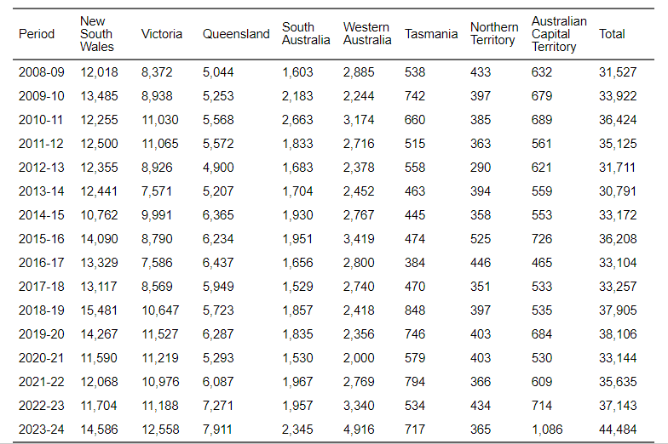
Source: ABS Labour Account Australia, Labour Force, Australia, Detailed, Quarterly; Jobs in Australia; Census of Population and Housing; BCARR calculations.
Victoria also maintains a substantial share of employment, attributable to its large population base. Melbourne is widely recognised Australia’s cultural capital, hosting an array of prestigious arts, theatre, and music events that consistently draw significant audiences.
Figure 23. Literature, creative and performing arts, employment distribution by states and territories, 2023–24
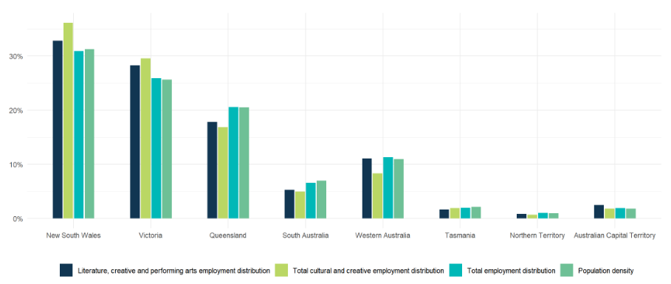
Source: ABS Labour Account Australia, Labour Force, Australia, Detailed, Quarterly; Jobs in Australia; Census of Population and Housing; National, state and territory population; BCARR calculations.
Queensland also attracts a significant share of tourism, although employment in literature, creative, and performing arts in this state was low relative to its total employment and population shares. By contrast, the Australian Capital Territory had a higher proportion of employment in literature, creative, and performing arts compared to its overall employment and population shares.
In 2023–24, individuals aged 30 to 39 years accounted for the largest proportion of this workforce, representing 26.1%. However, most authors were older, with a mean age of 50.2 years and median age of 50 years. This trend is likely because writing careers tend to start later and go on longer than other arts occupations.
Figure 24. Literature, creative and performing arts employment, main occupations share by age, 2023–24
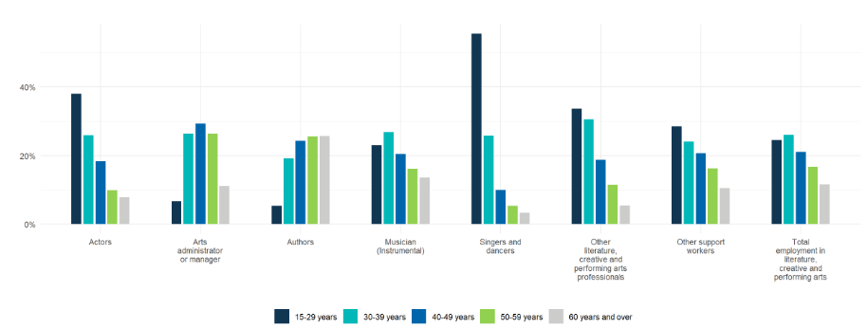
Source: ABS Labour Account Australia, Labour Force, Australia, Detailed, Quarterly; Jobs in Australia; Census of Population and Housing; BCARR calculations.
In contrast, singers and dancers were typically much younger, owing to the physical demands of these professions—especially dance—and tend to have shorter performing careers. However, many transition to other roles within their field afterward. The mean and median ages for singers and dancers in 2023–24 was 31.5 years and 28 years, respectively.
Figure 25. Literature, creative and performing arts employment, mean and median age, 2023–24
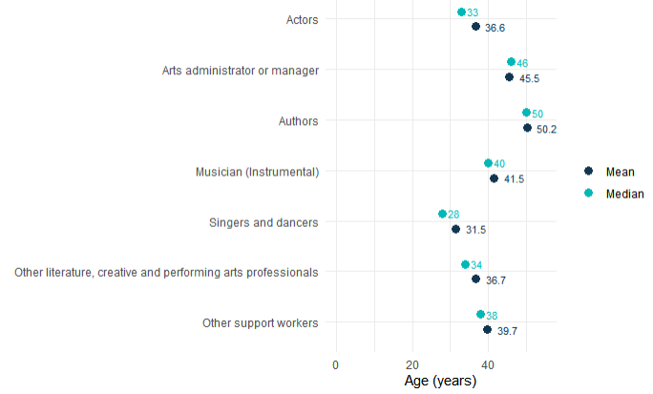
Source: ABS Labour Account Australia, Labour Force, Australia, Detailed, Quarterly; Jobs in Australia; Census of Population and Housing; BCARR calculations.
Females comprised 53% of total employed persons in this domain, while males accounted for 47%. Women were more strongly represented in occupations such as authors, singers and dancers; while men accounted for a larger share of musicians (Instrumental).
Figure 26. Literature, creative and performing arts employment, main occupations share by sex, 2023–24
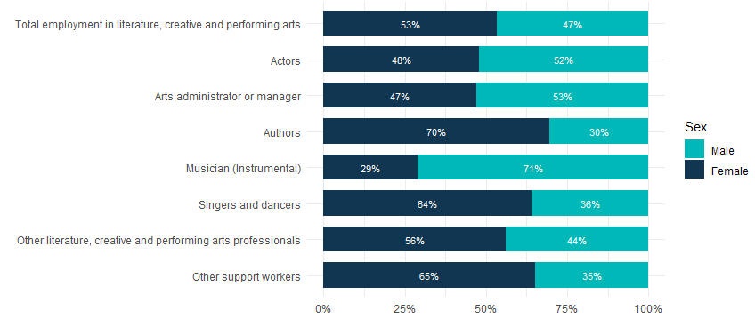
Source: ABS Labour Account Australia, Labour Force, Australia, Detailed, Quarterly; Jobs in Australia; Census of Population and Housing; BCARR calculations.
Male workers in literature, creative and performing arts were estimated at 20,717 in 2023–24, representing a 20.8% increase from 17,151 in 2008–09. Female workers were estimated at 23,768 in 2023–24, which is a 65.3% increase from 14,376 in 2008–09.
Figure 27. Literature, creative and performing arts employment, by sex and age, change between 2008–09 and 2023–24
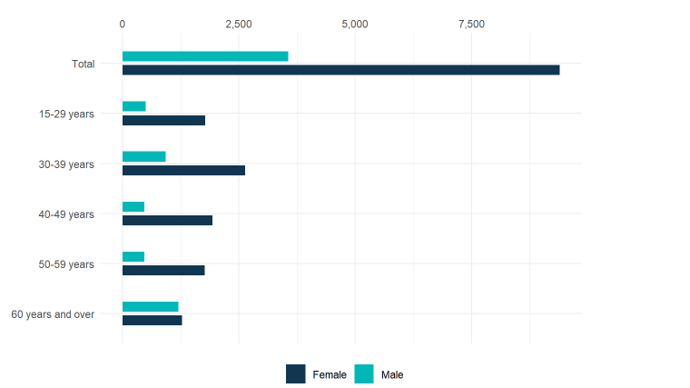
Source: ABS Labour Account Australia, Labour Force, Australia, Detailed, Quarterly; Jobs in Australia; Census of Population and Housing; BCARR calculations.
Between 2008–09 and 2023–24, employment in literature, creative, and performing arts for individuals aged 15–59 years increased by 36.3%, from 28,850 to 39,322; while workers aged 60 years and older increased by 92.8%, from 2,677 to 5,162 during the period.
Table 4. Literature, creative and performing arts employment, by sex and age, 2008–09 to 2023–24
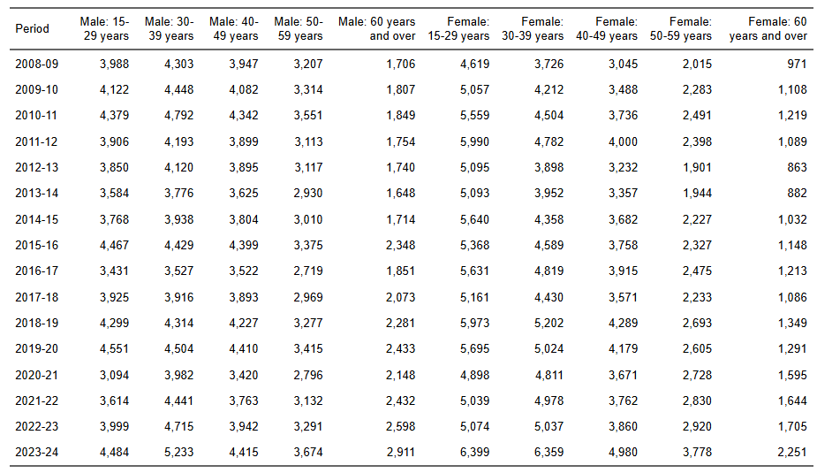
Source: ABS Labour Account Australia, Labour Force, Australia, Detailed, Quarterly; Jobs in Australia; Census of Population and Housing; BCARR calculations.

2. Visual arts and crafts
Visual arts and crafts include the activities of independent visual artists, craft manufacturing, professional photographic services, and photographic processing. Occupations within this domain include professionals who create visual concepts and forms through painting, drawing, carving, sculpting, modelling, printmaking, and other media for communication purposes. Additional roles involve individuals engaged in visual storytelling and technical production, such as cinematographers and illustrators; professionals involved in photographing and developing images, including photographers and their assistants; and jewellers who produce and repair jewellery.
In 2023–24, employment in visual arts and crafts was estimated at 65,434 individuals. Animators, visual effects artists, photographers, and jewellers account for about 75% of total employment in this domain.
Figure 28. Visual arts and crafts employment share by main occupations, 2023–24
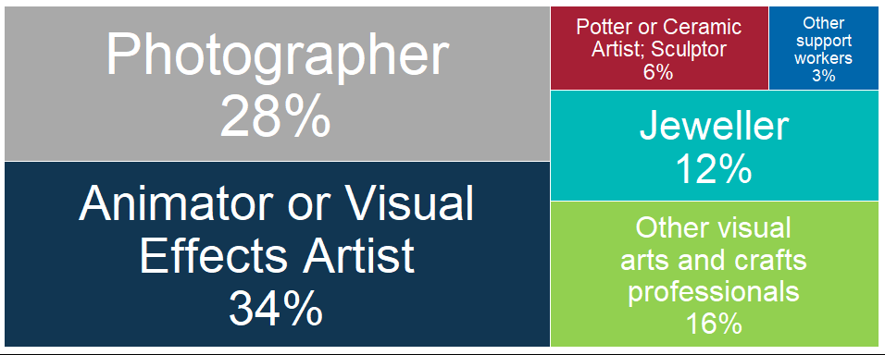
Source: ABS Labour Account Australia, Labour Force, Australia, Detailed, Quarterly; Jobs in Australia; Census of Population and Housing; BCARR calculations.
Visual arts and crafts employment increased by 43.8% (19,939 individuals) in 2023–24, from 45,495 people employed in 2008–09. The sector saw a drop in 2019–20 due to COVID-19, particularly affecting photographers, as lockdowns led households and businesses to use their own software and printers instead of professional services.
Figure 29. Visual arts and crafts employment, 2008–09 to 2023–24
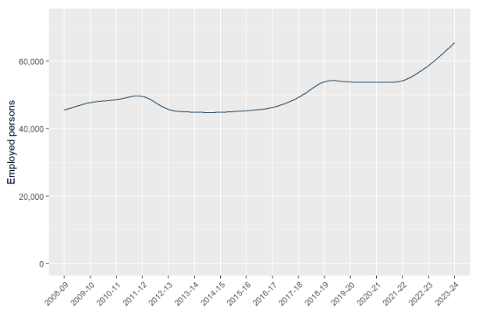
Source: ABS Labour Account Australia, Labour Force, Australia, Detailed, Quarterly; Jobs in Australia; Census of Population and Housing; BCARR calculations.
Many visual arts and crafts workers typically locate themselves in or near larger cities in New South Wales and Victoria where there is a deeper pool of potential clients.
Table 5. Visual arts and crafts employment by states, 2008–09 to 2023–24
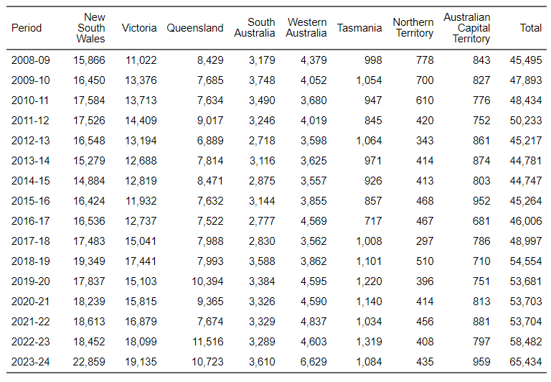
Source: ABS Labour Account Australia, Labour Force, Australia, Detailed, Quarterly; Jobs in Australia; Census of Population and Housing; BCARR calculations.
The concentration of visual arts and crafts employment in both New South Wales and Victoria exceeds that of total employment and general population shares in these states. The representation of visual arts and crafts employment in other states and territories—particularly Queensland—was comparatively lower than their respective overall employment distributions.
Figure 30. Visual arts and crafts, employment distribution by states and territories, 2023–24
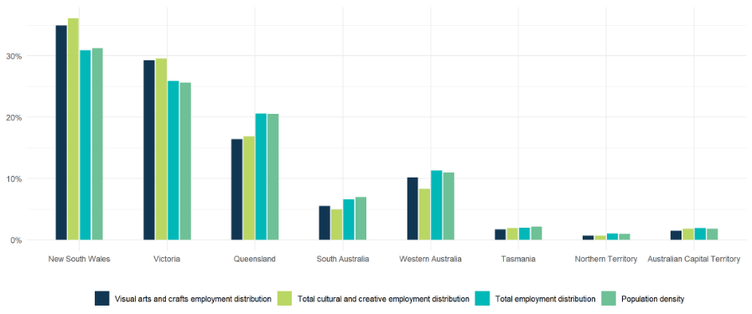
Source: ABS Labour Account Australia, Labour Force, Australia, Detailed, Quarterly; Jobs in Australia; Census of Population and Housing; National, state and territory population; BCARR calculations.
Individuals aged 30–39 years represented about 30% of the visual arts and crafts workforce, as shown in Figure 31.
Figure 31. Visual arts and crafts employment, main occupations share by age, 2023–24
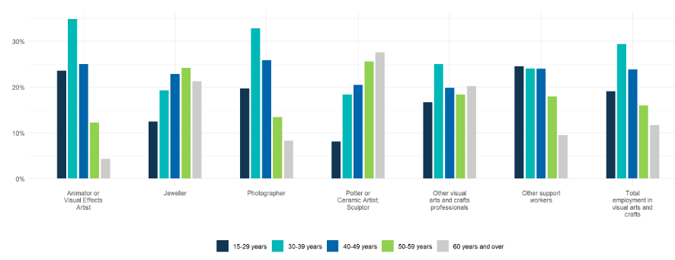
Source: ABS Labour Account Australia, Labour Force, Australia, Detailed, Quarterly; Jobs in Australia; Census of Population and Housing; BCARR calculations.
Meanwhile, most potters, ceramic artists, sculptors – the oldest artists in this domain – were typically in their 50s, with a median age of 51 years. People in these professions usually begin working later and continue working longer in the profession compared to other artistic occupations.
Figure 32. Visual arts and crafts employment, mean and median age, 2023–24
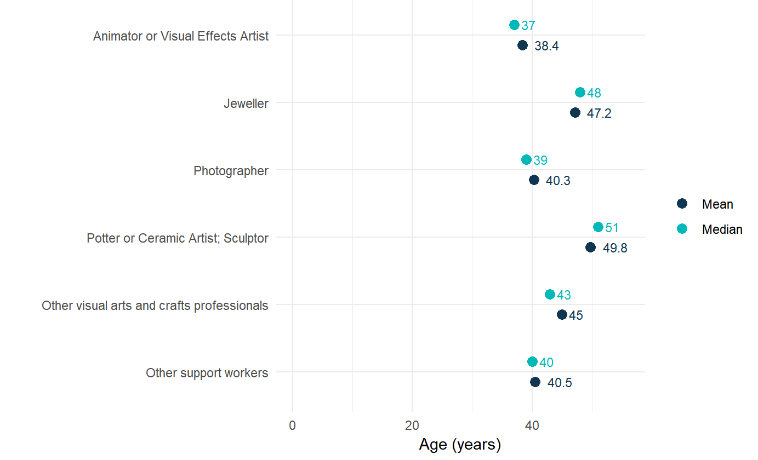
Source: ABS Labour Account Australia, Labour Force, Australia, Detailed, Quarterly; Jobs in Australia; Census of Population and Housing; BCARR calculations.
Females made up 55% of the total employed persons in this domain, while males represented 45%. A higher proportion of women were employed as potters, ceramic artists, and sculptors, whereas a greater proportion of men worked as jewellers.
Figure 33. Visual arts and crafts employment, main occupations share by sex, 2023–24
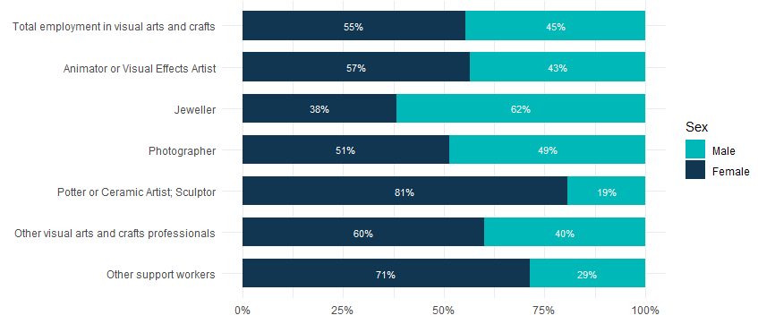
Source: ABS Labour Account Australia, Labour Force, Australia, Detailed, Quarterly; Jobs in Australia; Census of Population and Housing; BCARR calculations.
In 2023–24, male visual arts and crafts workers were estimated at 29,220, reflecting an increase of 21.0% from 24,147 in 2008–09. In comparison, female workers were estimated at 36,214 in 2023–24, marking a significantly higher growth rate of 69.6% from 21,348 employed persons in 2008–09.
Figure 34. Visual arts and crafts employment, by sex and age, change between 2008–09 and 2023–24
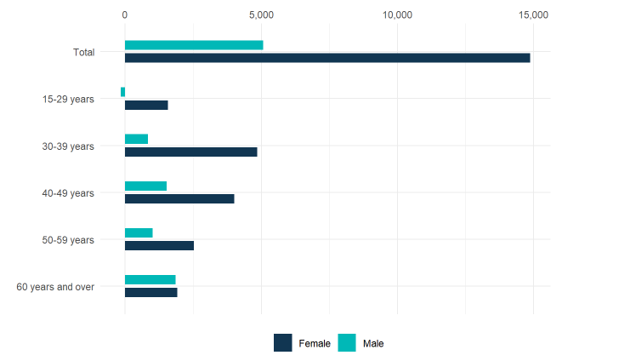
Source: ABS Labour Account Australia, Labour Force, Australia, Detailed, Quarterly; Jobs in Australia; Census of Population and Housing; BCARR calculations.
From 2008–09 to 2023–24, visual arts and crafts employment increased by 38.9% for those aged 15–59 years, from 41,630 to 57,808; while those over 60 years saw a greater growth rate of 97.3%, from 3,865 to 7,626 over the period.
Table 6. Visual arts and crafts employment, by sex and age, 2008–09 to 2023–24
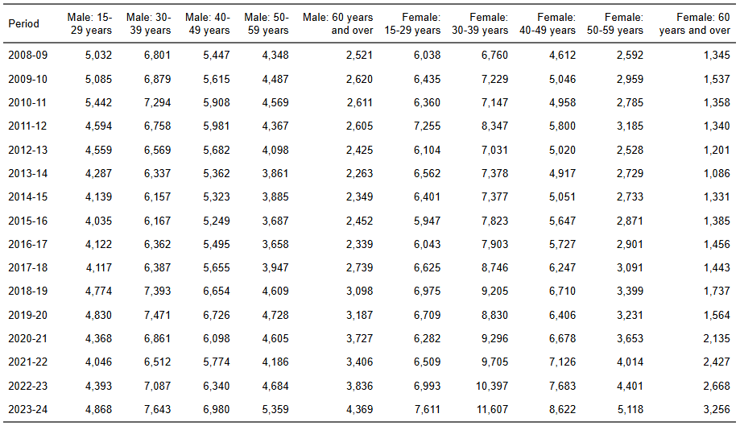
Source: ABS Labour Account Australia, Labour Force, Australia, Detailed, Quarterly; Jobs in Australia; Census of Population and Housing; BCARR calculations.

3. Music production and distribution
Music production and distribution includes activities such as manufacturing musical instruments, publishing and licensing copyrighted musical works, and producing, releasing, and distributing original master recordings.
Occupations in this domain include music professionals who arrange, orchestrate, conduct, and perform musical compositions; audio producers and engineers who plan and organise the creation and production of audio content and operate audio equipment; and musical instrument makers or repairers who build, repair, and restore musical instruments.
In 2023–24, an estimated 10,893 individuals were employed in music production and distribution, and over 90% work as audio engineers and producers, musical instrument makers or repairers, or other music professionals such as club DJs, music researchers, and repetiteurs.
Figure 35. Music production and distribution employment share by main occupations, 2023–24
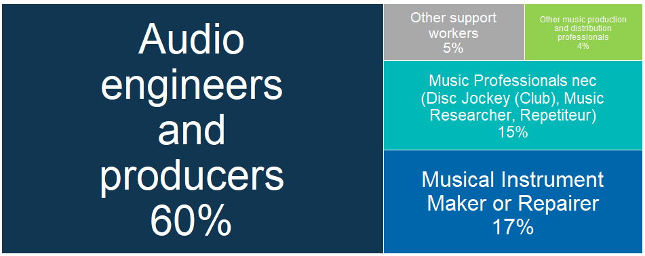
Source: ABS Labour Account Australia, Labour Force, Australia, Detailed, Quarterly; Jobs in Australia; Census of Population and Housing; BCARR calculations.
Music production and distribution employment experienced an increase of 1.2% or 126 individuals, from 10,767 employed in 2008–09.
Figure 36. Music production and distribution employment, 2008–09 to 2023–24
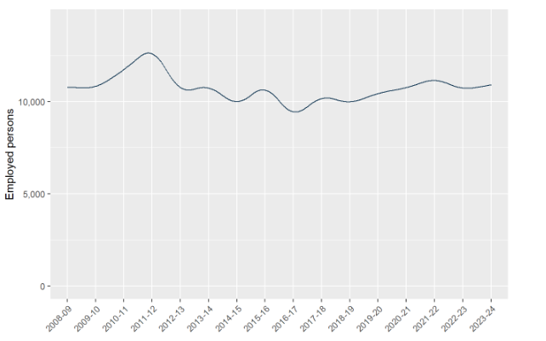
Source: ABS Labour Account Australia, Labour Force, Australia, Detailed, Quarterly; Jobs in Australia; Census of Population and Housing; BCARR calculations.
Sydney and Melbourne have the largest music publishing and sound recording workforce because of their size and relatively long history and presence in the Australian music scene.
Table 7. Music production and distribution employment by states, 2008–09 to 2023–24
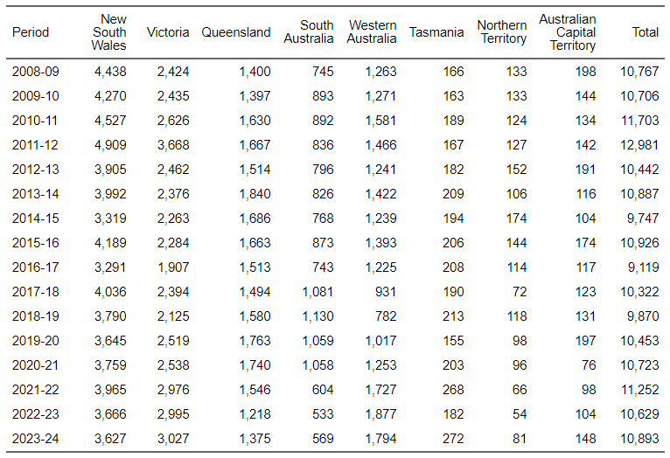
Source: ABS Labour Account Australia, Labour Force, Australia, Detailed, Quarterly; Jobs in Australia; Census of Population and Housing; BCARR calculations.
The distribution of music production and distribution employment in New South Wales, Victoria, Tasmania, and especially in Western Australia was greater than their corresponding shares of the total employment and population densities, while the other states and territories had lower employment in music production and distribution compared to their total employment shares, particularly in Queensland.
Figure 37. Music production and distribution, employment distribution by states and territories, 2023–24
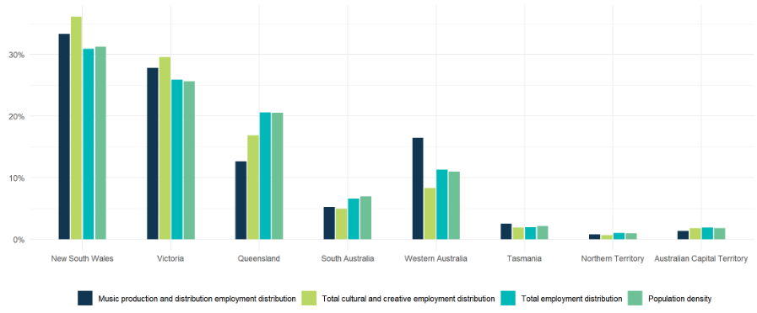
Source: ABS Labour Account Australia, Labour Force, Australia, Detailed, Quarterly; Jobs in Australia; Census of Population and Housing; National, state and territory population; BCARR calculations.
Individuals between the ages of 15 and 49 years comprised the largest segment of the music production and distribution workforce, accounting for 76.4% of the total.
Figure 38. Music production and distribution employment, main occupation shares by age, 2023–24
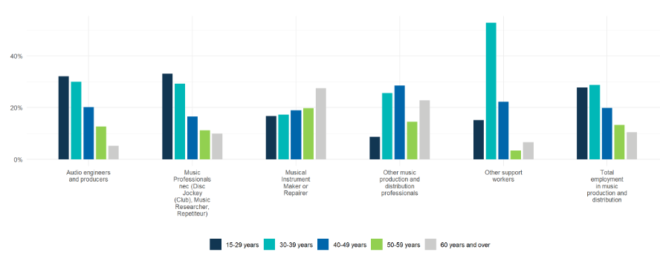
Source: ABS Labour Account Australia, Labour Force, Australia, Detailed, Quarterly; Jobs in Australia; Census of Population and Housing; BCARR calculations.
Musical instrument makers and repairers had the oldest average age in this domain, with a mean age of 47.3 years and a median age of 48 years. In contrast, audio engineers and producers had the youngest average age, representing a mean age of 37.3 years and a median age of 35 years.
Figure 39. Music production and distribution employment, mean and median age, 2023–24
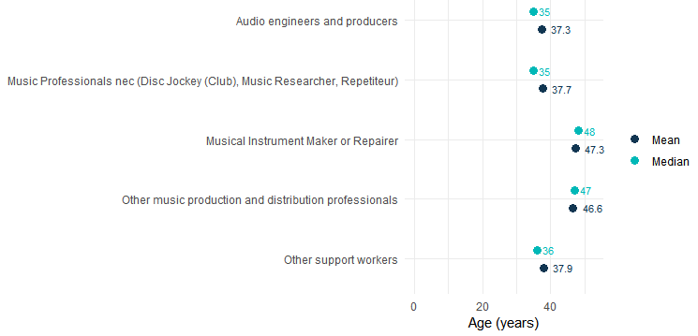
Source: ABS Labour Account Australia, Labour Force, Australia, Detailed, Quarterly; Jobs in Australia; Census of Population and Housing; BCARR calculations.
Females represented 20% of the total workforce in this sector, while males comprised 80%. Men were predominantly employed in professional roles within this domain, while women were primarily concentrated in support positions, such as customer service management and accounts clerks.
Figure 40. Music production and distribution employment, main occupations share by sex, 2023–24
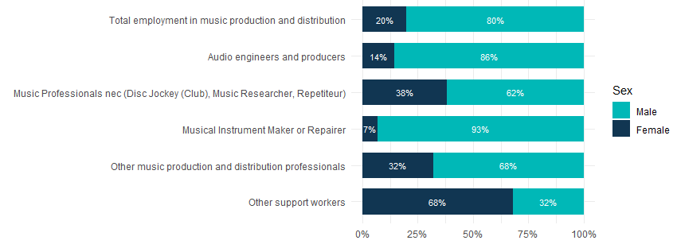
Source: ABS Labour Account Australia, Labour Force, Australia, Detailed, Quarterly; Jobs in Australia; Census of Population and Housing; BCARR calculations.
Male workers in music production and distribution were estimated at 8,721 in 2023–24, representing a 5.2% increase from 8,286 in 2008–09. Female workers were estimated at 2,172 in 2023–24, which is a 12.4% decrease from 2,481 in 2008–09.
Figure 41. Music production and distribution employment, by sex and age, change between 2008–09 and 2023–24
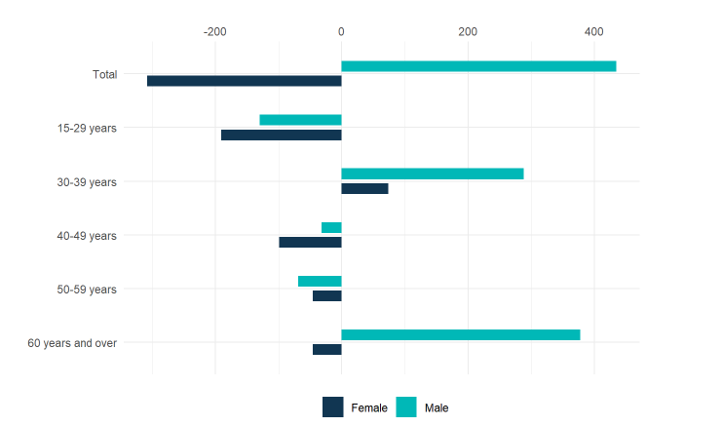
Source: ABS Labour Account Australia, Labour Force, Australia, Detailed, Quarterly; Jobs in Australia; Census of Population and Housing; BCARR calculations.
In 2023–24, there were an estimated 9,762 music production and distribution workers aged 15 to 59 years, a 2.1% decrease from 9,968 in 2008–09. Workers aged over 60 years increased by 41.5%, rising from 779 to 1,131.
Table 8. Music production and distribution employment, by sex and age, 2008–09 to 2023–24
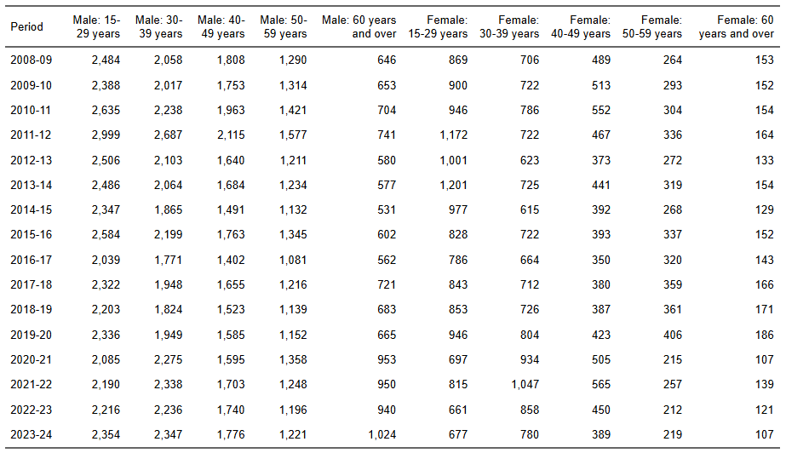
Source: ABS Labour Account Australia, Labour Force, Australia, Detailed, Quarterly; Jobs in Australia; Census of Population and Housing; BCARR calculations.

4. Museums and galleries
Museums and galleries protect and display objects, visual arts, and crafts of cultural, historical, or educational significance, including those at historical sites. Key occupations include curators, technicians, guides, heritage consultants, historians, and conservators, who manage collections, create exhibits, and assist visitors.
In 2023–24, the estimated number of individuals employed in museum and galleries was 8,230. The largest professional occupations were heritage consultants and gallery or museum guides, comprising approximately 40% of total employment in this domain. Other support workers represented about 40% of employment in this domain.
Figure 42. Museums and galleries employment by main occupations, 2023–24
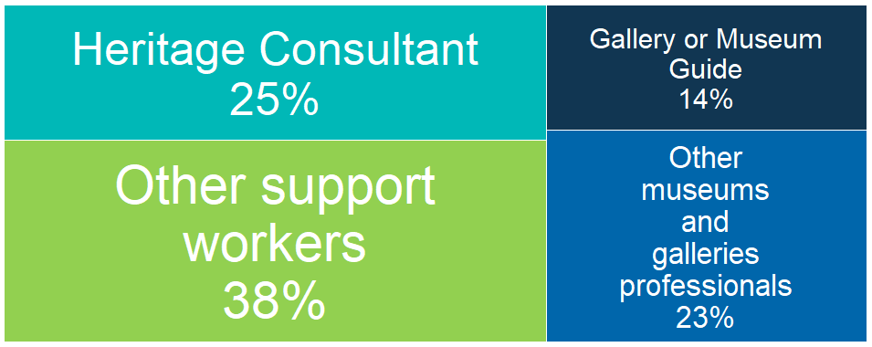
Source: ABS Labour Account Australia, Labour Force, Australia, Detailed, Quarterly; Jobs in Australia; Census of Population and Housing; BCARR calculations.
Museum and gallery employment rose 12.8% from 7,299 in 2008–09 to 8,230 in 2023–24, with a decline noted in 2019–20. Lockdowns beginning March 2020 led to prolonged closures and a sharp drop in visitor numbers.
Figure 43. Museum and galleries employment, 2008–09 to 2023–24
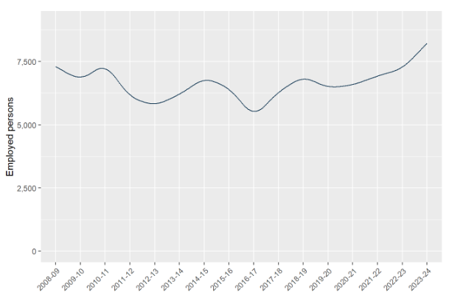
Source: ABS Labour Account Australia, Labour Force, Australia, Detailed, Quarterly; Jobs in Australia; Census of Population and Housing; BCARR calculations.
Victoria and New South Wales are home to the largest shares of employment in museums and galleries.
Table 9. Museums and galleries employment by states, 2008–09 to 2023–24
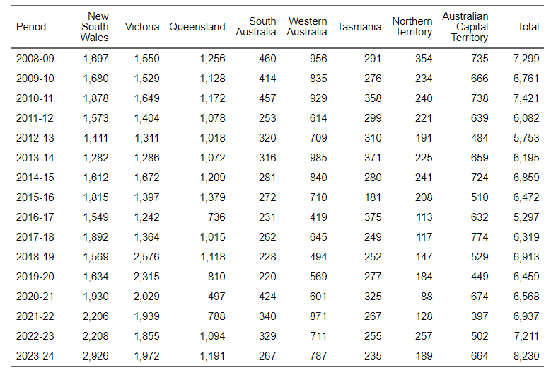
Source: ABS Labour Account Australia, Labour Force, Australia, Detailed, Quarterly; Jobs in Australia; Census of Population and Housing; BCARR calculations.
However, the employment distribution for museums and galleries in Victoria was less than its shares of total employment and population. In contrast, Tasmania, the Northern Territory, and the Australian Capital Territory had higher employment shares in museums and galleries compared to their respective shares of total employment and population.
Figure 44. Museum and galleries, employment distribution by states and territories, 2023–24
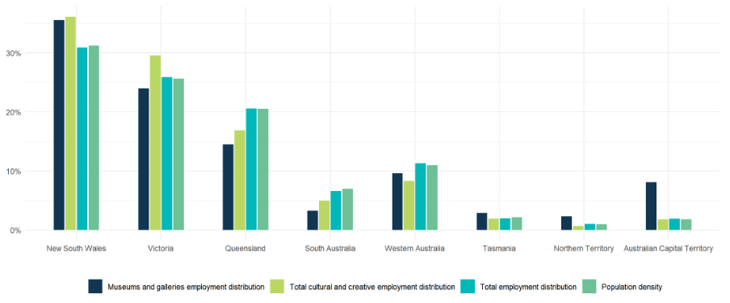
Source: ABS Labour Account Australia, Labour Force, Australia, Detailed, Quarterly; Jobs in Australia; Census of Population and Housing; National, state and territory population; BCARR calculations.
In 2023–24, individuals aged 30 to 59 years comprised more than 60% of the workforce in museums and galleries.
Figure 45. Museums and galleries employment, main occupation shares by age, 2023–24
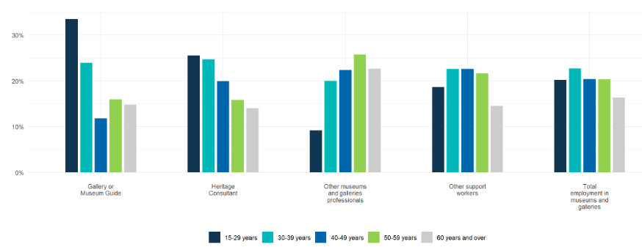
Source: ABS Labour Account Australia, Labour Force, Australia, Detailed, Quarterly; Jobs in Australia; Census of Population and Housing; BCARR calculations.
The youngest group within this domain was gallery and museum guides, with a mean age of 39.8 years and a median age of 36 years.
Figure 46. Museum and galleries employment, mean and median age, 2023–24
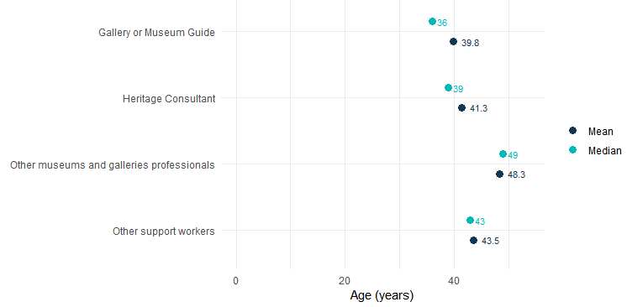
Source: ABS Labour Account Australia, Labour Force, Australia, Detailed, Quarterly; Jobs in Australia; Census of Population and Housing; BCARR calculations.
Women made up over 60% of the workforce in this domain in 2023–24, holding most positions in museums and galleries, including occupations like heritage consultants and museum guides.
Figure 47. Museums and galleries employment, main occupations share by sex, 2023–24
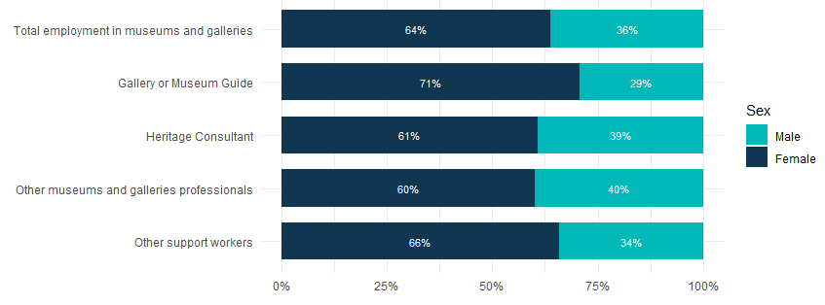
Source: ABS Labour Account Australia, Labour Force, Australia, Detailed, Quarterly; Jobs in Australia; Census of Population and Housing; BCARR calculations.
There were an estimated 2,973 male workers employed in museum and galleries, a 2.4% increase (71 individuals) from 2,902 in 2008–09. In the same period, there were an estimated 5,257 female workers, representing a 19.6% (860 individuals) increase from 4,397 in 2008–09.
Figure 48. Museum and galleries employment, by sex and age, change between 2008–09 and 2023–24
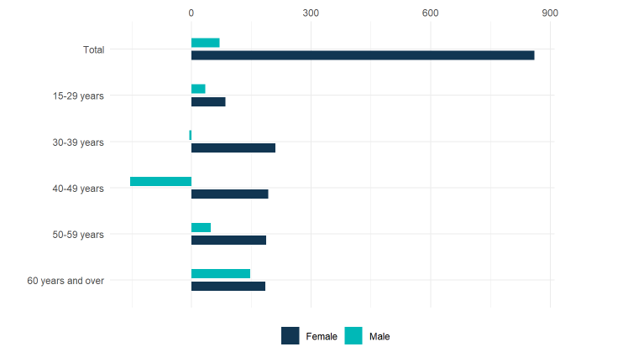
Source: ABS Labour Account Australia, Labour Force, Australia, Detailed, Quarterly; Jobs in Australia; Census of Population and Housing; BCARR calculations.
In 2023–24, an estimated 6,885 individuals aged 15 to 59 years were employed as museum and gallery workers, representing a 9.5% increase (599 individuals) from 6,286 in 2008–09. The number of workers over the age of 60 years increased by 32.8% (332 individuals), rising from 1,013 to 1,345 during the same period.
Table 10. Museum and galleries employment, by sex and age, 2008–09 to 2023–24
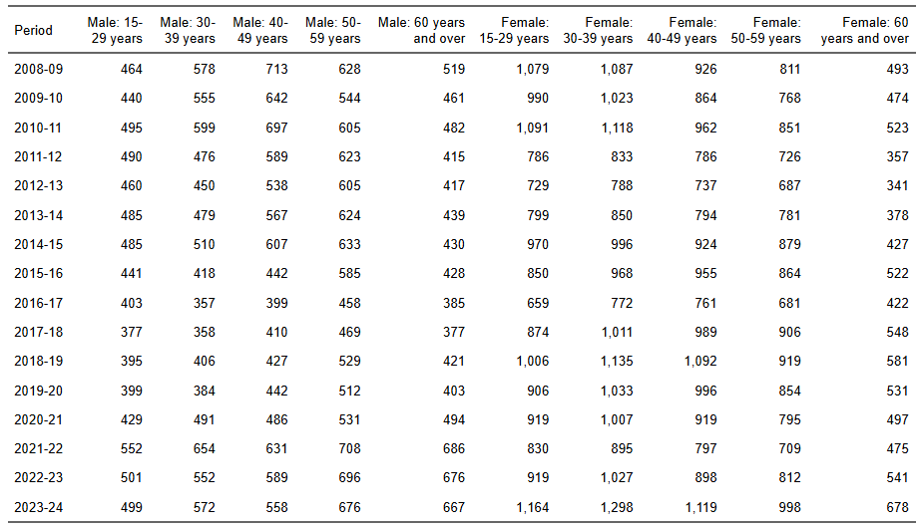
Source: ABS Labour Account Australia, Labour Force, Australia, Detailed, Quarterly; Jobs in Australia; Census of Population and Housing; BCARR calculations.

5. Film and television activities
Film and television activities includes motion picture and video production, distribution, exhibition, post-production services, as well as free-to-air, cable, and other subscription-based television broadcasting. This domain includes media directors and designers who manage creative and technical aspects of film and TV, professionals who direct, produce, present, write scripts, or edit news, as well as technicians and assistants involved in production, recording, broadcasting, and management roles like cinema managers and broadcast technicians.
In 2023–24, an estimated 43,658 people worked in this domain. About half were in screen or production professions (such as directors, editors, and camera operators), while other support workers represented around 33% of the workforce.
Figure 49. Film and television activities employment share by main occupations, 2023–24
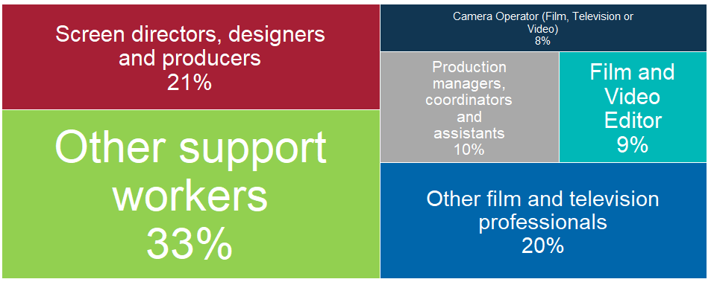
Source: ABS Labour Account Australia, Labour Force, Australia, Detailed, Quarterly; Jobs in Australia; Census of Population and Housing; BCARR calculations.
Employment in film and television activities increased by 14.2% or 5,440 individuals in 2023–24, compared to 38,218 in 2008–09. Since 2022–23, employment in this sector has decreased, mainly due to reductions in motion picture and video production, as well as motion picture exhibition industries.
Figure 50. Film and television activities employment, 2008–09 to 2023–24
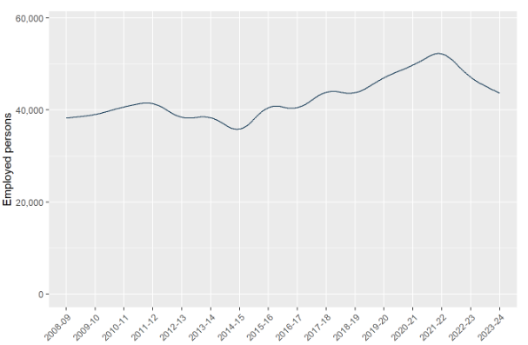
Source: ABS Labour Account Australia, Labour Force, Australia, Detailed, Quarterly; Jobs in Australia; Census of Population and Housing; BCARR calculations.
Over 85% of employment within this domain is in New South Wales, Victoria, and Queensland, reflecting the concentration of studio facilities, TV headquarters, advertising agencies, and post-production support in these states.
Table 11. Film and television activities employment by states, 2008–09 to 2023–24
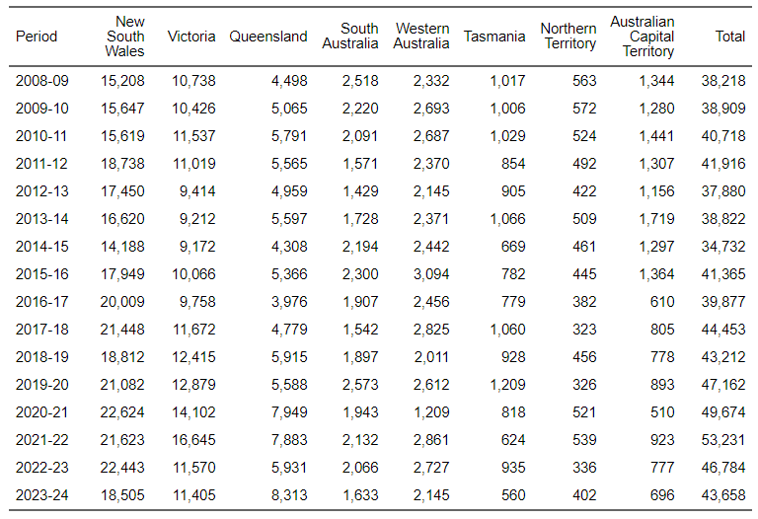
Source: ABS Labour Account Australia, Labour Force, Australia, Detailed, Quarterly; Jobs in Australia; Census of Population and Housing; BCARR calculations.
The distribution of film and television employment in New South Wales far exceeds its shares of total employment and population. In other states and territories, except Victoria, employment shares in this domain were lower than their overall employment shares, especially in Western Australia.
Figure 51. Film and television activities, employment distribution by states and territories, 2023–24
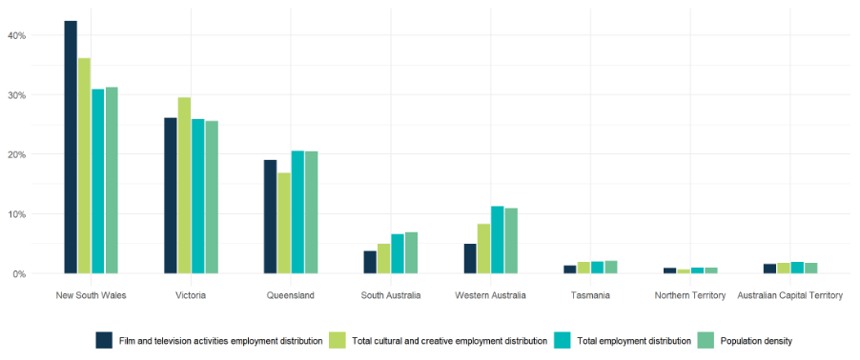
Source: ABS Labour Account Australia, Labour Force, Australia, Detailed, Quarterly; Jobs in Australia; Census of Population and Housing; National, state and territory population; BCARR calculations.
In 2023–24, individuals aged 15–39 years accounted for more than 60% of the workforce within film and television activities.
Figure 52. Film and television activities employment, main occupation shares by age, 2023–24
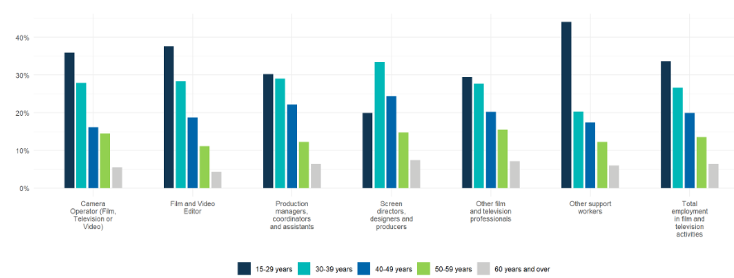
Source: ABS Labour Account Australia, Labour Force, Australia, Detailed, Quarterly; Jobs in Australia; Census of Population and Housing; BCARR calculations.
Screen directors, designers and producers were the oldest professional group in this domain, with a mean age of 40.2 years and a median age of 38 years; while film and video editors were the youngest on average, with a mean age of 35.7 years and median age of 33 years.
Figure 53. Film and television activities employment, mean and median age, 2023–24
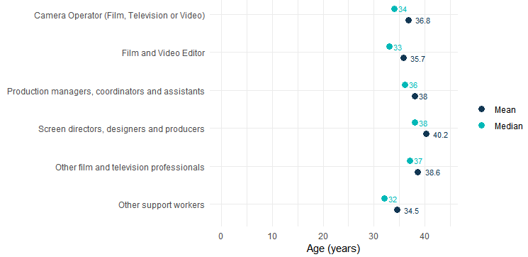
Source: ABS Labour Account Australia, Labour Force, Australia, Detailed, Quarterly; Jobs in Australia; Census of Population and Housing; BCARR calculations.
Males in this domain represented 56% of the total workforce in 2023–24, leading roles such as camera operators, film and video editors; while females represented 44%, leading roles relating to production professionals.
Figure 54. Film and television activities employment, main occupations share by sex, 2023–24
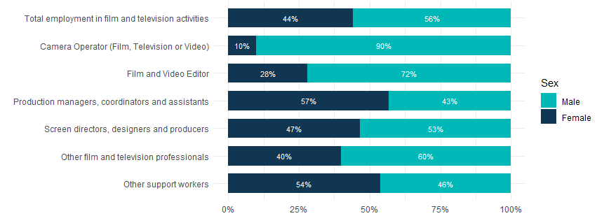
Source: ABS Labour Account Australia, Labour Force, Australia, Detailed, Quarterly; Jobs in Australia; Census of Population and Housing; BCARR calculations.
In 2023–24, film and television activities employed an estimated 24,401 men (up 13.1% from 21,573 in 2008–09) and 19,257 women (up 15.7% from 16,645 in 2008–09).
Figure 55. Film and television activities employment, by sex and age, change between 2008–09 and 2023–24
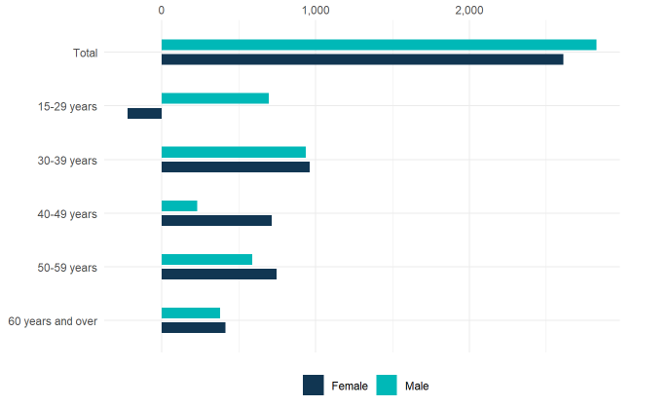
Source: ABS Labour Account Australia, Labour Force, Australia, Detailed, Quarterly; Jobs in Australia; Census of Population and Housing; BCARR calculations.
The number of film and television activities workers aged 15 to 59 was estimated at 40,879 in 2023–24, representing a 12.8% increase from 36,229 in 2008–09. The number of workers over 60 years grew by 39.7%, from 1,989 to 2,779 over the same period.
Table 12. Film and television activities employment, by sex and age, 2008–09 to 2023–24
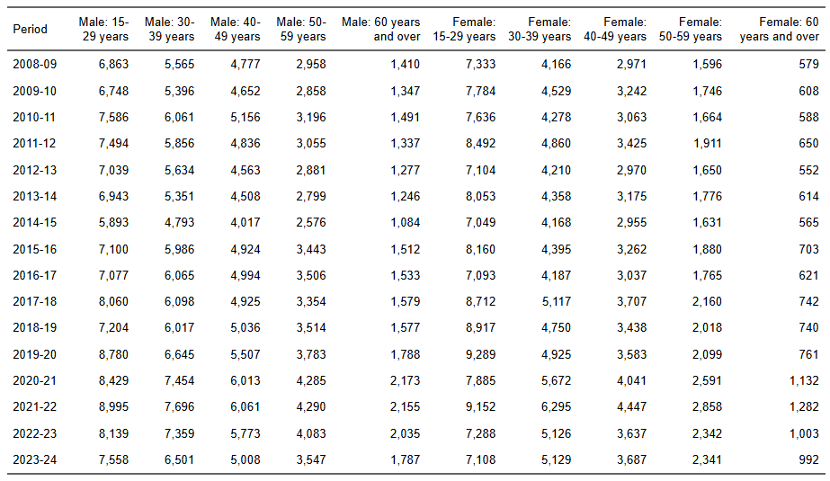
Source: ABS Labour Account Australia, Labour Force, Australia, Detailed, Quarterly; Jobs in Australia; Census of Population and Housing; BCARR calculations.

6. Radio broadcasting
This domain covers transmitting audio signals for radio programming. Occupations include media professionals who host shows, write and edit news, as well as radio broadcast technicians and production staff.
In 2023–24, the radio broadcasting domain was estimated at 3,309 employed individuals. The main radio broadcasting professionals include media presenters, directors, designers, and radio journalists. However, over 60% of employment was for support workers.
Figure 56. Radio broadcasting employment share by main occupations, 2023–24
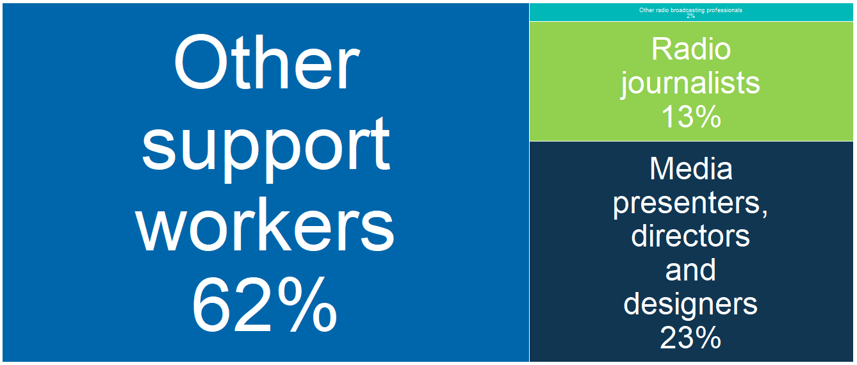
Source: ABS Labour Account Australia, Labour Force, Australia, Detailed, Quarterly; Jobs in Australia; Census of Population and Housing; BCARR calculations.
Radio broadcasting employment fell by 2,201 (39.9%) in 2023–24 compared to 5,510 in 2008–09. The adoption of automation for tasks such as playlist curation has contributed to reduced fixed labour costs. Additionally, the industry’s use of more flexible employment structures, including an increase in part-time and contract workers, has helped manage labour costs in response to changing demand.
Figure 57. Radio broadcasting employment, 2008–09 to 2023–24
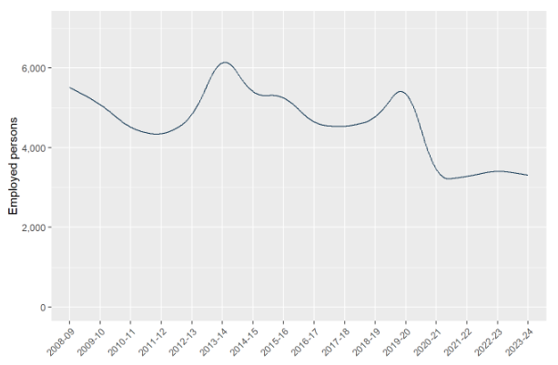
Source: ABS Labour Account Australia, Labour Force, Australia, Detailed, Quarterly; Jobs in Australia; Census of Population and Housing; BCARR calculations.
Radio broadcasters mainly operate in populous areas, with New South Wales having the most stations. This is due to strong competition, high advertising spending, and better access to skilled labour and infrastructure. Smaller states have fewer stations compared to their populations.
Table 13. Radio broadcasting employment by states, 2008–09 to 2023–24
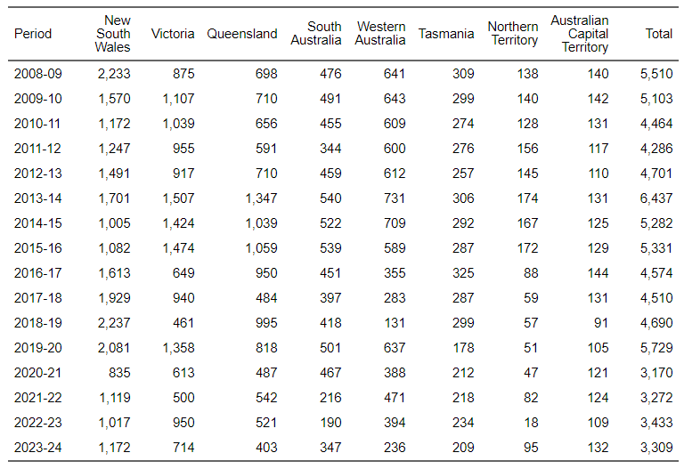
Source: ABS Labour Account Australia, Labour Force, Australia, Detailed, Quarterly; Jobs in Australia; Census of Population and Housing; BCARR calculations.
However, South Australia, Tasmania, Northern Territory and Australian Capital Territory also demonstrated a higher proportion of employment in this domain compared to their overall employment distributions and population densities.
Figure 58. Radio broadcasting, employment distribution by states and territories, 2023–24
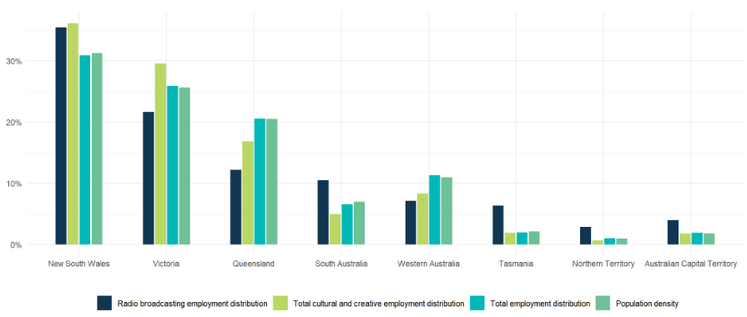
Source: ABS Labour Account Australia, Labour Force, Australia, Detailed, Quarterly; Jobs in Australia; Census of Population and Housing; National, state and territory population; BCARR calculations.
In 2023–24, over 50% employed individuals in this domain were aged 15–39 years. The 15–29 age group comprised the largest share of radio journalists (40%) and other radio broadcasting professionals (47%) such as broadcast technicians, while the 30–39 age group represented the largest share among media presenters (30%).
Figure 59. Radio broadcasting employment, main occupations share by age, 2023–24
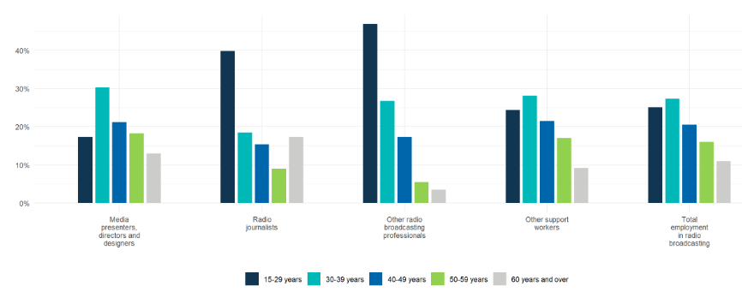
Source: ABS Labour Account Australia, Labour Force, Australia, Detailed, Quarterly; Jobs in Australia; Census of Population and Housing; BCARR calculations.
Media presenters, directors and designers were the oldest occupational group in this domain, with a mean age of 42.5 years and a median age of 41 years; while other radio broadcasting professionals, including broadcast technicians and audio or live performance directors were the youngest, with a mean age of 34 years and median age of 31 years.
Figure 60. Radio broadcasting employment, mean and median age, 2023–24
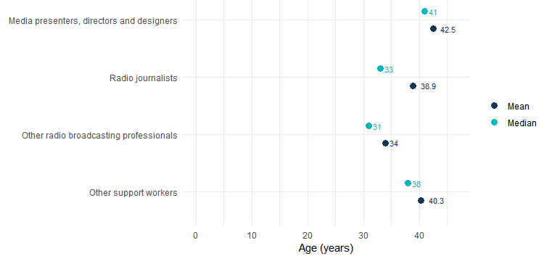
Source: ABS Labour Account Australia, Labour Force, Australia, Detailed, Quarterly; Jobs in Australia; Census of Population and Housing; BCARR calculations.
In 2023–24, females comprised 52% of the workforce in this domain, often working in roles related to radio journalists and other support positions, such as sales representatives. Males represented 48%, commonly occupying positions such as media presenters, directors, and designers and other radio broadcasting professionals.
Figure 61. Radio broadcasting employment, main occupations share by sex, 2023–24
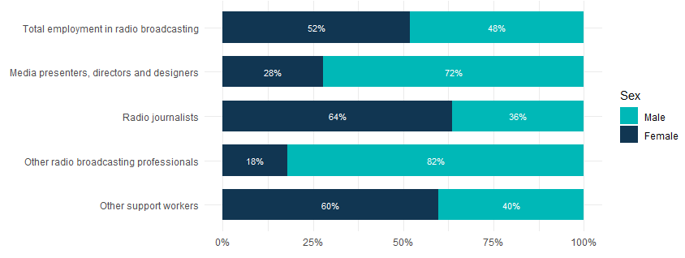
Source: ABS Labour Account Australia, Labour Force, Australia, Detailed, Quarterly; Jobs in Australia; Census of Population and Housing; BCARR calculations.
Male radio broadcasting workers were estimated at 1,592 in 2023–24, representing a 43.5% drop from 2,818 in 2008–09. Female workers in this domain declined by 36.2%, from 2,692 to 1,717 over the same period.
Figure 62. Radio broadcasting employment, by sex and age, change between 2008–09 and 2023–24
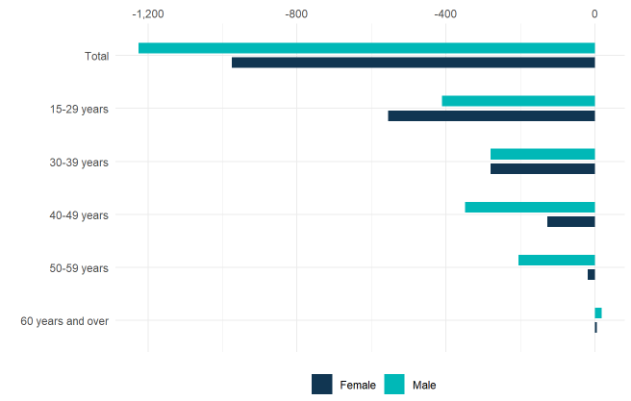
Source: ABS Labour Account Australia, Labour Force, Australia, Detailed, Quarterly; Jobs in Australia; Census of Population and Housing; BCARR calculations.
In 2023–24, there were 2,946 radio broadcasting workers aged 15 to 59 years, down 43.0% from 5,172 in 2008–09. In contrast, workers over 60 years increased by 7.3%, rising from 338 to 363.
Table 14. Radio broadcasting employment, by sex and age, 2008–09 to 2023–24
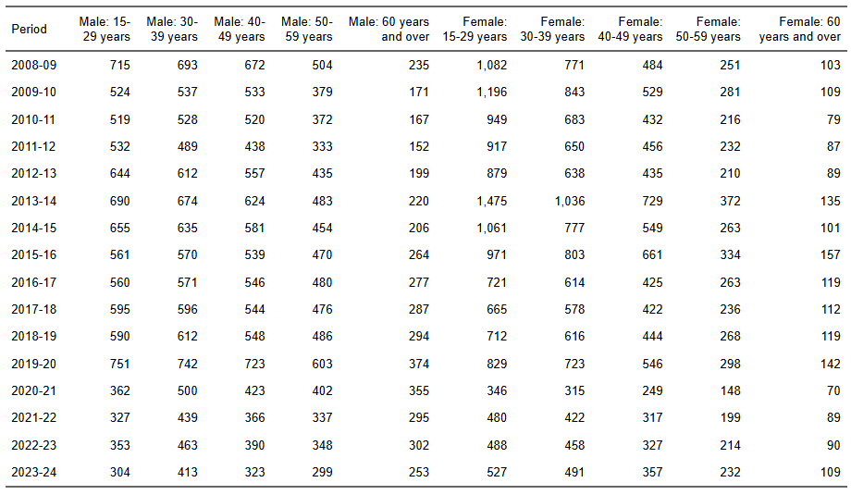
Source: ABS Labour Account Australia, Labour Force, Australia, Detailed, Quarterly; Jobs in Australia; Census of Population and Housing; BCARR calculations.

7. Internet publishing and broadcasting
Internet publishing and broadcasting includes publishing or broadcasting content online. Occupations within this domain include digital designers who plan, design, and develop user interfaces, user experiences, websites, and diverse forms of digital content tailored for various digital environments. Additionally, professionals such as online or digital book editors, script editors, journalists, and writers contribute to the creation and refinement of digital content.
In 2023–24, it was estimated that 7,594 people were employed in internet publishing and broadcasting. Multimedia designers and online or digital technical writers made up 42% of the workforce in this domain, while non-professional support workers—such as sales representatives, marketing specialists, and ICT project managers—also comprised a substantial 46% of total employment.
Figure 63. Internet publishing and broadcasting employment by main occupations, 2023–24
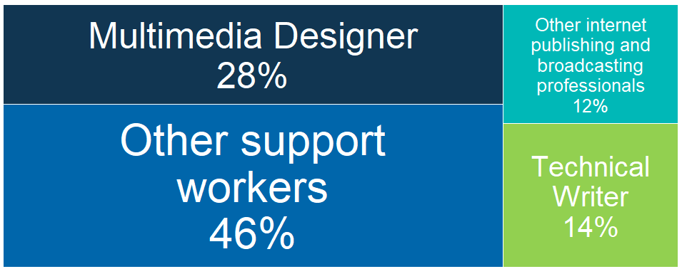
Source: ABS Labour Account Australia, Labour Force, Australia, Detailed, Quarterly; Jobs in Australia; Census of Population and Housing; BCARR calculations.
Employment in internet publishing and broadcasting experienced an increase of 2,327 people or 44.2% in 2023–24, compared to 5,267 employed persons in 2008–09. Employment in this domain saw consistent growth through 2020–21 due to rising consumer demand and increased SVOD usage during COVID-19 lockdowns. However, the pandemic led to weaker economic conditions, negatively impacting areas like online classifieds and limiting revenue for online advertising services. In addition, firms hired skilled software engineers for website databases, mobile apps, and cybersecurity, but efficiency gains and economies of scale limited overall workforce growth, with a focus on data analytics, cybersecurity, and software development skills.
Figure 64. Internet publishing and broadcasting employment, 2008–09 to 2023–24
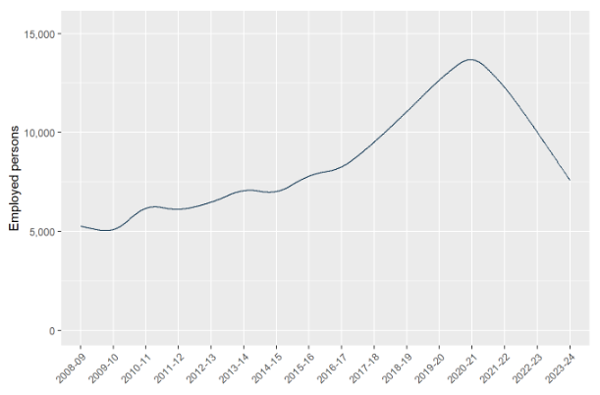
Source: ABS Labour Account Australia, Labour Force, Australia, Detailed, Quarterly; Jobs in Australia; Census of Population and Housing; BCARR calculations.
Sydney and Melbourne host many of Australia’s internet publishers and broadcasters, reflecting their sizable labour markets.
Table 15. Internet publishing and broadcasting employment by states, 2008–09 to 2023–24
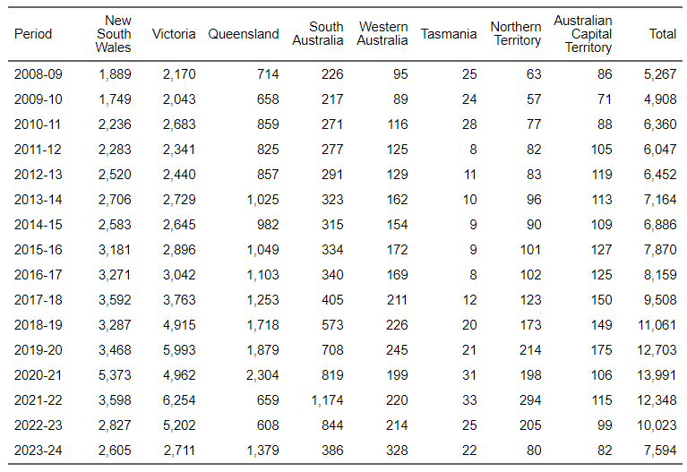
Source: ABS Labour Account Australia, Labour Force, Australia, Detailed, Quarterly; Jobs in Australia; Census of Population and Housing; BCARR calculations.
Economic activity within this domain is primarily concentrated in Sydney and Melbourne, resulting in lower representation of other states and territories relative to their population proportions. Because the industry operates largely via the internet, business activity can be conducted from a single establishment across wide regions, reducing the need for companies to maintain multiple locations. Major corporations are mainly located in Australia’s commercial centres, which contributes to the relatively stable geographic distribution of the industry.
Figure 65. Internet publishing and broadcasting, employment distribution by states and territories, 2023–24
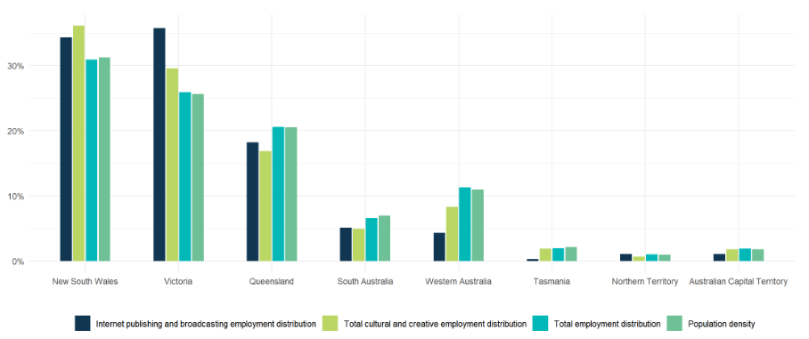
Source: ABS Labour Account Australia, Labour Force, Australia, Detailed, Quarterly; Jobs in Australia; Census of Population and Housing; National, state and territory population; BCARR calculations.
In 2023–24, individuals aged 30–39 represent the largest age group among employed persons in this domain, comprising approximately 33%.
Figure 66. Internet publishing and broadcasting employment, main occupation shares by age, 2023–24
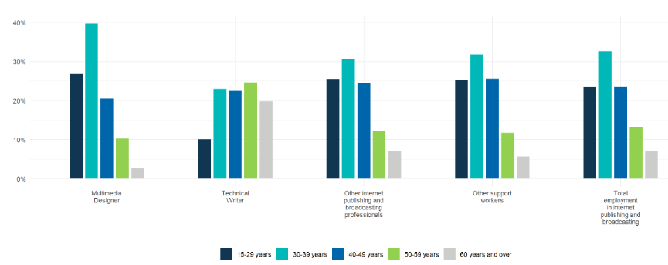
Source: ABS Labour Account Australia, Labour Force, Australia, Detailed, Quarterly; Jobs in Australia; Census of Population and Housing; BCARR calculations.
The primary occupations in the 30–39 group include multimedia designers, with a mean age of 36.9 years and a median age of 36 years; as well as support roles such as ICT sales representatives, with a mean age of 38.4 years and a median age of 37 years.
Figure 67. Internet publishing and broadcasting employment, mean and median age, 2023–24
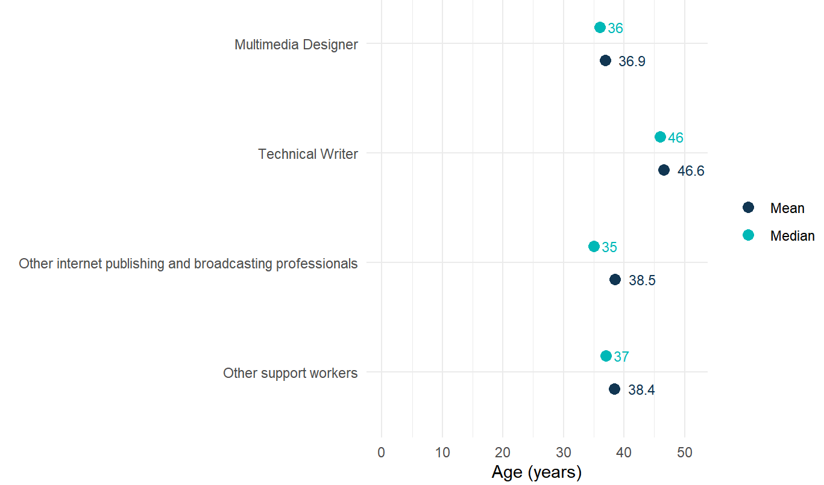
Source: ABS Labour Account Australia, Labour Force, Australia, Detailed, Quarterly; Jobs in Australia; Census of Population and Housing; BCARR calculations.
Females represented 51% of the total workforce in this domain, holding positions such as technical writers and digital content editors, while males comprised 49%, occupying roles including multimedia designers in 2023–24.
Figure 68. Internet publishing and broadcasting employment, main occupations share by sex, 2023–24
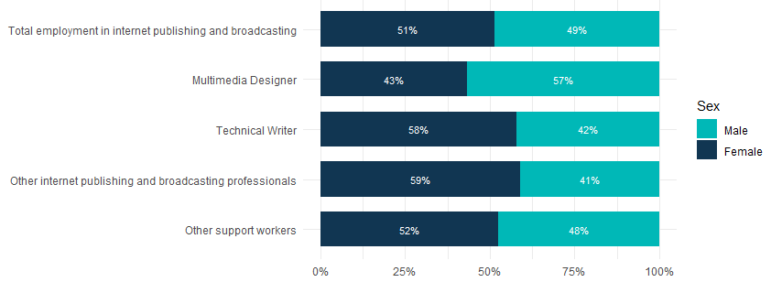
Source: ABS Labour Account Australia, Labour Force, Australia, Detailed, Quarterly; Jobs in Australia; Census of Population and Housing; BCARR calculations.
The estimated number of male workers employed in internet publishing and broadcasting was 3,687 in 2023–24, reflecting a 19.3% increase (an additional 596 individuals) from 3,091 in 2008–09. Over the same period, female employment rose to 3,907, marking a significant growth of 79.6% (additional 1,731 individuals) compared to 2,176 in 2008–09.
Figure 69. Internet publishing and broadcasting employment, by sex and age, change between 2008–09 and 2023–24
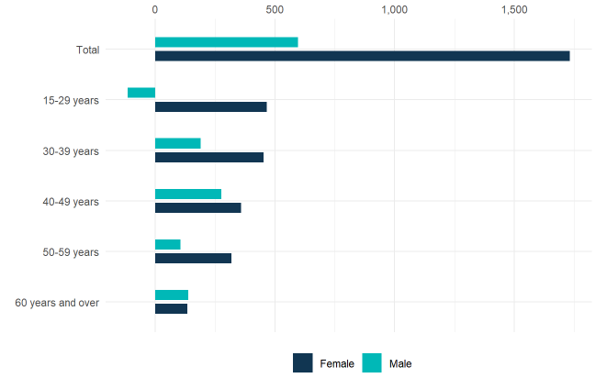
Source: ABS Labour Account Australia, Labour Force, Australia, Detailed, Quarterly; Jobs in Australia; Census of Population and Housing; BCARR calculations.
In 2023–24, there were 7,060 internet publishing and broadcasting workers aged 15 to 59 years, an increase of 41.0% from 5,006 in 2008–09. The number of workers aged over 60 years increased from 261 to 534 over the same period.
Table 16. Internet publishing and broadcasting employment, by sex and age, 2008–09 to 2023–24
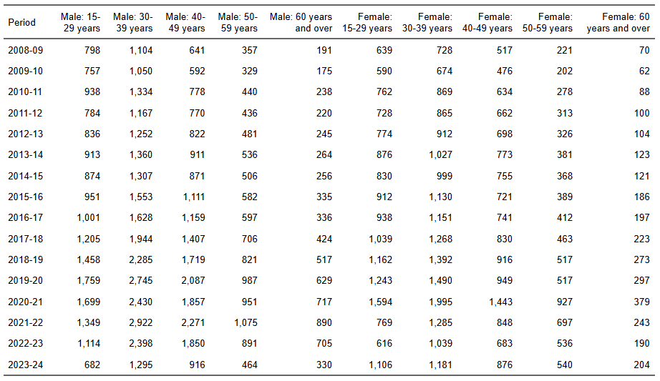
Source: ABS Labour Account Australia, Labour Force, Australia, Detailed, Quarterly; Jobs in Australia; Census of Population and Housing; BCARR calculations.

8. Libraries and archives
Libraries and archives include maintaining collections of documents and facilitating their use. Occupations in this domain includes librarians, library services managers, technicians and assistants, as well as archivists.
In 2023–24, the estimated number of individuals employed in libraries and archives was 22,304, with around 90% of employment relating to librarians, library technicians, managers and assistants.
Figure 70. Libraries and archives employment share by main occupations, 2023–24
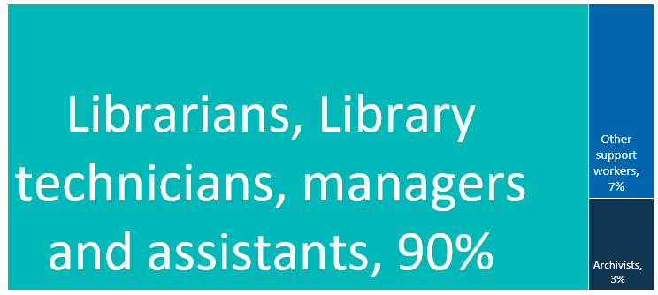
Source: ABS Labour Account Australia, Labour Force, Australia, Detailed, Quarterly; Jobs in Australia; Census of Population and Housing; BCARR calculations.
Library and archive employment in 2023–24 experienced a decrease of 19.0% (5,234 people) from 27,538 in 2008–09. This decline was due to revenue growing slowly, with libraries turning to more volunteers and reducing wage shares. However, the archiving sector will likely expand due to rising demand for skilled labour driven by more communication channels and digital content.
Figure 71. Libraries and archives employment, 2008–09 to 2023–24
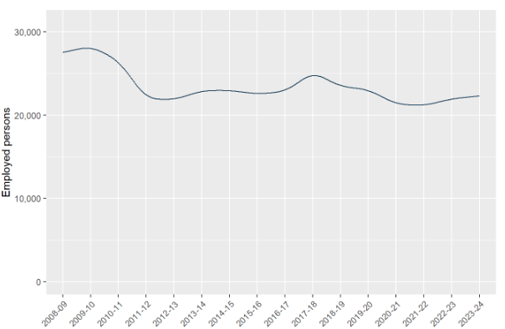
Source: ABS Labour Account Australia, Labour Force, Australia, Detailed, Quarterly; Jobs in Australia; Census of Population and Housing; BCARR calculations.
The distribution of library and archive locations generally reflects the distribution of the population and educational institutions. New South Wales, Victoria and Queensland accounted for more than 85% of industry enterprises in 2023–24, principally due to the large populations and greater numbers of schools and universities within these states.
Table 17. Libraries and archives employment by states, 2008–09 to 2023–24
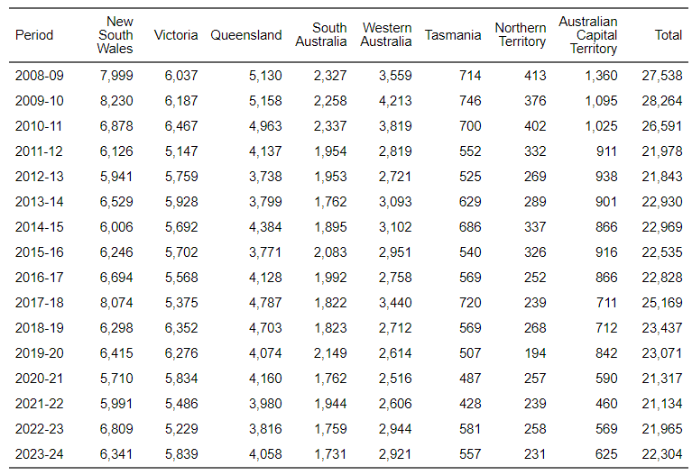
Source: ABS Labour Account Australia, Labour Force, Australia, Detailed, Quarterly; Jobs in Australia; Census of Population and Housing; BCARR calculations.
However, in New South Wales and Queensland, the proportion of employment in libraries and archives was lower than the respective total employment proportions and population densities. Other states and territories—particularly Western Australia and the Australian Capital Territory—had higher library and archive employment distributions compared to their overall employment figures.
Figure 72. Libraries and archives, employment distribution by states and territories, 2023–24
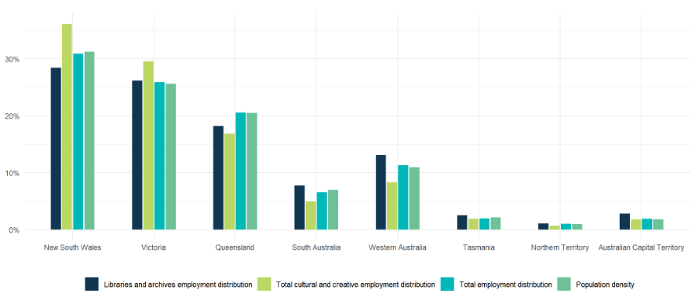
Source: ABS Labour Account Australia, Labour Force, Australia, Detailed, Quarterly; Jobs in Australia; Census of Population and Housing; National, state and territory population; BCARR calculations.
A significant proportion of the workforce in libraries and archives was made up of individuals from older age groups. In 2023–24, those aged 50 to 59 years represented more than 30% of total employment in this sector, as well as in all professional occupations within the domain.
Figure 73. Libraries and archives employment, main occupations share by age, 2023–24
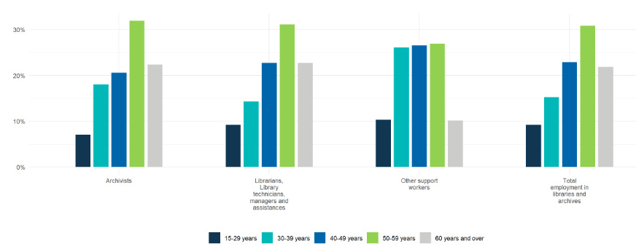
Source: ABS Labour Account Australia, Labour Force, Australia, Detailed, Quarterly; Jobs in Australia; Census of Population and Housing; BCARR calcu=lations.
The mean age of archivists was 49.5 years, with a median age of 51 years. For librarians, library technicians, managers and assistances, the mean age was 48.9 years and the median age was 51 years.
Figure 74. Libraries and archives employment, mean and median age, 2023–24
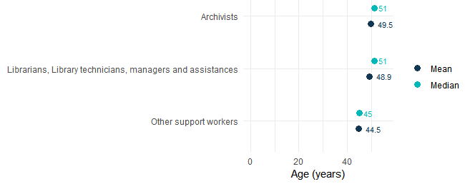
Source: ABS Labour Account Australia, Labour Force, Australia, Detailed, Quarterly; Jobs in Australia; Census of Population and Housing; BCARR calculations.
Women accounted for 80% of the workforce in this domain and represented the majority in both professional and support roles in 2023–24.
Figure 75. Libraries and archives employment, main occupations share by sex, 2023–24
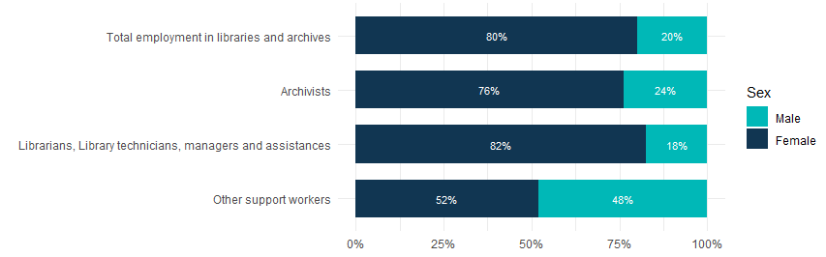
Source: ABS Labour Account Australia, Labour Force, Australia, Detailed, Quarterly; Jobs in Australia; Census of Population and Housing; BCARR calculations.
In 2023–24, there were 4,419 male workers in libraries and archives – a 20.5% drop from 5,561 in 2008–09. Female workers fell by 18.6%, from 21,978 to 17,885 over the same period.
Figure 76. Libraries and archives employment, by sex and age, change between 2008–09 and 2023–24
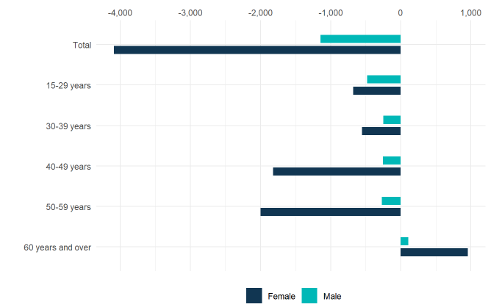
Source: ABS Labour Account Australia, Labour Force, Australia, Detailed, Quarterly; Jobs in Australia; Census of Population and Housing; BCARR calculations.
There were 17,435 libraries and archives workers aged 15–59 years in 2023–24, down 26.5% from 23,733 in 2008–09. In contrast, workers aged 60 years and older increased by 27.9%, rising from 3,806 to 4,868 over the same period.
Table 18. Libraries and archives employment, by sex and age, 2008–09 to 2023–24
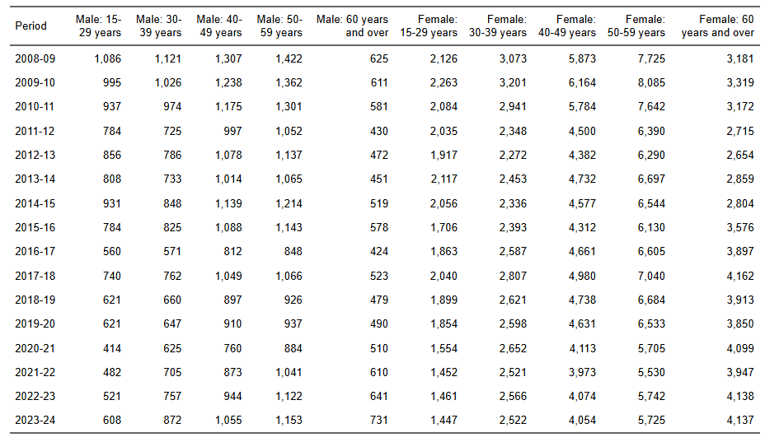
Source: ABS Labour Account Australia, Labour Force, Australia, Detailed, Quarterly; Jobs in Australia; Census of Population and Housing; BCARR calculations.

9. Print media and publishing (excl. internet)
Print media and publishing (excluding internet-based media) includes products that are printed but not necessarily published, as well as printing support services. This domain also includes newspapers, magazines and other periodicals, books, as well as software, and additional publishing and information services. Occupations within this domain include editors of print books or scripts, print journalists, print editors, and writers; engineers specialising in software publishing; and print trade professionals responsible for the design, binding, finishing, and production of printed materials.
In 2023–24, the estimated number of individuals employed in print media and publishing (excluding internet) was 60,611. The main print and media professionals include print content editors and machinists. Over 40% of the employment was for support workers like salespersons, corporate general or development managers.
Figure 77. Print media and publishing (excl. internet) employment by main occupations, 2023–24
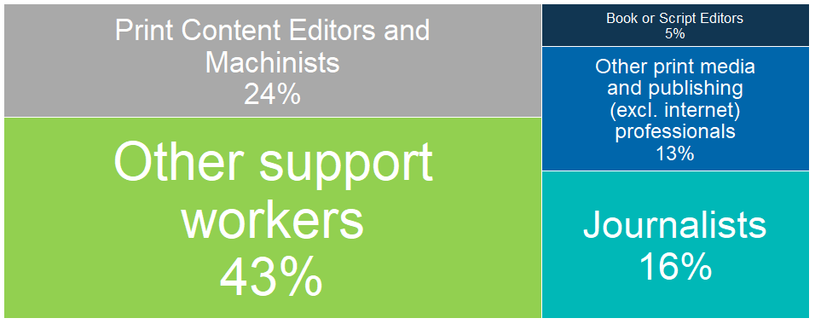
Source: ABS Labour Account Australia, Labour Force, Australia, Detailed, Quarterly; Jobs in Australia; Census of Population and Housing; BCARR calculations.
Print media and publishing (excluding internet) employment experienced a decrease of 5,154 people or 7.8% in 2023–24, from 65,765 employed in 2008–09. Employment in this domain declined steadily until 2020–21 but has since started to rebound – a trend that mirrors movements in gross value added for this domain.,
This domain includes traditional print activities as well as software publishing activities. It is likely that the shift towards remote working has helped to drive employment growth in software publishing. Additionally, COVID-19-related government assistance packages for small and medium-sized businesses were reported as a reason why some sectors, such as newspaper publishing, did not decline more significantly during the pandemic.
Figure 78. Print media and publishing (excl. internet) employment, 2008–09 to 2023–24
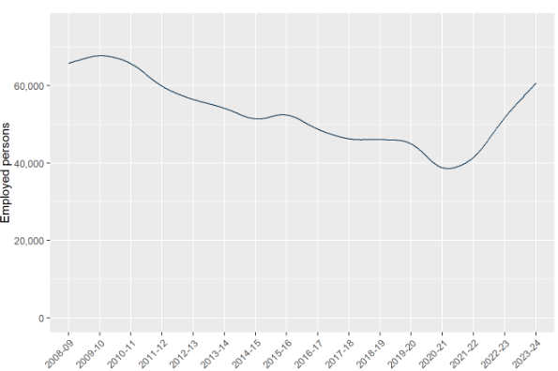
Source: ABS Labour Account Australia, Labour Force, Australia, Detailed, Quarterly; Jobs in Australia; Census of Population and Housing; BCARR calculations.
Geographic concentration significantly impacts employment distribution within the domain. In 2023–24, over 85.0% of employment in printing and publishing (excluding internet services) were based in Victoria, New South Wales, and Queensland.
Table 19. Print media and publishing (excl. internet) employment by states, 2008–09 to 2023–24
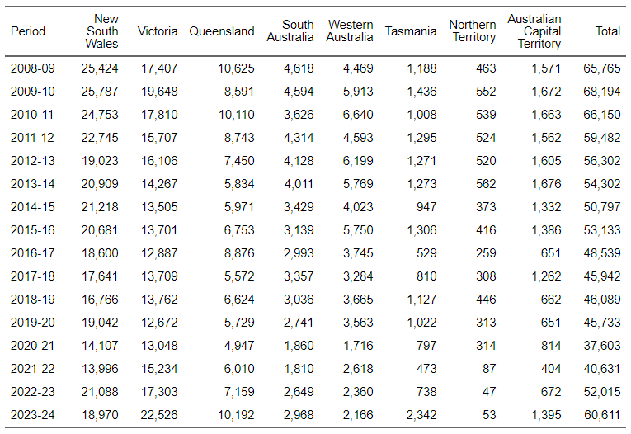
Source: ABS Labour Account Australia, Labour Force, Australia, Detailed, Quarterly; Jobs in Australia; Census of Population and Housing; BCARR calculations.
Victoria’s employment distribution in print media and publishing (excluding internet) was higher than its proportions of both total employment and population density. In New South Wales, the sector’s employment distribution closely matched its population share. Employment distributions in this domain for smaller states and territories, such as Tasmania and the Australian Capital Territory, also exceeded their population proportions. In contrast, other states and territories, particularly Western Australia, had employment distributions in this sector that were lower than their respective population shares.
Figure 79. Print media and publishing (excl. internet), employment distribution by states and territories, 2023–24
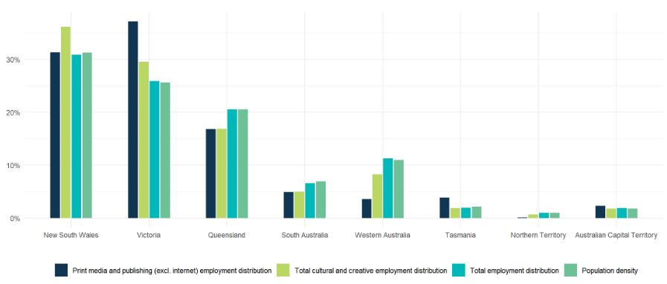
Source: ABS Labour Account Australia, Labour Force, Australia, Detailed, Quarterly; Jobs in Australia; Census of Population and Housing; National, state and territory population; BCARR calculations.
In 2023–24, nearly 70% of print media and publishing (excluding internet) workers were aged between 30 and 59 years old.
Figure 80. Print media and publishing (excl. internet) employment, main occupation shares by age, 2023–24
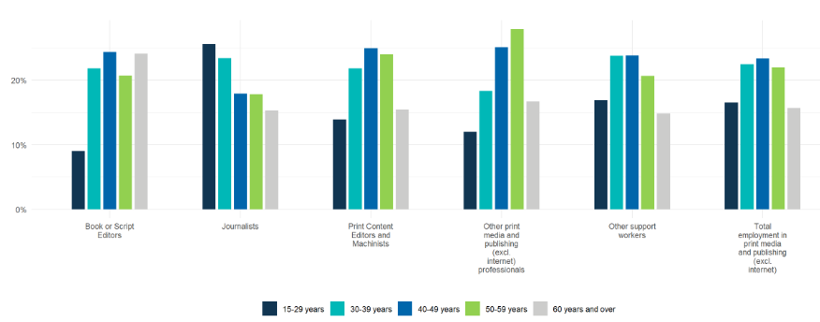
Source: ABS Labour Account Australia, Labour Force, Australia, Detailed, Quarterly; Jobs in Australia; Census of Population and Housing; BCARR calculations.
The mean age of this domain was 44.5 years, while the median age was 44 years in 2023–24. Individuals aged 40–49 years frequently held roles such as book or script editors (mean age 47.9 years, median age 47 years), print content editors and machinists (mean age 45.3 years, median age 46 years).
Figure 81. Print media and publishing (excl. internet) employment, mean and median age, 2023–24
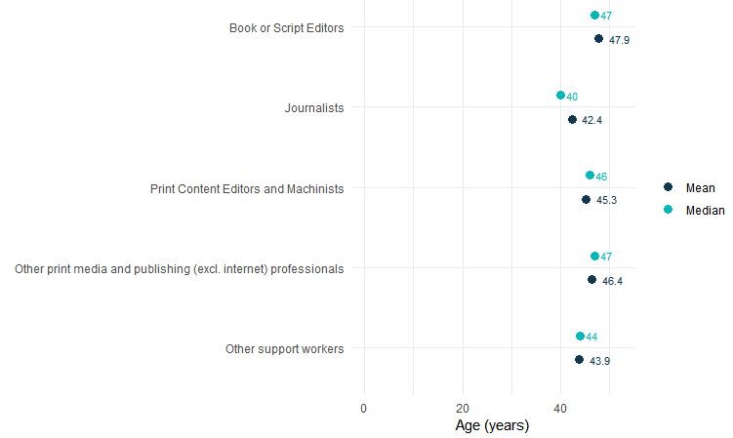
Source: ABS Labour Account Australia, Labour Force, Australia, Detailed, Quarterly; Jobs in Australia; Census of Population and Housing; BCARR calculations.
In 2023–24, women made up 60% of the workforce in this domain, mainly working as book or script editors, journalists, and support staff. Men comprised 40%, with a focus on print content editing, machinist roles, and other jobs like print finishing and graphic pre-press operators.
Figure 82. Print media and publishing (excl. internet) employment, main occupation shares by sex, 2023–24
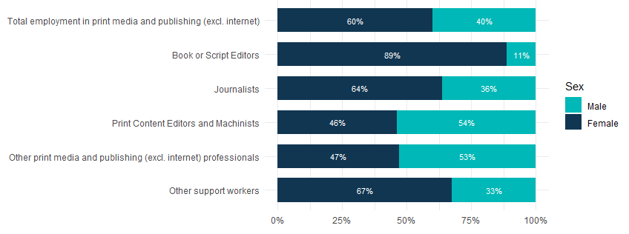
Source: ABS Labour Account Australia, Labour Force, Australia, Detailed, Quarterly; Jobs in Australia; Census of Population and Housing; BCARR calculations.
Male employment in print media and publishing (excl. internet) dropped by 41% to 24,266 in 2023–24, from 41,125 in 2008–09. In contrast, female employment rose 47.5% to 36,345 from 24,640 over the same period.
Figure 83. Print media and publishing (excl. internet) employment, by sex and age, change between 2008–09 and 2023–24
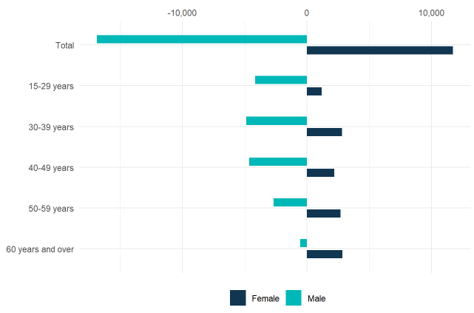
Source: ABS Labour Account Australia, Labour Force, Australia, Detailed, Quarterly; Jobs in Australia; Census of Population and Housing; BCARR calculations.
In 2023–24, the estimated number of workers aged 15 to 59 years in print media and publishing (excl. internet) was 51,092, representing a 12.7% decrease from 58,545 in 2008–09, and this decline was observed across most age groups. Additionally, the number of workers aged 60 and older increased by 31.8%, rising from 7,221 to 9,519.
Table 20. Print media and publishing (excl. internet) employment, by sex and age, 2008–09 to 2023–24
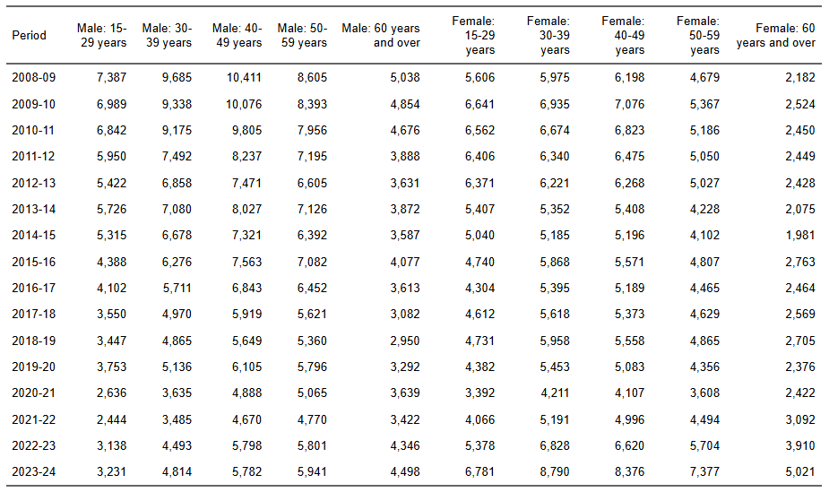
Source: ABS Labour Account Australia, Labour Force, Australia, Detailed, Quarterly; Jobs in Australia; Census of Population and Housing; BCARR calculations.

10. Architecture services
Architecture services include planning and designing buildings, structures, and land developments. Occupations in this domain includes architects, landscape architects, urban designers, and related professionals who create and oversee commercial, residential, and public spaces. Building and landscape designers, as well as technicians, produce detailed plans and monitor project progress in collaboration with architects and builders. Other roles include industrial designers.
In 2023–24, employment in architecture services was estimated at 90,257 individuals. The largest occupational groups were architects and building designers, together making up nearly 60% of total employment in this domain.
Figure 84. Architecture services employment share by main occupations, 2023–24
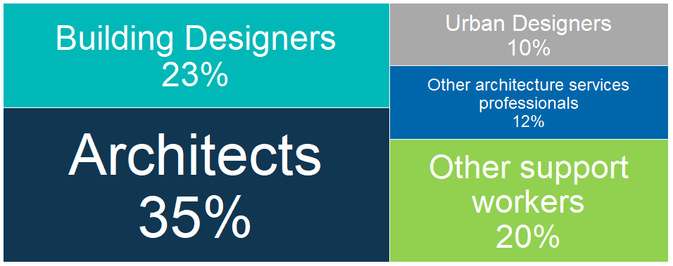
Source: ABS Labour Account Australia, Labour Force, Australia, Detailed, Quarterly; Jobs in Australia; Census of Population and Housing; BCARR calculations.
Architecture services employment experienced an increase of 32,408 or 56.0% in 2023–24, from 57,849 employed persons in 2008–09.
Figure 85. Architecture services employment, 2008–09 to 2023–24
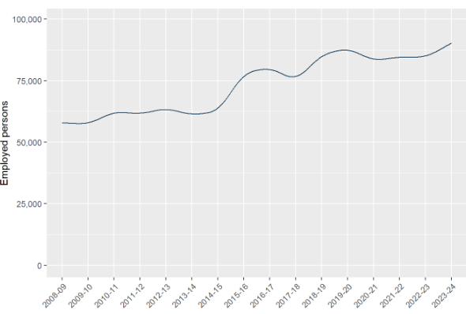
Source: ABS Labour Account Australia, Labour Force, Australia, Detailed, Quarterly; Jobs in Australia; Census of Population and Housing; BCARR calculations.
The distribution of architectural employment largely aligns with patterns of population, economic activity, and construction across Australia. Consequently, the workforce is predominantly concentrated along the eastern seaboard.
Table 21. Architecture services employment by states, 2008–09 to 2023–24
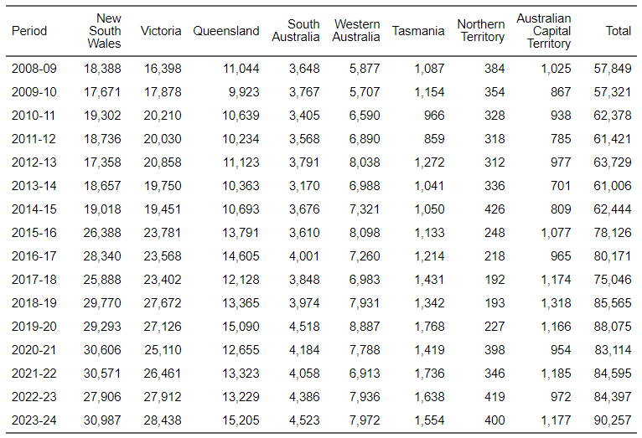
Source: ABS Labour Account Australia, Labour Force, Australia, Detailed, Quarterly; Jobs in Australia; Census of Population and Housing; BCARR calculations.
The employment distribution for architecture services was proportionally higher in New South Wales and Victoria than their respective employment and population shares, and lower in the other states and territories.
Figure 86. Architecture services, employment distribution by states and territories, 2023–24
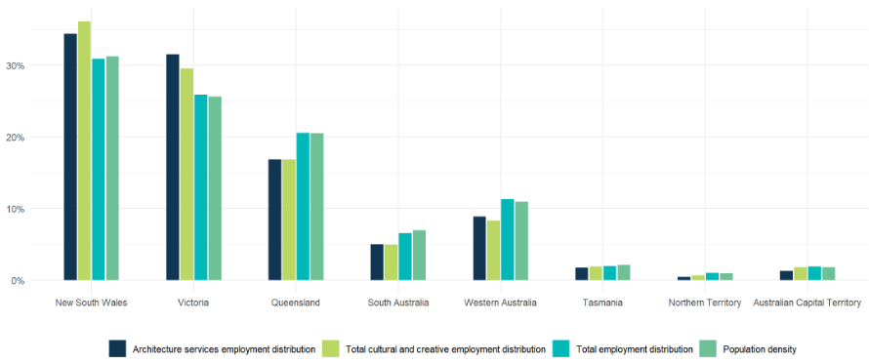
Source: ABS Labour Account Australia, Labour Force, Australia, Detailed, Quarterly; Jobs in Australia; Census of Population and Housing; National, state and territory population; BCARR calculations.
In 2023–24, individuals aged 30–49 years made up over 50% of those employed in architecture services, representing the largest age group within both professional and support roles.
Figure 87. Architecture services employment, main occupations share by age, 2023–24
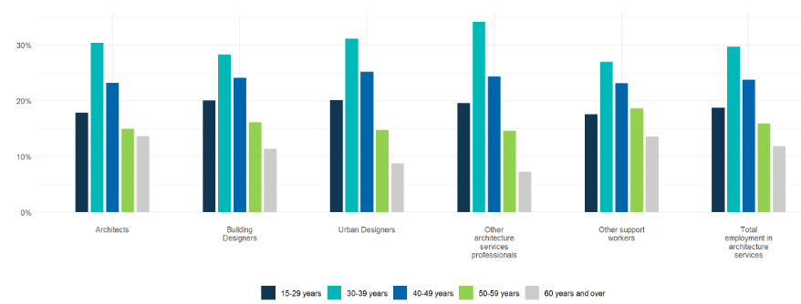
Source: ABS Labour Account Australia, Labour Force, Australia, Detailed, Quarterly; Jobs in Australia; Census of Population and Housing; BCARR calculations.
The mean and median ages were 42.6 years and 40 years for architects, 41.7 years and 40 years for building designers, and 40.7 years and 39 years for urban designers.
Figure 88. Architecture services employment, mean and median age, 2023–24
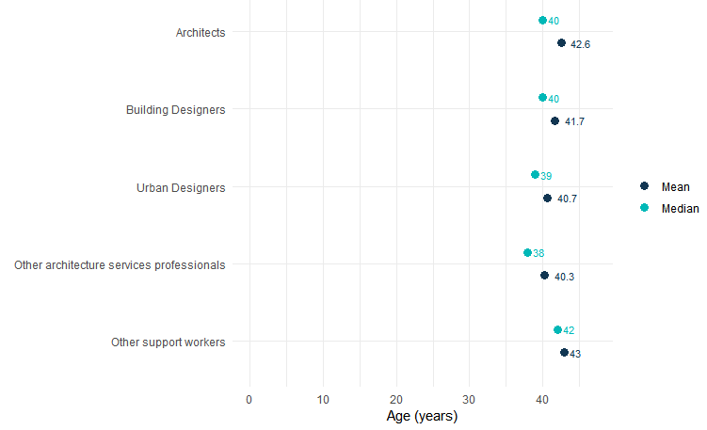
Source: ABS Labour Account Australia, Labour Force, Australia, Detailed, Quarterly; Jobs in Australia; Census of Population and Housing; BCARR calculations.
Employment in the architecture services sector was male-dominated, with men accounting for more than 65% of the workforce in 2023–24.
Figure 89. Architecture services employment, main occupations share by sex, 2023–24
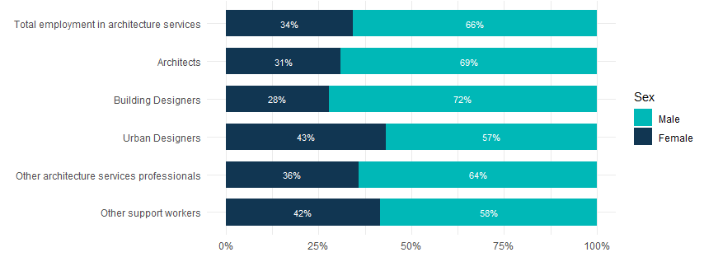
Source: ABS Labour Account Australia, Labour Force, Australia, Detailed, Quarterly; Jobs in Australia; Census of Population and Housing; BCARR calculations.
In 2023–24, architecture services employed 59,406 men, representing a 49.4% rise from 39,774 in 2008–09. The number of women employed was 30,850, an increase of 70.7% compared to 18,075 in 2008-09.
Figure 90. Architecture services employment, by sex and age, change between 2008–09 and 2023–24
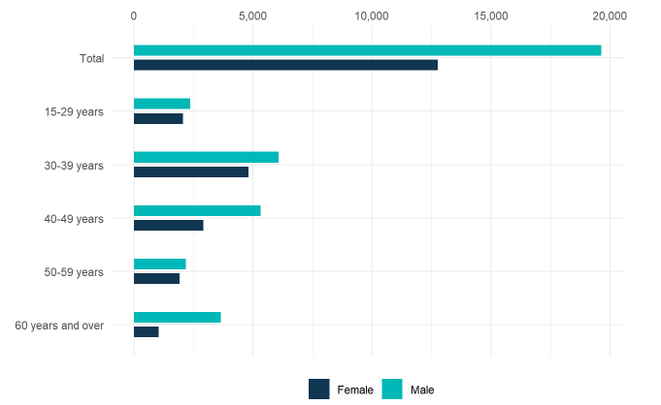
Source: ABS Labour Account Australia, Labour Force, Australia, Detailed, Quarterly; Jobs in Australia; Census of Population and Housing; BCARR calculations.
There were 79,558 architecture services workers aged 15 to 59 years in 2023–24 – a 53.5% increase from 51,841 in 2008–09. Workers aged 60 years and older grew by 78.1%, increasing from 6,008 to 10,699 over the same period.
Table 22. Architecture services employment, by sex and age, 2008–09 to 2023–24
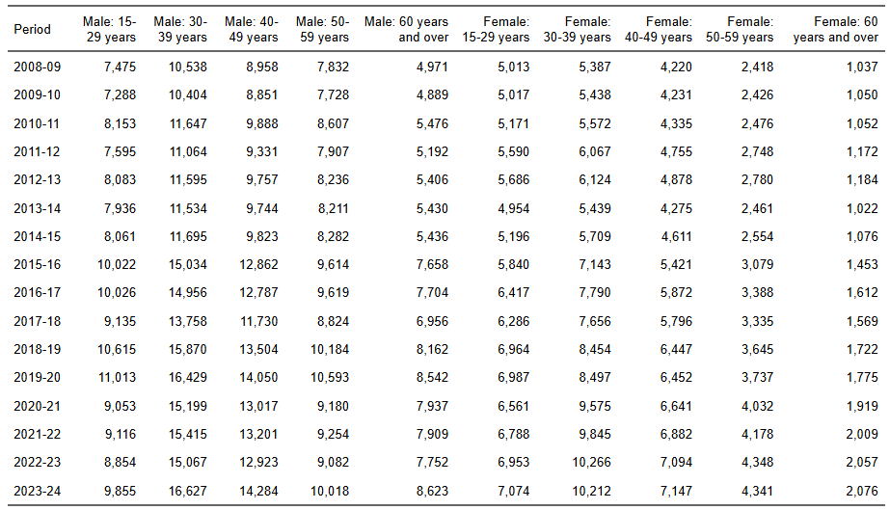
Source: ABS Labour Account Australia, Labour Force, Australia, Detailed, Quarterly; Jobs in Australia; Census of Population and Housing; BCARR calculations.

11. Design and fashion
Design and fashion cover commercial art, display services, and specialised design (fashion, interior, jewellery). Occupations include professionals who create and document designs for manufacturing, such as fashion, jewellery, and textile designers; graphic designers who develop visual content; and interior designers who plan spaces for function and performance. Other roles include signwriters, decorators, and stylists.
In 2023–24, employment in design and fashion was recorded at 60,141. The largest occupational groups were graphic and interior designers, together making up over 60% of total employment in this domain.
Figure 91. Design and fashion employment share by main occupations, 2023–24
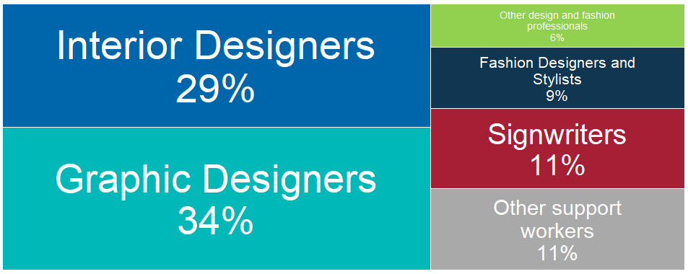
Source: ABS Labour Account Australia, Labour Force, Australia, Detailed, Quarterly; Jobs in Australia; Census of Population and Housing; BCARR calculations.
Design and fashion employment experienced an increase of 17,925 persons or 42.5% in 2023–24, compared to 42,216 employed persons in 2008–09.
Figure 92. Design and fashion employment, 2008–09 to 2023–24
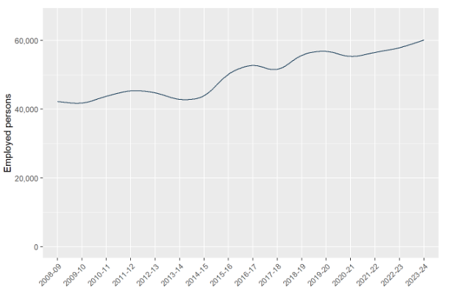
Source: ABS Labour Account Australia, Labour Force, Australia, Detailed, Quarterly; Jobs in Australia; Census of Population and Housing; BCARR calculations.
New South Wales and Victoria had higher employment in design and fashion relative to their populations. Specialised design firms are concentrated in eastern Australia, mirroring population density and proximity to clients. In contrast, other states and territories had lower employment in this domain relative to their population shares.
Table 23. Design and fashion employment by states, 2008–09 to 2023–24
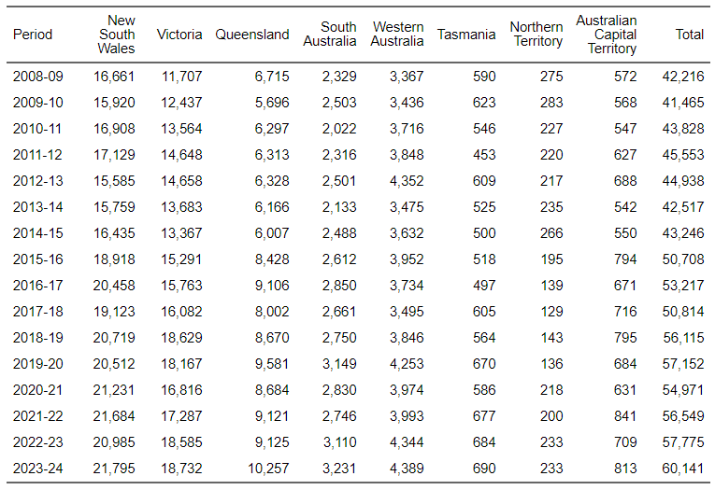
Source: ABS Labour Account Australia, Labour Force, Australia, Detailed, Quarterly; Jobs in Australia; Census of Population and Housing; BCARR calculations.
Figure 93. Design and fashion, employment distribution by states and territories, 2023–24
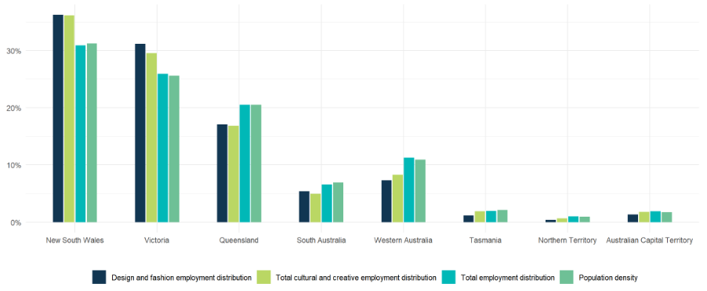
Source: ABS Labour Account Australia, Labour Force, Australia, Detailed, Quarterly; Jobs in Australia; Census of Population and Housing; National, state and territory population; BCARR calculations.
Individuals aged 30–39 years accounted for over 30% of total employment in design and fashion in 2023–24, comprising the largest age group in most professional roles.
Figure 94. Design and fashion employment, main occupations share by age, 2023–24
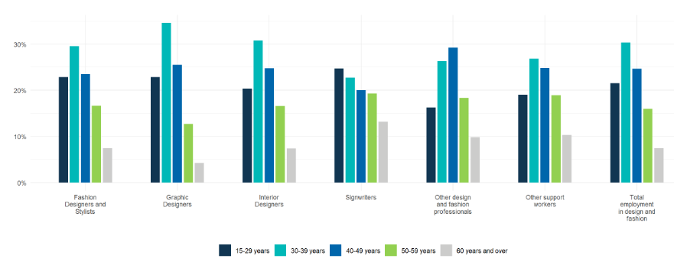
Source: ABS Labour Account Australia, Labour Force, Australia, Detailed, Quarterly; Jobs in Australia; Census of Population and Housing; BCARR calculations.
Graphic designers (mean age 38.6 years, median 37 years) were the youngest in this domain in 2023–24, while other design and fashion professionals such as interior decorators and jewellery designers were the oldest (mean age 42.7 years, median 42 years).
Figure 95. Design and fashion employment, mean and median age, 2023–24
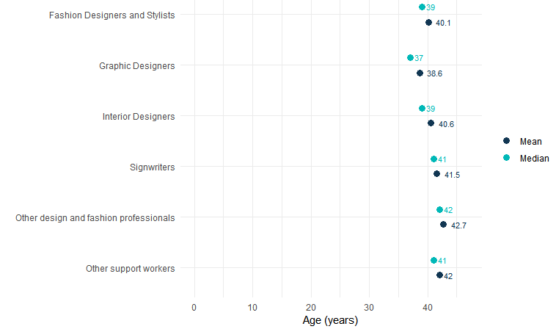
Source: ABS Labour Account Australia, Labour Force, Australia, Detailed, Quarterly; Jobs in Australia; Census of Population and Housing; BCARR calculations.
In 2023–24, females represented more than 60% of the workforce in design and fashion. Women were present in all professional roles within these fields, except for signwriters.
Figure 96. Design and fashion employment, main occupations share by sex, 2023–24
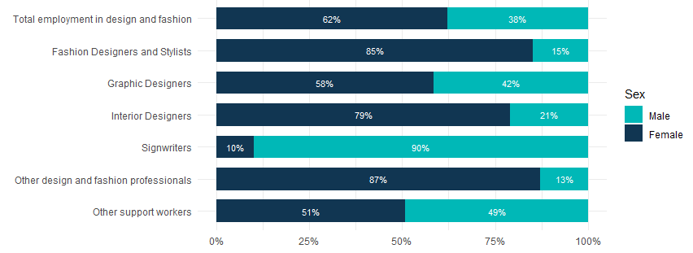
Source: ABS Labour Account Australia, Labour Force, Australia, Detailed, Quarterly; Jobs in Australia; Census of Population and Housing; BCARR calculations.
Male employment in design and fashion was estimated at 22,732 in 2023–24, up 18.4% from 19,198 in 2008–09; while female employment rose to 37,409, a 62.5% increase from 23,018 in 2008-09.
Figure 97. Design and fashion employment, by sex and age, change between 2008–09 and 2023–24
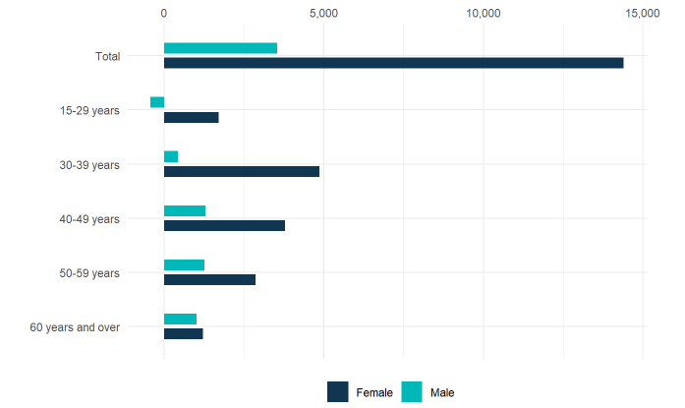
Source: ABS Labour Account Australia, Labour Force, Australia, Detailed, Quarterly; Jobs in Australia; Census of Population and Housing; BCARR calculations.
In 2023–24, there were an estimated 55,626 design and fashion workers aged 15–59 years, an increased of 39.4% from 39,909 in 2008–09. Workers aged 60 years and older nearly doubled, increasing from 2,307 to 4,515 over the same period.
Table 24. Design and fashion employment, by sex and age, 2008–09 to 2023–24
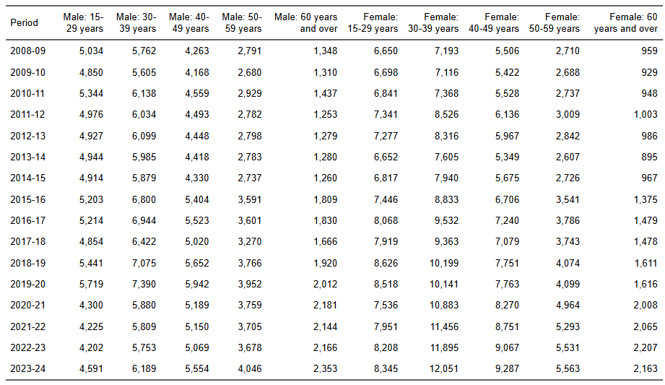
Source: ABS Labour Account Australia, Labour Force, Australia, Detailed, Quarterly; Jobs in Australia; Census of Population and Housing; BCARR calculations.

12. Advertising and promotion
Advertising and promotion includes services like campaign creation, media planning/buying, and management for businesses and professionals. Key occupations include advertising managers, specialists, content creators, copywriters, and visual merchandisers who coordinate and execute advertising activities.
In 2023–24, employment in advertising and promotion was estimated at 84,460 persons. Content creator (marketing) was the largest occupation, accounting for nearly 60% of total employment in this domain.
Figure 98. Advertising and promotion employment share by main occupations, 2023–24
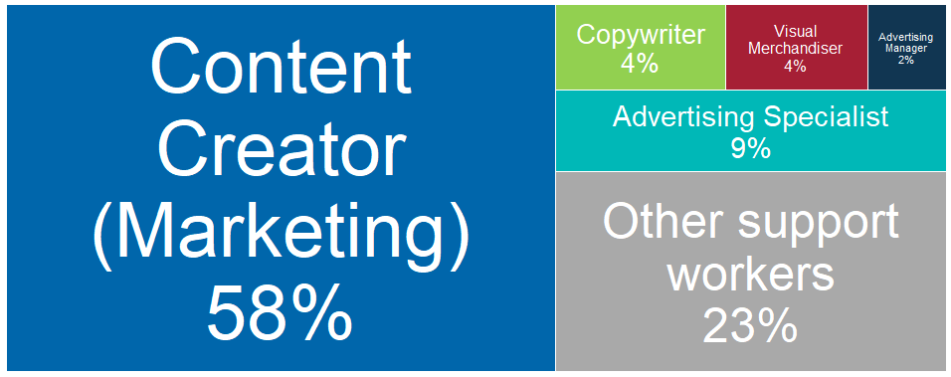
Source: ABS Labour Account Australia, Labour Force, Australia, Detailed, Quarterly; Jobs in Australia; Census of Population and Housing; BCARR calculations.
Advertising and promotion employment experienced an increase of 25,227 individuals or 42.6% in 2023–24, compared to 59,233 employed persons in 2008–09.
Figure 99. Advertising and promotion employment, 2008–09 to 2023–24
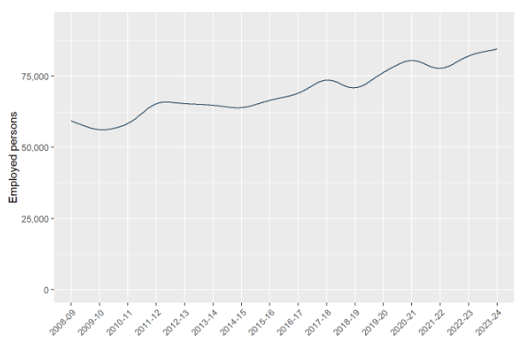
Source: ABS Labour Account Australia, Labour Force, Australia, Detailed, Quarterly; Jobs in Australia; Census of Population and Housing; BCARR calculations.
Advertising agencies are largely based in major cities, closer to market decision-makers and business hubs. Most advertising and promotion workers are employed in New South Wales and Victoria, reflecting the population density and number of businesses in these states.
Table 25. Advertising and promotion employment by states, 2008–09 to 2023–24
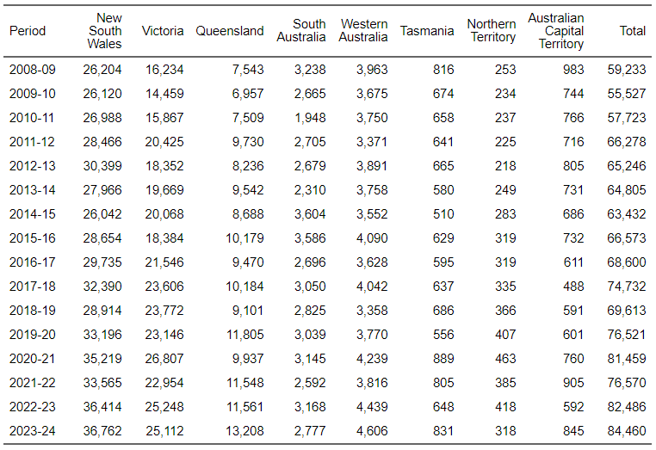
Source: ABS Labour Account Australia, Labour Force, Australia, Detailed, Quarterly; Jobs in Australia; Census of Population and Housing; BCARR calculations.
In contrast, employment in advertising and promotion for the other states and territories was lower than their respective population shares.
Figure 100. Advertising and promotion, employment distribution by states and territories, 2023–24
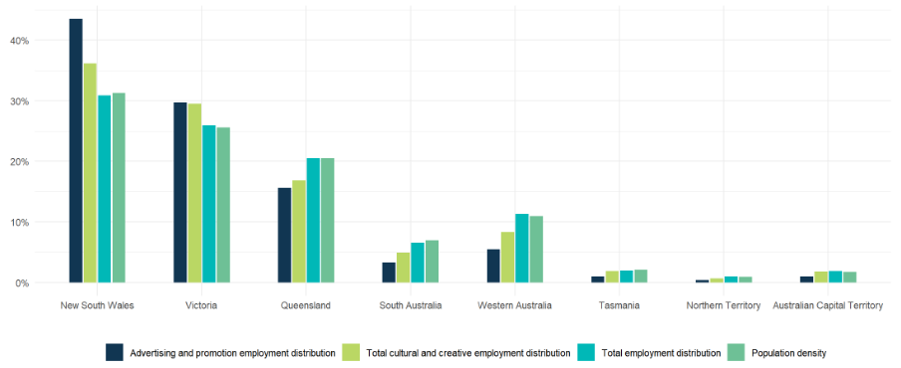
Source: ABS Labour Account Australia, Labour Force, Australia, Detailed, Quarterly; Jobs in Australia; Census of Population and Housing; National, state and territory population; BCARR calculations.
During 2023–24, individuals aged 30 to 39 accounted for approximately 36% of the workforce in advertising and promotion – the largest age group for both professional and general support positions in this domain.
Figure 101. Advertising and promotion employment, main occupations share by age, 2023–24
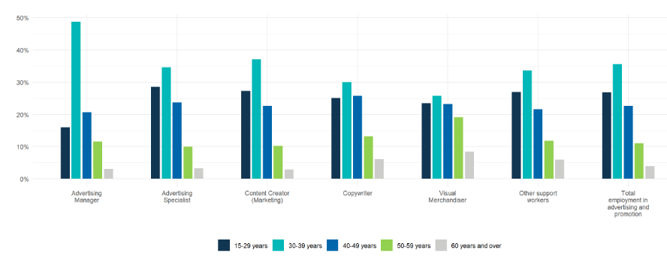
Source: ABS Labour Account Australia, Labour Force, Australia, Detailed, Quarterly; Jobs in Australia; Census of Population and Housing; BCARR calculations.
Content creators were the youngest in this domain in 2023–24, with a mean age of 36.9 years and a median age of 35 years; while visual merchandisers were the oldest, with a mean age of 40.8 years and a median age of 40 years.
Figure 102. Advertising and promotion employment, mean and median age, 2023–24
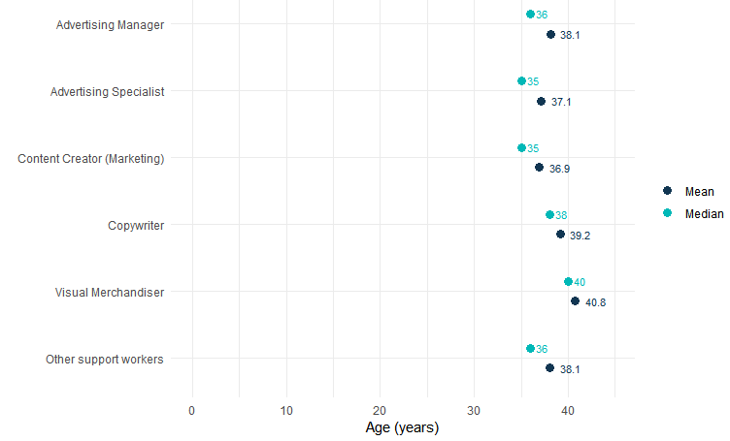
Source: ABS Labour Account Australia, Labour Force, Australia, Detailed, Quarterly; Jobs in Australia; Census of Population and Housing; BCARR calculations.
Females accounted for 61% of the workforce in this sector, while males comprised 39%. Women represented the largest share of all main occupations in this domain, especially in visual merchandising and copyrighting.
Figure 103. Advertising and promotion employment, main occupations share by sex, 2023–24
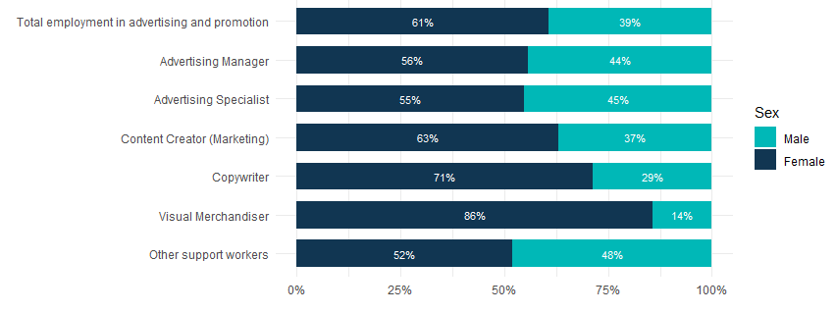
Source: ABS Labour Account Australia, Labour Force, Australia, Detailed, Quarterly; Jobs in Australia; Census of Population and Housing; BCARR calculations.
In 2023–24, male workers in advertising and promotion totalled 33,128, reflecting a 28.0% increase from 25,890 in 2008–09. Female workers were estimated at 51,331, a 54.0% rise from 33,342 in 2008–09.
Figure 104. Advertising and promotion employment, by sex and age, change between 2008–09 and 2023–24
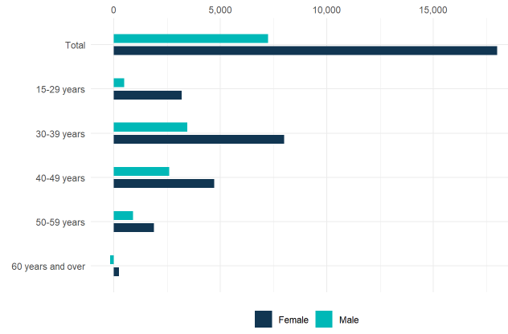
Source: ABS Labour Account Australia, Labour Force, Australia, Detailed, Quarterly; Jobs in Australia; Census of Population and Housing; BCARR calculations.
There were 81,125 advertising and promotion workers aged 15–59 years in 2023–24, which increased by 45.0% from 55,943 in 2008–09. Workers aged 60 years and older rose slightly by 1.4%, from 3,290 to 3,335 over the same period.
Table 26. Advertising and promotion employment, by sex and age, 2008–09 to 2023–24
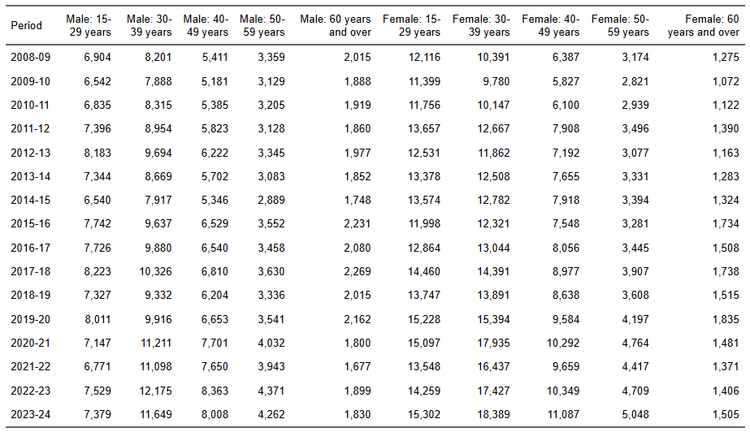
Source: ABS Labour Account Australia, Labour Force, Australia, Detailed, Quarterly; Jobs in Australia; Census of Population and Housing; BCARR calculations.

13. Events (arts)
Events (arts) include theatre and concert ticketing, booking services, event management or promotion, and fee-based fundraising or administration services. Occupations in this domain include event managers and entertainment venue attendants specifically for arts-related events and ticketing services.
In 2023–24, employment in events (arts) was estimated at 55,731, with events managers accounting for 95% of total employment in this domain.
Figure 105. Events (arts) employment share by main occupations, 2023–24
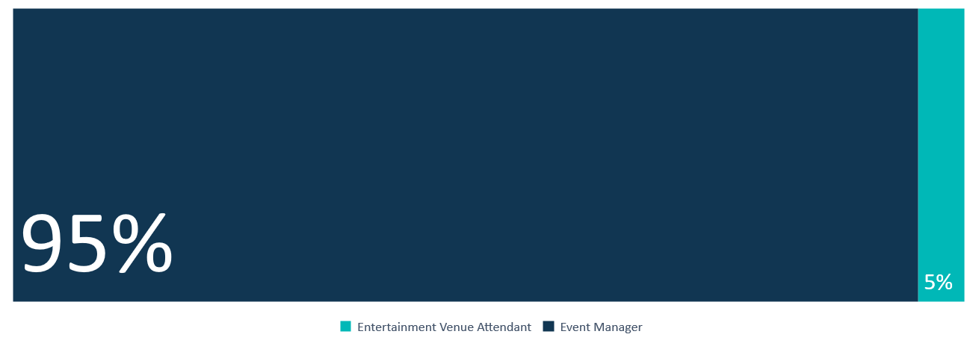
Source: ABS Labour Account Australia, Labour Force, Australia, Detailed, Quarterly; Jobs in Australia; Census of Population and Housing; BCARR calculations.
Events (arts) employment experienced an increase of 28,113 or 101.8% in 2023–24, from 27,617 employed persons in 2008–09.
Figure 106. Events (arts) employment, 2008–09 to 2023–24
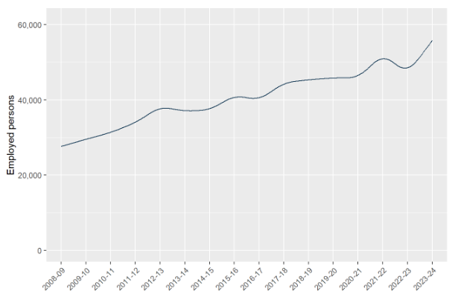
Source: ABS Labour Account Australia, Labour Force, Australia, Detailed, Quarterly; Jobs in Australia; Census of Population and Housing; BCARR calculations.
New South Wales and Victoria host over two-thirds of event promotion and management businesses, driven by large populations, business opportunities, and their roles as major international event destinations.
Table 27. Events (arts) employment by states, 2008–09 to 2023–24
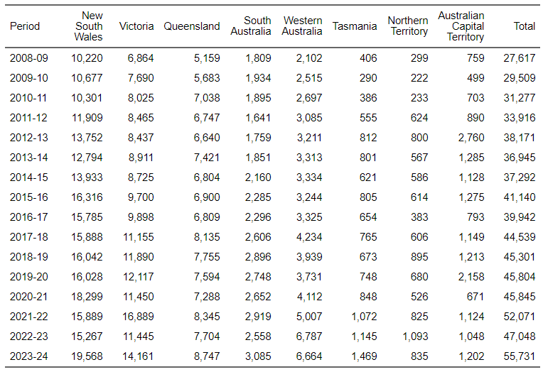
Source: ABS Labour Account Australia, Labour Force, Australia, Detailed, Quarterly; Jobs in Australia; Census of Population and Housing; BCARR calculations.
Employment in the events (arts) sector was more prevalent in New South Wales, Western Australia, Tasmania, Northern Territory, and the Australian Capital Territory relative to both their overall shares of total employment and population. In contrast, other states and territories, especially Queensland, had lower employment in the events (arts) sector when compared to their shares of total employment and population.
Figure 107. Events (arts), employment distribution by states and territories, 2023–24
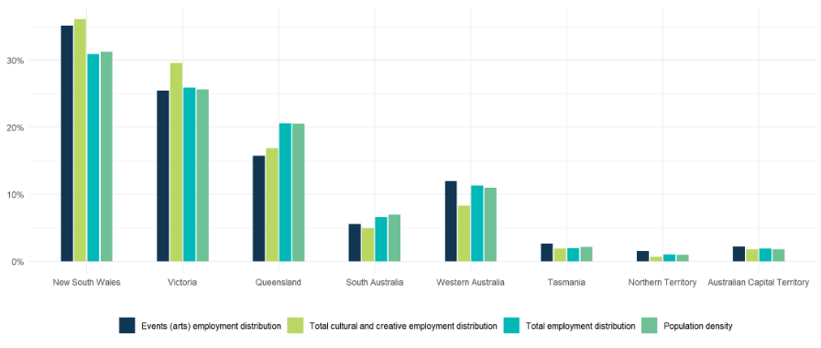
Source: ABS Labour Account Australia, Labour Force, Australia, Detailed, Quarterly; Jobs in Australia; Census of Population and Housing; National, state and territory population; BCARR calculations.
In 2023–24, most events managers were aged 30–39, while most entertainment venue attendants were 15–29 years. Overall, people aged 30–39 years made up over 30% of the arts events workforce, making them the largest age group.
Figure 108. Events (arts) employment, main occupations share by age, 2023–24
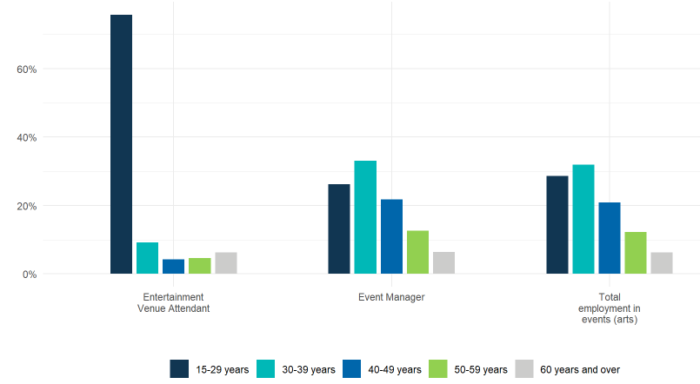
Source: ABS Labour Account Australia, Labour Force, Australia, Detailed, Quarterly; Jobs in Australia; Census of Population and Housing; BCARR calculations.
In 2023–24, event managers had an estimated mean age of 38.5 years and a median age of 36 years. For entertainment venue attendants, the mean age was 27.2 years and the median age was 22 years.
Figure 109. Events (arts) employment, mean and median age, 2023–24
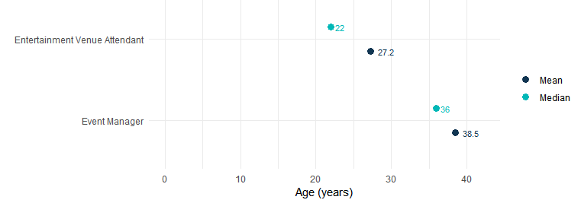
Source: ABS Labour Account Australia, Labour Force, Australia, Detailed, Quarterly; Jobs in Australia; Census of Population and Housing; BCARR calculations.
Females accounted for 72% of the workforce in this sector, while males comprised 28% in 2023–24.
Figure 110. Events (arts) employment, main occupations share by sex, 2023–24
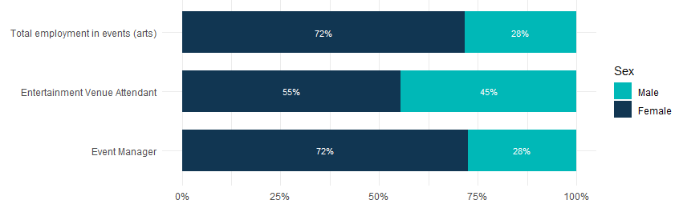
Source: ABS Labour Account Australia, Labour Force, Australia, Detailed, Quarterly; Jobs in Australia; Census of Population and Housing; BCARR calculations.
Male events (arts) workers were estimated at 15,793 in 2023–24, reflecting an 118.6% rise from 7,226 in 2008–09. Female workers totalled 39,937, up 95.9% from 20,391 in the same period.
Figure 111. Events (arts) employment, by sex and age, change between 2008–09 and 2023–24
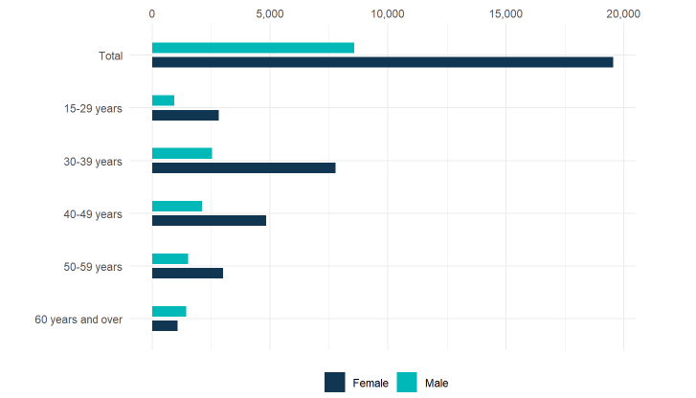
Source: ABS Labour Account Australia, Labour Force, Australia, Detailed, Quarterly; Jobs in Australia; Census of Population and Housing; BCARR calculations.
In 2023–24, there were an estimated 52,204 events (arts) workers aged 15–59 years, a 96.2% increase from 26,611 in 2008–09. Those aged 60 years and older rose from 1,006 to 3,527 during the same period.
Table 28. Events (arts) employment, by sex and age, 2008–09 to 2023–24
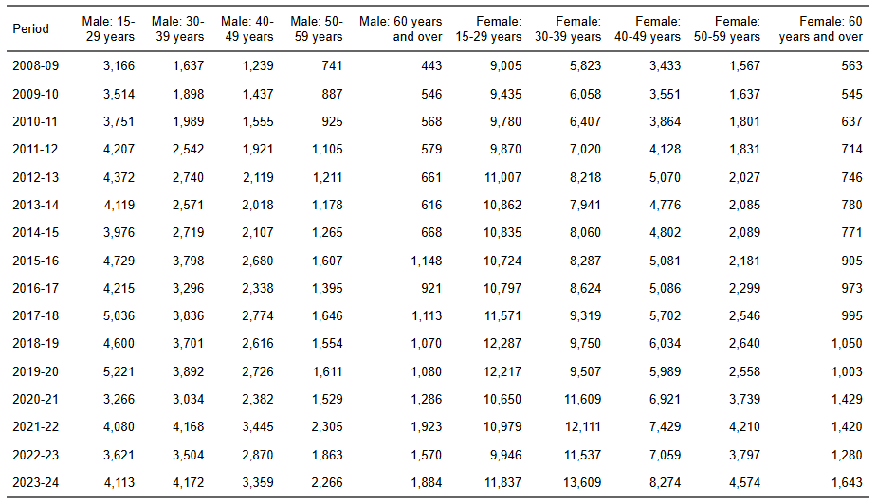
Source: ABS Labour Account Australia, Labour Force, Australia, Detailed, Quarterly; Jobs in Australia; Census of Population and Housing; BCARR calculations.

14. Arts education
Arts education offers non-vocational training in areas like art, dance, drama, and music. The field is fragmented, with many owner-operators offering lessons in music and the performing arts. Occupations within this domain include arts and personal enrichment instructors and private music teachers, who provide instruction in the practice, theory, and performance of art, dance, speech, drama, and music in private educational settings.
In 2023–24, employment in arts education was estimated at 29,328. The largest occupational groups were music and dance teachers, together accounting for over 70% of total employment in this domain.
Figure 112. Arts education employment share by main occupations, 2023–24
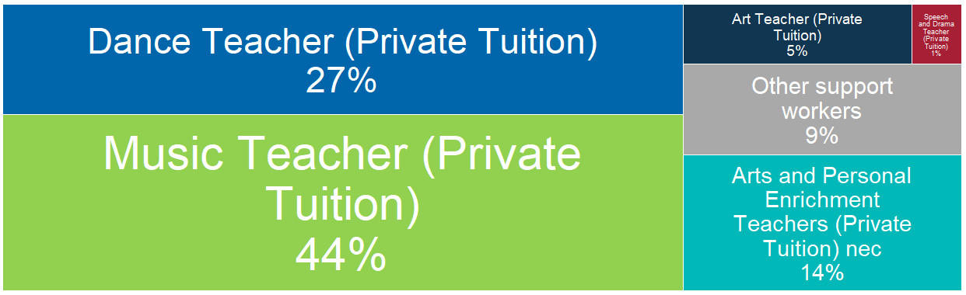
Source: ABS Labour Account Australia, Labour Force, Australia, Detailed, Quarterly; Jobs in Australia; Census of Population and Housing; BCARR calculations.
Arts education employment experienced an increase of 11,960 people or 68.9% in 2023–24, compared to 17,368 employed in 2008–09.
Figure 113. Arts education employment, 2008–09 to 2023–24
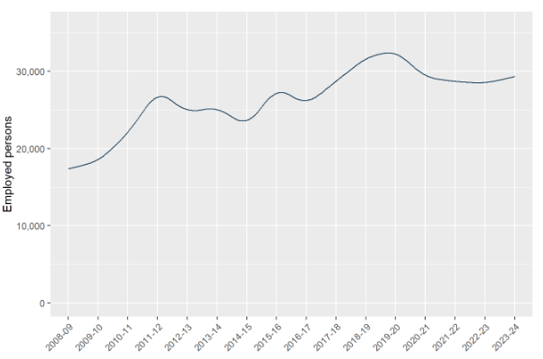
Source: ABS Labour Account Australia, Labour Force, Australia, Detailed, Quarterly; Jobs in Australia; Census of Population and Housing; BCARR calculations.
Areas with higher population density have more arts education providers as they can cater to a more extensive customer base. New South Wales, Victoria and Queensland account for the largest proportion of education providers.
Table 29. Arts education employment by states, 2008–09 to 2023–24
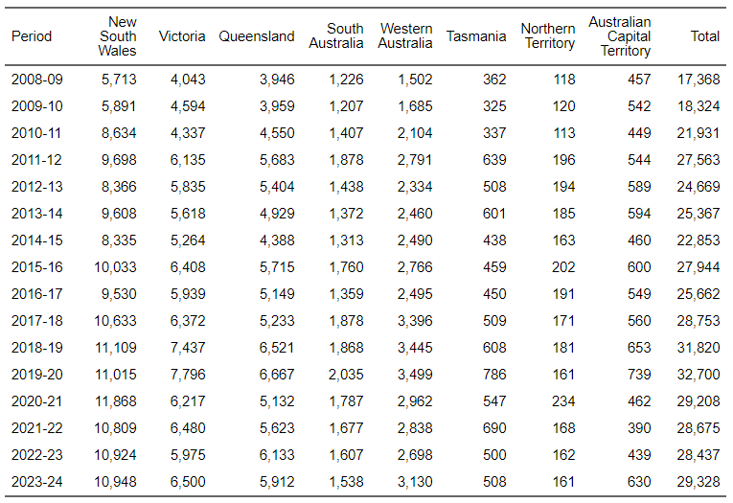
Source: ABS Labour Account Australia, Labour Force, Australia, Detailed, Quarterly; Jobs in Australia; Census of Population and Housing; BCARR calculations.
In 2023–24, employment in arts education in New South Wales was well above its population share and the Australian Capital Territory was slightly above. Other states and territories, especially Victoria and South Australia, had the lowest shares of employment in arts education relative to their populations.
Figure 114. Arts education, employment distribution by states and territories, 2023–24
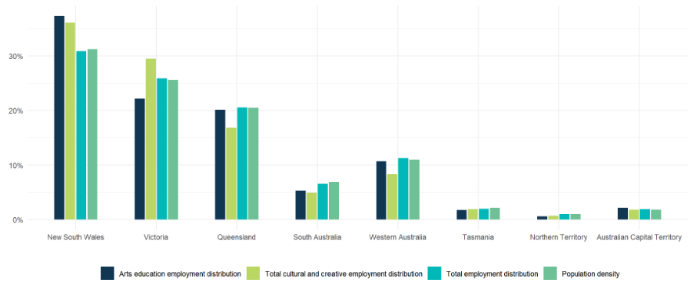
Source: ABS Labour Account Australia, Labour Force, Australia, Detailed, Quarterly; Jobs in Australia; Census of Population and Housing; National, state and territory population; BCARR calculations.
Figure 115. Arts education employment, main occupations share by age, 2023–24
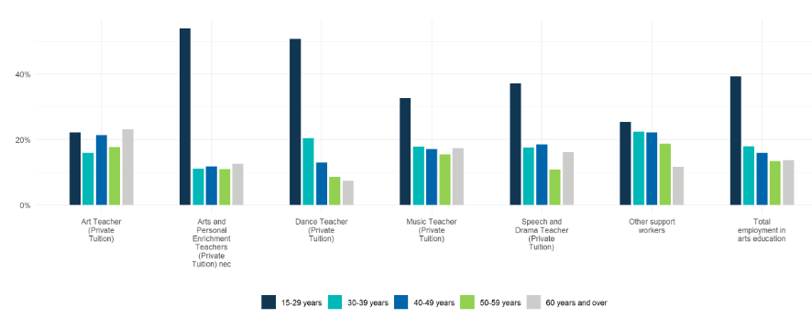
Source: ABS Labour Account Australia, Labour Force, Australia, Detailed, Quarterly; Jobs in Australia; Census of Population and Housing; BCARR calculations.
About 40% of employment in arts education was in the 15–29-year age group, although age distributions varied by occupation type. Arts and personal enrichment teachers nec (mean age 34.3 years, median 26 years) and dance teachers (mean age 33.2 years, median 29 years) were the youngest in this domain in 2023–24, while art teachers were the oldest (mean age 44.8 years, median 45 years).
Figure 116. Arts education employment, mean and median age, 2023–24
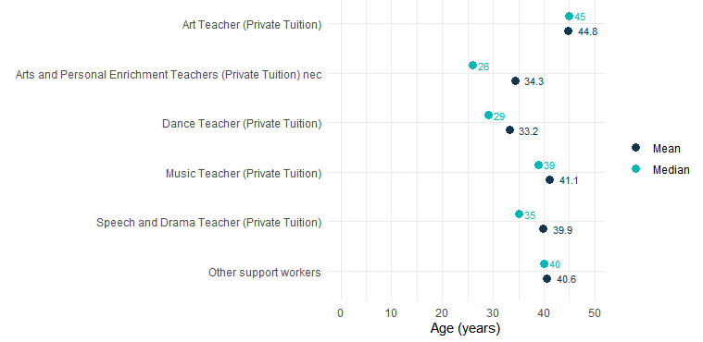
Source: ABS Labour Account Australia, Labour Force, Australia, Detailed, Quarterly; Jobs in Australia; Census of Population and Housing; BCARR calculations.
In 2023–24, women represented 75% of the total workforce in arts education across both professional and support positions, while men comprised the remaining 25%.
Figure 117. Arts education employment, main occupations share by sex, 2023–24
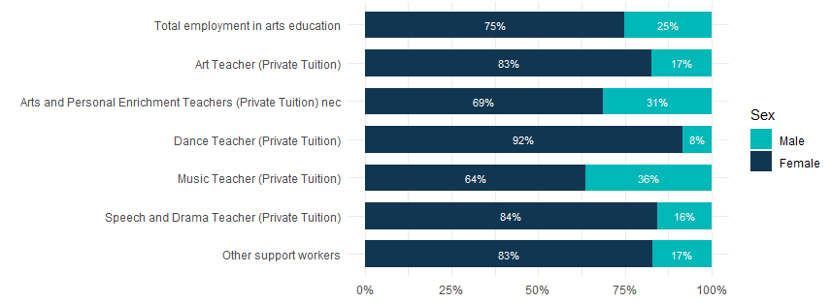
Source: ABS Labour Account Australia, Labour Force, Australia, Detailed, Quarterly; Jobs in Australia; Census of Population and Housing; BCARR calculations.
Female workers consistently comprised the majority within this domain. In 2023–24, there were an estimated 21,979 female workers in arts education, a 67.1% increase from 13,153 in 2008–09. Male workers were 7,348, up 74.3% from 4,215 over the same period.
Figure 118. Arts education employment, by sex and age, change between 2008–09 and 2023–24
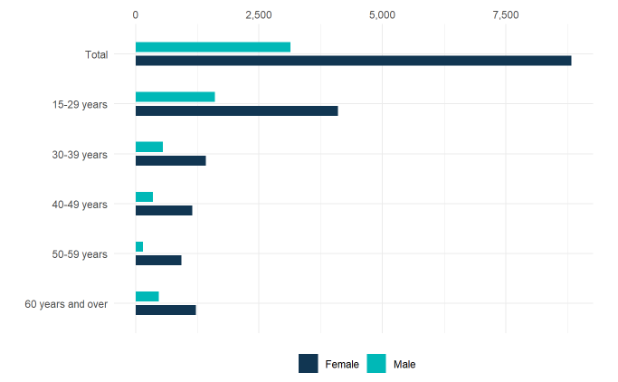
Source: ABS Labour Account Australia, Labour Force, Australia, Detailed, Quarterly; Jobs in Australia; Census of Population and Housing; BCARR calculations.
There were 25,314 arts education workers aged 15–59 years in 2023–24, a 68.3% increase from 15,045 in 2008–09. The number of workers aged 60 years and older rose 72.8%, from 2,323 to 4,013 over the same period.
Table 30. Arts education employment, by sex and age, 2008–09 to 2023–24
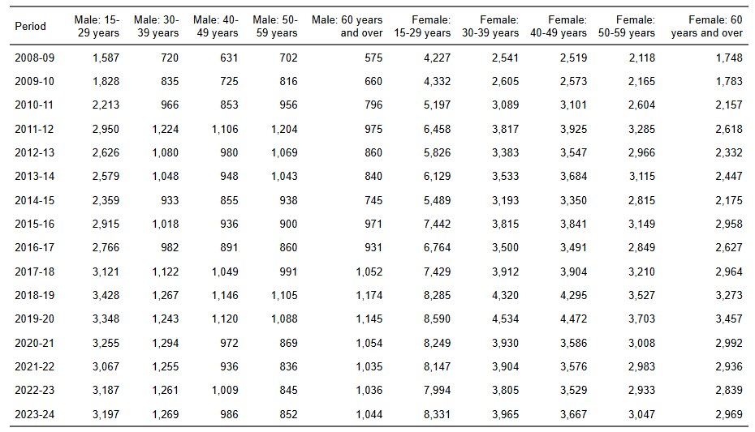
Source: ABS Labour Account Australia, Labour Force, Australia, Detailed, Quarterly; Jobs in Australia; Census of Population and Housing; BCARR calculations.

15. Digital games development
Digital games developer is the occupation relating to digital games development, with the tasks including designing and prototyping game concepts, coding mechanics and user interfaces, developing interactive elements, ensuring compatibility across platforms, optimising performance, testing for bugs, and potentially managing the development of game systems and features.
Employment in digital games development was estimated at 2,138 in 2023–24, an increase of 694 or 48.1% from 1,443 employed persons in 2008–09.
Figure 119. Digital games development employment, 2008–09 to 2023–24
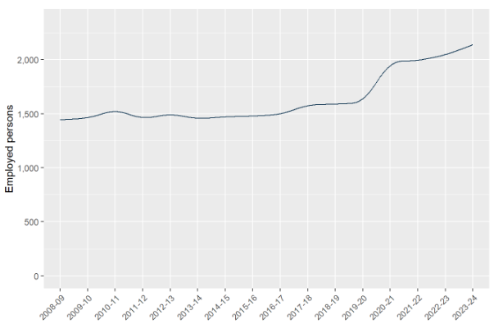
Source: ABS Labour Account Australia, Labour Force, Australia, Detailed, Quarterly; Jobs in Australia; Census of Population and Housing; BCARR calculations.
Population centres and business activity influence the geographic distribution of this domain. New South Wales and Victoria had the greatest proportion of enterprises, along with the largest shares of the national population.
Table 31. Digital games development employment by states, 2008–09 to 2023–24
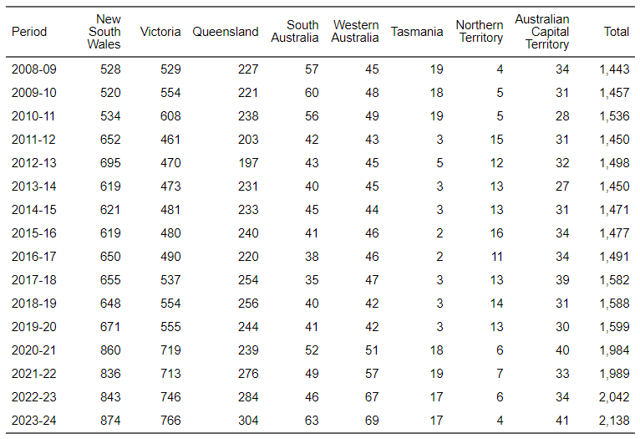
Source: ABS Labour Account Australia, Labour Force, Australia, Detailed, Quarterly; Jobs in Australia; Census of Population and Housing; BCARR calculations.
The Australian Capital Territory had a small portion of digital games developers, but with employment similar to its population density, while other states and territories had lower representation relative to their populations.
Figure 120. Digital games development, employment distribution by states and territories, 2023–24
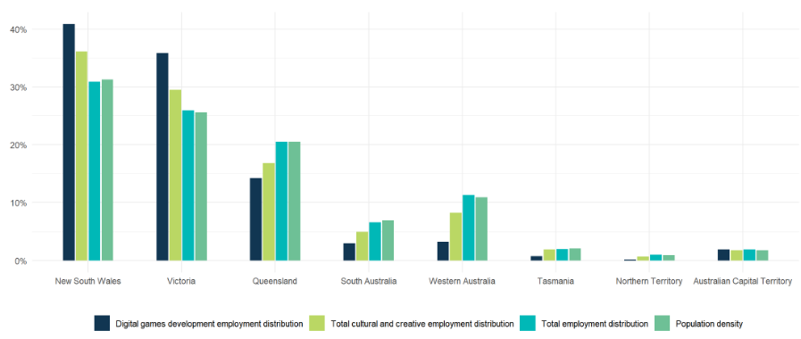
Source: ABS Labour Account Australia, Labour Force, Australia, Detailed, Quarterly; Jobs in Australia; Census of Population and Housing; National, state and territory population; BCARR calculations.
Individuals aged 30–39 years made up around 40% of digital games developers in 2023–24. The average age within this domain was 36.9 years, and the median age was 36 years.
Figure 121. Digital games development employment, by sex and age, 2023–24
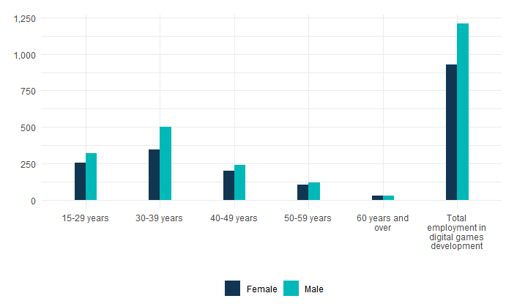
Source: ABS Labour Account Australia, Labour Force, Australia, Detailed, Quarterly; Jobs in Australia; Census of Population and Housing; BCARR calculations.
In 2023–24, 57% of workers within this domain were male and 43% were female. During the same period, 1,209 men and 928 women were employed in digital games development – up from 939 and 504, respectively in 2008–09.
Figure 122. Digital games development employment, by sex and age, change between 2008–09 and 2023–24
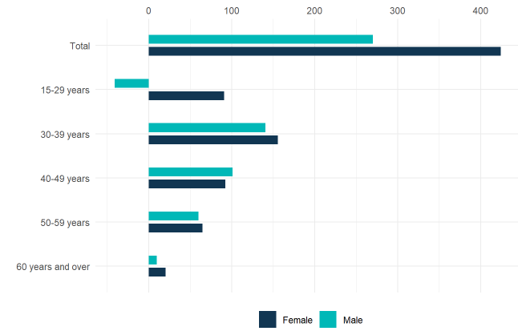
Source: ABS Labour Account Australia, Labour Force, Australia, Detailed, Quarterly; Jobs in Australia; Census of Population and Housing; BCARR calculations.
Between 2008–09 and 2023–24, the number of digital games developers aged 15–59 years grew from 1,416 to 2,081 (a 46.9% increase), while those aged 60 years and older rose from 27 to 57 workers.
Table 32. Digital games development employment, by sex and age, 2008–09 to 2023–24
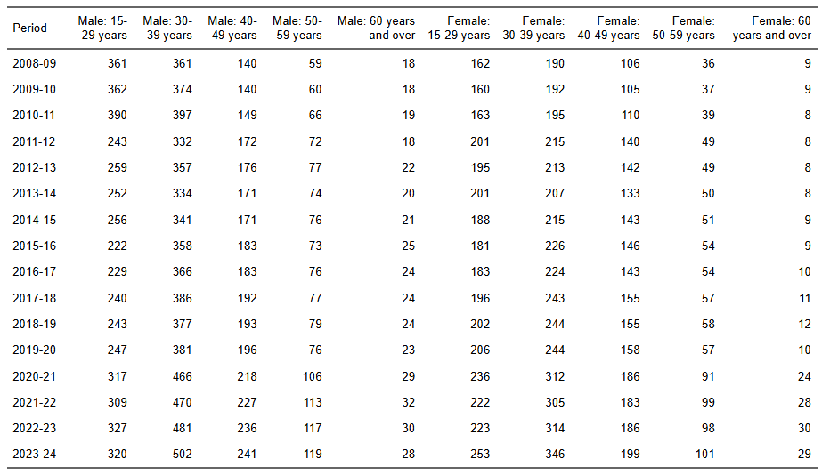
Source: ABS Labour Account Australia, Labour Force, Australia, Detailed, Quarterly; Jobs in Australia; Census of Population and Housing; BCARR calculations.

16. Arts health and wellbeing
Arts health and wellbeing was not included in Phase 1 due to the absence of a dedicated ANZSIC industry or IOPC product code. From an occupational perspective, arts health and wellbeing includes roles such as Community Arts Worker—who engages with communities to identify local needs, concerns, and aspirations through consultation, and develops strategies to support and promote community arts projects and cultural development; Arts Therapist—who utilises creative processes to help clients explore emotions, enhance self-awareness and expression, and decrease anxiety; and Music Therapist—who designs and implements music therapy interventions aimed at improving clients’ physical, psychological, cognitive, or behavioural abilities and functioning.
In 2023–24, employment in arts health and wellbeing was estimated at 2,732, with arts therapists accounting for 78% of total employment in this domain.
Figure 123. Arts and health wellbeing employment share by main occupations, 2023–24
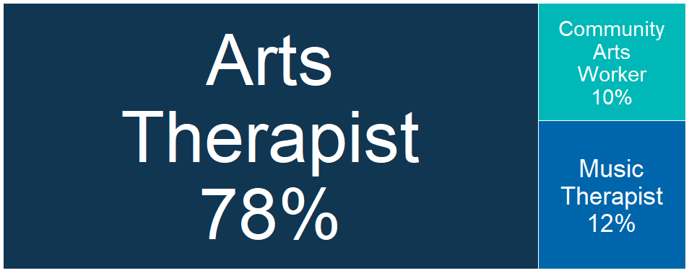
Source: ABS Labour Account Australia, Labour Force, Australia, Detailed, Quarterly; Jobs in Australia; Census of Population and Housing; BCARR calculations.
Arts health and wellbeing employment experienced an increase of 1,357 or 98.7% in 2023–24, from 1,375 employed persons in 2008–09.
Figure 124. Arts health and wellbeing employment, 2008–09 to 2023–24
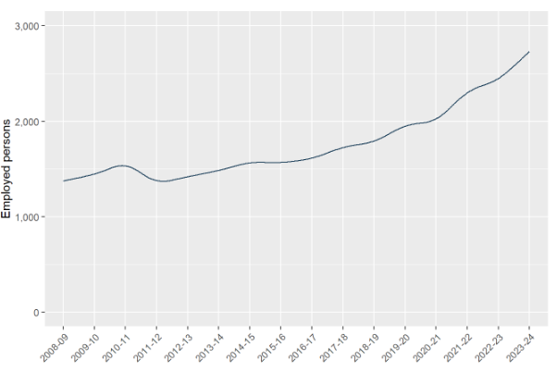
Source: ABS Labour Account Australia, Labour Force, Australia, Detailed, Quarterly; Jobs in Australia; Census of Population and Housing; BCARR calculations.
As with other health service sectors, the arts health and wellbeing workforce in New South Wales and Victoria is large compared to other states and territories. The share of arts health and wellbeing employment was also higher in New South Wales and Victoria relative to their population shares, while other states and territories had lower employment shares for this sector.
Table 33. Arts health and wellbeing employment by states, 2008–09 to 2023–24
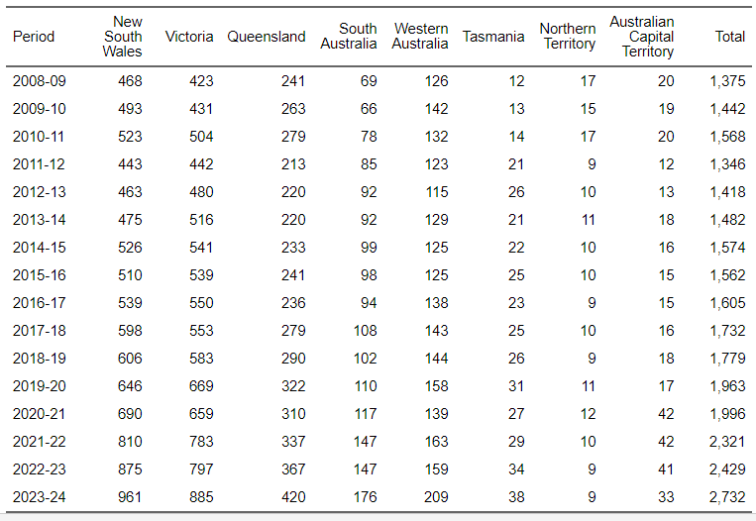
Source: ABS Labour Account Australia, Labour Force, Australia, Detailed, Quarterly; Jobs in Australia; Census of Population and Housing; BCARR calculations.
Figure 125. Arts health and wellbeing, employment distribution by states and territories, 2023–24
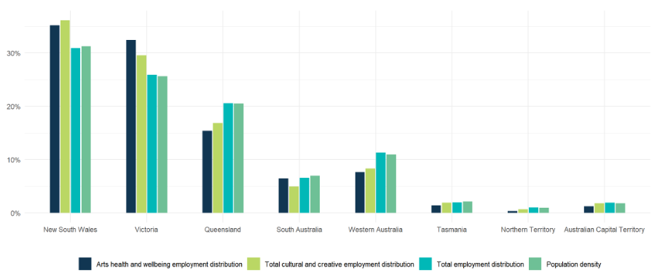
Source: ABS Labour Account Australia, Labour Force, Australia, Detailed, Quarterly; Jobs in Australia; Census of Population and Housing; National, state and territory population; BCARR calculations.
The arts health and wellbeing workforce was spread relatively evenly across age groups in 2023–24. A higher share of arts therapists were aged 60 years and older, while community arts workers tended to be in younger age groups.
Figure 126. Arts health and wellbeing employment, main occupations share by age, 2023–24
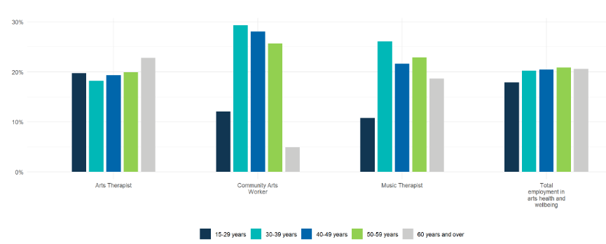
Source: ABS Labour Account Australia, Labour Force, Australia, Detailed, Quarterly; Jobs in Australia; Census of Population and Housing; BCARR calculations.
The mean and median ages were 45.8 years and 46 years for arts therapists, 42.8 years and 42 years for community arts workers, and 46 years and 45 years for music therapists.
Figure 127. Arts health and wellbeing employment, mean and median age, 2023–24
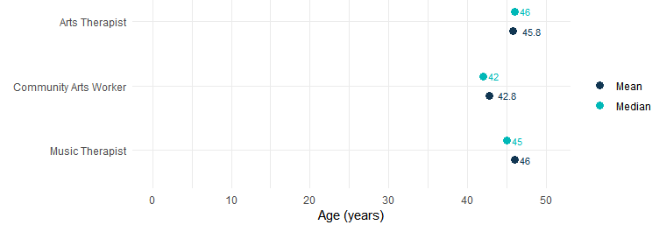
Source: ABS Labour Account Australia, Labour Force, Australia, Detailed, Quarterly; Jobs in Australia; Census of Population and Housing; BCARR calculations.
In 2023–24, approximately 80% of total workers in arts health and wellbeing were women, while men made up the remaining 20%.
Figure 128. Arts health and wellbeing employment, main occupations share by sex, 2023–24
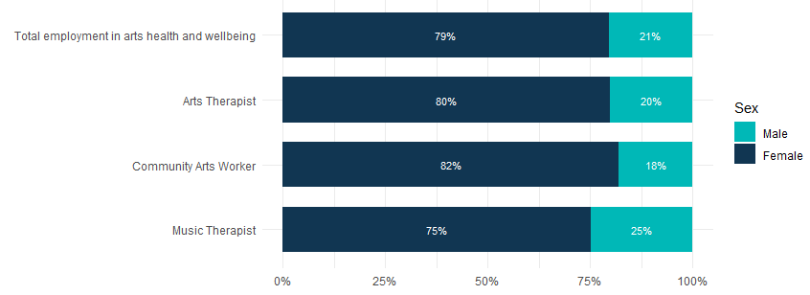
Source: ABS Labour Account Australia, Labour Force, Australia, Detailed, Quarterly; Jobs in Australia; Census of Population and Housing; BCARR calculations.
An estimated 560 males and 2,172 females worked in arts health and wellbeing in 2023–24 – a rise of 53.1% for men and 115.3% for women, from 366 and 1,009, respectively, in 2008–09.
Figure 129. Arts health and wellbeing employment, by sex and age, change between 2008–09 and 2023–24
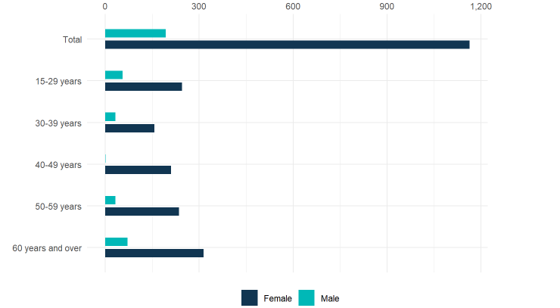
Source: ABS Labour Account Australia, Labour Force, Australia, Detailed, Quarterly; Jobs in Australia; Census of Population and Housing; BCARR calculations.
In 2023–24, the number of arts health and wellbeing workers aged 15–59 years was estimated at 2,169, representing an 81.2% increase from 1,198 in 2008–09. Additionally, the workforce aged 60 years and older grew from 177 to 563 over the same period.
Table 34. Arts health and wellbeing employment, by sex and age, 2008–09 to 2023–24
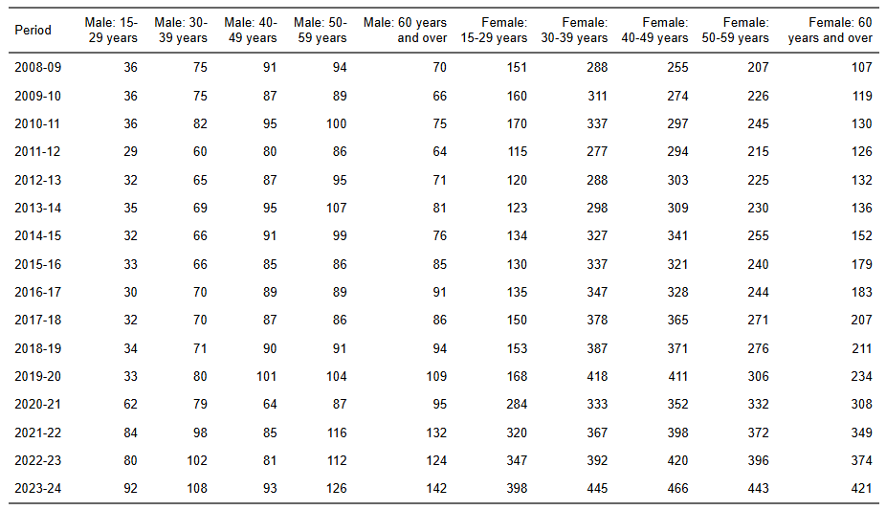
Source: ABS Labour Account Australia, Labour Force, Australia, Detailed, Quarterly; Jobs in Australia; Census of Population and Housing; BCARR calculations.

Secondary jobs
In 2023–24, an estimated 49,214 secondary jobs were related to the cultural and creative sector, an increase of 15,950 or 47.9% from 2008–09.
Figure 130. Total cultural and creative secondary jobs by trident types, 2008–09 to 2023–24
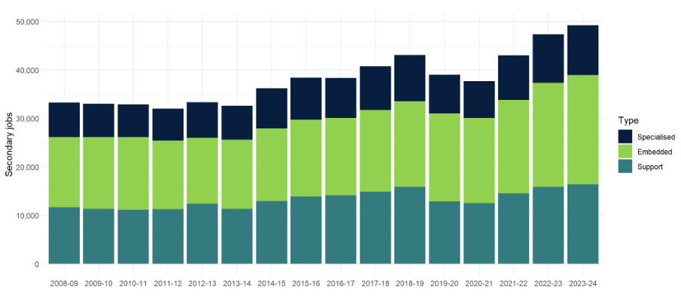
Source: ABS Labour Account Australia, Labour Force, Australia, Detailed, Quarterly; Jobs in Australia; Census of Population and Housing; BCARR calculations.
There were 10,269 (20.9%) secondary jobs in 2023–24 held by individuals whose main job is in a cultural and creative occupation and take on secondary jobs in a cultural and creative industry (specialised), 16,377 (33.3%) secondary jobs for those whose main job is not a cultural and creative occupation but take on secondary jobs within cultural and creative industries (support), and 22,567 (45.9%) secondary jobs for individuals with main jobs in cultural and creative occupations but take on secondary jobs in a non-cultural or creative industry (embedded).
Table 35. Total cultural and creative secondary jobs by trident types, 2008–09 to 2023–24
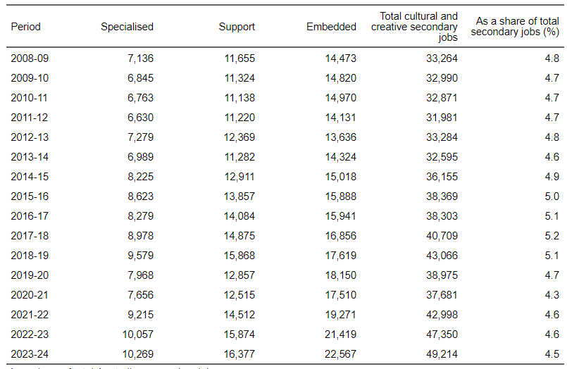
Source: ABS Labour Account Australia, Labour Force, Australia, Detailed, Quarterly; Jobs in Australia; Census of Population and Housing; BCARR calculations.
In 2023–24, the number of secondary jobs within the cultural and creative sector was estimated at 4.5% of all secondary jobs, which was higher than its share of main job employment in the economy (4.1%). Many individuals whose main jobs are in cultural and creative occupations often hold secondary jobs outside the cultural and creative industries. These patterns highlight the diversity of work arrangements in the cultural and creative sector, with many creatives relying on holding multiple jobs.
When compared to industry divisions across the Australian economy, the proportion of cultural and creative secondary jobs sits between that of the financial and insurance services (4.6%) and the arts and recreation services (3.8%) in 2023–24.
Figure 131. Cultural and creative secondary jobs and industry share of total economy, 2023–24
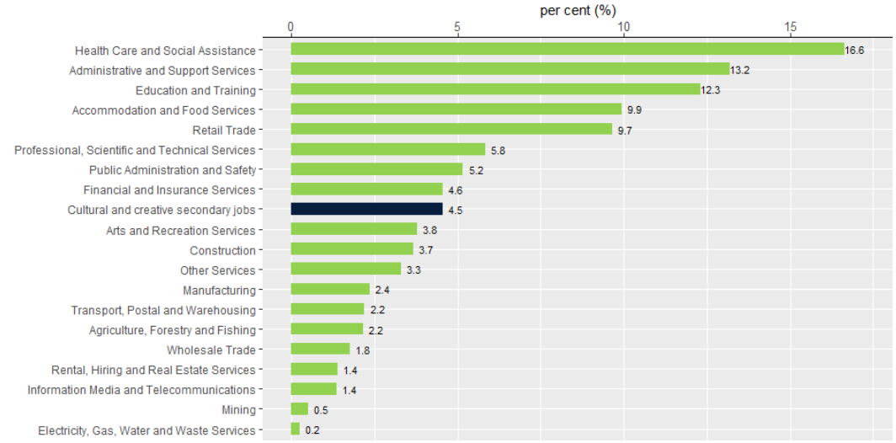
Source: ABS Labour Account Australia, Labour Force, Australia, Detailed, Quarterly; Jobs in Australia; Census of Population and Housing; BCARR calculations.
However, the proportion of secondary employment in the cultural and creative sector declined from 4.8% in 2008–09 to 4.5% in 2023–24. Notably, there were significant reductions during the COVID-19 period, with 4.7% in 2019–20 and 4.3% in 2020–21.
Figure 132. As a share of total Australian secondary jobs
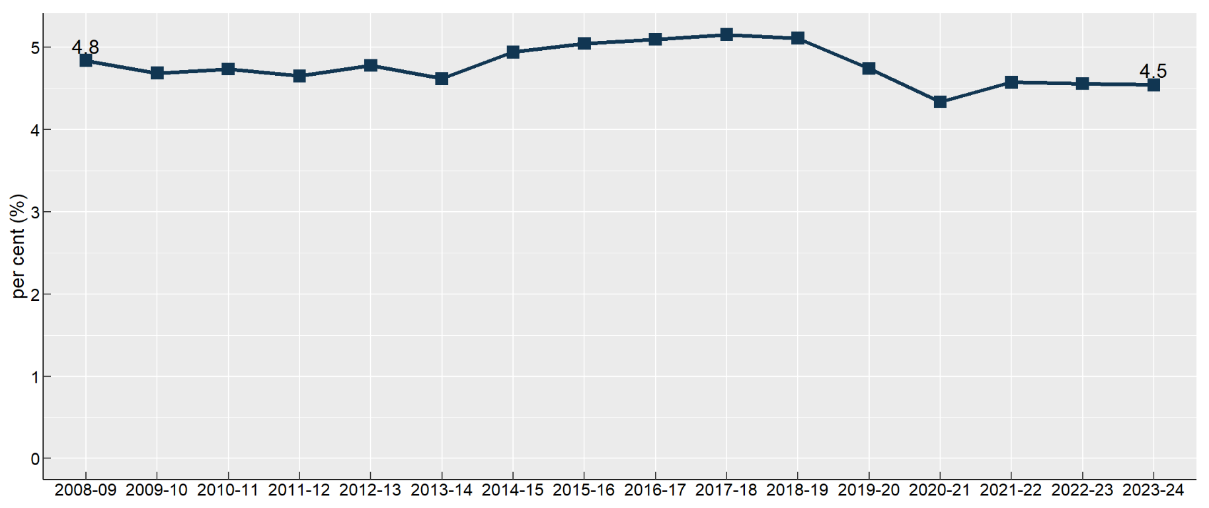
Source: ABS Labour Account Australia, Labour Force, Australia, Detailed, Quarterly; Jobs in Australia; Census of Population and Housing; BCARR calculations.
The largest domains of cultural and creative secondary jobs in 2023–24 were film and television activities; literature, creative and performing arts; and advertising and promotion.
Figure 133. Cultural and creative secondary jobs by domain, 2023–24
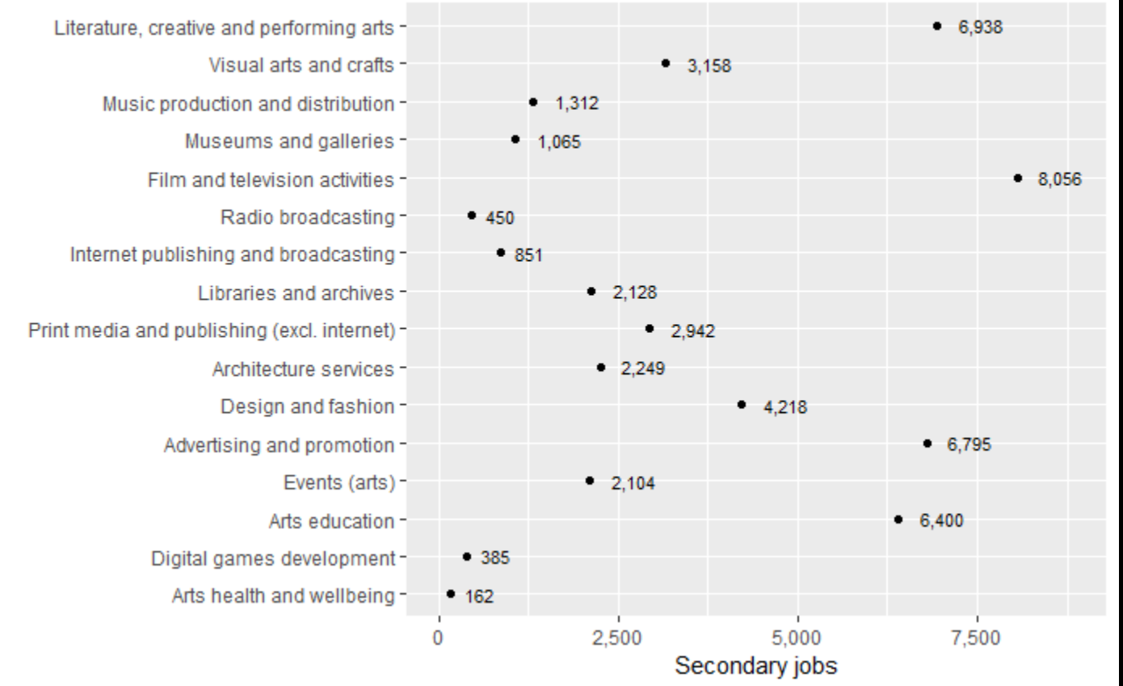
Source: ABS Labour Account Australia, Labour Force, Australia, Detailed, Quarterly; Jobs in Australia; Census of Population and Housing; BCARR calculations.
Between 2008–09 and 2023–24, arts education experienced the most significant growth, increasing by 2,801 secondary jobs or 77.8 %. Film and television activities followed, with an increase of 2,793 secondary jobs, representing a 53.1% rise. Literature, creative, and performing arts ranked third, with growth of 2,499 secondary jobs or 56.3%.
Figure 134. Cultural and creative secondary jobs by domain, change between 2008–09 and 2023–24
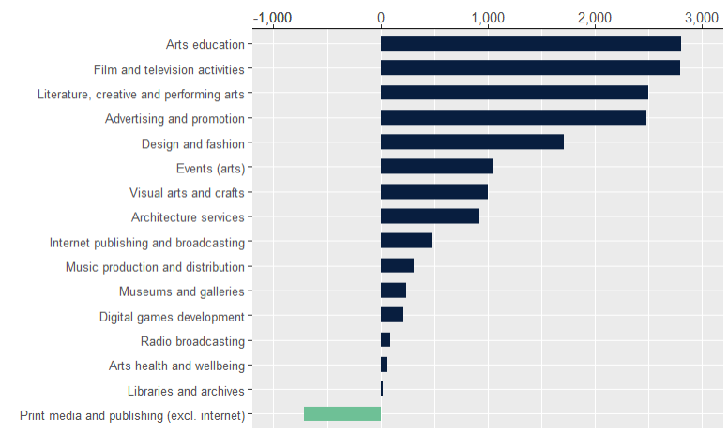
Source: ABS Labour Account Australia, Labour Force, Australia, Detailed, Quarterly; Jobs in Australia; Census of Population and Housing; BCARR calculations.
In contrast, print media and publishing (excluding internet) was the only domain to decline during the period, with a decline of 712 secondary jobs or 19.5% over the period.

Appendix A—Detailed review of the scope of cultural and creative occupations by domain
In BCARR’s 2024 working paper, cultural and creative activities were grouped into 15 domains. The activities within the domains were arranged in terms of the input-output product classification (IOPC) codes and the Australian and New Zealand Standard Industrial Classification 2006 (ANZSIC 06) class codes. Lists of the cultural and creative industries and products can be found in Appendix B and C.
In this report, cultural and creative occupations are categorised into these same domains to ensure alignment with the structure of cultural and creative industries and products.
The following sections detail the alignment between the domains and the in-scope industries and products which define these domains within the Cultural and Creative Activity in Australia, 2008–09 to 2022–23 (Methodology Refresh) and the occupations which define employment within each domain as part of Phase 2. These tables show the in-scope cultural and creative occupations using the definitions outlined in the ABS’s Australian and New Zealand Standard Industrial Classification (ANZSIC) and the Occupational Standard Classification for Australia (OSCA).

A.1 Literature, creative and performing arts
From an industry or product perspective, literature, creative and performing arts includes the creation and presentation of original artistic works, live performances, and the operation of venues that support these activities, involving both individual artists and organisations.
From an occupational perspective, this domain includes:
- Arts and media professionals that communicate ideas, impressions and factual information through visual and performance arts, direct and produce film, television, audio and live performance productions, present programs on radio and television, write and edit literary works, scripts, news reports and articles, and write, conduct and perform musical compositions;
- Performing arts technicians that provide technical and other assistance for the production, recording and broadcasting of artistic performances; and
- Other occupations such as arts administrators and managers, make-up artists, and live performance production assistants and coordinators.
Table 36. Overview of literature, creative and performing arts industries/products and occupations
Industries/ Products | Occupations
In-scope industry classifications:  - 9001 Performing Arts Operation: providing or producing live theatrical or musical presentations or performances. Primary activities include:  - Circus operation;  - Dance and ballet company operation;  - Musical comedy company operation;  - Musical productions;  - Opera company operation;  - Orchestra operation;  - Performing arts operation n.e.c.;  - Theatre restaurant operation (mainly entertainment facility);  - Theatrical company operation  - 9002 Creative Artists, Musicians, Writers and Performers: independent individuals or groups that are mainly engaged in the regular creation of original artistic or cultural works who may or may not produce and perform their works. Also includes activities providing independent technical expertise necessary for these productions, and celebrities mainly engaged in endorsing products or making speeches or public appearances for which they receive a fee. Primary activities include:  - Artists;  - Cartooning;  - Choreography service;  - Composing (including musical composition);  - Costume designing;  - Creative arts service;  - Journalistic service;  - Musicians;  - Playwriting or screenwriting;  - Producing or directing original artistic or cultural work;  - Set designing service;  - Speaking service (including radio and television announcing)  Activities providing theatre lighting design services are included in this industry.  - 9003 Performing Arts Venue Operation: operating venues for the presentation and rehearsal of performing arts. Primary activities include:  - Concert hall operation;  - Entertainment centre operation;  - Music bowl operation;  - Opera house operation;  - Performing arts venue operation n.e.c.;  - Playhouse operation;  - Theatre operation (except motion picture theatre)  Note: In ANZSIC, set designing, costume designing or theatre lighting design services are included in Class 9002 Creative Artists, Musicians, Writers and Performers. Occupations such as 231437 Screen or Live Performance Designer, 391234 Lighting Technician, etc. were also grouped under ‘Literature, creative and performing arts’ rather than ‘Design and fashion’.  In-scope product classifications:  - 90010010 Performing arts operation not elsewhere classified (incl theatre restaurants and circuses)  - 90020010 Services of independent creative artists, writers and performers  - 90020020 Theatre lighting, costume design and set design services  - 90030010 Performing arts venue operation. | - 149131 Arts Administrator or Manager: Plans, organises, directs, controls, coordinates and promotes artistic and cultural policies, programs, projects and services. Main tasks include:  - Plans and develops artistic and cultural policies and programs.  - Organises artistic and cultural events and exhibitions.  - Negotiates with artists and performers regarding contracts and agreements.  - Collaborates with artists and cultural organisations  - Manages budgets, keeps financial records, and assists with taxation requirements.  - Designs, writes and shares marketing materials such as newsletters, social media posts and advertisements.  - 149199 Arts, Culture and Sports Administrators nec: Occupations in this group include:  - Bishop  - Museum Director  - Recording Studio Manager.  - 161333 Cinema or Theatre Manager: Organises and controls the operations of a cinema or theatre. (Note: only theatre managers are classified under this domain).  - 231131 Actor: Entertains by portraying characters in film, television, video, live performance productions, audio media and digital games.  - 231132 Circus Performer or Trainer: Entertains by performing a variety of circus acts, or trains circus performers.  - 231133 Content Creator (Social Media): Entertains by streaming, uploading or posting social media content to websites or social media platforms.  - 231134 Dancer or Choreographer: Entertains by performing dances, or creates dance compositions.  - 231135 Entertainer or Variety Performer: Entertains by performing a variety of acts using a mix of acting, singing, dance and movement skills.  - 231199 Actors, Dancers and Other Entertainers nec  - 231231 Author: Produces literary or other written work for publication or performance.  - 231431 Artistic Director: Determines and oversees implementation of artistic policies for a performing arts organisation such as a theatre company, dance company, music ensemble, festival or venue.  - 231432 Audio or Live Performance Director: Oversees and directs the creative aspects of audio or live performance productions including script selection, casting, rehearsals, and filming or recording. (Note: only live performance directors are classified under this domain.)  - 231435 Production Manager (Screen or Live Performance): Plans, organises, supervises and coordinates the day-to-day operations of screen or live performance productions, including managing the activities of crew, artists and technicians. (Note: only live performance production managers are classified under this domain.)  - 231437 Screen or Live Performance Designer: Plans, organises and controls the artistic and visual design of film, television, video or live performance productions. Specialisations include:  - Art Director (Screen)  - Costume Designer  - Lighting Designer  - Production Designer (Screen)  - Set Designer  - (Note: only live performance designers are classified under this domain.)  - 231438 Technical Director: Controls the quality of pictures and sound for film, television, audio programs, live performances or digital content by directing technical teams, and planning and organising all technical facilities. (Note: this occupation is partially classified under this domain for activities related to live performance only.)  - 231499 Media Directors and Designers nec that includes casting director and lighting director. (Note: this occupation is partially classified under this domain for activities related to live performance only.)  - 231532 Live Performance Producer: Plans, administers and reviews the production of theatre, live music and other live performance festivals.  - 231631 Composer: Writes new, and rearranges existing, musical compositions such as songs, operas, symphonies and other musical scores for use in live performance, commercials, film, television and digital games.  - 231633 Musician (Instrumental): Entertains by playing one or more musical instruments. (Note: this occupation is partially classified in this domain, and partially classified under ‘music production and distribution’).  - 231634 Singer: Entertains by singing songs. (Note: this occupation is partially classified in this domain, and partially classified under ‘music production and distribution’).  - 242331 Animator or Visual Effects Artist: Designs and creates visual effects or animated content to conceptualise or enhance characters, scenes, backgrounds and other elements for film, television video games or other media.  - 391234 Lighting Technician: Positions and controls lighting equipment for film, television, live performance or video productions. (Note: this occupation is partially classified under this domain for activities related to live performance only).  - 391299 Performing Arts Technicians nec: Occupations in this group include:  - Camera Assistant (Screen)  - Microphone Boom Operator  - Performing Arts Road Manager  - Script Supervisor  - Special Effects Technician  - Television Equipment Operator  - Theatrical Dresser  - (Note: this occupation is partially classified in this domain, and partially classified under ‘film and television activities’).  - 461232 Make-up Artist: Designs and applies make-up products and techniques to transform or enhance the features of individuals. Specialisation is make-up artist (performing arts).  - 599934 Production Assistant (Audio, Screen or Live Performance): Provides administrative support, message and script delivery, catering services, and assistance with transportation, equipment and scheduling for film, television, radio or live performance productions. (Note: only live performance production assistants are classified under this domain.)  - 599935 Production Coordinator (Audio, Screen or Live Performance): Organises and coordinates the production office to support producers in the delivery of film, television, radio or live performance productions. (Note: only live performance production coordinators are classified under this domain.)

A.2 Visual arts and crafts
From an industry or product perspective, visual arts and crafts include the work of independent visual artists, craft manufacturing, professional photographic services, and photographic processing activities.
From an occupational perspective, this domain includes:
- Visual arts and crafts professionals that create visual concepts and forms through painting, drawing, carving, sculpting, modelling, printmaking and other media to communicate concepts and ideas;
- Other occupations include professionals involved in visual storytelling and technical production, such as cinematographers and illustrators; those skilled in taking and developing photographs, including photographers and their assistants; as well as jewellers that make and repair jewellery.
Table 37. Overview of visual arts and crafts industries and occupations
Industries/ Products | Occupations
In-scope industry classifications:  - 6991 Professional Photographic Services: consists of units mainly engaged in providing still, video or computer photography services, including the video taping of special events such as weddings. Primary activities:  - Portrait photography service  - Professional photography service  - Street photography service  - Studio photography service  - Video filming of special events (e.g. birthdays, weddings)  - Wedding photography service.  - 9002 Creative Artists: Activities of independent artists, e.g. sculptors, painters, etc.  - 9532 Photographic Film Processing: consists of units mainly engaged in developing film and/or making photographic slides, prints and enlargements. Primary activities:  - Digital photograph processing  - Film developing and printing (except motion picture)  - Photofinishing laboratory operation  - Photofinishing service  - Photographic film processing.  In-scope product classifications:  - 13200051 Handbags, suitcases (incl canvas), bags (of leather or leather substitute) (incl toiletry bags, purses, wallets) (excl bags for packaging).  - 20100030 Glass containers, bottles or jars; glass stoppers; glass inners for vacuum vessels.  - 20290040 Tableware, ornamental pottery and domestic ware not elsewhere classified.  - 25910020 Jewellery and silverware.  - 25910030 Imitation jewellery (excl incorporating precious metal except as plating or as minor constituents) (excl watch straps).  - 69000180 Photography services not elsewhere classified (incl Video filming of Weddings etc).  - 95320010 Photographic film processing. | - 231433 Cinematographer: Plans, directs and coordinates lighting, camera angles, movement and composition for films and videos.  - 231731 Painter (Visual Arts): Conceives and creates visual art forms such as pictures, abstract designs and similar compositions, to communicate impressions and ideas.  - 231732 Potter or Ceramic Artist: Conceives and creates functional or artistic articles by moulding clay, glass and other fusible materials using hand-building and wheel techniques.  - 231733 Sculptor: Conceives and creates three-dimensional forms to communicate impressions and ideas by carving or modelling materials such as wood, stone, clay and metal, or assembling found and manufactured materials.  - 231799 Visual Arts and Crafts Professionals nec include:  - Doll Artist  - Glass Artist  - Leadlighter  - Mosaic Artist  - Printmaker  - Quilter  - Scenic Artist  - Textile Artist.  - 242333 Illustrator: Plans, designs, develops and prepares pictures and diagrams to communicate messages, clarify meaning, assist in presentations and illustrate stories.  - 391331 Photographer: Operates a still camera to take photographs.  - 391932 Jeweller: Makes and repairs jewellery such as rings, brooches, chains and bracelets, crafts objects out of precious metals, or cuts, shapes and polishes rough gemstones to produce fashion or industrial jewels.  - 461936 Photographer's Assistant: Assists Photographers in taking and developing photographs.

A.3 Music production and distribution
From an industry or product perspective, music production and distribution includes the manufacture of musical instruments, the publishing and licensing of copyrighted musical works, as well as the production, release, and distribution of original (sound) master recordings.
From an occupational perspective, this domain includes:
- Music professionals that arrange, orchestrate, conduct and perform musical compositions;
- Audio producers and engineers that plan and organise the creation and production of audio content, as well as operate audio equipment; and
- Musical instrument maker or repairers that build, repair and restore musical instruments.
Table 38. Overview of Music production and distribution industries and occupations
Industries/ Products | Occupations
In-scope industry classifications:  - 5521 Music Publishing: consists of units mainly engaged in acquiring and registering copyrights for musical compositions and promoting and authorising the use of these compositions in recordings, radio, television, motion pictures, live performances, print, or other media. Units in this class represent the interest of the composing unit, or other owners of musical compositions, to produce revenues from the use of such works, usually through licensing agreements. These units may own the copyright or act as administrator of the music copyrights on behalf of copyright owners. Also included in this class are units publishing sheet music (including in bound book form).  Primary activities:  - Authorising use of copyrighted musical composition  - Music book publishing  - Music book (bound sheet music) publishing  - Music copyright buying and selling  - Music publishing  - Sheet music publishing  - Song publishing.  - 5522 Music and Other Sound Recording Activities: Music and other sound recording activities which is the production of original (sound) master recordings and the release and distribution of them to wholesalers, retailers or directly to the public. This also includes the operation of sound recording studios and in the production of pre-recorded radio programs.  In-scope product classifications:  - 25990070 Musical instruments (incl parts and accessories).  - 55210010 Music publishing not elsewhere classified (incl sheet music).  - 55210030 Music copyrights (Acquiring, registering and selling).  - 55220010 Music and other sound recording studios operation (incl pre-recorded radio programming services). | - 231531 Audio Producer: Plans and organises the creation and production of a diverse range of audio content, encompassing music recordings, radio broadcasts, audiobooks and podcast programs.  - 231632 Music Director: Conducts choirs, orchestras, bands, ensembles, opera companies and musical performances. Specialisations:  - Band Leader  - Choral Director  - Orchestra Conductor.  - 231633 Musician (Instrumental): Entertains by playing one or more musical instruments. (Note: this occupation is partially classified in this domain, and partially classified under ‘literature, creative and performing arts’).  - 231634 Singer: Entertains by singing songs. (Note: this occupation is partially classified in this domain, and partially classified under ‘literature, creative and performing arts’).  - 231699 Music Professionals nec: Occupations in this group include:  - Disc Jockey (Club)  - Music Researcher  - Repetiteur.  - 391231 Audio Engineer: Operates audio equipment to record, enhance, mix and amplify sound in support of music, live performance, television, radio, film or video productions.  - (Previous ANZSCO 399516 Sound Technician).  - 391933 Musical Instrument Maker or Repairer: Builds, repairs and restores musical instruments, and modifies and tunes them to owners' specifications.

A.4 Museums and galleries
From an industry perspective, museums and galleries preserve and exhibit heritage objects, visual arts, and crafts of cultural, historical, or educational value, including activities at historical sites.
From an occupational perspective, this domain includes:
- Gallery or museum curators, technicians, and guides who plan, organise, and prepare gallery or museum collections; arrange and construct exhibits; and assist and guide visitors through galleries and museums; and
- Other professionals in social science, natural and physical science such as heritage consultants, historians, and conservators.
Table 39. Overview of Museum and galleries industries and occupations
Industries/ Products | Occupations
In-scope industry classifications:  8910 Museum Operation: consists of museum operations such as the preservation and exhibition of heritage objects and artefacts as well as visual arts and crafts with aesthetic, historical, cultural, and educational value. This also includes activities related to entities operating in historical places, sites or houses.  Primary activities:  - Art gallery operation (except retail)  - Art museum operation (except retail)  - Historic or heritage place, site or house operation  - Museum operation n.e.c.  - Natural history and science museum operation  - Social history museum  - Transport and maritime museum operation  - War memorial museum operation.  In-scope product classifications:  - 89100010 Museum and art gallery services. | - 232334 Gallery or Museum Curator: Plans and organises a gallery or museum collection by drafting collection policies and arranging acquisitions of pieces.  - 232335 Heritage Consultant: Provides advice and guidance on the conservation and management of heritage sites such as historical buildings, landscapes and cultural sites. Heritage Consultants may require ‘cultural authority’.  - 232336 Historian: Researches, collects and analyses information about the history of human activity, events, cultures and eras, and prepares accounts of findings.  - 244931 Conservator: Investigates, documents, treats and prevents damage to material culture to facilitate access for people to whom they hold significance.  - 391131 Gallery or Museum Technician: Prepares artworks, specimens and artefacts for collections, and arranges and constructs gallery or museum exhibits.  - 461631 Gallery or Museum Guide: Answers enquiries and directs and guides visitors in a gallery or museum.

A.5 Film and television activities
From an industry or product perspective, film and television activities include motion picture and video production, distribution, exhibition, and post-production services, as well as free-to-air, cable and other subscription television broadcasting activities.
From an occupational perspective, this domain includes:
- Media directors and designers that direct the artistic, creative and technical aspects of films and televisions;
- Media professionals that direct and produce film and televisions, present programs on television, write and edit scripts, news reports, etc.;
- Performing arts technicians that provide technical and other assistance for the production, recording and broadcasting of artistic performances for films and televisions;
- Other occupations such as screen production assistants and coordinators, television broadcast technicians, cinema managers, etc.
Table 40. Overview of Film and television activities industries and occupations
Industries/ Products | Occupations
In-scope industry classifications:  - 5511 Motion Picture and Video Production: consists of units mainly engaged in producing motion pictures, videos and television programs or commercials. These productions are recorded and stored on a variety of analogue or digital visual media such as film, video tape or DVD.  Primary activities  - Motion picture production  - Television commercial production  - Television program production  - Video production.  - 5512 Motion Picture and Video Distribution: consists of units mainly engaged in acquiring distribution rights and distributing motion pictures and videos. These products are distributed (through leasing and wholesale channels) to a range of exhibitors such as motion picture theatres and television stations using a variety of visual media.  Primary activities  - Film distribution  - Motion picture and video distribution  - Motion picture leasing  - Motion picture library operation (stock footage)  - Television program distribution.  - 5513 Motion Picture Exhibition: consists of units mainly engaged in screening motion pictures using a variety of visual media. Included in this class are units screening productions at festivals and other similar events.  Primary activities  - Cinema operation  - Drive-in theatre operation  - Festival operation (exhibition of motion pictures)  - Motion picture screening  - Motion picture theatre operation.  - 5514 Post-production Services and Other Motion Picture and Video Activities: consists of units mainly engaged in providing post-production services and other motion picture and video activities, including specialised motion picture or video post-production services such as editing, film/tape transfers, titling, subtitling, credits, closed captioning and computer-produced graphics, animation and special effects, as well as developing and processing motion picture film.  Primary activities  - Computer graphic, animation and special effect post-production service  - Developing and printing motion picture film  - Film or tape closed captioning  - Film or video transfer service  - Motion picture film reproducing  - Motion picture or video editing service  - Motion picture production, special effects  - Post-production facility, motion picture or video  - Post synchronisation sound dubbing  - Sound dubbing service, motion picture  - Subtitling of motion picture, film or video  - Teleproduction service  - Titling of motion picture film or video  - Video conversion service (between audio and visual media formats).  - 5621 Free-to-Air Television Broadcasting: consists of units mainly engaged in free-to-air television broadcasting of visual content, in the form of electronic images together with sound, through broadcasting studios and facilities. These units may also produce or transmit visual programming to affiliated broadcast television stations, which in turn broadcast the programs on a pre-determined schedule. Transmissions are made available without cost to the viewer.  Primary activities  - Free-to-air television service  - Television broadcasting network operation  - Television broadcasting station operation.  - 5622 Cable and Other Subscription Broadcasting: consists of units mainly engaged in broadcasting television programs on a subscription or fee basis (such as subscription cable or satellite television broadcasting) to viewers.  Primary activities  - Cable broadcasting network operation  - Cable broadcasting station operation  - Pay television, broadcasting network operation  - Pay television, broadcasting service  - Pay television, broadcasting station operation  - Satellite broadcasting network operation  - Satellite broadcasting station operation  - Subscription television broadcasting service.  In-scope product classifications:  - 55110010 Motion picture and video production.  - 55120010 Motion picture and video distribution services.  - 55120020 Copyright leasing - motion pictures and videos.  - 55130010 Motion picture theatre services.  - 55140010 Post-production services and other motion picture and video activities.  - 56210010 Free-to-air television broadcasting services.  - 56220010 Cable (Pay TV) and other subscription broadcasting services. | - 161333 Cinema or Theatre Manager: Organises and controls the operations of a cinema or theatre. (Note: only cinema managers are classified under this domain.)  - 231332 Journalist: Collects and analyses facts about newsworthy events through interviews, investigations and observations, and then writes stories for publication in news media on television. (Note: only television journalists are classified under this domain.)  - 231399 Journalists and Other Writers nec: Occupations in this group include television researcher. (Note: only television related occupations are classified under this domain.)  - 231432 Audio or Live Performance Director: Oversees and directs the creative aspects of audio or live performance productions including script selection, casting, rehearsals, and filming or recording. (Note: only television and film related are classified under this domain.)  - 231434 Film and Video Editor: Makes and implements editorial decisions regarding mood, pace and climax of films, television programs, video productions or commercials.  - 231435 Production Manager (Screen or Live Performance): Plans, organises, supervises and coordinates the day-to-day operations of screen or live performance productions, including managing the activities of crew, artists and technicians. (Note: only screen production managers are classified under this domain.)  - 231436 Screen Director: Interprets, visualises and translates a screenplay or script by directing cast and crew to create a visual narrative in film, television, video or virtual production.  - 231437 Screen or Live Performance Designer: Plans, organises and controls the artistic and visual design of film, television, video or live performance productions. (Note: only screen designers are classified under this domain.)  - 231438 Technical Director: Controls the quality of pictures and sound for film, television, audio programs, live performances or digital content by directing technical teams, and planning and organising all technical facilities. (Note: this occupation is partially classified under this domain for activities related to film and television only.)  - 231499 Media Directors and Designers nec: Occupations in this group include Casting Director; Lighting Director. (Note: this occupation is partially classified under this domain for activities related to film and television only.)  - 231533 Screen Producer: Oversees and manages all aspects of a film or television production.  - 231932 Media Presenter: Prepares and presents commentary on news, sports, entertainment or other information. Conducts interviews, introduces or hosts music, performances and special events on radio, online or television. (Note: this occupation is partially classified under this domain for film and television related only.)  - 391232 Broadcast Technician: Installs, tests, operates and repairs electronic equipment used to record and transmit live and taped programs for broadcast. (Note: this occupation is partially classified under this domain for television broadcast related only.)  - 391233 Camera Operator (Film, Television or Video): Manages, sets up, tests and operates cameras to capture footage for film, television, live performance or video productions.  - 391234 Lighting Technician: Positions and controls lighting equipment for film, television, live performance or video productions. (Note: this occupation is partially classified under this domain for activities related to film and television only.)  - 391299 Performing Arts Technicians nec: Occupations in this group include:  - Camera Assistant (Screen)  - Microphone Boom Operator  - Performing Arts Road Manager  - Script Supervisor  - Special Effects Technician  - Television Equipment Operator  - Theatrical Dresser  - (Note: this occupation is partially classified in this domain, and partially classified under ‘film and television activities’).  - 599934 Production Assistant (Audio, Screen or Live Performance): Provides administrative support, message and script delivery, catering services, and assistance with transportation, equipment and scheduling for film, television, radio or live performance productions. (Note: only screen production assistants are classified under this domain.)  - 599935 Production Coordinator (Audio, Screen or Live Performance): Organises and coordinates the production office to support producers in the delivery of film, television, radio or live performance productions. (Note: only screen production coordinators are classified under this domain.)

A.6 Radio broadcasting
From an industry or product perspective, this domain involves transmitting audio signals through radio broadcasting studios and facilities for aerial programming.
From an occupational perspective, this domain includes:
- Media professionals that present programs on radio, write and edit news reports, etc.;
- Other occupations such as radio broadcast technicians, radio production assistants and coordinators.
Table 41. Overview of Radio broadcasting industries and occupations
Industries/ Products | Occupations
In-scope industry classifications:  5610 Radio broadcasting: consists of units mainly engaged in broadcasting audio signals, using radio broadcasting studios and facilities, to transmit aerial programming.  Primary activities  - Radio broadcasting service  - Radio station operation  - Radio (including satellite radio) network operation.  In-scope product classifications:  - 56100010 Radio broadcasting services. | - 231332 Journalist: Collects and analyses facts about newsworthy events through interviews, investigations and observations, and then writes stories for publication in news media on radio. (Note: only radio journalists are classified under this domain.)  - 231399 Journalists and Other Writers nec: Occupations in this group include television researcher. (Note: only radio related occupations are classified under this domain.)  - 231432 Audio or Live Performance Director: Oversees and directs the creative aspects of audio or live performance productions including script selection, casting, rehearsals, and filming or recording. Specialisations:  - Theatre Director  - Radio Director.  (Note: only radio directors are classified under this domain.)  - 231499 Media Directors and Designers nec: incl. casting director. (Note: this occupation is partially classified under this domain for activities related to radio only.)  - 231932 Media Presenter: Prepares and presents commentary on news, sports, entertainment or other information. Conducts interviews, introduces or hosts music, performances and special events on radio. (Note: this occupation is partially classified under this domain for radio related only.)  - 391232 Broadcast Technician: Installs, tests, operates and repairs electronic equipment used to record and transmit live and taped programs for broadcast. (Note: this occupation is radio broadcast related only.)  - 599934 Production Assistant (Audio, Screen or Live Performance): Provides administrative support, message and script delivery, catering services, and assistance with transportation, equipment and scheduling for film, television, radio or live performance productions. (Note: only radio production assistants are classified under this domain.)  - 599935 Production Coordinator (Audio, Screen or Live Performance): Organises and coordinates the production office to support producers in the delivery of film, television, radio or live performance productions. (Note: only radio production coordinators are classified under this domain.)

A.7 Internet publishing and broadcasting
From an industry or product perspective, this domain includes publishing or broadcasting content online.
From an occupational perspective, this domain includes:
- Digital designers who plan, design, and develop user interfaces, user experiences, websites, and other digital content for various digital platforms;
- Online or digital book editors, script editors, journalists, and writers involved in digital-related content creation and refinement.
Table 42. Overview of Internet publishing and broadcasting industries and occupations
Industries/ Products | Occupations
In-scope industry classifications:  - 5700 Internet publishing and broadcasting: consists of units mainly engaged in publishing and/or broadcasting content on the internet. Units in this class provide textual, audio and/or video content of general or specific interest on the internet.  Primary activities:  - Internet art print publishing  - Internet atlas publishing  - Internet audio broadcasting  - Internet book publishing  - Internet directory publishing  - Internet encyclopaedia and dictionary publishing  - Internet greeting card publishing  - Internet journal publishing  - Internet magazine publishing  - Internet news publishing  - Internet periodical publishing  - Internet video broadcasting.  In-scope product classifications:  - 57000010 Internet publishing and broadcasting services (incl radio, television, books, newspapers and magazines). | Following occupations are partially classified under this domain for online contents/ platforms related only:  - 231232 Book or Script Editor: Evaluates manuscripts of books or scripts to determine suitability for publication or production, and edits and supervises material in preparation for publication or for film, television, audio or live performance productions.  - 231332 Journalist: Collects and analyses facts about newsworthy events through interviews, investigations and observations, and then writes stories for publication in news media on online platforms.  - 231333 Print or Digital Content Editor: Plans and directs editing of content such as newspapers, magazines, journals, websites, blogs and social media, in accordance with editorial policies, guidelines and accepted rules of grammar, style and format prior to publishing.  - 231334 Technical Writer: Researches and writes technical information-based material and documentation for articles, manuals, textbooks, handbooks or multimedia products, usually for education or corporate purposes.  - 231399 Journalists and Other Writers nec: This occupation group covers Journalists and Other Writers not elsewhere classified, such as blogger, digital content writer.  - 231932 Media Presenter: Prepares and presents commentary on news, sports, entertainment or other information. Conducts interviews, introduces or hosts music, performances and special events on radio, online or television. (Note: this occupation is partially classified under this domain for online content only.)  - 242132 UI / UX Designer: Designs, develops and optimises the user interface and user experience of apps, websites or products, using digital tools, user research and consultation, interactive and visual design, and usability function and testing.  - 242133 Web Designer: Plans, designs, develops and prepares information for websites using text, pictures, colours, layout and data sources to deliver information tailored to an intended audience and purpose.  The following occupation is fully classified under this domain:  - 242131 Multimedia Designer: Plans, designs and produces digitally delivered information, promotional content, instructional material and entertainment through online and recorded digital media.

A.8 Libraries and archives
From an industry or product perspective, libraries and archives include maintaining collections of documents and facilitating their use.
From an occupational perspective, this domain includes librarians, library services managers, technicians and assistants, as well as archivists.
Table 43. Overview of Libraries and archives industries and occupations
Industries/ Products | Occupations
In-scope industry classifications:  6010 Libraries and Archives: This industry maintains collections of documents (e.g. books, journals, newspaper and music) and facilitate the use of such documents (recorded information regardless of its physical form and characteristics). All or parts of these collections may be accessible electronically.  Primary activities include:  - Archive operation  - Film archive operation  - Lending library operation  - Library operation (except motion picture stock footage and distribution)  - Mobile library operation  - Motion picture film archive operation  - Music archive operation  - Reference library operation.  In-scope product classifications:  - 60100010 Library and archive services. | - 149132 Library Services Manager: Plans, organises, directs, controls and evaluates the operations of a library or library system.  - 232131 Librarian: Delivers quality information services for the benefit of users by using unique technical skills to develop, acquire, organise, manage and preserve information resources, and to research, design and deliver customised services in a networked environment.  - 232332 Archivist: Analyses and documents records, and plans and organises systems and procedures for the safekeeping of records and historically valuable documents.  - 391132 Library Technician: Assists Librarians and other information managers in operational and technical aspects of library work. Provides access to information resources, delivers information and research services, maintains library resources and systems, and delivers customised services to users.  - 599132 Library Assistant: Assists with routine enquiries, operates library management systems, processes and shelves library items, and assists with promotional activities.

A.9 Print media and publishing (excl. internet)
From an industry or product perspective, print media and publishing (excl. internet) includes printing products and printing support services; newspaper, magazine (and other periodical), books, software and other publishing and information services.
From an occupational perspective, this domain encompasses:
- Editors of print books or scripts, print journalists, print editors, and writers;
- Engineers related to software publishing;
- Print trade workers involved in the design, binding, finishing, and production of printed materials.
Table 44. Overview of Print media and publishing (excl. internet) industries and occupations
Industries/ Products | Occupations
In-scope industry classifications:  - 1612 Printing Support Services: including primary activities as:  - Book repair service  - Bookbinding service  - Colour separation service, printing  - Image setting service, printing  - Platemaking service, printing  - Pre-press printing service  - Printing support service n.e.c.  - Typesetting service.  - 5411 Newspaper Publishing: consists of units mainly engaged in publishing (creating and disseminating) newspapers.  - 5412 Magazine and Other Periodical Publishing: consists of units mainly engaged in publishing (creating and disseminating) magazines, journals and other periodicals. Primary activities:  - Comic book publishing (except internet)  - Journal (including trade journal) publishing (except internet)  - Magazine publishing (except internet)  - Newsletter publishing (except internet)  - Periodical publishing (except internet)  - Racing form publishing (except internet)  - Radio and television guide publishing (except internet).  - 5413 Book Publishing: consists of units mainly engaged in publishing (creating and disseminating) books including atlases, textbooks and travel guides.  - Primary activities:  - Atlas publishing (except internet)  - Book publishing (except internet)  - Encyclopaedia publishing (except internet)  - Technical manual publishing (except internet)  - Textbook publishing (except internet)  - Travel guidebook publishing (except internet).  - 5419 Other Publishing (except Software, Music and Internet): consists of units mainly engaged in other publishing (creating and disseminating) activities (except software, music and internet publishing) such as greeting card, postcard and art print publishing. Primary activities:  - Art print publishing (except internet)  - Calendar publishing (except internet)  - Diary publishing (except internet)  - Greeting card publishing (except internet)  - Postcard publishing (except internet).  - 5420 Software Publishing: This class consists of units mainly engaged in creating and disseminating ready-made (non-customised) computer software.  - 6020 Other Information Services: This class consists of units mainly engaged in providing other information services. Primary activities:  - News collection service  - Telephone-based recorded information service.  In-scope product classifications:  - 16110010 Books (incl atlases & touring guides), maps, charts, plans, sheet music printed but not published by this business.  - 16110020 Newspapers, journals and periodicals printed but not published by this business once a week or more.  - 16110030 Newspapers, journals and periodicals printed but not published by this business less than weekly.  - 16110060 Letter and correspondence cards (printed but not published), postcards.  - 16120010 Typesetting and prepared printing plates/cylinders, or other media for use in printing.  - 16120020 Printing trade services nec (excluding desktop publishing).  - 54110010 Newspaper publishing (incl printed and published by the same business) published once a week or more.  - 54110020 Newspaper publishing (incl printed and published by the same business) published less than weekly.  - 54110040 Copyright leasing – newspapers.  - 54120010 Magazine and other periodical publishing (incl printed and published by the same business).  - 54120040 Copyright leasing - magazines and other periodicals.  - 54130010 Book publishing (incl textbooks, encyclopedias, travel guides and atlases) (incl printed and published by the same business).  - 54130040 Copyright leasing – books.  - 54190010 Other publishing not elsewhere classified (incl maps, greeting cards, postcards and calendars) (incl printed and published by the same business).  - 54190040 Copyright leasing – other.  - 54200010 Software publishing services (non-customised).  - 54200020 Copyright leasing - software (non-customised).  - 60200010 Other information services (incl radio and television new collection and telephone based recorded information services). | The following occupations are partially classified under this domain for print-related only:  - 231232 Book or Script Editor: Evaluates manuscripts of books or scripts to determine suitability for publication or production, and edits and supervises material in preparation for publication or for film, television, audio or live performance productions. Main tasks:  - Provides feedback and helps with the structure and organisation of a manuscript  - Proofreads manuscripts for clarity and coherence  - Evaluates manuscripts for publication or production suitability  - Provides feedback to Authors to improve drafts and produce a final version of the book  - Provides feedback to screenwriters to improve drafts and produce a final version of the screenplay or script  - Coordinates with designers and Illustrators to support production.  - 231332 Journalist: Collects and analyses facts about newsworthy events through interviews, investigations and observations, and then writes stories for publication in newspapers. (Print journalists included only.)  - 231333 Print or Digital Content Editor: Plans and directs editing of content such as newspapers, magazines, journals, websites, blogs and social media, in accordance with editorial policies, guidelines and accepted rules of grammar, style and format prior to publishing.  - 231334 Technical Writer: Researches and writes technical information-based material and documentation for articles, manuals, textbooks, handbooks or multimedia products, usually for education or corporate purposes.  - 231399 Journalists and Other Writers nec: Occupations in this group include:  - Book Indexer  - Critic  - Digital Content Writer  - Editorial Assistant  - Photojournalist  - Speech Writer  - Television Researcher.  - 273333 Software Engineer: Designs, develops, modifies, documents, tests and maintains software applications and systems using programming languages and development tools. (Note: only software publishing related occupations are classified under this domain.)  Following occupations are fully classified under this domain:  - 391431 Graphic Pre-press Operator: Prepares design files for printing, ensuring appropriate colours, graphics, layouts and technical specifications for printing and other visual media.  - 391432 Print Finisher: Binds books and other publications, and finishes printed products.  - 391433 Printing Machinist: Produces books, magazines, newspapers, brochures, posters, leaflets, packaging materials and stationery using printing presses.

A.10 Architecture services
From an industry or product perspective, architecture services involve planning and designing buildings, structures, and land development.
From an occupational perspective, this domain includes:
- Architects, landscape architects and urban designers that design commercial, industrial, iknstitutional, residential and recreational buildings, landscapes and urban areas;
- Building and landscape designers and technicians that create and coordinate building and landscape designs, produce detailed plans based off architectural drawings, and monitor the technical progress of architectural projects, in consultation with architects and builders;
- Other occupation such as industrial designers.
Table 45. Overview of Architecture services industries and occupations
Industries/ Products | Occupations
In-scope industry classifications:  - 6921 Architectural Services: consists of units mainly engaged in providing architectural services such as planning and designing buildings and structures; or planning and designing the development of land.  Units apply knowledge of design, construction procedures, zoning regulations, location and land use, building codes and building materials.  Primary activities  - Architectural service  - Drafting service, architectural  - Landscape architectural service  - Town planning service.  In-scope product classifications:  - 69000020 Architectural services. | - 241131 Architect: Plans and designs residential and multi-residential, commercial and industrial buildings. Provides concepts, plans, specifications and detailed drawings. Negotiates with builders and consultants, and advises on the procurement of buildings.  - 241132 Landscape Architect: Plans, designs and manages natural and built environments by applying aesthetic and scientific principles to address ecological sustainability, preserve cultural heritage, and enhance the quality and health of landscapes.  - 241133 Urban Designer: Designs and plans the spatial form and layout of cities, towns, suburbs and precincts, considering the relationship between urban systems and social, environmental and economic needs.  - 242232 Industrial Designer: Plans, designs, develops and documents industrial, commercial or consumer products for manufacture, and prepares designs and specifications of products for mass or batch production.  - 312131 Architectural Technician: Coordinates technical and design information, and monitors the technical progress of architectural projects. Assists with preparing building designs, regulatory applications and construction specifications.  - 312132 Building Designer: Creates concepts, designs and detailed documentation for buildings, renovations and extensions in consultation with builders, clients and consultants.  - 312133 Detailer Drafter: Produces detailed plans, drawings and other documents based on architectural and engineering drawings using BIM for fabricators to manufacture and erect frames, columns, beams, braces and trusses used in residential, commercial and industrial buildings and infrastructure.  - 312134 Landscape Designer: Designs and creates detailed plans and drawings for residential landscapes and small public or commercial landscape projects, with an emphasis on speciality horticulture and the integration of hard landscape elements to improve the aesthetic and functionality of outdoor spaces.  - 312199 Building and Landscape Designers and Technicians nec: Occupations in this group include Landscaping Draftsperson; and Town Planning Assistant.

A.11 Design and fashion
From an industry or product perspective, design and fashion includes commercial art, display services, and specialised design services like fashion, interior, and jewellery design.
From an occupational perspective, this domain includes:
- Fashion, jewellery and textile designers that plan, design, develop and document products for manufacture and prepare designs and specifications of products for mass, batch and one-off production;
- Graphic designers that plan, design, develop and prepare visual content for publication;
- Interior Designers that plan and design interior spaces for various settings, coordinating construction to enhance environment performance and purpose.
- Other occupations such as signwriters, interior decorators, and fashion stylists.
Table 46. Overview of Design and fashion industries and occupations
Industries/ Products | Occupations
In-scope industry classifications:  - 6924 Other Specialised Design Services: Primary activities include:  - Commercial art service  - Fashion design service  - Graphic design service  - Interior design service  - Jewellery design service  - Signwriting  - Textile design service  - Ticket writing.  In-scope product classifications:  - 69000060 Commercial art and display services  - 69000070 Specialised design services not elsewhere classified (incl fashion, interior and jewellery design). | - 242231 Fashion Designer: Plans, designs and develops clothing, accessories, footwear or other items of personal apparel, considering the form and construction of clothing, historical styles and contexts, contemporary and cultural trends, colour, fabric and decoration, and the techniques and processes available for manufacture.  - 242233 Jewellery Designer: Conceptualises and designs prototypes and details for the manufacture of jewellery and objects for personal adornment, such as pendants, rings, bracelets, necklaces, brooches, hair decorations and other decorative objects, using various precious and semi-precious metals, resins and gemstones.  - 242234 Textile Designer: Creates and develops patterns, prints, textures and illustrations for the production of different kinds of cloth, material and fabric for garments and soft furnishings.  - 242332 Graphic Designer: Plans, designs, develops and prepares visual content for publication using text, symbols, pictures, colours and layout to achieve commercial and communication needs using traditional and digital tools, with particular emphasis on tailoring the message for the intended audience.  - 242431 Interior Designer: Plans, designs, details and coordinates the construction of commercial, residential, institutional, recreational and temporary interior spaces to transform an environment and improve its performance, experience, meaning or purpose.  - 391531 Signwriter: Designs, fabricates, paints and wraps signs for displays, buildings, hoardings, boats and structures.  - 391931 Interior Decorator: Plans the interior styling of commercial or residential premises and arranges for decorating work to be done.  - 461932 Fashion Stylist: Assembles outfits for individuals or brands according to business needs or personal tastes.

A.12 Advertising and promotion
From an industry or product perspective, advertising and promotion includes advertising services like creating campaigns, materials, and media planning/buying; and management services for businesses, artists, entertainers, and sports professionals.
From an occupational perspective, this domain includes:
- Advertising managers and specialists that plan, organise, direct, control, and coordinate advertising activities within an organisation;
Other occupations such as content creators (marketing), copywriters, and visual merchandisers.
Table 47. Overview of Advertising and promotion industries and occupations
Industries/ Products | Occupations
In-scope industry classifications:  - 6940 Advertising Services: consists of units mainly engaged in providing advertising services such as the creation of advertising campaigns and materials; and media planning and buying (i.e. placing advertisements).  Primary activities  - Advertising agency service  - Advertising material preparation service  - Advertising placement service  - Advertising service (except the sale of advertising space in own publication or broadcast)  - Advertising space selling (on a commission or fee basis)  - Aerial advertising service  - Direct mail advertising service  - Sample distribution service.  In-scope product classifications:  - 69000110 Advertising services  - 69000150 Management services (incl business, artists, entertainers and sporting professionals). | - 112131 Advertising Manager: Plans, organises, directs, controls and coordinates advertising activities within an organisation.  - 221131 Advertising Specialist: Devises and coordinates advertising campaigns that encourage consumers to purchase particular goods or services.  - 221531 Content Creator (Marketing): Creates and publishes text, photos and videos designed to promote businesses, products or services to social media and digital platforms, to grow an audience, build brand awareness and increase sales. Schedules the release of, and updates to, marketing content on these platforms.  - 231331 Copywriter: Designs and composes written material to advertise products and services.  - 619135 Visual Merchandiser: Plans and installs internal, window and fixed displays to show goods to their best advantage.

A.13 Events (arts)
From the economic activity perspective, events (arts) includes theatre and concert ticketing, booking services, event management or promotion, and fee-based fund raising or administration services.
From an occupational perspective, this domain includes event managers and entertainment venue attendants specifically for arts-related events and ticketing services.
Table 48. Overview of Events (arts) industries and occupations
Industries/ Products | Occupations
In-scope product classifications:  The following two products were identified as partially in-scope and estimated for arts-related activity only  - 72990020 Theatre, concert ticketing and booking services  - 72990030 Event management or promotion (including art or similar); fund raising services (fee based) or administration services not elsewhere classified | - 172231 Event Manager: Develops, coordinates and organises services for events such as weddings, festivals, conventions, conferences, exhibitions, concerts and trade shows.  - 619931 Entertainment Venue Attendant: Assists customers in an entertainment venue such as a cinema, theatre, sporting venue or amusement park.

A.14 Arts education (and Health)
From an industry or product perspective, arts education provides non-vocational instruction in the arts, including art, dance, drama and music. This activity is highly fragmented as many providers are owner-operators who provide activities such as music and performing arts lessons.
From an occupational perspective, this domain includes arts and personal enrichment teachers, as well as music teachers (Private Tuition) that teach students in the practice, theory and performance of art, dance, speech, drama and music in private training establishments.
Table 49. Overview of Arts education industries and occupations
Industries/ Products | Occupations
In-scope industry classifications:  - 8212 Arts education: Primary activities include  - Acting and drama school operation  - Dance and ballet school operation  - Music school operation  - Painting instruction  - Performing arts school operation  - Photography school operation  - Sculpture instruction.  In-scope product classifications:  - 82120010 Arts education services (excl vocational). | - 259231 Art Teacher (Private Tuition): Teaches students in the practice and theory of art in private training establishments.  - 259232 Dance Teacher (Private Tuition): Teaches students in the practice, theory and performance of dance in private training establishments.  - 259233 Speech and Drama Teacher (Private Tuition): Teaches students in the practice, theory and performance of speech and drama in private training establishments.  - 259299 Arts and Personal Enrichment Teachers (Private Tuition) nec: incl. Bridge Teacher, Craft Teacher (Private Tuition), and Dressmaking Teacher (Private Tuition).  - 259431 Music Teacher (Private Tuition): Teaches students in the practice, theory and performance of music in private training establishments.

A.15 Digital games development
Digital games development does not have a specific ANZSIC industry or IOPC product class. From an industry or product perspective, this activity was estimated based on data imputed from computer design and related services.
From an occupational perspective, digital games development used to be coded under the occupations of multimedia designer and multimedia specialist. In the new release of OSCA, a new occupation of digital games developer was created, with the main tasks including:
- Develops and creates game ideas and translates creative concepts into functional digital game prototypes
- Writes code using programming languages to implement game mechanics, user interfaces and interactive elements
- Creates menus, buttons and interactive elements that enhance player navigation and engagement
- Ensures that the games are compatible with various operating systems, platforms and devices, including desktops, laptops, consoles, interactive headsets, tablets and smartphones
- Optimises games for performance, addressing issues, such as loading times, frame rates and memory usage
- Conducts testing to identify and fix bugs, glitches and gameplay issues
- May design and oversee the implementation of game systems, mechanics and features.
Table 50. Overview of Digital games development industries and occupations
Industries/ Products | Occupations
In-scope product classifications:  - 70000010 Computer systems, hardware and software design and development services (partially in-scope)  No specific ANZSIC industry or IOPC product class exists for digital game development. The ABS’s Film, Television and Digital Games, Australia was used as an additional data source to estimate this activity. Digital game development was predominantly coded to computer design and related services; however, the gross value added of this activity only accounts for a small share of the total industry. | 273131 Digital Game Developer: Develops and transforms digital games from a concept to an interactive product using coding, software programming, sound effects, rendering and testing.

A.16 Arts health and wellbeing
Arts health and wellbeing was not included in Phase 1 because this activity does not have a specific ANZSIC industry or IOPC product classification.
OSCA has established two new classifications for creative therapy professionals: arts therapist and music therapist. Additionally, community arts workers are related to arts wellbeing. These 3 occupations are considered within the scope of cultural and creative occupations.
Table 51. Overview of Arts health and wellbeing
Industries/ Products | Occupations
No specific ANZSIC industry or IOPC product class exists for Arts health. | - 231931 Community Arts Worker: Identifies issues of local need, concerns and aspirations through community consultation, and designs and implements strategies to facilitate and encourage community arts projects and happenings, and promote the value of community cultural development.  - 261931 Arts Therapist: Uses the creative process to facilitate the exploration of feelings, improve self-awareness and self-expression, and reduce anxiety for clients.  - 261933 Music Therapist: Plans and delivers music therapy interventions to improve physical, psychological, cognitive or behavioural skills and function.

Appendix B—Data sources summary table
This table provides a summary of the data sources published by the ABS that are utilised in the model to estimate the cultural and creative workforce.
No. | Data source | Description | Variable detail | Period
1 | Labour Account Australia | The Australian Labour Account offers quarterly data on Jobs, Persons, Hours, and Payments.  In the cultural and creative workforce model, this data serves as the national benchmark for employment (of main job) and secondary jobs. | ANZSIC industry subdivision (2-digit) level | September 2008 to June 2024
2 | Labour Force, Australia, Detailed | Detailed Labour Force Survey data by month and quarter covers information such as regions, industries, and occupations.  This data helps calculate the weights between 2-and 3-digit ANZSIC codes and breakdowns by states and territories. | ANZSIC industry group (3-digit) level;  States and territories;  Sex | September 2008 to June 2024
3 | Jobs in Australia (TableBuilder) | This data provides information about the number and nature of filled jobs and the people who hold them.  This information is used to develop weights for estimating employment and secondary jobs by 4-digit ANZSIC classifications, with additional breakdowns by 2-digit ANZSCO codes. | 4-digit ANZSIC classifications by 2-digit ANZSCO;  States and territories;  Sex | 2011–12 to 2021–22
4 | Census of Population and Housing  (TableBuilder) | The Census of Population and Housing is conducted every five years to record the number of people present in Australia on Census night and to provide detailed population information.  This data is used in the model to further develop the detailed weighting for industry-by-occupation, as well as the demographic variables including age, sex and First Nations Status. | 4-digit ANZSIC by 6-digit ANZSCO;  States and territories;  Age (10-year cohort);  Sex;  First Nations Status | 2011, 2016 and 2021
Note: TableBuilder is an online tool provided by the ABS that allows users to access detailed data, including information on the Census and labour statistics such as Jobs and Income of Employed Persons.

Appendix C—Industry coverage and classifications
ANZSIC | ANZSIC description | Domain name
1612 | Printing Support Services | Print media and publishing (excl. internet)
5411 | Newspaper Publishing | Print media and publishing (excl. internet)
5412 | Magazine and Other Periodical Publishing | Print media and publishing (excl. internet)
5413 | Book Publishing | Print media and publishing (excl. internet)
5419 | Other Publishing (except Software, Music and Internet) | Print media and publishing (excl. internet)
5420 | Software Publishing | Print media and publishing (excl. internet)
5511 | Motion Picture and Video Production | Film and television activities
5512 | Motion Picture and Video Distribution | Film and television activities
5513 | Motion Picture Exhibition | Film and television activities
5514 | Post-production Services and Other Motion Picture and Video Activities | Film and television activities
5521 | Music Publishing | Music production and distribution
5522 | Music and Other Sound Recording Activities | Music production and distribution
5610 | Radio Broadcasting | Radio Broadcasting
5621 | Free-to-Air Television Broadcasting | Film and television activities
5622 | Cable and Other Subscription Broadcasting | Film and television activities
5700 | Internet Publishing and Broadcasting | Internet publishing and broadcasting
6010 | Libraries and Archives | Libraries and archives
6020 | Other Information Services | Print media and publishing (excl. internet)
6921 | Architectural Services | Architecture services
6924 | Other Specialised Design Services | Design and fashion
6940 | Advertising Services | Advertising and promotion
6991 | Professional Photographic Services | Visual arts and crafts
8212 | Arts Education | Arts education
8910 | Museum Operation | Museums and galleries
9001 | Performing Arts Operation | Literature, creative and performing arts
9002 | Creative Artists, Musicians, Writers and Performers | Literature, creative and performing arts; Visual arts and crafts
9003 | Performing Arts Venue Operation | Literature, creative and performing arts
9532 | Photographic Film Processing | Visual arts and crafts

Appendix D—Product coverage and classifications
IOPC | IOPC description | Domain
13200051 | Handbags, suitcases (incl canvas), bags (of leather or leather substitute) (incl toiletry bags, purses, wallets) (excl bags for packaging) | Visual arts and crafts
16110010 | Books (incl atlases & touring guides), maps, charts, plans, sheet music printed but not published by this business | Print media and publishing (excl. internet)
16110020 | Newspapers, journals and periodicals printed but not published by this business once a week or more | Print media and publishing (excl. internet)
16110030 | Newspapers, journals and periodicals printed but not published by this business less than weekly | Print media and publishing (excl. internet)
16110060 | Letter and correspondence cards (printed but not published), postcards | Print media and publishing (excl. internet)
16120010 | Typesetting and prepared printing plates/cylinders, or other media for use in printing | Print media and publishing (excl. internet)
16120020 | Printing trade services nec (excluding desktop publishing) | Print media and publishing (excl. internet)
20100030 | Glass containers, bottles or jars; glass stoppers; glass inners for vacuum vessels | Visual arts and crafts
20290040 | Tableware, ornamental pottery and domestic ware not elsewhere classified | Visual arts and crafts
25910020 | Jewellery and silverware | Visual arts and crafts
25910030 | Imitation jewellery (excl incorporating precious metal except as plating or as minor constituents) (excl watch straps) | Visual arts and crafts
25990070 | Musical instruments (incl parts and accessories) | Music production and distribution
54110010 | Newspaper publishing (incl printed and published by the same business) published once a week or more | Print media and publishing (excl. internet)
54110020 | Newspaper publishing (incl printed and published by the same business) published less than weekly | Print media and publishing (excl. internet)
54110040 | Copyright leasing - newspapers | Print media and publishing (excl. internet)
54120010 | Magazine and other periodical publishing (incl printed and published by the same business) | Print media and publishing (excl. internet)
54120040 | Copyright leasing - magazines and other periodicals | Print media and publishing (excl. internet)
54130010 | Book publishing (incl textbooks, encyclopedias, travel guides and atlases) (incl printed and published by the same business) | Print media and publishing (excl. internet)
54130040 | Copyright leasing - books | Print media and publishing (excl. internet)
54190010 | Other publishing not elsewhere classified (incl maps, greeting cards, postcards and calendars) (incl printed and published by the same business) | Print media and publishing (excl. internet)
54190040 | Copyright leasing - other | Print media and publishing (excl. internet)
54200010 | Software publishing services (non-customised) | Print media and publishing (excl. internet)
54200020 | Copyright leasing - software (non-customised) | Print media and publishing (excl. internet)
55110010 | Motion picture and video production | Film and television activities
55120010 | Motion picture and video distribution services | Film and television activities
55120020 | Copyright leasing - motion pictures and videos | Film and television activities
55130010 | Motion picture theatre services | Film and television activities
55140010 | Post-production services and other motion picture and video activities | Film and television activities
55210010 | Music publishing not elsewhere classified (incl sheet music) | Music production and distribution
55210030 | Music copyrights (Acquiring, registering and selling) | Music production and distribution
55220010 | Music and other sound recording studios operation (incl pre-recorded radio programming services) | Music production and distribution
56100010 | Radio broadcasting services | Radio broadcasting
56210010 | Free-to-air television broadcasting services | Film and television activities
56220010 | Cable (Pay TV) and other subscription broadcasting services | Film and television activities
57000010 | Internet publishing and broadcasting services (incl radio, television, books, newspapers and magazines) | Internet publishing and broadcasting
60100010 | Library and archive services | Libraries and archives
60200010 | Other information services (incl radio and television new collection and telephone based recorded information services) | Print media and publishing (excl. internet)
69000020 | Architectural services | Architecture Services
69000060 | Commercial art and display services | Design and fashion
69000070 | Specialised design services not elsewhere classified (incl fashion, interior and jewellery design) | Design and fashion
69000110 | Advertising services | Advertising and promotion
69000150 | Management services (incl business, artists, entertainers and sporting professionals) | Advertising and promotion
69000180 | Photography services not elsewhere classified (incl Video filming of Weddings etc) | Visual arts and crafts
70000010 | Computer systems, hardware and software design and development services  (partially captured) | Digital games development
72990020 | Theatre, concert and sport ticketing and booking services  (partially captured for arts related activity only) | Events (arts)
72990030 | Event management or promotion (incl sport, art or similar); fund raising services (fee based) or administration services not elsewhere classified  (partially captured for arts related activity only) | Events (arts)
82120010 | Arts education services (excl vocational) | Arts education
89100010 | Museum and art gallery services | Museums and galleries
90010010 | Performing arts operation not elsewhere classified (incl theatre restaurants and circuses) | Literature, creative and performing arts
90020010 | Services of independent creative artists, writers and performers | Literature, creative and performing arts; Visual arts and crafts
90020020 | Theatre lighting, costume design and set design services | Literature, creative and performing arts
90030010 | Performing arts venue operation | Literature, creative and performing arts
95320010 | Photographic film processing | Visual arts and crafts

Appendix E—Occupation coverage, classifications and correspondence
OSCA | OSCA description | Domain | Definition | Was it in the previous ABS CCA occupation list? | Previous ANZSCO Code and Name | Partially or Fully captured from ANZSCO? | Weights applied from ANZSCO to OSCA
112131 | Advertising Manager | Advertising and promotion | Plans, organises, directs, controls and coordinates advertising activities within an organisation. | Yes | 131113 Advertising Manager | Fully captured | 1
149131 | Arts Administrator or Manager | Literature, creative and performing arts | Plans, organises, directs, controls, coordinates and promotes artistic and cultural policies, programs, projects and services. | Yes | 139911 Arts Administrator or Manager | Fully captured | 1
149132 | Library Services Manager | Libraries and archives | Plans, organises, directs, controls and evaluates the operations of a library or library system. | Yes | 224611 Librarian | Partially captured | 0.5
149199 | Arts, Culture and Sports Administrators nec | Literature, creative and performing arts | This occupation group covers Arts, Culture and Sports Administrators not elsewhere classified.  Occupations in this group include:  - Bishop  - Museum Director  - Recording Studio Manager. | No  The occupation was partially separated from ANZSCO 139999 Specialist Managers nec | 139999 Specialist Managers nec | Partially captured | 0.1
161333 | Cinema or Theatre Manager | Film and television activities/ Literature, creative and performing arts | Organises and controls the operations of a cinema or theatre. | Yes | 149912 Cinema or Theatre Manager | Fully captured | 1
172231 | Event Manager | Events (arts) | Develops, coordinates and organises services for events such as weddings, festivals, conventions, conferences, exhibitions, concerts and trade shows.  Partially estimated for arts-related events only. | No | 149311 Conference and Event Organiser | Fully captured | 1
221131 | Advertising Specialist | Advertising and promotion | Devises and coordinates advertising campaigns that encourage consumers to purchase particular goods or services. | Yes | 212112 Media Producer (excluding Video)  225111 Advertising Specialist | Partially captured  Fully captured | 0.134  1
221531 | Content Creator (Marketing) | Advertising and promotion | Creates and publishes text, photos and videos designed to promote businesses, products or services to social media and digital platforms, to grow an audience, build brand awareness and increase sales. Schedules the release of, and updates to, marketing content on these platforms. | Yes | 225113 Marketing Specialist | Partially captured | 0.5
231131 | Actor | Literature, creative and performing arts | Entertains by portraying characters in film, television, video, live performance productions, audio media and digital games. | Yes | 211111 Actor | Fully captured | 1
231132 | Circus Performer or Trainer | Literature, creative and performing arts | Entertains by performing a variety of circus acts, or trains circus performers. | Yes | 211113 Entertainer or Variety Artist  211199 Actors, Dancers and Other Entertainers nec | Partially captured  Partially captured | 0.5  0.25
231133 | Content Creator (Social Media) | Literature, creative and performing arts | Entertains by streaming, uploading or posting social media content to websites or social media platforms. | Yes | 211199 Actors, Dancers and Other Entertainers nec | Partially captured | 0.25
231134 | Dancer or Choreographer | Literature, creative and performing arts | Entertains by performing dances, or creates dance compositions. | Yes | 211112 Dancer or Choreographer | Fully captured | 1
231135 | Entertainer or Variety Performer | Literature, creative and performing arts | Entertains by performing a variety of acts using a mix of acting, singing, dance and movement skills. | Yes | 211113 Entertainer or Variety Artist | Partially captured | 0.5
231199 | Actors, Dancers and Other Entertainers nec | Literature, creative and performing arts | This occupation group covers Actors, Dancers and Other Entertainers not elsewhere classified.  Occupations in this group include:  - Extra (Film or Television)  - Motivational Speaker  - Public Speaker  - Stunt Performer. | Yes | 211199 Actors, Dancers and Other Entertainers nec | Partially captured | 0.5
231231 | Author | Literature, creative and performing arts | Write, edit and evaluate literary works for publication and scripts for film, television, audio and live performance productions. | Yes | 212211 Author | Fully captured | 1
231232 | Book or Script Editor | Print media and publishing (excl. internet)/ Internet publishing and broadcasting | Evaluates manuscripts of books or scripts to determine suitability for publication or production, and edits and supervises material in preparation for publication or for film, television, audio or live performance productions. | Yes | 212212 Book or Script Editor | Fully captured | 1
231331 | Copywriter | Advertising and promotion | Designs and composes written material to advertise products and services. | Yes | 212411 Copywriter | Fully captured | 1
231332 | Journalist | Print media and publishing (excl. internet) / Radio broadcasting/ Film and television activities)/ Internet publishing and broadcasting | Collects and analyses facts about newsworthy events through interviews, investigations and observations, and then writes stories for publication in news media on platforms such as newspapers, radio, television, online platforms or combinations of these platforms. | Yes | 212413 Print Journalist  212414 Radio Journalist  212416 Television Journalist  212499 Journalists and Other Writers nec | Fully captured  Fully captured  Fully captured  Partially captured | 1  1  1  0.5
231333 | Print or Digital Content Editor | Print media and publishing (excl. internet)/ Internet publishing and broadcasting | Plans and directs editing of content such as newspapers, magazines, journals, websites, blogs and social media, in accordance with editorial policies, guidelines and accepted rules of grammar, style and format prior to publishing. | Yes | 212412 Newspaper or Periodical Editor  599913 Proofreader | Fully captured  Fully captured | 1  1
231334 | Technical Writer | Print media and publishing (excl. internet)/ Internet publishing and broadcasting | Researches and writes technical information-based material and documentation for articles, manuals, textbooks, handbooks or multimedia products, usually for education or corporate purposes. | Yes | 212415 Technical Writer | Fully captured | 1
231399 | Journalists and Other Writers nec | Print media and publishing (excl. internet)/ Radio broadcasting/ Film and television activities/  Internet publishing and broadcasting | This occupation group covers Journalists and Other Writers not elsewhere classified.  Occupations in this group include:  - Blogger  - Book Indexer  - Critic  - Digital Content Writer  - Editorial Assistant  - Photojournalist  - Speech Writer  - Television Researcher. | Yes | 212499 Journalists and Other Writers nec | Partially captured | 0.5
231431 | Artistic Director | Literature, creative and performing arts | Determines and oversees implementation of artistic policies for a performing arts organisation such as a theatre company, dance company, music ensemble, festival or venue. | Yes | 212111 Artistic Director | Fully captured | 1
231432 | Audio or Live Performance Director | Film and television activities/ Radio broadcasting/ Literature, creative and performing arts | Oversees and directs the creative aspects of audio or live performance productions including script selection, casting, rehearsals, and filming or recording. | Yes | 212312 Director (Film, Television, Radio or Stage)  212399 Film, Television, Radio and Stage Directors nec | Partially captured  Partially captured | 0.5  0.333
231433 | Cinematographer | Visual arts and crafts | Plans, directs and coordinates lighting, camera angles, movement and composition for films and videos. | Yes | 212313 Director of Photography | Fully captured | 1
231434 | Film and Video Editor | Film and television activities | Makes and implements editorial decisions regarding mood, pace and climax of films, television programs, video productions or commercials. | Yes | 212314 Film and Video Editor | Fully captured | 1
231435 | Production Manager (Screen or Live Performance) | Film and television activities/ Literature, creative and performing arts | Plans, organises, supervises and coordinates the day-to-day operations of screen or live performance productions, including managing the activities of crew, artists and technicians. | Yes | 212112 Media Producer (excluding Video)  212316 Stage Manager | Partially captured  Fully captured | 0.388  1
231436 | Screen Director | Film and television activities | Interprets, visualises and translates a screenplay or script by directing cast and crew to create a visual narrative in film, television, video or virtual production. | Yes | 212312 Director (Film, Television, Radio or Stage) | Partially captured | 0.5
231437 | Screen or Live Performance Designer | Film and television activities/ Literature, creative and performing arts | Plans, organises and controls the artistic and visual design of film, television, video or live performance productions.  Specialisations  - Art Director (Screen)  - Costume Designer  - Lighting Designer  - Production Designer (Screen)  - Set Designer.  Note: In ANZSIC, set designing, costume designing or theatre lighting design services are included in Class 9002 Creative Artists, Musicians, Writers and Performers. | Yes | 212311 Art Director (Film, Television or Stage)  232311 Fashion Designer | Fully captured  Partially captured | 1  0.5
231438 | Technical Director | Film and television activities/ Literature, creative and performing arts | Controls the quality of pictures and sound for film, television, audio programs, live performances or digital content by directing technical teams, and planning and organising all technical facilities. | Yes | 212317 Technical Director  212399 Film, Television, Radio and Stage Directors nec | Fully captured  Partially captured | 1  0.333
231499 | Media Directors and Designers nec | Film and television activities/ Radio broadcasting/ Literature, creative and performing arts | This occupation group covers Media Directors and Designers not elsewhere classified.  Occupations in this group include:  - Casting Director  - Lighting Director. | Yes | 212399 Film, Television, Radio and Stage Directors nec | Partially captured | 0.333
231531 | Audio Producer | Music production and distribution | Plans and organises the creation and production of a diverse range of audio content, encompassing music recordings, radio broadcasts, audiobooks and podcast programs. | Yes | 212112 Media Producer (excluding Video)  212315 Program Director (Television or Radio) | Partially captured  Partially captured | 0.31  0.5
231532 | Live Performance Producer | Literature, creative and performing arts | Plans, administers and reviews the production of theatre, live music and other live performance festivals. | Yes | 212112 Media Producer (excluding Video) | Partially captured | 0.139
231533 | Screen Producer | Film and television activities | Oversees and manages all aspects of a film or television production. | Yes | 212112 Media Producer (excluding Video)  212315 Program Director (Television or Radio)  212318 Video Producer | Partially captured  Partially captured  Fully captured | 0.308  0.5  1
231631 | Composer | Literature, creative and performing arts | Write, arrange, orchestrate, conduct and perform musical compositions. | Yes | 211211 Composer | Fully captured | 1
231632 | Music Director | Music production and distribution | Conducts choirs, orchestras, bands, ensembles, opera companies and musical performances. | Yes | 211212 Music Director | Fully captured | 1
231633 | Musician (Instrumental) | Music production and distribution / Literature, creative and performing arts | Entertains by playing one or more musical instruments. | Yes | 211213 Musician (Instrumental) | Fully captured | 1
231634 | Singer | Music production and distribution / Literature, creative and performing arts | Entertains by singing songs. | Yes | 211214 Singer | Fully captured | 1
231699 | Music Professionals nec | Music production and distribution | This occupation group covers Music Professionals not elsewhere classified.  Occupations in this group include:  - Disc Jockey (Club)  - Music Researcher  - Repetiteur. | Yes | 211199 Actors, Dancers and Other Entertainers nec  211299 Music Professionals nec  212113 Radio Presenter | Partially captured  Fully captured  Partially captured | 0.25  1  0.5
231731 | Painter (Visual Arts) | Visual arts and crafts | Conceives and creates visual art forms such as pictures, abstract designs and similar compositions, to communicate impressions and ideas. | Yes | 211411 Painter (Visual Arts) | Fully captured | 1
231732 | Potter or Ceramic Artist | Visual arts and crafts | Conceives and creates functional or artistic articles by moulding clay, glass and other fusible materials using hand-building and wheel techniques. | Yes | 211412 Potter or Ceramic Artist | Fully captured | 1
231733 | Sculptor | Visual arts and crafts | Conceives and creates three-dimensional forms to communicate impressions and ideas by carving or modelling materials such as wood, stone, clay and metal, or assembling found and manufactured materials. | Yes | 211413 Sculptor | Fully captured | 1
231799 | Visual Arts and Crafts Professionals nec | Visual arts and crafts | This occupation group covers Visual Arts and Crafts Professionals not elsewhere classified.  Occupations in this group include:  - Doll Artist  - Glass Artist  - Leadlighter  - Mosaic Artist  - Printmaker  - Quilter  - Scenic Artist  - Textile Artist. | Yes | 211499 Visual Arts and Crafts Professionals nec | Fully captured | 1
231931 | Community Arts Worker | Arts health and wellbeing | Identifies issues of local need, concerns and aspirations through community consultation, and designs and implements strategies to facilitate and encourage community arts projects and happenings, and promote the value of community cultural development. | Yes | 272611 Community Arts Worker | Fully captured | 1
231932 | Media Presenter | Radio broadcasting/ Film and television activities/ Internet publishing and broadcasting | Prepares and presents commentary on news, sports, entertainment or other information. Conducts interviews, introduces or hosts music, performances and special events on radio, online or television. | Yes | 212113 Radio Presenter  212114 Television Presenter | Partially captured  Fully captured | 0.5  1
232131 | Librarian | Libraries and archives | Delivers quality information services for the benefit of users by using unique technical skills to develop, acquire, organise, manage and preserve information resources, and to research, design and deliver customised services in a networked environment. | Yes | 224611 Librarian | Partially captured | 0.5
232332 | Archivist | Libraries and archives | Analyses and documents records, and plans and organises systems and procedures for the safekeeping of records and historically valuable documents. | Yes | 224211 Archivist | Fully captured | 1
232334 | Gallery or Museum Curator | Museums and galleries | Plans and organises a gallery or museum collection by drafting collection policies and arranging acquisitions of pieces. | Yes | 224212 Gallery or Museum Curator | Fully captured | 1
232335 | Heritage Consultant | Museums and galleries | Provides advice and guidance on the conservation and management of heritage sites such as historical buildings, landscapes and cultural sites. Heritage Consultants may require 'cultural authority'.  Note: From an industry perspective, historic or heritage place, site or house operation is captured under ANZSIC 8910 Museum Operations. | No | 272499 Social Professionals nec | Partially captured | 0.5
232336 | Historian | Museum and galleries | Researches, collects and analyses information about the history of human activity, events, cultures and eras, and prepares accounts of findings. | Yes | 272411 Historian | Fully captured | 1
241131 | Architect | Architecture services | Plans and designs residential and multi-residential, commercial and industrial buildings. Provides concepts, plans, specifications and detailed drawings. Negotiates with builders and consultants, and advises on the procurement of buildings. | Yes | 232111 Architect | Fully captured | 1
241132 | Landscape Architect | Architecture services | Plans, designs and manages natural and built environments by applying aesthetic and scientific principles to address ecological sustainability, preserve cultural heritage, and enhance the quality and health of landscapes. | Yes | 232112 Landscape Architect | Partially captured | 0.333
241133 | Urban Designer | Architecture services | Designs and plans the spatial form and layout of cities, towns, suburbs and precincts, considering the relationship between urban systems and social, environmental and economic needs. | Yes | 232112 Landscape Architect  232611 Urban and Regional Planner | Partially captured  Partially captured | 0.333  0.5
242131 | Multimedia Designer | Internet publishing and broadcasting | Plans, designs and produces digitally delivered information, promotional content, instructional material and entertainment through online and recorded digital media. | Yes | 232413 Multimedia Designer  261211 Multimedia Specialist | Partially captured  Partially captured | 0.443  0.495
242132 | UI / UX Designer | Internet publishing and broadcasting | Designs, develops and optimises the user interface and user experience of apps, websites or products, using digital tools, user research and consultation, interactive and visual design, and usability function and testing.  Partially estimated for internet publishing and broadcasting related only. | No | 263299 ICT Support and Test Engineers nec | Partially captured | 0.5
242133 | Web Designer | Internet publishing and broadcasting | Plans, designs, develops and prepares information for websites using text, pictures, colours, layout and data sources to deliver information tailored to an intended audience and purpose.  Partially estimated for internet publishing and broadcasting related only. | Yes | 232414 Web Designer | Fully captured | 1
242231 | Fashion Designer | Design and fashion | Plans, designs and develops clothing, accessories, footwear or other items of personal apparel, considering the form and construction of clothing, historical styles and contexts, contemporary and cultural trends, colour, fabric and decoration, and the techniques and processes available for manufacture. | Yes | 232311 Fashion Designer | Partially captured | 0.5
242232 | Industrial Designer | Architecture services | Plans, designs, develops and documents industrial, commercial or consumer products for manufacture, and prepares designs and specifications of products for mass or batch production. | Yes | 232312 Industrial Designer | Partially captured | 0.975
242233 | Jewellery Designer | Design and fashion | Conceptualises and designs prototypes and details for the manufacture of jewellery and objects for personal adornment, such as pendants, rings, bracelets, necklaces, brooches, hair decorations and other decorative objects, using various precious and semi-precious metals, resins and gemstones. | Yes | 232313 Jewellery Designer | Fully captured | 1
242234 | Textile Designer | Design and fashion | Creates and develops patterns, prints, textures and illustrations for the production of different kinds of cloth, material and fabric for garments and soft furnishings. | Yes | 232312 Industrial Designer | Partially captured | 0.025
242331 | Animator or Visual Effects Artist | Literature, creative and performing arts | Designs and creates visual effects or animated content to conceptualise or enhance characters, scenes, backgrounds and other elements for film, television video games or other media. | Yes | 232411 Graphic Designer  232412 Illustrator  232413 Multimedia Designer | Partially captured  Partially captured  Partially captured | 0.5  0.5  0.007
242332 | Graphic Designer | Design and fashion | Plans, designs, develops and prepares visual content for publication using text, symbols, pictures, colours and layout to achieve commercial and communication needs using traditional and digital tools, with particular emphasis on tailoring the message for the intended audience. | Yes | 232411 Graphic Designer  (The occupation was split into OSCA 242332 Graphic Designer and 242331 Animator or Visual Effects Artist) | Partially captured | 0.5
242333 | Illustrator | Visual arts and crafts | Plans, designs, develops and prepares pictures and diagrams to communicate messages, clarify meaning, assist in presentations and illustrate stories. | Yes | 232412 Illustrator  (The occupation was split into OSCA 232412 Illustrator and 242331 Animator or Visual Effects Artist) | Partially captured | 0.5
242431 | Interior Designer | Design and fashion | Plans, designs, details and coordinates the construction of commercial, residential, institutional, recreational and temporary interior spaces to transform an environment and improve its performance, experience, meaning or purpose. | Yes | 232511 Interior Designer | Fully captured | 1
244931 | Conservator | Museums and galleries | Investigates, documents, treats and prevents damage to material culture to facilitate access for people to whom they hold significance. | Yes | 234911 Conservator | Fully captured | 1
259231 | Art Teacher (Private Tuition) | Arts education | Teaches students in the practice and theory of art in private training establishments. | Yes | 249211 Art Teacher (Private Tuition) | Fully captured | 1
259232 | Dance Teacher (Private Tuition) | Arts education | Teaches students in the practice, theory and performance of dance in private training establishments. | Yes | 249212 Dance Teacher (Private Tuition) | Fully captured | 1
259233 | Speech and Drama Teacher (Private Tuition) | Arts education | Teaches students in the practice, theory and performance of speech and drama in private training establishments. | Yes | 249213 Drama Teacher (Private Tuition) | Fully captured | 1
259299 | Arts and Personal Enrichment Teachers (Private Tuition) nec | Arts education | This occupation group covers Arts and Personal Enrichment Teachers (Private Tuition) not elsewhere classified.  Occupations in this group include:  - Bridge Teacher  - Craft Teacher (Private Tuition)  - Dressmaking Teacher (Private Tuition). | No | 249299 Private Tutors and Teachers nec | Partially captured | 0.333
259431 | Music Teacher (Private Tuition) | Arts education | Teaches students in the practice, theory and performance of music in private training establishments. | Yes | 249214 Music Teacher (Private Tuition) | Fully captured | 1
261931 | Arts Therapist | Arts health and wellbeing | Uses the creative process to facilitate the exploration of feelings, improve self-awareness and self-expression, and reduce anxiety for clients.  Out-of-scope in Phase 1. | No | 252299 Complementary Health Therapists nec  272314 Psychotherapist | Partially captured  Partially captured | 0.25  0.333
261933 | Music Therapist | Arts health and wellbeing | Plans and delivers music therapy interventions to improve physical, psychological, cognitive or behavioural skills and function.  Out-of-scope in Phase 1. | No | 252299 Complementary Health Therapists nec | Partially captured | 0.25
273131 | Digital Game Developer | Digital games development | Develops and transforms digital games from a concept to an interactive product using coding, software programming, sound effects, rendering and testing.  (This occupation is partially separated out from ANZSCO 232413 Multimedia Designer and 261211 Multimedia Specialist). | Yes | 232413 Multimedia Designer  261211 Multimedia Specialist | Partially captured  Partially captured | 0.443  0.495
273333 | Software Engineer | Print media and publishing (excl. internet) | Designs, develops, modifies, documents, tests and maintains software applications and systems using programming languages and development tools.  Note: only software publishing-related occupations are to be classified as in-scope. | Yes | 261212 Web Developer  261311 Analyst Programmer  261312 Developer Programmer  261313 Software Engineer  261399 Software and Applications Programmers nec | Partially captured  Fully captured  Fully captured  Partially captured  Fully captured | 0.5  1  1  0.143  1
312131 | Architectural Technician | Architecture services | Coordinates technical and design information, and monitors the technical progress of architectural projects. Assists with preparing building designs, regulatory applications and construction specifications. | No | 312999 Building and Engineering Technicians nec | Partially captured | 0.25
312132 | Building Designer | Architecture services | Creates concepts, designs and detailed documentation for buildings, renovations and extensions in consultation with builders, clients and consultants. | Yes | 312111 Architectural Draftsperson | Fully captured | 1
312133 | Detailer Drafter | Architecture services | Produces detailed plans, drawings and other documents based on architectural and engineering drawings using BIM for fabricators to manufacture and erect frames, columns, beams, braces and trusses used in residential, commercial and industrial buildings and infrastructure.  Note: this occupation was partially captured from ANZSCO 312199 Architectural, Building and Surveying Technicians nec. | No | 312199 Architectural, Building and Surveying Technicians nec | Partially captured | 0.333
312134 | Landscape Designer | Architecture services | Designs and creates detailed plans and drawings for residential landscapes and small public or commercial landscape projects, with an emphasis on speciality horticulture and the integration of hard landscape elements to improve the aesthetic and functionality of outdoor spaces. | Yes | 232112 Landscape Architect | Partially captured | 0.333
312199 | Building and Landscape Designers and Technicians nec | Architecture services | Occupations in this group include Landscaping Draftsperson; and Town Planning Assistant. | No | 312199 Architectural, Building and Surveying Technicians nec | Partially captured | 0.333
391131 | Gallery or Museum Technician | Museums and galleries | Prepares artworks, specimens and artefacts for collections, and arranges and constructs gallery or museum exhibits. | Yes | 399311 Gallery or Museum Technician | Fully captured | 1
391132 | Library Technician | Libraries and archives | Assists Librarians and other information managers in operational and technical aspects of library work. Provides access to information resources, delivers information and research services, maintains library resources and systems, and delivers customised services to users. | Yes | 399312 Library Technician | Fully captured | 1
391231 | Audio Engineer | Music production and distribution | Operates audio equipment to record, enhance, mix and amplify sound in support of music, live performance, television, radio, film or video productions.  This occupation was under 4-digit OSCA Performing Arts Technicians. | Yes | 399516 Sound Technician | Fully captured | 1
391232 | Broadcast Technician | Radio broadcasting/ Film and television activities | Installs, tests, operates and repairs electronic equipment used to record and transmit live and taped programs for broadcast. | Yes | 399511 Broadcast Transmitter Operator | Fully captured | 1
391233 | Camera Operator (Film, Television or Video) | Film and television activities | Manages, sets up, tests and operates cameras to capture footage for film, television, live performance or video productions. | Yes | 399512 Camera Operator (Film, Television or Video) | Fully captured | 1
391234 | Lighting Technician | Film and television activities/ Literature, creative and performing arts | Positions and controls lighting equipment for film, television, live performance or video productions. | Yes | 399513 Light Technician | Fully captured | 1
391299 | Performing Arts Technicians nec | Film and television activities/ Literature, creative and performing arts | This occupation group covers Performing Arts Technicians not elsewhere classified.  Occupations in this group include:  - Camera Assistant (Screen)  - Microphone Boom Operator  - Performing Arts Road Manager  - Script Supervisor  - Special Effects Technician  - Television Equipment Operator  - Theatrical Dresser. | Yes | 399517 Television Equipment Operator  399599 Performing Arts Technicians nec | Fully captured  Fully captured | 1  1
391331 | Photographer | Visual arts and crafts | Operates a still camera to take photographs. | Yes | 211311 Photographer | Fully captured | 1
391431 | Graphic Pre-press Operator | Print media and publishing (excl. internet) | Prepares design files for printing, ensuring appropriate colours, graphics, layouts and technical specifications for printing and other visual media. | Yes | 392211 Graphic Pre-press Trades Worker | Fully captured | 1
391432 | Print Finisher | Print media and publishing (excl. internet) | Binds books and other publications, and finishes printed products. | Yes | 392111 Print Finisher  899512 Printing Table Worker | Fully captured  Fully captured | 1  1
391433 | Printing Machinist | Print media and publishing (excl. internet) | Produces books, magazines, newspapers, brochures, posters, leaflets, packaging materials and stationery using printing presses. | Yes | 392311 Printing Machinist  392312 Small Offset Printer  899511 Printer's Assistant | Fully captured  Fully captured  Fully captured | 1  1  1
391531 | Signwriter | Design and fashion | Designs, fabricates, paints and wraps signs for displays, buildings, hoardings, boats and structures. | Yes | 399611 Signwriter | Fully captured | 1
391931 | Interior Decorator | Design and fashion | Plans the interior styling of commercial or residential premises and arranges for decorating work to be done. | No | 399912 Interior Decorator | Fully captured | 1
391932 | Jeweller | Visual arts and crafts | Makes and repairs jewellery such as rings, brooches, chains and bracelets, crafts objects out of precious metals, or cuts, shapes and polishes rough gemstones to produce fashion or industrial jewels. | Yes | 391932 Jeweller | Fully captured | 1
391933 | Musical Instrument Maker or Repairer | Music production and distribution | Builds, repairs and restores musical instruments, and modifies and tunes them to owners' specifications. | Yes | 399515 Musical Instrument Maker or Repairer | Fully captured | 1
461232 | Make-up Artist | Literature, creative and performing arts | Designs and applies make-up products and techniques to transform or enhance the features of individuals. | Yes | 399514 Make Up Artist | Fully captured | 1
461631 | Gallery or Museum Guide | Museums and galleries | Answers enquiries and directs and guides visitors in a gallery or museum. | Yes | 451411 Gallery or Museum Guide | Fully captured | 1
461932 | Fashion Stylist | Design and fashion | Assembles outfits for individuals or brands according to business needs or personal tastes. | Yes | 639511 Visual Merchandiser | Partially captured | 0.5
461936 | Photographer's Assistant | Visual arts and crafts | Assists Photographers in taking and developing photographs. | Yes | 399915 Photographer's Assistant | Fully captured | 1
599132 | Library Assistant | Libraries and archives | Assists with routine enquiries, operates library management systems, processes and shelves library items, and assists with promotional activities. | Yes | 599711 Library Assistant | Fully captured | 1
599934 | Production Assistant (Audio, Screen or Live Performance) | Film and television activities/ Radio broadcasting/ Literature, creative and performing arts | Provides administrative support, message and script delivery, catering services, and assistance with transportation, equipment and scheduling for film, television, radio or live performance productions. | Yes | 599912 Production Assistant (Film, Television, Radio or Stage) | Partially captured | 0.5
599935 | Production Coordinator (Audio, Screen or Live Performance) | Film and television activities/ Radio broadcasting/ Literature, creative and performing arts | Organises and coordinates the production office to support producers in the delivery of film, television, radio or live performance productions. | Yes | 599912 Production Assistant (Film, Television, Radio or Stage) | Partially captured | 0.5
619135 | Visual Merchandiser | Advertising and promotion | Plans and installs internal, window and fixed displays to show goods to their best advantage. | Yes | 639511 Visual Merchandiser | Partially captured | 0.5
619931 | Entertainment Venue Attendant | Events (arts) | Assists customers in an entertainment venue such as a cinema, theatre, sporting venue or amusement park.  Partially estimate for arts-related events and ticketing services only | No | 639411 Ticket Seller  899921 Ticket Collector or Usher | Partially captured  Fully captured | 0.25  1

Occupations in the previous ABS cultural and creative occupation list but out-of-scope in the methodology refresh
OSCA | OSCA description | Definition | Was it in the previous ABS CCA occupation list? | Previous ANZSCO Code and Name | Partially or Fully captured from ANZSCO? | Scope Determination
112231 | Communications Manager (Public Relations) | Plans, organises, directs, controls and coordinates public relations activities within an organisation. | Yes | 131114 Public Relations Manager | Fully captured | Out of Scope
149331 | Environmental Manager | Plans, organises, directs, controls and coordinates the development and implementation of an environmental management system within an organisation. Ensures corporate sustainable development or environmental sustainability by identifying, solving and alleviating environmental issues, such as invasive species, pollution and waste treatment, or ecosystem restoration, in compliance with environmental legislation. | Yes | 139912 Environmental Manager | Fully captured | Out of Scope
162132 | Antique Dealer | Organises and controls the operations of an antiques business, including buying and selling antiques such as furniture, art, jewellery and china. | Yes | 142112 Antique Dealer | Fully captured | Out of Scope
221231 | Communications Officer (Public Relations) | Plans, develops, implements and evaluates information and communication strategies that create an understanding and a favourable view of an organisation, its goods and services, and its role in the community. | Yes | 225311 Public Relations Professional | Fully captured | Out of Scope
221534 | Marketing Specialist | Identifies market opportunities and advises on the development, coordination and implementation of plans for pricing and promoting an organisation's goods and services. | Yes | 225113 Marketing Specialist | Partially captured | Out of Scope
223431 | Enterprise Architect | Develops, maintains and communicates the overarching enterprise architecture for an organisation, aligning processes, information and technology with business strategy. Ensures coherence and alignment across departments, and optimises systems and processes to achieve business goals. | Yes | 261111 ICT Business Analyst | Partially captured | Out of Scope
243938 | Naval Architect | Designs and oversees the construction and repair of marine craft and floating structures. | Yes | 233916 Naval Architect / Marine Designer | Fully captured | Out of Scope
244331 | Aboriginal and Torres Strait Islander Land and Sea Ranger | Combines traditional ecological knowledge with conservation training and western science to protect and manage land, sea and culture on the lands and waters on which they are culturally authorised to operate. | Yes | 234314 Park Ranger | Partially captured | Out of Scope
244334 | Park Ranger | Assists in managing a state or national park, recreation area, public or private conservation reserve, marine park, scenic area, historic site, nature reserve or protected area in accordance with authorised policies and priorities. | Yes | 234314 Park Ranger | Partially captured | Out of Scope
251931 | Teacher Librarian | Builds and delivers library and information management services in schools, works collaboratively with teachers to select appropriate resources that support the curriculum, and teaches students to access and use quality information and recreational reading material. | Yes | 241211 Kaiako Kura Kaupapa Māori (Māori-medium Primary School Teacher)  241212 Pouako Kura Kaupapa Māori (Māori-medium Primary School Senior Teacher)  241213 Primary School Teacher  241411 Secondary School Teacher | Partially captured  Partially captured  Partially captured  Partially captured | Out of Scope
259331 | Education Adviser | Conducts educational research and develops course curricula and associated teaching materials for use by educational institutions. | Yes | 232413 Multimedia Designer  249111 Education Adviser | Partially captured  Fully captured | Out of Scope
273132 | Web Developer | Plans, produces and maintains websites using web programming languages, software applications, technologies and databases together with specifications of user needs, often in conjunction with other ICT Professionals such as ICT Business Analysts, Web Designers and network and usability specialists. | Yes | 261211 Multimedia Specialist  261212 Web Developer | Partially captured  Partially captured | Out of Scope
273231 | Cloud Architect | Designs, develops and manages scalable, reliable and secure cloud infrastructure for an organisation. | Yes | 261111 ICT Business Analyst | Partially captured | Out of Scope
273232 | ICT Business Analyst | Identifies and communicates with users to formulate and produce a requirements specification to create system and software solutions. | Yes | 261111 ICT Business Analyst | Partially captured | Out of Scope
273233 | Solution Architect | Designs and coordinates the implementation of end-to-end technology solutions to meet business outcomes. Ensures the solution has technological compatibility, efficiency and scalability. | Yes | 261111 ICT Business Analyst  261112 Systems Analyst  261313 Software Engineer | Partially captured  Partially captured  Partially captured | Out of Scope
273234 | Systems Analyst | Evaluates processes and methods used in existing ICT systems and proposes modifications, additional system components or new systems to meet user needs as expressed in specifications and other documentation. | Yes | 261112 Systems Analyst | Partially captured | Out of Scope
273331 | Cloud Engineer | Builds, supports, manages and maintains cloud-based solutions and services, including cloud-based processes, applications, storage and computer networks. | Yes | 261313 Software Engineer | Partially captured | Out of Scope
273332 | DevOps Engineer | Facilitates and undertakes communication, collaboration, integration and automation to improve efficiency and workflow across different specialist IT teams. | Yes | 261313 Software Engineer | Partially captured | Out of Scope
341134 | Zookeeper | Feeds, provides water for, and monitors the health of animals in zoos, aquaria and wildlife parks. Cleans, fixes and maintains animal enclosures, and informs visitors about animals. | Yes | 361114 Zookeeper | Fully captured | Out of Scope
391434 | Screen Printer | Prepares stencils, and sets up and operates power-driven or hand-operated screen print equipment. | Yes | 392112 Screen Printer | Fully captured | Out of Scope
399533 | Picture Framer | Cuts out and assembles mouldings to make picture frames, and frames paintings, photographs, needlework and other artwork. | Yes | 394212 Picture Framer | Fully captured | Out of Scope
599999 | Clerical and Administrative Workers nec | This occupation group covers Clerical and Administrative Workers not elsewhere classified. Occupations in this group include: Cash Processor; Coding Clerk; Education Consultant (Student Information); Examination Supervisor; Statistical Clerk; Travel Clerk.  Note: This occupation has grouped several ANZSCO occupations incl. 561911 Classified advertising clerk (which was in the previous ABS CCA occupation list). | Yes | 552314 Statistical Clerk  561911 Classified Advertising Clerk  561999 Clerical and Office Support Workers nec  599999 Clerical and Administrative Workers nec  631112 Office Cashier | Fully captured  Fully captured  Fully captured  Partially captured  Partially captured | Out of Scope
731999 | Machine Operators nec | This occupation group covers Machine Operators not elsewhere classified. Occupations in this group include: Amusement Ride Operator; Drone Pilot; Mine Controller (Autonomous Haulage); Plaster Caster; Plaster Machine Operator; Projectionist; Remotely Operated Vehicle (ROV) Pilot.  Note: This occupation has grouped several ANZSCO occupations incl. 711912 Motion picture projectionist (which was in the previous ABS CCA occupation list). | Yes | 711199 Clay, Concrete, Glass and Stone Processing Machine Operators nec  711912 Motion Picture Projectionist  711999 Machine Operators nec | Fully captured  Fully captured  Fully captured | Out of Scope

Appendix F—Domain-Industry based mapping occupation list
OSCA | OSCA Description | ANZSIC | ANZSIC Description | Domain
161333 | Cinema or Theatre Manager | 5513 | Motion Picture Exhibition | Film and television activities
161333 | Cinema or Theatre Manager | 9001 | Performing Arts Operation | Literature, creative and performing arts
161333 | Cinema or Theatre Manager | 9003 | Performing Arts Venue Operation | Literature, creative and performing arts
172231 | Event Manager | 5513 | Motion Picture Exhibition | Events (arts)
172231 | Event Manager | 9001 | Performing Arts Operation | Events (arts)
172231 | Event Manager | 9002 | Creative Artists, Musicians, Writers and Performers | Events (arts)
172231 | Event Manager | 9003 | Performing Arts Venue Operation | Events (arts)
231232 | Book or Script Editor | 5413 | Book Publishing | Print media and publishing (excl. internet)
231232 | Book or Script Editor | 5700 | Internet Publishing and Broadcasting | Internet publishing and broadcasting
231332 | Journalist | 5411 | Newspaper Publishing | Print media and publishing (excl. internet)
231332 | Journalist | 5412 | Magazine and Other Periodical Publishing | Print media and publishing (excl. internet)
231332 | Journalist | 5413 | Book Publishing | Print media and publishing (excl. internet)
231332 | Journalist | 5414 | Directory and Mailing List Publishing | Print media and publishing (excl. internet)
231332 | Journalist | 5419 | Other Publishing (except Software, Music and Internet) | Print media and publishing (excl. internet)
231332 | Journalist | 5420 | Software Publishing | Print media and publishing (excl. internet)
231332 | Journalist | 5610 | Radio Broadcasting | Radio broadcasting
231332 | Journalist | 5621 | Free-to-Air Television Broadcasting | Film and television activities
231332 | Journalist | 5622 | Cable and Other Subscription Broadcasting | Film and television activities
231332 | Journalist | 5700 | Internet Publishing and Broadcasting | Internet publishing and broadcasting
231333 | Print or Digital Content Editor | 5411 | Newspaper Publishing | Print media and publishing (excl. internet)
231333 | Print or Digital Content Editor | 5412 | Magazine and Other Periodical Publishing | Print media and publishing (excl. internet)
231333 | Print or Digital Content Editor | 5413 | Book Publishing | Print media and publishing (excl. internet)
231333 | Print or Digital Content Editor | 5414 | Directory and Mailing List Publishing | Print media and publishing (excl. internet)
231333 | Print or Digital Content Editor | 5419 | Other Publishing (except Software, Music and Internet) | Print media and publishing (excl. internet)
231333 | Print or Digital Content Editor | 5420 | Software Publishing | Print media and publishing (excl. internet)
231333 | Print or Digital Content Editor | 5700 | Internet Publishing and Broadcasting | Internet publishing and broadcasting
231334 | Technical Writer | 5411 | Newspaper Publishing | Print media and publishing (excl. internet)
231334 | Technical Writer | 5412 | Magazine and Other Periodical Publishing | Print media and publishing (excl. internet)
231334 | Technical Writer | 5413 | Book Publishing | Print media and publishing (excl. internet)
231334 | Technical Writer | 5414 | Directory and Mailing List Publishing | Print media and publishing (excl. internet)
231334 | Technical Writer | 5419 | Other Publishing (except Software, Music and Internet) | Print media and publishing (excl. internet)
231334 | Technical Writer | 5420 | Software Publishing | Print media and publishing (excl. internet)
231334 | Technical Writer | 5700 | Internet Publishing and Broadcasting | Internet publishing and broadcasting
231399 | Journalists and Other Writers nec | 5411 | Newspaper Publishing | Print media and publishing (excl. internet)
231399 | Journalists and Other Writers nec | 5412 | Magazine and Other Periodical Publishing | Print media and publishing (excl. internet)
231399 | Journalists and Other Writers nec | 5413 | Book Publishing | Print media and publishing (excl. internet)
231399 | Journalists and Other Writers nec | 5414 | Directory and Mailing List Publishing | Print media and publishing (excl. internet)
231399 | Journalists and Other Writers nec | 5419 | Other Publishing (except Software, Music and Internet) | Print media and publishing (excl. internet)
231399 | Journalists and Other Writers nec | 5420 | Software Publishing | Print media and publishing (excl. internet)
231399 | Journalists and Other Writers nec | 5610 | Radio Broadcasting | Radio broadcasting
231399 | Journalists and Other Writers nec | 5621 | Free-to-Air Television Broadcasting | Film and television activities
231399 | Journalists and Other Writers nec | 5622 | Cable and Other Subscription Broadcasting | Film and television activities
231399 | Journalists and Other Writers nec | 5700 | Internet Publishing and Broadcasting | Internet publishing and broadcasting
231432 | Audio or Live Performance Director | 5511 | Motion Picture and Video Production | Film and television activities
231432 | Audio or Live Performance Director | 5512 | Motion Picture and Video Distribution | Film and television activities
231432 | Audio or Live Performance Director | 5513 | Motion Picture Exhibition | Film and television activities
231432 | Audio or Live Performance Director | 5514 | Post-production Services and Other Motion Picture and Video Activities | Film and television activities
231432 | Audio or Live Performance Director | 5621 | Free-to-Air Television Broadcasting | Film and television activities
231432 | Audio or Live Performance Director | 5622 | Cable and Other Subscription Broadcasting | Film and television activities
231432 | Audio or Live Performance Director | 5610 | Radio Broadcasting | Radio broadcasting
231432 | Audio or Live Performance Director | 9001 | Performing Arts Operation | Literature, creative and performing arts
231432 | Audio or Live Performance Director | 9002 | Creative Artists, Musicians, Writers and Performers | Literature, creative and performing arts
231432 | Audio or Live Performance Director | 9003 | Performing Arts Venue Operation | Literature, creative and performing arts
231435 | Production Manager (Screen or Live Performance) | 5511 | Motion Picture and Video Production | Film and television activities
231435 | Production Manager (Screen or Live Performance) | 5512 | Motion Picture and Video Distribution | Film and television activities
231435 | Production Manager (Screen or Live Performance) | 5513 | Motion Picture Exhibition | Film and television activities
231435 | Production Manager (Screen or Live Performance) | 5514 | Post-production Services and Other Motion Picture and Video Activities | Film and television activities
231435 | Production Manager (Screen or Live Performance) | 5621 | Free-to-Air Television Broadcasting | Film and television activities
231435 | Production Manager (Screen or Live Performance) | 5622 | Cable and Other Subscription Broadcasting | Film and television activities
231435 | Production Manager (Screen or Live Performance) | 9001 | Performing Arts Operation | Literature, creative and performing arts
231435 | Production Manager (Screen or Live Performance) | 9002 | Creative Artists, Musicians, Writers and Performers | Literature, creative and performing arts
231435 | Production Manager (Screen or Live Performance) | 9003 | Performing Arts Venue Operation | Literature, creative and performing arts
231437 | Screen or Live Performance Designer | 5511 | Motion Picture and Video Production | Film and television activities
231437 | Screen or Live Performance Designer | 5512 | Motion Picture and Video Distribution | Film and television activities
231437 | Screen or Live Performance Designer | 5513 | Motion Picture Exhibition | Film and television activities
231437 | Screen or Live Performance Designer | 5514 | Post-production Services and Other Motion Picture and Video Activities | Film and television activities
231437 | Screen or Live Performance Designer | 5621 | Free-to-Air Television Broadcasting | Film and television activities
231437 | Screen or Live Performance Designer | 5622 | Cable and Other Subscription Broadcasting | Film and television activities
231437 | Screen or Live Performance Designer | 9001 | Performing Arts Operation | Literature, creative and performing arts
231437 | Screen or Live Performance Designer | 9002 | Creative Artists, Musicians, Writers and Performers | Literature, creative and performing arts
231437 | Screen or Live Performance Designer | 9003 | Performing Arts Venue Operation | Literature, creative and performing arts
231438 | Technical Director | 5511 | Motion Picture and Video Production | Film and television activities
231438 | Technical Director | 5512 | Motion Picture and Video Distribution | Film and television activities
231438 | Technical Director | 5513 | Motion Picture Exhibition | Film and television activities
231438 | Technical Director | 5514 | Post-production Services and Other Motion Picture and Video Activities | Film and television activities
231438 | Technical Director | 5621 | Free-to-Air Television Broadcasting | Film and television activities
231438 | Technical Director | 5622 | Cable and Other Subscription Broadcasting | Film and television activities
231438 | Technical Director | 9001 | Performing Arts Operation | Literature, creative and performing arts
231438 | Technical Director | 9002 | Creative Artists, Musicians, Writers and Performers | Literature, creative and performing arts
231438 | Technical Director | 9003 | Performing Arts Venue Operation | Literature, creative and performing arts
231499 | Media Directors and Designers nec | 5511 | Motion Picture and Video Production | Film and television activities
231499 | Media Directors and Designers nec | 5512 | Motion Picture and Video Distribution | Film and television activities
231499 | Media Directors and Designers nec | 5513 | Motion Picture Exhibition | Film and television activities
231499 | Media Directors and Designers nec | 5514 | Post-production Services and Other Motion Picture and Video Activities | Film and television activities
231499 | Media Directors and Designers nec | 5621 | Free-to-Air Television Broadcasting | Film and television activities
231499 | Media Directors and Designers nec | 5622 | Cable and Other Subscription Broadcasting | Film and television activities
231499 | Media Directors and Designers nec | 5610 | Radio Broadcasting | Radio broadcasting
231499 | Media Directors and Designers nec | 9001 | Performing Arts Operation | Literature, creative and performing arts
231499 | Media Directors and Designers nec | 9002 | Creative Artists, Musicians, Writers and Performers | Literature, creative and performing arts
231499 | Media Directors and Designers nec | 9003 | Performing Arts Venue Operation | Literature, creative and performing arts
231633 | Musician (Instrumental) | 5521 | Music Publishing | Music production and distribution
231633 | Musician (Instrumental) | 5522 | Music and Other Sound Recording Activities | Music production and distribution
231633 | Musician (Instrumental) | 9001 | Performing Arts Operation | Literature, creative and performing arts
231633 | Musician (Instrumental) | 9002 | Creative Artists, Musicians, Writers and Performers | Literature, creative and performing arts
231633 | Musician (Instrumental) | 9003 | Performing Arts Venue Operation | Literature, creative and performing arts
231634 | Singer | 5521 | Music Publishing | Music production and distribution
231634 | Singer | 5522 | Music and Other Sound Recording Activities | Music production and distribution
231634 | Singer | 9001 | Performing Arts Operation | Literature, creative and performing arts
231634 | Singer | 9002 | Creative Artists, Musicians, Writers and Performers | Literature, creative and performing arts
231634 | Singer | 9003 | Performing Arts Venue Operation | Literature, creative and performing arts
231932 | Media Presenter | 5610 | Radio Broadcasting | Radio broadcasting
231932 | Media Presenter | 5621 | Free-to-Air Television Broadcasting | Film and television activities
231932 | Media Presenter | 5622 | Cable and Other Subscription Broadcasting | Film and television activities
231932 | Media Presenter | 5700 | Internet Publishing and Broadcasting | Internet publishing and broadcasting
242132 | UI / UX Designer | 5700 | Internet Publishing and Broadcasting | Internet publishing and broadcasting
242133 | Web Designer | 5700 | Internet Publishing and Broadcasting | Internet publishing and broadcasting
273333 | Software Engineer | 5420 | Software Publishing | Print media and publishing (excl. internet)
391232 | Broadcast Technician | 5610 | Radio Broadcasting | Radio broadcasting
391232 | Broadcast Technician | 5621 | Free-to-Air Television Broadcasting | Film and television activities
391232 | Broadcast Technician | 5622 | Cable and Other Subscription Broadcasting | Film and television activities
391234 | Lighting Technician | 5511 | Motion Picture and Video Production | Film and television activities
391234 | Lighting Technician | 5512 | Motion Picture and Video Distribution | Film and television activities
391234 | Lighting Technician | 5513 | Motion Picture Exhibition | Film and television activities
391234 | Lighting Technician | 5514 | Post-production Services and Other Motion Picture and Video Activities | Film and television activities
391234 | Lighting Technician | 5621 | Free-to-Air Television Broadcasting | Film and television activities
391234 | Lighting Technician | 5622 | Cable and Other Subscription Broadcasting | Film and television activities
391234 | Lighting Technician | 9001 | Performing Arts Operation | Literature, creative and performing arts
391234 | Lighting Technician | 9002 | Creative Artists, Musicians, Writers and Performers | Literature, creative and performing arts
391234 | Lighting Technician | 9003 | Performing Arts Venue Operation | Literature, creative and performing arts
391299 | Performing Arts Technicians nec | 5511 | Motion Picture and Video Production | Film and television activities
391299 | Performing Arts Technicians nec | 5512 | Motion Picture and Video Distribution | Film and television activities
391299 | Performing Arts Technicians nec | 5513 | Motion Picture Exhibition | Film and television activities
391299 | Performing Arts Technicians nec | 5514 | Post-production Services and Other Motion Picture and Video Activities | Film and television activities
391299 | Performing Arts Technicians nec | 5621 | Free-to-Air Television Broadcasting | Film and television activities
391299 | Performing Arts Technicians nec | 5622 | Cable and Other Subscription Broadcasting | Film and television activities
391299 | Performing Arts Technicians nec | 9001 | Performing Arts Operation | Literature, creative and performing arts
391299 | Performing Arts Technicians nec | 9002 | Creative Artists, Musicians, Writers and Performers | Literature, creative and performing arts
391299 | Performing Arts Technicians nec | 9003 | Performing Arts Venue Operation | Literature, creative and performing arts
599934 | Production Assistant (Audio, Screen or Live Performance) | 5511 | Motion Picture and Video Production | Film and television activities
599934 | Production Assistant (Audio, Screen or Live Performance) | 5512 | Motion Picture and Video Distribution | Film and television activities
599934 | Production Assistant (Audio, Screen or Live Performance) | 5513 | Motion Picture Exhibition | Film and television activities
599934 | Production Assistant (Audio, Screen or Live Performance) | 5514 | Post-production Services and Other Motion Picture and Video Activities | Film and television activities
599934 | Production Assistant (Audio, Screen or Live Performance) | 5621 | Free-to-Air Television Broadcasting | Film and television activities
599934 | Production Assistant (Audio, Screen or Live Performance) | 5622 | Cable and Other Subscription Broadcasting | Film and television activities
599934 | Production Assistant (Audio, Screen or Live Performance) | 5610 | Radio Broadcasting | Radio broadcasting
599934 | Production Assistant (Audio, Screen or Live Performance) | 9001 | Performing Arts Operation | Literature, creative and performing arts
599934 | Production Assistant (Audio, Screen or Live Performance) | 9002 | Creative Artists, Musicians, Writers and Performers | Literature, creative and performing arts
599934 | Production Assistant (Audio, Screen or Live Performance) | 9003 | Performing Arts Venue Operation | Literature, creative and performing arts
599935 | Production Coordinator (Audio, Screen or Live Performance) | 5511 | Motion Picture and Video Production | Film and television activities
599935 | Production Coordinator (Audio, Screen or Live Performance) | 5512 | Motion Picture and Video Distribution | Film and television activities
599935 | Production Coordinator (Audio, Screen or Live Performance) | 5513 | Motion Picture Exhibition | Film and television activities
599935 | Production Coordinator (Audio, Screen or Live Performance) | 5514 | Post-production Services and Other Motion Picture and Video Activities | Film and television activities
599935 | Production Coordinator (Audio, Screen or Live Performance) | 5621 | Free-to-Air Television Broadcasting | Film and television activities
599935 | Production Coordinator (Audio, Screen or Live Performance) | 5622 | Cable and Other Subscription Broadcasting | Film and television activities
599935 | Production Coordinator (Audio, Screen or Live Performance) | 5610 | Radio Broadcasting | Radio broadcasting
599935 | Production Coordinator (Audio, Screen or Live Performance) | 9001 | Performing Arts Operation | Literature, creative and performing arts
599935 | Production Coordinator (Audio, Screen or Live Performance) | 9002 | Creative Artists, Musicians, Writers and Performers | Literature, creative and performing arts
599935 | Production Coordinator (Audio, Screen or Live Performance) | 9003 | Performing Arts Venue Operation | Literature, creative and performing arts
619931 | Entertainment Venue Attendant | 5513 | Motion Picture Exhibition | Events (arts)
619931 | Entertainment Venue Attendant | 9001 | Performing Arts Operation | Events (arts)
619931 | Entertainment Venue Attendant | 9002 | Creative Artists, Musicians, Writers and Performers | Events (arts)
619931 | Entertainment Venue Attendant | 9003 | Performing Arts Venue Operation | Events (arts)

Appendix G—Glossary
The glossary provides a general guide to terms defined by the Australian Bureau of Statistics and used in this report.
ANZSIC: the Australian and New Zealand Standard Industrial Classification (ANZSIC) was developed for the compilation and analysis of industry statistics in Australia and New Zealand.
ANZSCO: the Australian and New Zealand Standard Classification of Occupations (ANZSCO) was developed for the standardised collection, analysis and dissemination of occupation data for Australia and New Zealand. ANZSCO has been jointly managed by the Australian Bureau of Statistics (ABS) and Tatauranga Aotearoa, Statistics NZ (Stats NZ) since it was first published in 2006. In 2024, the ABS and Stats NZ ended their joint custodianship of ANZSCO.
Domain: a group of cultural and creative activities. In the refreshed methodology, cultural and creative activity has been re-grouped by 15 domains.
Employment: People in paid employment are those of working age who, during a short reference period, were engaged in any activity to produce goods or provide services for pay or profit.
According to the international guidelines, people in employment comprise:
- employed people ‘at work’, i.e. who worked in a job for at least one hour; and
- employed people ‘not at work’ due to temporary absence from a job, or due to working-time arrangements (such as shift work, flex time and compensatory leave for overtime).
The ABS produces estimates of employment from both household and business surveys. The definition of employment used in household surveys is designed to be consistent with the international standards. The definition of employment used in business surveys relates more closely to paid employment.
Employed people: in this report we adopt the definition of employed people in the Labour Account, which is the sum of all people engaged by Australian resident enterprises in economic activity within the System of National Accounts (SNA) production boundary. This includes all people during the reference week:
- Worked for one hour or more for pay, profit, commission or payment in kind, in a job or business or on a farm (employees and owner managers of incorporated or unincorporated enterprises).
- Worked for one hour or more without pay in a family business or on a farm (contributing family workers).
- Were employees who had a job but not at work and were:
- away from work for less than four weeks up to the end of the reference week; or
- away from work for more than four weeks up to the end of the reference week and received pay for some or all of the four-week period to the end of the reference week; or
- away from work as a standard work or shift arrangement; or
- on strike or locked out; or
- on workers’ compensation and expected to return to their job.
- Were owner managers who had a job, business or farm, but were not at work.
Unlike the estimates of employed persons published in the monthly Labour Force Survey, which relate to the resident civilian population aged 15 years and over, employed persons in the labour account includes employed short-term non-residents, child workers, and defence force personnel.
Labour Account: is a term added as a prefix to a data item (e.g. Labour Account main job and Labour Account secondary job) to indicate statistical estimates that have been developed to address scope discrepancies between the principal data sources (such as the household Labour Force Survey) and the conceptual scope of the Australian Labour Account (the SNA 2008 production and residence boundaries). For example, the number of filled jobs reported in the Labour Force Survey is adjusted by adding estimates of jobs held by members of the permanent defence forces, child workers and short-term visa holders, and deducting an estimate of Australian residents employed by non-resident enterprises.
Job: is a set of production-related tasks that can be assigned to and undertaken by a person, and for which they are usually, but not necessarily, remunerated either in money or in kind.
Main job: in this report we adopt the definition of main job in the Labour Account, which is the main activity carried out by an employed person. In the Australian context, this is the job in which most hours are usually worked. An employed person can have only one main job.
OSCA: the Occupation Standard Classification for Australia (OSCA) is a standardised framework for storing, organising and reporting occupation-related information. It has been established by the ABS through a comprehensive review of the Australian and New Zealand Standard Classification of Occupations (ANZSCO) conducted between July 2022 and December 2024. OSCA replaces ANZSCO in Australia.
Secondary job: in this report we adopt the definition of secondary job in the Labour Account, which is any job held by an employed person, other than their main job. A person can have multiple secondary jobs.

References

28 ANZSIC classifications have been identified as in-scope cultural and creative industries in BCARR’s 2024 working paper.
Jobs in Australia uses this definition as the Linked Employer-Employee dataset (LEED) does not include information on hours worked, and so main source of employment income is used as a proxy.
The total employment distribution was calculated using seasonally adjusted data of June 2024 in Labour Force, Australia
No specific ANZSIC industry or IOPC product class exists for digital game development. The ABS’s Film, Television and Digital Games was used as an additional data source to estimate this activity. Digital game development was predominantly coded to computer design and related services; however, the gross value added of this activity only accounts for a small ratio of the total industry.
Department of Infrastructure, Transport, Regional Development, Communications, Sport and the Arts (2023), National Cultural Policy—Revive: a place for every story, a story for every place, p. 52.
Casey, B. (1995), Employment in the cultural sector, Cultural Trends, January 1995, p. 88.
European Commission (2006), Study on the Economy of Culture in Europe, October 2006, p. 74.
P. Higgs and S. Cunningham (2008), Creative Industries Mapping: Where have we come from and where are we going?, Creative Industries Journal, vol.1, no.1, pp. 7-30.
UNESCO (2024), 2025 UNESCO Framework For Cultural Statistics: Part I: Concepts and Definitions (Draft for Consultation), p. 86.
Bureau of Communications, Arts and Regional Research (2024), Cultural and Creative Activity in Australia, 2008-09 to 2023-24 (Methodology Refresh), December 2024, p. 10.
Australian Bureau of Statistics (2024), OSCA - Occupation Standard Classification for Australia, December 2024.
Australian Bureau of Statistics (2025), Labour Account Australia methodology, March 2025.
Australian Bureau of Statistics (2025), Tourism Satellite Accounts: quarterly tourism labour statistics, Australia, experimental estimates, March 2025.
Australian Bureau of Statistics (2025), Labour Account Australia methodology, March 2025.
Australian Bureau of Statistics (2024), Jobs in Australia methodology, November 2024.
Australian Bureau of Statistics (2025), Labour Account Australia methodology, March 2025.
Department of Infrastructure, Transport, Regional Development and Communications (2020), Submission to the House of Representatives Standing Committee on Communications and the Arts: Inquiry into Australia’s creative and cultural industries and institutions (sub. 293), Australia, October 2020, p. 7.
Australian Bureau of Statistics (2024), New occupation classification reflects modern Australian labour market, December 2024.
Australian Bureau of Statistics (2024), Film, Television and Digital Games, Australia, 2021-22 financial year, June 2023.
Australian Bureau of Statistics (2025), Labour Force, Australia, September 2025.
Jobs and Skills Australia, Occupation and Industry Profiles, accessed 11 December 2025.
Australian Bureau of Statistics (2021), 2021 Census Aboriginal and/or Torres Strait Islander people QuickStats
IBISWorld industry report (2021), R9001 Music and Theatre Production in Australia, June 2021, p. 3.
IBISWorld industry report (2023), R9001 Music and theatre production in Australia, September 2023, p. 8.
IBISWorld industry report (2024), R9001 Music and Theatre Production in Australia, July 2025, p. 38.
IBISWorld industry report (2025), R9003 Performing Arts Venues in Australia, May 2025, p. 20.
Throsby, D. and Petetskaya, K. (2024), Artists as Workers: An Economic Study of Professional Artists in Australia, May 2024, p. 22.
Throsby, D. and Petetskaya, K. (2024), Artists as Workers: An Economic Study of Professional Artists in Australia, May 2024, p. 22.
IBISWorld industry report (2023), S9532 Photographic Film Processing in Australia, May 2023, p. 8.
IBISWorld industry report (2024), M6991 Professional Photographic Services in Australia, February 2024, p. 37.
Throsby, D. and Petetskaya, K. (2024), Artists as Workers: An Economic Study of Professional Artists in Australia, May 2024, p. 22.
IBISWorld industry report (2024), J5520 Music Publishing and Sound Recording in Australia, May 2024, p. 35.
IBISWorld industry report (2021), R8910 Art Galleries and Museums in Australia, September 2021, p. 11.
IBISWorld industry report (2023), J5511 Motion Picture and Video Production in Australia, July 2023, p. 18.
IBISWorld industry report (2025), J5610 Radio Broadcasting in Australia, April 2025, p. 36.
IBISWorld industry report (2024), J5610 Radio Broadcasting in Australia, July 2024, p. 38.
IBISWorld industry report (2022), J5700 Internet Publishing and Broadcasting in Australia, December 2022, p. 9.
IBISWorld industry report (2024), J5700 Internet Publishing and Broadcasting in Australia, April 2024, p. 23.
IBISWorld industry report (2024), J5700 Internet Publishing and Broadcasting in Australia, April 2024, p. 36.
IBISWorld industry report (2024), J5700 Internet Publishing and Broadcasting in Australia, April 2024, p. 39.
IBISWorld industry report (2024), J6010 Libraries and Archives in Australia, August 2024, p. 23.
IBISWorld industry report (2024), J6010 Libraries and Archives in Australia, August 2024, p. 38.
Bureau of Communications, Arts and Regional Research (2024), Cultural and Creative Activity in Australia, 2008–09 to 2022–23 (Methodology Refresh), December 2024, p. 31.
Bureau of Communications, Arts and Regional Research (2025), Cultural and Creative Activity in Australia, 2014–15 to 2023–24 (Visual summary), September 2025, pp. 27-28.
IBISWorld industry report (2025), J5420 Software Publishing in Australia, January 2025, pp. 8-9.
IBISWorld industry report (2022), J5411 Newspaper Publishing in Australia, March 2022, p 36.
IBISWorld industry report (2024), M6924 Specialised Design Services in Australia, October 2024, p. 34.
IBISWorld industry report (2024), M6941 Advertising Agencies in Australia, July 2024, p. 39.
IBISWorld industry report (2024), N7299 Events Promotion and Management Services in Australia, October 2024, p. 38.
IBISWorld industry report (2023), P8210 Arts and Non-Vocational Education in Australia, June 2023, p. 9.
IBISWorld industry report (2024), P8210 Arts and Non-Vocational Education in Australia, October 2024, p. 34.
Office for the Arts (2023), National Cultural Policy—Revive: a place for every story, a story for every place, p. 53.
Bureau of Communications, Arts and Regional Research (2024), Cultural and Creative Activity in Australia, 2008–09 to 2022–23 (Methodology Refresh), December 2024, p. 18.
IBISWorld industry report (2023), P8210 Arts and Non-Vocational Education in Australia, June 2023, p. 9.

