

International comparison of fixed broadband performance
  - Migration to higher speed plans
December 2020

Role of fixed broadband
Fixed broadband plays a vital role in connecting Australians, and it is important that the performance of Australia’s fixed broadband infrastructure is known and comparable to our international peers.
Fixed broadband, including both fixed-line and wireless connections to fixed locations, plays a vital role in connecting Australians. There has been significant public investment to develop fixed broadband infrastructure with the rollout of the NBN. Therefore it is important that the performance of Australia’s fixed broadband infrastructure is known and can be compared to our international peers, especially in the COVID-19 environment.
This fact sheet outlines Australia’s fixed broadband performance on access to higher speeds and migration to higher speed services. Further information on this and other broadband performance indicators, including how the comparison countries identified in the analysis were selected is provided in the paper Measuring Australia’s fixed broadband performance.

Australians’ appetite for fixed broadband
Australians have demonstrated a strong appetite for fixed broadband services. From 2010 to 2019 household uptake of all types of fixed broadband services grew from 56 per cent to 88 per cent. Additionally, as the number of premises activated on the NBN has increased over the period 2013 to 2020, average speeds have increased threefold.
Coverage based on the percentage of premises able to access fixed broadband download speeds of at least 25 Mbps is approximately 99.3 per cent. Australia is ranked 1st out of 15 comparable countries on this measure (chart 1).
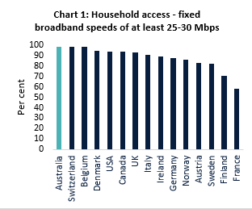 Source: Various, PwC analysis. NBN data used for Australia. Speed tiers differ by country. To enable international comparison this statistic reports the level of coverage based on a minimum speed of 25 Mbps or 30 Mbps.

A shift to higher speeds
Australians are embracing higher speed plans over time, which is reflected in increases in wholesale and retail subscriptions. As at June 2020, almost 70 per cent of NBN fixed subscriptions were for plans with download speeds of at least 50 Mbps, up from around 16 per cent in June 2016 (chart 2).
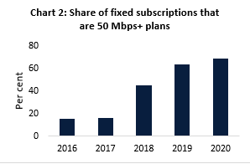 Source: ACCC Wholesale Market Indicators reports.
Similarly, at September 2020 around 70 per cent of all NBN wholesale subscriptions were for plans with download speeds of at least 50 Mbps, up from less than 40 per cent in early 2018. There has been a corresponding decline in the share of households subscribing to comparatively lower speed plans, indicating a pattern of migration to higher speed services (chart 3).
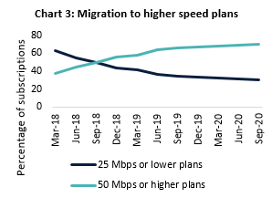Source: NBN Co. Monthly progress reports.
This change has been in part due to NBN Co’s introduction of discounted bundled products which have allowed retailers to offer more affordable 50 Mbps and above products.
Other factors include increased demand for higher speeds due to the increasing popularity of video streaming services, a greater number of internet-connected household devices and the increased importance of home internet due to the impact of the COVID-19 pandemic.
Australia ranks 6th amongst peer countries in terms of the proportion of households on speeds equal to or greater than 25 Mbps. Around 84 per cent of households have subscriptions that fall within this speed range in Australia (chart 4).
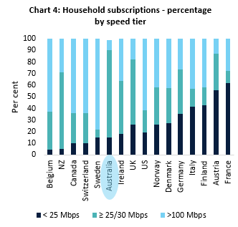
Source: ACCC, OECD (2019 data) PwC analysis. Australia’s data is based on speed tiers using NBN services only, using the ACCC’s NBN Services in Operation RKR data (June 2020).

Information in this fact sheet draws on data available as at September 2020 for countries analysed, and may not always relate to the same period. ‘Speeds’ refer to wholesale speeds.
Limitations on the availability of appropriate data means that for some measures, analysis of different subsets of countries from the list of identified peer countries was required.
Based on data available to the Department, NBN Co.
Note this captures NBN wholesale plans only and includes both fixed and wireless connections.
Refers to NBN subscriptions only.

