Bureau of
Communications
and Arts Research

Demand for fixed-line broadband in Australia
February 2018
WORKING PAPER



Disclaimer
The material in this paper is of a general nature and should not be regarded as legal advice or relied on for assistance in any particular circumstance or emergency situation. In any important matter, you should seek appropriate independent professional advice in relation to your own circumstances.
The Commonwealth accepts no responsibility or liability for any damage, loss or expense incurred as a result of the reliance on information contained in this discussion paper.
This paper has been prepared for consultation purposes only and does not indicate the Commonwealth’s commitment to a particular course of action. Additionally, any third party views or recommendations included in this discussion paper do not reflect the views of the Commonwealth, or indicate its commitment to a particular course of action.
The following Disclaimer Notice applies to data obtained from the HILDA Survey. The Household, Income and Labour Dynamics in Australia (HILDA) Survey was initiated and is funded by the Australian Government Department of Social Services (DSS), and is managed by the Melbourne Institute of Applied Economic and Social Research (Melbourne Institute). The findings and views based on these data should not be attributed to either DSS or the Melbourne Institute.

Copyright
© Commonwealth of Australia 2018
All content in this publication is provided under a Creative Commons Attribution 4.0 International (CC BY 4.0) licence, with the exception of:
- the Commonwealth Coat of Arms
- this Department’s logos
- any third party material, including any images and/or photographs, and
- any material protected by a trademark.

Third party copyright
The Department has made all reasonable efforts to clearly identify material where the copyright is owned by a third party. Permission may need to be obtained from third parties to re-use their material.

Attribution
The CC BY licence is a standard form licence agreement that allows you to copy and redistribute the material in any medium or format, as well as remix, transform, and build upon the material, on the condition that you provide a link to the licence, you indicate if changes were made, and you attribute the material as follows:
Licensed from the Commonwealth of Australia under a Creative Commons Attribution 3.0 International licence.
Enquiries about the use of any material in this publication can be sent to: copyright@communications.gov.au.

Using the Commonwealth Coat of Arms
The terms of use for the Coat of Arms are available from the It’s an Honour website (see www.itsanhonour.gov.au and click ‘Commonwealth Coat of Arms’).

Contents
Executive summary iv
Context and framework 1
Box 1: Bandwidth 2
Forecasting data demand 4
Changing demographics drive data demand 4
So too does technology 5
Although this depends on the pace of technology adoption 8
Forecasting bandwidth demand 9
Bandwidth demand depends on ‘peak’ usage… 9
…and household type 9
The relationship between data and bandwidth demand varies between households… 11
…and overall bandwidth demand will be higher in some locations 12
Appendix A. Technical methodology and assumptions 17
Demography—household formation 17
Demography—number of households 17
Demography—household characteristics 19
Technological developments 22
Bandwidth demand 24
Mapping regions 28
Caveats 28
Appendix B. Results of sensitivity analysis 30
Slower take-up of VR 30
Slower take-up of online video 30
IoT devices take-off 31
Faster take-up of online video 32
References 34

Executive summary
Australians’ appetites for internet services continue to grow, with expectations that they can access the services they want, when they want to, with ease and speed.
This has seen the rapid take-up of platforms and over-the-top services, such as Netflix and Skype, which has increased demand for data and the rate at which that data is transmitted—known as bandwidth. Households now reasonably expect to use a wide range of applications on demand and that infrastructure, networks and services will support this use.
Changing demand has occurred alongside infrastructure investment including in the National Broadband Network (NBN). In light of this the Bureau of Communications and Arts Research (BCAR) has forecast Australian households’ demand over the next decade for data and bandwidth delivered over fixed-line services. This working paper, the first in an annual series, identifies the drivers of demand for data and bandwidth and forecasts how this demand will change.
For the average household, the volume of data demanded each month is forecast to increase from 95 gigabytes (GB) in 2016 to 420 GB in 2026. Developments in technology will contribute significantly to this growth. Households will spend more of their available leisure time using new technologies such as ultra-high definition online video content and virtual reality (VR), and increasingly use more than one device at the same time. Demographic factors such as rising real incomes and the ageing of younger (connected) generations will also contribute to increased data demand.
Households that use the most data are most likely to demand the most bandwidth at peak periods, although the frequency and duration of this peak will vary between households. Peak bandwidth demand for the highest usage households is forecast to increase from between 11–20 megabits per second (Mbps) in 2016 to between 20–49 Mbps in 2026. 98 per cent of households are estimated to demand less than this amount of bandwidth in 2026—that is, only 2 per cent of households are expected to demand more than 49 Mbps in bandwidth.
For households that already demand significant amounts of bandwidth, the volume of data used is likely to grow at a faster rate than their bandwidth demand. These households are assumed to already have a range of data-intensive technology in their homes and use the maximum number of devices possible at a single point in time in the peak period. However, for other households data and bandwidth are expected to increase at a similar rate as they adopt new technologies that impact both data and bandwidth demand.
While the number of high usage households is not expected to increase significantly, they are expected to become more concentrated in particular areas. Over the period to 2026, bandwidth demand is expected to rise most rapidly in regions where the number of couple families with children is forecast to grow—often on the fringes of major metropolitan areas. Other factors such as income and the quality of existing infrastructure will also affect the growth of bandwidth demand at a regional level.
The BCAR will continue to monitor changes in demographics, technology and other factors each year to assess the impact on data and bandwidth demand.

Context and framework
Australia’s digital transformation has driven growth in a vast range of applications and platforms requiring an increasing use of data. Australians, enthusiastic adopters of new technologies, have embraced data-intensive applications such as video-on-demand (VOD) services. Households now reasonably expect that they will be able to use these applications on demand, at any time of day—and, by implication, that infrastructure, networks and services will have the capacity to deliver this.
The rapid uptake in recent years by consumers of video content and other VOD services—such as YouTube and most notably from the introduction of Netflix in Australia in March 2015—is reflected in the increase in the amount of data consumed by households each month. Demand for data grew at approximately 50 per cent per year from 2009 to 2016 (Figure 1).
Figure 1. Average monthly household data downloads, fixed-line connections
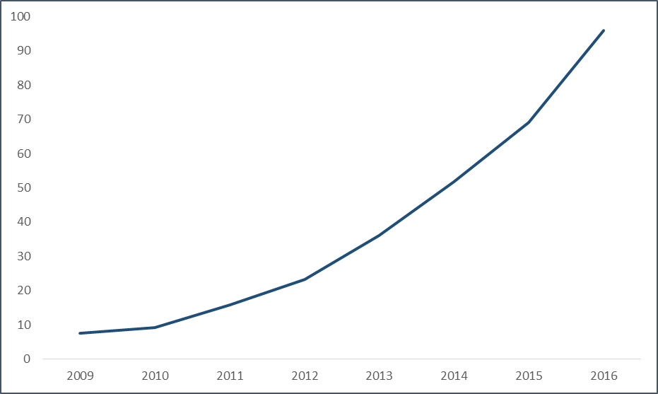
Source: Australian Bureau of Statistics (ABS), Internet Activity, Australia, June 2016, 8153.0.
VOD services are becoming customary for Australian viewing, with ongoing implications for bandwidth demand.
Previous research into the bandwidth requirements of Australian households was completed in 2014 when the Vertigan Panel review commissioned reports on consumer willingness to pay for speed, consumer take-up of the NBN and forecasts of bandwidth demand. However, this was at a very early stage of the NBN rollout and before the rapid rise of VOD. This paper does not analyse willingness to pay and NBN take-up by households.
In light of developments since 2014, the BCAR is taking a fresh look at the broadband demand of Australian households and how it is expected to change over the next decade. The BCAR has drawn on and extended the approach of the 2014 bandwidth forecasts by Communications Chambers, to look at the impact of technology and demography on bandwidth demand and data usage.
Appendix A provides the full details of the sources, inputs and methodology the BCAR has used to generate forecasts of bandwidth and data demand, including a comparison of how they differ from the analysis conducted by Communications Chambers in 2014. Further information regarding references to BCAR analysis are also found in Appendix A.
Understanding the demand for data alone is not sufficient to understand the extent to which household expectations will be met. This also depends on the capacity of the network to service this demand, particularly in relation to the level of bandwidth demand (Box 1).

Box 1: Bandwidth
Bandwidth is the rate at which information is transmitted over a line or through a circuit. It can be used to refer to the capacity of a line, or to the requirement of applications. The capacity of a line determines the ability for households to use applications requiring relatively large amounts of data, such as streaming video or downloading files. Bandwidth is measured in bits per second.
Bandwidth can be compared to the flow of traffic on a road, with the rate at which those cars travel dependent on the capacity of the road (the number of lanes) and the number of cars on the road at any given point in time. The more cars that use the road at the same time the slower will be the flow of traffic. In peak periods, it will take longer for any one vehicle to reach its destination.
Similarly, estimating how aggregate bandwidth demand relates to capacity will provide insight into the experience of any one household. The factors that influence both the bandwidth demand for individual households and at a regional basis are:
- The number of households accessing data at any given point in time, which affects overall demand.
- The demographics of those households, such as age and the number of people, which determines the propensity to use data-intensive applications.
- Technology developments which may either increase demand for bandwidth, through the adoption and increased usage of new applications, or alleviate pressures on bandwidth, for example through compression technology which decreases file sizes of video.
- The time of day, as aggregate household demand increases outside working hours, during evenings or weekends.
Given these factors, bandwidth demand is generally only an issue during peak periods and will have greater impact for users of high-bandwidth applications such as online video gaming or streaming ultra-high definition video content.
This means that households’ future demand for bandwidth is not the same as their demand for data. Data demand depends on household composition and changes in technology whereas bandwidth demand at a regional level is also influenced by the number of households and where they are located (Figure 2). The time of day that households use applications, which is also influenced by demographics and technology, is a key determinant of bandwidth demand (Figure 2). The way that these factors influence data and bandwidth demand is explored through the rest of the paper.
Figure 2. Drivers of the demand for data and bandwidth
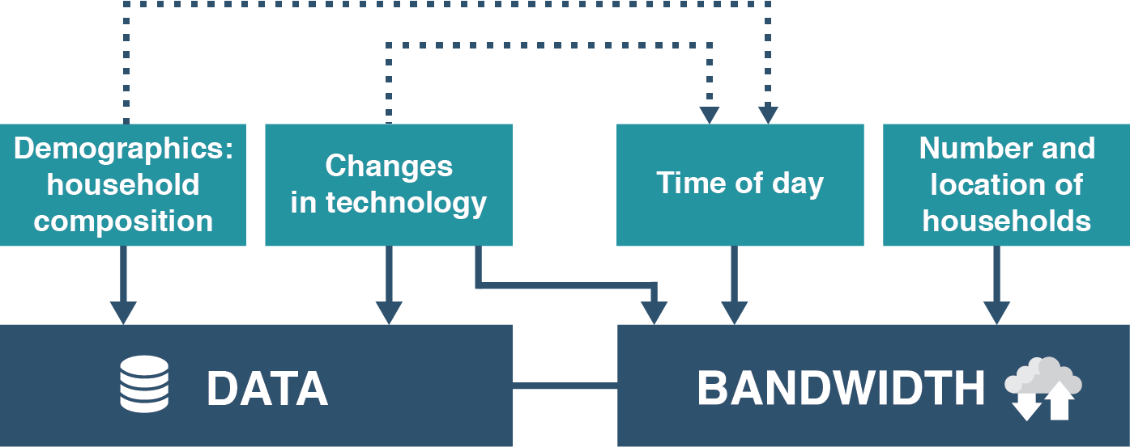
The forecast demand for data incorporates changes to household composition based on age, income and family type and how these affect the data requirements of households. Expected advancements in technology are then used to forecast how this will affect the consumption of data for the average household in 2026, both in aggregate and by region.
The bandwidth demand forecasts use the technological assumptions and demographic changes from the data forecasts to determine application usage in peak periods by different household types and by household location, taking into account how developments in technology can alleviate pressures on bandwidth demand.
The BCAR will continue to improve and update its forecasts each year. These forecasts would, for example, be improved by access to richer information on the data and bandwidth use of consumers, particularly how these change with respect to their age, income and other determinants such as their education and job.

Forecasting data demand

Changing demographics drive data demand
Data demand will increase due to the increase in the number of households and changes in their composition. Overall the number of households in Australia is expected to increase by 2 per cent per annum over the decade to 2026.
Household composition is important as every new generation becomes more digitally savvy. Recent data shows that younger Australians are relatively heavy users of data and this use will keep growing. Households with more people and with younger members are likely to demand more data—although the current difference in data usage between age groups is likely to lessen over time.
Figure 3 shows how data usage differs by household composition, based on communications expenditure, and the age of the highest income earner. Each value is shown relative to a single person household aged over 70 (the lowest users of data). Couple families with children where the highest income earner is in the 40–49 and 50–59 age brackets use the most data, while single person households tend to use less data on average than one parent families and couple families.
Figure 3. Data use by different household types and age of highest income earner
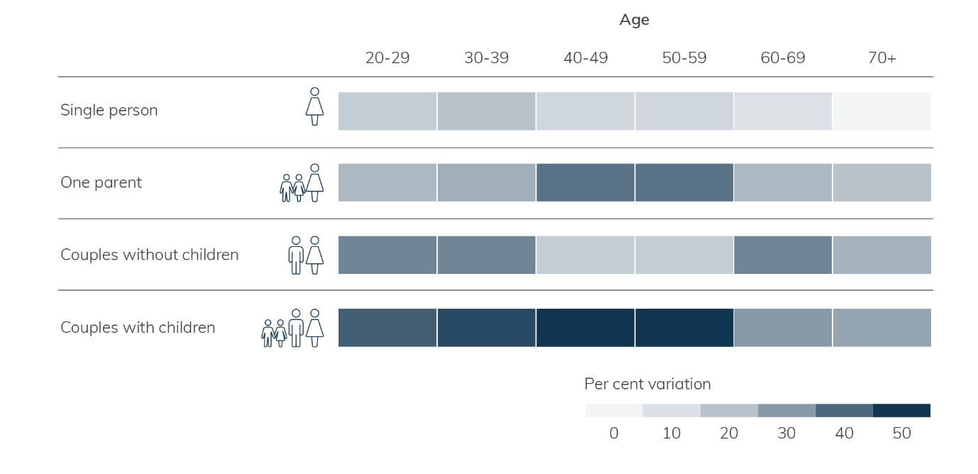
Source: BCAR analysis of the Household, Income and Labour Dynamics in Australia Survey.
The household type that is the heaviest data user also forms the largest share of all households in 2016 (Table 1). These shares are forecast to remain constant out to 2026.
Table 1. Household types as a share of total
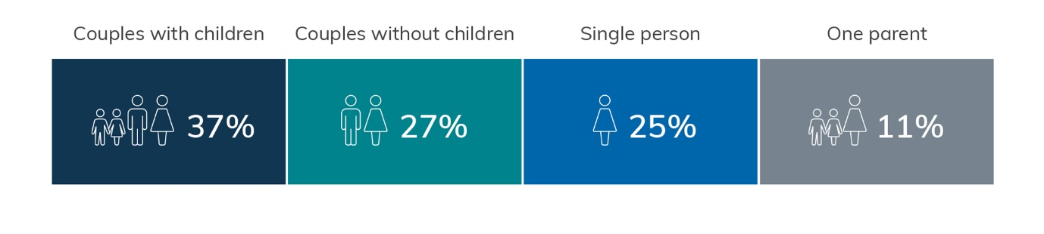
Source: BCAR analysis of the Household, Income and Labour Dynamics in Australia Survey.
Figure 4 shows how the connectedness of different generations is expected to change over time. Younger age groups have adopted broadband services more rapidly than older age groups, however older age groups are expected to continue to ‘catch up’ in the coming years as they become increasingly connected. While these figures are from the US, it is likely that broadband use by Australians would be similar. This is broadly supported by analysis from the Australian Communications and Media Authority.
Figure 4. How home broadband usage changes over time by cohorts
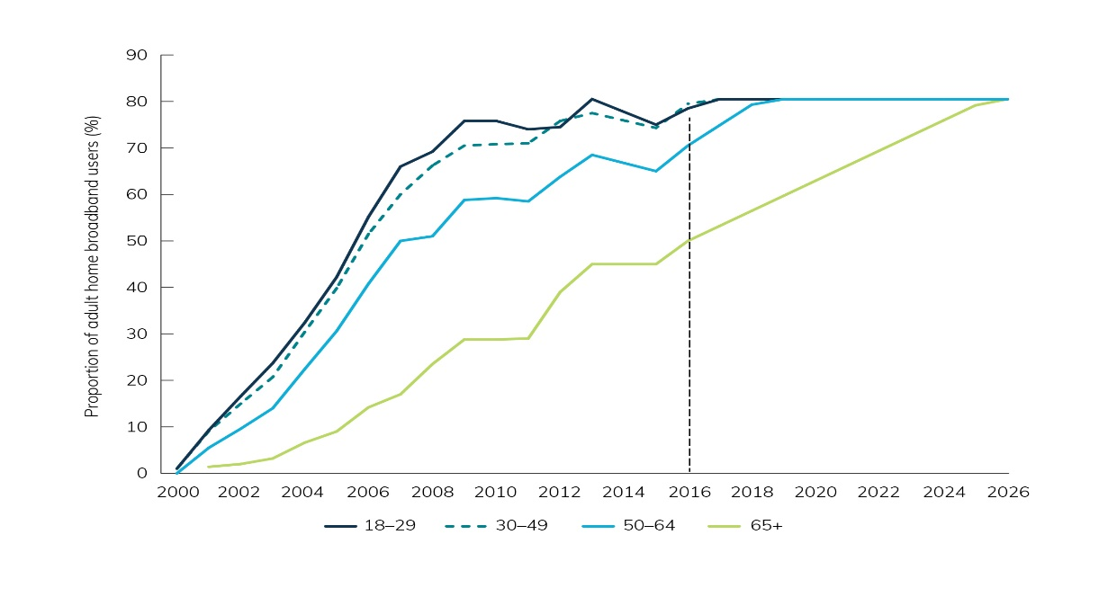
Source: Pew Research and BCAR analysis.
The same general demographic drivers that increase the consumption of data will also drive the demand for bandwidth as younger individuals demand more bandwidth to consume content over the internet. Ageing cohorts are expected to have a similar impact on bandwidth demand as individuals continue to use high-bandwidth applications as they age.

So too does technology
New and improved technology will continue to drive data usage. In aggregate, video will become more data intensive as more households switch from standard definition (SD) to high definition (HD). This will be further affected by the increasing uptake of 4K and 8K video.
The BCAR has forecast the requirements for technology developments to estimate the impact these applications will have on household demand for data and bandwidth. The central forecast takes into account the data intensity of applications such as the Internet of Things (IoT), HD/4K video streaming as well as uptake and usage by different household types.
The BCAR central technology forecast takes the bitrate requirements and usage assumptions for a range of application categories that includes online video viewing, content and software downloads, voice and video calling, IoT, VR and web usage. The assumptions applied in the central case for cloud storage, software downloads, video calls and web browsing are consistent with research previously conducted by Communications Chambers. The BCAR reviewed and compared these inputs with the most up-to-date sources and found that they were still current and did not require updating.
The BCAR’s central forecast does adjust for major changes in some online behaviours since this research was conducted. This includes:
- Online video: The rapid increase in VOD usage means that forecasts need to be updated to reflect the increasing time households spend watching online video. The BCAR estimates that the average household viewed 35 per cent of all screen content through online platforms in 2016. This is forecast to increase to 60 per cent of all screen content in 2026. The BCAR also accounts for the expected impact of 8K (introduction from 2020), which was not included in the Communications Chambers analysis.
- IoT: Households are expected to adopt IoT devices at a faster rate than was previously forecast. The BCAR forecast specifically incorporates the impact of these devices. In 2026, the average household is forecast to have 50 connected devices, which could include smart lights or heating.
- VR: The BCAR forecast also specifically estimates the impact of VR adoption, which was not explicitly included in the Communications Chambers analysis. Based on available information, the BCAR forecasts that 48 per cent of households will use VR devices in 2026, up from 2 per cent in 2016.
Appendix A contains further detail on the specific assumptions and sources used to develop the BCAR forecast.
Figure 5 shows the BCAR’s central forecast (for all households) of data downloads, and how it compares to other potential growth paths for the use of data, based on historic ABS data. While the ABS data refers to households with fixed-line connections, the BCAR’s forecast applies to all households.
Figure 5. Monthly household data downloads, comparison of trend and forecasts
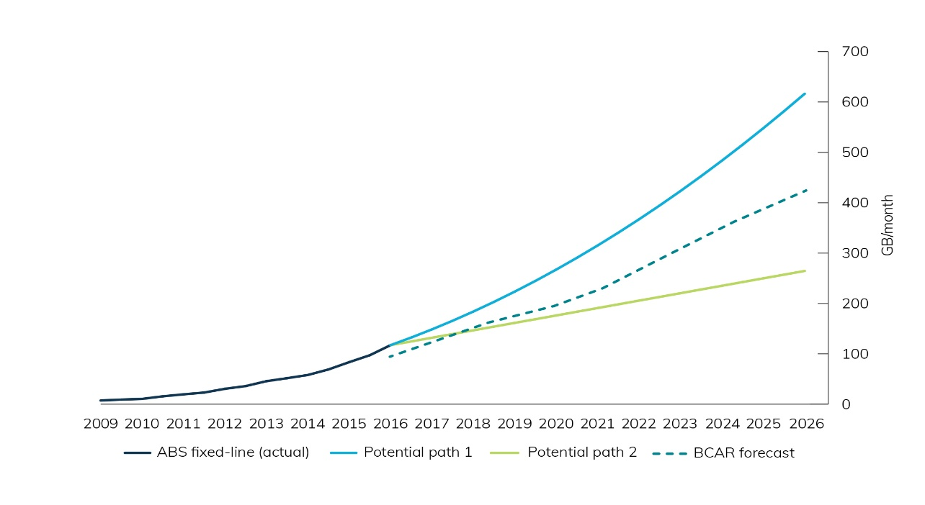
Source: ABS, Internet Activity, Australia, June 2016, 8153.0 and BCAR analysis.
The first potential growth path assumes the growth in actual data downloaded will increase each year, taking the average data consumed per fixed-line subscriber to approximately 620 GB per month in 2026. This scenario is likely to reflect a continued rapid take-up of video viewing over the internet and the introduction of new data intensive technologies.
The second potential growth path assumes that the growth in actual data downloaded will remain constant—that is, it will grow by the same amount each year. In June 2016, the average amount of data consumed per fixed-line subscriber was approximately 95 GB per month. Following this path would result in approximately 260 GB of data being consumed per month in 2026. This scenario could reflect a levelling off in the transition to internet TV and the slower introduction of new technologies.
The BCAR forecast incorporates the ramp up in video content activity in 2015 and 2016 as well as recent developments of new technologies, increasing to 420 GB per month in 2026. In addition, the BCAR forecast incorporates the impact of changing family demographics within households as younger age groups continue their high data consumption habits as they age. Figure 6 shows how each of these factors contributes to the BCAR’s forecast of data usage.
The BCAR forecast reflects the recent and continuing shift to watching online content rather than on traditional platforms, while still keeping total leisure time relatively stable. The BCAR forecast also includes the impact of demographic changes, such as ageing and rising real incomes, on data usage.
The continued transition toward accessing video over the internet will generate over half of the forecast growth in data. The major drivers of this impact are the availability of higher quality video that requires more data, increased penetration of internet-capable TV sets and widespread availability of content through free and subscription-based VOD platforms. However, there are limits on the leisure time available for people to watch video content and total viewing hours are held constant from 2016 to 2026.
Figure 6 shows the contribution of different technologies to the BCAR’s central forecast, with further detail found in Appendix A. The figure reflects households spending more time watching video over the internet and that content providers will also shift from SD or HD video to 4K and 8K content that is more data intensive. This means that both SD and HD video are expected to contribute less to overall demand in 2026 when compared to 2016. Further improvements in compression technology mean that the bandwidth requirements for each video type decline over time. Compression rate improvements also apply to VR technology.
Figure 6. Components of cumulative data download growth in Australia, 2016–2026
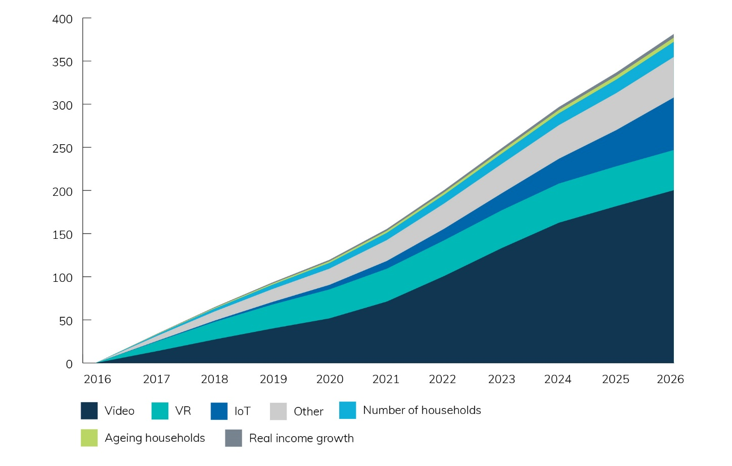
Source: BCAR analysis.
The second largest contributor to total growth in 2026 is expected to be data generated by IoT devices. While the impact of IoT is relatively small until 2021, it increases between 2021 and 2026—contributing over 15 per cent of total growth during that period.
This growth is due to the increase in the number of devices in each household and the data needs of the average IoT-connected device. While each device does not necessarily require a large amount of bandwidth, increasing data use results from the significant increase in the number of devices owned by each household over the next decade. With the majority of IoT growth occurring further in the future this element of the forecast is more uncertain than other factors.
Between 2016 and 2026, growth in VR and other usage takes a more gradual path and makes a similar contribution to total growth in 2026. VR is a computer-generated environment which allows the user to experience a simulated reality through a headset and other accompanying devices. It has a broad range of applications from video games and movies to live events. The BCAR forecast is based on analysis that estimates VR will reach a quarter of Australian households by 2021, up from 2 per cent in 2016.
As with IoT, the contribution of VR to future growth is subject to greater uncertainty than some other technologies. The BCAR forecasts that data growth from VR will slow after 2021 due to lower market penetration and the limits on available leisure time for VR usage due to work or other commitments.
Finally, demographic changes in the period 2016–2026 are expected to play a lesser, but still significant, role in data growth. The increase in the number of households, ageing and real income growth is expected to contribute almost 10 per cent to growth in the period.
The BCAR assumes that households will continue to have limits on their available leisure time. As such, the effect of technology changes, which drive increased data usage, will eventually peak and growth in data usage will slow. However, this is unlikely to have fully played out before 2026.

Although this depends on the pace of technology adoption
While demographics tend to grow on a steady path, the pace of developments in technologies and their uptake by households is more uncertain.
The BCAR has tested its central forecast against the most likely alternatives in take-up rates for VR, online video and IoT. Forecasts for data usage are sensitive to how quickly households adopt technologies, with a faster than expected take-up of online video likely to have the most significant impact on data demand:
- If the take-up of VR is slower than expected (80 per cent lower), data demand would be 14 per cent lower in 2021, and 9 per cent lower in 2026, relative to the BCAR’s central forecast.
- If the take-up of online video is slower than expected (one-third lower), then data demand would be 13 per cent lower in 2021, and 19 per cent lower in 2026, than the BCAR’s central forecast.
- Alternatively, if the take-up of online video is faster than expected (one-third higher), then data demand would be 19 per cent higher in 2021 and 29 per cent higher in 2026 than the BCAR’s central forecast.
- If household take-up of IoT devices is double what is expected, data demand will be 14 per cent higher in 2026 than the BCAR’s forecast.
Further information on the sensitivity analysis is at Appendix B.

Forecasting bandwidth demand

Bandwidth demand depends on ‘peak’ usage…
The demand for bandwidth varies throughout the day, week and month and across households. Often there will be no bandwidth demand where no applications are in use. However, demand can increase rapidly in busy evening periods when a number of individuals are at home using multiple devices.
As the demand for data grows so does the concentration and concurrent usage of various applications, which affects the amount of bandwidth required by a household over the ‘typical’ day.
Based on industry information, Figure 7 shows the proportion of usage activity over a 24-hour period. Average household usage is highest between 5:00pm and 11:00pm with bandwidth demand peaking between 8:00pm and 9:00pm on a typical day. The typical day should not be assumed to represent one particular day of the week because a range of factors influence the traffic profile on any given day and how this profile may change over time. The usage profile for each individual household may be more or less concentrated than this.
Figure 7. Distribution of broadband usage throughout the day
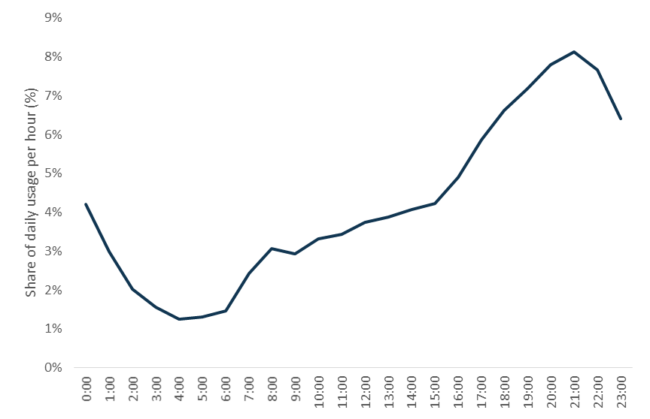
Source: BCAR analysis of industry data.

…and household type
As each individual household has its own pattern of usage requiring bandwidth capacity to serve its needs, very detailed information would be needed to provide accurate forecasts of bandwidth demand.
Averages are easier to determine but tend not to be useful as these smooth through the extremes in cycles of demand. Using the road analogy in Box 1, the average would even out the peaks and troughs and conceal the degree of congestion in the peak traffic period.
Even a median measure of bandwidth demand would show only the bandwidth speed that would satisfy half of all households, rather than the majority.
The BCAR has sought to address these limitations by using available data to proxy for the variation in bandwidth demand between households and in the concentration of households, by constructing ‘typical’ households and their location.
Averages are easier to determine but tend not to be useful as these smooth through the extremes in cycles of demand. Using the road analogy in Box 1, the average would even out the peaks and troughs and conceal the degree of congestion in the peak traffic period.
Even a median measure of bandwidth demand would show only the bandwidth speed that would satisfy half of all households, rather than the majority.
The BCAR has sought to address these limitations by using available data to proxy for the variation in bandwidth demand between households and in the concentration of households, by constructing ‘typical’ households and their location.
The Bureau has constructed four ‘typical’ households which together represent 98 per cent of all households. The four ‘typical’ households are: single person, single parent/two children, two adult/no children and two adult/two children.
The two adult/two children household has the highest maximum bandwidth requirements. In 2016, maximum peak bandwidth is up to 10 Mbps for the single person household and up to 20 Mbps for the two adult/two children household. By 2026, the maximum peak bandwidth requirement rises to 15 Mbps for the single person household and to 49 Mbps for the two adult/two children household.
This means the maximum bandwidth requirement for 98 per cent of households is forecast to be 49 Mbps by 2026. Consequently, only 2 per cent of households will require 50 Mbps or more to meet their peak bandwidth demand by 2026.
Figure 8 shows the peak bandwidth demand and the share of households that have this demand. It also maps speeds forecast to be capable from NBN infrastructure in 2020 to show that most households will have their broadband needs met by the NBN.
Figure 8: Peak household bandwidth demand (2016 versus 2026) and NBN speed capability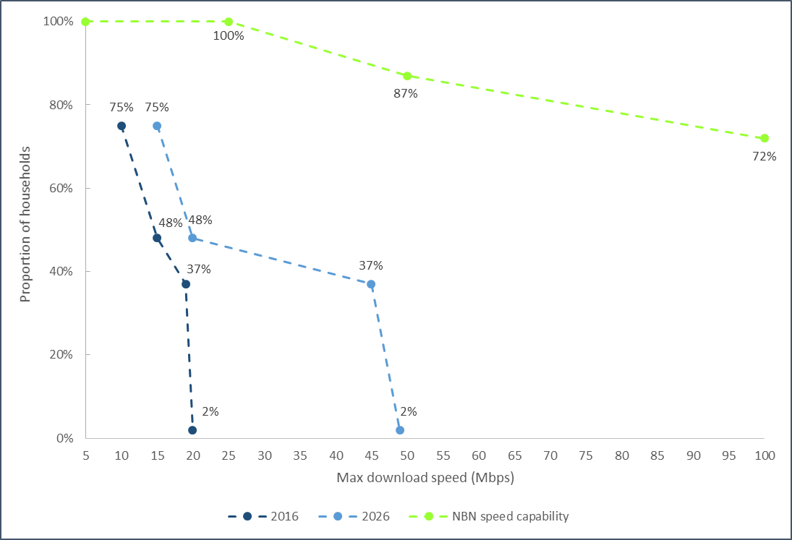
Sources: BCAR analysis and NBN Co Limited.
Note: Beyond 100 Mbps, 52 per cent of households are forecast to be capable of achieving speeds of 500 Mbps, and 49 per cent to achieve speeds up to 1 Gbps.

The relationship between data and bandwidth demand varies between households…
Overall, Table 2 indicates that bandwidth demand is forecast to approximately double for the highest usage household types. While this growth rate appears to be lower than for average data demand, it only reflects the bandwidth demand for specific high usage households who are assumed to have taken up a large range of technological applications already in 2016. That is, the growth rates are based on two different measures, with data demand based on the average household and bandwidth demand based on high usage households. However, for other households data and bandwidth are expected to increase at a similar rate as they adopt new technologies that impact both data and bandwidth demand.
Other factors that contribute to the difference between the forecast for high usage household bandwidth demand and data usage are the impact of technology (e.g. high usage households are assumed already to be using a range of new technology that may not be present in the average household) and the expectation that there are physical limits on the number of devices that a household can use at one point in time constrains the growth in bandwidth demand relative to that for data. From the perspective of all consumers, lower usage households are likely to take up a range of new applications between 2016 and 2026, which results in overall bandwidth growth that is in line with growth in data demand.
With the amount of leisure time available to households expected to remain broadly constant over the forecast period, the increase in data use relative to bandwidth demand results from the substitution to internet-connected applications, such as online video content, away from offline technologies such as ‘traditional’ television. High usage households are assumed to have adopted new technologies in 2016, which means this effect does not contribute their bandwidth demand growth over the period to 2026.
There are two main ways in which technological change affects the bandwidth requirements for households.
- The introduction and take-up of new technologies—new technologies previously mentioned include 4K video, VR and IoT devices. New applications usually require more bandwidth and this is particularly the case for video content and VR.
- Improvements to existing technology—the most common example of this is the impact of compression rates. An improvement in compression reduces the bandwidth required to download or stream content at a particular point in time. Compression is generally applied to video or other similar content.
The combined effects will determine how bandwidth demand will grow over time. New technologies are likely to increase the bandwidth required, while improvements in compression technology will reduce it.

…and overall bandwidth demand will be higher in some locations
Notwithstanding the limitations of using average measures to provide insight into bandwidth and data demand at the individual household level, these measures can be useful in determining the impact of broader population trends on service provision. This is because analysing average demand by location shows areas which may be above or below ‘average’ demand.
Regions that have a higher concentration of couple families with children are likely to experience a higher peak bandwidth demand across the region as a whole when compared with those regions that have more single person households for example. Similarly, regions with high population growth are likely to demand greater amounts of bandwidth at the regional level compared to regions where the number of households does not increase significantly, because a larger number of people means that the total bandwidth required at a given point in time will be higher. The impact of technology is assumed to grow at the same rate nationally.
Figures 9 to 11 use demographic modelling detailed in Appendix A to compare how the concentration and number of couple families with children changes across the Sydney, Melbourne, Brisbane and Perth metropolitan areas between 2016 and 2026.
In 2016, the regions where couple families take up a greater share of the population are a darker shade and would be expected to experience a higher peak bandwidth demand. Suburban areas on the fringe of metropolitan areas (e.g. Western Sydney and Ipswich) make up the majority of these regions in 2016.
Over the forecast period to 2026 the impact of population growth takes effect with an increasing number of couple families with children likely in most regions, which is illustrated by the darker shades across each metropolitan area. A number of new regions arise as hot spots for couple families with children due to their rapid rate of population growth. These locations are largely the inner suburbs of metropolitan areas or new growth areas on the fringe of cities characterised by new housing developments. The effects of ageing highlighted in Figure 4 are incorporated into the regional analysis through the collapsed household types.
At a national level high demand for bandwidth is more likely in regions that skew towards young families, which include outback and mining cities and towns. While these regions have a greater concentration of couple families with children, the population across these regions is sparse with a small number of growing population centres driving activity. As such, high usage is likely to be concentrated in very small parts of these regions. For most areas of those regions there is likely to be very little demand due to large unpopulated areas.
Figure 9. Concentration of couple families with children by region, Greater Sydney, 2016 and 2026
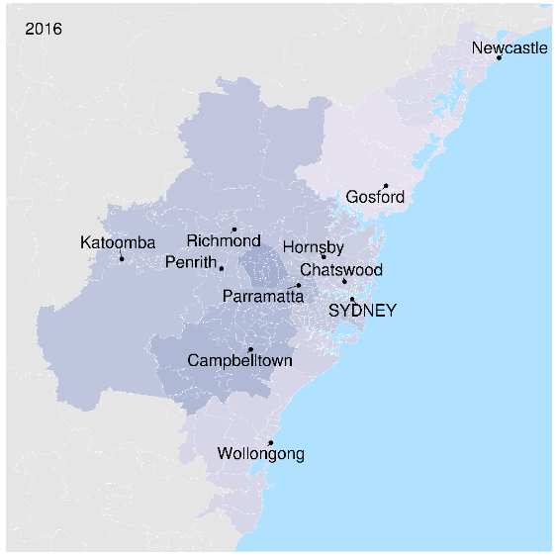
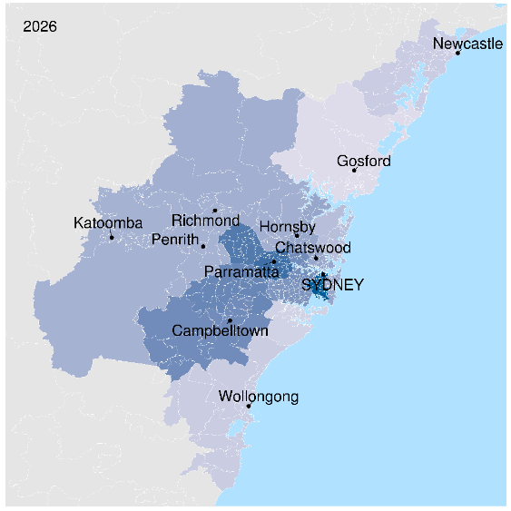
Source: BCAR analysis.
Note: Darker shades of blue indicate higher concentration of couple families with children. Regions with higher population growth (inner Sydney) and a greater share of couple family households (Western Sydney) exhibit a darker shade.
Figure 10. Concentration of couple families with children by region, Greater Melbourne, 2016 and 2026
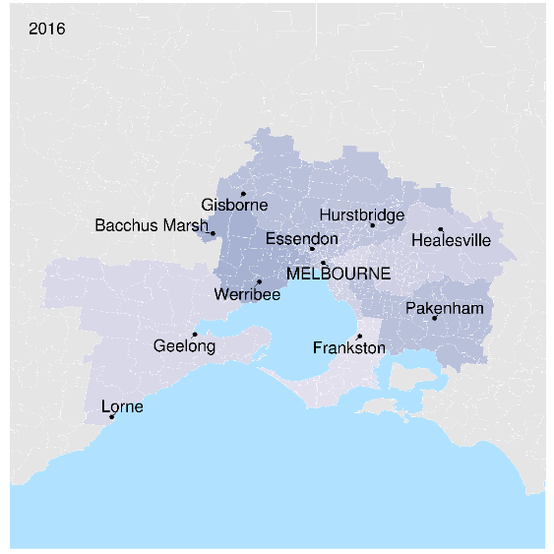
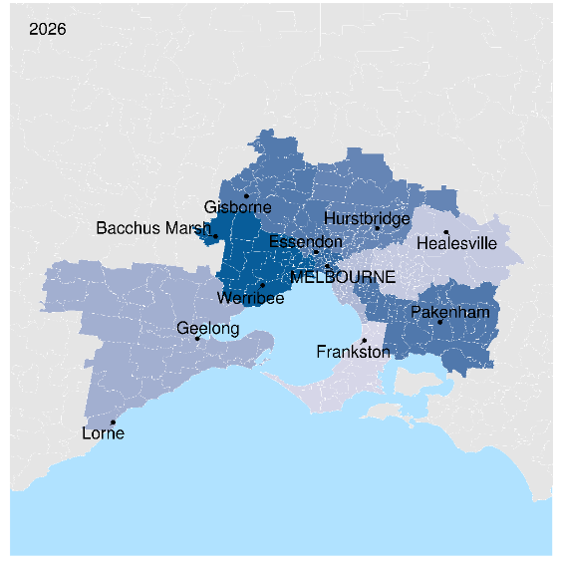
Source: BCAR analysis.
Note: Darker shades of blue indicate higher concentration of couple families with children. Regions with higher population growth (inner Melbourne) and a greater share of couple family households (Western suburbs) exhibit a darker shade.
Figure 11. Concentration of couple families with children by region, Greater Brisbane, 2016 and 2026
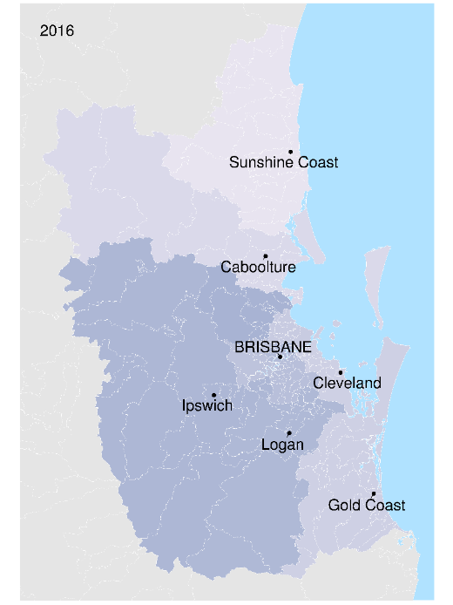
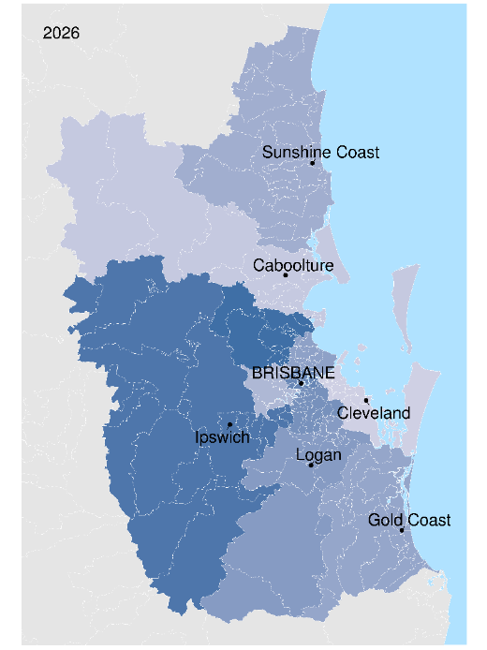
Source: BCAR analysis.
Note: Darker shades of blue indicate higher concentration of couple families with children. Regions with higher population growth and a greater share of couple family households (Ipswich) exhibit a darker shade.
Figure 12. Concentration of couple families with children by region, Greater Perth, 2016 and 2026
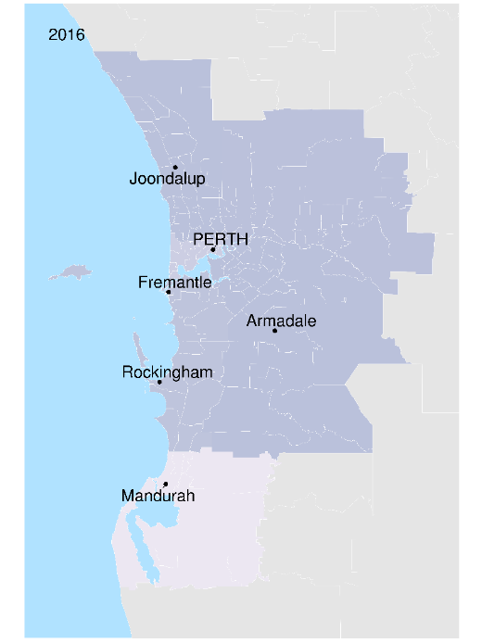
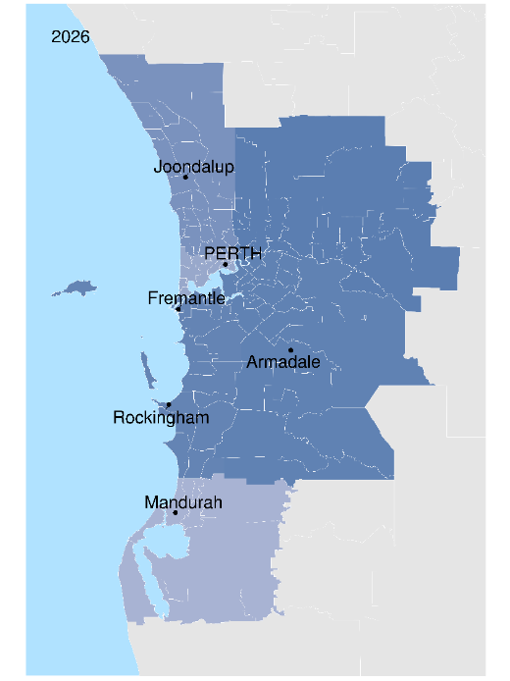
Source: BCAR analysis.
Note: Darker shades of blue indicate higher concentration of couple families with children. Regions with higher population growth and a greater share of couple family households (Fremantle) exhibit a darker shade.

Appendix A. Technical methodology and assumptions
The following technical appendix sets out in more detail the sources, assumptions, methodology and results for each part of the modelling. These parts include: household formation and characteristics, demography by region, technology development, and bandwidth requirements.

Demography—household formation

Sources
The Australian Bureau of Statistics (ABS), Census of Population and Housing 2016 (Household type by year of age, Australia).

Assumptions
Household formation is constant across time. That is, the propensity to form a household of type i (e.g. single, couples with and without children, and group households), for someone of age j (Pij) does not change from the propensities calculated in the 2016 census. Propensities were tested and found to be relatively stable in the 2006, 2011 and 2016 censuses.

Method
The propensity to live in a household of type i for individuals of age j (in single years of life) were calculated based on 2016 census data. These were applied through matrix multiplication for each region for each year of the forecast period. This resulted in counts of households of each type for each year in the forecast period.

Demography—number of households
Demography has been forecast at the Statistical Area 4 Level (SA4), which is one of the spatial units defined under the Australian Statistical Geography Standard (ASGS). The ASGS is a hierarchical geographical classification, defined by the ABS. It is used in the collection and dissemination of official statistics. The base year for the demographic model is the 2016 ABS Census.
For the demographic model, population has been projected depending on year of birth out to 2026. The projections for Australia and each SA4 are driven by four components. These components are:
- fertility
- mortality
- net overseas migration (NOM), and
- net internal migration (NIM).

Sources
Sources for the population forecasts and drivers are listed below:
- Fertility—ABS, Births Australia, cat. no. 3301.0, 2015.
- Mortality—ABS, Deaths Australia, cat. no. 3302.0, 2015
- NOM—ABS, Population Projections series B, Australia cat. no. 3222.0, 2013–16.
- NIM—ABS, Census, 2011 and 2016.

Assumptions
The BCAR has assumed that the rate for fertility, mortality, NOM and NIM remain constant during the forecast period out to 2026. Births are reported at an SA4 level in five-year age blocks for women between 15 and 49. The release captures all births in Australia and includes them in the report. The BCAR has assumed that all mothers are aged between 15 and 49. Available data only contains state death rates. The BCAR has therefore assumed that all SA4s in the same state have the same death rate.
While this approach is appropriate for this purpose, care should be taken when interpreting the results, particularly at the SA4 level. Interstate migration, as an unrestricted and unregulated effect on population, is volatile and an unpredictable component in population estimation or projection. The movement of people between the states and territories of Australia is influenced by many factors such as varying economic opportunities, overseas immigration and settlement patterns, lifestyle choices and marketing campaigns targeting interstate movers by state/territory governments. As the effect of these factors cannot be anticipated, past net interstate migration trends are used as the basis for assuming future levels.

Method

Fertility
Fertility rates are given for each SA4 per 1000 women in five-year age brackets for women aged between 15 and 49. The BCAR has distributed the fertility rates for the five-year age groups by the population of a certain age in a certain area. The rates are then applied to the corresponding population in order to estimate the number of new births each year during the forecast period.

Mortality
The BCAR has multiplied the population of a particular age in a SA4 by the corresponding state and age death rate in order to estimate the number of people of a certain age who may die each year in the forecast period.

Net Overseas Migration (NOM)
Average NOM has been taken as a percentage of the population. NOM is split between greater metropolitan area and the rest of the state. The rest of the state NOM is applied uniformly across all regional SA4s in the corresponding state. Greater metropolitan areas have been multiplied with the corresponding NOM rate.

Net internal migration (NIM)
NIM is calculated using both the 2011 and 2016 Census taken by the ABS. NIM is estimated for each SA4. The BCAR estimated the difference between the expected population in 2016 by SA4 and the actual population counts of the 2016 Census by SA4 level. The difference between the two estimates is equal to the NIM for that region. This estimate is then applied to future forecasts in the corresponding SA4.

Results
Figure A1 shows the forecast population for Australia, broken into 10-year age brackets using the components above. This is an illustrative example of how each SA4 was calculated. Each regional estimate applies the same approach, but uses different growth rates.
Figure A1. Forecast population of Australia by age brackets
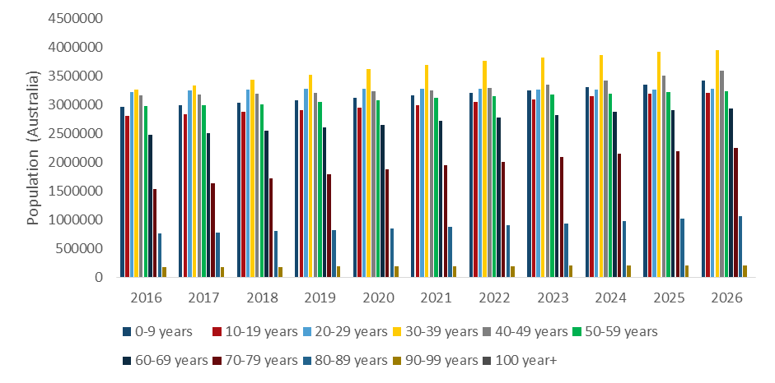
Source: BCAR analysis.

Demography—household characteristics

Sources
To estimate how broadband demand changes by household types and household occupants’ ages, the BCAR used release 15 of the Household, Income and Labour Dynamics in Australia Survey (HILDA). To estimate how the data consumption of different age cohorts will change over time, the BCAR used data on home broadband users in the US from Pew Research Centre.

Assumptions
HILDA does not include a variable on household broadband bandwidth demand or data usage, which was the desired variable. To overcome this, the BCAR used the ‘household annual expenditure on telephone rent, calls and internet charges’ variable (expenditure) from HILDA as a proxy for broadband demand.
The BCAR validated the HILDA estimates using data more closely related to bandwidth and data usage from the Australian Communications and Media Authority’s consumer survey relating to the amount of time spent streaming video per week. The HILDA estimates were considered to be more robust due to a larger sample size.
To estimate a representative age for each household, the age of the highest income earner in the household was taken. In the case of a tie, the average of the ages of the equal highest income earners were taken.
The different households were collapsed into the four broad ABS household types as per Table A1. Note that ‘group’ and ‘multiple family households’ were excluded from the analysis. The very small number of these households introduces a high level of variability, which reduces the robustness of the analysis.
Outlying observations, where household income was less than zero, or where expenditure was greater than 5000 were dropped.
When modelling how age cohorts change over time, the maximum percentage of adults who use broadband at home was capped at the highest level recorded for any cohort in history –approximately 80 per cent. This is a reasonable assumption as the younger cohorts do not display an increasing trend in recent history, which suggests there is an 80 per cent penetration rate threshold in this data set.
Table A1. Household Classifications
HILDA household types | ABS household types
Couple family wo children or others | Couple with no children
Couple family wo children w other related | Couple with no children
Couple family wo children w other not related | Couple with no children
Couple family w children < 15 wo others | Couple with children
Couple family w children < 15 w other related | Couple with children
Couple family w children < 15 w other not related | Couple with children
Couple family w depdnt wo others | Couple with children
Couple family w depdnt w other related | Couple with children
Couple family w depdnt w other not related | Couple with children
Couple family w no depdnt wo others | Couple with children
Couple family w no depdnt w other related | Couple with children
Couple family w no depdnt w other not related | Couple with children
Lone parent w children < 15 wo others | One parent family
Lone parent w children < 15 w other related | One parent family
Lone parent w children < 15 w other not related | One parent family
Lone parent w depdnt wo others | One parent family
Lone parent w depdnt w other related | One parent family
Lone parent w depdnt w other not related | One parent family
Lone parent w no depdnt wo others | One parent family
Lone parent w no depdnt w other related | One parent family
Lone parent w no depdnt w other not related | One parent family
Other related family wo children < 15 or others | Couple with no children
Other related family wo children < 15 w others | Couple with no children
Lone person | Single person household
Group household | Not included
Multi family household | Not included

Method
To estimate the differences in broadband demand from the 28 different household types and age cohorts a logarithmic regression using dummy variables was used. The analysis also controls for differences in household income (also in the logarithmic scale).
The dummy variables were set to one if the observation is within the specific category with all other dummy variables for that observation set to zero. For example, if the first observation in the survey is in the ‘couple with children 0–19’ category, it would record a one for that dummy variable and record a zero for all of the other dummy variables.
To avoid the dummy variable trap, one dummy variable is dropped. The BCAR dropped the cohort with the lowest expenditure after controlling for income, which was the ‘single person household 70+’ and used this group as the ‘base case’. The coefficients for the other household groups measure the average percentage point difference between it and the base case (Table A2).

Results
Table A2. HILDA Regression output
 | Dependent variable: Log(expenditure)
Constant | 5.186***
Log(household income) | 0.152***
Couple with children 0-19 | 0.383*
Couple with children 20-29 | 0.423***
Couple with children 30-39 | 0.463***
Couple with children 40-49 | 0.500***
Couple with children 50-59 | 0.480***
Couple with children 60-69 | 0.341***
Couple with children 70+ | 0.315**
Couple with no children 0-19 | 0.047
Couple with no children 20-29 | 0.359***
Couple with no children 30-39 | 0.349***
Couple with no children 40-49 | 0.225***
Couple with no children 50-59 | 0.246***
Couple with no children 60-69 | 0.336***
Couple with no children 70+ | 0.147***
Single person 0-19 | 0.287***
Single person 20-29 | 0.173***
Single person 30-39 | 0.215***
Single person 40-49 | 0.139***
Single person 50-59 | 0.135***
Single person 60-69 | 0.103**
Single person 70+ | Dropped
Single parent with children 0-19 | 0.222
Single parent with children 20-29 | 0.264***
Single parent with children 30-39 | 0.306***
Single parent with children 40-49 | 0.371***
Single parent with children 50-59 | 0.370***
Single parent with children 60-69 | 0.265***
Single parent with no children 70+ | 0.221*
Observations | 8728
R2 | 0.121
Adjusted R2 | 0.118
Residual Standard Error | 0.668 (df = 8699)
F-Statistic | 42.655*** (df = 28; 8699)
Note | *p<0.1; **p<0.05; ***p<0.01

For the different age cohorts the data was aggregated into calendar year by taking the average of all observations within each year (Table A3). Each age bracket was individually forecast using an automatic autoregressive integrated moving average (ARIMA) model.
Table A3. Percentage of broadband users by age
Year | Age bracket | Age bracket | Age bracket | Age bracket
 | 18-29 | 30-49 | 50-64 | 65+
2000 | 1.00 | 1.00 | 0.00 | ..
2001 | 9.30 | 9.10 | 5.50 | 1.40
2002 | 16.60 | 15.00 | 9.60 | 2.00
2003 | 23.70 | 20.70 | 14.00 | 3.20
2004 | 32.40 | 30.40 | 22.40 | 6.60
2005 | 42.20 | 39.80 | 30.60 | 9.00
2006 | 55.20 | 51.50 | 40.80 | 14.20
2007 | 66.00 | 60.00 | 50.00 | 17.00
2008 | 69.20 | 66.20 | 51.00 | 23.50
2009 | 75.80 | 70.50 | 58.80 | 28.80
2010 | 75.80 | 70.80 | 59.20 | 28.80
2011 | 74.00 | 71.00 | 58.50 | 29.00
2012 | 74.50 | 75.80 | 63.80 | 39.00
2013 | 80.50 | 77.50 | 68.50 | 45.00
2014 | .. | .. | .. | ..
2015 | 75.00 | 74.30 | 65.00 | 45.00
2016 | 78.50 | 79.50 | 70.50 | 50.00
2017(f) | 80.50 | 80.50 | 74.91 | 53.24
2018(f) | 80.50 | 80.50 | 79.31 | 56.48
2019(f) | 80.50 | 80.50 | 80.50 | 59.72
2020(f) | 80.50 | 80.50 | 80.50 | 62.96
2021(f) | 80.50 | 80.50 | 80.50 | 66.20
2022(f) | 80.50 | 80.50 | 80.50 | 69.44
2023(f) | 80.50 | 80.50 | 80.50 | 72.68
2024(f) | 80.50 | 80.50 | 80.50 | 75.92
2025(f) | 80.50 | 80.50 | 80.50 | 79.16
2026(f) | 80.50 | 80.50 | 80.50 | 80.50
Source: Pew Research Centre and BCAR analysis.

Technological developments
The technology modelling is based on similar inputs and assumptions to those used by Communications Chambers in 2014. However, as noted in the paper a number of changes have occurred in relation to the usage and bandwidth requirements for particular technological applications. The following section sets out where the BCAR has introduced new or updated sources of data.

Sources
There is no single source for estimates of data and bandwidth consumption for all technologies addressed. As such, a number of sources were required to formulate inputs for the model. Each source provides an estimate of current usage and a forecast estimate. This allowed the BCAR to derive growth rates to model.
The primary sources used were:
- CISCO, Virtual Networking Index (VNI) 2016–2021 forecasts
- Telsyte, AR & VR 2017 Market Study
- Nielsen, Australian Connected Consumer Report 2017
- Telsyte, IoT @ Home
- Creative Content Australia, Piracy Behaviours report 2016, and
- additional supplementary evidence as required.

Assumptions
The following assumptions were made for each of the technologies included in the model:
Video type (high definition (HD), 4K): The growth rates for these video types were taken from the CISCO VNI figures.
Video type (standard definition (SD)): The growth rate for SD video was taken from the CISCO VNI forecast figures, which was then adjusted for the forecast penetration of 8K TV starting after 2020 as older TV sets start to be replaced.
Video type (8K): The growth of this video type begins in 2021 due to 8K TV sets reaching significant penetration in Australia after the anticipated commercial availability of 8K TVs in 2020. The rate of growth is assumed to be the same as for 4K TV.
Bitrates for video types: The relevant bitrate requirements were taken from the Netflix recommended speed index. 8K video bitrate is assumed to be double the 4K bitrate.
Virtual Reality (VR): The growth rate for VR penetration was obtained from the compound annual growth rate (CAGR) estimated in the Telsyte VR & AR Study for the period 2016 to 2021.
Compression: Video compression technology improvements are assumed to result in a 9 per cent reduction in video and VR bitrate requirements each year. This is consistent with the Communications Chambers estimates.
Internet of Things (IoT): Growth in the number of IoT devices by household was estimated using the CAGR estimated in the Telsyte IoT @ Home report for the period 2017 to 2021. Due to the uncertainty regarding growth after 2021, the BCAR capped the number of devices in households to 50 in 2026 for the central case. IoT devices connected to fixed-line internet were isolated by excluding those forecast to be mobile connected in the VNI forecasts.
Bitrate for an individual for an IoT device: Calculated by using the CISCO VNI estimate of the share of IoT device internet traffic divided by the number of devices.
BitTorrent traffic: Average weekly hours for file downloads for individuals is calculated from the Nielsen Connected Consumer and Piracy Behaviours report data. This source provides estimates of the average weekly hours for content downloads and the proportion of individuals engaged in content downloading. This allows for an estimate of the average weekly hours for file downloads across all households. This is combined with video type penetration and bitrates to estimate data download usage.
Other: Communications Chambers growth rates for data usage and bitrates for other technology types including cloud storage, software downloads, video calls and web browsing were applied. The BCAR reviewed all of these inputs with the most up-to-date sources and found that they were still current and did not require updating.

Method
The output provided by the assumptions allowed for a central forecast to be made.
From the central case four sensitivity tests were constructed to measure the potential impact a lower or higher than expected adoption of certain technologies would have on household data demand. These scenarios and associated assumptions are as follows:
- Slow take-up of VR: VR to only achieve ten per cent household penetration by 2026.
- Slow transition to online video: The proportion of all screen content viewed online reaches 40 per cent by 2026.
- Rapid transition to online video: The proportion of all screen content viewed online reaches 80 per cent by 2026.
- Rapid take up of IoT devices: The number of IoT devices per household increases to 100 by 2026.

Results
Table A4. Bandwidth requirements and take-up by various technologies
Technology | Bandwidth  (Mbps) |  | Penetration
 | 2016 | 2026 | 2016 | 2026
SD | 3 | 1.2 | 73% | 0%
HD | 5 | 1.9 | 26% | 57%
4K | 25 | 10.7 | 1% | 29%
8K | 50 | 19.5 | 0% | 14%
VR | 50 | 19.5 | 2% | 48%
IoT (per device) | 0.000727 | 0.010742 | N/A | N/A
BitTorrent | N/A | N/A | 20% | 10%

Table A5. Sensitivity tests—deviation from central forecast
Technology | Penetration/usage minutes per month/devices per household  2016 | Penetration/usage minutes per month/devices per household  2026 central forecast | Penetration/usage minutes per month/devices per household  2026 scenarios
VR slow take-off | 2% | 48% | 10%
Rapid transition to online video | 2058 minutes | 4911 minutes | 7367 minutes
Slow transition to online video | 2058 minutes | 4911 minutes | 3273 minutes
IoT takes off | 10.6 devices | 50 devices | 100 devices

Bandwidth demand
While the technological forecasts outlined above are based on bandwidth requirements, they are largely translated into the demand for data over the month. To provide more insight into the demand for bandwidth by household, the BCAR built a bandwidth demand profile for four household types at a period of peak usage. This approach is a simplification of the approach taken by Communications Chambers, where a profile of bandwidth demand across the month was calculated for 192 different household types. The BCAR has estimated a peak bandwidth demand for four household types that are representative of a proportion of household types. The peak usage scenario for the high-usage two adults, two children household appears to be comparable with the 95th percentile usage household from the Communications Chambers analysis.

Sources
The sources used to forecast household bandwidth demand requirements by technology type are discussed in the technology section above. A further comparison was made with Communication Chambers’ forecasts to validate the scenarios developed.
The share of each household type as a proportion of the population adopts the sources used to produce the population growth and household characteristics.

Assumptions

Bandwidth stacks
The BCAR developed a number of ‘bandwidth stacks’ that indicate the amount of bandwidth required to support the simultaneous use of numerous applications and devices. This method takes a similar approach to previous research. The benefit of this measure is that it provides more insight into the level of bandwidth a household will demand at its busiest period of usage.
Where previous analysis has developed more complex distributions of how households use applications (to identify how frequently devices are used concurrently), the BCAR has taken a less complex approach while still remaining comparable. The BCAR approach estimates what would be physically and realistically possible for a household at an intensive period of usage. However, because the BCAR does not assume a particular distribution of this usage amongst all households it is hard to compare results directly with other research. Based on previous estimates it appears that the stylised high-usage two adults, two children household is comparable to the 95th percentile usage household estimated by Communications Chambers. That is, the bandwidth stack for this household type is similar to the bandwidth requirements for the highest 5 per cent of bandwidth usage as estimated by Communications Chambers. The bandwidth demands estimated for the other three household types are below this level, but are above the median estimated by Communications Chambers.
Table A6 outlines the usage of each household and how this is distributed within the household.
Table A6. Peak usage profiles by high-usage household type
Household type | Application usage | Explanation of usage
Single person | VOD  Video calling  Software download | An individual may be streaming VOD, while sharing the experience with a friend over video call, with a software update downloading.
Single parent/two children | VOD  YouTube  Online gaming  Software download | While a parent streams VOD, two children are watching YouTube and gaming online. An update to software is downloading in the background.
Two adults/no children | VOD  Video calling  Web browsing  Software download | While one adult makes a video call, the other multi-screens by streaming VOD and browsing the web. An update to software is downloading in the background.
Two adults/two children | VOD  YouTube  Video calling  Web browsing  Online gaming  Software download | While one adult makes a video call, the other multi-screens by streaming VOD and browsing the web. The two children are watching YouTube and gaming online. An update to software is downloading in the background.

As an extension to further illustrate the maximum bandwidth demand scenario, the BCAR investigated the usage profile of the highest use household type (two adults, two children) at specific times of the day. Five points throughout the day were chosen (12:00 pm, 5:00 pm, 7:00 pm 9:00 pm and 11:00 pm). As outlined in the report, each of the times are associated with a scenario and the relevant applications used in that scenario (e.g. 5:00 pm—both children doing homework, utilising web search and video). The bandwidth requirements for each application were summed to estimate a bandwidth stack for each time of day.
Table A7 provides further detail on the on the technological applications used throughout the day in both 2016 and 2026.
Table A7. Application usage throughout the day, two adult-two children household
Time of day | 2016 applications | 2026 applications
12:00pm | SD Video calling  Software download | HD Video calling  Software download
5:00pm | HD YouTube  Web browsing | 4K YouTube  Web browsing
7:00pm | HD VOD  HD YouTube  SD Video calling | 4K VOD  4K YouTube  HD Video calling
9:00pm | HD VOD  HD YouTube  SD Video calling  Web browsing  Online gaming  Software download | 4K VOD  4K YouTube  HD Video calling  Web browsing  VR online gaming  Software download
11:00pm | HD VOD  Web browsing | 4K VOD  Web browsing

The four indicative household types, typical application use and the range of peak monthly bandwidth demand scenarios are shown in Table 2 A8. This collapses the cohorts in Figure 3 to four categories: a single person, single parent/two children, two adult/no children and a two adult/two children household. Table A8 sets out the applications each particular household type could use, the range of bandwidth requirements that this would generate and the share of total population that each high usage household type represents.
Table A8. Maximum bandwidth requirements by high-usage household type
Household type | 2016 typical application usage | 2016 peak bandwidth range | 2026 typical application usage | 2026 peak bandwidth range | Share of households with peak demand up to this level (2016 and 2026)
Single person | HD VOD  Video calling  Software download | 5-10 Mbps | 4K VOD  Video calling  Software download | 10-15 Mbps | 25%
Single parent/two children | HD VOD  HD YouTube  Online gaming  Software download | 10-19 Mbps | 4K VOD  4K YouTube  VR online gaming  Software download | 20-45 Mbps | 63%
Two adults/no children | HD VOD  Video calling  Web browsing  Software download | 5-15 Mbps | 4K VOD  Video calling  Web browsing  Software download | 11-20 Mbps | 52%
Two adults/two children | HD VOD  HD YouTube  Video calling  Web browsing  Online gaming  Software download | 11-20 Mbps | 4K VOD  4K YouTube  Video calling  Web browsing  VR online gaming  Software download | 20-49 Mbps | 98%
Source: BCAR analysis.
Each scenario represents an illustration of a potential busy period of usage for a ‘typical’ high usage household type.
- For the single person household, this would range from streaming VOD to a situation where they stream their favourite show whilst video calling a friend to share what is going on.
- In the single parent household, this ranges from a scenario where two video streams are running to a situation where one child is gaming online while another streams YouTube and the parent watches internet-enabled television.
- In a two adult only household, this ranges from a situation where the couple streams their favourite show to one where one adult streams VOD and browses the internet, while the other adult makes a video call.
- Finally, the two adult/two children household ranges from a situation where the children stream VOD together while the parents browse the internet and video call, to a situation where all the applications are in use.
- In the background of each household, the latest mobile operating system software is downloading.
Some caution should be exercised when applying these scenarios to all households because this approach only attempts to estimate the demand of a typical high usage household. However, Table A8 does indicate that 98 per cent of households would have up to this level of bandwidth demand in 2026—that is, only 2 per cent of households are expected to demand more than 49 Mbps in bandwidth. The remaining households not covered by this figure would largely be made up of couple families with more than two children.
This proportion remains constant across the forecast period out to 2026 because the composition of the Australian population is not forecast to change significantly over that period. In addition, the maximum bandwidth requirements could occur infrequently and for short periods, during which each household type would reasonably expect to engage in this sort of usage without interruption.

Household types as a share of population
In order to provide a point of comparison the BCAR has estimated the share of population that represents the high usage household types. The methodology used to calculate the number and composition of households is consistent with the demographic modelling approach described above. An adjustment is also made to account for the share of households that have two children.
Not all households can be described as high usage households. To address this, the BCAR has used the analysis of household characteristics in HILDA to determine the share of high usage households in each category of household type. A household is categorised as high usage where expenditure is above a particular threshold.

Mapping regions

Sources
Data used to map the concentration of couple families with children are taken from the sources used for household formation and population growth discussed above.

Method
Examining the concentration of these household types by region allows for insight into how the composition of household types and population growth in a particular region impacts the demand for bandwidth.
Concentration in each region is calculated based on the proportion of each household type in each region. Regions with a higher proportion of couple with children households will have a higher weighted average bandwidth demand, while those regions with a higher share of single person or other households are expected to have a lower per-household bandwidth demand relative to other regions.
Over the forecast period to 2026, the maps include the impact of population growth for each region, which introduces further differentiation. Population growth is included because an increasing number of households in a region will increase the aggregate bandwidth demand relative to regions that have slower population growth.

Results
Figures 9 to 12 in the paper illustrate the results of this analysis.

Caveats
A lack of available data has limited aspects of the analysis in this paper. This has been addressed through the construction of proxy measures using alternative data sources.
The main limitation is an absence of data showing the distribution of bandwidth usage—both at a point in time (during the peak period) and how it varies between different household types.
In relation to data at a point in time, the BCAR had access to industry data on the proportion of activity that occurred over the course of a day. The BCAR analysis then assumed that high use bandwidth demand would occur predominantly during an identified ‘peak period’.
While it is not known precisely what proportion of users are in this high use category, the BCAR’s high bandwidth demand scenario for a two adult, two child household is comparable with the Communications Chambers estimate for the highest 5 per cent of bandwidth usage. Communications Chambers estimated that those users had a forecast bandwidth demand of 43 Mbps in 2023, while the BCAR estimates bandwidth demand for a high usage household of between 20-49 Mbps in 2026.
The 2014 Vertigan Panel review commissioned three additional reports as part of its cost-benefit analysis, which included choice modelling of consumer willingness to pay for speed by the Institute for Choice, bandwidth demand forecasting by Communications Chambers, and an assessment of consumer take-up of the NBN. This paper relates only to the work undertaken by Communications Chambers and should not be compared with other analysis that does not forecast demand for bandwidth or data.
In relation to how bandwidth demand varies between households, the BCAR used a proxy measure based on actual demand for data using the Household Income and Labour Dynamics in Australia (HILDA) survey and survey data obtained from the Australian Communications and Media Authority (ACMA).
The BCAR analysis has been careful to avoid inferring that broadband capacity should provide access to a network for applications by all users, at any time of the day. The BCAR cautions against using the analysis for this purpose. Estimates driven purely by demand-side factors, as in this analysis, do not factor in the ability, or willingness of individual consumers to pay to have data available on demand at any time of day.
Specifically, the analysis does not incorporate the extent to which consumers value bandwidth taking into account the cost of acquiring it. Put another way, it cannot be assumed that ‘high demand’ consumers would be prepared to pay to have the facility available to enable them to access any quantity of broadband at any time of the day. Budgetary constraints mean that consumers are likely to prefer to delay the use of data-intensive applications to other times of the day.
That said, macroeconomic factors such as income growth will support higher demand for bandwidth by increasing consumers’ capacity to pay, as well as purchase hardware that demands higher bandwidth.
The analysis should not be used to predict what might occur after 2026. The range of new technologies and the way in which households use them could change substantially over the next decade.
Lastly, while bandwidth is the focus of this paper, it is not the only enabler for the adoption of new technologies. For example, low latency will be crucial for the use of many devices connected to the Internet of Things.

Appendix B. Results of sensitivity analysis

Slower take-up of VR
The first sensitivity scenario looks at the effect of VR being less popular than anticipated and not achieving significant penetration in Australian households.
Price and lack of content have been barriers to the widespread take-up of VR. This is because a VR application is complex and difficult to produce due to its immersive nature, which drives up the cost of production. Developers have been reluctant to invest in content development due to this cost and the small customer base.
Under this scenario, VR is expected to achieve a 10 per cent penetration rate in 2026 rather than 48 per cent in the central forecast. Figure B1 shows that this scenario leads to a 14 per cent decrease in data demand in 2021, and a 9 per cent decrease in 2026, relative to the BCAR’s forecast.
Figure B1. Slower take-up of VR
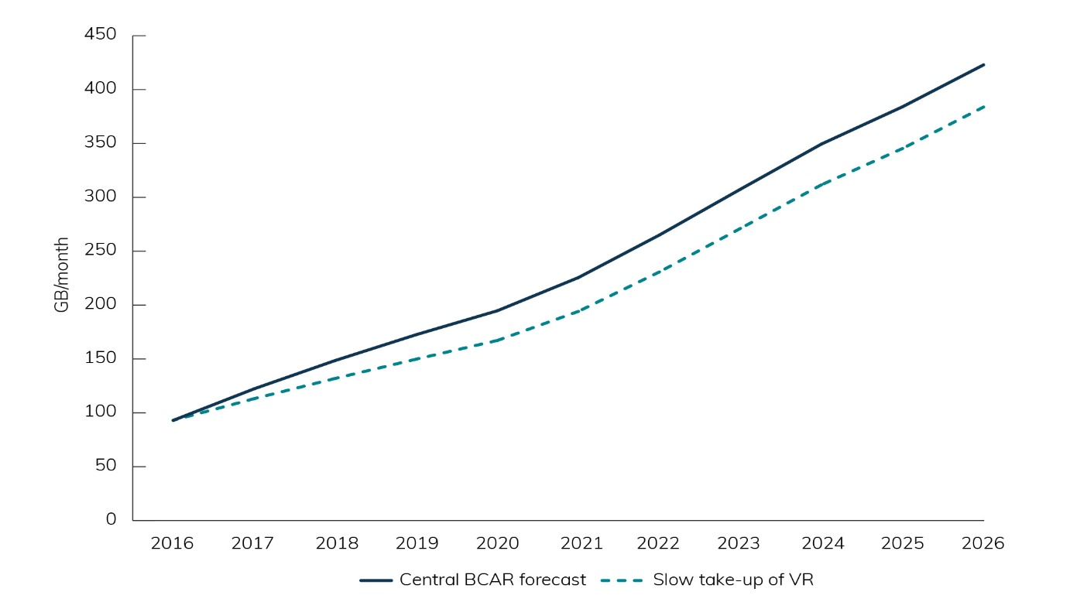
Source: BCAR analysis.

Slower take-up of online video
The amount of video streamed by households is a major contributor to the growth in total demand. Much of this growth is driven by households watching more video over the internet, including catch up services. It is possible that households adopt these viewing habits more slowly than is captured in the BCAR’s forecast.
This could occur for a number of reasons, including the availability of content on particular platforms and the ease with which content can be viewed. Households may stream less video if their preferred content is only available on ‘traditional’ TV, or if they have difficulty accessing that content, due to technological or other factors.
Figure B2 shows the impact on the BCAR’s forecast of a slower take-up of online video (including catch-up services), where 40 per cent of all video is viewed online compared with 60 per cent in the central forecast. This would result in a 13 per cent reduction in demand in 2021 and a 19 per cent reduction in 2026.
Figure B2. Slower take-up of online video
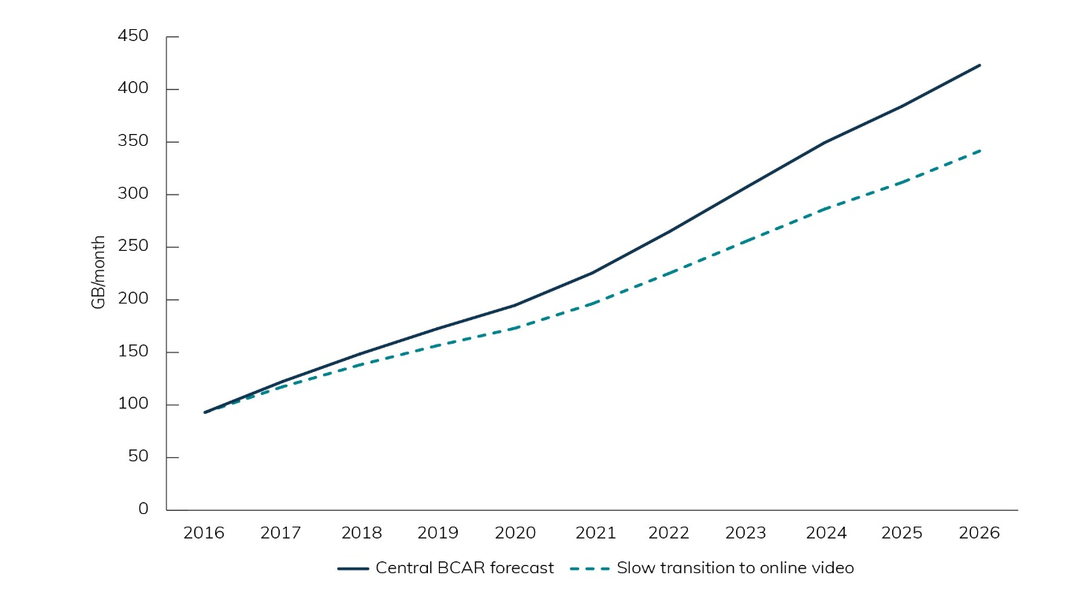
Source: BCAR analysis.
The combined impact of both a slower take-up in VR and online video reduces the BCAR’s forecast by 27 per cent in 2021 (Figure B3). The effect diminishes between 2021 and 2026 as the influence of the slower VR take-up declines.
Figure B3. Cumulative impact of slower growth scenarios
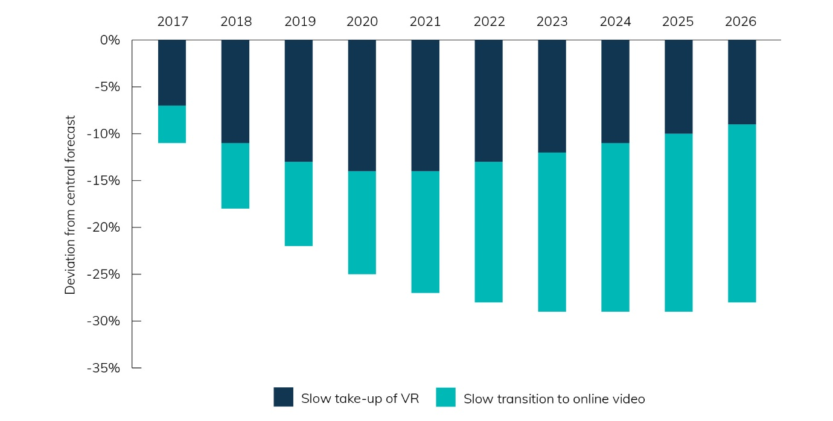
Source: BCAR analysis.

IoT devices take-off
There is also uncertainty around whether application usage will exceed expectations. In 2016 the Productivity Commission highlighted the uncertainty over expectations of the number of connected devices.
The BCAR’s forecast is based on the assumption that each household will have 50 IoT-connected devices in 2026, although some sources suggest this number could reach 100 devices per household, and other sources predict even higher numbers. These devices include smart light switches, air conditioning, refrigerators and security. While each connected device does not require a large amount of bandwidth, the large number of devices and the regular intervals at which updates are required mean that over time it contributes to household data demand.
Figure B4 shows the expected increase in data demand if IoT devices increase at a faster rate than the BCAR’s forecast.
Although this reflects the assumption that the take-up of IoT devices between 2016 and 2021 is at a constant rate, the gap widens after 2021 resulting in demand being 14 per cent greater in 2026 because the average household is forecast to own 100 devices, rather than 50 in the central forecast.
Figure B4. IoT devices take-off
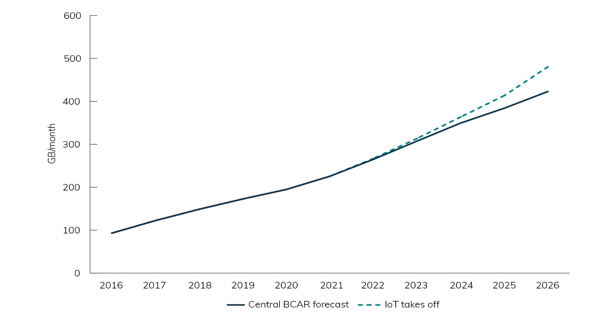
Source: BCAR analysis.

Faster take-up of online video
While a slower transition to online video may lower overall demand (Figure B2), the current speed of growth in VOD subscriptions could be maintained over the next decade. This could be fuelled by the widespread availability of content, particularly if 4K video becomes commonplace.
This would lead to data usage rising at a faster rate than forecast by the BCAR, to be 19 per cent higher in 2021 (Figure B5). This divergence is partly influenced by the impact of higher quality video (4K or 8K) becoming more available online relative to SD or HD video. By 2026, demand would be expected to be 29 per cent greater than the BCAR’s central forecast because 80 per cent of video is viewed online compared with 60 per cent in the central forecast.
Figure B5. Faster take-up of online video
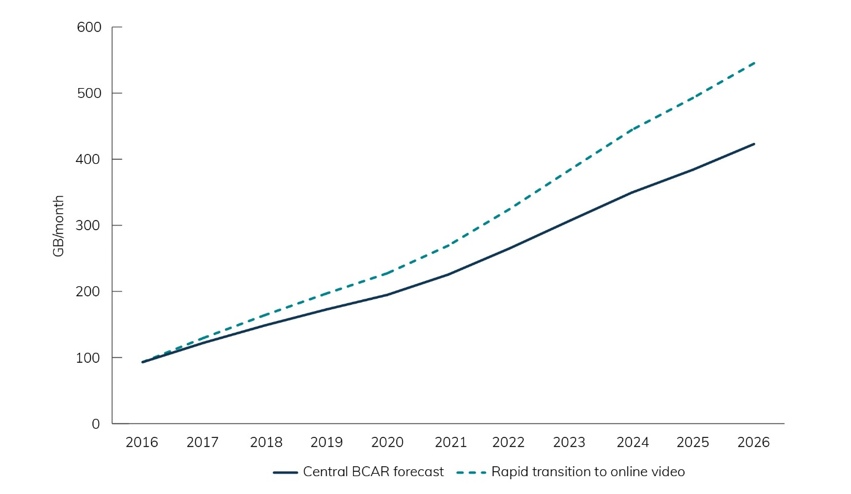
Source: BCAR analysis.
When combined, these two scenarios could result in demand that is over 40 per cent higher in 2026 than forecast by the BCAR with video viewing the main contributor (Figure B6).
Figure B6. Combined impact of higher growth scenarios
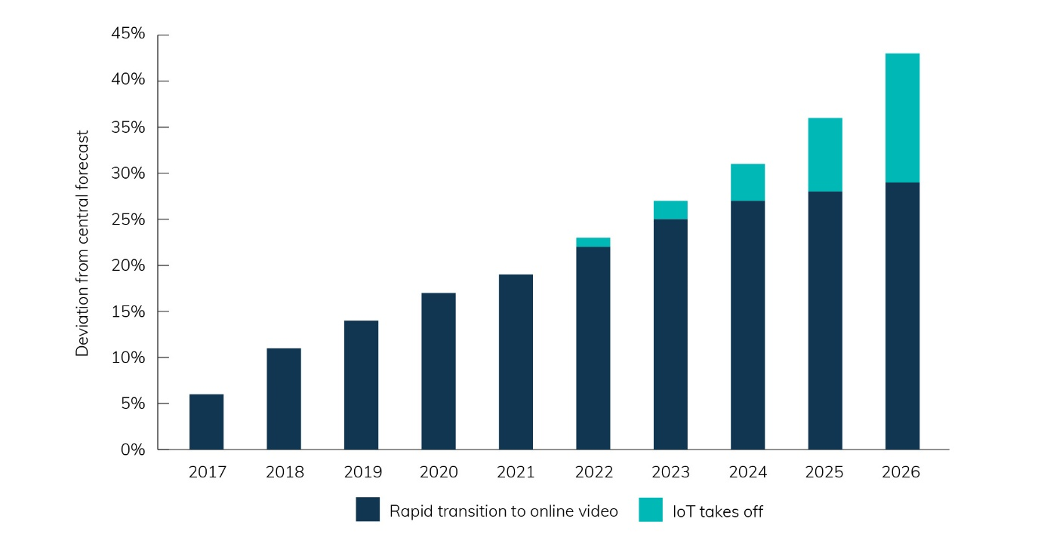
Source: BCAR analysis.

References

The NBN Panel of Experts (2014), Independent Cost-Benefit Analysis.
ACMA (2016), Digital lives of older Australians.
4K and 8K are the two video resolutions considered ultra-high definition (UHD), which is the successor to HD video. 4K and 8K video resolution is two and four times higher respectively than full HD resolution.
Communications Chambers (2014), Domestic bandwidth requirements in Australia.
Other usage refers to web browsing, voice over internet protocol calling, video calling, peer-to-peer sharing, gaming and software downloading.
Net internal migration (NIM) is a number used for population flows from one SA4 to another in Australia. This means that NIM has not been calculated for Australia. It should also be noted that internal migration is volatile and an unpredictable component in population estimation or projection. The movement of people between the states and territories of Australia is influenced by many factors such as varying economic opportunities, overseas immigration and settlement patterns, lifestyle choices and marketing campaigns targeting interstate movers by state/territory governments. As the effect of these factors cannot be anticipated, past net interstate migration trends are used as the basis for assuming future levels.
Communications Chambers (2014), Domestic bandwidth requirements in Australia.
Cisco (2016), Visual Networking Index Forecast.
Telsyte (2017), Australian VR & AR Market Study.
Nielsen (2017), Australian Connected Consumer Report.
Telsyte (2017), IoT @ Home.
Creative Content Australia (2016), Australian Piracy Behaviours.
Communications Chambers (2014), Domestic bandwidth requirements in Australia.
Communications Chambers (2014), Domestic bandwidth requirements in Australia.
Communications Chambers (2014), Domestic bandwidth requirements in Australia.
Aronson-Rath, R., et al. (2016), Virtual Reality Journalism.
Productivity Commission (2016), Digital Disruption: What do governments need to do?
Sources include Cisco (2016), Visual Networking Index Forecast and Telsyte (2017), IoT @ Home.

