BUREAU OF COMMUNICATIONS, ARTS AND REGIONAL RESEARCH

At a glance: Measuring Australia’s Cultural and Creative Workforce, 2008–09 to 2023–24 (Interim Estimates)
December 2025

Cultural and creative employment is significant

An estimated 591,302 people were employed in a cultural and creative industry or occupation as their main job in 2023–24. Of this total:  - 252,506 (42.7%) were in cultural and creative occupations within cultural and creative industries (specialised workers)  - 107,341 (18.2%) were in other occupations within cultural and creative industries (support workers)  - 231,455 (39.1%) were in cultural and creative occupations in other industries (embedded workers).  While much cultural and creative talent is concentrated within the sector – a significant share of cultural and creative workers is employed in other industries. These embedded workers contribute cultural and creative skills and innovation across the broader labour market. | Key changes  Cultural and creative employment increased by 33% between 2008–09 and 2023–24, mainly due to growth in architecture services, events (arts) and advertising and promotion. Most domains, including literature, creative and performing arts, experienced strong recovery after COVID.  Figure 1. Total cultural and creative employment by trident types, 2008–09 to 2023–24  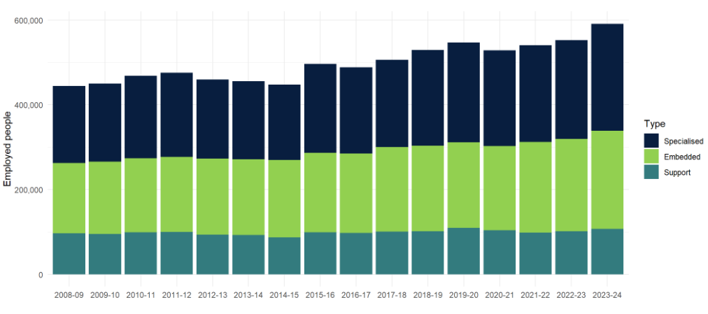  Source: ABS Labour Account Australia, Labour Force, Australia, Detailed, Quarterly; Jobs in Australia; Census of Population and Housing; BCARR calculations.

Comparison with Australian industries

As a share of total employment, cultural and creative employment has remained relatively stable over the analysis period. After peaking at 4.2% in 2019–20, the share decreased during the pandemic to 3.9% of total employment in 2022–23, before rebounding to 4.1% in 2023–24.  The share of cultural and creative employment in 2023–24 is comparable to the employment share of transport, postal and warehousing (4.6%), and wholesale trade (3.8%).  Note: The cultural and creative sector is not an industry division, but rather includes employment from industries across the economy. | Figure 2. Cultural and creative employment and industry share of total employment, 2023–24  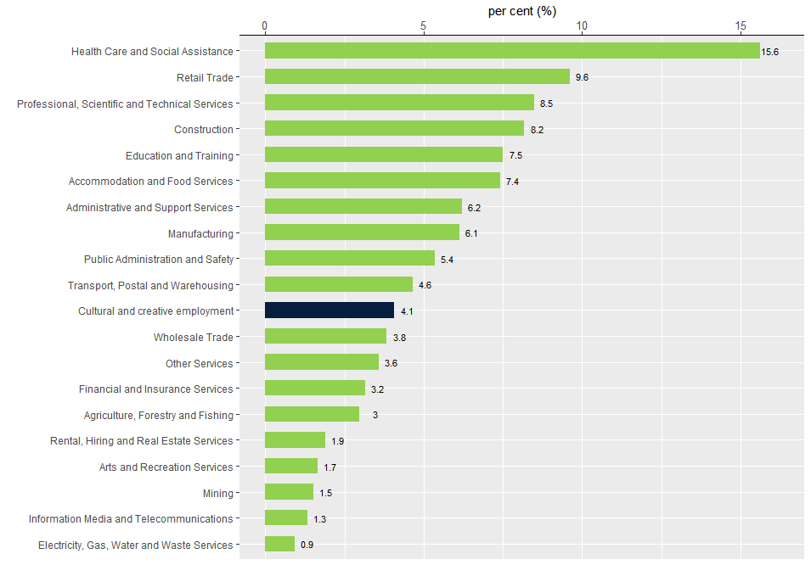  Source: ABS Australian System of National Accounts, Australian National Accounts: Input-Output Tables (Product Details); Australian National Accounts: Supply Use Tables; BCARR calculations.

Cultural and creative employment varies by states and territories

In relative terms, cultural and creative employment is higher in New South Wales and Victoria – with these states having higher shares of their respective total workforces in cultural and creative employment.  Tasmania and the Australian Capital Territory show cultural and creative employment shares that are broadly consistent with their total employment shares.  Other states and territories—particularly Queensland and Western Australia—recorded lower shares of cultural and creative employment relative to their total employment shares.  Between 2008–09 and 2023–24, cultural and creative employment growth was strongest in Victoria, increasing by 49.4%, which equates to an additional 57,692 individuals employed in this sector. | Figure 3. Cultural and creative employment shares by states and territories, 2023–24  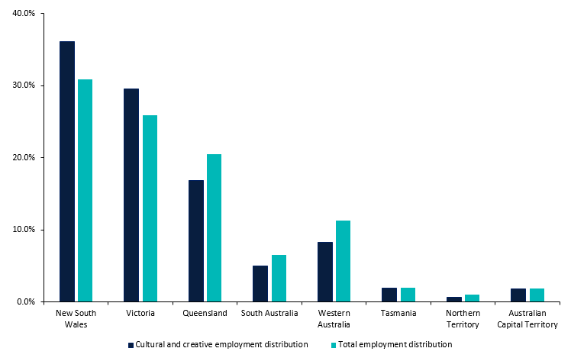  Source: ABS Australian System of National Accounts, Australian National Accounts: Input-Output Tables (Product Details); Australian National Accounts: Supply Use Tables; BCARR calculations.

Women are strongly represented in cultural and creative domains

In 2023–24, women made up 56% (331,130) of cultural and creative employment, while men accounted for 44% (260,172). This contrasts with overall employment, in which men accounted for 52.2% and women for 47.8%.  Women are strongly represented in cultural and creative domains, particularly in libraries and archives, arts health and wellbeing, and arts education.  Men represented a larger share of roles in music production and distribution, architecture services, digital games development, and film and television activities. | Figure 4. Cultural and creative employment by domain and sex, 2023–24  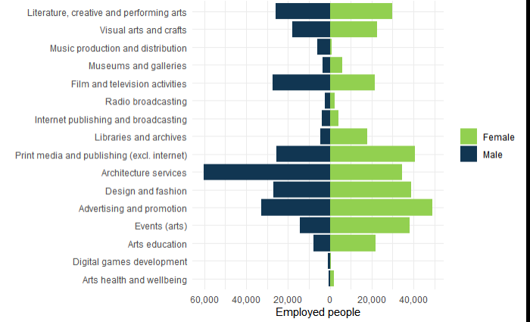  Source: ABS Australian System of National Accounts, Australian National Accounts: Input-Output Tables (Product Details); Australian National Accounts: Supply Use Tables; BCARR calculations.

Age profile of Australia’s cultural and creative workforce

Individuals working in cultural and creative domains were predominantly between the ages of 20 and 49 years.  The mean age of the cultural and creative workforce increased from 39.5 years in 2008–09 to 40.6 years in 2023–24, while the median age changed from 38 years to 39 years over the same period. The median age of those employed within the cultural and creative sector was in line with total employment in Australia – also 39 years in 2023–24.  The libraries and archives domain had the oldest workers on average, with a mean age of 48.6 years and a median age of 50 years in 2023–24. Conversely, the digital games development domain had the youngest workers on average, with a mean age of 36.9 years and a median age of 36 years. | Figure 5. Mean and median age of cultural and creative employment, 2023–24  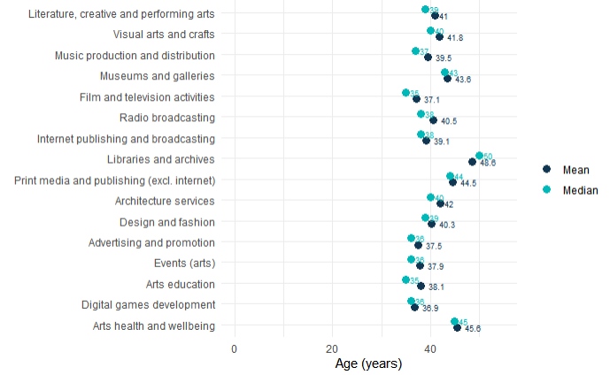  Source: ABS Australian System of National Accounts, Australian National Accounts: Input-Output Tables (Product Details); Australian National Accounts: Supply Use Tables; BCARR calculations.

First Nations employment in the cultural and creative sector

Although First Nations employment in the cultural and creative sector remains small compared to non-Indigenous employment, it has grown significantly.  In 2023–24, an estimated 4,955 First Nations were employed in the cultural and creative sector, an increase of 82.5% from 2,716. First Nations share of total cultural and creative employment rose from 0.6% to 0.8% during this period.  Most First Nations workers were employed in the domains of visual arts and crafts; events (arts); literature, creative and performing arts; and advertising and promotion. These four domains constituted approximately 52% of total First Nations employment within the cultural and creative sector in 2023–24. | Figure 6. First Nations employment in the cultural and creative sector  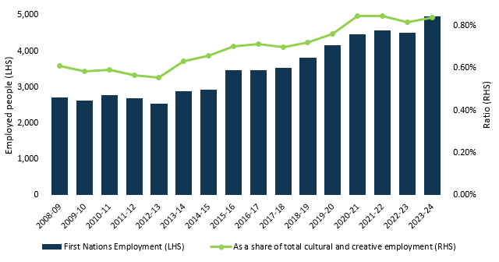  Source: ABS Australian System of National Accounts, Australian National Accounts: Input-Output Tables (Product Details); Australian National Accounts: Supply Use Tables; BCARR calculations.

Secondary jobs play an important role in the cultural and creative sector
Secondary jobs in the cultural and creative sector can supplement main jobs by offering additional income, opportunities for skills development, and networking options.  In 2023–24, an estimated 49,214 secondary jobs were related to the cultural and creative sector. The number of secondary jobs within the cultural and creative sector was 4.5% of all secondary jobs, higher than the sector’s share of main job employment in the economy (4.1%). | Many individuals whose main jobs are in cultural and creative occupations often hold secondary jobs outside of cultural and creative industries. These patterns highlight the diversity of work arrangements in the cultural and creative sector, with many creatives relying on holding multiple jobs.  Figure 7. Total cultural and creative secondary jobs by trident types, 2008–09 to 2023–24  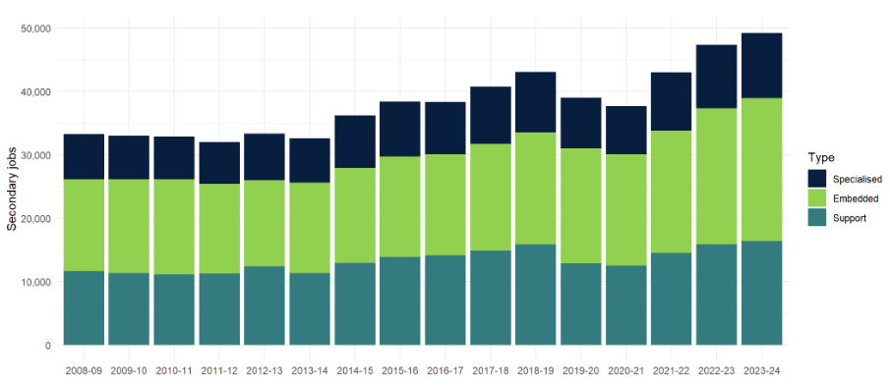  Source: ABS Australian System of National Accounts, Australian National Accounts: Input-Output Tables (Product Details); Australian National Accounts: Supply Use Tables; BCARR calculations.

About this document
The Bureau of Communications, Arts and Regional Research (BCARR) within the Department of Infrastructure, Transport, Regional Development, Communications, Sport and the Arts has estimated the Cultural and Creative Workforce in Australia from 2008–09 to 2023–24.
This document outlines the key findings shown in BCARR’s interim report: Measuring Australia’s Cultural and Creative Workforce, 2008–09 to 2023–24 and is presented alongside a document of Frequently Asked Questions. Further information on the methods used in this research can be found in BCARR’s interim report.

