

Cultural and Creative Activity Satellite Accounts Methodology Refresh
  - Consultation paper
February 2023

Ownership of intellectual property rights in this publication
Unless otherwise noted, copyright (and any other intellectual property rights, if any) in this publication is owned by the Commonwealth of Australia (referred to below as the Commonwealth).

Disclaimer
The material contained in this publication is made available on the understanding that the Commonwealth is not providing professional advice, and that users exercise their own skill and care with respect to its use, and seek independent advice if necessary.
The Commonwealth makes no representations or warranties as to the contents or accuracy of the information contained in this publication. To the extent permitted by law, the Commonwealth disclaims liability to any person or organisation in respect of anything done, or omitted to be done, in reliance upon information contained in this publication.

Creative Commons licence
With the exception of (a) the Coat of Arms; (b) the Department of Infrastructure, Transport, Regional Development and Communications photos and graphics; and (c) [OTHER], copyright in this publication is licensed under a Creative Commons Attribution 4.0 Australia Licence.
Creative Commons Attribution 4.0 Australia Licence is a standard form licence agreement that allows you to copy, communicate and adapt this publication provided that you attribute the work to the Commonwealth and abide by the other licence terms.
Further information on the licence terms is available from https://creativecommons.org/licenses/by/4.0/
This publication should be attributed in the following way: © Commonwealth of Australia 2022.

Use of the Coat of Arms
The Department of the Prime Minister and Cabinet sets the terms under which the Coat of Arms is used. Please refer to the Commonwealth Coat of Arms - Information and Guidelines publication available at http://www.pmc.gov.au.

Contact us
This publication is available in hard copy or PDF format. All other rights are reserved, including in relation to any departmental logos or trade marks which may exist. For enquiries regarding the licence and any use of this publication, please contact:
Director – Creative Services
Communication Branch
Department of Infrastructure, Transport, Regional Development and Communications
GPO Box 594
Canberra ACT 2601
Australia
Email: publishing@infrastructure.gov.au
Website: www.infrastructure.gov.au

Table of contents
Introduction 5
A satellite account for cultural and creative activity 5
Defining and measuring cultural and creative activity 6
The need to refresh the satellite accounts 7
Data sources 7
Definition and scope 7
Methodology 8
Methodology review and proposed update 9
Existing approaches to defining cultural and creative industries 9
Review of current framework and methodology 10
Current framework 10
Review of BCARR’s 2018 methodology 11
Proposed update of cultural and creative activity satellite accounts 12
Proposed framework update 12
Proposed update on the methodology used for the estimation process 13
Opportunities for additional cultural and creative statistics 17
Employment 17
Other types of cultural and creative statistics 17
Events activity 18
Request for feedback 19
Appendix A—BCARR’s 2018 Methodology 20
Appendix B—Cultural and creative domains – BCARR’s current framework 22
Appendix C—Proposed IOPC list of cultural and creative activity 28
Appendix D—Proposed industry classification list of cultural and creative activity 34
Appendix E—Proposed occupation identified as cultural and creative 37
Appendix F—Glossary 40
References 41

List of tables
Table 1. Selected models for cultural and creative industries 9
Table 2. Data gaps for current methodology 15
Table 3. Component 1 and 2: Cultural and creative industry supply chains and Imputed COE 20
Table 4. Component 3 and 4: Volunteer services and non-market output of cultural and creative activities 21
Table 5. Cultural and creative domains – BCARR’s current framework 22
Table 6. Proposed IOPC list of cultural and creative activity 28
Table 7. Proposed industry classification list of cultural and creative activity 34
Table 8. Proposed occupation identified as cultural and creative 37

List of figures
Figure 1. Current framework for the cultural and creative activity satellite accounts 10
Figure 2. The cultural and creative employment trident 11
Figure 3. Proposed new trident framework of cultural and creative activity 12
Figure 4. Proposed estimation process to quantify the economic value of cultural and creative activity 13
Figure 5. The concentric circles model of the cultural industries 13
Figure 6. Cultural and creative domains – ABS 2014 and BCARR’s 2018 framework 14
Figure 7. Matrix to link the trident and concentric circles models 16

Introduction
Cultural and creative sectors are important for knowledge-based economies. In Australia, this workforce makes a valuable contribution to our economic and social wellbeing. The economic activity generated from the production and support of cultural and creative goods and services is referred to as ‘cultural and creative activity’.
Australia’s ‘cultural and creative activity satellite accounts’ quantify cultural and creative activity and track how it changes over time. This information is used by industry, academia, and policymakers within government. The accounts were established by the Australian Bureau of Statistics (ABS) and have been updated annually by the Bureau of Communications, Arts and Regional Research (BCARR).
The cultural and creative activity satellite accounts are being reviewed to ensure that these estimates remain fit-for-purpose in our changing economy. The review will examine the definition, scope, methodology and data used for quantifying this activity.
As outlined in Revive: a place for every story, a story for every place – Australia’s cultural policy for the next five years, an updated methodology is proposed for estimating cultural and creative activity on an annual basis. Refreshing the methodological framework for these satellite accounts will help to better capture the contribution of the cultural and creative sectors and understand how this activity is changing and growing.
The purpose of this consultation paper is to share BCARR’s proposed approach to refreshing the cultural and creative activity satellite accounts. It supports a consultation process which invites stakeholders to provide feedback on these proposals.
Feedback on this paper is sought by Friday, 26 May 2023. Please refer to the ‘Request for feedback’ section for more information. We look forward to hearing your views.

A satellite account for cultural and creative activity
Most cultural and creative activity is captured in the national accounts – a statistical framework which summarises the economic activity of a nation. However, the information captured by these accounts does not provide enough detail to accurately measure cultural and creative activity. Furthermore, the national accounts do not capture non-market activity, such as volunteer services and the non-market output of cultural and creative industries.
As cultural and creative activity is not explicitly identified in the national accounts, it requires the construction of a satellite account. A satellite account is a supplemental framework linked to the national accounts which enables focused attention on a particular aspect of economic or social life, making information more visible and easier to use.
Satellite accounts combine national accounts estimates with findings from other statistics and data sources. Satellite accounts can be categorised into two broad types. One type includes the rearrangement of central classifications and can include complementary elements. The other type is based mainly on concepts alternative to the system of national accounts or that extend the production boundary.
The cultural and creative satellite account was developed to fill these gaps for Australia by collecting cultural and creative activity from across the economy. In 2014, the ABS published the Cultural and Creative Activity Satellite Accounts, which presented an experimental framework to estimate the size of Australia’s cultural and creative activity using 2008–09 data. BCARR within the Department of Infrastructure, Transport, Regional Development, Communications and the Arts adopted this framework and has updated estimates of cultural and creative activity on an annual basis since 2018.

Defining and measuring cultural and creative activity
While there is no universally-accepted definition, the terms ‘cultural’ and ‘creative’ are used to describe activities connected with the arts, media, heritage, design, fashion, and information technology.
The actual size (or value) of the economic contribution of cultural and creative activity is determined by how it is defined and identified for each activity. In constructing the scope and coverage of Australia’s first cultural and creative activity satellite accounts, the ABS described human creativity as a vital input to cultural and creative activity. Cultural activity requires human creativity as an input and may contain intellectual property to communicate symbolic meaning; while creative activity also requires human creativity as a significant and identifiable input.
These broad definitions were developed by the ABS in consultation with key stakeholders and drew heavily on satellite accounts produced overseas, as well as existing statistical frameworks and academic literature that underpin much of the international research. For example, the cultural statistics frameworks published by the United Nations Educational, Scientific and Cultural Organization (UNESCO) highlighted that cultural goods and services ‘encompass artistic, aesthetic, symbolic and spiritual values’; while the United Nations Conference on Trade and Development (UNCTAD)’s Creative Economy Report noted that the creative industries ‘are the cycles of creation, production and distribution of goods and services that use creativity and intellectual capital as primary inputs.’
The existing definition for what industries comprise Australia’s cultural and creative sectors was formulated based on consultation with the federal and state government organisations involved in the Cultural Ministers’ Statistics Working Group, as well as input from Australian academics. The framework was based on the 2009 UNESCO Framework for Cultural Statistics, adapted for Australian use following a series of national industry workshops and consultation. This definition was agreed by the Meeting of Cultural Ministers, which included representatives from all state and territory governments.
This definition forms the basis of the current cultural and creative satellite account. The satellite account has been important for understanding the types of cultural and creative activity occurring in the Australian economy in more detail. For example, it allows us to consider types of activity by category and domain (such as ‘Performing arts’, ‘Visual arts and crafts’, and ‘Museums’). Given the wide-ranging nature of cultural and creative activity, these more granular domain-level figures provide insights into the economic contribution of particular sectors.
Within this satellite accounts framework, cultural and creative activity is estimated from cultural and creative industry supply chains using a ‘top-down’ approach. Estimates are calculated from aggregates published annually in input-output tables (ABS Cat. no. 5209.0). Industry information shown in these tables is presented by 114 Input-Output Industry Groups (IOIGs). Cultural and creative industries are identified using the Australian and New Zealand Standard Industrial Classification (ANZSIC) at the class level (4-digit level).

The need to refresh the satellite accounts
Current estimates of cultural and creative activity are used widely across government, industry and academia, and have informed our understanding of how cultural and creative industries contribute to economic outcomes relative to other industries. However, while these satellite accounts address some of the limitations when compared to using national accounts estimates, some concerns have been raised about the data sources, scope and approach of the current cultural and creative activity satellite accounts.
The satellite accounts will be reviewed to ensure that estimates remain fit-for-purpose in our changing economy. The review will examine the definition, scope, methodology and data used for quantifying cultural and creative activity.
Following consultation based on this paper, it is proposed that an updated methodology for estimating cultural and creative activity be adopted for future BCARR updates to the satellite account.
A summary of potential issues and the improvements with the current cultural and creative activity satellite accounts is shown below.

Data sources
- Data sources for the satellite accounts could be updated to incorporate newly available data and address concerns that some industries which are currently included in the satellite account are not representative of creative activity.
- Opportunities to include newly available datasets and data with more granular detail.
- Opportunities to better represent evolving cultural and creative industries and platforms, such as the games sector and online media content, as well as activity not well captured, such as workers whose second jobs are creative. Specific considerations of First Nations cultural and creative activity is also a potential area that could be investigated, to test whether data collection and use is fit for purpose.

Definition and scope
- Opportunities to improve the accuracy of the scope of activity. Some activities in the current cultural and creative satellite account may not relate to either cultural or creative activity. For example, clothing retailing and wholesaling are included as creative output despite these industries being dominated by large companies not typically associated with the arts.
- Classifying ‘core’ sectors of the cultural and creative economy may help to draw distinctions of this activity from wider and related sectors that support this core activity.
- Considering international comparisons may highlight opportunities to align the scope and approach with current and emerging international approaches which consider cultural/creative activity (for example, approaches by the OECD, UNESCO, United Kingdom, United States).
- The current scope of cultural and creative activity is based on, and consistent with, the Australian and New Zealand standard classifications of industries and occupations (ANZSIC and ANZSCO). The ABS is undertaking a consultation process to review and update both classifications,, which were last released in 2006. More contemporary classifications of ANZSIC and ANZSCO will improve the data collections and their analysis. This will have implications for the use of industry and occupation classifications by the satellite account.

Methodology
- The construction of the satellite accounts is complex and is not well understood by stakeholders, which can result in information being incorrectly described or attributed. Ensuring a transparent and replicable approach may help support better and more accurate use of the available data.
- The current approach assumes that the weight of the gross value added (GVA) for each cultural or creative industry class within its underlying IOIG remains constant since 2008–09. Using updated data weights from the latest input-output tables and applying a more detailed approach to benchmarking these weights may more accurately reflect current cultural and creative economic activity.
- Changes to help avoid the risk of double counting involved in estimating the economic contribution of cultural and creative activity from both the production and income sides of the ‘creative trident’ framework (see Figure 2).

Methodology review and proposed update

Existing approaches to defining cultural and creative industries
Despite its importance to contemporary economies, economic analysis of cultural and creative activity has been limited, both in Australia and abroad. No universally-accepted definition exists for the scope of this activity and no international standard is available to construct a satellite accounts framework. Country specific activities may also be important to consider. Accordingly, a range of models of cultural and/or creative activity have been developed based on how industry classification systems identify the scope of this activity (Table 1).
Table 1. Selected models for cultural and creative industries
Model / framework | Organisation / source | Detail
DCMS model | UK Department of Culture, Media and Sport | This model defines creative industries as ‘those industries which have their origin in individual creativity, skill and talent and which have a potential for wealth and job creation through the generation and exploitation of intellectual property.’
Concentric circles model | Throsby, D. (2001), Economics and Culture, Cambridge: Cambridge University Press, 2001 | This model was based on the origin and diffusion of creative ideas in sound, text and image from core creative arts.  It was used to develop our current definition of cultural and creative activity.
Nesta/ CIIC model/ QUT | National Endowment for Science, Technology and the Arts (UK) / Creative Industry Innovation Centre / Queensland University of Technology | The Nesta/CIIC model was built based on the DCMS model. The method used focused on a measure of creative intensity, which was defined as the proportion of workers in any given creative industry engaged in a creative occupation.  In 2014, QUT applied the Nesta methodology to the Australian system of industry and occupation classifications.
UIS trade-related model | UNESCO Institute for Statistics | This model was based on cultural goods and services entering international trade.
UNESCO framework | United Nations Educational, Scientific and Cultural Organisation | This publication examined multiple models and methodologies used internationally. The UNESCO Framework for Cultural Statistics defines culture through the identification and measurement of the behaviours and practices resulting from the beliefs and values of a society or a social group.
The European framework for cultural statistics | European Statistical System Network on Culture (ESSnet-Culture) | This framework updated the framework established by the Leadership Group Culture (LEG-Culture), with ten cultural domains and six cultural functions being organised.
Arts and Cultural Production Satellite Account (ACPSA) | US Bureau of Economic Analysis and the National Endowment for the Arts | This model is largely consistent with the definitions used by the United Nations and the EU, and is based on an input-output (I-O) framework to conduct an in-depth analysis of the arts and cultural sector’s contribution to domestic product (GDP).
Canadian Framework for Culture Statistics | Statistics Canada | For the purpose of measurement, culture is defined as ‘creative artistic activity and the goods and services produced by it, and the preservation of heritage’.
Creative industries mapping framework | New Zealand Institute of Economic Research (NZIER) | The framework is based on the Creative Trident model. Six creative segments are the basis for mapping and valuing the creative sector.

Review of current framework and methodology

Current framework
The current ABS cultural and creative activity satellite accounts framework, which has been continued by BCARR, consists of two boundaries (Figure 1):
- the national accounts basis, which captures market-based transactions; and
- an extension beyond the national accounts production boundary which adds volunteer services and non-market production to the types of activity included.
Figure 1. Current framework for the cultural and creative activity satellite accounts
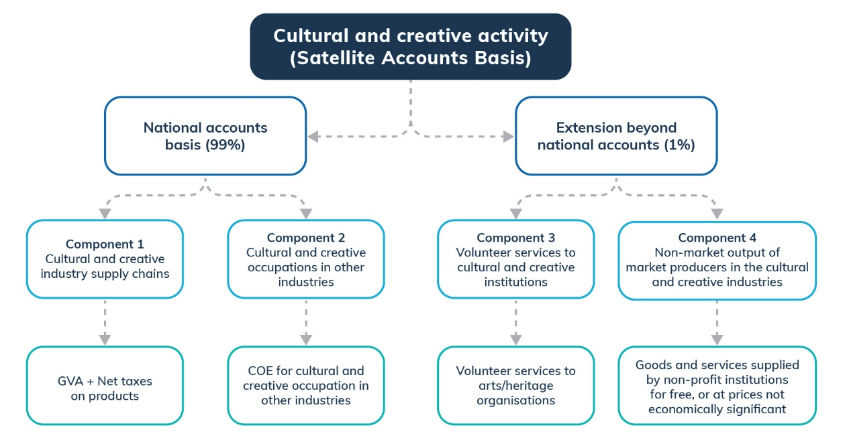
Source: ABS Cat. no. 5271.0
The national accounts production boundary captures most cultural and creative activity, accounting for 99 per cent of the economic contribution. This boundary includes two components:
- Component 1 is activity in industries which form the supply chains for cultural and creative goods and services. This component contains the activity of industries which generate cultural and creative ideas, use these ideas to produce or manufacture cultural and creative goods and services, or distribute cultural and creative goods and services to final consumers. This component comprises gross value added (GVA) and net taxes on products of cultural and creative industries.
- Component 2 is activity in other industries performed by workers in cultural and creative occupations. As this component was initially valued as a share of aggregated compensation of employees (COE), it is also called ‘Imputed COE’.
Extending beyond the national accounts production boundary, cultural and creative activity is measured by two further components:
- Component 3 is volunteer services to arts and heritage organisations.
- Component 4 is the non-market output of market producers in the cultural and/or creative industries. This refers to the value of cultural and creative goods and services supplied by non-profit institution for free, or at the prices that are not economically significant.
This current framework applies the ‘creative trident’ model. The trident model initially referred to the three locations of employment within the creative occupations and industries – specialist, embedded and support workers (Figure 2). The trident model includes activity from specialist and support workers inside cultural and creative industries as well as embedded workers in cultural and creative occupations in other industries.
Figure 2. The cultural and creative employment trident
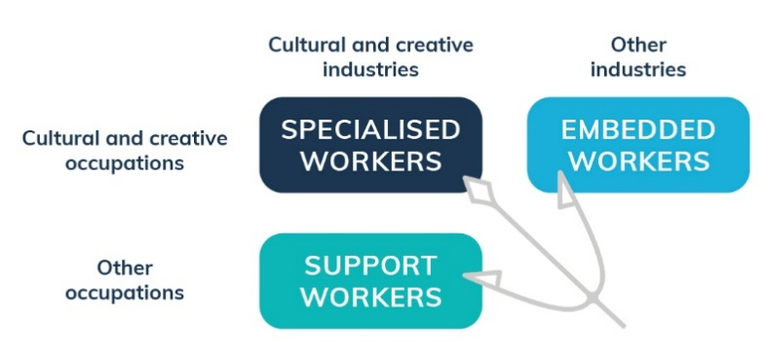
Source: S. Cunningham and P. Higgs (2010)
In theory, these three areas of activity are mutually exclusive from each other. Estimates of activity from the production by specialist and support workers in cultural and creative industries (component 1) should not double-count income from embedded workers in other industries (component 2).
However, the method for applying this approach in the context of the national accounts system differs for Components 1 and Component 2. While component 1 can be readily identified from the national accounts input-output tables, estimates of Component 2 need to be imputed using different data sources (a far more complicated process).
For example, the Compensation of Employees (COE) shares were calculated starting with employment data from input-output tables, Labour Force data, and the Census workforce occupation structure. This data was then combined with average earnings data from the ABS Survey of Employee Earnings and Hours to estimate employee remuneration in main jobs (the job in which most hours are usually worked) by occupation and industry. Employee remuneration in secondary jobs was estimated in this approach by using data from the ABS Survey of Employment Arrangements, Retirement and Superannuation, adjusted over time for wage inflation using the ABS Wage Price Index.

Review of BCARR’s 2018 methodology
The methodology used in BCARR’s current cultural and creative activity estimates is broadly consistent with the ABS’s approach to defining the coverage of cultural and creative activity.
Cultural and creative proportions within individual Input-Output Industry Groups (IOIG) for the 2008–09 year were replicated. To provide consistency with the ABS approach, BCARR used 2008–09 as the base year and ensured the economic indicators such as GVA, net taxes on products, and imputed COE were aligned with the ABS satellite accounts. Details on BCARR’s 2018 methodology can be found at Appendix A.
Due to the unavailability of some data, BCARR estimates assume that the ratio of the GVA for each cultural or creative industry class (ANZSIC) makes up the same proportion of the GVA of its underlying Input Output Industry Groups (IOIGs) as it did in 2008–09. As more time passes since 2008–09, uncertainty around the granular (domain-level) GVA figures grows and the more likely it is that this assumption will generate erroneous results.

Proposed update of cultural and creative activity satellite accounts
The proposed update of cultural and creative activity satellite accounts will involve two elements that address issues highlighted in the current methodology: an update to the framework used to scope and identify cultural and creative activity; and an update to the methodology used to produce estimates.

Proposed framework update
The proposed update to the framework for producing estimates of cultural and creative activity described in this paper is focused on the national accounts production boundary. Components within this production boundary are proposed to be captured through a new ‘trident’ framework (Figure 3). This update allows the economic value of all three types of cultural and creative activities to be captured within the production-side only, to make sure Component 1 and Component 2 are measured using a consistent approach.
Figure 3. Proposed new trident framework of cultural and creative activity
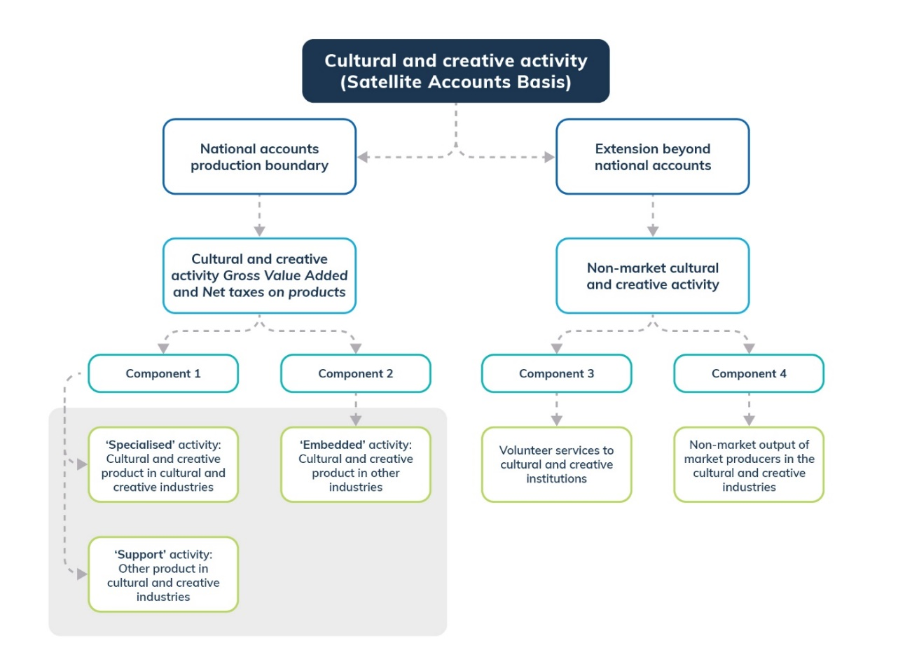
Source: BCARR analysis
In this new trident framework, cultural and creative activity is represented as GVA and net taxes on products, and is re-identified as three activities:
- Specialised activity: cultural and creative products in cultural and creative industries;
- Embedded activity: cultural and creative products in other industries outside the cultural and creative scope; and
- Support activity: any other products outside the scope of cultural and creative products within cultural and creative industries.
This proposed change replaces the former ‘imputed COE’ with ‘embedded activity’ (component 2). Component 1 will continue to capture ‘specialised’ and ‘support’ activities. These activities can be identified based on the ABS input-output tables which details around 1,000 Input-Output Product Classifications (IOPCs) and then links these to the four layers of the concentric circles model of the cultural and creative industries. Further detail is provided below (Figure 5).

Proposed update on the methodology used for the estimation process
To implement this proposed updated framework, estimates of the economic value of cultural and creative activity would be quantified using the following four step approach (Figure 4).
Figure 4. Proposed estimation process to quantify the economic value of cultural and creative activity
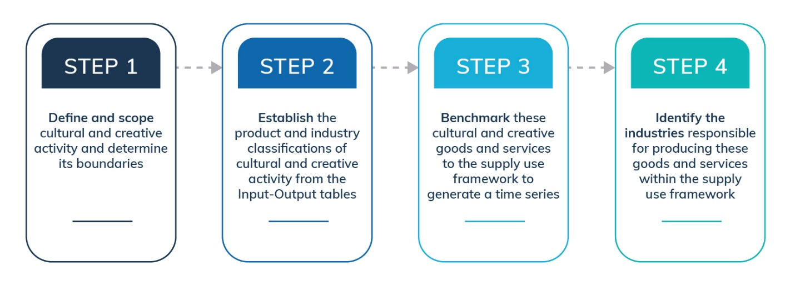
Source: BCARR analysis

Step 1: Define and scope cultural and creative activity and determine its boundaries
In this proposed framework we continue to follow the broad definition of cultural and creative activity as the sum of market and non-market activities that produce and support cultural and creative final goods and services. This activity can also be analysed by domains, which are grouped in terms of related industry classifications. The concentric circles model of cultural industries developed by Throsby was adopted when scoping these domains (Figure 5).
Figure 5. The concentric circles model of the cultural industries

Source: Throsby, D. (2008)
The concentric circles model identifies four layers (or circles), which can be used to classify industries that produce cultural and creative goods and services according to the definitions described earlier. In this model, the circle at the centre represents core industries whose proportion of cultural content is deemed highest, with layers extending outwards from the centre as the cultural content falls relative to the commercial value of the commodities or services produced.
However, when scoping these domains initially, some were either categorised across different layers such as Literature and print media, or not explicitly identified in the original concentric circles model, such as Supporting activities. Also, because domains were defined based on the ANZSIC industry classification level only, some data issues were identified in the current cultural and creative activity satellite accounts.
Twelve domains are listed in the current cultural and creative activity satellite accounts framework (see Figure 6 and Appendix B).
Figure 6. Cultural and creative domains – ABS 2014 and BCARR’s 2018 framework
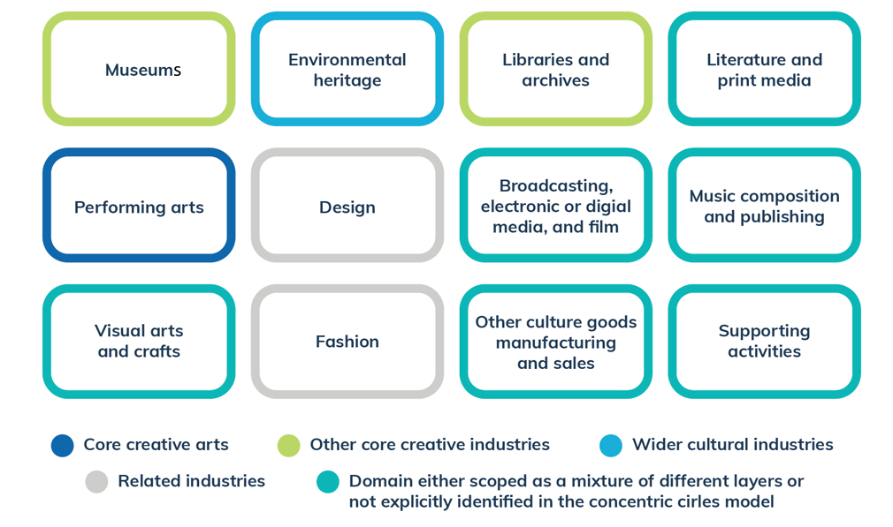
Source: ABS Cat. no. 5271.0; BCARR analysis

Data gaps
Consistent with the ABS satellite accounts, some industries currently identified as in-scope contain significant amounts of activity that may not be considered cultural or creative. An example used by the ABS is higher education (a supporting industry) that covers entities engaged mainly in undergraduate or postgraduate teaching, of which only a small part is considered cultural or creative activity.
In these cases, where possible, out-of-scope activities are currently removed from the Satellite Accounts through an apportioning process. When this cannot be achieved, such industries are excluded. This is done in order to prevent the accounts overstating the amount of cultural and creative activity.
The industries currently excluded for this reason are listed in Table 2. Cultural and creative activity in these industries is, however, partly captured by the existing methodology in the second component of the Satellite Accounts (compensation of employees for cultural and creative workers in other industries).
Table 2. Data gaps for current methodology
Code | ANZSIC Class Name
1320 | Leather Tanning, Fur Dressing and Leather Product Manufacturing
2029 | Other Ceramic Product Manufacturing
2599 | Other Manufacturing n.e.c.
3020 | Non-Residential Building Construction
3109 | Other Heavy and Civil Engineering Construction
4520 | Pubs, Taverns and Bars
4530 | Clubs (Hospitality)
6639 | Other Goods and Equipment Rental and Hiring n.e.c.
6962 | Management Advice and Related Consulting Services
7211 | Employment Placement and Recruitment Services
7212 | Labour Supply Services
7299 | Other Administrative Services n.e.c.
7510 | Central Government Administration
7520 | State Government Administration
7530 | Local Government Administration
8101 | Technical and Vocational Education and Training
8102 | Higher Education
9499 | Other Repair and Maintenance n.e.c.
9551 | Business and Professional Association Services
9552 | Labour Association Services
9559 | Other Interest Group Services n.e.c.
Source: ABS Cat. no. 5271.0

Linking the new trident framework with the concentric circles model
A ‘matrix’ framework is proposed to link the new trident framework with the concentric circles model (Figure 7). This approach would resolve the data gap issue described above. In the matrix, cultural and creative activity can be defined and identified using a two-way approach, based on both the IOPCs and ANZSIC industry classifications.
The IOPC is an industry of origin product classification that has been specifically developed by the ABS for the compilation and application of the Australian Input-Output (I-O) Tables. The structure of IOPC is implemented based on ANZSIC, in which the first four digits of the IOPC (which form the I-O product group) typically refer to the ANZSIC class to which the product is primary to that industry.
Through this process, any industry class initially identified as ‘partially in-scope’ can be removed from the original industry list:
- For example, ANZSIC 8102 Higher Education is not identified as a cultural and creative industry. However, final cultural and creative goods and services, such as computer system design services, can still be captured by this industry through the proposed new matrix framework.
- Another example relates to the events sector. ANZSIC 7299 Other Administrative Services n.e.c is an industry class which consists of activities which provide administrative services not elsewhere classified. Events activity, such as those relating to sport, the arts, or similar events promotion services, is a primary component within this class. While the share of events activity is difficult to estimate separately from this broader industry class, it can be identified from the input-output table through the two IOPCs:
- 72990020 Theatre, concert and sport ticketing and booking services; and
- 72990030 Event management or promotion (incl sport, art or similar); fund raising services (fee based) or administration services nec.
For any other ANZSIC industry class highlighted as a data gap in Table 2 and excluded from the current satellite accounts, the proposed approach does not require it to be identified as a cultural and creative industry, but will capture the cultural and creative component within this industry at the product level. Furthermore, the matrix allows for opportunities to measure other economic variables such as international trade, household and government spending, and investment based on the input-output tables.
Figure 7. Matrix to link the trident and concentric circles models
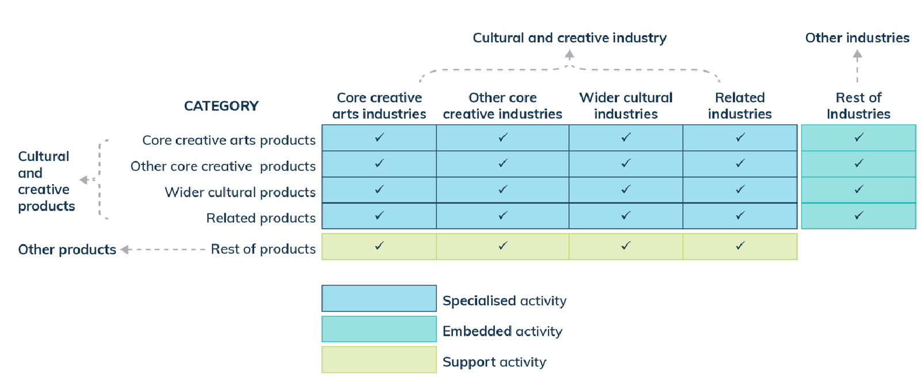
Source: BCARR analysis
After setting up cultural and creative activity in this proposed new matrix framework, the second step is to establish the product and industry classifications that will capture cultural and creative activity based on the input-output tables.

Step 2: Establish the product and industry classifications of cultural and creative activity from the input-output tables
The input-output tables present details for around 1,000 IOPCs in the latest edition of the ABS release Australian National Accounts: Input-Output Tables (Product Details). These product classifications originate from the ANZSIC industry classification and provide the most disaggregated product classification level within the Australian National Accounts System. These tables provide rich information about the supply and use of products in the Australian economy, and the structure of, and inter-relationships between Australian industries, which can be used as a necessary tool to identify and estimate cultural and creative activity at both product and industry levels.
A ‘bottom-up’ approach was applied during this process, by reviewing the entire list of cultural and creative products. During this approach, if a product from the input-output table was considered as partially in-scope but primarily related to cultural and creative activity, it has been included in the total.
Also, because the input-output tables publish only data for the 114 IOIGs (Input-Output Industry Groups) at the industry level, the estimates of ANZSIC industry classification within each IOIG needed to be weighted and imputed based on different data sources such as the ABS Australian Industry Survey and Census data.
Lists of the input-output product classifications and industries proposed to be considered in-scope for cultural and creative are detailed in the appendices.

Step 3: Benchmark these cultural and creative goods and services to the supply use framework to generate a time series
After identifying cultural and creative activity from the input-output tables, these goods and services need to be benchmarked to the supply use framework to generate a time series for the analysed period. The benchmarking process is required because input-output tables are published only as a point in time and are not revised once finalised. In contrast, supply use tables provide a time series for all periods from 1994–95 up to the year preceding the latest completed financial year, and are subject to revision.
During this benchmarking process, a revision of cultural and creative activity satellite accounts back to 2008–09 will be applied accordingly.

Step 4: Identify the industries responsible for producing these goods and services within the supply use framework
The industries responsible for producing these cultural and creative products can be identified after step 3. Output can be estimated by aggregating the product output across industries. Total intermediate use is estimated by assuming it comprises the same ratio of total industry intermediate consumption to total industry output. GVA can then be derived as the difference between the output and total intermediate use.

Opportunities for additional cultural and creative statistics
Adopting the approach described above may help unlock additional sources of information and statistics about Australia’s cultural and creative economy that are not provided by the current satellite accounts. This section outlines some of the opportunities that could be explored in subsequent research.

Employment
BCARR’s current cultural and creative activity satellite accounts do not provide an estimate of cultural and creative employment. Employment estimates could be included in this refreshed process, based on the trident framework. The occupations defined as being within the scope of the cultural and creative sectors would be consistent with the ABS 2014 publication of cultural and creative activity satellite accounts (Appendix E).
These occupations will be determined by analysing data included in the ABS Census of Population and Housing, Labour Force Australia (Detailed), and Labour Account Australia. They can be then used to generate an annual time series at both national and state/territory levels.

Other types of cultural and creative statistics
Other types of cultural and creative statistics may be possible under the proposed new approach, including economic variables such as chain volume measures, international trade, household final consumption expenditure (HFCE), government final consumption expenditure (GFCE), and gross fixed capital formation (GFCF). These new cultural and creative statistics would provide further scope for cross-industry comparisons and trend analysis.
The cultural and creative economic contributions of states and territories have not been covered in the current satellite accounts. Possible data sources that could be used to develop these estimates include ABS Census data, labour force data, labour account data and the State Accounts data. Due to less availability of the state-level input data, such estimates, if possible at all, would have less industry detail than at the national level.

Events activity
The proposed updated methodology also provides options to better capture other activities such as events activity. As mentioned earlier, events activity is out of scope for the current satellite accounts framework because it cannot be identified directly from the latest ANZSIC classification. The proposed refreshed methodology could resolve this issue by identifying events activity through the product details level.
In this paper, the definition of events activity refers to activities that provide event management, promotion and ticketing services, as well as other events-related administration services. It also includes theatre and concert booking services.

Request for feedback
Australia’s cultural and creative activity satellite account has been an important framework for helping people understand the cultural and creative economy and how this contribution has changed over time. The proposed refresh of the definition, scope and methodology is an important step to improve the satellite accounts framework and ensure the relevance of future estimates.
BCARR welcomes input and feedback on these proposed updates. This could include feedback on the following questions:
- How do you currently use the cultural and creative activity satellite accounts and estimates?
- Are there further studies in the cultural and creative literature relevant for this analysis?
- What are your thoughts on the proposed new trident framework? Do you think this will address current issues and provide better estimates of cultural and creative activity?
- What are your thoughts on the scope of proposed layers, domains and categories of cultural and creative activity?
- What are your thoughts on the scope of industries and occupations included in the proposed definition of cultural and creative sector?
- What products, industries or occupations are still not captured in the proposed definition of cultural and creative activity?
- Do you have suggestions on which products, industries or occupations should be included, excluded or modified?
- What other datasets could BCARR use to further improve the estimates?
If you have any feedback or comments on aspects of this proposed refresh, please contact the Bureau of Communications, Arts and Regional Research by email bcarr@infrastructure.gov.au.
Feedback on this paper is sought by Friday, 26 May 2023.

Appendix A—BCARR’s 2018 Methodology
Table 3. Component 1 and 2: Cultural and creative industry supply chains and Imputed COE
Indicator | BCARR 2018 Methodology
GVA of cultural and creative industries | - Replicate Satellite Accounts (ABS Cat. no. 5271.0) cultural and creative proportions within individual Input-Output Industry Groups (IOIG) for the 2008–09 year. This sets up 2008–09 as the base year, and aligns the GVA with ABS Cat. no. 5271.0.  - Apply the current price movement from the 2016-17 publication of Australian System of National Accounts (ABS Cat. no. 5204.0) to step 1. This generates the time series from 2008–09 to 2016-17 as well as incorporate any revisions during the period.  - Split total GVA into IOIGs by using the proportions from each corresponding Input-Output table (ABS Cat. no. 5209.0).  - Apply cultural and creative ratios to every financial year to derive each cultural and creative industry GVA.  - Aggregate all cultural and creative industry GVAs.
Net taxes on products of cultural and creative industries | - Replicate Satellite Accounts (ABS Cat. no. 5271.0) cultural and creative proportions within individual IOIG for the 2008–09 year. This sets up 2008–09 as the base year, and aligns the net taxes on products with ABS Cat. no. 5271.0.  - Apply the current price movement from the 2016-17 publication of Australian System of National Accounts (ABS Cat. no. 5204.0) to step 1. This will generate the time series from 2008–09 to 2016-17 as well as incorporate any revisions during the period.  - Split total net taxes on products into IOIGs by using the proportions from Input-Output tables (ABS Cat. no. 5209.0).  - Apply cultural and creative ratio to every financial year, to derive cultural and creative activity net taxes on products for each industry.  - Aggregate the net taxes on products for all cultural and creative industries.  - Apply the below ratio to Gross Fixed Capital Formation (Private) and Exports  $$\frac{Total net taxes on products for cultural and creative industries}{Total net taxes on products for cultural and creative activity related IOIGs}×100\%$$  - Add figures from Step 5 and Step 6 to generate the total of net taxes on products for cultural and creative activity
COE for cultural and creative occupations in other industries | - Replicate 2008–09 Satellite Accounts (ABS Cat. no. 5271.0) cultural and creative proportions of COE for cultural and creative occupations in other industries by industry division. This sets up 2008–09 as the base year, and aligns the COE for cultural and creative occupations in other industries with ABS Cat. no. 5271.0.  - Apply the proportions from step 1 to the COE data for financial years after 2008–09.
Outside the national accounts boundary, the current approach for quantifying volunteer services and non-market output for cultural and creative activities assumes these two components as a share of total cultural and creative activity on a national account basis remains stable over the analysed period.
Table 4. Component 3 and 4: Volunteer services and non-market output of cultural and creative activities
Indicator | BCARR 2018 Methodology
Volunteer services to arts/ heritage organisations | The current approach assumes that the volunteer services to arts/heritage organisations retains a constant share of total cultural and creative activity on a national accounts basis over the period.
Non-market output of market producers in the cultural and creative industries | The current approach assumes that non-market output of market producers in the cultural and creative industries retains a constant share of total cultural and creative activity on a national accounts basis over the period.

Appendix B—Cultural and creative domains – BCARR’s current framework
Table 5. Cultural and creative domains – BCARR’s current framework
No. | Domain | ANZSIC Name and Code | Layer of concentric circles model | Segment | Scope
1. | Museums | Museum Operation (8910) | Other core creative industries | Both | Wholly in-scope
2. | Environmental heritage | Zoological and Botanical Gardens Operation (8921) | Wider cultural industries | Cultural | Wholly in-scope
 |  | Nature Reserves and Conservation Parks Operation (8922) | Wider cultural industries | Cultural | Wholly in-scope
3. | Libraries and archives | Libraries and Archives (6010) | Other core creative industries | Both | Wholly in-scope
4. | Literature and print media | Printing (1611) | Wider cultural industries | Cultural | Partially in-scope. Photocopying is out-of-scope.
 |  | Printing Support Services (1612) | Wider cultural industries | Creative | Wholly in-scope
 |  | Book and Magazine Wholesaling (3735) | Wider cultural industries | Cultural | Wholly in-scope
 |  | Newspaper and Book Retailing (4244) | Wider cultural industries | Cultural | Wholly in-scope
 |  | Newspaper Publishing (5411) | Wider cultural industries | Both | Wholly in-scope
 |  | Magazine and Other Periodical Publishing (5412) | Wider cultural industries | Both | Partially in-scope. Racing forms publishing is out-of-scope.
 |  | Book Publishing (5413) | Wider cultural industries | Both | Wholly in-scope
 |  | Other Publishing (except Software, Music and Internet) (5419) | Wider cultural industries | Creative | Partially in-scope. Calendar and diary publishing is out-of-scope.
5. | Performing arts | Pubs, Taverns and Bars (4520) | Not in the concentric circles model | Cultural | Partially in-scope. Included for the activity generated at venues during live entertainment  performances.
 |  | Clubs (Hospitality) (4530) | Not in the concentric circles model | Creative | Partially in-scope. Included for the activity generated at venues during live entertainment performances.
 |  | Performing Arts Operation (9001) | Core creative arts | Cultural | Wholly in-scope
 |  | Creative Artists, Musicians, Writers and Performers (9002) | Core creative arts | Cultural | Wholly in-scope
 |  | Performing Arts Venue Operation (9003) | Core creative arts | Both | Wholly in-scope
6. | Design | Architectural Services (6921) | Related industries | Both | Wholly in-scope
 |  | Other Specialised Design Services (6924) | Related industries | Both | Wholly in-scope
 |  | Advertising Services (6940) | Related industries | Both | Wholly in-scope
 |  | Computer System Design and Related Services (7000) | Related industries | Creative | Wholly in-scope
7. | Broadcasting, electronic or digital media, and film | Software Publishing (5420) | Wider cultural industries | Both | Wholly in-scope
 |  | Motion Picture and Video Production (5511) | Wider cultural industries | Both | Wholly in-scope
 |  | Motion Picture and Video Distribution (5512) | Wider cultural industries | Both | Wholly in-scope
 |  | Motion Picture Exhibition (5513) | Wider cultural industries | Both | Wholly in-scope
 |  | Post-production Services and Other Motion Picture and Video Activities (5514) | Wider cultural industries | Both | Wholly in-scope
 |  | Radio Broadcasting (5610) | Wider cultural industries | Both | Wholly in-scope
 |  | Free-to-Air Television Broadcasting (5621) | Wider cultural industries | Both | Wholly in-scope
 |  | Cable and Other Subscription Broadcasting (5622) | Wider cultural industries | Both | Wholly in-scope
 |  | Internet Publishing and Broadcasting (5700) | Wider cultural industries | Both | Wholly in-scope
 |  | Video and Other Electronic Media Rental and Hiring (6632) | Wider cultural industries | Cultural | Wholly in-scope
8. | Music composition and publishing | Music Publishing (5521) | Wider cultural industries | Both | Wholly in-scope
 |  | Music and Other Sound Recording Activities (5522) | Wider cultural industries | Both | Wholly in-scope
9. | Visual arts and crafts | Leather Tanning, Fur Dressing and Leather Product Manufacturing (1320) | Not in the concentric circles model | Both | Partially in-scope. Associated with crafts.
 |  | Other Ceramic Product Manufacturing (2029) | Not in the concentric circles model | Both | Partially in-scope. Associated with crafts.
 |  | Jewellery and Silverware Manufacturing (2591) | Not in the concentric circles model | Both | Partially in-scope. Coin minting is out-of-scope.
 |  | Jewellery and Watch Wholesaling (3732) | Not in the concentric circles model | Both | Partially in-scope. Watch and clock wholesaling are out-of- scope.
 |  | Watch and Jewellery Retailing (4253) | Not in the concentric circles model | Both | Partially in-scope. Watch retailing is out-of-scope.
 |  | Professional Photographic Services (6991) | Other core cultural industries | Both | Wholly in-scope
10. | Fashion | Clothing Manufacturing (1351) | Related industries | Creative | Wholly in-scope
 |  | Footwear Manufacturing (1352) | Related industries | Creative | Wholly in-scope
 |  | Clothing and Footwear Wholesaling (3712) | Related industries | Creative | Wholly in-scope
 |  | Clothing Retailing (4251) | Related industries | Creative | Wholly in-scope
 |  | Footwear Retailing (4252) | Related industries | Creative | Wholly in-scope
 |  | Other Personal Accessory Retailing (4259) | Related industries | Creative | Partially in-scope. Briefcase and luggage retailing are out-of-scope.
11. | Other culture goods manufacturing and sales | Reproduction of Recorded Media (1620) | Wider cultural industries | Cultural | Wholly in-scope
 |  | Other Manufacturing nec (2599) | Not in the concentric circles model | Cultural | Partially in-scope. Included for musical instrument manufacturing.
 |  | Other Goods Wholesaling nec (3739) | Not in the concentric circles model | Cultural | Partially in-scope. Included for musical instrument and recorded media wholesaling.
 |  | Commission-Based Wholesaling (3800) | Not in the concentric circles model | Cultural | Partially in-scope. Included for its role in reselling cultural and creative goods.
 |  | Entertainment Media Retailing (4242) | Wider cultural industries | Cultural | Wholly in-scope
 |  | Antique and Used Goods Retailing (4273) | Not in the concentric circles model | Cultural | Partially in-scope. Coin and stamp dealing are out-of-scope.
 |  | Other Store-Based Retailing nec (4279) | Not in the concentric circles model | Cultural | Partially in-scope. Included for retail art gallery operation and musical instrument retailing.
 |  | Non-Store Retailing (4310) | Not in the concentric circles model | Cultural | Partially in-scope. Included for direct selling of books.
 |  | Retail Commission-Based Buying and/or Selling (4320) | Not in the concentric circles model | Cultural | Partially in-scope. Included for selling and buying of books.
 |  | Other Goods and Equipment Rental and Hiring nec (6639) | Not in the concentric circles model | Both | Partially in-scope. Included for art work, video recorder and sound equipment rental.
12. | Supporting activities | Non-Residential Building Construction (3020) | Related industries | Cultural | Partially in-scope. Included for construction of cultural facilities.
 |  | Other Heavy and Civil Engineering Construction (3109) | Related industries | Cultural | Partially in-scope. Included for construction of cultural facilities.
 |  | Management Advice and Related Consulting Services (6962) | Not in the concentric circles model | Cultural | Partially in-scope. Included for artist / entertainer management services.
 |  | Employment Placement and Recruitment Services (7211) | Not in the concentric circles model | Cultural | Partially in-scope. Included for casting agency operation.
 |  | Labour Supply Services (7212) | Not in the concentric circles model | Cultural | Partially in-scope.
 |  | Other Administrative Services nec (7299) | Not in the concentric circles model | Cultural | Partially in-scope. Included for cultural event management, arts promotion and theatre and concert booking services.
 |  | Central Government Administration (7510) | Not in the concentric circles model | Cultural | Partially in-scope
 |  | State Government Administration (7520) | Not in the concentric circles model | Cultural | Partially in-scope
 |  | Local Government Administration (7530) | Not in the concentric circles model | Cultural | Partially in-scope
 |  | Technical and Vocational Education and Training (8101) | Not in the concentric circles model | Cultural | Partially in-scope
 |  | Higher Education (8102) | Not in the concentric circles model | Cultural | Partially in-scope
 |  | Arts Education (8212) | Core creative arts | Cultural | Wholly in-scope
 |  | Other Repair and Maintenance nec (9499) | Not in the concentric circles model | Cultural | Partially in-scope. Included for jewellery and musical instrument repair.
 |  | Business and Professional Association Services (9551) | Not in the concentric circles model | Cultural | Partially in-scope
 |  | Labour Association Services (9552) | Not in the concentric circles model | Cultural | Partially in-scope
 |  | Other Interest Group Services nec (9559) | Not in the concentric circles model | Cultural | Partially in-scope

Appendix C—Proposed IOPC list of cultural and creative activity
Table 6. Proposed IOPC list of cultural and creative activity
IOPC | IOPC Description | Layer | Domain | Segment
13200051 | Handbags, suitcases (incl canvas), bags (of leather or leather substitute) (incl toiletry bags, purses, wallets) (excl bags for packaging) | Related activities | Fashion | Both
13510011 | Men's and boys' clothing (excl shirts, blouses, T-shirts) | Related activities | Fashion | Creative
13510030 | Women's and girls' clothing (excl shirts, blouses, T-shirts) | Related activities | Fashion | Creative
13510040 | Shirts and blouses (with collars) | Related activities | Fashion | Creative
13510050 | T-shirts and tank tops | Related activities | Fashion | Creative
13510061 | Swimwear and wetsuits | Related activities | Fashion | Creative
13510071 | Underwear and foundation garments (incl brassieres, corsets, girdles) | Related activities | Fashion | Creative
13510090 | Outer nightwear (incl dressing gowns and robes) and sleepwear | Related activities | Fashion | Creative
13510101 | Plastic clothing and clothing accessories nec (incl waterproof, headwear) (excl footwear, handbags, rubber clothing accessories) | Related activities | Fashion | Creative
13510130 | Fur and sheepskin clothing and clothing accessories (excl headwear, footwear, handbags, toys) | Related activities | Fashion | Creative
13510140 | Hats and other headgear (excl safety, rubber or plastic) | Related activities | Fashion | Creative
13510151 | Safety headgear and eyewear (industrial or sporting) (incl goggles) | Related activities | Fashion | Creative
13510170 | Clothing and clothing accessories nec (incl textile or leather belts, gloves) (excl headwear, footwear, handbags, rubber clothing accessories) | Related activities | Fashion | Creative
13520010 | Footwear with plastic or rubber uppers (incl waterproof footwear, thongs) (excl sports footwear) | Related activities | Fashion | Creative
13520030 | Sports footwear | Related activities | Fashion | Creative
13520041 | Footwear with leather uppers (incl leather footwear with outer soles of rubber or plastic) (excl sports footwear) | Related activities | Fashion | Creative
13520050 | Footwear nec (incl steel capped footwear) | Related activities | Fashion | Creative
13520060 | Footwear parts nec (incl plastic heels) | Related activities | Fashion | Creative
15100020 | Newsprint | Wider cultural activities | Publishing and print media | Cultural
15290020 | Paper festival, carnival or other entertainment articles (incl conjuring tricks, novelties, Christmas decorations) | Related activities | Visual crafts | Both
16110010 | Books (incl atlases & touring guides), maps, charts, plans, sheet music printed but not published by this business | Wider cultural activities | Publishing and print media | Cultural
16110020 | Newspapers, journals and periodicals printed but not published by this business once a week or more | Wider cultural activities | Publishing and print media | Cultural
16110030 | Newspapers, journals and periodicals printed but not published by this business less than weekly | Wider cultural activities | Publishing and print media | Cultural
16110060 | Letter and correspondence cards (printed but not published), postcards | Wider cultural activities | Publishing and print media | Cultural
16110070 | Trade advertising material or commercial catalogues printed but not published by this business; other printed matter nec | Related activities | Advertising | Both
16120010 | Typesetting and prepared printing plates/cylinders, or other media for use in printing | Wider cultural activities | Publishing and print media | Creative
16120020 | Printing trade services nec (excluding desktop publishing) | Wider cultural activities | Publishing and print media | Creative
16200011 | Pre-recorded Audio media, manufactured but not published by this business | Related activities | Other support activities | Cultural
16200020 | Reproduced computer software, manufactured but not published by this business | Related activities | Other support activities | Cultural
16200040 | Other pre-recorded media (including records), manufactured but not published by this business | Related activities | Other support activities | Cultural
20290040 | Tableware, ornamental pottery and domestic ware nec | Related activities | Visual crafts | Both
24110020 | Photographic goods nec (excl sensitised photographic film, paper, plates & chemicals) | Other core cultural activities | Photography | Creative
24190080 | Radio and radar equipment, navigational aids, and radio remote control equipment | Wider cultural activities | Television and radio | Creative
24210061 | Printing and photocopying machinery and parts | Wider cultural activities | Publishing and print media | Creative
24220022 | Radio and television studio equipment (incl cameras, transmitters and transceivers) | Wider cultural activities | Television and radio | Creative
24220060 | Parts for radio and television studio equipment, transmitters and radio transceivers | Wider cultural activities | Television and radio | Creative
24220070 | Television antennae parts | Wider cultural activities | Television and radio | Creative
24290010 | Television receiving sets (excl parts) | Wider cultural activities | Television and radio | Creative
24290020 | Radio receiving sets (incl car radios and clock radios) (excl parts) | Wider cultural activities | Television and radio | Creative
24290030 | Sound and video recording and reproducing equipment (incl CD players, record players) (excl parts) | Wider cultural activities | Sound recording | Creative
24290060 | Video games, poker machines and other coin or disc operated games | Wider cultural activities | Video and computer games | Creative
24290070 | Prepared unrecorded media for sound or video recording (incl blank CDs, magnetic tapes) | Wider cultural activities | Sound recording | Creative
24290080 | Other audio and video equipment and accessories (excl parts) | Wider cultural activities | Video and computer games | Creative
24290090 | Parts for television and radio receiving sets, sound and video recording and reproducing equipment, other audio and video equipment | Wider cultural activities | Television and radio | Creative
24690100 | Printing machinery and parts | Wider cultural activities | Publishing and print media | Creative
24690120 | Machinery and parts for paper or book-binding | Wider cultural activities | Publishing and print media | Creative
25910020 | Jewellery and silverware | Related activities | Visual crafts | Creative
25910030 | Imitation jewellery (excl incorporating precious metal except as plating or as minor constituents)(excl watch straps) | Related activities | Visual crafts | Creative
25990030 | Advertising signs, name-plates and sign-plates (excl electric and metal) | Related activities | Advertising | Both
25990070 | Musical instruments (incl parts and accessories) | Related activities | Other support activities | Creative
54110010 | Newspaper publishing (incl printed and published by the same business) published once a week or more | Wider cultural activities | Publishing and print media | Both
54110020 | Newspaper publishing (incl printed and published by the same business) published less than weekly | Wider cultural activities | Publishing and print media | Both
54110030 | Newspapers - advertising services | Related activities | Advertising | Both
54110040 | Copyright leasing - newspapers | Wider cultural activities | Publishing and print media | Both
54120010 | Magazine and other periodical publishing (incl printed and published by the same business) | Wider cultural activities | Publishing and print media | Both
54120030 | Magazines and other periodicals - advertising services | Related activities | Advertising | Both
54120040 | Copyright leasing - magazines and other periodicals | Wider cultural activities | Publishing and print media | Both
54130010 | Book publishing (incl textbooks, encyclopedias, travel guides and atlases) (incl printed and published by the same business) | Wider cultural activities | Publishing and print media | Both
54130030 | Books - advertising services | Related activities | Advertising | Both
54130040 | Copyright leasing - books | Wider cultural activities | Publishing and print media | Both
54140030 | Directory, mailing list, collection or compilation - advertising services | Related activities | Advertising | Both
54190010 | Other publishing nec (incl maps, greeting cards, postcards and calendars) (incl printed and published by the same business) | Wider cultural activities | Publishing and print media | Creative
54190030 | Other publishing - advertising services | Related activities | Advertising | Both
54190040 | Copyright leasing - other | Wider cultural activities | Publishing and print media | Creative
54200010 | Software publishing services (non-customised) | Wider cultural activities | Publishing and print media | Both
54200020 | Copyright leasing - software (non-customised) | Wider cultural activities | Publishing and print media | Both
55110010 | Motion picture and video production | Wider cultural activities | Video and computer games | Both
55120010 | Motion picture and video distribution services | Wider cultural activities | Video and computer games | Both
55120020 | Copyright leasing - motion pictures and videos | Wider cultural activities | Video and computer games | Both
55130010 | Motion picture theatre services | Core creative arts | Film | Both
55140010 | Post-production services and other motion picture and video activities | Wider cultural activities | Video and computer games | Both
55210010 | Music publishing nec (incl sheet music) | Core creative arts | Music | Both
55210030 | Music copyrights (Acquiring, registering and selling) | Core creative arts | Music | Both
55220010 | Music and other sound recording studios operation (incl pre-recorded radio programming services) | Core creative arts | Music | Both
56100010 | Radio broadcasting services | Wider cultural activities | Television and radio | Both
56210010 | Free-to-air television broadcasting services | Wider cultural activities | Television and radio | Both
56220010 | Cable (Pay TV) and other subscription broadcasting services | Wider cultural activities | Television and radio | Both
57000010 | Internet publishing and broadcasting services (incl radio, television, books, newspapers and magazines) | Wider cultural activities | Publishing and print media | Both
57000020 | Internet publishing - advertising services | Related activities | Advertising | Both
60100010 | Library and archive services | Other core cultural activities | Libraries | Both
60200010 | Other information services (incl radio and television new collection and telephone based recorded information services) | Wider cultural activities | Television and radio | Both
66320010 | Video and other electronic media rental or hire | Wider cultural activities | Video and computer games | Cultural
66390010 | Other goods and equipment rental hire nec (incl art works, household goods and office machinery) | Related activities | Other support activities | Both
69000020 | Architectural services | Related activities | Architecture | Both
69000050 | Engineering design and consulting services | Related activities | Architecture | Both
69000060 | Commercial art and display services | Related activities | Design | Both
69000070 | Specialised design services nec (incl fashion, interior and jewellery design) | Related activities | Design | Both
69000110 | Advertising services | Related activities | Advertising | Both
69000150 | Management services (incl business, artists, entertainers and sporting professionals) | Related activities | Other support activities | Cultural
69000180 | Photography services nec (incl Video filming of Weddings etc) | Other core cultural activities | Photography | Both
69000200 | Interpreting and translating services | Related activities | Other support activities | Cultural
70000010 | Computer systems, hardware and software design and development services | Related activities | Design | Creative
72990020 | Theatre, concert and sport ticketing and booking services | Related activities | Events | Cultural
72990030 | Event management or promotion (incl sport, art or similar); fund raising services (fee based) or administration services nec | Related activities | Events | Cultural
82120010 | Arts education services (excl vocational) | Related activities | Other support activities | Cultural
89100010 | Museum and art gallery services | Other core cultural activities | Museums and galleries | Both
89210010 | Zoological and botanical services | Wider cultural activities | Heritage services | Cultural
89220010 | Nature reserve and conservation park services | Wider cultural activities | Heritage services | Cultural
90010010 | Performing arts operation nec (incl theatre restaurants and circuses) | Core creative arts | Performing arts | Both
90020010 | Services of independent creative artists, writers and performers | Core creative arts | Literature and/ or creative arts | Both
90020020 | Theatre lighting, costume design and set design services | Core creative arts | Literature and/ or creative arts | Both
90030010 | Performing arts venue operation | Core creative arts | Performing arts | Both
95320010 | Photographic film processing | Other core cultural activities | Photography | Creative

Appendix D—Proposed industry classification list of cultural and creative activity
Table 7. Proposed industry classification list of cultural and creative activity
ANZSIC | ANZSIC Description | IOIG | IOIG Description | Layer | Domain | Segment
1351 | Clothing Manufacturing | 1305 | Clothing Manufacturing | Related industries | Fashion | Creative
1352 | Footwear Manufacturing | 1306 | Footwear Manufacturing | Related industries | Fashion | Creative
1611 | Printing | 1601 | Printing (including the reproduction of recorded media) | Wider cultural industries | Publishing and print media | Cultural
1612 | Printing Support Services | 1601 | Printing (including the reproduction of recorded media) | Wider cultural industries | Publishing and print media | Creative
1620 | Reproduction of Recorded Media | 1601 | Printing (including the reproduction of recorded media) | Related industries | Other support activities | Cultural
2591 | Jewellery and Silverware Manufacturing | 2502 | Other Manufactured Products | Related industries | Visual crafts | Creative
5411 | Newspaper Publishing | 5401 | Publishing (except Internet and Music Publishing) | Wider cultural industries | Publishing and print media | Both
5412 | Magazine and Other Periodical Publishing | 5401 | Publishing (except Internet and Music Publishing) | Wider cultural industries | Publishing and print media | Both
5413 | Book Publishing | 5401 | Publishing (except Internet and Music Publishing) | Wider cultural industries | Publishing and print media | Both
5420 | Software Publishing | 5401 | Publishing (except Internet and Music Publishing) | Wider cultural industries | Publishing and print media | Both
5511 | Motion Picture and Video Production | 5501 | Motion Picture and Sound Recording | Wider cultural industries | Video and computer games | Both
5512 | Motion Picture and Video Distribution | 5501 | Motion Picture and Sound Recording | Wider cultural industries | Video and computer games | Both
5513 | Motion Picture Exhibition | 5501 | Motion Picture and Sound Recording | Core creative arts | Film | Both
5514 | Post-production Services and Other Motion Picture and Video Activities | 5501 | Motion Picture and Sound Recording | Wider cultural industries | Video and computer games | Both
5521 | Music Publishing | 5501 | Motion Picture and Sound Recording | Core creative arts | Music | Both
5522 | Music and Other Sound Recording Activities | 5501 | Motion Picture and Sound Recording | Core creative arts | Music | Both
5610 | Radio Broadcasting | 5601 | Broadcasting (except Internet) | Wider cultural industries | Television and radio | Both
5621 | Free-to-Air Television Broadcasting | 5601 | Broadcasting (except Internet) | Wider cultural industries | Television and radio | Both
5622 | Cable and Other Subscription Broadcasting | 5601 | Broadcasting (except Internet) | Wider cultural industries | Television and radio | Both
5700 | Internet Publishing and Broadcasting | 5701 | Internet Service Providers, Internet Publishing and Broadcasting, Websearch Portals and Data Processing | Wider cultural industries | Publishing and print media | Both
6010 | Libraries and Archives | 6001 | Library and Other Information Services | Other core cultural industries | Libraries | Both
6632 | Video and Other Electronic Media Rental and Hiring | 6601 | Rental and Hiring Services (except Real Estate) | Wider cultural industries | Video and computer games | Cultural
6921 | Architectural Services | 6901 | Professional, Scientific and Technical Services | Related industries | Architecture | Both
6924 | Other Specialised Design Services | 6901 | Professional, Scientific and Technical Services | Related industries | Design | Both
6940 | Advertising Services | 6901 | Professional, Scientific and Technical Services | Related industries | Advertising | Both
6991 | Professional Photographic Services | 6901 | Professional, Scientific and Technical Services | Other core cultural industries | Photography | Both
8212 | Arts Education | 8210 | Arts, Sports, Adult and Other Education Services (incl community education) | Related industries | Other support activities | Cultural
8910 | Museum Operation | 8901 | Heritage, Creative and Performing Arts | Other core cultural industries | Museums and galleries | Both
8921 | Zoological and Botanical Gardens Operation | 8901 | Heritage, Creative and Performing Arts | Wider cultural industries | Heritage services | Cultural
8922 | Nature Reserves and Conservation Parks Operation | 8901 | Heritage, Creative and Performing Arts | Wider cultural industries | Heritage services | Cultural
9001 | Performing Arts Operation | 8901 | Heritage, Creative and Performing Arts | Core creative arts | Creative and performing arts | Both
9002 | Creative Artists, Musicians, Writers and Performers | 8901 | Heritage, Creative and Performing Arts | Core creative arts | Creative and performing arts | Both
9003 | Performing Arts Venue Operation | 8901 | Heritage, Creative and Performing Arts | Core creative arts | Creative and performing arts | Both

Appendix E—Proposed occupation identified as cultural and creative
Table 8. Proposed occupation identified as cultural and creative
ANZSCO | ANZSCO Description | Segment
131100 | Advertising, Public Relations and Sales Managers nfd | Both
131113 | Advertising Manager | Both
131114 | Public Relations Manager | Both
139911 | Arts Administrator or Manager | Both
139912 | Environmental Manager | Cultural
142112 | Antique Dealer | Cultural
149912 | Cinema or Theatre Manager | Cultural
210000 | Arts and Media Professionals nfd | Both
211000 | Arts Professionals nfd | Both
211100 | Actors, Dancers and Other Entertainers nfd | Both
211111 | Actor | Both
211112 | Dancer or Choreographer | Both
211113 | Entertainer or Variety Artist | Both
211199 | Actors, Dancers and Other Entertainers nec | Both
211200 | Music Professionals nfd | Both
211211 | Composer | Both
211212 | Music Director | Both
211213 | Musician (Instrumental) | Both
211214 | Singer | Both
211299 | Music Professionals nec | Both
211311 | Photographer | Both
211400 | Visual Arts and Crafts Professionals nfd | Both
211411 | Painter (Visual Arts) | Both
211412 | Potter or Ceramic Artist | Both
211413 | Sculptor | Both
211499 | Visual Arts and Crafts Professionals nec | Both
212000 | Media Professionals nfd | Both
212100 | Artistic Directors, and Media Producers and Presenters nfd | Both
212111 | Artistic Director | Both
212112 | Media Producer (excluding Video) | Both
212113 | Radio Presenter | Both
212114 | Television Presenter | Both
212200 | Authors, and Book and Script Editors nfd | Both
212211 | Author | Both
212212 | Book or Script Editor | Both
212300 | Film, Television, Radio and Stage Directors nfd | Both
212311 | Art Director (Film, Television or Stage) | Both
212312 | Director (Film, Television, Radio or Stage) | Both
212313 | Director of Photography | Both
212314 | Film and Video Editor | Both
212315 | Program Director (Television or Radio) | Both
212316 | Stage Manager | Both
212317 | Technical Director | Both
212318 | Video Producer | Both
212399 | Film, Television, Radio and Stage Directors nec | Both
212400 | Journalists and Other Writers nfd | Both
212411 | Copywriter | Both
212412 | Newspaper or Periodical Editor | Both
212413 | Print Journalist | Both
212414 | Radio Journalist | Both
212415 | Technical Writer | Both
212416 | Television Journalist | Both
212499 | Journalists and Other Writers nec | Both
224200 | Archivists, Curators and Records Managers nfd | Both
224211 | Archivist | Both
224212 | Gallery or Museum Curator | Both
224611 | Librarian | Both
225100 | Advertising and Marketing Professionals nfd | Both
225111 | Advertising Specialist | Both
225113 | Marketing Specialist | Both
232000 | Architects, Designers, Planners and Surveyors nfd | Creative
232100 | Architects and Landscape Architects nfd | Both
232111 | Architect | Both
232112 | Landscape Architect | Both
232300 | Fashion, Industrial and Jewellery Designers nfd | Both
232311 | Fashion Designer | Both
232312 | Industrial Designer | Both
232313 | Jewellery Designer | Both
232400 | Graphic and Web Designers, and Illustrators nfd | Both
232411 | Graphic Designer | Both
232412 | Illustrator | Both
232413 | Multimedia Designer | Both
232414 | Web Designer | Both
232511 | Interior Designer | Both
232611 | Urban and Regional Planner | Both
233916 | Naval Architect | Creative
234314 | Park Ranger | Cultural
234911 | Conservator | Both
249211 | Art Teacher (Private Tuition) | Cultural
249212 | Dance Teacher (Private Tuition) | Cultural
249213 | Drama Teacher (Private Tuition) | Cultural
249214 | Music Teacher (Private Tuition) | Cultural
261100 | ICT Business and Systems Analysts nfd | Creative
261111 | ICT Business Analyst | Creative
261112 | Systems Analyst | Creative
261200 | Multimedia Specialists and Web Developers nfd | Both
261211 | Multimedia Specialist | Both
261212 | Web Developer | Both
261300 | Software and Applications Programmers nfd | Creative
261311 | Analyst Programmer | Creative
261312 | Developer Programmer | Creative
261399 | Software and Applications Programmers nec | Creative
272411 | Historian | Cultural
272611 | Community Arts Worker | Cultural
312111 | Architectural Draftsperson | Cultural
361114 | Zookeeper | Cultural
392000 | Printing Trades Workers nfd | Cultural
392100 | Print Finishers and Screen Printers nfd | Cultural
392111 | Print Finisher | Cultural
392112 | Screen Printer | Cultural
392211 | Graphic Pre-press Trades Worker | Cultural
392300 | Printers nfd | Cultural
392311 | Printing Machinist | Cultural
392312 | Small Offset Printer | Cultural
394212 | Picture Framer | Cultural
399300 | Gallery, Library and Museum Technicians nfd | Cultural
399311 | Gallery or Museum Technician | Cultural
399312 | Library Technician | Cultural
399411 | Jeweller | Both
399500 | Performing Arts Technicians nfd | Cultural
399511 | Broadcast Transmitter Operator | Cultural
399512 | Camera Operator (Film, Television or Video) | Cultural
399513 | Light Technician | Cultural
399514 | Make Up Artist | Both
399515 | Musical Instrument Maker or Repairer | Cultural
399516 | Sound Technician | Cultural
399517 | Television Equipment Operator | Cultural
399599 | Performing Arts Technicians nec | Cultural
399611 | Signwriter | Cultural
399915 | Photographer's Assistant | Cultural
451400 | Gallery, Museum and Tour Guides nfd | Cultural
451411 | Gallery or Museum Guide | Cultural
561911 | Classified Advertising Clerk | Cultural

Appendix F—Glossary
ANZSIC: Australian and New Zealand Standard Industrial Classification developed for the compilation and analysis of industry statistics in Australia and New Zealand.
Gross domestic product (GDP): is the total market value of goods and services produced in Australia within a given period after deducting the cost of goods and services used up in the process of production but before deducting allowances for the consumption of fixed capital. Gross domestic product is ‘at market prices’. It is equivalent to gross national expenditure plus exports of goods and services less imports of goods and services.
Gross value added (GVA): the value of output at basic prices minus the value of intermediate consumption at purchasers’ prices. The term is used to describe gross product by industry and by sector. Basic prices valuation of output removes the distortion caused by variations in the incidence of commodity taxes and subsidies across the output of individual industries.
Input-Output tables: input and output tables are a means of presenting a detailed analysis of the process of production and the use of goods and services (products) and the income generated in the production process. These tables can be either in the form of (a) supply and use tables or (b) symmetric input and output tables.
National accounts: system of measuring the economic activity of a nation by representing all output, expenditure, and income activities of the economy.
National accounts basis: the activity measured by the satellite accounts that falls within the national accounts production boundary. In the satellite accounts this comprises activity of cultural and creative industries, net taxes on their products, and activity in other industries performed by workers in cultural and creative occupations.
Output: goods and services that are produced by an establishment for use or consumption both within and outside that establishment.
Production boundary: The national accounts production boundary includes:
- the production of all individual or collective goods and services that are supplied to units other than the producers, or intended to be supplied, including the production of goods and services used up in the process of producing such goods and services;
- the own-account production of all goods that are retained by their producers for their own final consumption or gross capital formation; and
- the own-account production of housing services by owner-occupiers.
Satellite account: a framework linked to the national accounts, which enables focused attention on a particular aspect of economic or social life (e.g. cultural and creative activity) by combining national accounts estimates with the findings of other surveys and statistics.
Satellite accounts basis: in the example of cultural and creative activity - refers to the activity included on a national accounts basis, plus volunteer services and non-market output of market producers in the cultural and creative industries. Data presented on a satellite accounts basis are not directly comparable with national accounts aggregates.

References

In 2018, BCARR published a working paper Cultural and creative activity in Australia, 2008–09 to 2016–17. This paper expanded the updates by quantifying activity over a 10-year period. Annual updates to the cultural and creative activity estimates have been released in 2020, 2021, and 2022.
Cultural and Creative Sectors and Local Development - OECD
Economy | Diversity of Cultural Expressions (unesco.org)
DCMS Sectors Economic Estimates: Monthly GVA (to September 2021) - GOV.UK (www.gov.uk)
Arts and Cultural Production Satellite Account, U.S. and States | U.S. Bureau of Economic Analysis (BEA)
Australian and New Zealand Standard Industrial Classification (ANZSIC), 2006 (Revision 2.0) | Australian Bureau of Statistics (abs.gov.au)
ANZSCO - Australian and New Zealand Standard Classification of Occupations, 2022 | Australian Bureau of Statistics (abs.gov.au)
Help Shape the Future of Classification on Industries in Australia - Australian Bureau of Statistics - Citizen Space (abs.gov.au)
Have your say on ANZSCO review | Australian Bureau of Statistics (abs.gov.au)
Gross value added (GVA) refers to the gross value of economic output, minus the value of the goods and services consumed as inputs to the production process (intermediate consumption).
The approach to derive cultural and creative COE is the same as methodology outlined in Component 1 GVA of cultural and creative industries.
Office for the Arts (2023), National Cultural Policy - Revive: a place for every story, a story for every place, p. 103.
Australian Bureau of Statistics (2014), Australian National Accounts, Cultural and Creative Activity Satellite Accounts, Experimental, ABS Cat. no. 5271.0.
Australian Bureau of Statistics (2014), Australian National Accounts, Cultural and Creative Activity Satellite Accounts, Experimental, ABS Cat. no. 5271.0, p. 4.
Australian Bureau of Statistics (2014), Discussion Paper: Cultural and Creative Activity Satellite Accounts, Australia, ABS Cat. no. 5271.0.55.001, p. 8.
United Nations Educational, Scientific and Cultural Organisation (2009), 2009 UNESCO Framework for Cultural Statistics, France, p. 22.
United Nations Conference on Trade and Development (2008), Creative Economy Report 2008, p. 13
Statistical Working Group of the Meeting of Cultural Ministers (2017), Measuring the economic value of cultural and creative industries, Australia, April 2018, p. 9.
Australian Bureau of Statistics (2014), Discussion Paper: Cultural and Creative Activity Satellite Accounts, Australia, ABS Cat. no. 5271.0.55.001, p. 13.
Australian Bureau of Statistics (2022), Help Shape the Future of Classification on Industries in Australia, Australia, September 2022.
Department of Culture, Media and Sport (2001), The Creative Industries Mapping Document 2001, United Kingdom, April 2001.
Nesta and Creative Industries Innovation Centre (2013), A dynamic mapping of the UK’s creative industries, United Kingdom, January 2013, p. 8.
Queensland University of Technology (2014), Australian Creative Employment in 2011—applying the NESTA Dynamic Mapping definition methodology to Australian Classifications, 2014, p. 1.
UNESCO Institute for Statistics (2005), International flows of selected cultural goods and services, 1994-2003 – Defining and capturing the flows of global cultural trade.
UNESCO (2012), 2009 UNESCO Framework for Cultural Statistics Handbook No. 1, Measuring the economic contribution of cultural industries: A review and assessment of current methodological approaches, Canada, 2012.
UNESCO (2009), 2009 UNESCO Framework for Cultural Statistics, p.9, Canada, 2009.
ESSnet‐CULTURE (2012), European Statistical System Network on Culture Final Report, Luxembourg (LU), September 2012, p. 29.
Bureau of Economic Analysis (2014), The Arts and Cultural Production Satellite Account (ACPSA), United States, July 2014, p. 1.
Statistics Canada (2011), Classification Guide for the Canadian Framework for Culture Statistics 2011, Ottawa, 2011.
New Zealand Institute of Economic Research (NZIER) (2009), The Creative Sector in New Zealand: Mapping and Economic Role, Wellington, January 2009, p. 1.
Australian Bureau of Statistics (2014), Australian national accounts: cultural and creative activity satellite accounts, experimental, ABS Cat. no. 5271.0, p. 4.
Australian Bureau of Statistics (2014), Information Paper: Cultural and Creative Activity Satellite Accounts, Australia, ABS Cat. no. 5271.0.55.002, p. 5.
S. Cunningham and P. Higgs (2010), What’s your other job – A census analysis of arts employment in Australia, Australia, August 2010, p. 4.
Australian Bureau of Statistics (2014), Information Paper: Cultural and Creative Activity Satellite Accounts, Australia, ABS Cat. no. 5271.0.55.002, p. 6.
Australian Bureau of Statistics (2014), Information Paper: Cultural and Creative Activity Satellite Accounts, Australia, ABS Cat. no. 5271.0.55.002, p. 7.
Throsby, D. (2008), The Concentric Circles model of the Cultural Industries, Cultural Trends, p. 151.
Throsby, D. (2008), The Concentric Circles model of the Cultural Industries, Cultural Trends, p. 149.
Throsby, D. (2008), The Concentric Circles model of the Cultural Industries, Cultural Trends, p. 149.
Australian Bureau of Statistics (2014), 5271.0 - Australian National Accounts: Cultural and Creative Activity Satellite Accounts, Experimental, 2008–09, Explanatory notes 13.
Australian Bureau of Statistics (2016), Information Paper: Australian National Accounts - Changes to the Input-Output Product Classification, 2017.
Australian Bureau of Statistics (2022), Australian National Accounts: Input-Output Tables, ABS Cat. no. 5209.0.55.001.
Australian Bureau of Statistics, Australian National Accounts: Supply Use Tables, Australia, ABS Cat. no. 5217.0.

