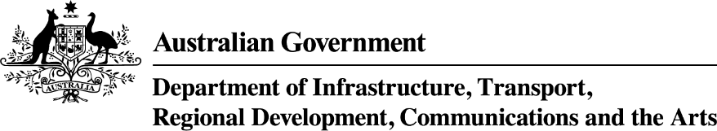

Visual summary: Cultural and creative activity in Australia, 2010–11 to 2019–2020
October 2022

Ownership of intellectual property rights in this publication
Unless otherwise noted, copyright (and any other intellectual property rights, if any) in this publication is owned by the Commonwealth of Australia (referred to below as the Commonwealth).

Disclaimer
The material contained in this publication is made available on the understanding that the Commonwealth is not providing professional advice, and that users exercise their own skill and care with respect to its use, and seek independent advice if necessary.
The Commonwealth makes no representations or warranties as to the contents or accuracy of the information contained in this publication. To the extent permitted by law, the Commonwealth disclaims liability to any person or organisation in respect of anything done, or omitted to be done, in reliance upon information contained in this publication.

Use of the Coat of Arms
The Department of the Prime Minister and Cabinet sets the terms under which the Coat of Arms is used. Please refer to the Commonwealth Coat of Arms - Information and Guidelines publication available at http://www.pmc.gov.au.

Use of the Coat of Arms
The Department of the Prime Minister and Cabinet sets the terms under which the Coat of Arms is used. Please refer to the Commonwealth Coat of Arms - Information and Guidelines publication available at http://www.pmc.gov.au.

Contact us
This publication is available in hard copy PDF format. All other rights are reserved, including in relation to any departmental logos or trademarks which may exist. For enquiries regarding the licence and any use of this publication, please contact:
Director – Creative Services
Communication Branch
Department of Infrastructure, Transport, Regional Development, Communications and the Arts
GPO Box 594
Canberra ACT 2601
Australia
Email: publishing@infrastructure.gov.au
Website: www.infrastructure.gov.au

Contents

About this document 1
Table 1. Cultural and creative activity 2010–11 and 2019–20 2
Figure 1. Cultural and creative activity, 2019–20 3
Figure 2. Cultural and creative industries, Gross Value Added (GVA) by domain 2019–20 4
Figure 3. Cultural and creative activity, 2010–11 to 2019–20 5
Table 2. Cultural and creative activity, share of GDP, 2010–11 to 2019–20 6
Figure 4. Cultural and creative activity relative to nominal GDP 7
Figure 5. Cultural and creative activity, share of GDP, 2010–11 to 2019–20 8
Table 3. Cultural and creative activity, GVA by industry division, 2010–11 to 2019–20 9
Figure 6. GVA change by division, cultural and creative industries, 2010–11 to 2019–20 10
Figure 7. GVA change of cultural and creative industries in manufacturing, 2010–11 to 2019–20 11
Figure 7a. GVA change of cultural and creative industries in information media and telecommunications, 2010–11 to 2019–20 12
Figure 8. GVA relative to GDP by industry division 13
Table 4. Cultural activity, share of GDP, 2010–11 to 2019–20 14
Figure 9. GVA by domain, cultural industries, 2019–20 ($m) 15
Figure 10. Cultural activity, share of GDP, 2010–11 to 2019–20 16
Table 5. Creative activity, share of GDP, 2010–11 to 2019–20 17
Figure 11. GVA by domain, creative industries, 2019–20 ($m) 18
Figure 12. Creative activity, share of GDP, 2010–11 to 2019–20 19
Figure 13. Contribution of cultural and creative activity, GVA (by domain), net taxes on products, and COE in other industries, 2010–11 and 2019–20 20
Figure 14. Nominal GVA growth by domain, cultural and creative industries, 2010–11 to 2019–20 21
Figure 15. GVA relative to GDP by domain 22
Table 6. Cultural and creative activity in museums, 2010–11 to 2019–20 23
Figure 16. GVA, cultural and creative activity in museums, 2010–11 to 2019–20 24
Table 7. Cultural and creative activity in environmental heritage, 2010–11 to 2019–20 25
Figure 17. GVA, cultural and creative activity in environmental heritage, 2010–11 to 2019–20 26
Table 8. Cultural and creative activity in libraries and archives, 2010–11 to 2019–20 27
Figure 18. GVA, cultural and creative activity in libraries and archives, 2010–11 to 2019–20 28
Table 9. Cultural and creative activity in literature and print media, 2010–11 to 2019–20 29
Figure 19. GVA, cultural and creative activity in literature and print media, 2010–11 to 2019–20 30
Table 10. Cultural activity in literature and print media, 2010–11 to 2019–20 31
Table 11. Creative activity in literature and print media, 2010–11 to 2019–20 31
Table 12. Cultural and creative activity in performing arts, 2010–11 to 2019–20 32
Figure 20. GVA, cultural and creative activity in performing arts, 2010–11 to 2019–20 33
Table 13. Cultural and creative activity in design, 2010–11 to 2019–20 34
Figure 21. GVA, cultural and creative activity in design, 2010–11 to 2019–20 35
Table 14. Cultural activity in design, 2010–11 to 2019–20 36
Table 15. Cultural and creative activity in broadcasting, electronic or digital media, and film, 2010–11 to 2019–20 37
Figure 22. GVA, cultural and creative activity in broadcasting, electronic or digital media, and film, 2010–11 to 2019–20 38
Table 16. Creative activity in broadcasting, electronic or digital media, and film, 2010–11 to 2019–20 39
Table 17. Cultural and creative activity in music composition and publishing, 2010–11 to 2019–20 39
Figure 23. GVA, cultural and creative activity in music composition and publishing, 2010–11 to 2019–20 40
Table 18. Cultural and creative activity in visual arts and crafts, 2010–11 to 2019–20 41
Figure 24. GVA, cultural and creative activity in visual arts and crafts, 2010–11 to 2019–20 42
Table 19. Cultural and creative activity in fashion, 2010–11 to 2019–20 43
Figure 25. GVA, cultural and creative activity in fashion, 2010–11 to 2019–20 44
Table 20. Cultural and creative activity in other culture goods manufacturing and sales, 2010–11 to 2019–20 45
Figure 26. GVA, cultural and creative activity in other culture goods manufacturing and sales, 2010–11 to 2019–20 46
Table 21. Cultural and creative activity in supporting activities, 2010–11 to 2019–20 47
Figure 27. GVA, cultural and creative activity in supporting activities, 2010–11 to 2019–20 48
Appendix A – Detailed explanatory notes 49

About this document
The Bureau of Communications, Arts and Regional Research (BCARR) within the Department of Infrastructure, Transport, Regional Development, Communications and the Arts has estimated the economic contribution of cultural and creative activity in Australia over a 10-year period, from 2010–11 to 2019–20.
This publication provides an update to BCARR’s working paper: Cultural and creative activity in Australia, 2008–09 to 2016–17 released in October 2018 and the visual summaries for Cultural and creative activity in Australia, 2008–09 to 2017–18 released in October 2020, and Cultural and creative activity in Australia, 2009–10 to 2018–19. The updated estimates are presented as a visual summary. Each table and figure corresponds to those used in BCARR’s working paper.
This publication follows the same approach taken in the working paper.
Note that data is subject to revisions by the Australian Bureau of Statistics (ABS) national accounts and estimates in this release vary from those published previously.
Further information on these updates can be found in the FAQ: Cultural and creative activity in Australia, 2010–11 to 2019–20.

Table 1. Cultural and creative activity 2010–11 and 2019–20
Gross Domestic Product—National Accounts Basis ($m) (a) | 2010–11 | 2019–20 | 10-year change | Growth in nominal activity
Cultural activity | 56,194 | 64,948 | 8,754 | 15.6%
As a proportion of GDP (%) | 4.0 | 3.3 | -0.7
Creative activity | 84,912 | 109,836 | 24,924 | 29.4%
As a proportion of GDP (%) | 6.0 | 5.6 | -0.4
Total for cultural and creative activity (b) | 96,233 | 122,267 | 26,034 | 27.1%
As a proportion of GDP (%) | 6.8 | 6.2 | -0.6
(a) (b) Activity considered both cultural and creative activity is counted only once in the total.
Source: ABS Australian System of National Accounts, Australian National Accounts: Input-Output Tables; BCARR calculations
Corresponding reference: Cultural and creative activity in Australia, 2008–09 to 2016–17, Table 1.

Figure 1. Cultural and creative activity, 2019–20
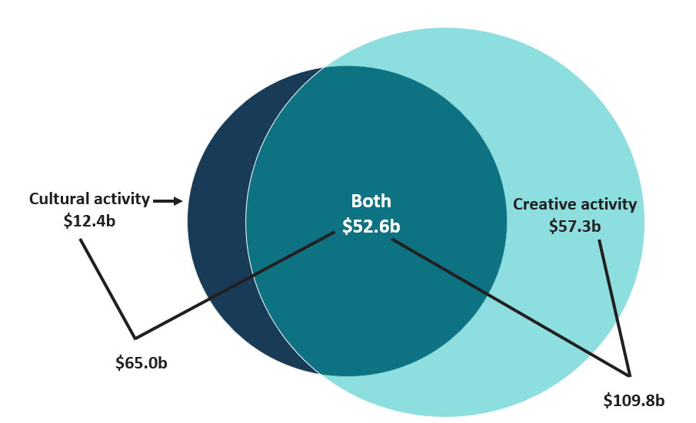
Source: ABS Australian System of National Accounts, Australian National Accounts: Input-Output Tables; BCARR calculations
Corresponding reference: Cultural and creative activity in Australia, 2008–09 to 2016–17, Figure 1.

Figure 2. Cultural and creative industries, Gross Value Added (GVA) by domain 2019–20
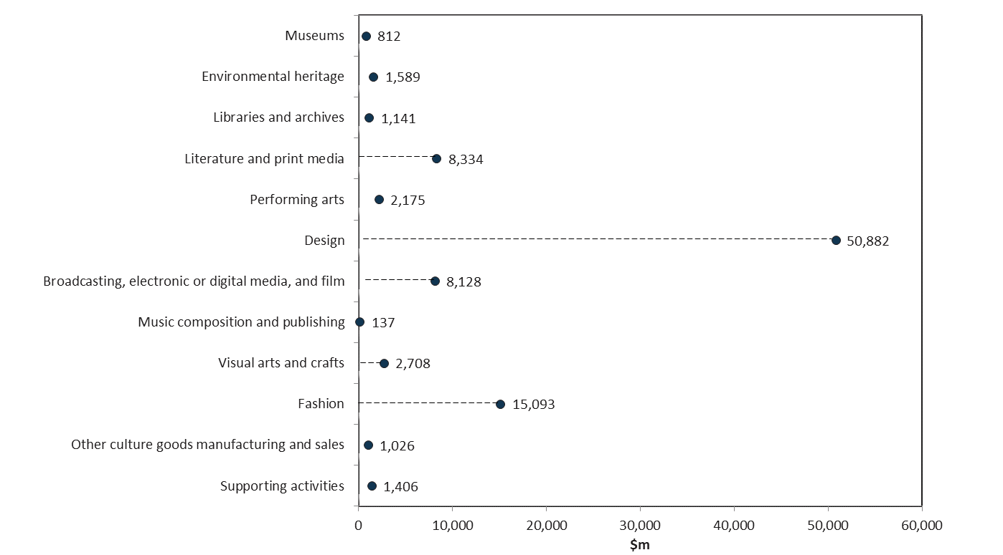
Source: ABS Australian System of National Accounts, Australian National Accounts: Input-Output Tables; BCARR calculations
Corresponding reference: Cultural and creative activity in Australia, 2008–09 to 2016–17, Figure 2.

Figure 3. Cultural and creative activity, 2010–11 to 2019–20
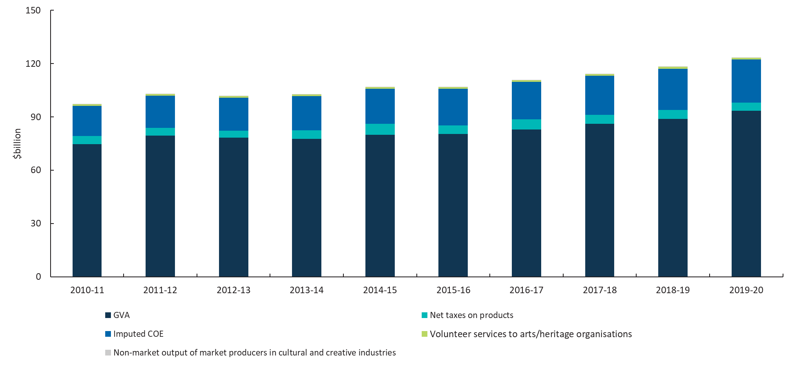
Source: ABS Australian System of National Accounts, Australian National Accounts: Input-Output Tables; BCARR calculations
Corresponding reference: Cultural and creative activity in Australia, 2008–09 to 2016–17, Figure 3.

Table 2. Cultural and creative activity, share of GDP, 2010–11 to 2019–20
Cultural and creative activity (C&C) | 2010–11  $m | 2011–12  $m | 2012–13  $m | 2013–14  $m | 2014–15  $m | 2015–16  $m | 2016–17  $m | 2017–18  $m | 2018–19  $m | 2019–20  $m
C&C activity GDP–national accounts basis | 96,233 | 102,062 | 100,837 | 101,790 | 105,961 | 105,825 | 109,713 | 113,215 | 117,186 | 122,267
Gross value added of C&C industries | 74,725 | 79,466 | 78,273 | 77,636 | 79,964 | 80,379 | 82,898 | 86,087 | 88,956 | 93,431
Net taxes on products of C&C industries | 4,496 | 4,486 | 3,924 | 4,888 | 6,194 | 4,890 | 5,726 | 5,076 | 5,002 | 4,748
COE for C&C occupations in other industries^{(a)} | 17,013 | 18,110 | 18,640 | 19,266 | 19,803 | 20,556 | 21,090 | 22,052 | 23,229 | 24,088
C&C activity GDP–satellite account basis^{(b)} | 97,157 | 103,042 | 101,805 | 102,766 | 106,975 | 106,839 | 110,764 | 114,300 | 118,309 | 123,439
C&C activity GDP–national accounts basis | 96,233 | 102,062 | 100,837 | 101,790 | 105,961 | 105,825 | 109,713 | 113,215 | 117,186 | 122,267
Volunteer services to arts/heritage organisations | 846 | 898 | 887 | 895 | 932 | 931 | 965 | 996 | 1,031 | 1,075
Non-market output of market producers in C&C industries | 77 | 82 | 81 | 80 | 83 | 83 | 86 | 89 | 92 | 97
C&C activity GDP national accounts basis share of GDP (%) | 6.8 | 6.9 | 6.6 | 6.4 | 6.6 | 6.4 | 6.3 | 6.2 | 6.1 | 6.2
Source: ABS Australian System of National Accounts, Australian National Accounts: Input-Output Tables; BCARR calculations.
(a) COE: Compensation of Employees.
(b) Satellite accounts basis refers to the activity included on a national accounts basis, plus volunteer services and non-market output of market producers in the cultural and creative industries.
Corresponding reference: Cultural and creative activity in Australia, 2008–09 to 2016–17, Table 2.

Figure 4. Cultural and creative activity relative to nominal GDP
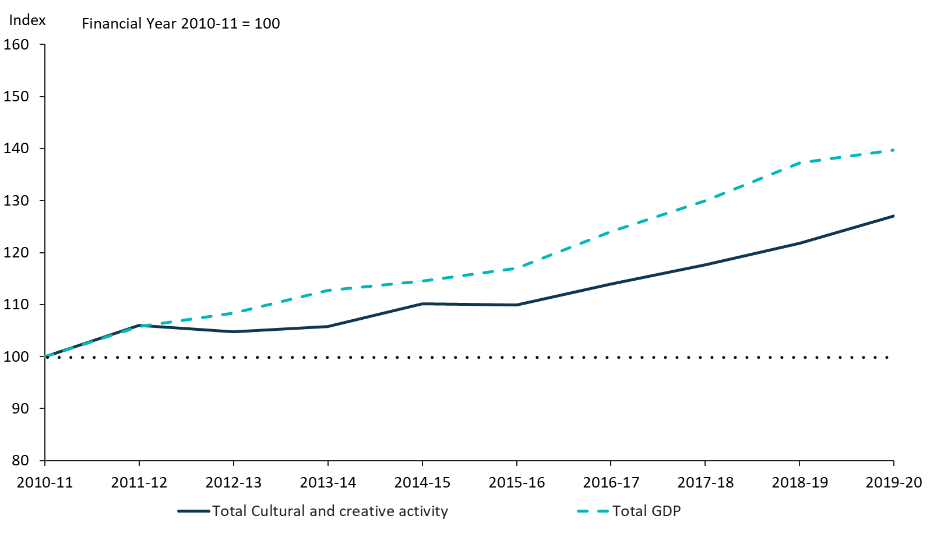
Source: ABS Australian System of National Accounts, Australian National Accounts: Input-Output Tables; BCARR calculations
Corresponding reference: Cultural and creative activity in Australia, 2008–09 to 2016–17, Figure 4.

Figure 5. Cultural and creative activity, share of GDP, 2010–11 to 2019–20
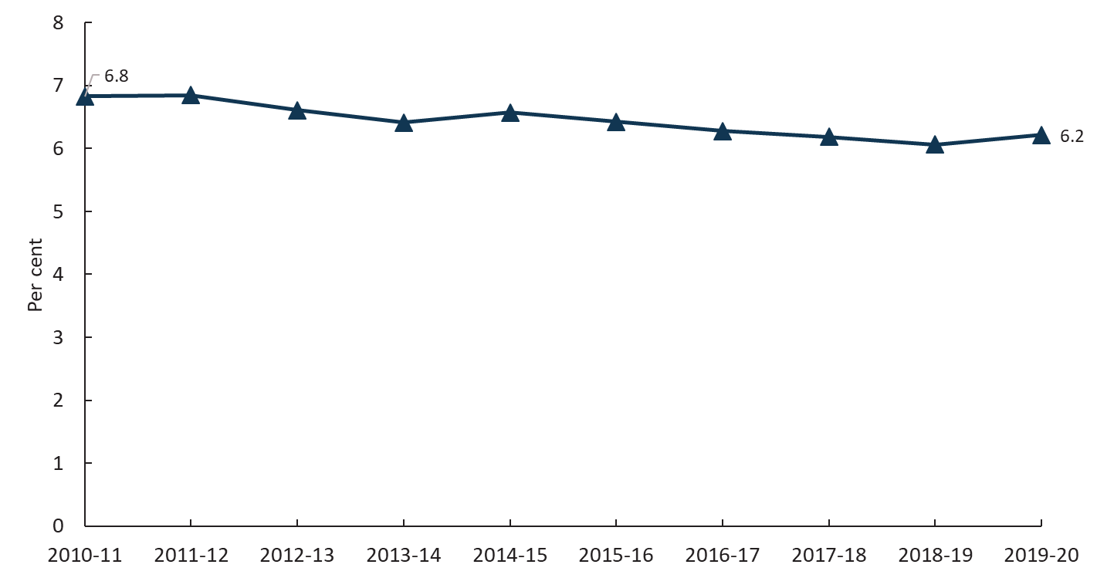
Source: ABS Australian System of National Accounts, Australian National Accounts: Input-Output Tables; BCARR calculations
Corresponding reference: Cultural and creative activity in Australia, 2008–09 to 2016–17, Figure 5.

Table 3. Cultural and creative activity, GVA by industry division, 2010–11 to 2019–20
Division name | 2010–11  $m | 2011–12  $m | 2012–13  $m | 2013–14  $m | 2014–15  $m | 2015–16  $m | 2016–17  $m | 2017–18  $m | 2018–19  $m | 2019–20  $m
↓ Manufacturing | 5,872 | 5,943 | 4,606 | 4,207 | 4,265 | 3,932 | 4,017 | 3,753 | 3,693 | 3,343
↑ Wholesale Trade | 3,935 | 4,142 | 4,275 | 4,252 | 4,258 | 4,382 | 4,530 | 4,599 | 4,696 | 4,900
↑ Retail Trade | 10,742 | 11,546 | 11,782 | 11,829 | 12,020 | 12,430 | 12,717 | 12,965 | 13,376 | 13,814
↓ Information Media and Telecommunications | 16,246 | 16,478 | 15,745 | 15,222 | 15,444 | 15,776 | 14,773 | 14,494 | 13,443 | 13,585
↑ Rental, Hiring and Real Estate Services | 152 | 174 | 159 | 141 | 145 | 140 | 146 | 154 | 167 | 166
↑ Professional, Scientific and Technical Services | 33,571 | 36,727 | 37,006 | 37,071 | 38,715 | 38,857 | 41,628 | 44,709 | 47,752 | 51,641
↑ Education and Training | 933 | 984 | 1,032 | 1,083 | 1,126 | 1,175 | 1,216 | 1,271 | 1,339 | 1,406
↑ Arts and Recreation Services | 3,274 | 3,472 | 3,668 | 3,831 | 3,991 | 3,687 | 3,870 | 4,143 | 4,491 | 4,576
Total | 74,725 | 79,466 | 78,273 | 77,636 | 79,964 | 80,379 | 82,898 | 86,087 | 88,956 | 93,431
Source: ABS Australian System of National Accounts, Australian National Accounts: Input-Output Tables; BCARR calculations
Corresponding reference: Cultural and creative activity in Australia, 2008–09 to 2016–17, Table 3.

Figure 6. GVA change by division, cultural and creative industries, 2010–11 to 2019–20
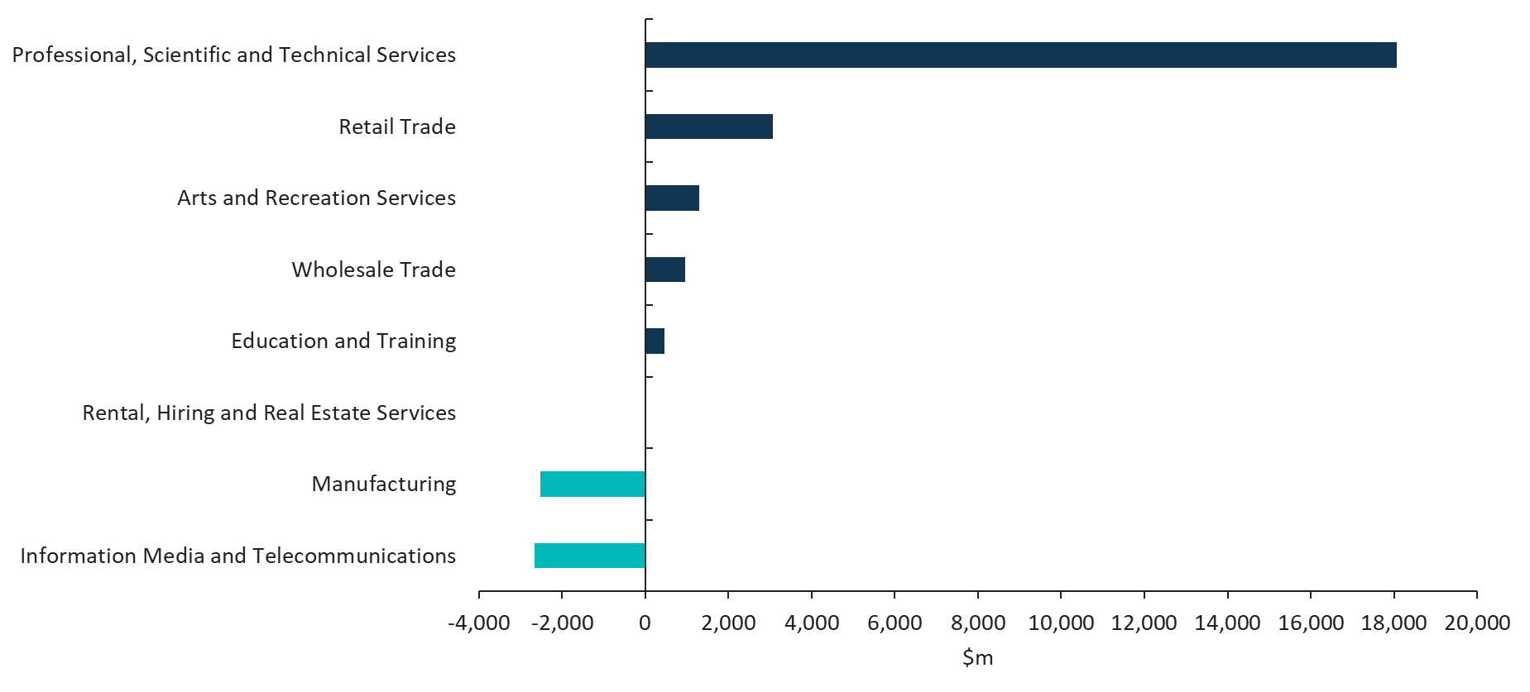
Source: ABS Australian System of National Accounts, Australian National Accounts: Input-Output Tables; BCARR calculations
Corresponding reference: Cultural and creative activity in Australia, 2008–09 to 2016–17, Figure 6.

Figure 7. GVA change of cultural and creative industries in manufacturing, 2010–11 to 2019–20
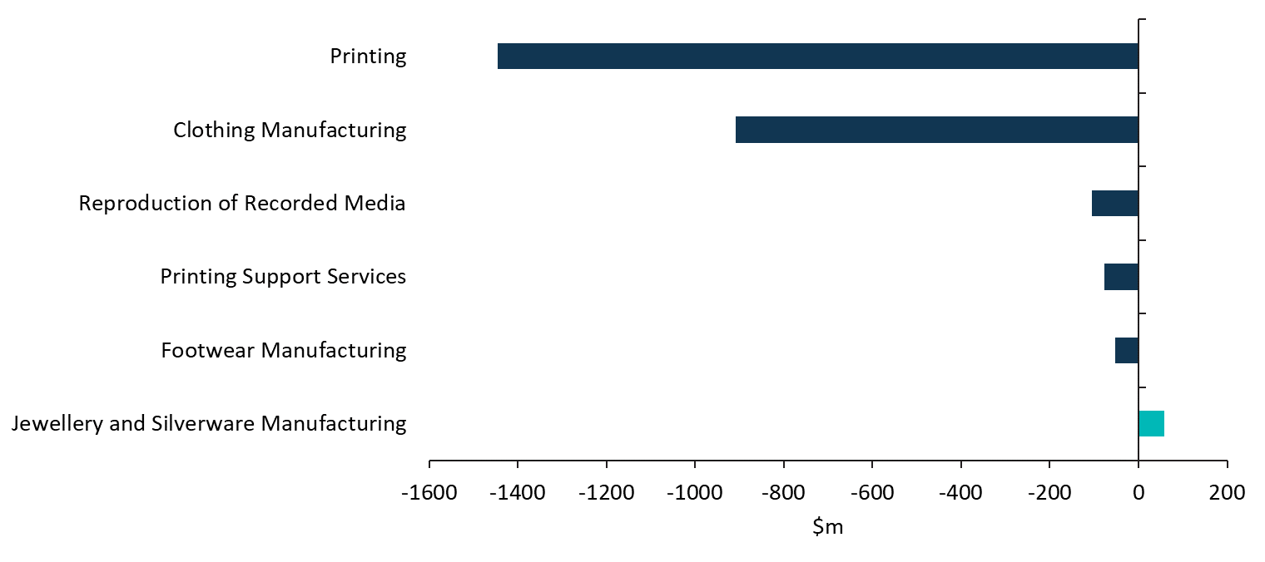
Source: ABS Australian System of National Accounts, Australian National Accounts: Input-Output Tables; BCARR calculations
Corresponding reference: Cultural and creative activity in Australia, 2008–09 to 2016–17, Figure 7.

Figure 7a. GVA change of cultural and creative industries in information media and telecommunications, 2010–11 to 2019–20
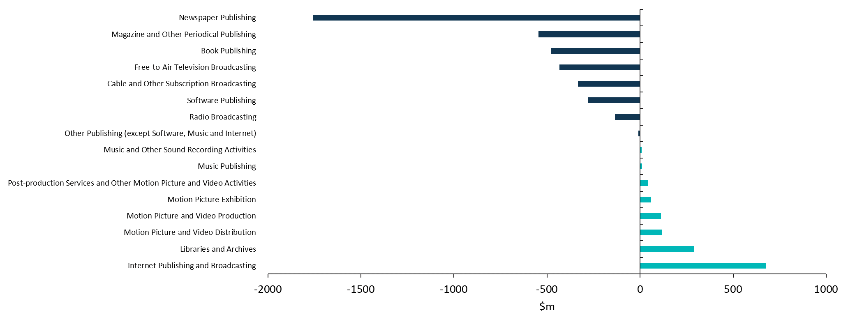
Source: ABS Australian System of National Accounts, Australian National Accounts: Input-Output Tables; BCARR calculations

Figure 8. GVA relative to GDP by industry division
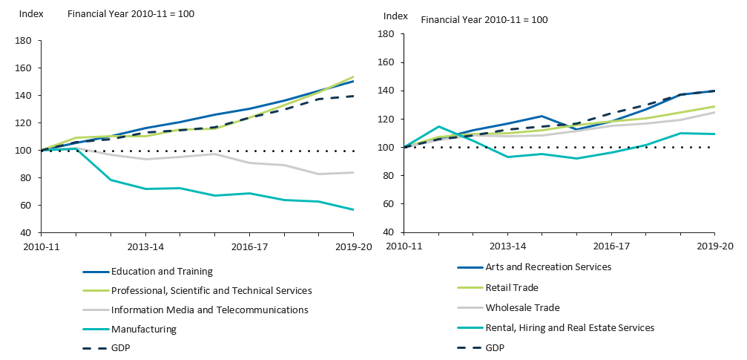
Source: ABS Australian System of National Accounts, Australian National Accounts: Input-Output Tables; BCARR calculations
Corresponding reference: Cultural and creative activity in Australia, 2008–09 to 2016–17, Figure 8.

Table 4. Cultural activity, share of GDP, 2010–11 to 2019–20
Cultural activity | 2010–11  $m | 2011–12  $m | 2012–13  $m | 2013–14  $m | 2014–15  $m | 2015–16  $m | 2016–17  $m | 2017–18  $m | 2018–19  $m | 2019–20  $m
Cultural activity GDP–national accounts basis | 56,194 | 58,801 | 58,873 | 59,702 | 61,325 | 61,337 | 62,770 | 63,965 | 63,504 | 64,948
Gross value added of cultural industries | 38,213 | 39,962 | 40,059 | 39,376 | 40,081 | 40,193 | 40,756 | 41,481 | 41,732 | 42,679
Net taxes on products of cultural industries | 4,567 | 4,557 | 4,097 | 5,122 | 5,630 | 4,927 | 5,360 | 5,072 | 3,443 | 3,238
COE for cultural occupations in other industries^{(a)} | 13,414 | 14,282 | 14,717 | 15,204 | 15,614 | 16,218 | 16,654 | 17,412 | 18,329 | 19,031
Cultural activity GDP–satellite account basis^{(b)} | 57,097 | 59,756 | 59,815 | 60,652 | 62,313 | 62,323 | 63,790 | 65,016 | 64,590 | 66,079
Cultural activity GDP–national accounts basis | 56,194 | 58,801 | 58,873 | 59,702 | 61,325 | 61,337 | 62,770 | 63,965 | 63,504 | 64,948
Volunteer services to arts/heritage organisations | 846 | 898 | 887 | 895 | 932 | 931 | 965 | 996 | 1,031 | 1,075
Non-market output of market producers in cultural industries | 57 | 58 | 55 | 54 | 56 | 55 | 56 | 56 | 55 | 56
Cultural activity GDP national accounts basis share of GDP (%) | 4.0 | 3.9 | 3.9 | 3.8 | 3.8 | 3.7 | 3.6 | 3.5 | 3.3 | 3.3
Source: ABS Australian System of National Accounts, Australian National Accounts: Input-Output Tables; BCARR calculations. (a) COE: Compensation of Employees. (b) Satellite accounts basis refers to the activity included on a national accounts basis, plus volunteer services and non-market output of market producers in the cultural and creative industries.
Corresponding reference: Cultural and creative activity in Australia, 2008–09 to 2016–17, Table 4.

Figure 9. GVA by domain, cultural industries, 2019–20 ($m)
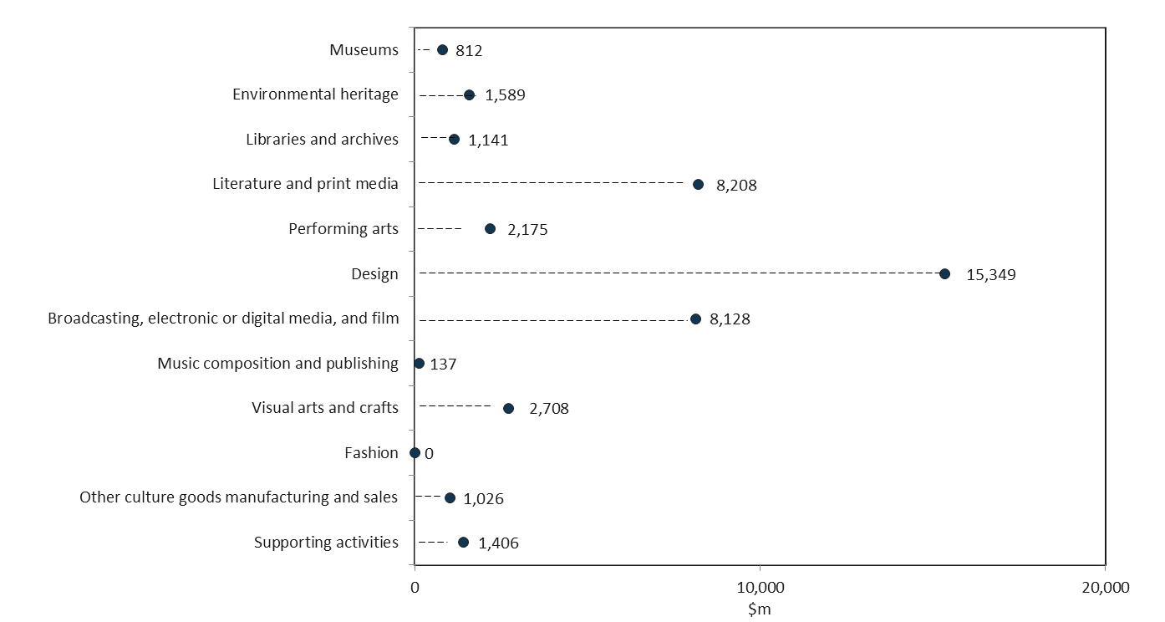
Source: ABS Australian System of National Accounts, Australian National Accounts: Input-Output Tables; BCARR calculations
Corresponding reference: Cultural and creative activity in Australia, 2008–09 to 2016–17, Figure 9.

Figure 10. Cultural activity, share of GDP, 2010–11 to 2019–20
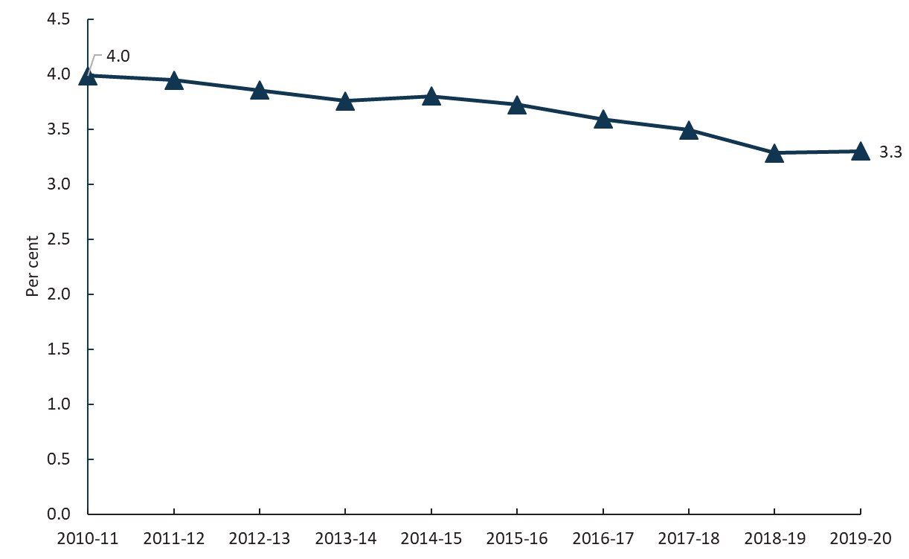
Source: ABS Australian System of National Accounts, Australian National Accounts: Input-Output Tables; BCARR calculations
Corresponding reference: see Cultural and creative activity in Australia, 2008–09 to 2016–17, Figure 10.

Table 5. Creative activity, share of GDP, 2010–11 to 2019–20
Creative activity | 2010–11  $m | 2011–12  $m | 2012–13  $m | 2013–14  $m | 2014–15  $m | 2015–16  $m | 2016–17  $m | 2017–18  $m | 2018–19  $m | 2019–20  $m
Creative activity GDP–national accounts basis | 84,912 | 90,223 | 89,137 | 90,018 | 94,040 | 94,084 | 97,752 | 101,083 | 104,824 | 109,836
Gross value added of creative industries | 66,620 | 71,030 | 70,107 | 69,642 | 71,828 | 72,681 | 74,985 | 78,173 | 80,805 | 85,365
Net taxes on products of creative industries | 4,141 | 4,132 | 3,559 | 4,392 | 5,785 | 4,361 | 5,286 | 4,637 | 4,764 | 4,539
COE for creative occupations in other industries^{(a)} | 14,151 | 15,061 | 15,472 | 15,984 | 16,427 | 17,042 | 17,481 | 18,272 | 19,254 | 19,931
Creative activity GDP–satellite account basis^{(b)} | 85,817 | 91,179 | 90,079 | 90,968 | 95,028 | 95,070 | 98,774 | 102,136 | 105,912 | 110,969
Creative activity GDP–national accounts basis | 84,912 | 90,223 | 89,137 | 90,018 | 94,040 | 94,084 | 97,752 | 101,083 | 104,824 | 109,836
Volunteer services to arts/heritage organisations | 846 | 898 | 887 | 895 | 932 | 931 | 965 | 996 | 1,031 | 1,075
Non-market output of market producers in creative industries | 58 | 59 | 54 | 55 | 57 | 56 | 57 | 57 | 57 | 58
Creative activity GDP national accounts basis share of GDP (%) | 6.0 | 6.1 | 5.8 | 5.7 | 5.8 | 5.7 | 5.6 | 5.5 | 5.4 | 5.6
Source: ABS Australian System of National Accounts, Australian National Accounts: Input-Output Tables; BCARR calculations. (a) COE: Compensation of Employees. (b) Satellite accounts basis refers to the activity included on a national accounts basis, plus volunteer services and non-market output of market producers in the cultural and creative industries.
Corresponding reference: Cultural and creative activity in Australia, 2008–09 to 2016–17, Table 5.

Figure 11. GVA by domain, creative industries, 2019–20 ($m)
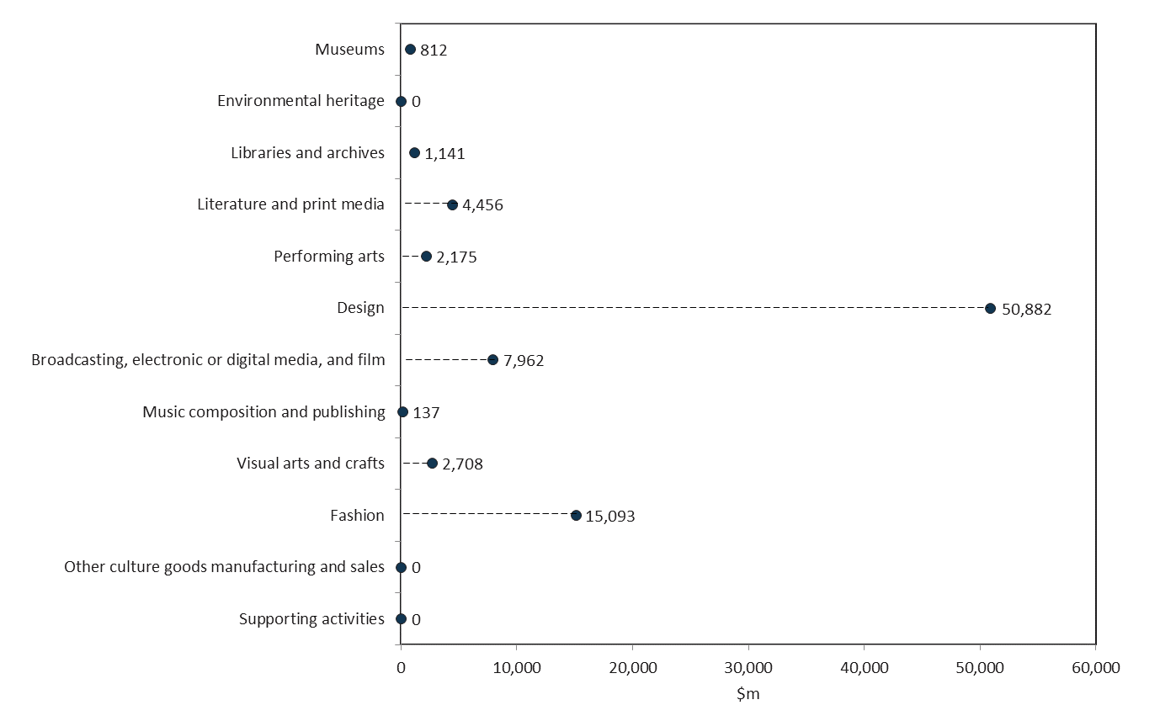
Source: ABS Australian System of National Accounts, Australian National Accounts: Input-Output Tables; BCARR calculations
Corresponding reference: Cultural and creative activity in Australia, 2008–09 to 2016–17, Figure 11.

Figure 12. Creative activity, share of GDP, 2010–11 to 2019–20
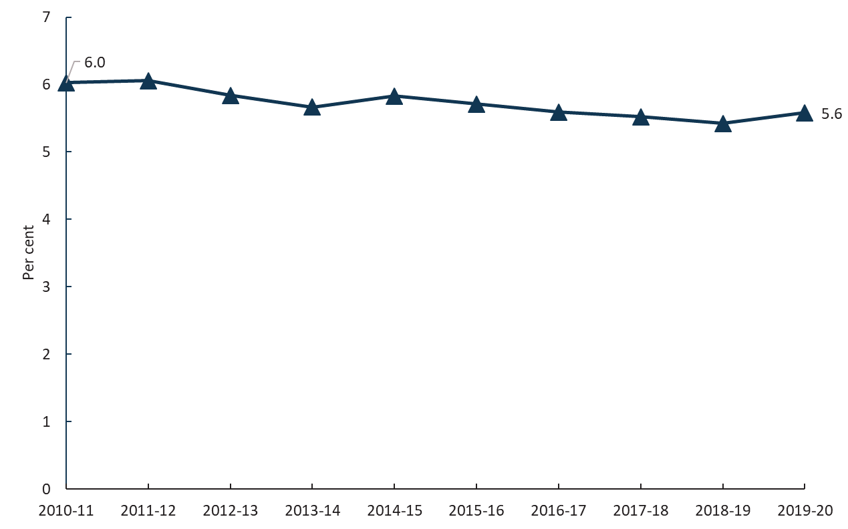
Source: ABS Australian System of National Accounts, Australian National Accounts: Input-Output Tables; BCARR calculations
Corresponding reference: Cultural and creative activity in Australia, 2008–09 to 2016–17, Figure 12.

Figure 13. Contribution of cultural and creative activity, GVA (by domain), net taxes on products, and COE in other industries, 2010–11 and 2019–20
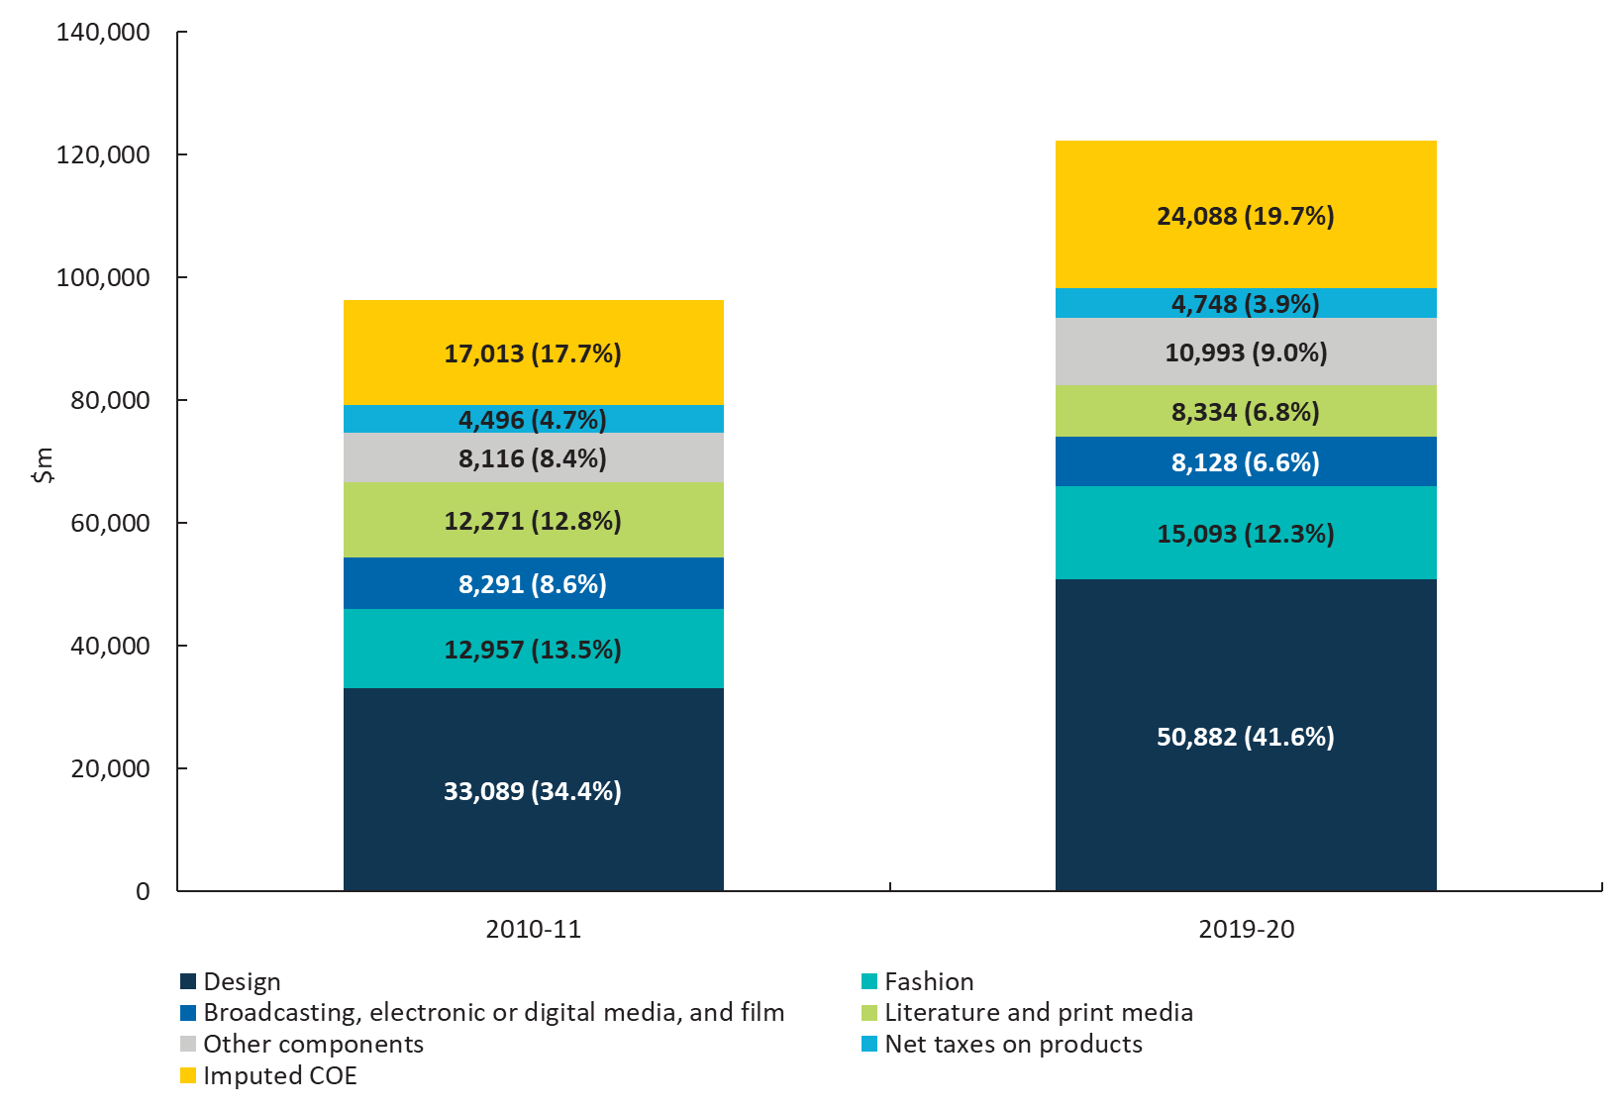
Source: ABS Australian System of National Accounts, Australian National Accounts: Input-Output Tables; BCARR calculations
Corresponding reference: Cultural and creative activity in Australia, 2008–09 to 2016–17, Figure 13.

Figure 14. Nominal GVA growth by domain, cultural and creative industries, 2010–11 to 2019–20
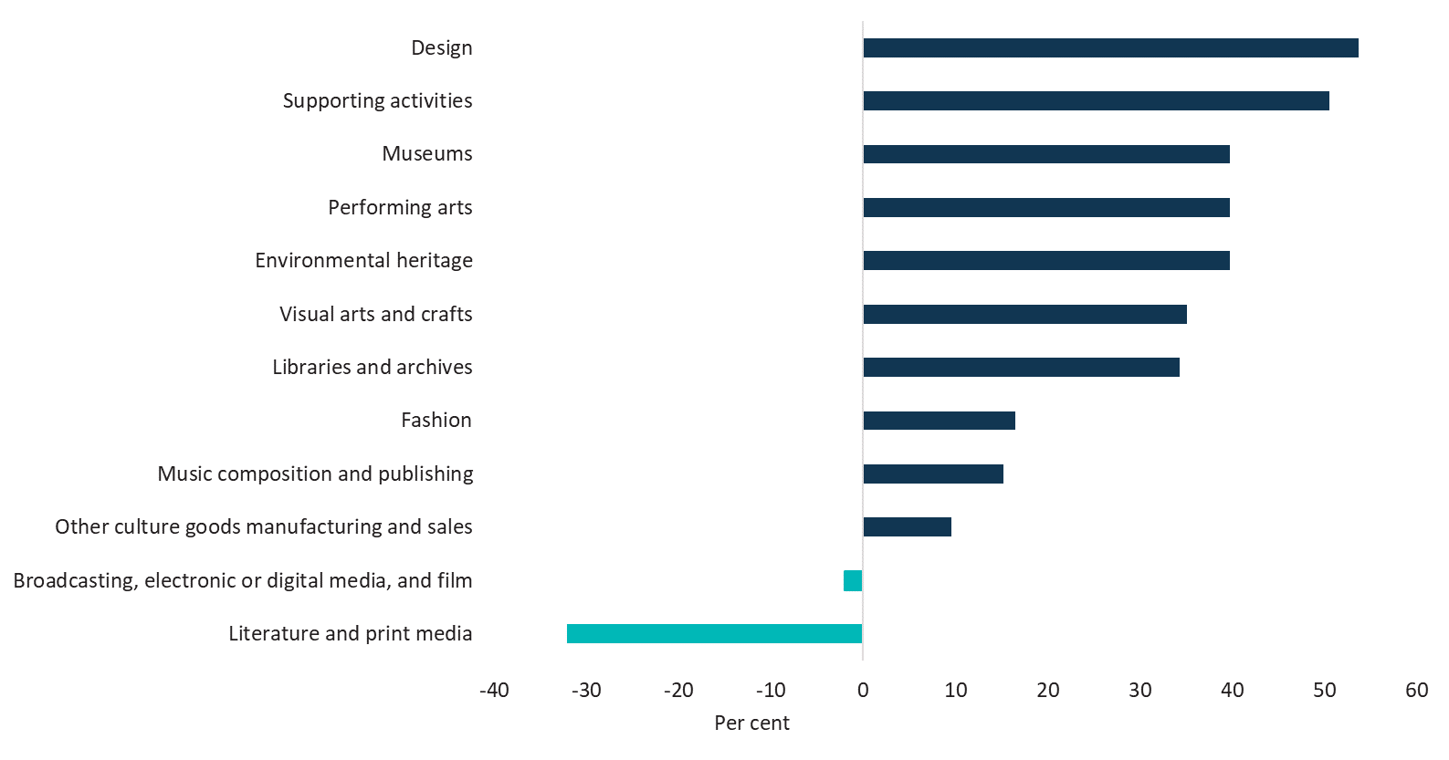
Source: ABS Australian System of National Accounts, Australian National Accounts: Input-Output Tables; BCARR calculations
Corresponding reference: see Cultural and creative activity in Australia, 2008–09 to 2016–17, Figure 14.

Figure 15. GVA relative to GDP by domain
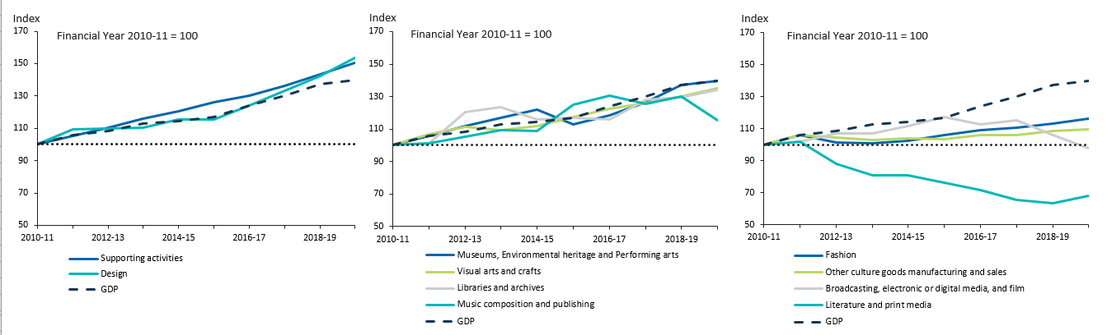
Source: ABS Australian System of National Accounts, Australian National Accounts: Input-Output Tables; BCARR calculations
Corresponding reference: Cultural and creative activity in Australia, 2008–09 to 2016–17, Figure 15.

Table 6. Cultural and creative activity in museums, 2010–11 to 2019–20
Museums | 2010–11  $m | 2011–12  $m | 2012–13  $m | 2013–14  $m | 2014–15  $m | 2015–16  $m | 2016–17  $m | 2017–18  $m | 2018–19  $m | 2019–20  $m
Output | 1,435 | 1,518 | 1,271 | 1,340 | 1,353 | 1,408 | 1,517 | 1,589 | 1,746 | 1,731
COE | 395 | 422 | 347 | 354 | 341 | 360 | 377 | 403 | 459 | 460
GOS and GMI | 210 | 219 | 340 | 364 | 396 | 336 | 358 | 378 | 368 | 652
Taxes less subsidies on production | -23 | -25 | -36 | -38 | -29 | -42 | -48 | -45 | -30 | -300
GVA | 581 | 616 | 651 | 680 | 708 | 655 | 687 | 736 | 797 | 812
As a per cent of GDP | 0.04 | 0.04 | 0.04 | 0.04 | 0.04 | 0.04 | 0.04 | 0.04 | 0.04 | 0.04
Source: ABS Australian System of National Accounts, Australian National Accounts: Input-Output Tables; BCARR calculations
Corresponding reference: Cultural and creative activity in Australia, 2008–09 to 2016–17, Table 6.

Figure 16. GVA, cultural and creative activity in museums, 2010–11 to 2019–20
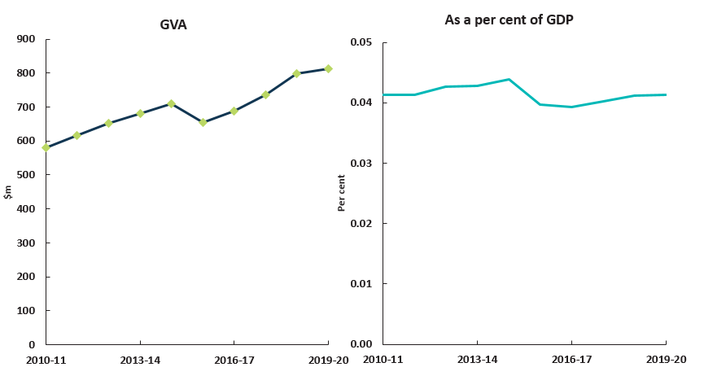
Source: ABS Australian System of National Accounts, Australian National Accounts: Input-Output Tables; BCARR calculations
Corresponding reference: Cultural and creative activity in Australia, 2008–09 to 2016–17, Figure 16.

Table 7. Cultural and creative activity in environmental heritage, 2010–11 to 2019–20
Environmental heritage | 2010–11  $m | 2011–12  $m | 2012–13  $m | 2013–14  $m | 2014–15  $m | 2015–16  $m | 2016–17  $m | 2017–18  $m | 2018–19  $m | 2019–20  $m
Output | 2,749 | 2,908 | 2,435 | 2,568 | 2,592 | 2,698 | 2,906 | 3,045 | 3,344 | 3,316
COE | 493 | 526 | 433 | 442 | 426 | 450 | 471 | 503 | 573 | 574
GOS and GMI | 687 | 725 | 907 | 959 | 1,013 | 908 | 961 | 1,019 | 1,041 | 1,566
Taxes less subsidies on production | -43 | -45 | -65 | -70 | -53 | -77 | -87 | -83 | -55 | -551
GVA | 1,137 | 1,206 | 1,274 | 1,330 | 1,386 | 1,281 | 1,344 | 1,439 | 1,559 | 1,589
As a per cent of GDP | 0.08 | 0.08 | 0.08 | 0.08 | 0.09 | 0.08 | 0.08 | 0.08 | 0.08 | 0.08
Source: ABS Australian System of National Accounts, Australian National Accounts: Input-Output Tables; BCARR calculations
Corresponding reference: Cultural and creative activity in Australia, 2008–09 to 2016–17, Table 7.

Figure 17. GVA, cultural and creative activity in environmental heritage, 2010–11 to 2019–20
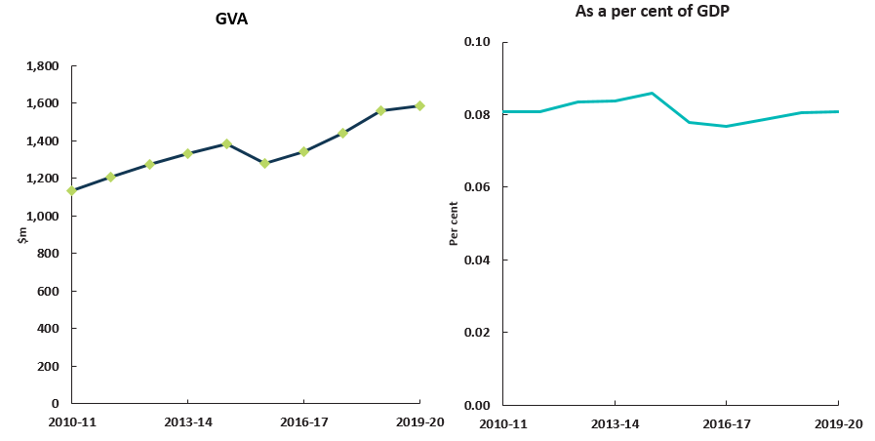
Source: ABS Australian System of National Accounts, Australian National Accounts: Input-Output Tables; BCARR calculations
Corresponding reference: Cultural and creative activity in Australia, 2008–09 to 2016–17, Figure 17.

Table 8. Cultural and creative activity in libraries and archives, 2010–11 to 2019–20
Libraries and archives | 2010–11  $m | 2011–12  $m | 2012–13  $m | 2013–14  $m | 2014–15  $m | 2015–16  $m | 2016–17  $m | 2017–18  $m | 2018–19  $m | 2019–20  $m
Output | 1,425 | 1,507 | 1,428 | 1,447 | 1,448 | 1,517 | 1,551 | 1,672 | 1,665 | 1,734
COE | 464 | 495 | 494 | 504 | 457 | 483 | 604 | 628 | 570 | 580
GOS and GMI | 373 | 353 | 517 | 536 | 513 | 498 | 369 | 445 | 515 | 524
Taxes less subsidies on production | 13 | 14 | 11 | 11 | 13 | 13 | 12 | 15 | 15 | 37
GVA | 850 | 862 | 1,022 | 1,051 | 983 | 994 | 985 | 1,088 | 1,100 | 1,141
As a per cent of GDP | 0.06 | 0.06 | 0.07 | 0.07 | 0.06 | 0.06 | 0.06 | 0.06 | 0.06 | 0.06
Source: ABS Australian System of National Accounts, Australian National Accounts: Input-Output Tables; BCARR calculations
Corresponding reference: Cultural and creative activity in Australia, 2008–09 to 2016–17, Table 8.

Figure 18. GVA, cultural and creative activity in libraries and archives, 2010–11 to 2019–20
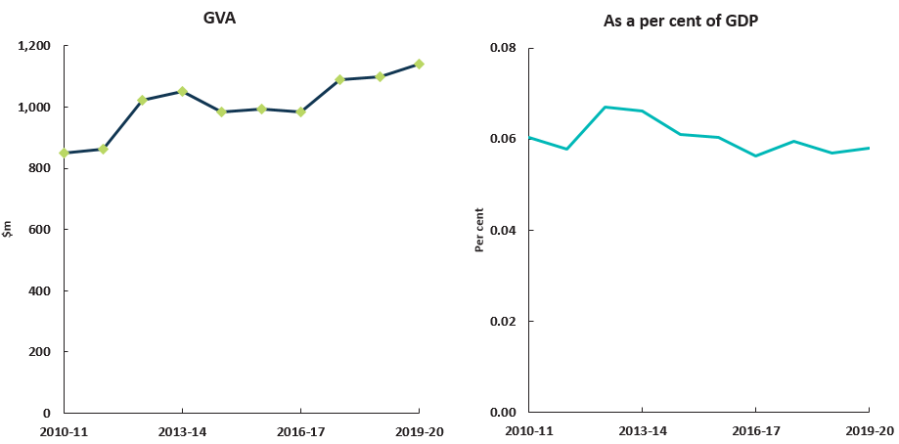
Source: ABS Australian System of National Accounts, Australian National Accounts: Input-Output Tables; BCARR calculations
Corresponding reference: Cultural and creative activity in Australia, 2008–09 to 2016–17, Figure 18.

Table 9. Cultural and creative activity in literature and print media, 2010–11 to 2019–20
Literature and print media | 2010–11  $m | 2011–12  $m | 2012–13  $m | 2013–14  $m | 2014–15  $m | 2015–16  $m | 2016–17  $m | 2017–18  $m | 2018–19  $m | 2019–20  $m
Output | 25,198 | 26,652 | 20,327 | 19,976 | 17,761 | 18,017 | 17,508 | 15,921 | 16,113 | 16,492
COE | 6,552 | 6,999 | 6,004 | 5,834 | 5,883 | 5,755 | 5,734 | 5,449 | 5,532 | 5,654
GOS and GMI | 5,468 | 5,246 | 4,565 | 3,874 | 3,743 | 3,333 | 2,810 | 2,345 | 2,006 | 3,117
Taxes less subsidies on production | 251 | 266 | 225 | 238 | 263 | 233 | 234 | 228 | 240 | -437
GVA | 12,271 | 12,511 | 10,793 | 9,946 | 9,889 | 9,321 | 8,779 | 8,022 | 7,778 | 8,334
As a per cent of GDP | 0.87 | 0.84 | 0.71 | 0.63 | 0.61 | 0.57 | 0.50 | 0.44 | 0.40 | 0.42
Source: ABS Australian System of National Accounts, Australian National Accounts: Input-Output Tables; BCARR calculations
Corresponding reference: Cultural and creative activity in Australia, 2008–09 to 2016–17, Table 9.

Figure 19. GVA, cultural and creative activity in literature and print media, 2010–11 to 2019–20
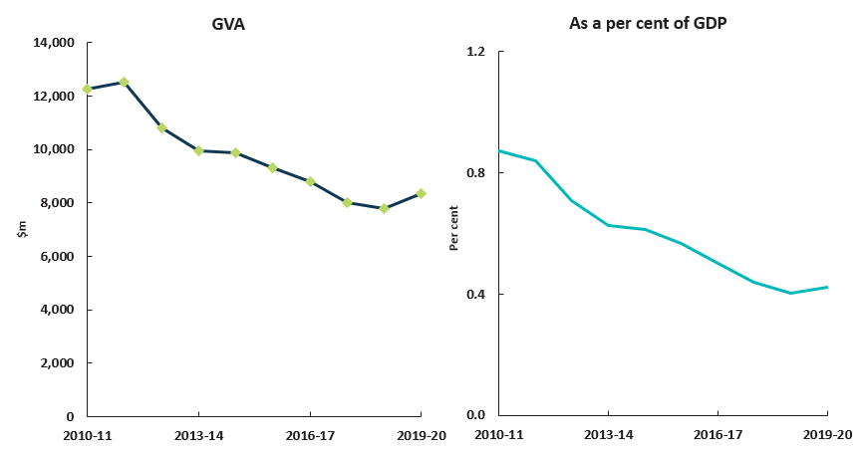
Source: ABS Australian System of National Accounts, Australian National Accounts: Input-Output Tables; BCARR calculations
Corresponding reference: Cultural and creative activity in Australia, 2008–09 to 2016–17, Figure 19.

Table 10. Cultural activity in literature and print media, 2010–11 to 2019–20
Literature and print media | 2010–11  $m | 2011–12  $m | 2012–13  $m | 2013–14  $m | 2014–15  $m | 2015–16  $m | 2016–17  $m | 2017–18  $m | 2018–19  $m | 2019–20  $m
Output | 24,754 | 26,183 | 19,960 | 19,595 | 17,476 | 17,712 | 17,204 | 15,646 | 15,831 | 16,237
COE | 6,390 | 6,826 | 5,869 | 5,701 | 5,746 | 5,627 | 5,607 | 5,328 | 5,408 | 5,535
GOS and GMI | 5,421 | 5,208 | 4,513 | 3,836 | 3,709 | 3,313 | 2,789 | 2,329 | 1,997 | 3,088
Taxes less subsidies on production | 247 | 261 | 221 | 234 | 259 | 229 | 230 | 224 | 236 | -415
GVA | 12,058 | 12,295 | 10,603 | 9,771 | 9,714 | 9,169 | 8,627 | 7,882 | 7,640 | 8,208
As a per cent of GDP | 0.86 | 0.83 | 0.69 | 0.62 | 0.60 | 0.56 | 0.49 | 0.43 | 0.40 | 0.42
Source: ABS Australian System of National Accounts, Australian National Accounts: Input-Output Tables; BCARR calculations
Corresponding reference: Cultural and creative activity in Australia, 2008–09 to 2016–17, Table 10.

Table 11. Creative activity in literature and print media, 2010–11 to 2019–20
Literature and print media | 2010–11  $m | 2011–12  $m | 2012–13  $m | 2013–14  $m | 2014–15  $m | 2015–16  $m | 2016–17  $m | 2017–18  $m | 2018–19  $m | 2019–20  $m
Output | 13,692 | 14,482 | 9,772 | 9,101 | 8,868 | 8,484 | 7,852 | 6,722 | 6,609 | 7,461
COE | 2,883 | 3,079 | 2,692 | 2,537 | 2,505 | 2,432 | 2,404 | 2,201 | 2,176 | 2,353
GOS and GMI | 4,337 | 4,238 | 3,282 | 2,831 | 2,768 | 2,666 | 2,067 | 1,677 | 1,444 | 2,027
Taxes less subsidies on production | 106 | 112 | 95 | 101 | 111 | 91 | 92 | 86 | 89 | 76
GVA | 7,325 | 7,429 | 6,068 | 5,468 | 5,384 | 5,188 | 4,562 | 3,964 | 3,709 | 4,456
As a per cent of GDP | 0.52 | 0.50 | 0.40 | 0.34 | 0.33 | 0.31 | 0.26 | 0.22 | 0.19 | 0.23
Source: ABS Australian System of National Accounts, Australian National Accounts: Input-Output Tables; BCARR calculations
Corresponding reference: Cultural and creative activity in Australia, 2008–09 to 2016–17, Table 11.

Table 12. Cultural and creative activity in performing arts, 2010–11 to 2019–20
Performing arts | 2010–11  $m | 2011–12  $m | 2012–13  $m | 2013–14  $m | 2014–15  $m | 2015–16  $m | 2016–17  $m | 2017–18  $m | 2018–19  $m | 2019–20  $m
Output | 3,935 | 4,162 | 3,486 | 3,676 | 3,710 | 3,861 | 4,159 | 4,358 | 4,787 | 4,746
COE | 809 | 865 | 711 | 726 | 700 | 739 | 773 | 826 | 941 | 943
GOS and GMI | 807 | 849 | 1,125 | 1,193 | 1,271 | 1,122 | 1,190 | 1,260 | 1,270 | 2,008
Taxes less subsidies on production | -60 | -64 | -92 | -99 | -75 | -108 | -123 | -117 | -77 | -776
GVA | 1,556 | 1,650 | 1,743 | 1,821 | 1,896 | 1,752 | 1,839 | 1,969 | 2,134 | 2,175
As a per cent of GDP | 0.11 | 0.11 | 0.11 | 0.11 | 0.12 | 0.11 | 0.11 | 0.11 | 0.11 | 0.11
Source: ABS Australian System of National Accounts, Australian National Accounts: Input-Output Tables; BCARR calculations
Corresponding reference: Cultural and creative activity in Australia, 2008–09 to 2016–17, Table 12.

Figure 20. GVA, cultural and creative activity in performing arts, 2010–11 to 2019–20
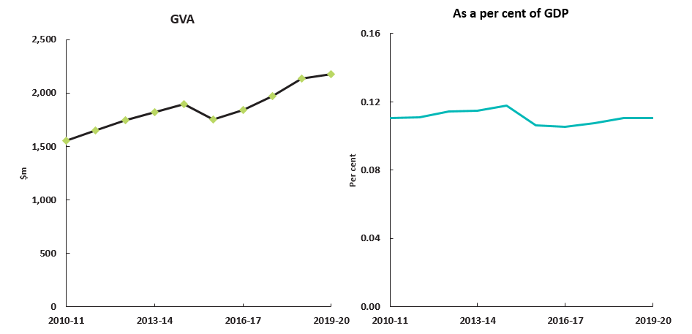
Source: ABS Australian System of National Accounts, Australian National Accounts: Input-Output Tables; BCARR calculations
Corresponding reference: Cultural and creative activity in Australia, 2008–09 to 2016–17, Figure 20.

Table 13. Cultural and creative activity in design, 2010–11 to 2019–20
Design | 2010–11  $m | 2011–12  $m | 2012–13  $m | 2013–14  $m | 2014–15  $m | 2015–16  $m | 2016–17  $m | 2017–18  $m | 2018–19  $m | 2019–20  $m
Output | 64,493 | 68,215 | 72,778 | 74,025 | 75,687 | 80,144 | 85,677 | 91,737 | 101,113 | 106,418
COE | 21,264 | 22,715 | 25,762 | 26,011 | 26,945 | 29,600 | 30,782 | 33,383 | 35,929 | 39,521
GOS and GMI | 11,000 | 12,612 | 9,819 | 9,597 | 10,213 | 7,633 | 9,108 | 9,503 | 9,842 | 13,220
Taxes less subsidies on production | 825 | 873 | 855 | 895 | 980 | 1,031 | 1,090 | 1,137 | 1,259 | -1,859
GVA | 33,089 | 36,200 | 36,435 | 36,503 | 38,138 | 38,265 | 40,980 | 44,023 | 47,029 | 50,882
As a per cent of GDP | 2.35 | 2.43 | 2.39 | 2.30 | 2.36 | 2.32 | 2.34 | 2.40 | 2.43 | 2.59
Source: ABS Australian System of National Accounts, Australian National Accounts: Input-Output Tables; BCARR calculations
Corresponding reference: Cultural and creative activity in Australia, 2008–09 to 2016–17, Table 13.

Figure 21. GVA, cultural and creative activity in design, 2010–11 to 2019–20
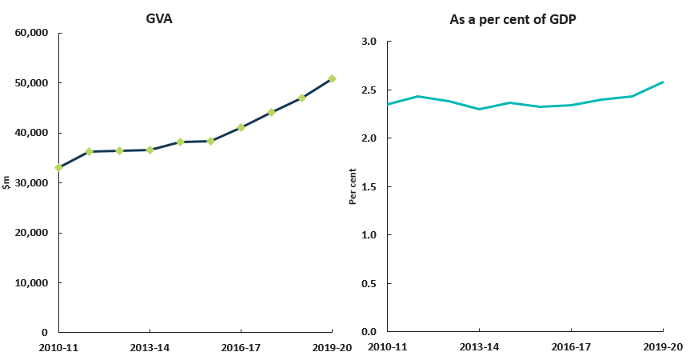
Source: ABS Australian System of National Accounts, Australian National Accounts: Input-Output Tables; BCARR calculations
Corresponding reference: Cultural and creative activity in Australia, 2008–09 to 2016–17, Figure 21.

Table 14. Cultural activity in design, 2010–11 to 2019–20
Design | 2010–11  $m | 2011–12  $m | 2012–13  $m | 2013–14  $m | 2014–15  $m | 2015–16  $m | 2016–17  $m | 2017–18  $m | 2018–19  $m | 2019–20  $m
Output | 24,961 | 26,401 | 26,547 | 27,805 | 28,131 | 29,201 | 31,549 | 33,673 | 35,157 | 36,928
COE | 6,477 | 6,919 | 8,069 | 8,450 | 8,451 | 9,698 | 10,321 | 11,051 | 11,647 | 12,510
GOS and GMI | 2,949 | 3,405 | 3,146 | 2,697 | 2,842 | 1,908 | 2,385 | 2,390 | 2,518 | 4,264
Taxes less subsidies on production | 322 | 340 | 328 | 344 | 379 | 374 | 395 | 418 | 445 | -1,425
GVA | 9,747 | 10,664 | 11,543 | 11,491 | 11,672 | 11,980 | 13,102 | 13,859 | 14,610 | 15,349
As a per cent of GDP | 0.69 | 0.72 | 0.76 | 0.72 | 0.72 | 0.73 | 0.75 | 0.76 | 0.76 | 0.78
Source: ABS Australian System of National Accounts, Australian National Accounts: Input-Output Tables; BCARR calculations
Corresponding reference: Cultural and creative activity in Australia, 2008–09 to 2016–17, Table 14.

Table 15. Cultural and creative activity in broadcasting, electronic or digital media, and film, 2010–11 to 2019–20
Broadcasting, electronic or digital media, and film | 2010–11  $m | 2011–12  $m | 2012–13  $m | 2013–14  $m | 2014–15  $m | 2015–16  $m | 2016–17  $m | 2017–18  $m | 2018–19  $m | 2019–20  $m
Output | 21,058 | 22,273 | 22,074 | 21,703 | 22,982 | 23,902 | 23,883 | 23,389 | 23,235 | 22,175
COE | 4,243 | 4,533 | 4,441 | 4,433 | 4,672 | 4,996 | 4,891 | 5,048 | 5,212 | 5,195
GOS and GMI | 3,843 | 3,680 | 4,219 | 4,228 | 4,345 | 4,490 | 4,219 | 4,282 | 3,306 | 3,088
Taxes less subsidies on production | 205 | 217 | 197 | 209 | 232 | 234 | 243 | 244 | 252 | -154
GVA | 8,291 | 8,430 | 8,857 | 8,870 | 9,249 | 9,720 | 9,354 | 9,573 | 8,771 | 8,128
As a per cent of GDP | 0.59 | 0.57 | 0.58 | 0.56 | 0.57 | 0.59 | 0.54 | 0.52 | 0.45 | 0.41
Source: ABS Australian System of National Accounts, Australian National Accounts: Input-Output Tables; BCARR calculations
Corresponding reference: Cultural and creative activity in Australia, 2008–09 to 2016–17, Table 15.

Figure 22. GVA, cultural and creative activity in broadcasting, electronic or digital media, and film, 2010–11 to 2019–20
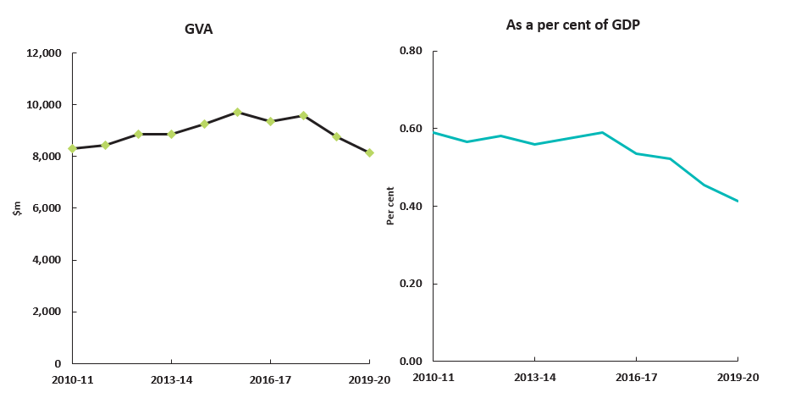
Source: ABS Australian System of National Accounts, Australian National Accounts: Input-Output Tables; BCARR calculations
Corresponding reference: Cultural and creative activity in Australia, 2008–09 to 2016–17, Figure 22.

Table 16. Creative activity in broadcasting, electronic or digital media, and film, 2010–11 to 2019–20
Broadcasting, electronic or digital media, and film | 2010–11  $m | 2011–12  $m | 2012–13  $m | 2013–14  $m | 2014–15  $m | 2015–16  $m | 2016–17  $m | 2017–18  $m | 2018–19  $m | 2019–20  $m
Output | 20,466 | 21,647 | 21,392 | 21,025 | 22,323 | 23,259 | 23,208 | 22,690 | 22,505 | 21,440
COE | 4,027 | 4,302 | 4,166 | 4,153 | 4,396 | 4,716 | 4,616 | 4,756 | 4,906 | 4,880
GOS and GMI | 3,912 | 3,742 | 4,340 | 4,371 | 4,482 | 4,635 | 4,354 | 4,425 | 3,453 | 3,231
Taxes less subsidies on production | 201 | 212 | 192 | 204 | 227 | 229 | 238 | 238 | 246 | -149
GVA | 8,139 | 8,255 | 8,698 | 8,728 | 9,104 | 9,580 | 9,207 | 9,419 | 8,604 | 7,962
As a per cent of GDP | 0.58 | 0.55 | 0.57 | 0.55 | 0.56 | 0.58 | 0.53 | 0.51 | 0.45 | 0.40
Source: ABS Australian System of National Accounts, Australian National Accounts: Input-Output Tables; BCARR calculations
Corresponding reference: Cultural and creative activity in Australia, 2008–09 to 2016–17, Table 16.

Table 17. Cultural and creative activity in music composition and publishing, 2010–11 to 2019–20
Music composition and publishing | 2010–11  $m | 2011–12  $m | 2012–13  $m | 2013–14  $m | 2014–15  $m | 2015–16  $m | 2016–17  $m | 2017–18  $m | 2018–19  $m | 2019–20  $m
Output | 377 | 399 | 433 | 418 | 466 | 493 | 510 | 477 | 500 | 463
COE | 92 | 98 | 96 | 98 | 102 | 113 | 114 | 121 | 122 | 113
GOS and GMI | 21 | 16 | 24 | 26 | 21 | 29 | 34 | 22 | 25 | 41
Taxes less subsidies on production | 5 | 6 | 5 | 6 | 6 | 6 | 7 | 7 | 7 | -17
GVA | 119 | 120 | 125 | 129 | 129 | 148 | 155 | 149 | 154 | 137
As a per cent of GDP | 0.01 | 0.01 | 0.01 | 0.01 | 0.01 | 0.01 | 0.01 | 0.01 | 0.01 | 0.01
Source: ABS Australian System of National Accounts, Australian National Accounts: Input-Output Tables; BCARR calculations
Corresponding reference: Cultural and creative activity in Australia, 2008–09 to 2016–17, Table 17.

Figure 23. GVA, cultural and creative activity in music composition and publishing, 2010–11 to 2019–20
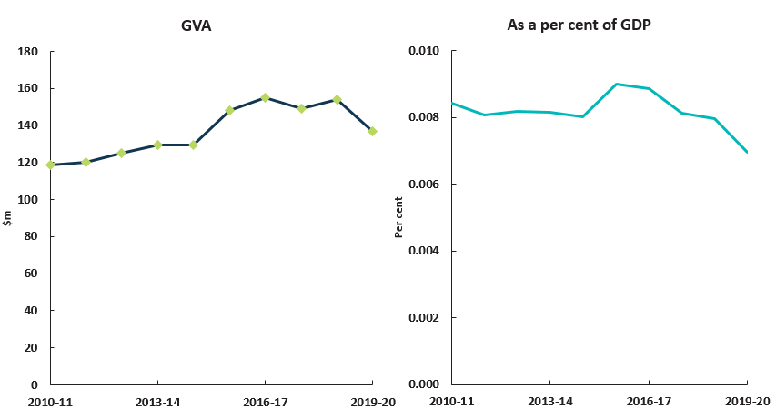
Source: ABS Australian System of National Accounts, Australian National Accounts: Input-Output Tables; BCARR calculations
Corresponding reference: Cultural and creative activity in Australia, 2008–09 to 2016–17, Figure 23.

Table 18. Cultural and creative activity in visual arts and crafts, 2010–11 to 2019–20
Visual arts and crafts | 2010–11  $m | 2011–12  $m | 2012–13  $m | 2013–14  $m | 2014–15  $m | 2015–16  $m | 2016–17  $m | 2017–18  $m | 2018–19  $m | 2019–20  $m
Output | 4,317 | 4,566 | 4,391 | 4,354 | 4,400 | 4,684 | 4,722 | 4,874 | 5,072 | 5,251
COE | 1,359 | 1,451 | 1,490 | 1,520 | 1,553 | 1,690 | 1,747 | 1,787 | 1,869 | 1,947
GOS and GMI | 584 | 627 | 683 | 605 | 621 | 590 | 639 | 665 | 665 | 862
Taxes less subsidies on production | 62 | 66 | 59 | 63 | 69 | 70 | 72 | 72 | 77 | -102
GVA | 2,004 | 2,144 | 2,232 | 2,188 | 2,243 | 2,350 | 2,457 | 2,524 | 2,610 | 2,708
As a per cent of GDP | 0.14 | 0.14 | 0.15 | 0.14 | 0.14 | 0.14 | 0.14 | 0.14 | 0.14 | 0.14
Source: ABS Australian System of National Accounts, Australian National Accounts: Input-Output Tables; BCARR calculations
Corresponding reference: Cultural and creative activity in Australia, 2008–09 to 2016–17, Table 18.

Figure 24. GVA, cultural and creative activity in visual arts and crafts, 2010–11 to 2019–20
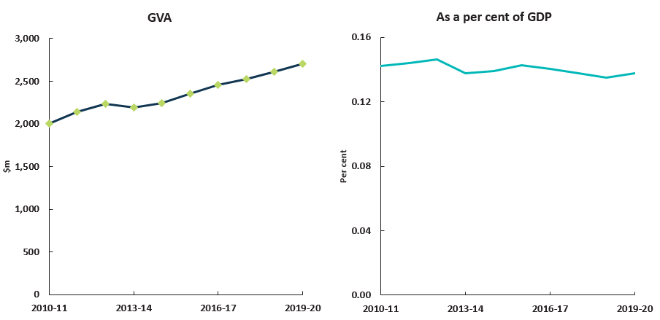
Source: ABS Australian System of National Accounts, Australian National Accounts: Input-Output Tables; BCARR calculations
Corresponding reference: Cultural and creative activity in Australia, 2008–09 to 2016–17, Figure 24.

Table 19. Cultural and creative activity in fashion, 2010–11 to 2019–20
Fashion | 2010–11  $m | 2011–12  $m | 2012–13  $m | 2013–14  $m | 2014–15  $m | 2015–16  $m | 2016–17  $m | 2017–18  $m | 2018–19  $m | 2019–20  $m
Output | 23,104 | 24,437 | 22,000 | 21,313 | 21,417 | 22,439 | 22,909 | 23,185 | 24,169 | 24,875
COE | 7,211 | 7,703 | 7,602 | 7,514 | 7,714 | 8,026 | 8,189 | 8,219 | 8,499 | 8,686
GOS and GMI | 5,392 | 5,675 | 5,199 | 5,210 | 5,140 | 5,337 | 5,524 | 5,685 | 5,746 | 6,923
Taxes less subsidies on production | 354 | 374 | 331 | 350 | 389 | 387 | 399 | 397 | 423 | -516
GVA | 12,957 | 13,753 | 13,132 | 13,074 | 13,242 | 13,750 | 14,111 | 14,302 | 14,668 | 15,093
As a per cent of GDP | 0.92 | 0.92 | 0.86 | 0.82 | 0.82 | 0.83 | 0.81 | 0.78 | 0.76 | 0.77
Source: ABS Australian System of National Accounts, Australian National Accounts: Input-Output Tables; BCARR calculations
Corresponding reference: Cultural and creative activity in Australia, 2008–09 to 2016–17, Table 19.

Figure 25. GVA, cultural and creative activity in fashion, 2010–11 to 2019–20
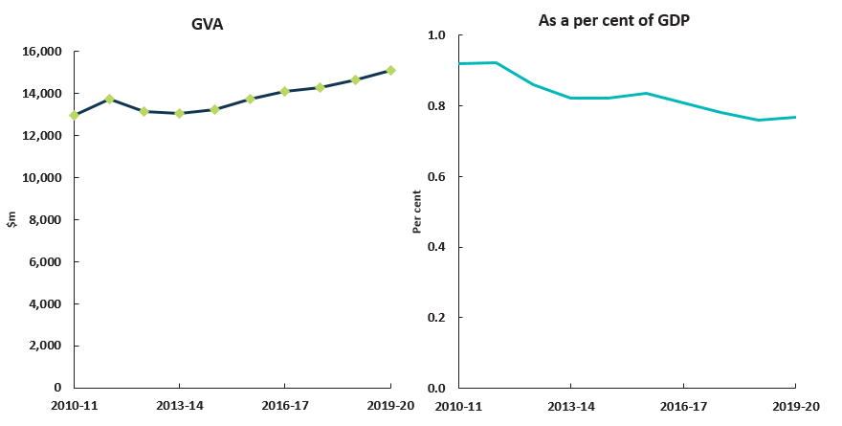
Source: ABS Australian System of National Accounts, Australian National Accounts: Input-Output Tables; BCARR calculations
Corresponding reference: Cultural and creative activity in Australia, 2008–09 to 2016–17, Figure 25.

Table 20. Cultural and creative activity in other culture goods manufacturing and sales, 2010–11 to 2019–20
Other culture goods manufacturing and sales | 2010–11  $m | 2011–12  $m | 2012–13  $m | 2013–14  $m | 2014–15  $m | 2015–16  $m | 2016–17  $m | 2017–18  $m | 2018–19  $m | 2019–20  $m
Output | 2,749 | 2,908 | 2,583 | 2,629 | 2,224 | 2,399 | 2,433 | 2,345 | 2,437 | 2,373
COE | 557 | 595 | 560 | 560 | 574 | 593 | 599 | 601 | 622 | 630
GOS and GMI | 341 | 354 | 381 | 365 | 359 | 338 | 353 | 353 | 353 | 522
Taxes less subsidies on production | 39 | 41 | 35 | 37 | 41 | 39 | 39 | 39 | 42 | -126
GVA | 936 | 990 | 976 | 961 | 974 | 970 | 991 | 993 | 1,016 | 1,026
As a per cent of GDP | 0.07 | 0.07 | 0.06 | 0.06 | 0.06 | 0.06 | 0.06 | 0.05 | 0.05 | 0.05
Source: ABS Australian System of National Accounts, Australian National Accounts: Input-Output Tables; BCARR calculations
Corresponding reference: Cultural and creative activity in Australia, 2008–09 to 2016–17, Table 20.

Figure 26. GVA, cultural and creative activity in other culture goods manufacturing and sales, 2010–11 to 2019–20
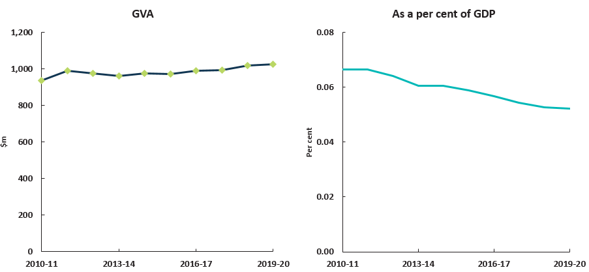
Source: ABS Australian System of National Accounts, Australian National Accounts: Input-Output Tables; BCARR calculations
Corresponding reference: Cultural and creative activity in Australia, 2008–09 to 2016–17, Figure 26.

Table 21. Cultural and creative activity in supporting activities, 2010–11 to 2019–20
Supporting activities | 2010–11  $m | 2011–12  $m | 2012–13  $m | 2013–14  $m | 2014–15  $m | 2015–16  $m | 2016–17  $m | 2017–18  $m | 2018–19  $m | 2019–20  $m
Output | 1,244 | 1,316 | 1,418 | 1,494 | 1,563 | 1,758 | 1,863 | 1,935 | 2,043 | 2,128
COE | 792 | 846 | 916 | 954 | 995 | 1,043 | 1,079 | 1,132 | 1,189 | 1,262
GOS and GMI | 129 | 125 | 104 | 117 | 121 | 120 | 124 | 127 | 139 | 175
Taxes less subsidies on production | 13 | 13 | 11 | 12 | 10 | 12 | 13 | 11 | 11 | -31
GVA | 933 | 984 | 1,032 | 1,083 | 1,126 | 1,175 | 1,216 | 1,271 | 1,339 | 1,406
As a per cent of GDP | 0.07 | 0.07 | 0.07 | 0.07 | 0.07 | 0.07 | 0.07 | 0.07 | 0.07 | 0.07
Source: ABS Australian System of National Accounts, Australian National Accounts: Input-Output Tables; BCARR calculations
Corresponding reference: Cultural and creative activity in Australia, 2008–09 to 2016–17, Table 21.

Figure 27. GVA, cultural and creative activity in supporting activities, 2010–11 to 2019–20
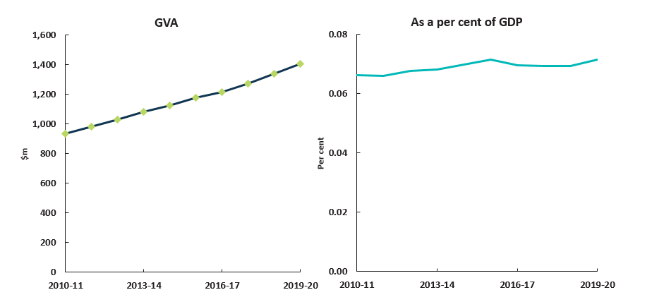
Source: ABS Australian System of National Accounts, Australian National Accounts: Input-Output Tables; BCARR calculations
Corresponding reference: Cultural and creative activity in Australia, 2008–09 to 2016–17, Figure 27.

- Detailed explanatory notes
Table/figure name | Explanatory notes
Table 1. Cultural and creative activity 2010–11 and 2019–20 | - Cultural and creative activity in Australia grew to $122.3 billion in 2019–20, an increase of $26.0 billion or 27.1 per cent over the last 10 years.  - As a share of GDP, cultural and creative activity declined by 0.6 percentage points, from 6.8 per cent in 2010–11 to 6.2 per cent in 2019–20.  - Examining the breakdown of cultural and creative activity:  - Cultural activity grew from $56.2 billion in 2010–11 to $65.0 billion in 2019–20, while its share of GDP declined from 4.0 per cent to 3.3 per cent over this period.  - Creative activity increased from $84.9 billion in 2010–11 to $109.8 billion in 2019–20, while its share of GDP declined from 6.0 per cent to 5.6 per cent over this period.
Figure 1. Cultural and creative activity, 2019–20 | - Cultural and creative activity can be measured separately or as both cultural and creative activity.  - Cultural activity contributed $65.0 billion or 3.3 per cent to GDP in 2019–20, while creative activity contributed $109.8 billion or 5.6 per cent to GDP in 2019–20.  - There is considerable overlap of industries and occupations common with these segments. Activity identified as both cultural and creative accounted for $52.6 billion or 2.7 per cent to GDP. This common activity is counted only once in the total for cultural and creative activity.
Figure 2. Cultural and creative industries, Gross Value Added (GVA) by domain 2019–20 | - The value of cultural and creative activity in industries considered to be cultural or creative was $93.4 billion in 2019–20. The largest components were design at $50.9 billion, fashion at $15.1 billion, literature and print media at $8.3 billion, and broadcasting, electronic or digital media, and film at $8.1 billion.
Figure 3. Cultural and creative activity, 2010–11 to 2019–20 | - Cultural and creative activity increased by $26.0 billion or 27.1 per cent from $96.2 billion in 2010–11 to $122.3 billion in 2019–20. This growth was driven mainly by an increase of $18.7 billion in GVA from cultural and creative industries—primarily from activities within professional, scientific and technical services.
Table 2. Cultural and creative activity, share of GDP, 2010–11 to 2019–20 | - Cultural and creative activity, on a satellite accounts basis, consists of four components:  - Gross value added (GVA) from cultural and creative industries increased by $18.7 billion or 25.0 per cent, from $74.7 billion in 2010–11 to $93.4 billion in 2019–20; and Net taxes on products attributable to cultural and creative industries increased over the period by 5.6 per cent or $252 million.  - Compensation of employees (COE) received by individuals working in cultural and creative occupations that are outside industries identified as cultural and creative was $24.1 billion in 2019–20. This grew by $7.1 billion or 41.6 per cent over the period.  - The value of volunteer services to arts and heritage organisations was $1.1 billion in 2019–20, $230 million more than in 2010–11.  - Non‑market output of market producers in cultural and creative industries was $97 million in 2019–20, an increase of $19 million compared to 2010–11.
Figure 4. Cultural and creative activity relative to nominal GDP | - While cultural and creative activity is growing in absolute terms, the increase is slower than the pace of the Australian economy overall. The Australian economy has been supported by activities that are almost entirely outside cultural and creative activity, such as mining-related activity over the period.  - The dotted line at 100, represents the base year index of 2010–11. The area above the line represents growth whereas the area below the line represents a contraction since 2010–11. Similarly, the dashed line represents GDP growth for the entire Australian economy relative to the base year.
Figure 5. Cultural and creative activity, share of GDP, 2010–11 to 2019–20 | - Cultural and creative activity as a share of GDP declined by 0.6 percentage points over the period, from 6.8 per cent in 2010–11 to 6.2 per cent in 2019–20.
Table 3. Cultural and creative activity, GVA by industry division, 2010–11 to 2019–20 | - Cultural and creative activity increased significantly in absolute terms within the industry division of professional, scientific and technical services with an increase of $18.1 billion or 53.8 per cent over the period; followed by retail trade at $3.1 billion or 28.6 per cent.  - Cultural and creative activity within the manufacturing and information media and telecommunications industry divisions recorded an absolute decline in GVA over the period.
Figure 6. GVA change by division, cultural and creative industries, 2010–11 to 2019–20 | - See notes above.
Figure 7. GVA change of cultural and creative industries in manufacturing, 2010–11 to 2019–20 | - Five out of six cultural and creative industries within the manufacturing industry division experienced a decline from 2010–11 to 2019–20.  - Printing fell by $1.4 billion or 40.8 per cent, while clothing manufacturing fell by $908 million or 61.8 per cent over the period.
Figure 7a. GVA change of cultural and creative industries in information media and telecommunications, 2010–11 to 2019–20 | - Publishing industries within the information media and telecommunications industry division have experienced declines from 2010–11 to 2019–20.  - These declines were especially significant for newspaper, magazine and other periodical, book and software publishing.  - Internet publishing and broadcasting was the largest growing industry within the information media and telecommunications industry division.
Figure 8. Industry division’s GVA relative to GDP | - When each industry division’s growth is compared with the pace of the economy as a whole, three industry divisions met or exceeded the rest of the economy by the end of the 10-year period.  - Growth of cultural and creative activity in professional, scientific and technical services was above the economy by 10.1 percentage points, and growth of cultural and creative activity in education and training outpaced the economy by 7.8 percentage points and in 2019–20.  - The dotted line at 100, represents the base year index of 2010–11. As noted earlier, the area above the line represents growth whereas the area below the line represents a contraction since 2010–11. If an industry division grew but did not outpace the economy as a whole, as did five out of the eight industry divisions, then their growth would be between the base year line and the dashed nominal GDP line.
Table 4. Cultural activity, share of GDP, 2010–11 to 2019–20 | - Cultural activity increased by $8.8 billion or 15.7 per cent from $56.2 billion in 2010–11 to $65.0 billion in 2019–20.  - GVA for cultural industries increased by $4.5 billion or 11.7 per cent from $38.2 billion in 2010–11 to $42.7 billion in 2019–20. Net taxes on products attributable to cultural industries decreased by $1.3 billion or 29.1 per cent from 2010–11 to 2019–20.  - COE received by individuals working in cultural occupations that are outside industries identified as cultural was $19.0 billion in 2019–20. This has grown by $5.6 billion or 41.9% over the period.  - The value of volunteer services to arts and heritage organisations was $1.1 billion in 2019–20, $229 million more than in 2010–11. This value is identical to the total cultural and creative value of volunteer services due to the cultural and creative overlap of arts and heritage organisations.  - Non‑market output of market producers in cultural industries was $56 million in 2019–20, a decrease of $0.5 million compared to 2010–11.
Figure 9. GVA by domain, cultural industries, 2019–20 ($m) | - Cultural activity represents a smaller share of total GVA compared to creative activity and primarily consists of design at $15.3 billion, broadcasting, electronic or digital media, and film at $8.1 billion, and literature and print media at $8.2 billion in 2019–20.
Figure 10. Cultural activity, share of GDP, 2010–11 to 2019–20 | - Cultural activity, as a share of GDP, declined by 0.7 percentage points, from 4.0 per cent in 2010–11 to 3.3 per cent in 2019–20.
Table 5. Creative activity, share of GDP, 2010–11 to 2019–20 | - Creative activity increased by $24.9 billion or 29.4 per cent from $84.9 billion in 2010–11 to $109.8 billion in 2019–20.  - GVA for creative industries increased by $18.7 billion or 28.1 per cent from $66.6 billion in 2010–11 to $85.4 billion in 2019–20. Net taxes on products attributable to creative industries increased by $398 million or 9.6 per cent from 2010–11 to 2019–20.  - COE received by individuals working in creative occupations that are outside industries identified as creative was $19.9 billion in 2019–20. This has grown by 40.8 per cent during the period.  - The value of volunteer services to arts and heritage organisations was $1.1 billion in 2019–20, $229 million more than $846 million in 2009–10. This value is identical to the total cultural and creative value of volunteer services due to the cultural and creative overlap of arts and heritage organisations.  - Non‑market output of market producers in the creative industries was $58 million in 2019–20, an increase of $0.2 million compared to 2010–11.
Figure 11. GVA by domain, creative industries, 2019–20 ($m) | - Creative activity represents a larger share of total GVA compared to cultural activity and displays a very similar structure to the overall combination of creative and cultural activity, being dominated by design at $50.8 billion, fashion at $15.1 billion, and broadcasting, electronic or digital media, and film at $8.0 billion in 2019–20.
Figure 12. Creative activity, share of GDP, 2010–11 to 2019–20 | - Creative activity as a share of GDP declined by 0.4 percentage points, from 6.0 percent in 2010–11 to 5.6 per cent in 2019–20.
Figure 13. Contribution of cultural and creative activity, GVA (by domain), net taxes on products and COE in other industries, 2010–11 and 2019–20 | - Cultural and creative activity can be also analysed by domains which are grouped in terms of related industries.  - The largest contribution to cultural and creative activity was design. This domain increased by 7.2 percentage points as a share of total activity, from 34.4 per cent in 2010–11 to 41.6 per cent in 2019–20. Fashion, the second largest domain as a share of cultural and creative activity declined by 1.1 percentage points, from 13.5 per cent in 2010–11 to 12.3 per cent in 2019–20. The share of broadcasting, electronic or digital media, and film has also declined, down from 8.6 per cent in 2010–11 to 6.6 per cent in 2019–20. Literature and print media, the third largest domain in 2010–11 at 12.8 per cent dropped to 6.8 per cent and became the fourth largest domain of cultural and creative activity in 2019–20.  - These four domains, in total, contributed 67.4 per cent of cultural and creative activity. All other domains had a much smaller impact at 9.0 per cent in 2019–20. The remaining 23.6 per cent was made up of income received from creative and cultural workers in other industries (imputed COE) and net taxes on products.
Figure 14. Nominal GVA growth by domain, cultural and creative industries, 2010–11 to 2019–20 | - Ten of the twelve domains experienced growth from 2010–11 to 2019–20. Design had the strongest growth of 53.8 per cent or $17.8 billion. The only two domains to decline in absolute terms were literature and print media which decreased by 32.1 per cent or $4.0 billion, and broadcasting, electronic or digital media, and film which decreased by 2.0 per cent or $163 million.
Figure 15. Domain’s GVA relative to GDP | - Literature and print media contracted over the period; most cultural and creative domains grew, but did not keep pace with the economy as a whole; only supporting activities outpaced the economy.
Table 6. Cultural and creative activity in museums, 2010–11 to 2019–20 | - GVA of cultural and creative activity in museums increased by $231 million or 39.8 per cent from 2010–11 to 2019–20. As a share of GDP, it has remained relatively flat over the period.
Figure 16. GVA, cultural and creative activity in museums, 2010–11 to 2019–20 | - See notes above.
Table 7. Cultural and creative activity in environmental heritage, 2010–11 to 2019–20 | - GVA of cultural and creative activity in environmental heritage increased by $452 million or 39.8 per cent from 2010–11 to 2019–20. As a share of GDP, it has remained relatively flat over the period.
Figure 17. Cultural and creative activity in environmental heritage, 2010–11 to 2019–20 | - See notes above.
Table 8. Cultural and creative activity in libraries and archives, 2010–11 to 2019–20 | - GVA of cultural and creative activity in libraries and archives has increased by $291 million or 34.3 per cent from 2010–11 to 2019–20. As a share of GDP, it has remained relatively flat over the period.
Figure 18. GVA, cultural and creative activity in libraries and archives, 2010–11 to 2019–20 | - See notes above.
Table 9. Cultural and creative activity in literature and print media, 2010–11 to 2019–20 | - GVA of cultural and creative activity in literature and print media has declined by $4.0 billion or 32.1 per cent from 2010–11 to 2019–20. As a share of GDP, literature and print media has more than halved during this period, from 0.9 per cent in 2010–11 to 0.4 per cent in 2019–20.
Figure 19. GVA, cultural and creative activity in literature and print media, 2010–11 to 2019–20 | - See notes above.
Table 10. Cultural activity in literature and print media, 2010–11 to 2019–20 | - Literature and print media is a domain that has different outcomes for the segments of cultural activity and creative activity. Each segment shows a similar decline to cultural and creative activity in literature and print media. The outcomes for cultural activity during the period from 2010–11 to 2019–20 are presented in Table 10 and creative activity in Table 11.
Table 11. Creative activity in literature and print media, 2010–11 to 2019–20 | - See notes above.
Table 12. Cultural and creative activity in performing arts, 2010–11 to 2019–20 | - GVA of cultural and creative activity in performing arts has experienced growth of $619 million or 39.8 per cent from 2010–11 to 2019–20. As a share of GDP, it has remained relatively flat over the period.
Figure 20. GVA, cultural and creative activity in performing arts, 2010–11 to 2019–20 | - See notes above.
Table 13. Cultural and creative activity in design, 2010–11 to 2019–20 | - GVA of cultural and creative activity in design has experienced significant growth of $17.8 billion or 53.8 per cent from 2010–11 to 2019–20. As a share of GDP, it has remained relatively flat over the period.
Figure 21. GVA, cultural and creative activity in design, 2010–11 to 2019–20 | - See notes above.
Table 14. Cultural activity in design, 2010–11 to 2019–20 | - Cultural activity in design, increased from $9.7 billion in 2010–11 to $15.3 billion in 2019–20.
Table 15. Cultural and creative activity in broadcasting, electronic or digital media, and film, 2010–11 to 2019–20 | - GVA of cultural and creative activity in broadcasting, electronic or digital media, and film has decreased by $163 million or 2.0 per cent from 2010–11 to 2019–20. This domain has decreased as a share of GDP from 0.59 per cent in 2010–11 to 0.41 per cent in 2019–20.
Figure 22. GVA, cultural and creative activity in broadcasting, electronic or digital media, and film, 2010–11 to 2019–20 | - See notes above.
Table 16. Creative activity in broadcasting, electronic or digital media, and film, 2010–11 to 2019–20 | - Creative activity in broadcasting, electronic or digital media, and film, decreased from $8.1 billion in 2010–11 to $7.9 billion in 2019–20.
Table 17. Cultural and creative activity in music composition and publishing, 2010–11 to 2019–20 | - GVA of cultural and creative activity in music composition and publishing increased by $18 million or 15.2 per cent from 2010–11 to 2019–20. This domain has slightly decreased as a share of GDP in recent years.
Figure 23. GVA, cultural and creative activity in music composition and publishing, 2010–11 to 2019–20 | - See notes above.
Table 18. Cultural and creative activity in visual arts and crafts, 2010–11 to 2019–20 | - GVA of cultural and creative activity in visual arts and crafts has experienced growth of $703 million or 35.1 per cent from 2010–11 to 2019–20. While this domain has increased in absolute terms, it has declined slightly as a share of GDP over the period.
Figure 24. GVA, cultural and creative activity in visual arts and crafts, 2010–11 to 2019–20 | - See notes above.
Table 19. Cultural and creative activity in fashion, 2010–11 to 2019–20 | - GVA of cultural and creative activity in fashion has increased by $2.1 billion or 16.5 per cent from 2010–11 to 2019–20. As a share of GDP, this domain has fallen by 0.15 percentage points over the period, from 0.92 per cent in 2010–11 to 0.77 per cent in 2019–20.
Figure 25. GVA, cultural and creative activity in fashion, 2010–11 to 2019–20 | - See notes above.
Table 20. Cultural and creative activity in other culture and goods manufacturing and sales, 2010–11 to 2019–20 | - GVA of cultural and creative activity in other culture and goods manufacturing has increased by $90 million or 9.6 per cent from 2010–11 to 2019–20. As a share of GDP, it has slightly declined over the period.
Figure 26. GVA, cultural and creative activity in other culture and goods manufacturing and sales, 2010–11 to 2019–20 | - See notes above.
Table 21. Cultural and creative activity in supporting activities, 2010–11 to 2019–20 | - GVA for supporting activities increased by $472 million or 50.6 per cent from 2010–11 to 2019–20. As a share of GDP, it has remained relatively flat over the period.
Figure 27. GVA, cultural and creative activity in supporting activities, 2010–11 to 2019–20 | - See notes above.

