

Subscription video on demand (SVOD)

March 2022 statistical snapshot
  SVOD catalogue sizes continue to grow.  There were over 27,500 distinct titles available in June 2021. |   Local SVOD services  (Foxtel Now and Stan) had over 5% Australian content in their catalogues; large foreign owned SVODs had 4% or less. |   Commissioning of Australian TV content is still led by free-to-air broadcasters, particularly public broadcasters. |   Over 10,000 instances of Australian shows on foreign SVODs, from over 1,600 unique Australian titles.

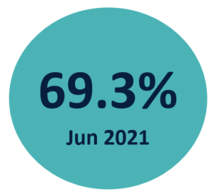 | Following strong growth in recent years, the proportion of Australians accessing SVOD services has steadied since the start of the COVID-19 pandemic.

  Awareness of broadcast video on demand  increased over the COVID-19 period from 67% in 2019 to 82% in 2021. |   SVOD content is most likely to be produced in the USA, followed by the UK, India, Australia, Canada and France. |   SVOD services are adding newer titles to their catalogues.  Between June 2020 and June 2021, there was a net increase of 1,431 titles under 2 years old. |   81% of survey respondents watched free-to-air TV  within the  last seven days.
The summary findings above are intended to accompany the SVOD dashboard updated in March 2022 by the Bureau of Communications, Arts and Regional Research (BCARR), within the Department of Infrastructure, Transport, Regional Development and Communications.
Sources: Roy Morgan Single Source; Ampere Analysis SVOD and Commissioning services

