
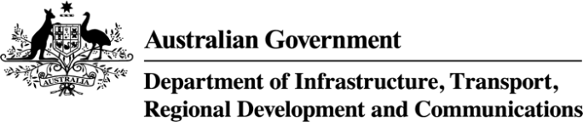


Australia’s Broadband Performance
Update 2021

 |   2nd  Australia ranks |   100+ Mbps
Australia is one of only five comparable countries where at least 99.9% of households can access fixed broadband services. | 98.5% of Australian premises have access to broadband speeds of at least 25 Mbps, ranking Australia 2nd out of 15 comparable countries. | Almost 75% of Australian premises can access 100 Mbps and above services.

The proportion of households with a fixed broadband connection increased to 90.2%  (up from 88% as reported in the 2020 update)  ranking Australia 8th out of 17 comparable countries. | 
Broadband refers to broadband services at a fixed location, and includes satellite, fixed wireless and fixed-line broadband services.
The summary findings above are intended to accompany the Australia’s Broadband Performance Dashboard – Update 2021
released in March 2022 by the Bureau of Communications, Arts and Regional Research,
within the Department of Infrastructure, Transport, Regional Development and Communications.
 |  | 
Australia performs strongly against international peers for data consumption, with average yearly growth of more than 34% between 2017 and 2019. | Between 2019 and 2021, Australia’s total data consumption has  nearly doubled to  111.7 gigabytes  per month per capita. | Around 75% of NBN subscriptions are for speeds 50 Mbps and above.

