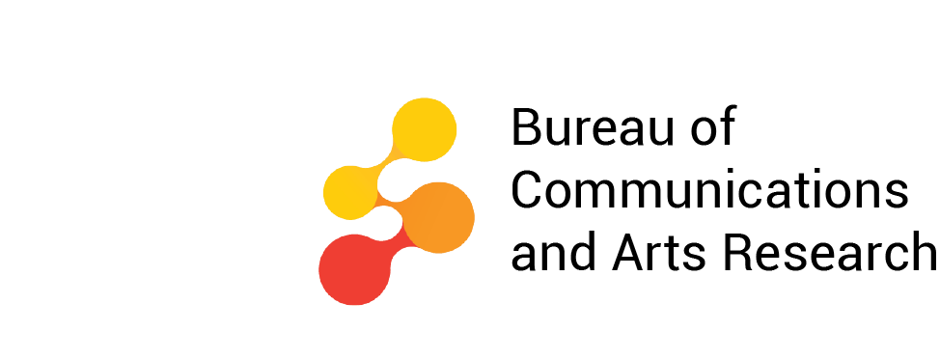

Cultural and creative activity in Australia, 2008–09 to 2017–18—visual summary
October 2020

Ownership of intellectual property rights in this publication
Unless otherwise noted, copyright (and any other intellectual property rights, if any) in this publication is owned by the Commonwealth of Australia (referred to below as the Commonwealth).

Disclaimer
The material contained in this publication is made available on the understanding that the Commonwealth is not providing professional advice, and that users exercise their own skill and care with respect to its use, and seek independent advice if necessary.
The Commonwealth makes no representations or warranties as to the contents or accuracy of the information contained in this publication. To the extent permitted by law, the Commonwealth disclaims liability to any person or organisation in respect of anything done, or omitted to be done, in reliance upon information contained in this publication.

Creative Commons licence
With the exception of (a) the Coat of Arms; (b) the Department of Infrastructure, Transport, Regional Development and Communications photos and graphics; and (c) [OTHER], copyright in this publication is licensed under a Creative Commons Attribution 4.0 Australia Licence.
Creative Commons Attribution 4.0 Australia Licence is a standard form licence agreement that allows you to copy, communicate and adapt this publication provided that you attribute the work to the Commonwealth and abide by the other licence terms.
Further information on the licence terms is available from https://creativecommons.org/licenses/by/4.0/.
This publication should be attributed in the following way: © Commonwealth of Australia 2020.

Use of the Coat of Arms
The Department of the Prime Minister and Cabinet sets the terms under which the Coat of Arms is used. Please refer to the Commonwealth Coat of Arms — Information and Guidelines publication available at www.pmc.gov.au.

Contact us
This publication is available in hard copy or PDF format. All other rights are reserved, including in relation to any Departmental logos or trademarks which may exist. For enquiries regarding the licence and any use of this publication, please contact:
Director—Publishing and Communications
Communication Branch
Department of Infrastructure, Transport, Regional Development and Communications
GPO Box 594
Canberra ACT 2601
Australia
Email: publishing@communications.gov.au
Websites: www.infrastructure.gov.au | www.communications.gov.au | www.arts.gov.au.

Contents
About this document 1
Table 1. Cultural and creative activity 2008–09 and 2017–18 2
Figure 1. Cultural and creative activity, 2017–18 3
Figure 2. Cultural and creative industries, Gross Value Added (GVA) by domain 2017–18 4
Figure 3. Cultural and creative activity, 2008–09 to 2017–18 5
Table 2. Cultural and creative activity, share of GDP, 2008–09 to 2017–18 6
Figure 4. Cultural and creative activity relative to nominal GDP 7
Figure 5. Cultural and creative activity, share of GDP, 2008–09 to 2017–18 8
Table 3. Cultural and creative activity, GVA by industry division, 2008–09 to 2017–18 9
Figure 6. GVA change by division, cultural and creative industries, 2008–09 to 2017–18 10
Figure 7. GVA change of cultural and creative industries in manufacturing, 2008–09 to 2017–18 11
Figure 8. Industry division’s GVA relative to GDP 12
Table 4. Cultural activity, share of GDP, 2008–09 to 2017–18 13
Figure 9. GVA by domain, cultural industries, 2017–18 ($m) 14
Figure 10. Cultural activity, share of GDP, 2008–09 to 2017–18 15
Table 5. Creative activity, share of GDP, 2008–09 to 2017–18 16
Figure 11. GVA by domain, creative industries, 2017–18 ($m) 17
Figure 12. Creative activity, share of GDP, 2008–09 to 2017–18 18
Figure 13. Contribution of cultural and creative activity, GVA (by domain), net taxes on products and COE in other industries, 2008–09 and 2017–18 19
Figure 14. Nominal GVA growth by domain, cultural and creative industries, 2008–09 to 2017–18 20
Figure 15. Domain’s GVA relative to GDP 21
Table 6. Cultural and creative activity in museums, 2008–09 to 2017–18 22
Figure 16. GVA, cultural and creative activity in museums, 2008–09 to 2017–18 23
Table 7. Cultural and creative activity in environmental heritage, 2008–09 to 2017–18 24
Figure 17. GVA, cultural and creative activity in environmental heritage, 2008–09 to 2017–18 25
Table 8. Cultural and creative activity in libraries and archives, 2008–09 to 2017–18 26
Figure 18. GVA, cultural and creative activity in libraries and archives, 2008–09 to 2017–18 27
Table 9. Cultural and creative activity in literature and print media, 2008–09 to 2017–18 28
Figure 19. GVA, cultural and creative activity in literature and print media, 2008–09 to 2017–18 29
Table 10. Cultural activity in literature and print media, 2008–09 to 2017–18 30
Table 11. Creative activity in literature and print media, 2008–09 to 2017–18 30
Table 12. Cultural and creative activity in performing arts, 2008–09 to 2017–18 31
Figure 20. GVA, cultural and creative activity in performing arts, 2008–09 to 2017–18 32
Table 13. Cultural and creative activity in design, 2008–09 to 2017–18 33
Figure 21. GVA, cultural and creative activity in design, 2008–09 to 2017–18 34
Table 14. Cultural activity in design, 2008–09 to 2017–18 35
Table 15. Cultural and creative activity in broadcasting, electronic or digital media, and film, 2008–09 to 2017–18 35
Figure 22. GVA, cultural and creative activity in broadcasting, electronic or digital media, and film, 2008–09 to 2017–18 36
Table 16. Creative activity in broadcasting, electronic or digital media, and film, 2008–09 to 2017–18 37
Table 17. Cultural and creative activity in music composition and publishing, 2008–09 to 2017–18 37
Figure 23. GVA, cultural and creative activity in music composition and publishing, 2008–09 to 2017–18 38
Table 18. Cultural and creative activity in visual arts and crafts, 2008–09 to 2017–18 39
Figure 24. GVA, cultural and creative activity in visual arts and crafts, 2008–09 to 2017–18 40
Table 19. Cultural and creative activity in fashion, 2008–09 to 2017–18 41
Figure 25. GVA, cultural and creative activity in fashion, 2008–09 to 2017–18 42
Table 20. Cultural and creative activity in other culture and goods manufacturing and sales, 2008–09 to 2017–18 43
Figure 26. GVA, cultural and creative activity in other culture and goods manufacturing and sales, 2008–09 to 2017–18 44
Table 21. Cultural and creative activity in supporting activities, 2008–09 to 2017–18 45
Figure 27. GVA, cultural and creative activity in supporting activities, 2008–09 to 2017–18 46

About this document
The Bureau of Communications and Arts Research (BCAR) within the Department of Infrastructure, Transport, Regional Development and Communications has estimated the economic contribution of cultural and creative activity in Australia over a 10-year period, from 2008–09 to 2017–18.
This publication provides an annual update to the BCAR working paper: Cultural and creative activity in Australia, 2008–09 to 2016–17 released in October 2018. The updated estimates are presented as a visual summary. Each table and figure corresponds to those used in the BCAR working paper.
This publication follows the same approach taken in the BCAR working paper.
Note that data is subject to revisions by the Australian Bureau of Statistics (ABS) national accounts (cat. no. 5204.0) and estimates vary from those published in the working paper.
Further information on these updates can be found in the Explanatory notes: Cultural and creative activity in Australia, 2008–09 to 2017–18.

Table 1. Cultural and creative activity 2008–09 and 2017–18
Gross Domestic Product—National Accounts Basis ($m) (a) | 2008–09 | 2017–18
Cultural activity | 51,395 | 65,283
As a proportion of GDP (%) | 4.1 | 3.6
Creative activity | 75,210 | 102,653
As a proportion of GDP (%) | 6.0 | 5.6
Total for cultural and creative activity (b) | 85,956 | 115,185
As a proportion of GDP (%) | 6.9 | 6.3

- (b) Activity considered both cultural and creative activity is counted only once in the total.
Source: ABS cat. 5204, 5209; BCAR calculations
Corresponding reference: Cultural and creative activity in Australia, 2008–09 to 2016–17, Table 1.

Figure 1. Cultural and creative activity, 2017–18
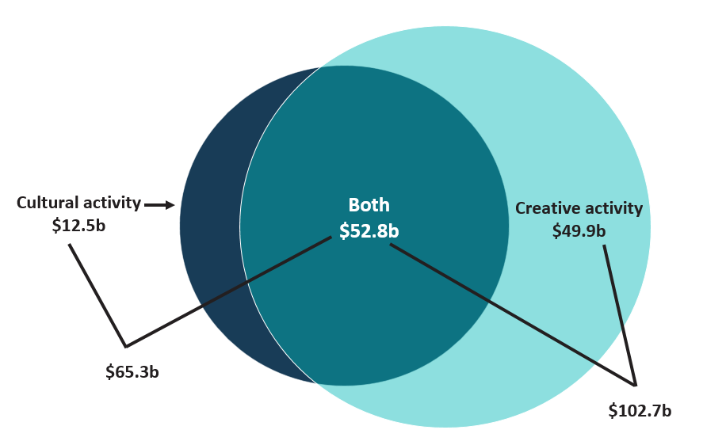
Source: ABS cat. 5204, 5209; BCAR calculations
Corresponding reference: Cultural and creative activity in Australia, 2008–09 to 2016–17, Figure 1.

Figure 2. Cultural and creative industries, Gross Value Added (GVA) by domain 2017–18
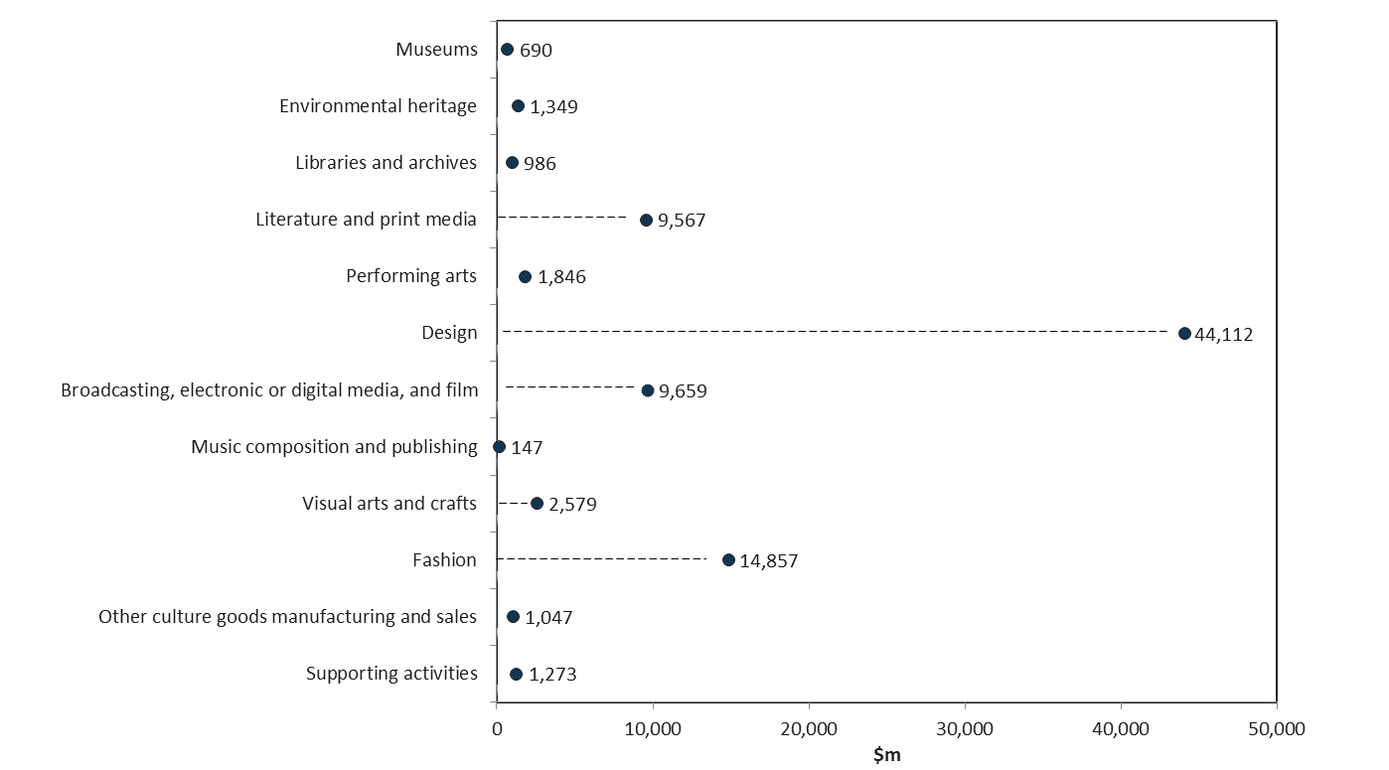
Source: ABS cat. 5204, 5209; BCAR calculations
Corresponding reference: Cultural and creative activity in Australia, 2008–09 to 2016–17, Figure 2.

Figure 3. Cultural and creative activity, 2008–09 to 2017–18
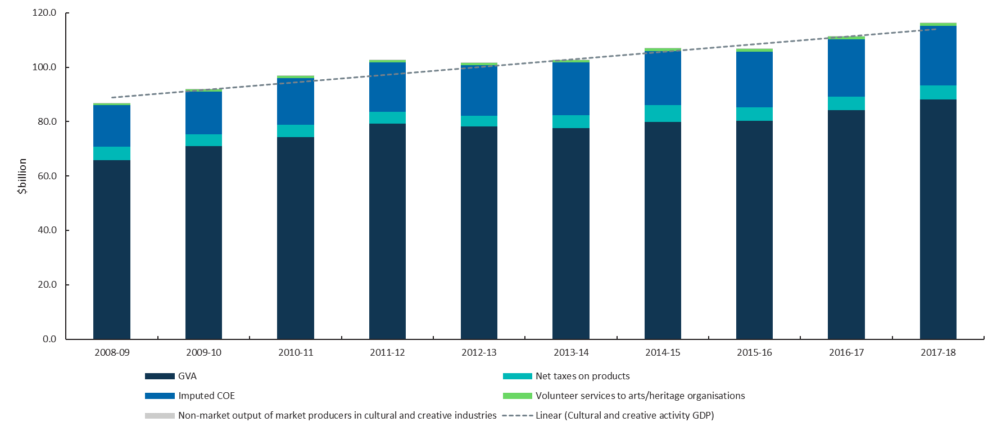
Source: ABS cat. 5204, 5209; BCAR calculations
Corresponding reference: Cultural and creative activity in Australia, 2008–09 to 2016–17, Figure 3.

Table 2. Cultural and creative activity, share of GDP, 2008–09 to 2017–18
Cultural and creative activity (C&C)  share of Gross Domestic Product | 2008–09  $m | 2009–10  $m | 2010–11  $m | 2011–12  $m | 2012–13  $m | 2013–14  $m | 2014–15  $m | 2015–16  $m | 2016–17  $m | 2017–18  $m
C&C activity GDP–national accounts basis | 85,956 | 90,963 | 95,908 | 101,779 | 100,744 | 101,694 | 105,947 | 105,770 | 110,279 | 115,185
Gross value added of C&C industries | 65,772 | 70,887 | 74,384 | 79,162 | 78,151 | 77,516 | 79,927 | 80,295 | 84,236 | 88,111
Net taxes on products of C&C industries | 4,967 | 4,408 | 4,496 | 4,486 | 3,925 | 4,889 | 6,194 | 4,887 | 4,977 | 5,215
COE for C&C occupations in other industries | 15,217 | 15,668 | 17,028 | 18,132 | 18,668 | 19,289 | 19,826 | 20,588 | 21,066 | 21,859
C&C activity GDP–satellite account basis | 86,780 | 91,837 | 96,828 | 102,756 | 101,711 | 102,669 | 106,961 | 106,783 | 111,336 | 116,289
C&C activity GDP–national accounts basis | 85,956 | 90,963 | 95,908 | 101,779 | 100,744 | 101,694 | 105,947 | 105,770 | 110,279 | 115,185
Volunteer services to arts/heritage organisations | 756 | 800 | 844 | 895 | 886 | 894 | 932 | 930 | 970 | 1,013
Non-market output of market producers in C&C industries | 68 | 73 | 77 | 82 | 81 | 80 | 83 | 83 | 87 | 91
C&C activity GDP national accounts basis share of GDP (%) | 6.9 | 7.0 | 6.8 | 6.8 | 6.6 | 6.4 | 6.6 | 6.4 | 6.3 | 6.3
Source: ABS cat. 5204, 5209; BCAR calculations
Corresponding reference: Cultural and creative activity in Australia, 2008–09 to 2016–17, Table 2.

Figure 4. Cultural and creative activity relative to nominal GDP
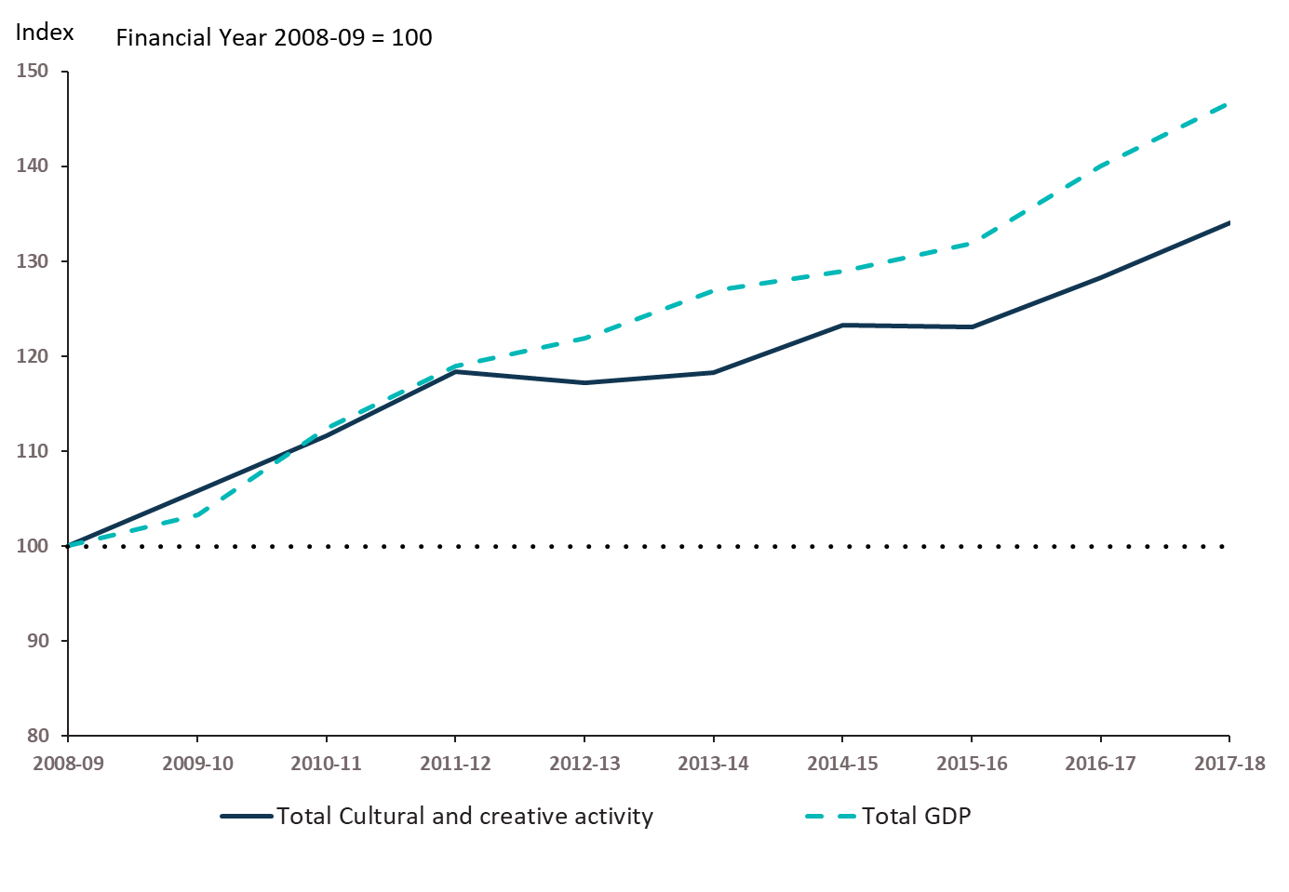
Source: ABS cat. 5204, 5209; BCAR calculations
Corresponding reference: Cultural and creative activity in Australia, 2008–09 to 2016–17, Figure 4.

Figure 5. Cultural and creative activity, share of GDP, 2008–09 to 2017–18
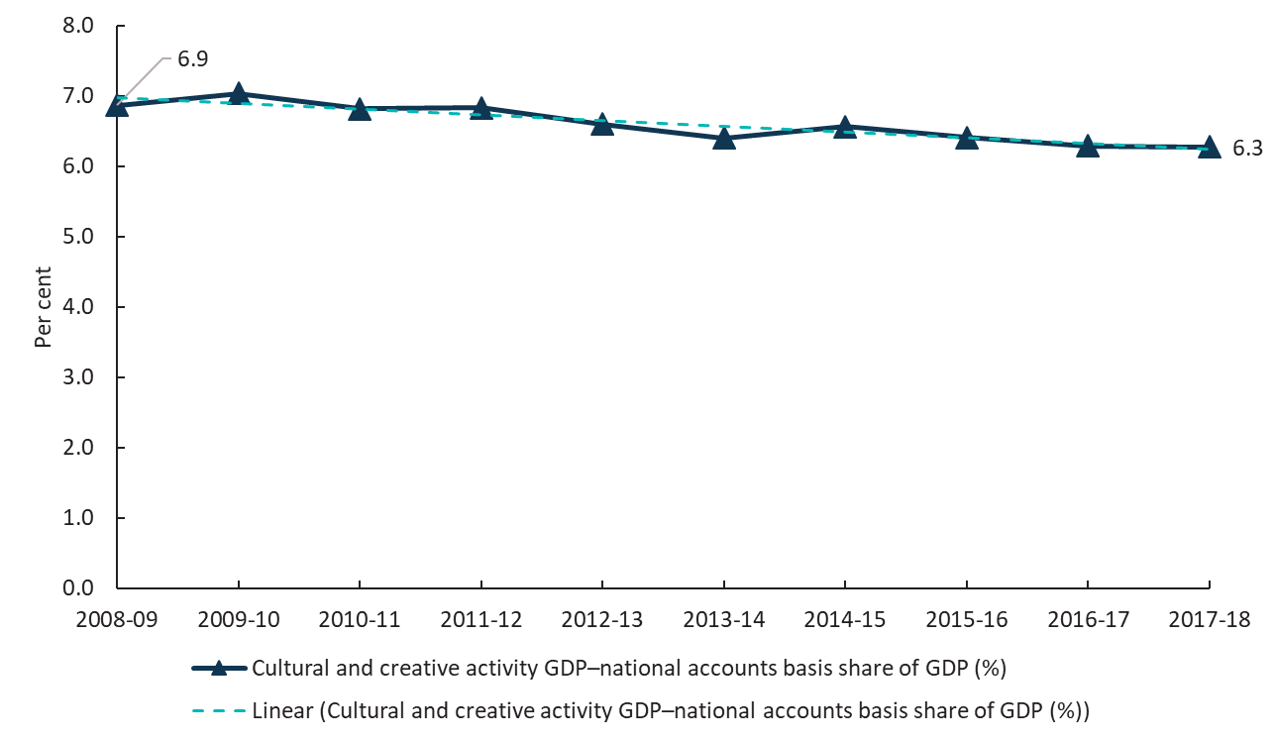
Source: ABS cat. 5204, 5209; BCAR calculations
Corresponding reference: Cultural and creative activity in Australia, 2008–09 to 2016–17, Figure 5.

Table 3. Cultural and creative activity, GVA by industry division, 2008–09 to 2017–18
Division Name | 2008–09  $m | 2009–10  $m | 2010–11  $m | 2011–12  $m | 2012–13  $m | 2013–14  $m | 2014–15  $m | 2015–16  $m | 2016–17  $m | 2017–18  $m
Manufacturing | 6,246 | 5,845 | 5,855 | 5,926 | 4,600 | 4,201 | 4,263 | 3,945 | 3,979 | 4,162
Wholesale Trade | 3,535 | 3,701 | 3,917 | 4,129 | 4,271 | 4,245 | 4,261 | 4,405 | 4,597 | 4,708
Retail Trade | 9,701 | 10,053 | 10,702 | 11,515 | 11,774 | 11,813 | 12,017 | 12,417 | 12,812 | 13,482
Information Media and Telecommunications | 15,507 | 16,209 | 16,185 | 16,423 | 15,714 | 15,185 | 15,434 | 15,739 | 15,726 | 15,653
Rental, Hiring and Real Estate Services | 121 | 141 | 149 | 172 | 158 | 141 | 145 | 141 | 149 | 153
Professional, Scientific and Technical Services | 27,051 | 30,940 | 33,380 | 36,548 | 36,938 | 37,023 | 38,692 | 38,786 | 42,002 | 44,795
Education and Training | 779 | 852 | 932 | 982 | 1,030 | 1,081 | 1,124 | 1,171 | 1,210 | 1,273
Arts and Recreation Services | 2,832 | 3,146 | 3,265 | 3,466 | 3,665 | 3,828 | 3,990 | 3,690 | 3,761 | 3,884
Total | 65,772 | 70,887 | 74,384 | 79,162 | 78,151 | 77,516 | 79,927 | 80,295 | 84,236 | 88,111
Source: ABS cat. 5204, 5209; BCAR calculations
Corresponding reference: Cultural and creative activity in Australia, 2008–09 to 2016–17, Table 3.

Figure 6. GVA change by division, cultural and creative industries, 2008–09 to 2017–18
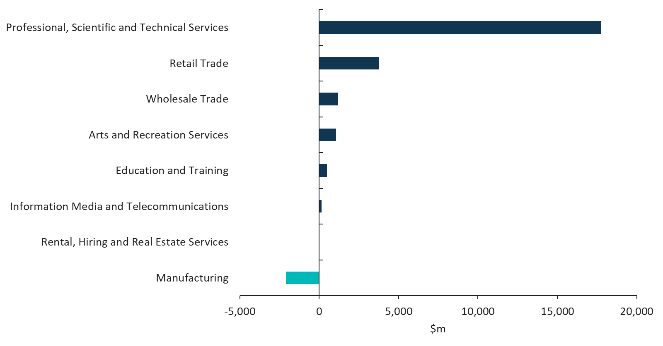
Source: ABS cat. 5204, 5209; BCAR calculations
Corresponding reference: Cultural and creative activity in Australia, 2008–09 to 2016–17, Figure 6.

Figure 7. GVA change of cultural and creative industries in manufacturing, 2008–09 to 2017–18
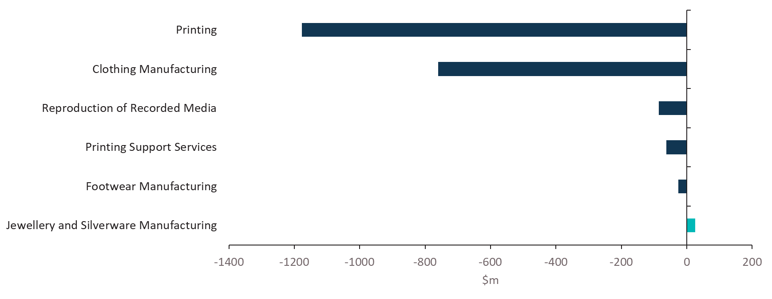
Source: ABS cat. 5204, 5209; BCAR calculations
Corresponding reference: Cultural and creative activity in Australia, 2008–09 to 2016–17, Figure 7.

Figure 8. Industry division’s GVA relative to GDP
Source: ABS cat. 5204, 5209; BCAR calculations
Corresponding reference: Cultural and creative activity in Australia, 2008–09 to 2016–17, Figure 8.

Table 4. Cultural activity, share of GDP, 2008–09 to 2017–18
Cultural activity share of Gross Domestic Product | 2008–09  $m | 2009–10  $m | 2010–11  $m | 2011–12  $m | 2012–13  $m | 2013–14  $m | 2014–15  $m | 2015–16  $m | 2016–17  $m | 2017–18  $m
Cultural activity GDP–national accounts basis | 51,395 | 53,735 | 56,030 | 58,656 | 58,806 | 59,630 | 61,299 | 61,285 | 63,073 | 65,283
Gross value added of cultural industries | 35,223 | 36,921 | 38,055 | 39,821 | 39,993 | 39,308 | 40,060 | 40,145 | 41,452 | 42,793
Net taxes on products of cultural industries | 4,531 | 4,477 | 4,567 | 4,557 | 4,098 | 5,123 | 5,630 | 4,925 | 5,015 | 5,254
COE for cultural occupations in other industries | 11,641 | 12,338 | 13,408 | 14,278 | 14,715 | 15,200 | 15,610 | 16,215 | 16,606 | 17,237
Cultural activity GDP–satellite account basis | 52,206 | 54,593 | 56,930 | 59,608 | 59,748 | 60,579 | 62,287 | 62,271 | 64,099 | 66,353
Cultural activity GDP–national accounts basis | 51,395 | 53,735 | 56,030 | 58,656 | 58,806 | 59,630 | 61,299 | 61,285 | 63,073 | 65,283
Volunteer services to arts/heritage organisations | 756 | 800 | 844 | 895 | 886 | 894 | 932 | 930 | 970 | 1,013
Non-market output of market producers in cultural industries | 55 | 58 | 57 | 58 | 55 | 54 | 56 | 55 | 57 | 57
Cultural activity GDP national accounts basis share of GDP (%) | 4.1 | 4.2 | 4.0 | 3.9 | 3.9 | 3.8 | 3.8 | 3.7 | 3.6 | 3.6
Source: ABS cat. 5204, 5209; BCAR calculations
Corresponding reference: Cultural and creative activity in Australia, 2008–09 to 2016–17, Table 4.

Figure 9. GVA by domain, cultural industries, 2017–18 ($m)
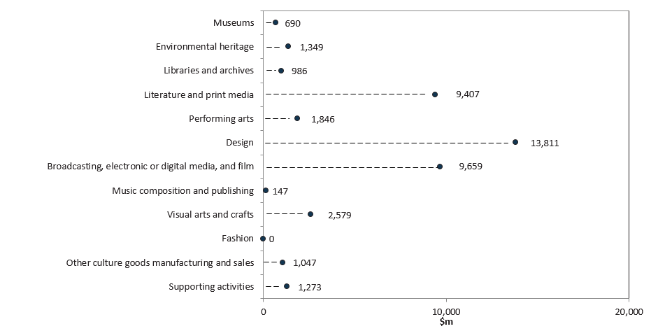
Source: ABS cat. 5204, 5209; BCAR calculations
Corresponding reference: Cultural and creative activity in Australia, 2008–09 to 2016–17, Figure 9.

Figure 10. Cultural activity, share of GDP, 2008–09 to 2017–18
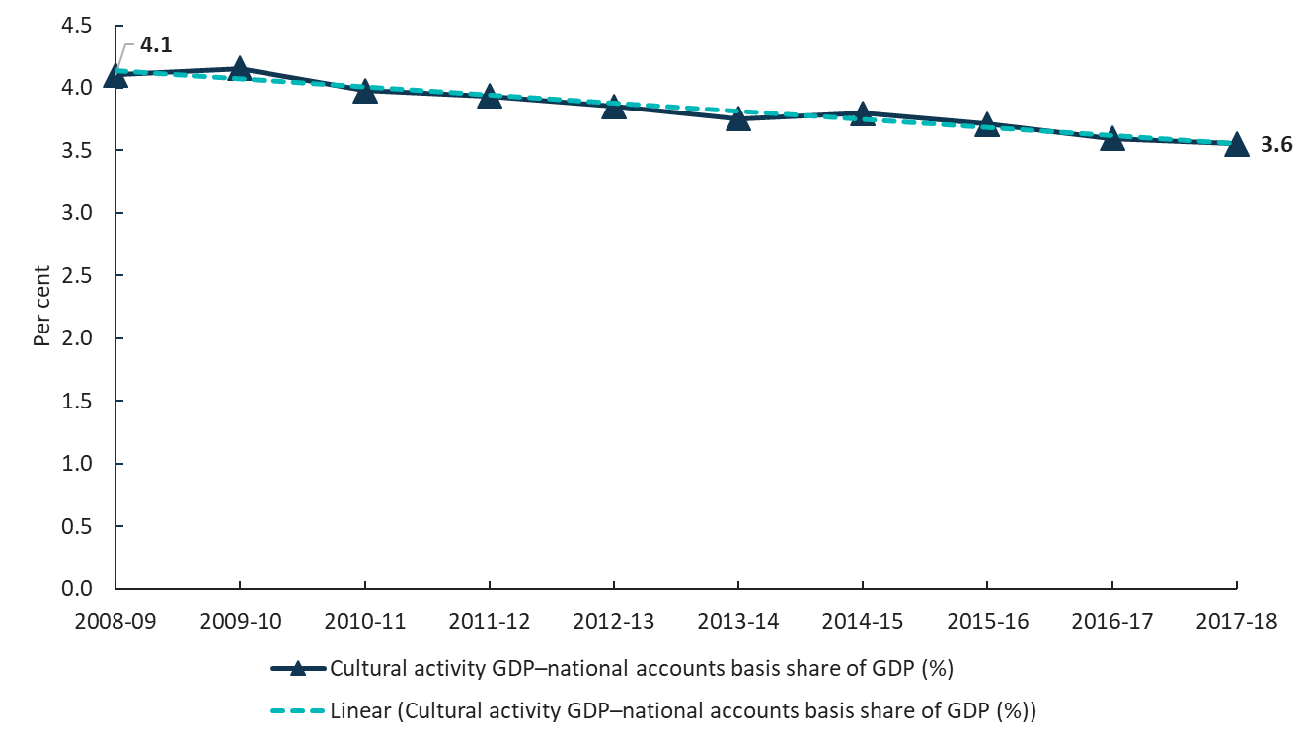
Source: ABS cat. 5204, 5209; BCAR calculations
Corresponding reference: see Cultural and creative activity in Australia, 2008–09 to 2016–17, Figure 10.

Table 5. Creative activity, share of GDP, 2008–09 to 2017–18
Creative activity share of Gross Domestic Product | 2008–09  $m | 2009–10  $m | 2010–11  $m | 2011–12  $m | 2012–13  $m | 2013–14  $m | 2014–15  $m | 2015–16  $m | 2016–17  $m | 2017–18  $m
Creative activity GDP–national accounts basis | 75,210 | 80,175 | 84,618 | 89,969 | 89,060 | 89,939 | 94,035 | 94,026 | 98,266 | 102,653
Gross value added of creative industries | 57,871 | 63,067 | 66,306 | 70,750 | 69,995 | 69,534 | 71,794 | 72,587 | 76,351 | 79,878
Net taxes on products of creative industries | 4,499 | 4,060 | 4,141 | 4,132 | 3,560 | 4,393 | 5,785 | 4,359 | 4,439 | 4,650
COE for creative occupations in other industries | 12,840 | 13,048 | 14,171 | 15,088 | 15,505 | 16,012 | 16,456 | 17,080 | 17,477 | 18,125
Creative activity GDP–satellite account basis | 76,021 | 81,035 | 85,520 | 90,923 | 90,001 | 90,888 | 95,023 | 95,012 | 99,294 | 103,724
Creative activity GDP–national accounts basis | 75,210 | 80,175 | 84,618 | 89,969 | 89,060 | 89,939 | 94,035 | 94,026 | 98,266 | 102,653
Volunteer services to arts/heritage organisations | 756 | 800 | 844 | 895 | 886 | 894 | 932 | 930 | 970 | 1,013
Non-market output of market producers in Creative industries | 55 | 60 | 58 | 59 | 54 | 55 | 57 | 56 | 58 | 58
Creative activity GDP national accounts basis share of GDP (%) | 6.0 | 6.2 | 6.0 | 6.0 | 5.8 | 5.7 | 5.8 | 5.7 | 5.6 | 5.6
Source: ABS cat. 5204, 5209; BCAR calculations
Corresponding reference: Cultural and creative activity in Australia, 2008–09 to 2016–17, Table 5.

Figure 11. GVA by domain, creative industries, 2017–18 ($m)
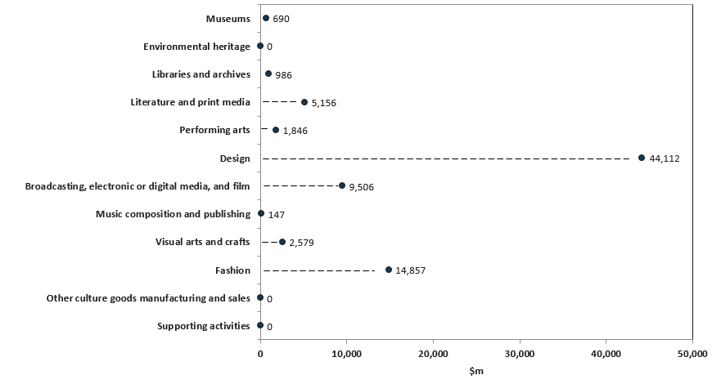
Source: ABS cat. 5204, 5209; BCAR calculations
Corresponding reference: Cultural and creative activity in Australia, 2008–09 to 2016–17, Figure 11.

Figure 12. Creative activity, share of GDP, 2008–09 to 2017–18
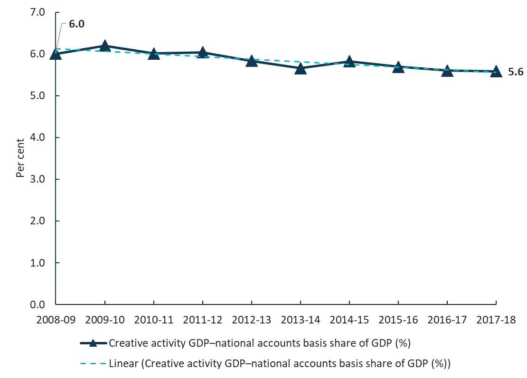
Source: ABS cat. 5204, 5209; BCAR calculations
Corresponding reference: Cultural and creative activity in Australia, 2008–09 to 2016–17, Figure 12.

Figure 13. Contribution of cultural and creative activity, GVA (by domain), net taxes on products and COE in other industries, 2008–09 and 2017–18
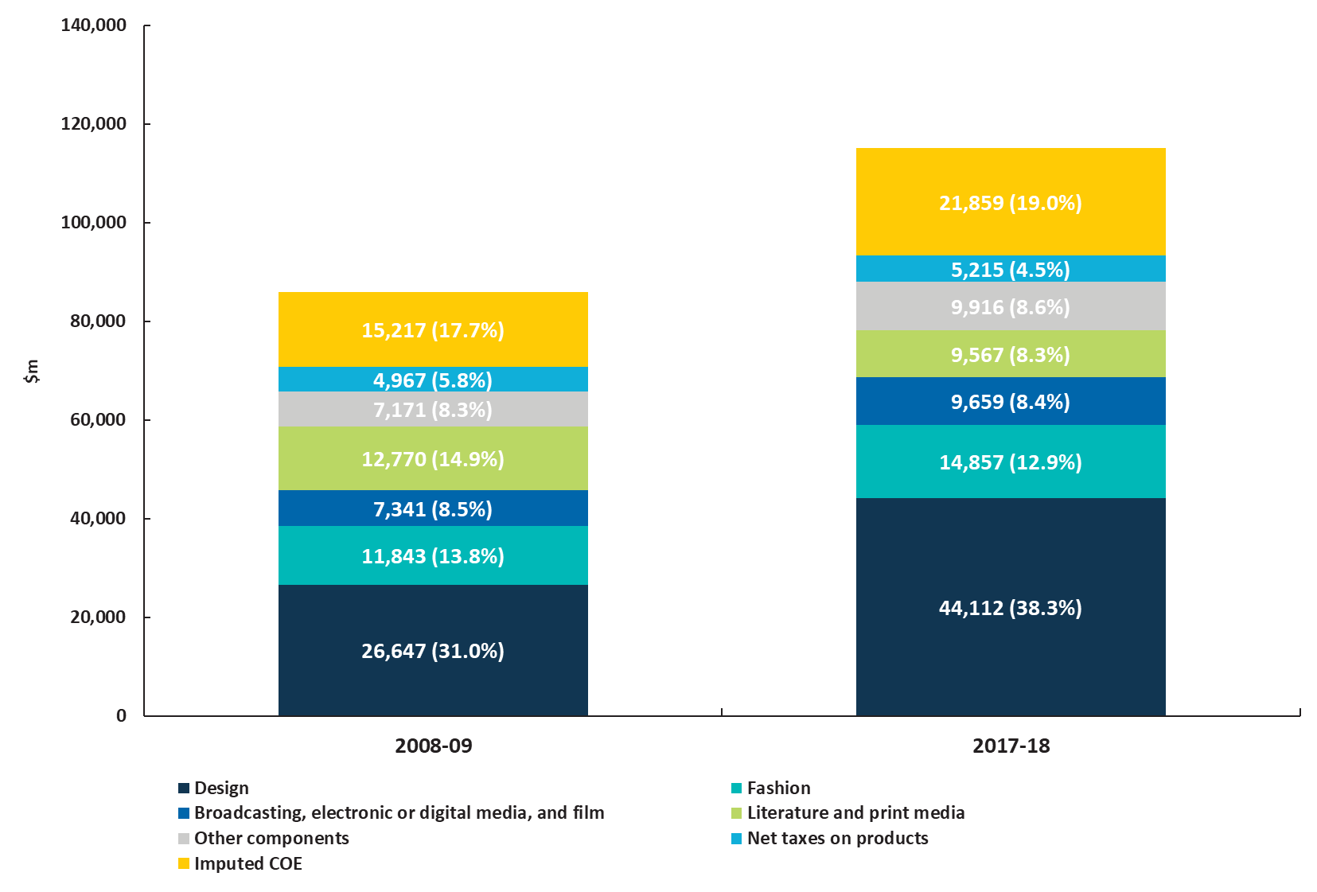
Source: ABS cat. 5204, 5209; BCAR calculations
Corresponding reference: Cultural and creative activity in Australia, 2008–09 to 2016–17, Figure 13.

Figure 14. Nominal GVA growth by domain, cultural and creative industries, 2008–09 to 2017–18
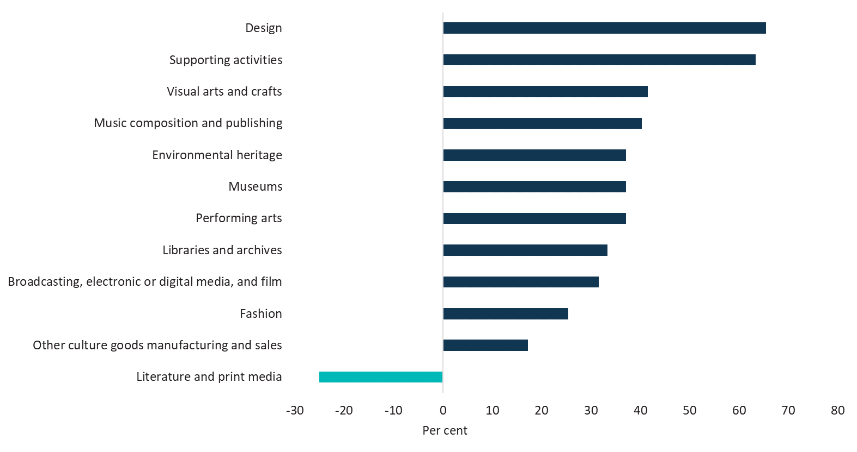
Source: ABS cat. 5204, 5209; BCAR calculations
Corresponding reference: see Cultural and creative activity in Australia, 2008–09 to 2016–17, Figure 14.

Figure 15. Domain’s GVA relative to GDP
Source: ABS cat. 5204, 5209; BCAR calculations
Corresponding reference: Cultural and creative activity in Australia, 2008–09 to 2016–17, Figure 15.

Table 6. Cultural and creative activity in museums, 2008–09 to 2017–18
Museums | 2008–09  $m | 2009–10  $m | 2010–11  $m | 2011–12  $m | 2012–13  $m | 2013–14  $m | 2014–15  $m | 2015–16  $m | 2016–17  $m | 2017–18  $m
Output | 1,145 | 1,317 | 1,434 | 1,518 | 1,271 | 1,341 | 1,354 | 1,412 | 1,499 | 1,571
COE | 337 | 362 | 395 | 422 | 347 | 355 | 341 | 361 | 369 | 386
GOS and GMI | 188 | 218 | 208 | 218 | 339 | 363 | 396 | 336 | 343 | 350
Taxes less subsidies on production | -23 | -21 | -23 | -25 | -36 | -38 | -29 | -42 | -44 | -47
GVA | 503 | 558 | 580 | 615 | 651 | 680 | 708 | 655 | 668 | 690
As a per cent of GDP | 0.04 | 0.04 | 0.04 | 0.04 | 0.04 | 0.04 | 0.04 | 0.04 | 0.04 | 0.04
Source: ABS cat. 5204, 5209; BCAR calculations
Corresponding reference: Cultural and creative activity in Australia, 2008–09 to 2016–17, Table 6.

Figure 16. GVA, cultural and creative activity in museums, 2008–09 to 2017–18
Source: ABS cat. 5204, 5209; BCAR calculations
Corresponding reference: Cultural and creative activity in Australia, 2008–09 to 2016–17, Figure 16.

Table 7. Cultural and creative activity in environmental heritage, 2008–09 to 2017–18
Environmental heritage | 2008–09  $m | 2009–10  $m | 2010–11  $m | 2011–12  $m | 2012–13  $m | 2013–14  $m | 2014–15  $m | 2015–16  $m | 2016–17  $m | 2017–18  $m
Output | 2,194 | 2,524 | 2,747 | 2,908 | 2,436 | 2,569 | 2,594 | 2,706 | 2,872 | 3,009
COE | 421 | 452 | 493 | 526 | 433 | 442 | 426 | 450 | 461 | 482
GOS and GMI | 604 | 680 | 684 | 723 | 905 | 957 | 1,013 | 909 | 927 | 953
Taxes less subsidies on production | -42 | -39 | -43 | -45 | -65 | -70 | -53 | -77 | -82 | -86
GVA | 983 | 1,092 | 1,134 | 1,204 | 1,273 | 1,329 | 1,386 | 1,282 | 1,306 | 1,349
As a per cent of GDP | 0.08 | 0.08 | 0.08 | 0.08 | 0.08 | 0.08 | 0.09 | 0.08 | 0.07 | 0.07
Source: ABS cat. 5204, 5209; BCAR calculations
Corresponding reference: Cultural and creative activity in Australia, 2008–09 to 2016–17, Table 7.

Figure 17. GVA, cultural and creative activity in environmental heritage, 2008–09 to 2017–18
Source: ABS cat. 5204, 5209; BCAR calculations
Corresponding reference: Cultural and creative activity in Australia, 2008–09 to 2016–17, Figure 17.

Table 8. Cultural and creative activity in libraries and archives, 2008–09 to 2017–18
Libraries and archives | 2008–09  $m | 2009–10  $m | 2010–11  $m | 2011–12  $m | 2012–13  $m | 2013–14  $m | 2014–15  $m | 2015–16  $m | 2016–17  $m | 2017–18  $m
Output | 1,303 | 1,308 | 1,424 | 1,507 | 1,428 | 1,447 | 1,450 | 1,522 | 1,615 | 1,692
COE | 442 | 425 | 464 | 496 | 494 | 504 | 457 | 483 | 495 | 518
GOS and GMI | 283 | 410 | 370 | 350 | 515 | 533 | 512 | 495 | 482 | 454
Taxes less subsidies on production | 14 | 12 | 13 | 14 | 11 | 11 | 13 | 13 | 14 | 14
GVA | 739 | 848 | 846 | 859 | 1,020 | 1,049 | 982 | 991 | 990 | 986
As a per cent of GDP | 0.06 | 0.07 | 0.06 | 0.06 | 0.07 | 0.07 | 0.06 | 0.06 | 0.06 | 0.05
Source: ABS cat. 5204, 5209; BCAR calculations
Corresponding reference: Cultural and creative activity in Australia, 2008–09 to 2016–17, Table 8.

Figure 18. GVA, cultural and creative activity in libraries and archives, 2008–09 to 2017–18
Source: ABS cat. 5204, 5209; BCAR calculations
Corresponding reference: Cultural and creative activity in Australia, 2008–09 to 2016–17, Figure 18.

Table 9. Cultural and creative activity in literature and print media, 2008–09 to 2017–18
Literature and print media | 2008–09  $m | 2009–10  $m | 2010–11  $m | 2011–12  $m | 2012–13  $m | 2013–14  $m | 2014–15  $m | 2015–16  $m | 2016–17  $m | 2017–18  $m
Output | 22,971 | 23,131 | 25,182 | 26,653 | 20,331 | 19,980 | 17,778 | 18,072 | 19,182 | 20,098
COE | 6,361 | 6,008 | 6,552 | 7,001 | 6,007 | 5,836 | 5,884 | 5,758 | 5,899 | 6,165
GOS and GMI | 6,158 | 5,911 | 5,424 | 5,205 | 4,544 | 3,853 | 3,736 | 3,329 | 3,250 | 3,142
Taxes less subsidies on production | 250 | 231 | 251 | 266 | 225 | 238 | 264 | 234 | 248 | 260
GVA | 12,770 | 12,151 | 12,228 | 12,472 | 10,776 | 9,927 | 9,884 | 9,321 | 9,397 | 9,567
As a per cent of GDP | 1.02 | 0.94 | 0.87 | 0.84 | 0.71 | 0.62 | 0.61 | 0.56 | 0.54 | 0.52
Source: ABS cat. 5204, 5209; BCAR calculations
Corresponding reference: Cultural and creative activity in Australia, 2008–09 to 2016–17, Table 9.

Figure 19. GVA, cultural and creative activity in literature and print media, 2008–09 to 2017–18
Source: ABS cat. 5204, 5209; BCAR calculations
Corresponding reference: Cultural and creative activity in Australia, 2008–09 to 2016–17, Figure 19.

Table 10. Cultural activity in literature and print media, 2008–09 to 2017–18
Literature and print media | 2008–09  $m | 2009–10  $m | 2010–11  $m | 2011–12  $m | 2012–13  $m | 2013–14  $m | 2014–15  $m | 2015–16  $m | 2016–17  $m | 2017–18  $m
Output | 22,547 | 22,724 | 24,738 | 26,184 | 19,963 | 19,600 | 17,493 | 17,766 | 18,857 | 19,758
COE | 6,206 | 5,860 | 6,391 | 6,828 | 5,872 | 5,703 | 5,748 | 5,629 | 5,767 | 6,028
GOS and GMI | 6,087 | 5,852 | 5,378 | 5,168 | 4,493 | 3,816 | 3,702 | 3,309 | 3,233 | 3,124
Taxes less subsidies on production | 246 | 227 | 247 | 261 | 221 | 234 | 259 | 230 | 244 | 256
GVA | 12,539 | 11,938 | 12,016 | 12,257 | 10,586 | 9,752 | 9,709 | 9,168 | 9,244 | 9,407
As a per cent of GDP | 1.00 | 0.92 | 0.85 | 0.82 | 0.69 | 0.61 | 0.60 | 0.55 | 0.53 | 0.51
Source: ABS cat. 5204, 5209; BCAR calculations
Corresponding reference: Cultural and creative activity in Australia, 2008–09 to 2016–17, Table 10.

Table 11. Creative activity in literature and print media, 2008–09 to 2017–18
Literature and print media | 2008–09  $m | 2009–10  $m | 2010–11  $m | 2011–12  $m | 2012–13  $m | 2013–14  $m | 2014–15  $m | 2015–16  $m | 2016–17  $m | 2017–18  $m
Output | 12,202 | 12,569 | 13,683 | 14,482 | 9,774 | 9,103 | 8,877 | 8,510 | 9,032 | 9,464
COE | 2,930 | 2,644 | 2,883 | 3,080 | 2,693 | 2,538 | 2,505 | 2,433 | 2,492 | 2,605
GOS and GMI | 4,601 | 4,567 | 4,309 | 4,212 | 3,269 | 2,817 | 2,764 | 2,653 | 2,585 | 2,450
Taxes less subsidies on production | 115 | 97 | 106 | 112 | 95 | 101 | 111 | 91 | 96 | 101
GVA | 7,646 | 7,308 | 7,298 | 7,405 | 6,057 | 5,455 | 5,381 | 5,176 | 5,173 | 5,156
As a per cent of GDP | 0.61 | 0.57 | 0.52 | 0.50 | 0.40 | 0.34 | 0.33 | 0.31 | 0.30 | 0.28
Source: ABS cat. 5204, 5209; BCAR calculations
Corresponding reference: Cultural and creative activity in Australia, 2008–09 to 2016–17, Table 11.

Table 12. Cultural and creative activity in performing arts, 2008–09 to 2017–18
Performing arts | 2008–09  $m | 2009–10  $m | 2010–11  $m | 2011–12  $m | 2012–13  $m | 2013–14  $m | 2014–15  $m | 2015–16  $m | 2016–17  $m | 2017–18  $m
Output | 3,140 | 3,612 | 3,932 | 4,162 | 3,487 | 3,677 | 3,714 | 3,873 | 4,111 | 4,307
COE | 692 | 742 | 809 | 865 | 711 | 727 | 700 | 739 | 757 | 791
GOS and GMI | 713 | 808 | 802 | 846 | 1,123 | 1,192 | 1,271 | 1,123 | 1,145 | 1,175
Taxes less subsidies on production | -59 | -55 | -60 | -64 | -92 | -99 | -75 | -108 | -115 | -121
GVA | 1,346 | 1,495 | 1,551 | 1,647 | 1,742 | 1,819 | 1,896 | 1,754 | 1,787 | 1,846
As a per cent of GDP | 0.11 | 0.12 | 0.11 | 0.11 | 0.11 | 0.11 | 0.12 | 0.11 | 0.10 | 0.10
Source: ABS cat. 5204, 5209; BCAR calculations
Corresponding reference: Cultural and creative activity in Australia, 2008–09 to 2016–17, Table 12.

Figure 20. GVA, cultural and creative activity in performing arts, 2008–09 to 2017–18
Source: ABS cat. 5204, 5209; BCAR calculations
Corresponding reference: Cultural and creative activity in Australia, 2008–09 to 2016–17, Figure 20.

Table 13. Cultural and creative activity in design, 2008–09 to 2017–18
Design | 2008–09  $m | 2009–10  $m | 2010–11  $m | 2011–12  $m | 2012–13  $m | 2013–14  $m | 2014–15  $m | 2015–16  $m | 2016–17  $m | 2017–18  $m
Output | 55,027 | 59,204 | 64,452 | 68,217 | 72,790 | 74,043 | 75,762 | 80,386 | 85,324 | 89,398
COE | 19,194 | 19,500 | 21,267 | 22,723 | 25,775 | 26,018 | 26,953 | 29,613 | 30,339 | 31,709
GOS and GMI | 6,662 | 10,238 | 10,809 | 12,428 | 9,737 | 9,542 | 10,181 | 7,546 | 9,924 | 11,252
Taxes less subsidies on production | 791 | 757 | 824 | 873 | 855 | 896 | 981 | 1,035 | 1,098 | 1,150
GVA | 26,647 | 30,496 | 32,900 | 36,023 | 36,368 | 36,455 | 38,115 | 38,194 | 41,361 | 44,112
As a per cent of GDP | 2.13 | 2.36 | 2.34 | 2.42 | 2.38 | 2.29 | 2.36 | 2.31 | 2.36 | 2.40
Source: ABS cat. 5204, 5209; BCAR calculations
Corresponding reference: Cultural and creative activity in Australia, 2008–09 to 2016–17, Table 13.

Figure 21. GVA, cultural and creative activity in design, 2008–09 to 2017–18
Source: ABS cat. 5204, 5209; BCAR calculations
Corresponding reference: Cultural and creative activity in Australia, 2008–09 to 2016–17, Figure 21.

Table 14. Cultural activity in design, 2008–09 to 2017–18
Design | 2008–09  $m | 2009–10  $m | 2010–11  $m | 2011–12  $m | 2012–13  $m | 2013–14  $m | 2014–15  $m | 2015–16  $m | 2016–17  $m | 2017–18  $m
Output | 22,471 | 22,914 | 24,945 | 26,402 | 26,551 | 27,812 | 28,159 | 29,289 | 31,088 | 32,572
COE | 5,866 | 5,939 | 6,477 | 6,921 | 8,073 | 8,452 | 8,454 | 9,702 | 9,940 | 10,389
GOS and GMI | 1,998 | 2,749 | 2,893 | 3,351 | 3,121 | 2,679 | 2,832 | 1,880 | 2,611 | 3,004
Taxes less subsidies on production | 307 | 295 | 322 | 340 | 328 | 345 | 379 | 375 | 398 | 417
GVA | 8,171 | 8,984 | 9,692 | 10,612 | 11,522 | 11,476 | 11,665 | 11,958 | 12,949 | 13,811
As a per cent of GDP | 0.65 | 0.69 | 0.69 | 0.71 | 0.75 | 0.72 | 0.72 | 0.72 | 0.74 | 0.75
Source: ABS cat. 5204, 5209; BCAR calculations
Corresponding reference: Cultural and creative activity in Australia, 2008–09 to 2016–17, Table 14.

Table 15. Cultural and creative activity in broadcasting, electronic or digital media, and film, 2008–09 to 2017–18
Broadcasting, electronic or digital media, and film | 2008–09  $m | 2009–10  $m | 2010–11  $m | 2011–12  $m | 2012–13  $m | 2013–14  $m | 2014–15  $m | 2015–16  $m | 2016–17  $m | 2017–18  $m
Output | 18,235 | 19,331 | 21,045 | 22,274 | 22,078 | 21,709 | 23,004 | 23,974 | 25,447 | 26,662
COE | 3,659 | 3,891 | 4,244 | 4,534 | 4,444 | 4,434 | 4,673 | 4,999 | 5,121 | 5,352
GOS and GMI | 3,503 | 4,182 | 3,810 | 3,649 | 4,199 | 4,205 | 4,338 | 4,466 | 4,329 | 4,046
Taxes less subsidies on production | 179 | 188 | 205 | 217 | 197 | 209 | 232 | 235 | 249 | 261
GVA | 7,341 | 8,262 | 8,258 | 8,400 | 8,840 | 8,848 | 9,243 | 9,699 | 9,699 | 9,659
As a per cent of GDP | 0.59 | 0.64 | 0.59 | 0.56 | 0.58 | 0.56 | 0.57 | 0.59 | 0.55 | 0.53
Source: ABS cat. 5204, 5209; BCAR calculations
Corresponding reference: Cultural and creative activity in Australia, 2008–09 to 2016–17, Table 15.

Figure 22. GVA, cultural and creative activity in broadcasting, electronic or digital media, and film, 2008–09 to 2017–18
Source: ABS cat. 5204, 5209; BCAR calculations
Corresponding reference: Cultural and creative activity in Australia, 2008–09 to 2016–17, Figure 22.

Table 16. Creative activity in broadcasting, electronic or digital media, and film, 2008–09 to 2017–18
Broadcasting, electronic or digital media, and film | 2008–09  $m | 2009–10  $m | 2010–11  $m | 2011–12  $m | 2012–13  $m | 2013–14  $m | 2014–15  $m | 2015–16  $m | 2016–17  $m | 2017–18  $m
Output | 17,702 | 18,788 | 20,453 | 21,648 | 21,395 | 21,030 | 22,345 | 23,330 | 24,763 | 25,945
COE | 3,455 | 3,693 | 4,027 | 4,303 | 4,168 | 4,154 | 4,397 | 4,718 | 4,834 | 5,052
GOS and GMI | 3,591 | 4,244 | 3,881 | 3,713 | 4,321 | 4,349 | 4,474 | 4,610 | 4,473 | 4,198
Taxes less subsidies on production | 175 | 184 | 200 | 212 | 193 | 204 | 227 | 229 | 243 | 255
GVA | 7,220 | 8,121 | 8,109 | 8,228 | 8,681 | 8,707 | 9,098 | 9,558 | 9,550 | 9,506
As a per cent of GDP | 0.58 | 0.63 | 0.58 | 0.55 | 0.57 | 0.55 | 0.56 | 0.58 | 0.54 | 0.52
Source: ABS cat. 5204, 5209; BCAR calculations
Corresponding reference: Cultural and creative activity in Australia, 2008–09 to 2016–17, Table 16.

Table 17. Cultural and creative activity in music composition and publishing, 2008–09 to 2017–18
Music composition and publishing | 2008–09  $m | 2009–10  $m | 2010–11  $m | 2011–12  $m | 2012–13  $m | 2013–14  $m | 2014–15  $m | 2015–16  $m | 2016–17  $m | 2017–18  $m
Output | 323 | 346 | 377 | 399 | 433 | 418 | 467 | 494 | 525 | 550
COE | 73 | 84 | 92 | 98 | 96 | 98 | 102 | 113 | 116 | 121
GOS and GMI | 28 | 29 | 21 | 16 | 23 | 25 | 21 | 28 | 25 | 19
Taxes less subsidies on production | 4 | 5 | 5 | 6 | 5 | 6 | 6 | 6 | 7 | 7
GVA | 105 | 118 | 118 | 120 | 125 | 129 | 129 | 148 | 148 | 147
As a per cent of GDP | 0.01 | 0.01 | 0.01 | 0.01 | 0.01 | 0.01 | 0.01 | 0.01 | 0.01 | 0.01
Source: ABS cat. 5204, 5209; BCAR calculations
Corresponding reference: Cultural and creative activity in Australia, 2008–09 to 2016–17, Table 17.

Figure 23. GVA, cultural and creative activity in music composition and publishing, 2008–09 to 2017–18
Source: ABS cat. 5204, 5209; BCAR calculations
Corresponding reference: Cultural and creative activity in Australia, 2008–09 to 2016–17, Figure 23.

Table 18. Cultural and creative activity in visual arts and crafts, 2008–09 to 2017–18
Visual arts and crafts | 2008–09  $m | 2009–10  $m | 2010–11  $m | 2011–12  $m | 2012–13  $m | 2013–14  $m | 2014–15  $m | 2015–16  $m | 2016–17  $m | 2017–18  $m
Output | 3,834 | 3,963 | 4,314 | 4,567 | 4,392 | 4,355 | 4,405 | 4,698 | 4,987 | 5,225
COE | 1,227 | 1,246 | 1,359 | 1,452 | 1,491 | 1,520 | 1,553 | 1,691 | 1,732 | 1,810
GOS and GMI | 537 | 579 | 575 | 620 | 680 | 602 | 620 | 590 | 648 | 691
Taxes less subsidies on production | 58 | 57 | 62 | 66 | 59 | 63 | 69 | 70 | 74 | 78
GVA | 1,823 | 1,882 | 1,996 | 2,137 | 2,230 | 2,185 | 2,242 | 2,350 | 2,454 | 2,579
As a per cent of GDP | 0.15 | 0.15 | 0.14 | 0.14 | 0.15 | 0.14 | 0.14 | 0.14 | 0.14 | 0.14
Source: ABS cat. 5204, 5209; BCAR calculations
Corresponding reference: Cultural and creative activity in Australia, 2008–09 to 2016–17, Table 18.

Figure 24. GVA, cultural and creative activity in visual arts and crafts, 2008–09 to 2017–18
Source: ABS cat. 5204, 5209; BCAR calculations
Corresponding reference: Cultural and creative activity in Australia, 2008–09 to 2016–17, Figure 24.

Table 19. Cultural and creative activity in fashion, 2008–09 to 2017–18
Fashion | 2008–09  $m | 2009–10  $m | 2010–11  $m | 2011–12  $m | 2012–13  $m | 2013–14  $m | 2014–15  $m | 2015–16  $m | 2016–17  $m | 2017–18  $m
Output | 20,164 | 21,209 | 23,089 | 24,438 | 22,003 | 21,318 | 21,438 | 22,507 | 23,889 | 25,030
COE | 6,627 | 6,613 | 7,212 | 7,706 | 7,606 | 7,516 | 7,716 | 8,030 | 8,226 | 8,598
GOS and GMI | 4,887 | 5,304 | 5,342 | 5,634 | 5,185 | 5,190 | 5,137 | 5,343 | 5,581 | 5,828
Taxes less subsidies on production | 329 | 325 | 354 | 374 | 331 | 350 | 389 | 388 | 412 | 431
GVA | 11,843 | 12,242 | 12,908 | 13,715 | 13,122 | 13,056 | 13,242 | 13,761 | 14,219 | 14,857
As a per cent of GDP | 0.95 | 0.95 | 0.92 | 0.92 | 0.86 | 0.82 | 0.82 | 0.83 | 0.81 | 0.81
Source: ABS cat. 5204, 5209; BCAR calculations
Corresponding reference: Cultural and creative activity in Australia, 2008–09 to 2016–17, Table 19.

Figure 25. GVA, cultural and creative activity in fashion, 2008–09 to 2017–18
Source: ABS cat. 5204, 5209; BCAR calculations
Corresponding reference: Cultural and creative activity in Australia, 2008–09 to 2016–17, Figure 25.

Table 20. Cultural and creative activity in other culture and goods manufacturing and sales, 2008–09 to 2017–18
Other culture goods manufacturing and sales | 2008–09  $m | 2009–10  $m | 2010–11  $m | 2011–12  $m | 2012–13  $m | 2013–14  $m | 2014–15  $m | 2015–16  $m | 2016–17  $m | 2017–18  $m
Output | 2,540 | 2,524 | 2,748 | 2,908 | 2,583 | 2,630 | 2,226 | 2,406 | 2,554 | 2,675
COE | 508 | 511 | 557 | 595 | 560 | 560 | 575 | 593 | 607 | 635
GOS and GMI | 350 | 345 | 337 | 351 | 380 | 363 | 359 | 338 | 347 | 369
Taxes less subsidies on production | 36 | 35 | 39 | 41 | 35 | 37 | 41 | 39 | 42 | 44
GVA | 893 | 891 | 933 | 987 | 976 | 960 | 974 | 970 | 996 | 1,047
As a per cent of GDP | 0.07 | 0.07 | 0.07 | 0.07 | 0.06 | 0.06 | 0.06 | 0.06 | 0.06 | 0.06
Source: ABS cat. 5204, 5209; BCAR calculations
Corresponding reference: Cultural and creative activity in Australia, 2008–09 to 2016–17, Table 20.

Figure 26. GVA, cultural and creative activity in other culture and goods manufacturing and sales, 2008–09 to 2017–18
Source: ABS cat. 5204, 5209; BCAR calculations
Corresponding reference: Cultural and creative activity in Australia, 2008–09 to 2016–17, Figure 26.

Table 21. Cultural and creative activity in supporting activities, 2008–09 to 2017–18
Supporting activities | 2008–09  $m | 2009–10  $m | 2010–11  $m | 2011–12  $m | 2012–13  $m | 2013–14  $m | 2014–15  $m | 2015–16  $m | 2016–17  $m | 2017–18  $m
Output | 1,057 | 1,142 | 1,244 | 1,316 | 1,418 | 1,495 | 1,564 | 1,763 | 1,871 | 1,961
COE | 666 | 726 | 792 | 846 | 917 | 955 | 995 | 1,044 | 1,069 | 1,118
GOS and GMI | 105 | 114 | 127 | 123 | 102 | 114 | 119 | 115 | 128 | 142
Taxes less subsidies on production | 9 | 12 | 13 | 13 | 11 | 12 | 10 | 12 | 13 | 13
GVA | 779 | 852 | 932 | 982 | 1,030 | 1,081 | 1,124 | 1,171 | 1,210 | 1,273
As a per cent of GDP | 0.06 | 0.07 | 0.07 | 0.07 | 0.07 | 0.07 | 0.07 | 0.07 | 0.07 | 0.07
Source: ABS cat. 5204, 5209; BCAR calculations
Corresponding reference: Cultural and creative activity in Australia, 2008–09 to 2016–17, Table 21.

Figure 27. GVA, cultural and creative activity in supporting activities, 2008–09 to 2017–18
Source: ABS cat. 5204, 5209; BCAR calculations
Corresponding reference: Cultural and creative activity in Australia, 2008–09 to 2016–17, Figure 27.

