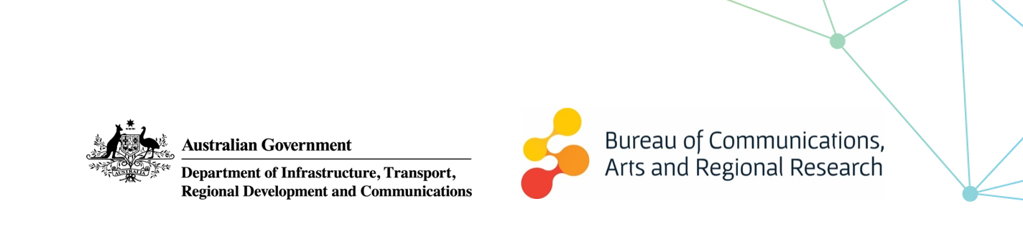

At a glance: Cultural and Creative Activity estimates, 2009–10 to 2018–19

Cultural and creative activity refers to activities involving human creativity as a major input. While there is no universally accepted definition, the terms ‘cultural’ and ‘creative’ describe activities connected with the arts, media, heritage, design, fashion, and information technology.
Cultural and creative activity is increasingly recognised as an important component of economic growth and the updated publication quantifies the economic contribution of cultural and creative activity in Australia from 2009–10 to 2018–19. It has the potential to continue to increase as the economy transforms through the growing use of advanced technologies and the rise of automation.

Key changes
Cultural and creative activity plays an important role in Australia’s economy, growing to $115.8 billion in 2018–‍19, an increase of $24.9 billion (27.4 per cent) over the last 10 years.
Chart 1: Cultural and creative activity, 2009–10 and 2018–19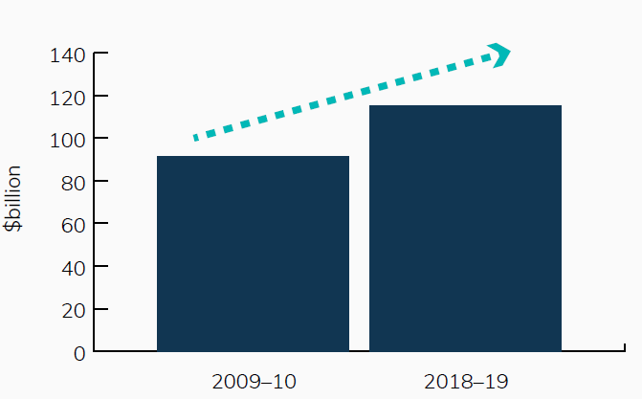Source: ABS Australian System of National Accounts, Australian National Accounts: Input-Output Tables; BCARR calculations
On a satellite accounts basis, cultural and creative activity consists of four components:
- Over 10 years, Gross Value Added (GVA) from cultural and creative industries increased by $16.8 billion to $87.7 billion in 2018–19 (23.7 per cent). Net taxes on products attributable to cultural and creative industries increased over the period to $5.1 billion in 2018–19 (16.2 per cent).
- Compensation of employees received by individuals working in cultural and creative occupations outside the cultural and creative industries was $23.0 billion in 2018–19. This grew by $7.4 billion over the period (47.0 per cent).
- The value of volunteer services to arts and heritage organisations was $1.0 billion in 2018–19, $219 million more than in 2009–10.
- Non‑market output of market producers in cultural and creative industries was $91 million in 2018–19, an increase of $17 million compared to 2009–10.
Chart 2: Components of cultural and creative activity in 2018–19
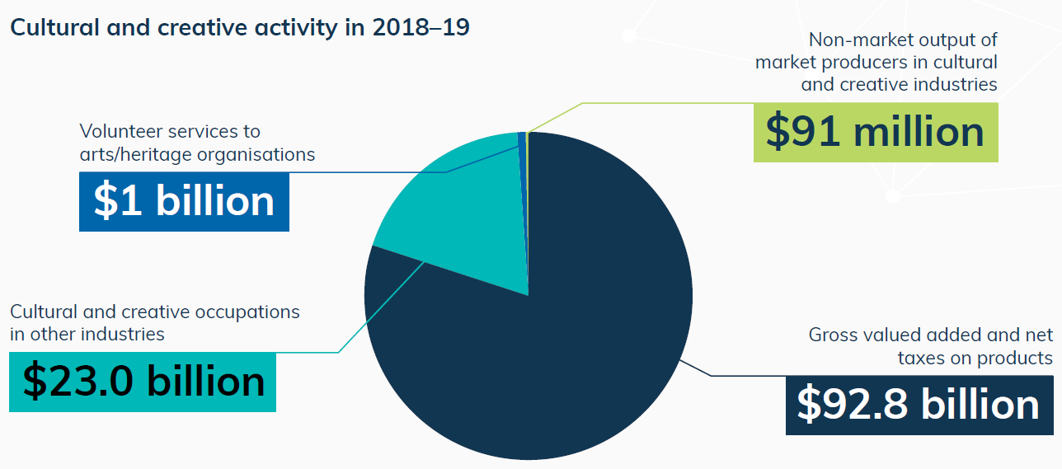
Source: ABS Australian System of National Accounts, Australian National Accounts: Input-Output Tables; BCARR calculations
The industry domains with the greatest contribution to activity in 2018–19 were design at $45.3 billion, fashion at $14.7 billion, broadcasting, electronic or digital media, and film at $9.2 billion, and literature and print media at $8.0 billion.
Chart 3: GVA by domain, cultural and creative industries, 2018–19
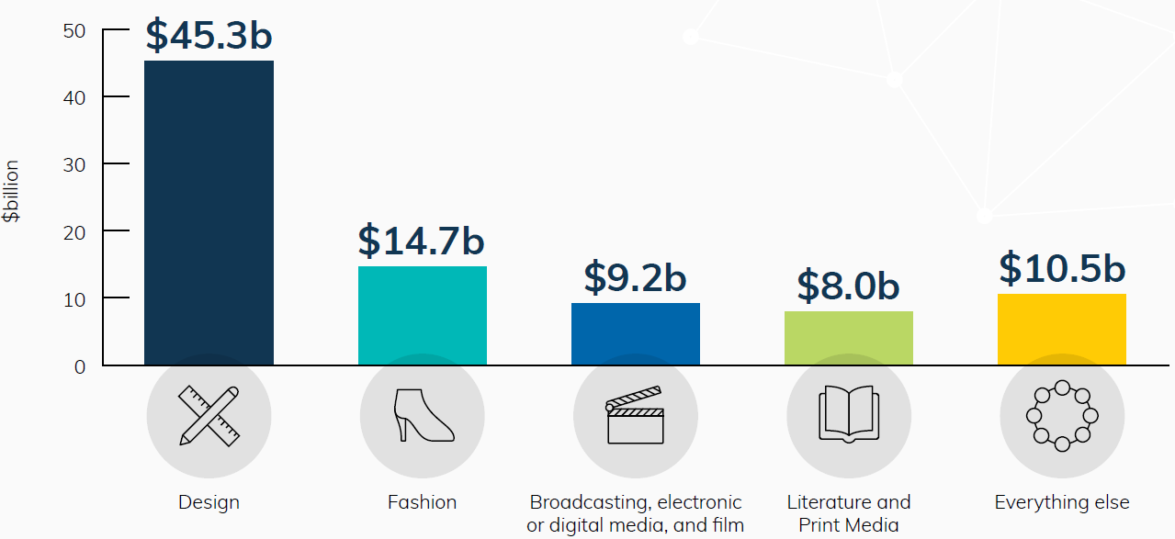
Source: ABS Australian System of National Accounts, Australian National Accounts: Input-Output Tables; BCARR calculations
Most cultural and creative industry domains grew in absolute terms over the 10-year period but did not keep pace with the economy as a whole. Design activity grew strongly over the decade (↑$14.8 billion) and maintained its share of gross domestic product (GDP). Fashion (↑$2.5 billion) and broadcasting, electronic or digital media, and film (↑$0.9 billion) activity also grew but now make up a smaller share of GDP, while literature and print media activity declined both as a share of GDP and in absolute terms (↓$4.2 billion).
The shrinking share of GDP for these domains partially reflects the structural changes occurring within these industries. For example, clothing manufacturing, printing and publishing have all faced increased global competition and are adjusting to automation and the shift from traditional print media towards digital content.
Overall, growth in cultural and creative activity has been slower than the pace of growth for the Australian economy. This largely reflects the continued strength in the mining sector, which falls almost entirely outside of cultural and creative activity. As a share of GDP, cultural and creative activity declined by 1.0 percentage point, from 7.0 per cent in 2009–10 to 6.0 per cent in 2018–‍19.‌
Chart 4: Cultural and creative activity, share of GDP, 2009–10 to 2018–19
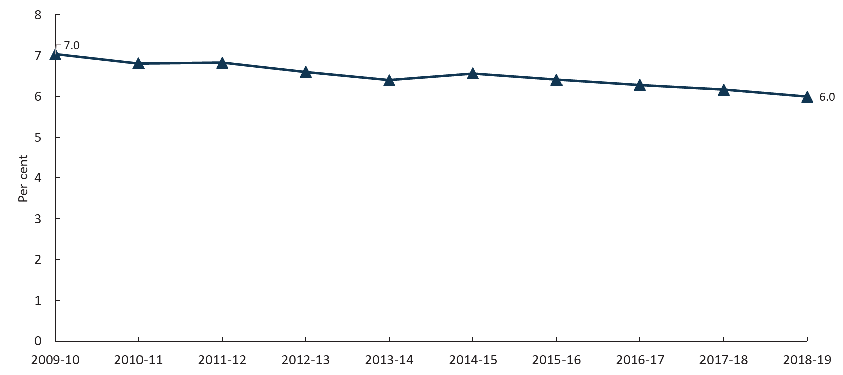
Source: ABS Australian System of National Accounts, Australian National Accounts: Input-Output Tables; BCARR calculations

About this document
The Bureau of Communications, Arts and Regional Research (BCARR) within the Department of Infrastructure, Transport, Regional Development and Communications has estimated the economic contribution of cultural and creative activity in Australia over a 10-year period, from 2009–10 to 2018–19.
This document outlines the key findings from the tables and figures shown in the BCARR visual summary document: Cultural and creative activity in Australia, 2009–10 to 2018–19 and is presented alongside a document of frequently asked questions.
Unless otherwise noted, the 10-year period refers to 2009–10 to 2018–19. This release covers a period prior to the COVID-19 pandemic, and as such does not examine the impact of COVID-19 on cultural and creative activity. The next release of these updates will begin to cover the period of the COVID-19 pandemic.
Further information on the methods used in this research can be found in the BCARR working paper: Cultural and creative activity in Australia, 2008–09 to 2016–17.

Satellite account is a term used to measure the size of economic sectors that are not defined as industries in national accounts. The ABS has developed satellite accounts such as tourism, non-profit institutions, and cultural and creative activity.

