

Affordability of communications services for low income households
April 2020
Working paper

© Commonwealth of Australia 2020
April 2020 / INFRASTRUCTURE
Ownership of intellectual property rights in this publication
Unless otherwise noted, copyright (and any other intellectual property rights, if any) in this publication is owned by the Commonwealth of Australia (referred to below as the Commonwealth).
Disclaimer
The material contained in this publication is made available on the understanding that the Commonwealth is not providing professional advice, and that users exercise their own skill and care with respect to its use, and seek independent advice if necessary.
The Commonwealth makes no representations or warranties as to the contents or accuracy of the information contained in this publication. To the extent permitted by law, the Commonwealth disclaims liability to any person or organisation in respect of anything done, or omitted to be done, in reliance upon information contained in this publication.
Creative Commons licence
With the exception of (a) the Coat of Arms; (b) the Department of Infrastructure, Transport, Regional Development and Communications photos and graphics; and (c) [OTHER], copyright in this publication is licensed under a Creative Commons Attribution 4.0 Australia Licence.
Creative Commons Attribution 4.0 Australia Licence is a standard form licence agreement that allows you to copy, communicate and adapt this publication provided that you attribute the work to the Commonwealth and abide by the other licence terms.
Further information on the licence terms is available from https://creativecommons.org/licenses/by/4.0/.
This publication should be attributed in the following way: © Commonwealth of Australia 2020.
Use of the Coat of Arms
The Department of the Prime Minister and Cabinet sets the terms under which the Coat of Arms is used. Please refer to the Commonwealth Coat of Arms — Information and Guidelines publication available at www.pmc.gov.au.
Contact us
This publication is available in hard copy or PDF format. All other rights are reserved, including in relation to any Departmental logos or trade marks which may exist. For enquiries regarding the licence and any use of this publication, please contact:
Director—Publishing and Communications
Communication Branch
Department of Infrastructure, Transport, Regional Development and Communications
GPO Box 594
Canberra ACT 2601
Australia
Email: publishing@communications.gov.au
Websites: www.communications.gov.au | www.infrastructure.gov.au | www.arts.gov.au.
Contents
Background 5
Findings 6
Communications services are essential for everyday activities 7
The lowest income households have the largest communications spend as a share of income… 8
…particularly for mobile services 9
Some low income groups spend a larger share than others 10
An activity—and its data requirements - determine communications spend 11
Different groups have different data needs 13
Basic data needs 13
Additional data needs 14
Retirees 14
Job seekers 14
Tertiary students 15
Data requirements for households can grow quickly 17
The market is offering a range of services to meet the basic data needs of low income individuals 18
The price of communications services has been declining over time and data inclusions have been increasing 18
Prepaid and post-paid plans have similar prices 20
Data free content is increasing 24
Location may affect the price of data 25
Developments in the market suggest a role for ongoing monitoring 26
Appendix A: Technical methodology and assumptions 28
Case studies 28
Data collection methodology for mobile plans 31
References 33

List of figures
Figure 1. Activities performed online by Australian internet users in the last six months, May 2015 and May 2018 (percentage) 7
Figure 2. Average share of disposable income spent on necessity goods and services, all households and equivalised disposable income decile 1, 2017 8
Figure 3. Comparison of access conditions for prepaid, post-paid and fixed-line broadband 9
Figure 4. Share of disposable income spent on mobile communications services, by equivalised income decile 10
Figure 5. Average share of disposable income spent on communications services, 2017, by group 11
Figure 6. Total data downloaded and proportion downloaded by access connection, June 2013 to December 2018 12
Figure 7. Basic data needs 14
Figure 8. Proportion of enrolment count, by study mode, over time 15
Figure 9. Basic data needs for different groups 16
Figure 10. Activities and estimated basic data needs 17
Figure 11. Average data inclusions for prepaid and post-paid mobile services, 2014–15 to 2017–18 19
Figure 12. Average data allowances at various price points, for prepaid mobile services 19
Figure 13. Price per GB for mobile plans, by included data 20
Figure 14. Share of disposable income spent on mobile and fixed internet services, by equivalised income decile, 2015–16 21
Figure 15. Average cost of prepaid and post-paid plans, by 15 GB increments 22
Figure 16. Number of monthly prepaid and post-paid plans, by 15 GB increments 23
Figure 17. Cost of plans below 20GB per month, with case study ranges for basic data needs 24
Figure 18. Mobile plans under $40 per month, Telstra compared to other networks, by 5 GB increments 25
Figure 19. Share of households that are ‘low income, high spending’ or ‘low income, low spending’, 2006–17 27

List of tables
Table 1. Comparison of broadband and mobile connections and downloads, December 2018 quarter 11
Table 2. Data requirement by task 12
Table 3. Changes in the average price of various communications services 18
Table 4. Data requirement by task 29
Table 5. Estimates of task frequency for case studies 31

Background
Participation in the digital economy relies on access to internet and mobile telecommunications services. These services connect people with economic and social opportunities such as finding a job, pursuing education, interacting with government and staying in touch with friends and family.
The Australian Government is enabling Australians to take advantage of the opportunities provided by the digital economy by facilitating competition for mobile communications services and providing access to fast fixed-line internet services through the National Broadband Network (NBN).
The Government is also improving the efficiency and effectiveness of its service delivery by increasingly moving government services online. Australia already has a large number of public services online compared to other nations—in 2018, the United Nations scored Australia second out of 193 member states in their E-government development index. This digitisation trend will continue with the Digital Transformation Agency’s Digital Transformation Strategy aiming to have all government services digitally accessible by 2025.
As Australians’ reliance on the internet grows, so does the role of affordability in accessing communications services.
Affordability measures are broader than just price and take into account quantity consumed as well as income. Affordability is typically measured at the household level as the proportion of total household income spent on a good or service by all members of a household.
This paper examines the affordability of communications services with a focus on low income households, particularly those in the bottom equivalised income decile where the average annual disposable household income was $22,233 in 2017. Households in this lowest income decile tend to spend the most, as a share of income, on communications services.
This paper aims to understand the basic data needs of low income individuals and what services are available in the market to meet their needs. Due to data availability, communications expenditure is calculated at the household level while basic data needs are calculated on an individual basis.
Further, the paper uses prepaid mobile services to assess the market options as they better reflect personal data use and are more accessible for low income individuals. These services offer a convenient and flexible way to access the internet for those on low incomes, and many low income consumers use prepaid mobile services to control their telecommunications expenditure.
As the NBN retail market matures over the coming years, consumers will have more choice and NBN fixed-line services could become a more attractive option for lower income households.
In 2017, the Bureau of Communications and Arts Research found that the affordability of communications services in Australia had improved overall. In general, consumers were getting better value as prices stayed the same or fell, while product inclusions (such as data) increased.
This paper updates and extends that analysis.

Findings
- In general, the affordability of communications services has continued to improve for households in recent years. However, low income households spend disproportionately more on telecommunications services. In 2017, the lowest 10 per cent of households spent around 8.3 per cent of their annual income on telecommunications services, compared to 3.3 per cent for an average household.
- Demand for telecommunications services has been growing with everyday activities moving online, including interacting with government services. Access to the internet is increasingly needed to access essential services online, with data needs varying based on household composition and the extent to which individuals undertake data-intensive activities.
- Based on a series of case studies, it is estimated that an individual’s basic data needs range from around 2 GB to 20 GB per month. These figures represent the basic data needs for an individual to participate in the digital economy, they do not necessarily represent the amount of data an individual may want to use each month.
- Based on these data requirements, it appears that the telecommunications market is offering a range of services to meet the basic data needs of low income individuals.
- The prices of mobile and fixed-line plans have been falling over time and data inclusions have been increasing, including for prepaid services that low income individuals often rely on. However, cheaper low data prepaid plans continue to have a higher cost per unit of data than plans with larger inclusions.
- There is a role for ongoing monitoring of pricing trends to ensure the telecommunications market continues to offer a range of services that meet the needs of low income individuals.

Communications services are essential for everyday activities
The internet is vital for connecting individuals with economic opportunities such as finding a job and accessing education. Everyday activities such as staying in touch with friends and family, banking, buying goods and services, accessing news and interacting with government are increasingly done online. The use of content streaming services, social media and interactive games has also increased rapidly in Australia in recent years.
Most Australians rely on the internet for everyday activities. In the six months to May 2018, 95 per cent of internet users used email, while 94 per cent used the internet for research and information purposes (Figure 1). Many users accessed services online, such as banking or paying bills (87 per cent) or accessing government websites (66 per cent).
Figure 1. Activities performed online by Australian internet users in the last six months, May 2015 and May 2018 (percentage)
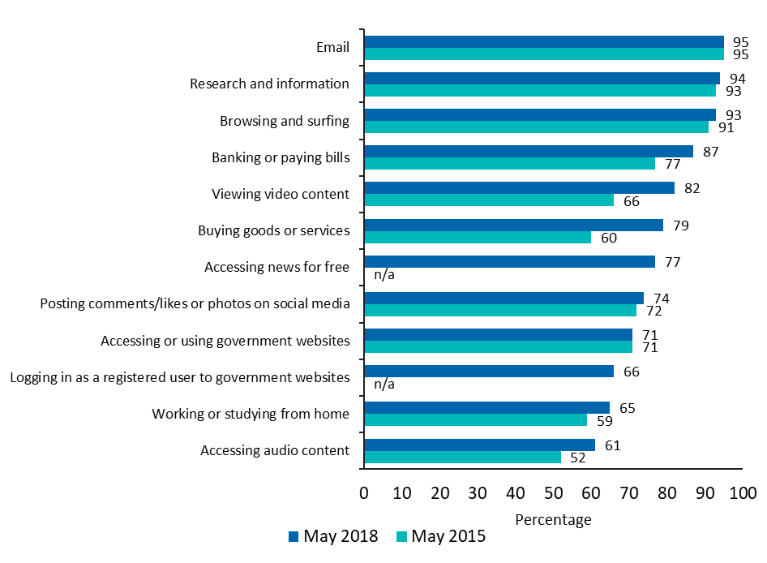
Source: Australian Communications and Media Authority (ACMA) Communications Report 2017–18; ACMA Communications Report 2014–15.
More Australians are also going online to interact with government. In the five years to May 2019, approximately two million new myGov accounts were created each year. As at May 2019, 15 million myGov accounts had been registered. Centrelink, the Australian Tax Office (ATO) and Medicare are the most commonly utilised services in the previous 12 months on myGov.

The lowest income households have the largest communications spend as a share of income…
The reliance on the internet for everyday activities means that telecommunications services have become a ‘necessity good’ for households—along with other such goods and services such as rent and food.
However, the lowest income households tend to spend the greatest proportion of their income on necessity goods, when compared with other households. In 2017, the average annual disposable income of households in the bottom equivalised income decile (adjusted for household size) was $22,233. Disposable income is defined as the combined income of all household members after receipt of government benefits and deduction of income taxes.
In 2017, expenditure on telecommunications (fixed-line telephone, mobile and internet services) was the fourth largest expenditure as a share of income behind rent, groceries and motor vehicle fuel for the bottom income decile (Figure 2).
The Household, Income and Labour Dynamics in Australia (HILDA) survey indicates that households in the bottom income decile spent 5 percentage points more of their disposable income on telecommunications services in 2017 compared to an average household (8.3 per cent compared to 3.3 per cent).
Figure 2. Average share of disposable income spent on necessity goods and services, all households and equivalised disposable income decile 1, 2017
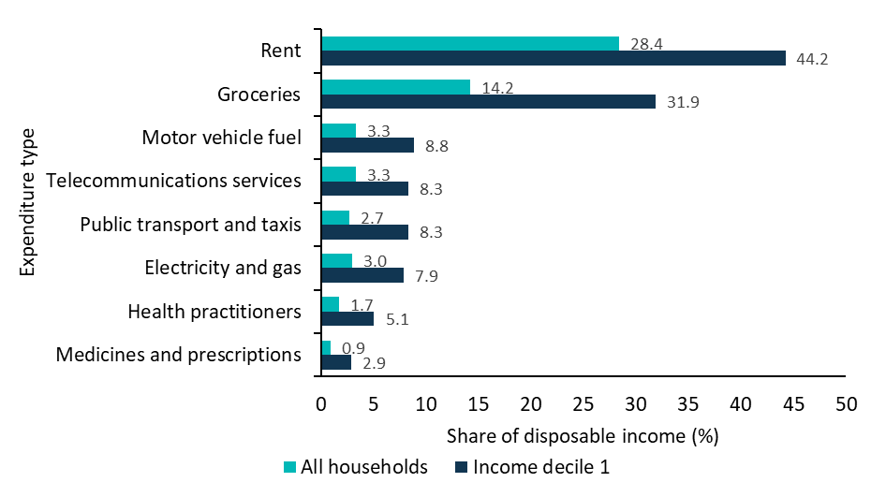
Source: The HILDA Survey, Release 17, August 2018; BCAR calculations.
Note: The measure of household equivalised disposable income is estimated using the square root scale, which is calculated by dividing household disposable income by the square root of the number of individuals in the household.

…particularly for mobile services
Mobile services provide a low priced and convenient way to access the internet. They can be used as the sole means of accessing the internet for individuals who wish to control their expenditure or may not be able to afford to access fixed-line broadband plans. Mobile services, particularly prepaid plans, can offer internet access to those without secure accommodation and credit records, and are available without upfront connection costs or lock-in contracts.
Many low income individuals use prepaid mobile plans over post-paid mobile and fixed-line broadband because prepaid mobile plans allow individuals to better control their expenditure. They also allow for control over commitment periods and can reduce the risk of incurring excess fees (Figure 3)., Figure 3 below shows the general conditions for accessing prepaid, post-paid and fixed-line broadband services. It does not necessarily reflect specific offerings of all providers across all technologies, which may change with market developments.
Figure 3. Comparison of access conditions for prepaid, post-paid and fixed-line broadband
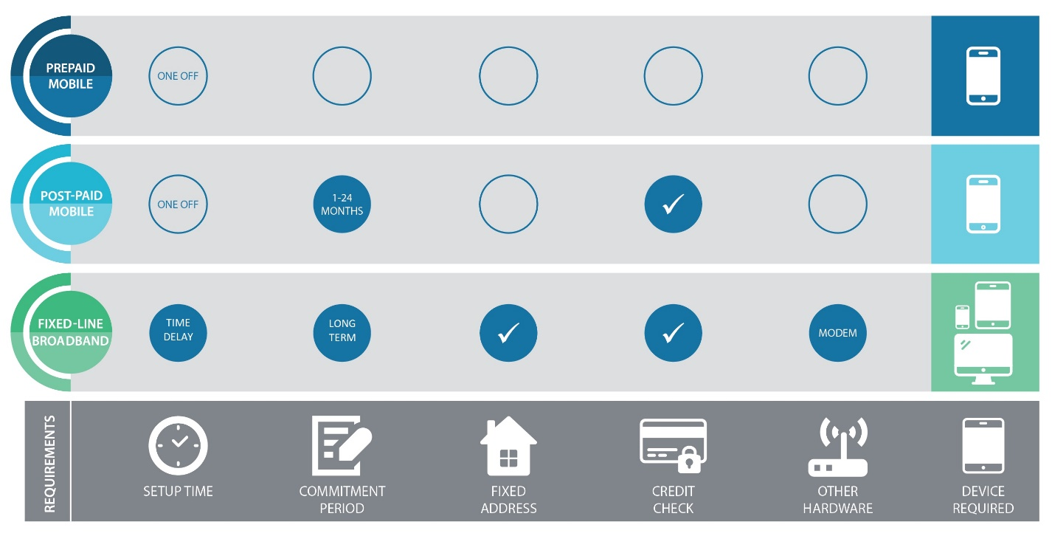
Source: BCAR
For a prepaid plan, consumers pay an upfront fee, giving them an allowance for a set period in the future.
Post-paid plans involve a contractual agreement between the consumer and their retail service provider where the balance is paid at the end of their billing cycle (often month-end). Post-paid plans generally offer a higher number of voice calls, SMS and larger mobile data allowances than prepaid plans, but users can incur extra charges if the allowance is exceeded or the user wishes to exit the plan early. Many post-paid plans also bundle equipment (e.g. smartphone) or content (e.g. exclusive sports content) which increases pricing.
Some low income consumers may not qualify for post-paid and fixed-line broadband plans where they do not pass a credit check, may not have a physical address or require permission from the landlord to get a fixed-line connection.
The lowest income households spend more than double that of higher income deciles on mobile services, as a share of disposable income (Figure 4). This proportion has remained relatively stable—increasingly only slightly from 6.3 per cent to 6.5 per cent—between 2009-10 and 2015–16.
Figure 4. Share of disposable income spent on mobile communications services, by equivalised income decile
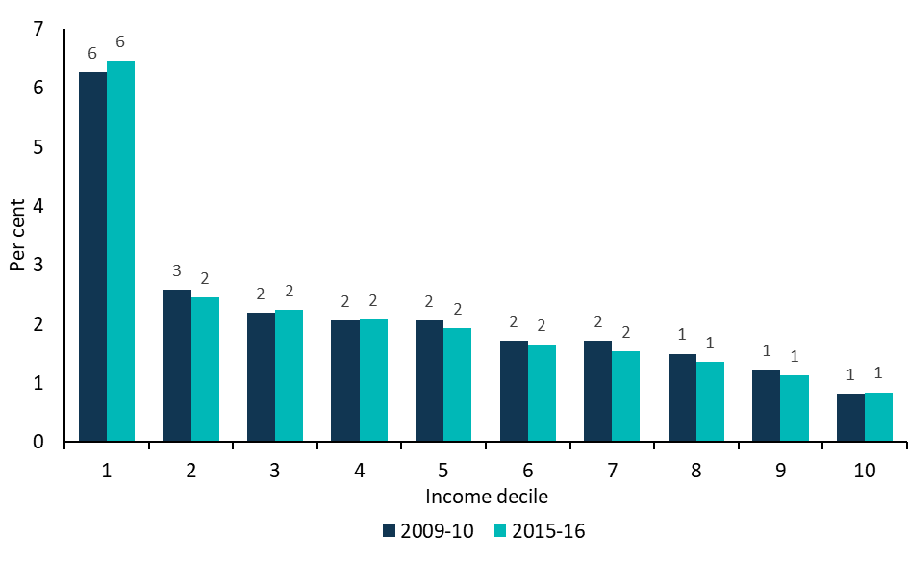
Source: ABS cat. 6540.0 Released October 2017—Microdata: Household Expenditure, Income and Housing; BCAR calculations

Some low income groups spend a larger share than others
Full-time students, the unemployed and retirees tend to spend more of their disposable income on communications services than the average lone person household (Figure 5).
This in part reflects lower than average incomes for these groups but could also reflect higher communication needs for some groups. For example, students are increasingly required to access educational material and complete assessments online.
On the other hand, older Australians use the internet less frequently and are less likely to be connected than other age groups, but their use of internet and mobile technology is increasing.
Figure 5. Average share of disposable income spent on communications services, 2017, by group
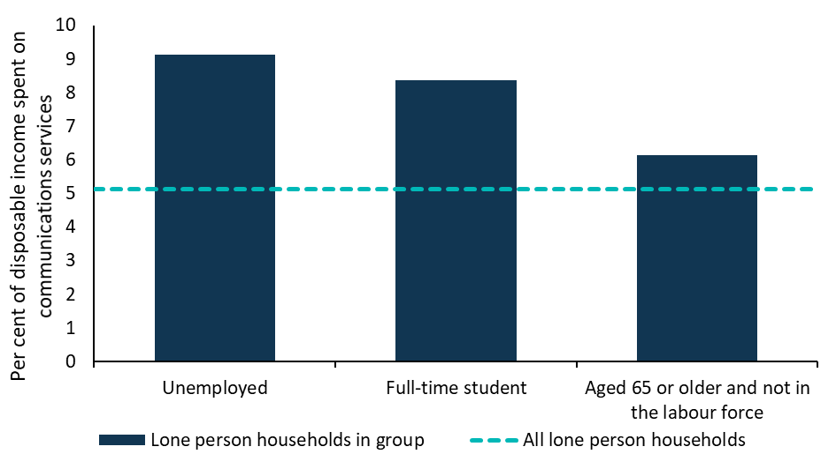
Source: The HILDA Survey, Release 17; BCAR calculations.

An activity—and its data requirements - determine communications spend
The cost of communications services is generally related to data consumption. This is dependent on both the range of activities undertaken using the internet (more activities require more data) and which activities the internet is used for (different activities have different data requirements).
The average data use for a mobile handset was around 5 GB per month in the December 2018 quarter (compared with over 200 GB per month for a fixed-line broadband connection) (Table 1).
Table 1. Comparison of broadband and mobile connections and downloads, December 2018 quarter
 | Number of subscribers / handsets | Download per subscriber / handset (GB monthly)
Mobile handsets | 24,298,000 | 5.2
Fixed-line broadband | 7,207,000 | 212.7
Wireless broadband | 8,402,000 | 5.4
Total broadband | 15,609,000 | 101.1
Source: Australian Competition and Consumer Commission (ACCC) Internet Activity Record Keeping Rule (RKR), for December 2018 quarter, released in May 2019 and revised October 2019.
Note: The ACCC measures all data use and does not make the distinction between data used for essential activities and data use for leisure activities. These figures are not representative of the basic data needs for an individual to access essential services as they include data consumption for data-intensive leisure activities such as music and video streaming which may be a luxury item for some individuals.
Some activities require more data than others, such as those requiring video streaming (Table 2).
The emergence and rapid growth in popularity of content-rich online services, such as video streaming, social media and over-the-top (OTT) services, has been a large contributor to the increased volume of data downloaded. Almost 14 million Australians, or 55 per cent of the population, have access to a paid video streaming service. The increased popularity of streaming is highlighted by the 25 per cent increase in Netflix subscribers between February 2018 and February 2019.
Table 2. Data requirement by task
Task | Eliminated data requirement for task
General web browsing and use of online services | 60 MB per hour
Social media | 160 MB per hour (assuming Facebook with streaming of video content) (Using Facebook)
General video streaming | 300 MB per hour (using YouTube with standard definition)
Downloading and updating applications | 100 MB per download
Source: WhistleOut, as at April 2018; Size of applications approximated based on the sizes of various applications available on the Apple App Store and Google Play Store, e.g. Instagram, Facebook, YouTube, Express Plus Centrelink and more. Further explanation of these figures are detailed in Appendix A.
Mobile data downloads are the fastest growing segment of the market, despite comprising less than 10 per cent of total downloads. In the five years to the December quarter 2018, mobile downloads grew at a compound annual rate of 68.9 per cent compared with 41.1 per cent for fixed-line downloads over the same period. As a proportion of total downloads, mobile has more than doubled in recent years—from 3.1 per cent in the December quarter 2013 to 7.4 per cent in the December quarter 2018 (Figure 6).
This is in line with increased smart phone ownership in Australia which rose from 76 per cent in 2014 to 89 per cent in 2018.
Figure 6. Total data downloaded and proportion downloaded by access connection, June 2013 to December 2018
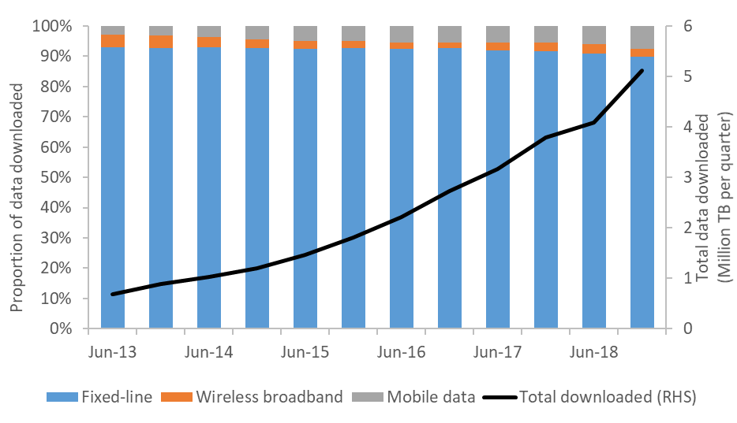
Sources: ABS 8153.0 Internet Activity, June 2018; ACCC Internet Activity RKR, December 2018
Note: Differences in collection do exist between ABS data (collected until June 2018) and ACCC data (December 2018 onwards).

Different groups have different data needs
While useful as an overall measure, and to track general trends, averages tend not to be informative in comparing data use by different groups. As data needs vary by activity, they will also vary by individual depending on why and how often they use the internet to access services.
The BCAR has therefore developed a set of case studies to explore how much data particular groups are likely to need for basic or essential activities. The focus on basic activities is intended to provide a measure of the minimum data requirements for these groups.
Basic data needs will depend on:
- the activities undertaken
- the frequency of these activities
- the amount of data that is required for these activities.
This approach acknowledges that what might be essential for one person might not be essential for another. For example, a student is likely to require video streaming to complete their studies, but for others, video streaming may be considered a leisure activity.
Actual data use will depend on the quality of video being streamed and the size of applications. For example viewing web pages for an hour only requires around 60 MB while viewing Facebook can use 160 MB per hour.
Basic data needs may be higher for specific low income groups such as job seekers and students, though might be lower for some groups such as retirees.
The BCAR has estimated the basic data needs for an individual, and then how this may vary for four low income groups: retirees, job seekers, tertiary students and tertiary students streaming lectures remotely. These case studies assume that all groups have basic data needs, as well as a set of activities specific to their type.
These case studies are representative only and actual data needs are likely to vary based on individual preferences and circumstances. Further explanation of the case studies’ assumptions and calculations are detailed in Appendix A.

Basic data needs
The basic data need for an individual is estimated to be between 2 and 4.5 GB of data per month. This represents the basic data usage for individuals to participate in the digital economy (Figure 7). Activities undertaken by these groups include:
- general web browsing, such as google searches, engaging with media and reading government web pages
- general use of online services, such as accessing online banking and filling out government forms online
- some daily social media use, such as communicating with family and friends, buying, selling and viewing information about goods and services
- a small amount of standard definition video streaming per week, such as viewing short videos with media articles or looking up YouTube videos for information on a specific subject (but not including subscription video on demand (SVOD) services such as Netflix)
- a small number of downloads or updates to applications per month, such as updating the operating system on a mobile phone or updates to apps.
Figure 7. Basic data needs
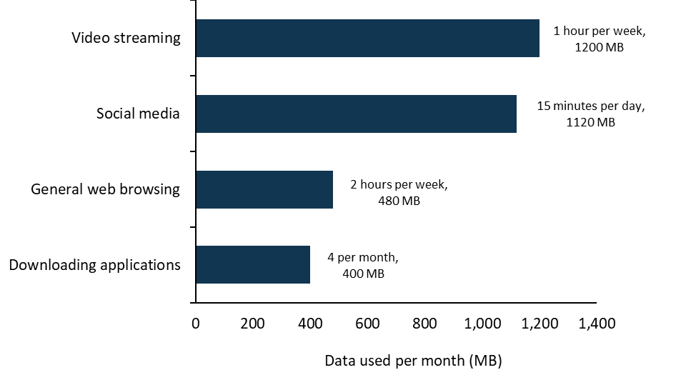
Source: WhistleOut, as at April 2018; Size of applications approximated based on the sizes of various applications available on the Apple App Store and Google Play Store, e.g. Instagram, Facebook, YouTube, Express Plus Centrelink and more; BCAR calculations
Note: The calculations assume four weeks per month. Estimates are based on assumptions that are detailed in Appendix A. Units displayed are based on how people access these applications.

Additional data needs

Retirees
Older Australians generally have lower engagement with data-intensive activities such as video streaming.
A retired person is expected to require 1.5 to 3.5 GB per month to use for basic activities, with reduced social media and video streaming.

Job seekers
Job seekers use communications services to undertake online job searches and to communicate with potential employers about job opportunities. Many job seekers are also likely to undertake training courses to improve their skills, which could have associated online tasks such as accessing course materials or streaming video content.
BCAR analysis suggests that job seekers undertaking various everyday tasks, including job searches and training, could require around 2.7–5.6 GB of data per month.

Tertiary students
University students are another category of low income user who are likely to use the internet for many purposes.
Of all tertiary enrolments in 2017, 28 per cent reported all or some of their studies were done off-campus compared to 22 per cent in 2012 (Figure 8). This was driven mainly by the increase in students reporting multi-modal study which increased from 8.3 per cent to 12.7 per cent in those five years.
Figure 8. Proportion of enrolment count, by study mode, over time
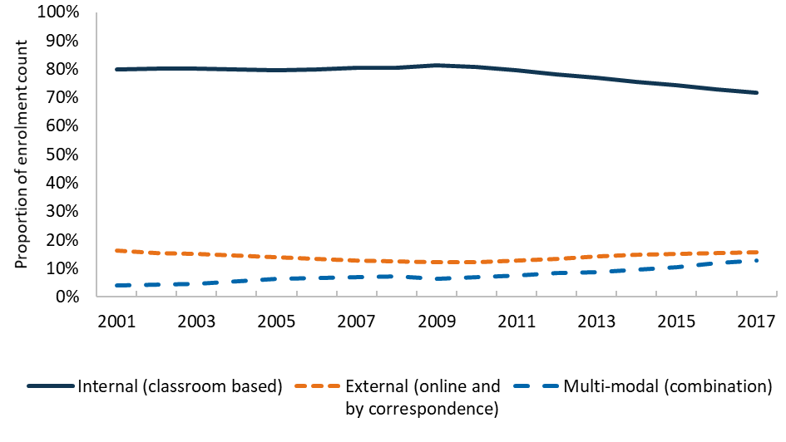
Source: Department of Education uCube
Online study provides flexibility that could be of particular use for regional and remote Australians, who cannot access physical schools or universities, or must keep up their studies if they return home during study breaks. Further, online study can be useful for part-time students who are working or managing other responsibilities while studying.
Depending on the course studied and the method of delivery, a student could use the internet to perform tasks such as accessing course materials, undertaking research, completing assessments and uploading assignments, streaming lectures or participating in virtual classrooms.
While some students may also look for work online, this has not been factored in, as it is not the primary activity of the student for the purpose of this analysis. Further, any additional data requirements do not represent a significant increase above their study requirements.
Students studying on campus are likely to have access to internet services through Wi-Fi or in places such as libraries at no extra cost. However, students studying off campus may need to rely on own-cost internet services to complete tasks for their studies. These students may also need to undertake more streaming activities because they are off campus.
Tertiary students could require around 3.5–7.5 GB per month if they undertake online study, or 10-20 GB per month if they also stream lectures (Figure 9).
Figure 9. Basic data needs for different groups
Data needs for basic activities (2 to 4.5 GB per month)  - A range of basic activities including:  - general web browsing and use of online services  - daily social media use  - a small amount of standard definition video streaming per week  - a small number of downloads or updates to applications per month. |  | Retiree (1.5 to 3.5 GB per month)  - Basic activities with reduced social media and video streaming  Job seeker (2.5 to 5.5 GB per month)  - Basic activities  - 20 to 40 online job searches per month, and 20 to 40 minutes of online training per week  Student (3.5 to 7.5 GB per month)  - Basic activities  - 6 to 12 hours of online study per week (accessing online course materials)  Student—with streaming of lectures (10 to 20 GB per month)  - Basic activities  - 6 to 12 hours of online study per week (accessing online course materials)  - 6 to 10 hours of lecture streaming per week
Source: BCAR data use estimates
Figure 10 compares the data intensity of different activities for the four groups. It shows that overall data requirements are driven by particular data intensive activities (for example, accessing education services by students) and which activities are undertaken.
Figure 10. Activities and estimated basic data needs
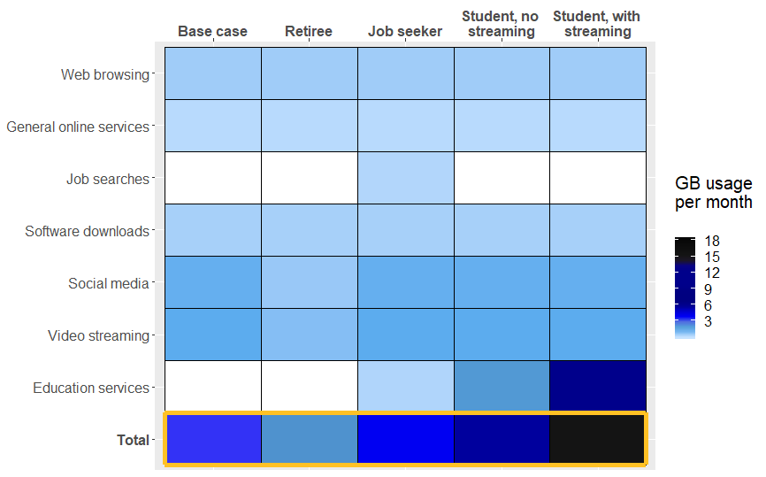
Source: BCAR estimates of basic data needs
Note: Activities represent those expected to primarily be used by those groups. For example, some, but not all, students may also be job seekers.

Data requirements for households can grow quickly
Aggregate data needs for households will depend on household composition and the extent to which individuals undertake data-intensive activities. Data requirements can multiply quickly in households with a number of high data users.
Even amongst households with larger data requirements, such as households with students, the amount of time spent online will vary for different students as curricula and access to technology differ amongst schools, study levels and families. Households with school age children are likely to require data for essential activities such as homework. Primary and secondary school students are likely to spend a number of hours each week completing homework activities involving online content accessed through web browsing or video streaming.
The BCAR estimates that if a primary school student spends around 15 minutes per weekday on online homework activities of which half is streamed this could require almost 1 GB of data per month. If a secondary school student spends around 45 minutes per weekday doing online homework activities—of which half are streamed—these activities could require almost 3 GB per month. These students could also spend time on leisure activities such as gaming which tend be data-intensive, although different games may use different amounts of data.
In addition to this, parents will have their own data requirements such as accessing online services, using social media and downloading software updates. If one or both of the parents are students, job seekers or did some work from home, the data needs could compound even more.

The market is offering a range of services to meet the basic data needs of low income individuals
Previous BCAR research found that low income households spend proportionally more on communications services than other income groups. The research also found that regional consumers often face higher costs for communications services due to lower levels of competition and less choice for services.
Market developments that improve outcomes for low income consumers include:
- a continued fall in prices, in real (inflation adjusted) terms
- increased data inclusions
- similar pricing for prepaid and post-paid plans
- the availability of data-free content.
While market developments overall are positive for most consumers, they cannot necessarily be taken as an indication that overall affordability for particular low income groups will improve.

The price of communications services has been declining over time and data inclusions have been increasing
The prices of mobile and fixed-line broadband services have declined in recent years. The price of prepaid mobile plans declined by almost 4 per cent per annum between 2014 and 2018, while the price of fixed-line broadband and post-paid mobile declined by around 3.5 per cent and 9 per cent respectively (Table 3).
Table 3. Changes in the average price of various communications services
 | 2014–15 | 2015–16 | 2016–17 | 2017–18 | Compound average 2014–18
Total fixed broadband | -4.2% | -4.4% | -3.8% | -1.5% | -3.5%
Post-paid mobile | -12.8% | -13.3% | -2.5% | -8.6% | -9.4%
Prepaid mobile | 0.4% | -6.0% | -2.0% | -7.0% | -3.7%
Total mobile phone services | -10.4% | -12.0% | -2.4% | -8.3% | -8.3%
Mobile broadband | -6.0% | -4.6% | -4.2% | -7.5% | -5.6%
Consumer Price Index | 1.7% | 1.4% | 1.7% | 1.9% | 1.7%
Sources: ACCC Communications Market report 2017–18, ABS
Note: Total fixed broadband includes NBN and non-NBN plans. Mobile broadband includes all mobile connections other than mobile handsets e.g. USB modems and tablets.
The average mobile data allowances for prepaid mobile increased by 153 per cent to 11.5 GB and for post-paid plans increased by 91 per cent between 2016–17 and 2017–18 to 14.2 GB (Figure 11).
There has been an increase in the range of plans available in the market, with more options available at different price points and increased data limits.
The biggest increases in data allowances have been experienced for post-paid plans over $70 per month and prepaid plans over $60 per month (Figure 12).
Figure 11. Average data inclusions for prepaid and post-paid mobile services, 2014–15 to 2017–18
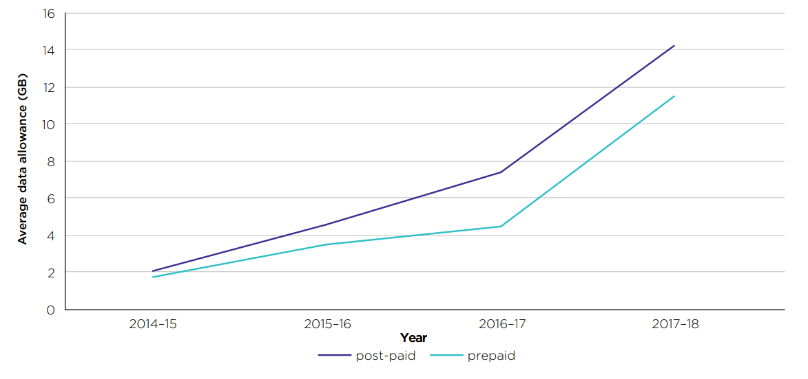
Source: ACCC Communications Market Report 2017–18
Figure 12. Average data allowances at various price points, for prepaid mobile services
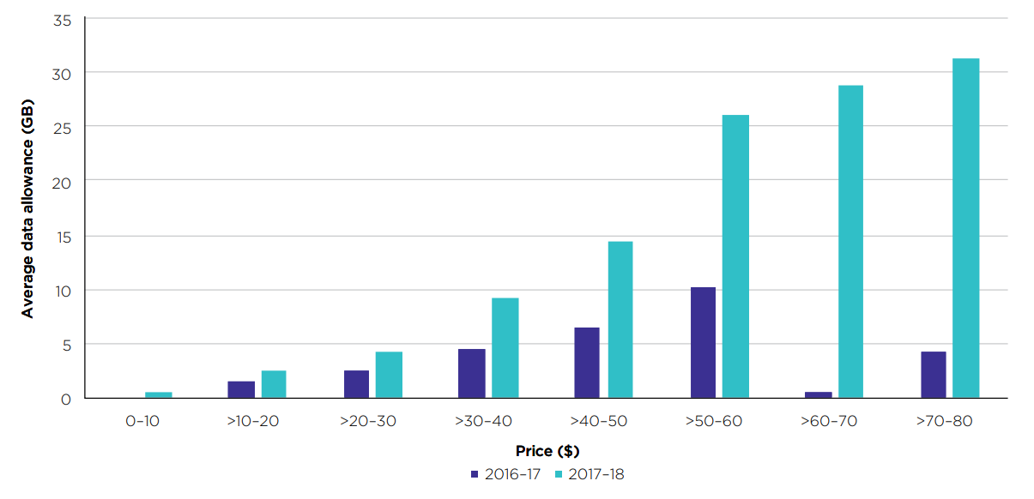
Source: ACCC Communications Market Report 2017–18
While prices have fallen and average mobile data allowances for mobile phone plans have increased, these changes have not necessarily led to services being more affordable for low income individuals.
Similarly, while prices for NBN fixed-line services have fallen, these changes have not necessarily led to these services being used by lower income households. As the service offerings by NBN Co and NBN retailers continue to evolve, the NBN fixed-line services could become more a more attractive option for lower income households.
Plans with higher data inclusions tend to offer better value for money than those with lower data inclusions. The cost per GB—the cost of a plan divided by the amount of data it includes—tends to decline as data inclusions increase (Figure 13). Fixed-line plans which have higher data limits tend to have a lower cost per GB than prepaid and post-paid mobile plans. Low income consumers who buy cheaper low data plans are therefore paying a higher cost per unit of data than those on high data plans.
Figure 13. Price per GB for mobile plans, by included data
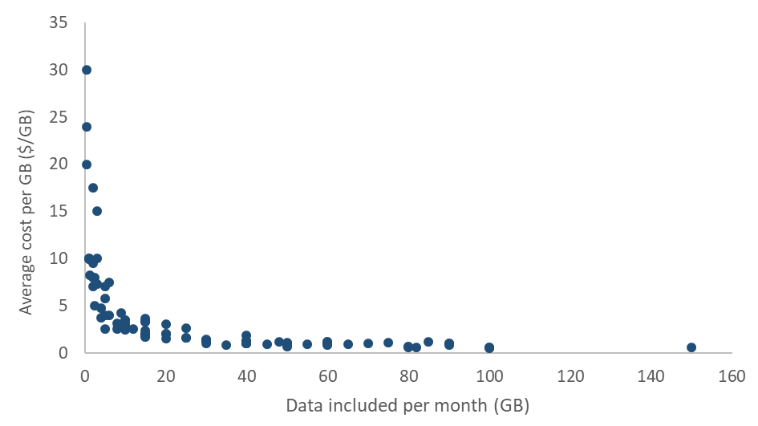
Source: BCAR mobile data plan collection.
Note: Includes month-long plans with unlimited talk and text (n=92). This does not account for any further inclusions.

Prepaid and post-paid plans have similar prices
Lower income households appear to rely more heavily on prepaid services than post-paid. Households in income deciles 1 to 4 spend more on prepaid mobile as a share of income, while those in income deciles 7 to 10 spend more on post-paid mobile products (Figure 14).
Figure 14. Share of disposable income spent on mobile and fixed internet services, by equivalised income decile, 2015–16
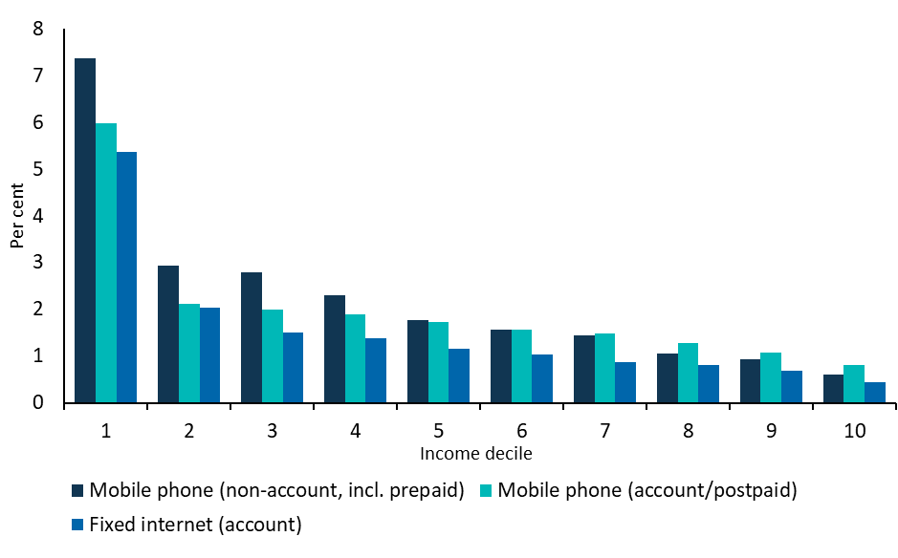
Source: ABS cat. 6540.0—Microdata: Household Expenditure, Income and Housing; BCAR calculations
A survey of mobile phone plans undertaken by the BCAR in June 2019 shows that the average costs of prepaid plans and post-paid plans are broadly similar for plans with data inclusions of 75 GB or less (Figure 15). This suggests that those who are unable to access post-paid plans are generally not unduly disadvantaged when accessing a prepaid plan instead. See Appendix A for further information regarding the methodology.
For plans with very high data inclusions—more than 60-75 GB per month—prepaid tends to be more expensive than post-paid. People consuming more than 75 GB per month are considered very high data users and are likely to be using the internet for a range of data-intensive leisure activities such as gaming and Netflix. For example to consume 75 GB of standard definition video on mobile, an individual could watch around 250 hours of video on YouTube or 300 hours of Netflix.
Figure 15. Average cost of prepaid and post-paid plans, by 15 GB increments
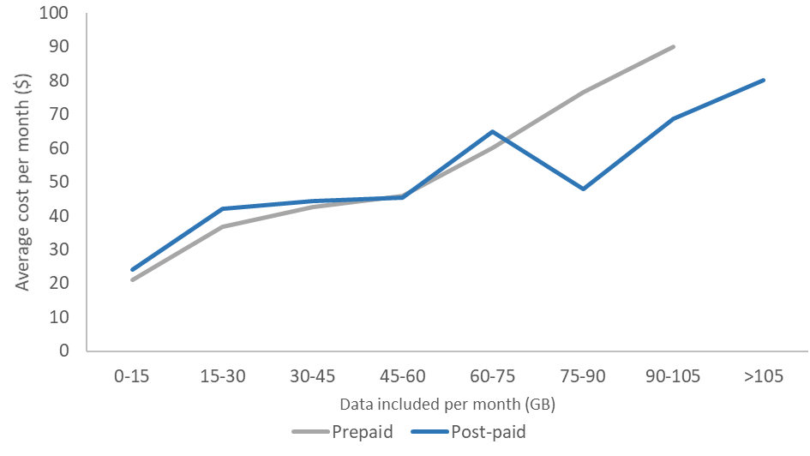
Source: BCAR mobile data plan collection.
Note: Includes month-long plans with unlimited talk and text. n = 32(prepaid), n = 60(post-paid). This does not account for any further inclusions.
Data and call inclusions have increased significantly for prepaid plans in recent years. Nearly all prepaid plans (103 of 107 surveyed) now have unlimited calls and text, compared to two years ago when unlimited calls were only prevalent in more expensive plans. While choice amongst data plans has improved for prepaid customers, there is less choice of plans in the prepaid market compared to the post-paid market. Of the month-long plans with unlimited talk and text included, 60 of the available plans were post-paid while only 32 were prepaid. Figure 16 shows that post-paid customers have more than double the number of plan options under 45 GB. While the data comparisons are monthly, prepaid users are able to recharge data at more frequent intervals than their monthly expiry, subject to their ability to pay for more data.
Figure 16. Number of monthly prepaid and post-paid plans, by 15 GB increments
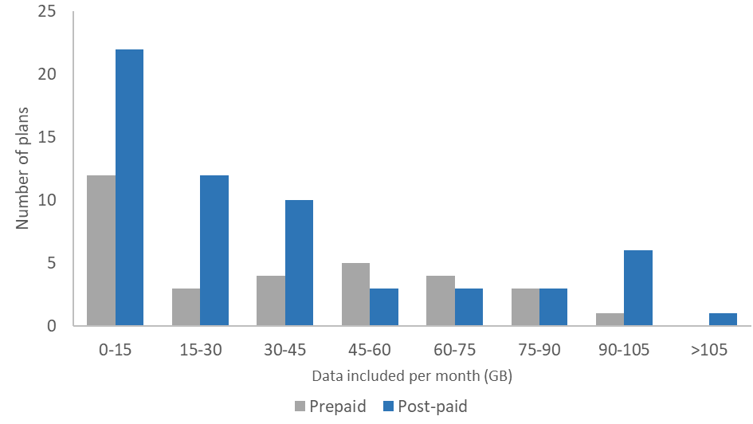
Source: BCAR mobile data plan collection.
Note: Includes month-long plans with unlimited talk and text. n = 32(prepaid), n = 60(post-paid). This does not account for any further inclusions.
As basic data needs are estimated to be under 10 GB (the exception being the student with high volumes of lecture streaming), this suggests that there are options of prepaid and post-paid plans for this data range at $35 per month and below (Figure 17). For those with very low basic data needs of between 1 and 2 GB per month, there were plans available for around $10 per month.
There were a number of prepaid and post-paid plans available for consumers who require low amounts of data. For mobile plans with 10 GB or less of data per month, there were 27 plans available, with 9 of these prepaid and 18 post-paid (Figure 17). For the students with streaming case study, there were fewer prepaid plans with a data allowance matching their estimated basic data needs of 10 to 20 GB per month.
Figure 17. Cost of plans below 20GB per month, with case study ranges for basic data needs
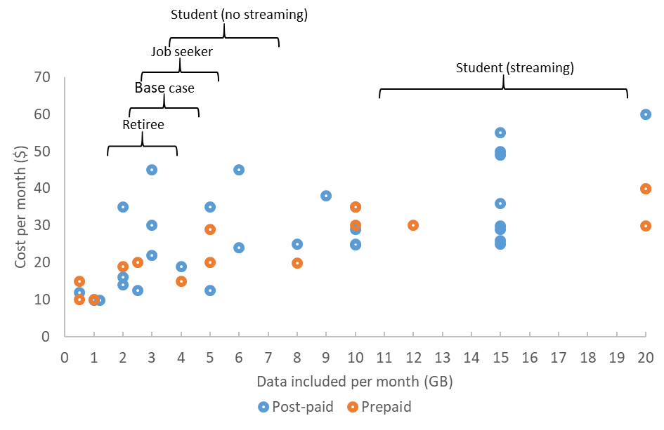
Source: BCAR mobile data plan collection.
Note: Includes month-long plans with unlimited talk, text and 20GB or less of included data. n = 15(prepaid), n = 31(post-paid). This does not account for any further inclusions.

Data free content is increasing
To gain a competitive advantage in the market, some MNOs have been offering their mobile customers additional inclusions such as data free music streaming and video streaming for select content. Downloading this content does not count towards the consumer’s data allowance. It is often referred to as being unmetered or having a zero rating.
For regional customers on the NBN SkyMuster Plus™, some essential services have become unmetered to allow continued access. Users can now use email, general web-browsing and common critical smartphone software updates without using their monthly data allowance. This enables consumers to have ongoing access to online services such as banking and weather after their data allowance is reached.
For educational services there have been efforts to encourage free access to data. On Telstra plans, certain educational institutions and resources have their IP addresses unmetered so that study will not contribute to reaching the data limit. Other programs to facilitate study in regional areas include the Education Port on the NBN SkyMuster™ service and the Australian Government Department of Education’s Regional Study Hubs.

Location may affect the price of data
Although carriers apply nationally consistent pricing, the range of mobile products on offer varies across locations due to differences in the coverage of both mobile network operators (MNOs) and mobile virtual network operators (MVNOs). This variation can impact choice and affordability, particularly for regional and remote areas.
Telstra has the largest footprint of any mobile carrier, both in terms of population reach and geographic coverage. Telstra covers 99.4 per cent of the population compared to Optus’ coverage of 98.5 per cent and Vodafone’s 96 per cent. Further, Telstra covers more land than other networks. For those customers in areas with multiple networks, Telstra’s coverage may be a factor in their choice of provider. However, some regional consumers may not have access to coverage from multiple networks and can only access mobile plans provided on the Telstra network.
Consumers in regional or remote areas only able to receive mobile coverage through Telstra may have less choice of plans and may pay a premium in some instances. Based on the BCAR’s survey of advertised mobile plans, there were 8 plans under $40 utilising the Telstra network, compared to 46 using Optus or Vodafone. When looking at the minimum prices for plans in Figure 18, there are fewer plans on offer with Telstra and the minimum cost at each available increment is either comparable or more expensive than other networks. The Telstra plans that are comparable in price to other providers are mostly under 15 GB.
Figure 18. Mobile plans under $40 per month, Telstra compared to other networks, by 5 GB increments
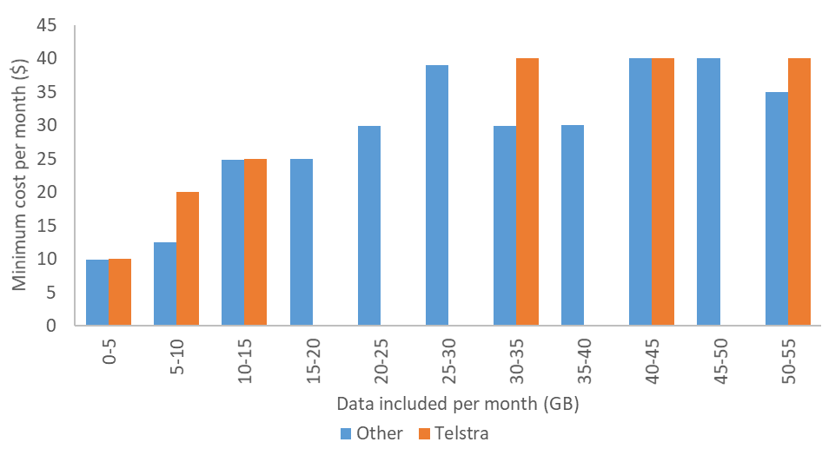
Source: BCAR mobile data plan collection.
Note: Includes month-long plans with unlimited talk and text up to $40 per month. n = 46(Other), n = 8(Telstra). This does not account for any further inclusions.

Developments in the market suggest a role for ongoing monitoring
Overall affordability will depend on a range of factors. The demand for communication services has been increasing and a competitive market has ensured that the prices of these services has been falling. As more services move online, the amount of data needed for everyday activities is expected to increase alongside the range of online activities considered ‘essential’.
A highly competitive mobile sector is likely to support ongoing access to affordable mobile services with growing data allowances. Technological improvements in handsets and software also allow for more efficient data use and expand the amount of services available for the same amount of data.
The types of products that communications providers offer is also a factor. If providers choose to include more unmetered essential activities in their plans, such as those that relate to education and health, this could benefit to low income households.
Households experiencing affordability issues also may respond in different ways. They could spend a significant amount of their income on communications services, which over time may be unsustainable, or they could choose to spend their income on other necessities and underutilise communications services, resulting in reduced participation in the digital economy.
Two measures are considered to capture these different aspects of affordability for low income individuals (Figure 19).
- ‘Low income, high spending households’ as those households with household income that is less than half of the median and telecommunications expenditure as a share of income at more than three times the median.
- ‘Low income, low spending households’ as those households with household income that is less than half of the median and telecommunications expenditure as a share of income at less than half the median.
The two measures for low income households indicate a potential for unsustainable expenditure or constrained participation in the digital economy.
In recent years, the share of households identified as ‘low income, high spending’ increased from 6.2 per cent in 2015 to 6.7 per cent in 2017. This could indicate that more low income households are maintaining expenditure on communications services by forgoing expenditure on other goods and services. However, this could also be driven by the preferences of households.
The share of households identified as ‘low income, low spending’ has remained between 0.8 and 0.9 per cent since 2010.
Figure 19. Share of households that are ‘low income, high spending’ or ‘low income, low spending’, 2006–17
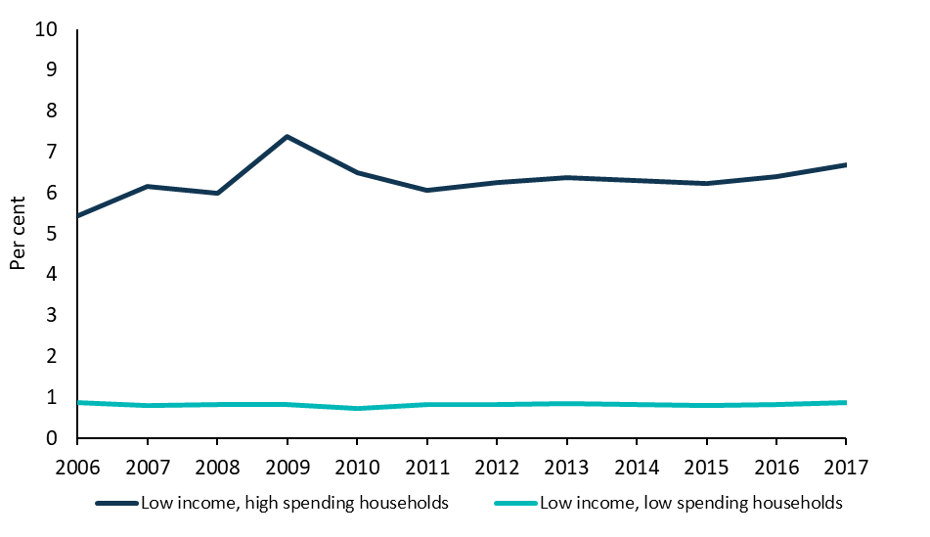
Source: The HILDA Survey, Release 17; August 2018; BCAR calculations.

Appendix A: Technical methodology and assumptions
The following technical appendix sets out in more detail the sources, assumptions, methodology and results for the case studies for data needs and for the survey of advertised mobile phone plan prices conducted by the BCAR.

Case studies
The BCAR has constructed case studies of how much data is needed for basic everyday tasks and for particular groups. These case studies are representative only and actual basic data needs are likely to vary based on individual preferences and circumstances. For example, some individuals may choose to undertake some activities in person at a physical shopfront or over the phone instead of online. Other individuals may choose to access other external networks such as public Wi-Fi networks instead of their own internet connection. Additionally, data usage for different tasks are likely to change over time with updates to applications and online services. For example, websites changing their interface or adding new features may increase their data intensiveness.
Data needs depend on what activities are required to be undertaken online, the frequency of these activities and the amount of data that is required for these activities. Total estimates are calculated by multiplying the estimates of data usage for each activity by frequency of activity. Ranges are used to indicate that this could vary based on individual circumstances. For example, estimates could vary based on quality of videos being streamed and the number of videos versus photographs on social media.
Table 4 outlines estimates of basic data requirements for different tasks. Estimates of data usage from WhistleOut, which is a search engine that compares mobile and internet plans, have been used as a basis for a number of the estimates.
Basic data usage has been estimated based on a number of assumptions:
- Web browsing and general online services: based on WhistleOut assumptions for web browsing.
- Social media: based on WhistleOut assumptions for Facebook as this is the most used social media platform in Australia and can be used to undertake a range of essential tasks. Data usage may vary if a different platform is used. For example, Instagram is much more data intensive with an estimate of 720 MB per hour compared to Snapchat with 160 MB per hour.
- General video streaming: based on WhistleOut assumptions for YouTube standard definition on mobile. Data usage will be greater if high definition is used. There is variance in online estimates of how much data video streaming will consume. This WhistleOut source was selected for consistency with other assumptions, the specification of mobile data usage, and it’s middle ground position between other estimates of YouTube data use at 240MB and 500MB per hour for 480p viewing.,
- Downloading and updating applications: based on applications available through the Apple App store and Google Play store. This estimate is based on a number of applications such as Express Plus (Centrelink), Instagram and Facebook. The amount of data required to download and update applications will depend on a number of factors such as the size of the application and how frequently the application is updated.
- Online education services with video streaming: based on WhistleOut assumptions for YouTube standard definition video. Data usage might be higher if high definition is used.
- Online job services: based on WhistleOut assumptions for web browsing. It is assumed that job seekers view 5 web pages per job search. Job search for the context of this paper refers to each time someone goes online to look or apply for a job.
- Online training: based on WhistleOut assumptions for an hour of webpage browsing and YouTube standard definition video. Data usage will be higher if high definition is used.
Table 4. Data requirement by task
Task | Data requirement for task
Web browsing | 60 MB per hour
General online services | 60 MB per hour
Social media | 160 MB per hour (assuming Facebook with streaming of video content)
General video streaming | 300 MB per hour (assuming YouTube standard definition streaming)
Downloading and updating applications | 100 MB per download
Online education services—with video streaming | 300 MB per hour (assuming YouTube standard definition streaming)
Online job searches | 17 MBs per search (assuming 10 pages visited per search, with 1.7 MBs per page)
Online training—without video streaming | 60 MBs per hour
Online training—with video streaming | 300 MB per hour (assuming YouTube standard definition streaming)
Sources: Choros, A., 2018; HTTP Archive, June 2019.
There is information available on the data requirements to complete online activities, but not on how much time low income individuals spend undertaking these tasks in a given day, week or month. Table 5 outlines the task frequency for the case studies. The frequency of use estimates for low income individuals were developed by the BCAR to reflect what a low income user could reasonably expect to use. The frequency estimates are informed by benchmarks that report on frequency through average time on service. Any benchmarks were then lowered before being input to the model. Average time on services would overestimate the basic data needs, as it would be skewed by high data users and include non-essential use.
Frequency of tasks for each case study has been estimated based on a number of assumptions. This paper looks to estimate the basic data needs of low income Australians, which has not been done before to the knowledge of the BCAR.
The assumptions are as follows:
- Web browsing and general online services: Around 1–3 hours of web browsing each week and 0.5—1 hours of accessing general online services has been assumed for the base case. Web browsing assumes that individuals view webpages to undertake essential everyday tasks. This could include google searches, engaging with media and reading government web pages. General online services can include such activities as accessing online banking and filling out government forms online. In 2019, an estimate of the average time spent online is around 5 hours per day on any device in Australia.
- Social Media: Around 10–20 minutes of social media per day has been assumed for the base case. This assumption is based on the social media use of Australians reported by Roy Morgan Single Source data. Social media can be used for both essential everyday activities such as communicating with family and friends, buying and selling goods and services and viewing information about goods and services, as well as for leisure purposes. Determining how much social media is used for essential activities is challenging as it is likely to vary by individual and platform used. It is assumed that less than half of social media use is used for essential activities. Roy Morgan indicates that on average that Australian use 340 minutes of social media a week, equivalent to almost 50 minutes per day. Roy Morgan data shows that older Australians are less likely to use social media and younger Australians are more likely to use social media.
- General video streaming: 45–75 minutes of video streaming per week has been assumed for the base case. This assumes that all individuals undertake some form of video streaming to undertake everyday activities such as viewing short videos with media articles and looking up YouTube videos for information on a specific subject. We exclude the use of SVOD services, such as Netflix. Retirees are assumed to undertake less video streaming than other groups in line with older groups tending to undertake less video streaming. An ACMA study has shown older people are less likely to undertake these types of activities online.
- Downloading and updating applications: It is assumed that 2–6 applications are updated per month for the base case with 100 MB of data required per application. This could include updating the operating system on a mobile phone or updating apps used for online banking, social media or government services (such as Express Plus Centrelink). Updates are important for keeping devices operational and maintaining security protection, as well as accessing new features on apps. The median update for popular apps is around 1-4 updates a month but apps can be updated much more frequently. It has been assumed that these updates would be undertaken through their mobile service and not Wi-Fi access.
- Online education services: It is assumed that online training or education services with streaming and without streaming is undertaken by job seekers as well as students. For job seekers, BCAR has assumed they spend some amount of time each week (20–40 minutes per week) undertaking online training – of which a third is streamed. For students, BCAR has assumed that they would accessing online learning material 6–12 hours a week. The BCAR has assumed a full-time study load of around 8–10 hours per a subject and not all of this study or assessment is conducted online. These hours are based on a full-time load of four subjects. Online training and educational services without streaming includes using university websites to access research and reading materials, complete online assessments, participate in discussion forums, chat groups, and virtual classes.
- Online education services with streaming video: 6–10 hours of streaming was estimated based on a student streaming four lectures a week and that not all study activities involve video streaming. A single lecture is estimated to be around 2 hours long, but this streaming time may vary if lectures are longer or if students are also streaming tutorials in addition to their lectures. A longer time streaming may be required for distance education students. Lengths of lectures and tutorials as well as the availability of materials online will depend on not only the course undertaken but also which university or training provider is providing the course. A student is assumed to have a full-time course load of around 4 subjects.
- Online Job searches: It is assumed that job seekers look for around 5–10 jobs a week (or 20–40 jobs per month). This is in line with stream A and stream B job seekers in the jobactive program who are required to undertake a maximum of 20 jobs searches a month. The actual number of job searches per individual is likely to vary significantly and will also depend on factors such as local labour market conditions. While many students may also be looking for work, it is assumed that this is not the primary activity of the student and therefore has not included in the data use assumptions for a student.
Table 5. Estimates of task frequency for case studies
Task | Base case | Retiree | Job seeker | Student | Student with additional streaming
Web browsing | 1–3 hours per week | 1–3 hours per week | 1–3 hours per week | 1–3 hours per week | 1–3 hours per week
General online services | 0.5–1 hour per week | 0.5–1 hour per week | 0.5–1 hour per week | 0.5–1 hour per week | 0.5–1 hour per week
Social media | 70–140 minutes per week | 35–70 minutes per week | 70–140 minutes per week | 70–140 minutes per week | 70–140 minutes per week
General video streaming | 45–75 minutes per week | 30–50 minutes per week | 45–75 minutes per week | 45–75 minutes per week | 45–75 minutes per week
Downloading and updating applications | 2–6 per month | 2–6 per month | 2–6 per month | 2–6 per month | 2–6 per month
Online job searches | n/a | n/a | 5–10 times per week | n/a | n/a
Online training or education services—without video streaming | n/a | n/a | 1–3 hours per week | 6–12 hours per week | 6–12 hours per week
Online training or education services—with video streaming | n/a | n/a | 20–40 minutes per week | n/a | 6–10 hours per week

Data collection methodology for mobile plans
The BCAR collected the prepaid and post-paid mobile plan data from the comparison website WhistleOut on 4 June 2019. Data was collected for plans that did not include a handset and had some included data allowance. In total, there were 107 plans; 46 prepaid and 61 post-paid. Of the plans, 103 had unlimited talk and text included with four having limited call or text balances. Throughout the report, it specified where only unlimited plans were included.
Mobile plans were classified as prepaid or post-paid by the specified time to pay for the service. For prepaid plans, consumers pay an upfront fee, giving them an allowance for a set time period in the future. Post-paid plans usually involve a contractual agreement between the consumer and telecommunications carrier where the balance is paid at the end of their billing cycle (often month-end). Post-paid plans generally offer higher voice call, SMS and mobile data allowances than prepaid plans, but users can incur extra charges if the allowance is exceeded or you wish to exit the plan early.
It is noted that plans offer special conditions such as unmetered access to partnered services or international call allowances, these however were not able to be factored in to estimations of plan value. Set up costs were also excluded from the prices recorded in the dataset e.g. equipment, installation or provider-specific registration fees.
The data most utilised in the report were price and included data. Where plans had discounted rates or bonus data, the amount would only be taken if it spanned the entire contract period (for post-paid plans). Otherwise, the standard data allowance was considered the total data inclusion.
The data collected is not an exhaustive list of options on the mobile market. Further the mobile market is changing rapidly and it is expected that the results would be different for any day. For example, this June 2019 data collection occurred prior to Telstra announcing their new pricing structure of mobile plans.

References

¹ United Nations—Department of Economic and Social Affairs, 2018, E-Government survey, New York, p. xxv DTA, 2018, Vision 2025 DTA, Canberra
Breunig, R. and O. McCarthy, 2019, Household Telecommunications Expenditure in Australia, Telecommunications Policy, Article in press, p. 10
The HILDA Survey, Release 17, August 2018; BCAR calculations. Disposable income is defined by the HILDA survey as “total income after receipt of government benefits and deduction of income tax”.
Ogle, G. & Musolino, V. 2016, Connectivity Costs: Telecommunications Affordability for Low Income Australians, Australian Communications Consumer Action Network (ACCAN), Sydney, pp. 38, 43
BCAR, 2017, Trends and drivers in the affordability of communications services for Australian households
DTA, 2019, myGov performance dashboard data, DTA, Canberra
Ibid.
The HILDA Survey, Release 17, August 2018; BCAR calculations.
Roger Wilkins, Inga Laß, Peter Butterworth and Esperanza Vera-Toscano (2019) The Household, Income and Labour Dynamics in Australia Survey: Selected Findings from Waves 1 to 17. Melbourne Institute: Applied Economic & Social Research, University of Melbourne, p. 29.
A measure of household equivalised disposable income is constructed by dividing household disposable income by the square root of the number of individuals in the household. See OECD, 2013, OECD Framework for Statistics on the Distribution of Household Income, Consumption and Wealth, pp. 173-177. The analysis excludes a small number of households where disposable income is negative, or where the share of expenditure on telecommunications services is equal to zero or greater than or equal to one. Household disposable income does not include stocks of assets, such as home ownership, that would be considered in wealth measurement.
Wise, S., 2013, Trying to connect—Telecommunications access and affordability among people experiencing financial hardship, ACCAN and Anglicare Victoria, Melbourne, p. 3
Ibid.
Ogle, G. & Musolino, V. 2016, Connectivity Costs: Telecommunications Affordability for Low Income Australians, ACCAN, Sydney, p. 43
Canstar Blue, 2019, Can I get a phone plan with bad credit?, Canstar Blue, Brisbane.
Cooley, D., 2016, A renter’s guide to getting NBN connected Telstra, Melbourne
There are differences in methodology between the HES and HILDA surveys, with HES measuring weekly expenditure, while HILDA measures annual expenditure. The analysis excludes households where disposable income is negative, or where the share of expenditure on a service is equal to zero or greater than or equal to one.
ACMA, 2016, Digital Lives of older Australians , ACMA, Canberra
Fixed-line broadband includes DSL, cable and fibre
Wireless broadband includes satellite, fixed wireless, mobile wireless, dongle, USB modem or tablet SIM card
ACCC, 2019, Internet Activity RKR, May 2019 (revised October 2019), ACCC, Canberra
Calculated as 13.966 million subscribers (Roy Morgan) and 25.1802 million Australians (ABS, December 2018)
Roy Morgan, 2019, Almost 14 million Australian have Subscription or Pay TV media release, Melbourne
ABS, 2018, 8153.0 Internet Activity, Australia, June 2018, ; ACCC, 2019, Internet Activity RKR, May 2019 (revised October 2019), ACCC, Canberra; BCAR calculations
Deloitte, 2018, Mobile consumer survey 2018, Deloitte, Sydney, p. 6; Deloitte, 2014, Mobile consumer survey 2014, Deloitte, Sydney, p. 3
ACMA, 2016, Digital Lives of older Australians, ACMA, Canberra
Department of Education and Training, 2019, uCube - Higher education statistics, Department of Education and Training, Canberra
Calculations assume standard definition YouTube streaming of 300 MBs per hour. Eight in 10 young people aged 8–17 played games online in the 12 months to June 2017. Office of the Children’s eSafety Commissioner’s, 2018, State of Play—Youth and Online Gaming in Australia, Office of the Children’s eSafety Commissioner’s, Sydney
ABS, 2018, 8146.0 Household use of IT, 2016-17, ABS, Canberra showed that 44.6 per cent of employed persons accessed the internet for home based work in last 3 months of 2016-17.
BCAR, 2017, Trends and drivers in the affordability of Communications services for Australian households, Department of Communications and the Arts, Canberra, p. 27
ACCC price comparisons are made by comparing ‘like for like’ plans across time periods i.e. adjusted for non-price characteristics such as data inclusion and connection speed.
Australian Bureau of Statistics, 2019, Consumer Price Index, cat. No. 6401, ABS, Canberra
ACCC, 2019, ACCC Communications Market Report 2017-18, Canberra
Calculation for YouTube based on 300 MB per hour of use; calculations for Netflix based on 250 MB per hour
BCAR, 2017, Trends and drivers in the affordability of Communications services for Australian households Department of Communications and the Arts, Canberra, p. 22
Ibid., p. 23
Fletcher, P. (Minister for Communications and the Arts) and Coulton, M. (Minister for Regional Services, Decentralisation and Local Government), 2019. More Data delivered on NBN Sky Muster, media release, Parliament House, Canberra, 12 August 2019
Isolated Children’s Parents’ Association of Australia, nbn™ Sky Muster™ Satellite 'Educational Port' & Un-metered Education sites, 1 March 2016
The Education Port is a metered service for primary and secondary school students studying by distance. The Regional Study Hubs are physically located at 23 sites across Australia.
BCAR, 2017, Trends and drivers in the affordability of Communications services for Australian households Department of Communications and the Arts, Canberra, p. 24
Choros, A., 2019 Telstra mobile coverage explained, WhistleOut, Sydney
Ibid.
$40 chosen as an arbitrary maximum. This is not to be interpreted as a cut off for affordability.
Breunig, R. and O. McCarthy, 2019, Household Telecommunications Expenditure in Australia, Telecommunications Policy, Article in press, pp. 10, 12
Choros, A., 2018, How much mobile data do you need?, WhistleOut, Sydney
Gallup, C., 2017, How Much Data Does YouTube Use?, WhistleOut, Sydney
Ilumba, A., 2019, How Much Data Does YouTube Use?, WhistleOut, Sydney
An approximation based on the sizes of various applications available on the Apple App Store and Google Play Store, e.g. Instagram, Facebook, YouTube, Express Plus Centrelink and more.
Http archive, June 2019, Report: State of the Web
Danno, Michelle, 2019, Digital 2019: Australia social media usage is growing, Sydney, February 4, We are social
Roy Morgan, 2018, Young Women the Queens of social media in Australia, media release, Melbourne, May 14
Ibid.
ACMA, 2016, Digital Lives of older Australians, ACMA, Canberra
GBKSoft,2018, How Often Should you Update your App,
Federation University, 2019, Minimum IT requirements for studying with FedUni, Federation University, Ballarat
Department of Social Services (DSS),2019, 3.2.9.30 Job Search - Setting Job Search Requirements - General Guide to Social Security Law, DSS, Canberra
Telstra, 25 June 2019, Telstra says goodbye to lock-in plans and introduces new build-your-own mobile plans, Media Release

