# Montage of rural, regional and city scapes.**Title: An Introduction to where Australians live**

# **Authors: Kyle Thomson, Lucy Williams, Karen Malam**

# **Publisher: Bureau of Infrastructure, Transport and Regional Economics**

# At a glance:

* This information sheet explores where Australians live, and focuses on the distribution of the Australian population across the country.
* The most important feature of the Australian population distribution is that the vast majority (some 96.5 per cent) of Australians live together in a formal settlement, be that a city, town or village.
* This paper defines Cities, Towns and Villages (CTVs) based on two characteristics. First, they must be a population centre, and second, they must be a service centre containing at least one identified service (usually a government primary school or an Australia Post Office). Using this definition, we have identified 2,450 CTVs across Australia.
* The vast majority of towns and villages are small, with almost 2,300 having populations of 5,000 or fewer people. Only 3.5 per cent of the population live outside identified CTVs.
* There are very few large cities in Australia, with only five having over 1 million people. These are Sydney, Melbourne, Brisbane, Adelaide and Perth, which are unique in the Australian settlement pattern with no other close peers in terms of size.
* Darwin, Townsville and Hobart are also unique to the settlement pattern due to their combination of size and relative isolation.
* The maximum population density of a CTV tends to increase with population size. This relationship is strongest for smaller towns and villages and the effect diminishes as the population increases.

# Introduction

This paper provides information on the spatial distribution of the population across Australia. The discussion is presented in two sections. The first describes the distribution of where people live across Australia, examines the way in which people are clustered into Cities, Towns and Villages (CTVs) and then analyses the distribution of these clusters. The second outlines how two characteristics, isolation and density, change across CTVs, with a particular focus on the link to population size.

The data analysed in this discussion is sourced from the Australian Population Grid 2016, which provides the Estimated Resident Population as at June 2016 (ABS 2016). The consistent size of grid cells (1 square km) provides a more robust estimate of spatial relationships, a consistent estimate of population density and greater spatial accuracy in sparsely populated areas. However, this comes at the cost of spatial accuracy in more densely populated areas.

# The distribution of people

To introduce the way in which the Australian population is distributed consider Map 1, which shows the population density of Australia at the square kilometre level.[1] The map deliberately leaves out any references to social constructs like towns or cities, states and territories or statistical geography, as it is useful to see the population distribution independently from its social context. Accordingly, the following observations about this map try to ignore what we already know about the social geography of Australia.

The main feature is that the vast majority of Australia is unpopulated. While this is an obvious observation, it is a very important consideration when dealing with official statistics and statistical geographies. Because statistical geographies are made up of large regions, especially in areas with low populations, we tend to see the population as occupying all of the geographic space. This gives the misleading impression that people are spread across all areas of sparsely populated regions.

Map 1 shows that most of Australians live together in some kind of cluster – as illustrated by the bright clusters on the map. Although there are many bright clusters, only a few are very large. Of these, all are on the coast and all but one are in the south-east of the country.

These bright clusters broadly represent Australia’s CTVs, at least in a population sense. However a CTV is more than just a place where people live. The definition used in this paper also specifically includes the role of a CTV as a place where people access services. The definition combines these two concepts; the idea of a population centre, like one of the bright spots on Map 1, and a service centre in which one or more service is located. Where a location is both a population centre and a service centre it is considered to be a CTV.

The advantage of using both population and services to define place is that this geography specifically relates to service provision and we are able to include towns and villages with very small populations that are not usually identified in statistical geography. In this way we have identified 2450 CTVs across Australia. More information about how these are defined can be found in Appendix A.

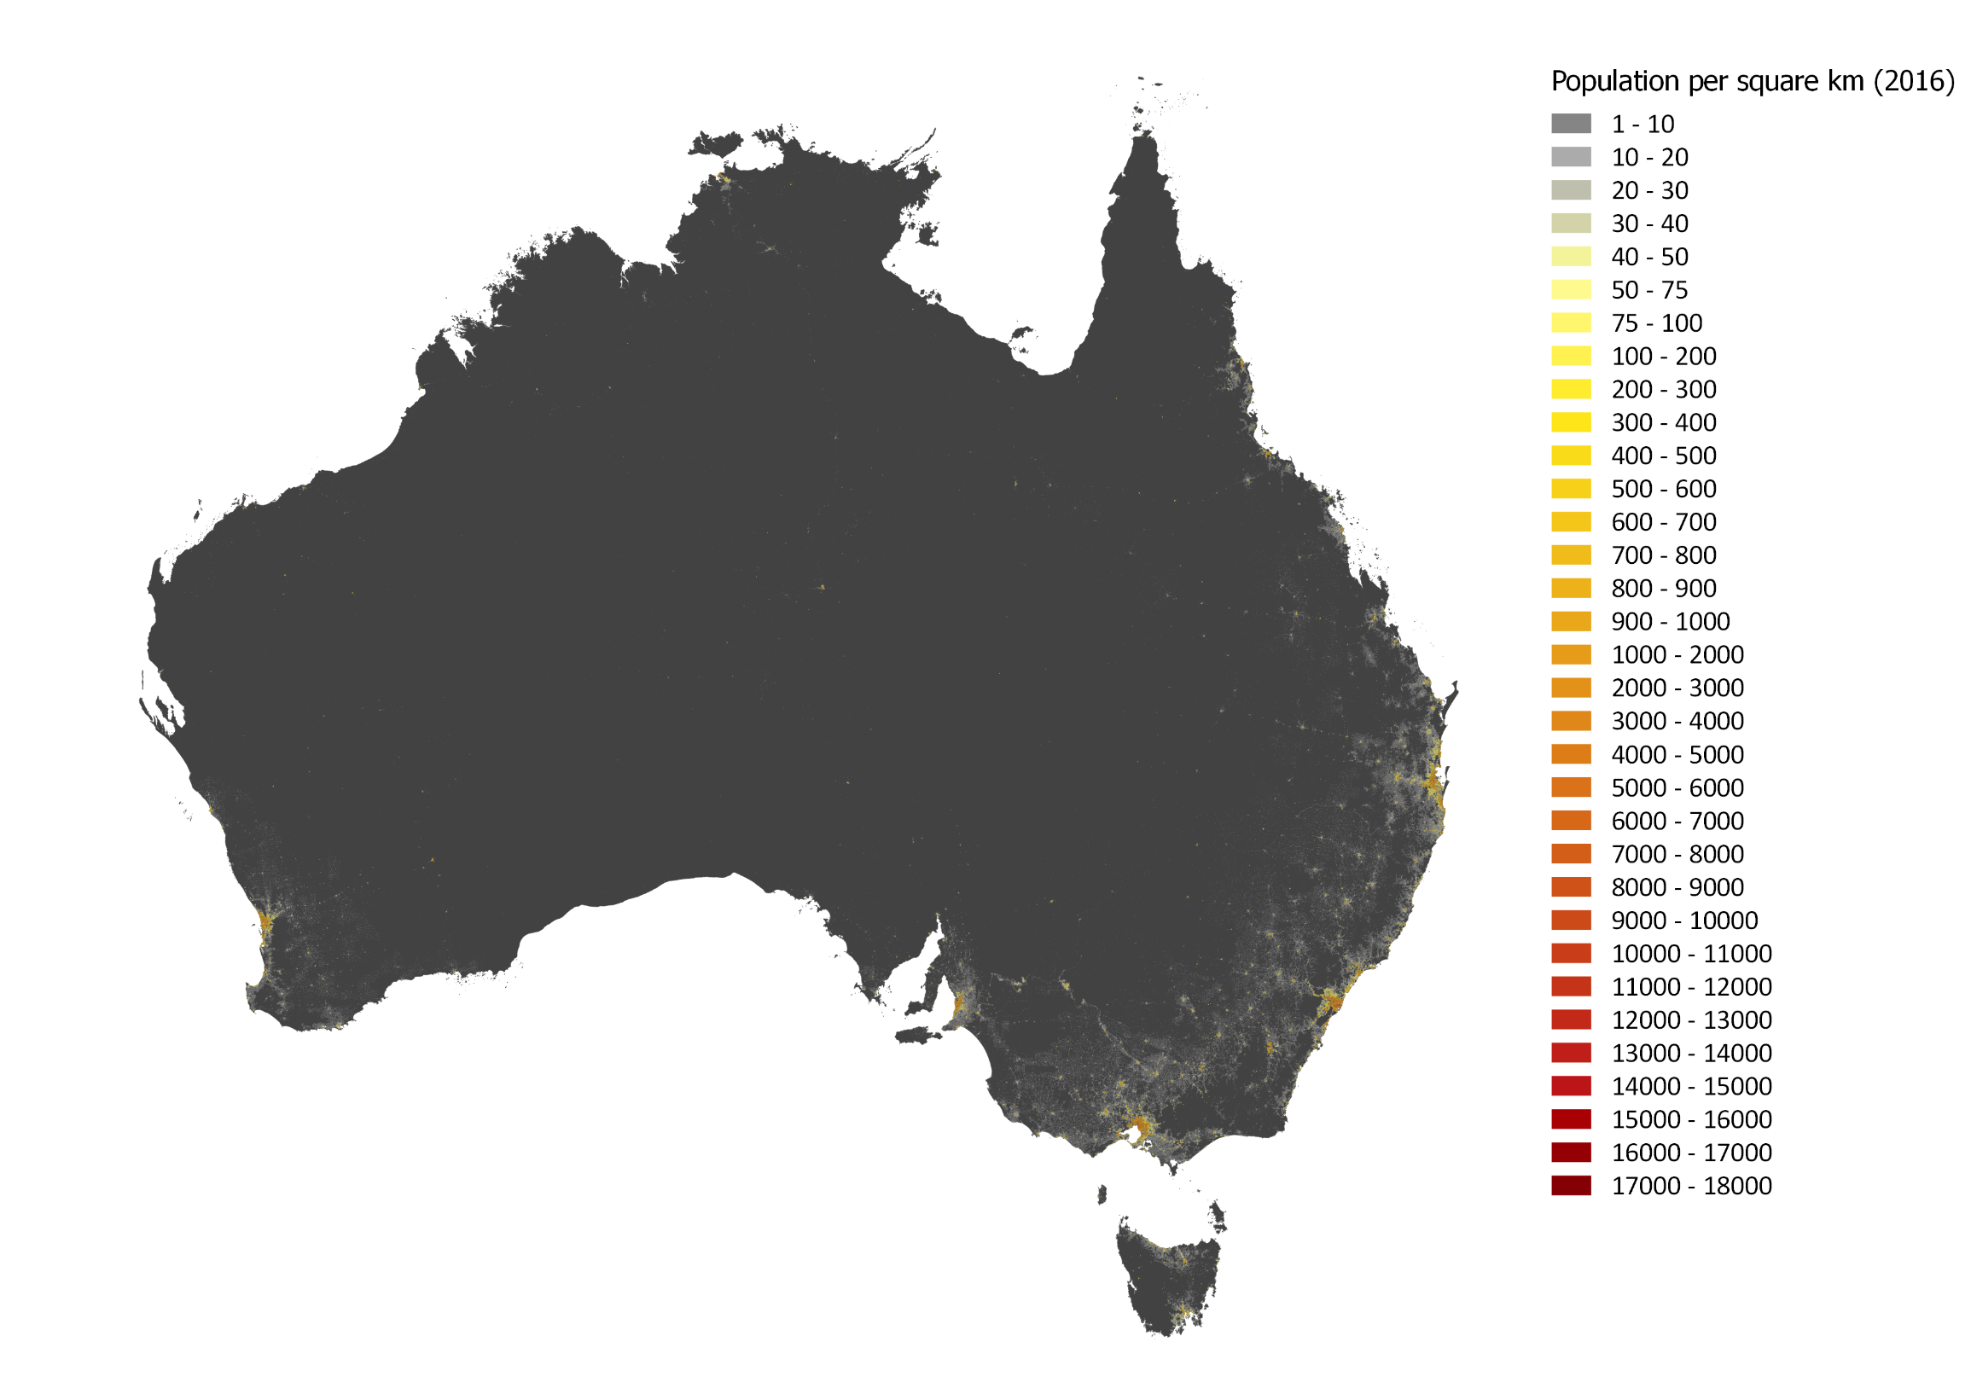

Map 1: Populated Australia, 2016

Source: Australian Population Grid 2016 (ABS 2017)

CTVs come in a variety of population sizes as illustrated in Figure 1. There are very few large CTVs in Australia, with only five having over 1 million people. These correspond to the capital cities of Sydney, Melbourne, Brisbane, Adelaide and Perth. In the next largest category (with over 250,000 people) are the cities of Gold Coast-Tweed Heads[2], Newcastle-Maitland, Canberra-Queanbeyan, the Sunshine Coast and Wollongong. Cities of over 100,000 include Hobart, Geelong, Townsville, Cairns, Darwin, Toowoomba and Ballarat. At the other end of the spectrum the vast majority of CTVs are small, with almost 2,300 CTVs having less than 5,000 people.

Figure 1: Cities, Towns and Villages by population size, 2016

Source: BITRE analysis of the Australian Population Grid 2016 (ABS 2017)

A feature of this definition is that only 3.5 per cent of the population lives outside identified CTVs. Further, as we can see in Table 1, the population is extremely concentrated in the largest centres. Even if we exclude the five largest centres, a greater proportion of the population still live in the large cities than in small towns and villages.

Table 1: Cumulative proportion of the total population living in CTVs by size, 2016

Source: BITRE analysis of the Australian Population Grid 2016 (ABS 2017)

|  |  |  |  |
| --- | --- | --- | --- |
| CTV population | Proportion of total population living in CTV of a given size | Cumulative Proportion | Number of CTVs |
| 1 million or more | 63.4% | 63.4% | 5 |
| 250,000 to 999,999 | 8.7% | 72.1% | 5 |
| 100,000 to 249,999 | 4.5% | 76.6% | 7 |
| 50,000 to 99,999 | 3.1% | 79.7% | 10 |
| 20,000 to 49,999 | 4.8% | 84.5% | 36 |
| 10,000 to 19,999 | 2.8% | 87.3% | 45 |
| 5,000 to 9,999 | 2.4% | 89.7% | 84 |
| 1,000 to 4,999 | 4.6% | 94.3% | 525 |
| 500 to 999 | 1.1% | 95.4% | 376 |
| 200 to 499 | 0.8% | 96.2% | 594 |
| Less than 200 | 0.3% | 96.5% | 763 |
| Not in a CTV | 3.5% | 100.0% |  |

This pattern is reflected in figure 2, which compares the proportion of the population and the number of CTVs by each population size category against each other.

Figure 2: Per cent of resident population and per cent of CTVs by CTV population category, 2016

Source: BITRE analysis of the Australian Population Grid 2016 (ABS 2017)

The concentration of the Australian population into CTVs makes them central to discussions of Australia’s population distribution. The following sections provide a brief overview of the distribution of CTVs themselves in terms of two characteristics; isolation and density.

# Isolation

## Isolated people

To get a broad view of the concept of isolation we first draw on the ABS Remoteness Area classification and the Hugo Centre for Migration and Population Research’s (HCMPR) Accessibility/Remoteness Index of Australia (ARIA), which are both measures of population isolation. The ARIA score of a region increases as the isolation of people living in the areas from other people increases. The relationship between ARIA and the location of CTVs is shown below in Map 2. Remoteness Areas group regions with similar ARIA scores (and so a similar level of isolation) into five broad categories. Box 1 describes both in more detail.

We can see in Figure 3 that more than 70 per cent of the population live in areas that are considered the least isolated (Major cities of Australia). This should come as no surprise given the discussion above about the concentration of Australia’s population into a few large population centres. We can also see that as remoteness increases, the proportion of people living in increasingly remote areas decreases.

|  |  |  |  |  |  |  |  |  |  |  |  |  |  |  |  |  |  |  |
| --- | --- | --- | --- | --- | --- | --- | --- | --- | --- | --- | --- | --- | --- | --- | --- | --- | --- | --- |
| Box 1: ARIA and Remoteness Areas The ABS Remoteness Area structure divides Australia into five Remoteness Areas. Its purpose is to provide a method for classifying Australia into *large regions* that share common characteristics of isolation.  The ABS Remoteness Area classification itself is built upon the Accessibility/Remoteness Index of Australia (ARIA), which classifies the population of *small areas* (1 square kilometre) along a spectrum of isolation from other people. ARIA was developed by the Hugo Centre for Migration and Population Research (HCMPR) as a joint project with the Australian Department of Health and Ageing in 1998 (HCMPR 2013), and has since undergone several updates, including ARIA+ and ARIA++.  ARIA is an index (continuous variable) in which isolation is defined on the basis of road distance from any point to the nearest town in each of five population size classes. Because it measures distance to a number of population size classes it approximates a global measure of population isolation and service access. Population size is used as a proxy for the availability of a range of services and road distance is used as a proxy for the degree of remoteness from those services. This is in contrast to a specific measure of isolation which would only focus on one aspect, such as a single size class.  The ABS Remoteness Areas (2011) are aggregations of small statistical units (Statistical Area Level 1s), which are similarly remote according to ARIA+ (2011), as defined by the ranges shown in Table 2.  Table 2: Remoteness Areas 2011 and ARIA+ values   |  |  |  | | --- | --- | --- | | RA Category | RA Name | SA1 Average ARIA + value ranges | | 0 | Major Cities of Australia | 0 to 0.2 | | 1 | Inner Regional Australia | greater than 0.2 and less than or equal to 2.4 | | 2 | Outer Regional Australia | greater than 2.4 and less than or equal to 5.92 | | 3 | Remote Australia | greater than 5.92 and less than or equal to 10.53 | | 4 | Very Remote Australia | greater than 10.53 |   Source: ABS 2013  Major Cities of Australia include the five largest cities and the surrounding hinterland, as well as other large centres including Newcastle – Maitland, Wollongong, Gold Coast – Tweed Heads, Sunshine Coast and Canberra – Queanbeyan. Inner Regional Australia includes some medium sized cities such as Greater Hobart, Toowoomba and Wagga Wagga. Outer Regional includes cities such as Greater Darwin, Cairns, Townsville and Broken Hill, while Remote Australia includes centres such as Mount Isa and Alice Springs. Very Remote Australia includes centres such as Bourke and Charleville.  By design the Remoteness Area structure aggregates areas of similar isolation and provides a quick guide to isolation. By construction it also obscures differences in isolation within the defined Remoteness Areas and so we use ARIA ++ (an extension of the original ARIA) where a higher level of detail is needed.  This paper uses 2011 Remoteness Areas (ABS 2013) by allocating grid squares to the SA1 which is closest to the grid square’s geographic centre (centroid). |

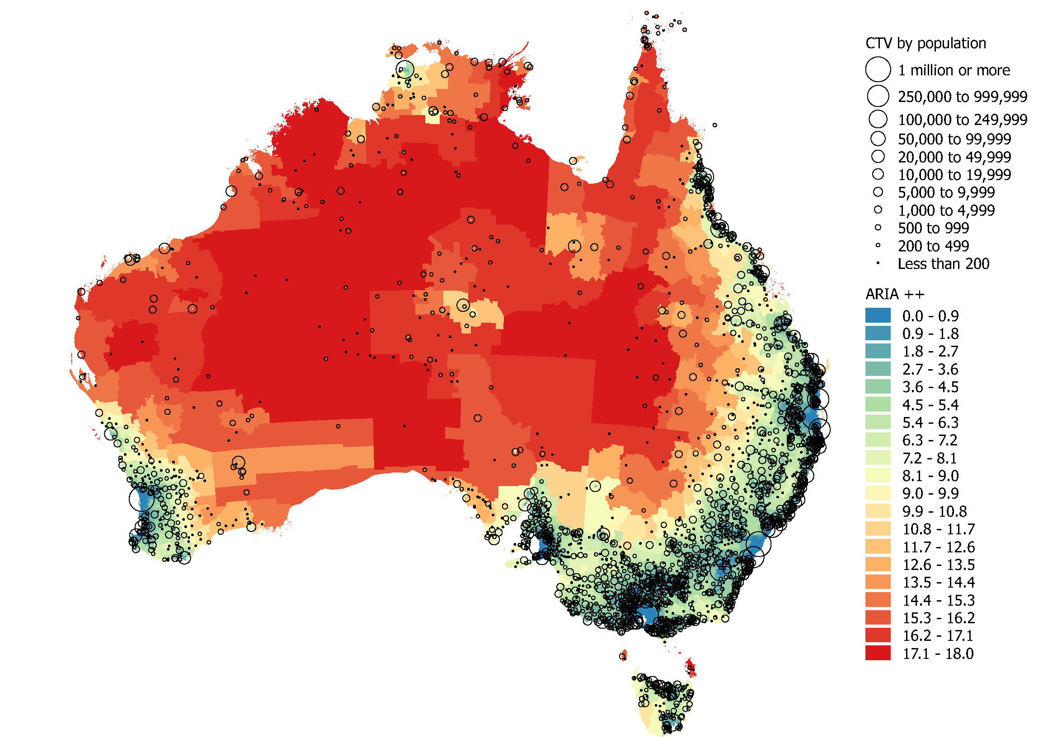

Map 2: Australia’s Cities, Towns and Villages, 2016

Sources: BITRE analysis of the Australian Population Grid 2016 (ABS 2017) and ARIA ++ at the SA1 (2011) scale (HCMPR 2013)

Figure 3: Proportion of the population living in each remoteness category, 2016

Source: BITRE analysis of the Australian population grid 2016

Large cities have the lowest isolation in a population sense because residents are close to each other, which is reflected in their ARIA score (where a lower score indicates less isolation).

For smaller centres, more variation is possible – however, on average isolation increases as the population of CTVs decrease. While their own population is not large enough to ensure that residents are not isolated, they can be satellites to larger cities, meaning that their residents are close to many other people. Take for example towns with populations from 500 to 999 people. We see towns like Hall (ACT), Tumbulgum (NSW), Beerburrum (QLD), Marong (VIC), Wasleys (SA) and Allanson (WA), all of which are satellites of larger cities. Of course, small towns can also be very remote communities. In the same size category very remote towns include Warruwi (NT), Kalumburu (WA), Lockhart River (QLD), Pukatja (Ernabella) (SA) and Currie (TAS). The distribution of smaller towns by their degree of isolation can be seen Table 3.

Table 3: Number of CTVs by population size and Remoteness Area, 2016

Source: BITRE analysis of the Australian Population Grid 2016 (ABS 2017)

|  |  |  |  |  |  |  |
| --- | --- | --- | --- | --- | --- | --- |
|  | Major Cities | Inner Regional | Outer Regional | Remote | Very Remote | Total |
| 1 million or more | 5 | 0 | 0 | 0 | 0 | 5 |
| 250,000 to 999,999 | 5 | 0 | 0 | 0 | 0 | 5 |
| 100,000 to 249,999 | 1 | 3 | 3 | 0 | 0 | 7 |
| 50,000 to 99,999 | 0 | 10 | 0 | 0 | 0 | 10 |
| 20,000 to 49,999 | 0 | 26 | 8 | 2 | 0 | 36 |
| 10,000 to 19,999 | 2 | 26 | 12 | 5 | 0 | 45 |
| 5,000 to 9,999 | 1 | 45 | 34 | 3 | 1 | 84 |
| 1,000 to 4,999 | 2 | 259 | 185 | 34 | 45 | 525 |
| 500 to 999 | 1 | 143 | 154 | 36 | 42 | 376 |
| 200 to 499 | 0 | 186 | 261 | 54 | 93 | 594 |
| Less than 200 | 0 | 85 | 360 | 169 | 149 | 763 |
| Total | 17 | 783 | 1017 | 303 | 330 | 2450 |

## Isolated CTVs

An alternative way to measure isolation is to consider the distance of an individual CTV from another CTV of roughly equal population (within 10%) or larger. This provides insight into a CTV’s local importance. Australia’s five largest cities are relatively isolated by this measure, as they have no close neighbours of a similar size or larger. In fact, overall we observe the opposite pattern to population isolation, with smaller CTVs being in general much closer to other CTVs of roughly the same size or larger. Figure 4 below shows the average distance to the nearest CTV of the same size or larger by CTV population size, for towns and cities with populations below 1 million people.

Figure 4: Average distance to nearest CTV of the equal (within 10%) or larger population, 2016

Source: BITRE analysis of the Australian Population Grid 2016 (ABS 2017)

The overall pattern in Figure 4 is not surprising; smaller towns are on average less isolated from towns of the same size or larger. There are, after all, a much greater number of small towns, making it much easier to be close to a town of equal size or larger.

The 100,000 to 249,999 category is a clear exception. This category includes Hobart, Townsville and Darwin, which are respectively around 1,700km, 1000km and 600km from cities of roughly the same size or larger. Figure 5 illustrates the unique place these cities have in the pattern of Australian settlement due to the combination of size and comparative isolation with no local peers.

Figure 5: CTV population by distance to a CTV of equal (within 10%) or larger population, 2016

Source: BITRE analysis of the Australian Population Grid 2016 (ABS 2017)

Note: Cities above 300,000 persons are excluded.

Overlooking the previously mentioned outliers (Greater Hobart, Townsville and Greater Darwin) and cities with more than 300,000 people, there is a distinct ‘L’ shape in Figure 5. This brings to the fore an important characteristic of the Australian settlement pattern - while there are small settlements across the spectrum of isolation, large cities tend not to be isolated from other large cities.

# Density

We now turn our attention to population density, and as would be expected, CTVs with large populations are not only larger in terms of area, but also tend to have a higher population density. This paper uses maximum density (rather than a mean or median measure) as it better caputures differences between CTVs of different sizes. It should be noted that as the 1 sqkm population grid has been used to calculate density, the density of population centres smaller than 1 sqare km are underestimated.

Figure 6 presents the population denisty of Australia’s CTVs, illustrating a strong positive relationship between population size and population density, with Sydney and Melbourne the most densely populated, followed by Brisbane, Perth and Adelaide.

Figure 6: Maximum density and population size, 2016

Source: BITRE analysis of the Australian Population Grid 2016 (ABS 2017)

However, this pattern is also evident for smaller cities. Figure 7 omits cities with populations greater than 300,000 people and shows this relationship still holds among smaller CTVs.

Figure 7: Maximum density and population size (cities over 300,000 omitted), 2016

Source: BITRE analysis of the Australian Population Grid 2016 (ABS 2017)

While we continue to see the strong positive relation between population and population density in Figure 7, we can also see that where populations are lower, a small increase in the population is associated with a large increase in density. Where populations are higher, the same increase in population is associated with a much lower increase in density. The relationship is positive but the strength of the relationship diminishes with population size. Overall, this aggregate relationship is very strong, although there is considerable variation in the population density for a given CTV population, especially for smaller CTVs. Population density can differentiate CTVs of similar sizes, especially when they are small.

# Conclusion

In this paper we have discussed the way in which people are spatially distributed in Australia. The most important consideration is that the vast majority of Australia is unpopulated. Correspondingly, most people live together in some kind of cluster, such as a city, town or village. In fact, only 3.5 per cent of the population live outside an identified CTV.

There are few very large CTVs in Australia, with only five having a population of over 1 million people. Because of their size, they hold a unique position in the country’s settlement pattern as most of the country’s population is highly concentrated into these few large cities. In contrast, while there are numerous small settlements, only a small proportion of the population lives in smaller towns. In effect, the number of towns of a given size and the population who live in towns of that size have the opposite pattern.

In the second section, we discussed two aspects of CTVs – their isolation and their density. With respect to isolation, more than 70 per cent of the population live in the least remote parts of Australia. By definition large cities are not isolated in a population sense, and tend to be close to cities of a similar size. In contrast, smaller towns and villages can be found across the spectrum of isolation, with satellites to large cities at one extreme and very remote settlements at the other. In terms of population density, we have seen that it increases with town size. The relationship is positive, but the strength of the relationship diminishes with population size.

This very brief introduction to the population distribution and to the population size, isolation and density of CTVs provides a foundation for further investigation into how place affects people’s lives in Australia.

# Appendix A: Defining Cities Towns and Villages through service locations

## Key points

* This appendix outlines how the BITRE Cities, Towns and Villages (CTVs) geographical classification was developed.
* The CTV geography is designed to assist in analysing the spatial distribution of people and services in regional Australia.
* The classification is based on locations which are both places where people live, and places where services are located.
* The CTV geography is designed to extend existing statistical geography in two areas:
  + The classification only includes population centres, which are also service centres (and vice versa).
  + The CTV geography consistently identifies joint population and service centres of all population sizes as such locations with populations of fewer than 200 persons are included.

The concentration of both population and services in cities, towns and villages across Australia means that these features of human geography are integral to understanding service location. To assist in understanding the spatial services BITRE has developed the Cities, Towns and Villages (CTV) geographical classification, which is based on the intersection of where people live (population centres) and where services are located (service centres). Hence, a CTV is a place identified as both a population centre and a service centre.

The key motivation for developing the CTV geography is the existence of two important limitations to the Australian Bureau of Statistics (ABS) Australian Statistical Geography Standard (ASGS) for the purposes of conducting an analysis of services. The first limitation is that the ASGS does not identify population centres consistently where populations are small and tends to exclude population centres below 200 persons – as below 200 persons it becomes hard to analyse cross classified Census data due to small sample size and perturbation. A key consideration in developing the CTV classification is to extend statistical geography to consistently include joint population and service centres of any population size.

A second limitation of the standard geography is that it has been largely designed to capture population centres, rather than joint population and service centres. For the most part, population centre and the service centre overlap as most population centres are also service centres, and vice versa. However, there are some exceptions such as small geographic concentrations of people that are not co-located with any identified service points or groups of co-located services not located with any clear geographic concentration of people. A function of the CTV classification is to limit the scope to only places that are both population centres and service centres.

## The ASGS as it relates to joint population and service centres

The CTV classification was developed using the ABS 2011 ASGS. At the time of construction this represented the basic geographic classification system used to disseminate population, social and economic statistics in Australia. The ASGS has been updated with the release of the 2016 census, however the CTV classification remains based on the 2011ASGS.

Within the ASGS there are three structures which lend themselves to classifying population centres: Greater Capital City Statistical Area (GCCSA), Significant Urban Areas (SUA) and Urban Centres and Localities/Section of State (UCL).

The GCCSA structure is designed to represent a socio-economic definition of each of the eight State and Territory capital cities. The greater capital city boundary is designed to capture people who regularly socialise, shop or work within the capital city (ABS 2010).

SUAs are designed to represent concentrations of urban development with a population of 10,000 or more. They do not necessarily represent a single urban centre and can represent a cluster of related urban centres with a core urban population over 10,000. They can also include related peri-urban and satellite settlements and the area into which the urban development is likely to expand (ABS 2012). The eight capital cities are also included in the SUA classification, however (with the exception of the ACT GCCSA/Canberra-Queanbeyan SUA)[3] the SUA boundary of each of the capital cities is smaller than the GCCSA boundary for each city and does not include some satellite urban centres and peri-urban areas that are included in the GCCSA boundary.

UCLs are designed to represent areas of concentrated urban development. The eight capital cities and many smaller cities included in the SUA classification are also included in the UCL classification. Where a UCL represents a town or city that is also in the SUA or GCCSA structure, the UCLs are at most the same size, and typically smaller, than the representation of that town or city in the other structures. Often clusters of related urban centres that are represented as a single geography in the SUA structure will be represented as individual urban centres under the UCL structure (ABS 2012). An example of the GCCSA, SUA and UCL geographies surrounding Adelaide are shown in Map 3.

All of these structures represent a definition of a population centre; however, none perfectly represents the nexus of population and service centre that is required for a detailed analysis of service access. Importantly, far fewer population centres are identified in the ASGS than the number of service centres suggested by data on service locations. In addition, the definition of a population centre is slightly different in each structure but all of these classifications under-identify smaller population centres, either because they are not capital cities (GCCSAs), do not have a population over 10,000 (SUAs), or do not represent a clear aggregation of residential population with at least 200 usual residents (UCLs). As a further consideration, some identified population centres are not co-located with services, and so do not meet the definition of a joint population and service centre.

## Identifying service and population centres

### Service centres

The process of classifying CTVs begins with the identification of service centres, using the point location of identified services. These include health, education, postal, retail and government services, which reflect the service location data collected by BITRE. A complete list of service types can be found in Table 4 on page 22, while the data sources of identified services can be found in Appendix B. The availability of service location data is a limitation of this approach and in future, the inclusion of more service types would increase the number of service centres identified. As the purpose is to extend existing statistical geography, where possible services have been grouped using the three ASGS structures listed above. Where this has not been possible the location of the service itself has been used.

Map 3: GCCSA, SUA and UCL geographies around Adelaide

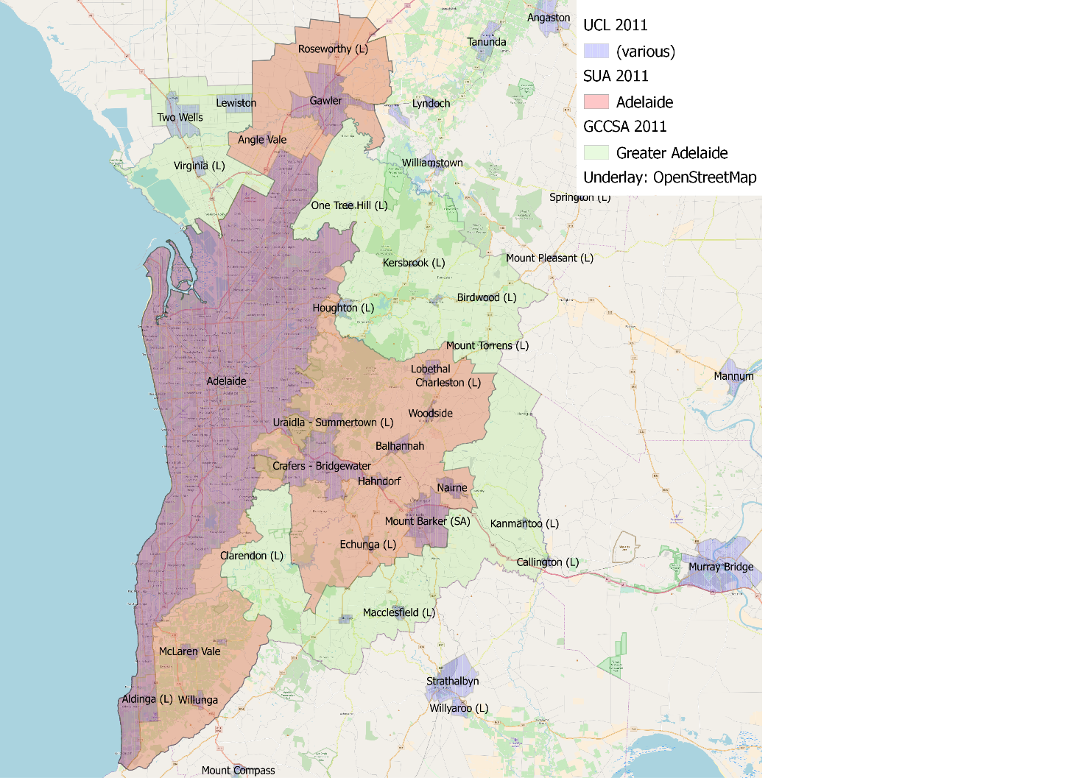

Source: BITRE analysis of ASGS 2011 (ABS 2012). Underlay: OpenStreetMap 2018.

The following rules are used to identify service centres and place them into a single geographic classification.

1. If a service is located within a GCCSA capital city (excluding Canberra) then it is considered to be within that capital city.
2. If not, then if a service is located within an SUA then it is considered to be within that SUA.
3. If neither of the above, then if a service is located within a (non-remainder) UCL then it is considered to be within that UCL.

If a service is located outside of any of these geographies, but is within 5km of a UCL[4], then the following rules have been used with respect to the closest UCL to the service:

1. If the closest UCL is within a GCCSA, then the service is considered to be in that GCCSA.
2. If not, then if the closest UCL is within an SUA, then the service is considered to be in that SUA.
3. If neither, then the service is considered to be in the closest UCL.

Map 4 below provides an example of these rules using the service points around the UCL and SUA of Bendigo and the UCL of Marong. The orange diamonds are within the Bendigo SUA and so are also assigned to the Bendigo CTV by rule 2. The green circles are services within the Marong UCL and so are assigned to the Marong CTV by rule 3. The blue squares are within 5km of the Bendigo UCL and so have also been assigned to Bendigo CTV by rule 5. The red pentagon is more than 5 km from any UCL and so falls outside the rules above.

Map 4: Service points around the SUA/UCL of Bendigo and the UCL of Marong, VIC

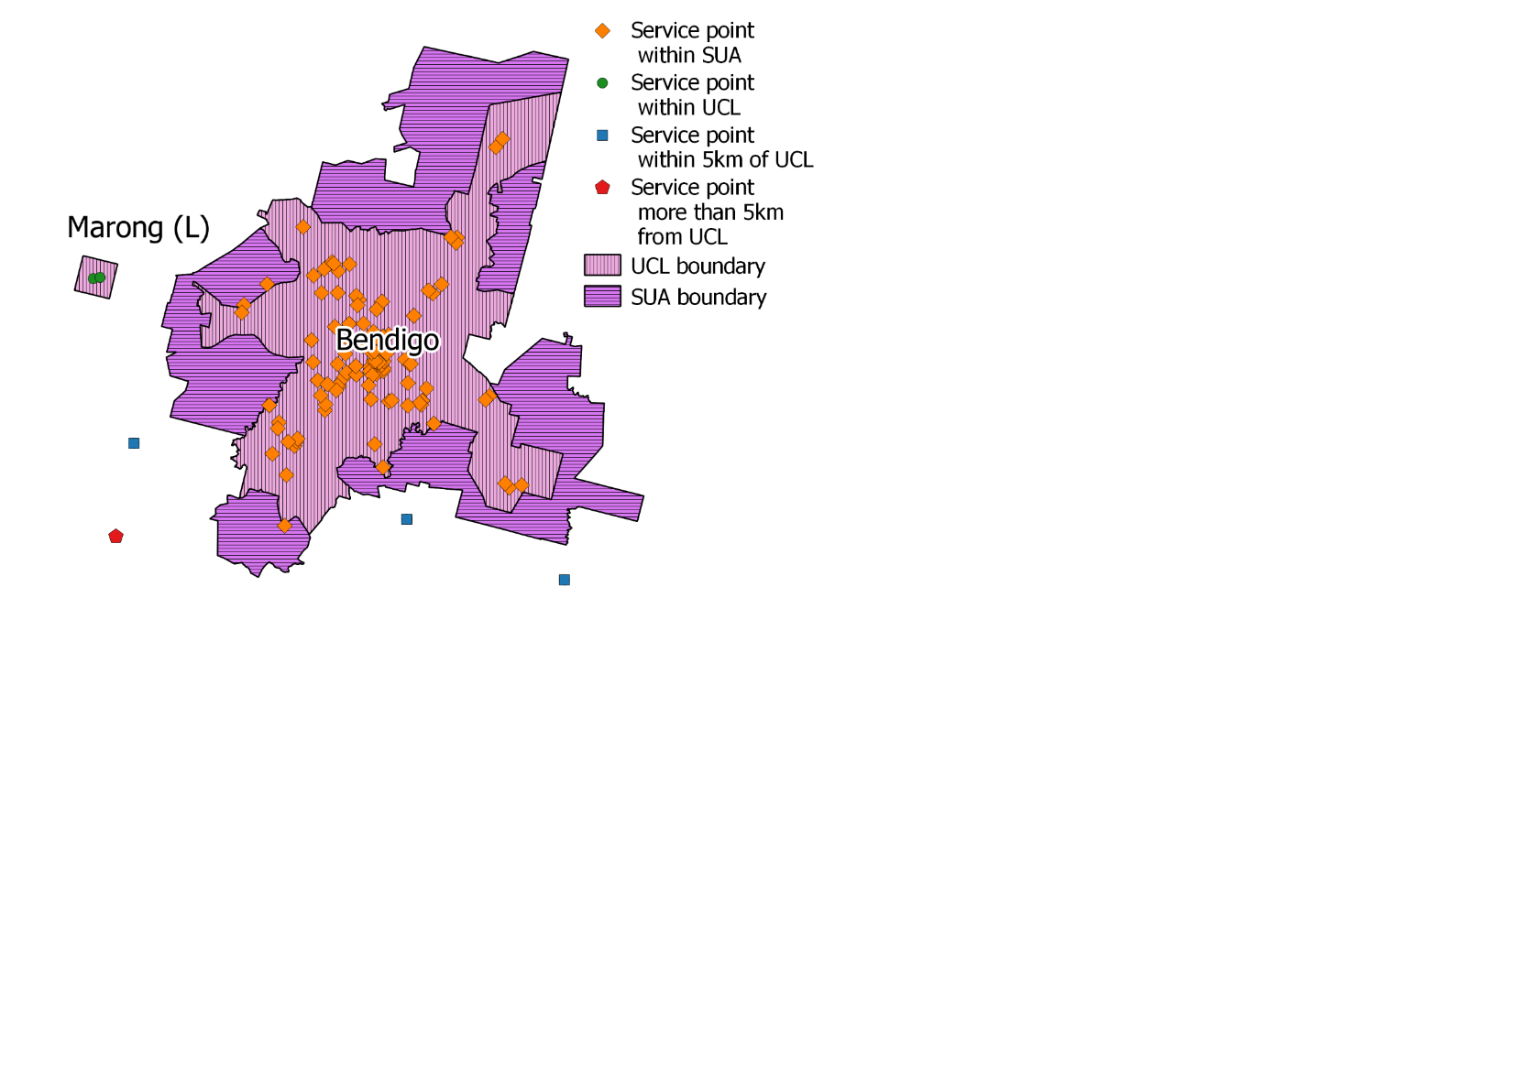

Source: BITRE analysis of identified service points and ASGS 2011 (ABS 2012).

If a service is more than 5km from the closest UCL a further two rules are used to classify the service. This allows the CTV classification to go beyond the geographies included in the ASGS.

1. If two services are within 1600m of each other then they are considered to be part of the same service centre and form a cluster.
2. If two or more service points or clusters are providing services to the same population centre, then they are considered to be part of the same service centre. This is approximated using the population weighted centroid of each cluster based on the population living within 5km of any service in that cluster. If the population weighted centroids of two or more service points/clusters is within 1600m of each other, then the service points/clusters are considered to be part of the same service centre. The method for assigning population to CTVs, including points and clusters, is outlined in the section Estimating CTV populations.

The distance threshold in steps 7 and 8 (set at 1600 metres) was chosen through sensitivity testing of step 7. The number of service centres identified initially drops off very steeply and begins to stabilise around 1200 metres, and becomes almost flat around 1800 metres. A 1600-metre threshold was chosen within this upper and lower limit as this traditionally represents walking distance and is approximately 1 mile.

To see the intuition behind step 8 imagine the typical main street in a regional town. If services are located at either end of the main street, they can be a signification distance from each other. However, both ends of the street service the same population, which is concentrated around the middle section of the main street. Step 8 applies to a variety of urban configurations where services are located at the edge of urban areas. Figure 8 provides some stylised examples for steps 7 and 8.

Where a service centre does not have a resident population within 5km of its location it is not considered to be a CTV. This occurs for 38 service centres.

Figure 8: Stylised examples of service centre rules 7 and 8

S

Service and 5km radius

Grid square with population centroid

Key:

Service catchment population weighted centroid

**Does not meet rule 8**: Services do not form a cluster as the services are further than 5km apart and the centroids of the population they service are greater than 1600m apart

S

S

**Rule 7**: Services form cluster as they are within 5km of each other

S

S

Less than 5km

**Rule 8**: Services form cluster as the centroids of the populations they service are within 1600m of each other

S

S

Less than 1600m

**Does not meet rule 7**: Services do not form a cluster as the services are further than 5km apart

S

S

Greater than 5km

Greater than 5km

Greater than 1600m

Source: BITRE analysis.

### Population centres

Identifying population centres also begins using the ASGS structures of GCCSA, SUA and UCL. These population centres and the corresponding ABS population estimate are used as the foundation for the estimates of the CTV population.

1. If a person lives within a GCCSA capital city (excluding Canberra) then they are considered to live in that capital city.
2. If not, then if a person lives within an SUA then they are considered to live in that SUA.
3. If neither of the above, then if a person lives within a (non-remainder) UCL then they are considered to live in that UCL.[5]

There are 102 UCLs which can be identified as population centres, but do not provide any of the identified services and so are excluded from the definition of a CTV. However, these UCLs, where they are within 5km of a service, are instead considered part of the CTV in which the service is located. This is explained further in the section that follows.

## Estimating CTV populations

The existing statistical geography provides good population estimates of the identified CTVs where they are available. However, a large number of CTVs do not correspond to an existing ASGS statistical geography and so an alternative means of estimating the population is needed. For this reason a population based on an estimated catchment population of the CTV has been developed. For consistency, this has been applied to all CTVs, even though other estimates are available.

The method of estimating population was initially tested using the 2011 census population of Australia at the Australian Population Grid scale (ABS 2014) and the ASGS geographies. The population estimates reported have been updated to the Estimated Resident Population as at June 2016, again at the Australian Population Grid scale (see ABS 2017). The Australian Population Grid 2016 provides an Estimated Resident Population density for each square kilometre of Australia. This has been further simplified to provide a single representative point estimate of the population at the geographic centre (centroid) of each grid square. Population estimates at the meshblock scale were not considered, as geographies with different shapes and sizes can cause error in estimating spatial relationships, such as population and population density.

The process for allocating population to service centres begins by generating simple catchment areas for each identified service based on the following assumptions:

* That services within a service type (i.e. government public schools) are homogenous.
* All else being equal, the further a person lives from a service the more difficult it is to access that service.
  + Therefore, consumers will access the nearest service.

This creates a catchment area that corresponds to the area closest to a given service.

In practice these assumptions do not necessarily hold and services at different locations provide different offerings and catchment areas can overlap as people may not choose the closest service. However, given the available information, these assumptions make defining catchment areas possible using limited information. Using the nearest service, or ‘as the crow flies’ distance removes considerations like access to transport, transport mode and time of day.

A complication that arises from simple service catchments is that a service may not have any recorded population due to their being no single representative point of the population grid that falls within the simple catchment area. An example is shown in

Map 5 below for major retailers in the town of Parkes in northern NSW. The red line divides the catchment areas of each retail service point, represented by an orange diamond. As can be seen below, no population grid centroids (represented by black dots) are located within the central service catchment area. As a result, this service has an (implausible) estimated catchment population of zero.

Map 5: Example service level catchment area with no population, Parkes NSW

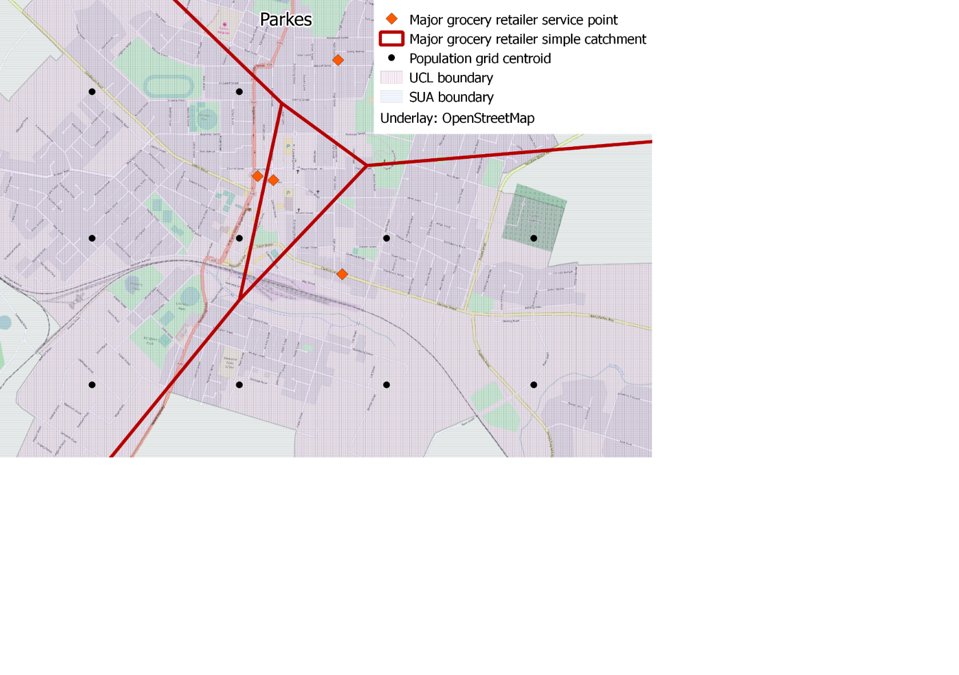

Source: BITRE analysis of identified service points, ASGS 2011 (ABS 2012), Australian Population Grid, 2011 (ABS 2014). Underlay: OpenStreetMap 2018.

To work around the problem, catchment areas are aggregated to the level of each service centre. In this sense, the catchment areas of individual services are merged to a single service centre. In reality the catchment areas will continue to overlap, but to a lesser extent than at the service level. Any service centre for which there is no populated population grid centroid within 5km of any service fails to meet the criteria of a CTV. As noted above, 38 service centres fall into this category.

Most CTVs contain service points from multiple service types – for example several schools, offices and hospitals. The simple catchment population (limited to 5km from any given service) for each service type within each CTV has been estimated using the process described above. This leads to as many population estimates as there are service types. The final CTV population is estimated use the service type which provides the best population estimate.

The 2011 population of the largest structure in the ASGS 2011 (using the rules described in the section above on *Population Centres)* wasused as the population benchmark in deciding which service type to use to estimate the CTV population. For each service type the average ratio of the catchment population within 5km of any service within a CTV to the corresponding ABS estimate (where it exists) was calculated and is shown below in Table 4.

Some services, such as Government Primary Schools and Australia Post outlets, provide very accurate approximations of the ASGS 2011 population, with the populations living within 5km of these service being respectively on average around 100 per cent and 101 per cent of the corresponding ASGS estimate. Other services, such as Principal Referral Hospitals, provide poor approximations, with the ASGS population being on average around 331 per cent higher than the catchment population within 5km of a service. Given the services that are located in a CTV, whichever service is on average closest to the ABS population estimate is used to define the population of the CTV. While the ratio is derived from 2011 census population estimates at the 2011 population grid and ASGS geographies, the populations reported in this paper use the Estimated Resident Population estimate at June 2016 on an updated population grid.

Table 4: Estimated relationship between catchment and town populations, 2011

|  |  |
| --- | --- |
| Service Type | Estimated ratio of ASGS population to catchment population within 5km of a service |
| Schools - Government Primary | 1.00 |
| Australia Post | 1.01 |
| Major Grocery Retailers | 1.04 |
| Schools - Government Secondary | 1.04 |
| Schools - Catholic Primary | 1.04 |
| Aged Care - Residential Care (Low) | 1.05 |
| Aged Care - Residential Care (High) | 1.06 |
| Schools - Independent Primary | 1.09 |
| Schools - Independent Secondary | 1.12 |
| Employment Services | 1.16 |
| Aged Care - Home Care (Low) | 1.17 |
| Schools - Catholic Secondary | 1.19 |
| Schools - Government Special | 1.25 |
| Private Hospitals | 1.27 |
| Centrelink - Access Point | 1.28 |
| Centrelink - Agent | 1.28 |
| Centrelink - Customer Service Centre | 1.29 |
| Aged Care - Home Care (High) | 1.29 |
| Medicare | 1.39 |
| Public Hospitals - Very small | 1.59 |
| Public Hospitals - Small | 1.59 |
| Public Hospitals - Small (with Surgery/Obstetrics) | 1.61 |
| Public Hospitals - Medium | 1.65 |
| Schools - Independent Special | 1.92 |
| Public Hospitals - Large | 2.05 |
| Aged Care - Transition Care | 2.47 |
| Public Hospitals - Principal Referral | 3.31 |
| Schools - Catholic Special | 4.60 |

Source: BITRE analysis of identified service points and the ABS Census of Population and Housing 2011.

Because some services always occur with other services, only a subset of services have been used to derive population estimates. In fact, due to their wide distribution, 97 per cent of the population estimates are based on Government Primary Schools or Australia Post outlets, making population estimates that use other services a rare exception, rather than the rule. The table below shows how many CTVs have been estimated using the catchment areas of each service type.

Table 5: Number of CTVs estimated using each service type

|  |  |  |  |
| --- | --- | --- | --- |
| Service Type | Number of CTVs |  | Proportion of CTVs |
| Schools - Government Primary | 1916 |  | 78.20 |
| Australia Post | 456 |  | 18.61 |
| Schools - Independent Primary | 22 |  | 0.90 |
| Centrelink - Access Point | 17 |  | 0.69 |
| Schools - Catholic Primary | 13 |  | 0.53 |
| Employment Services | 7 |  | 0.29 |
| Aged Care - Residential Care (Low) | 7 |  | 0.29 |
| Schools - Independent Secondary | 5 |  | 0.20 |
| Aged Care - Home Care (Low) | 3 |  | 0.12 |
| Schools - Catholic Secondary | 2 |  | 0.08 |
| Schools - Independent Special | 1 |  | 0.04 |
| Major Grocery Retailers | 1 |  | 0.04 |
| Total | 2450 |  | 100.00 |

BITRE analysis of identified service points.

As well as small joint population and service centres which are not identified in the ASGS there are a number of population centres identified in the ASGS which are not co-located with any identified service, and so do not meet the definition of a CTV. An example of the most common case can be seen below in Map 6, which shows the two UCLs of Tolga and Tolga - West in Queensland. Although these have been identified as separate population centres in the UCL structure, since Tolga - West does not have any of the identified services it is not considered a CTV. Instead, the population of Tolga - West within 5km of the service that defines Tolga’s population (a Government Primary School) will be considered part of the population of Tolga. Consequently, the population is still captured in the CTV geography. If a grid square could be allocated to two CTVs the grid square is allocated to the closest service.

Map 6: Population centres without services, Tolga area, QLD

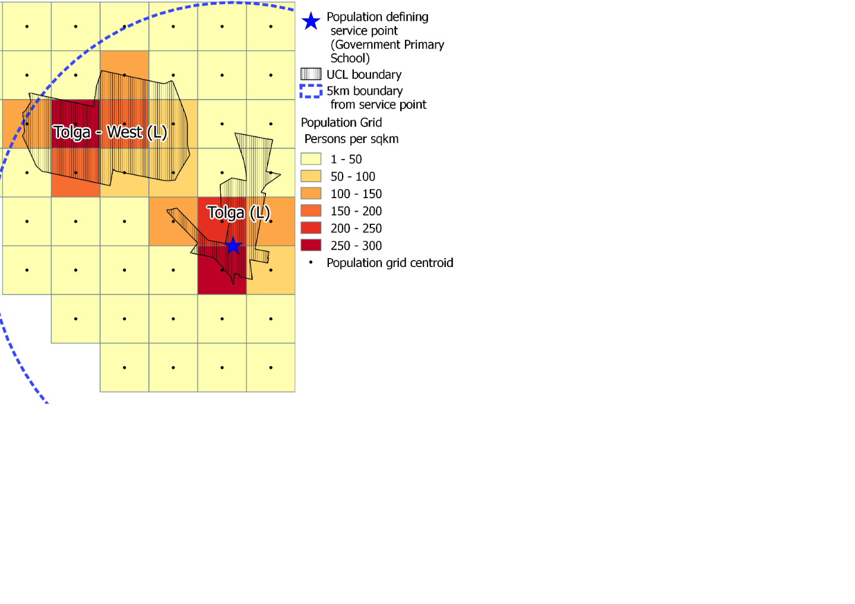

Source: BITRE analysis of identified service points, ASGS 2011 (ABS 2012), Australian Population Grid, 2011 (ABS 2014).

Overall, 2450 places which are both population centres and service centres have been identified as CTVs across Australia. These CTVs are estimated to include around 96.5 per cent of the Australian population and are made up of cities, towns and villages of various sizes. The number of CTVs and how they have been identified is summarised below in Table 6.

Table 6: Number of CTVs by population category and type, 2016

|  |  |  |  |  |  |  |
| --- | --- | --- | --- | --- | --- | --- |
| CTV population | GCCSA | SUA | UCL | Cluster | Point | Total |
| 1 million or more | 5 | 0 | 0 | 0 | 0 | 5 |
| 250,000 to 999,999 | 0 | 5 | 0 | 0 | 0 | 5 |
| 100,000 to 249,999 | 2 | 4 | 0 | 0 | 0 | 6 |
| 50,000 to 99,999 | 0 | 10 | 0 | 0 | 0 | 10 |
| 20,000 to 49,999 | 0 | 35 | 0 | 0 | 0 | 35 |
| 10,000 to 19,999 | 0 | 35 | 13 | 0 | 0 | 48 |
| 5,000 to 9,999 | 0 | 0 | 72 | 0 | 0 | 72 |
| 1,000 to 4,999 | 0 | 0 | 498 | 3 | 3 | 504 |
| 500 to 999 | 0 | 0 | 325 | 24 | 28 | 377 |
| 200 to 499 | 0 | 0 | 280 | 166 | 170 | 616 |
| Less than 200 | 0 | 0 | 10 | 278 | 484 | 772 |
| Total | 7 | 89 | 1198 | 471 | 685 | 2450 |

BITRE analysis of identified service points and ABS 2017.

## Summary

The CTV geography is designed to assist BITRE analyse the spatial distribution of services and service access in regional Australia. The classification is based on identifying locations which are both places where people live and places where services are located. The CTV geography extends existing statistical geography in two areas. First, the CTV geography consistently identifies joint population and service centres of all population sizes. Second, the classification only includes population centres which are also service centres (and vice versa).

# Appendix B: Identified services

This appendix outlines the services used to identify service centres and provides notes on the treatment of the data. The services chosen for inclusion overwhelmingly reflect data availability. More complete service location data would likely identify more joint population and service centres.

**Aged Care:** Data geocoded in house from addresses provided on the aged care service list, Department of Health, as at June 2014. Corrections: 4 service points moved to correctly form a cluster.

**Centrelink:** Downloaded from data.gov.au; accurate as at 13 January 2015. Corrections: Two incorrectly located access points moved into the nearest town (White Cliffs and Bedourie).

**Hospitals:** Address geocoded from data available from AIHW. Cross checked against My Hospitals website information <https://www.myhospitals.gov.au/>.

Exclusions: Blackwood River Clinic (as this is a retreat that does not relate to its surroundings in a standard manner – i.e. it is deliberately isolated).

Issues noted but not corrected: Only private providers that have voluntarily provided data are listed.

**Employment Services:** Data provided by the (then) Australian Government Department of Employment as at January 2015.

Notes: At the time of construction Employment Services only covered an area defined by the then Department of Employment as ‘metropolitan Australia’ through the Job Services Australia (JSA) program. Areas outside ‘metropolitan Australia’ are covered by the Remote Jobs and Community (RJCP) program. In generating metrics related to employment services this report only considers the population covered by the JSA program and therefore excludes those who live within an RJCP area. Technically any person who lives within a grid square that intersects with the RJCP area, even if only in part, has been considered out of scope of this service.

Corrections: 26 incorrectly geocoded service points moved that otherwise led to the misclassification of a cluster.

**Major Grocery Retailers:** Data provided by each retailer separately. Coles and Aldi stores provided addresses while Woolworths provided geocodes. Corrections: 1 incorrect Woolworths geocode changed from Redmond, WA to Bayonet Head, WA.

**Medicare:** Downloaded from data.gov.au 13 January 2013.

**Post offices:** Data provided by Australia Post.

Corrections: 62 incorrectly geocoded service points moved that otherwise led to the misclassification of a cluster.

Exclusions: Cape Denison Station CPA, Macquarie CPA, Mawson CPA, Casey CPA, Davis CPA (as these fall outside the scope of this research).

Issues noted but not corrected: Incorrect geocodes that did not lead to a misclassification of a cluster.

**Schools:** Data provided by Australian Curriculum, Assessment and Reporting Authority for the 2015 school year.

Corrections: 64 incorrect school locations have been adjusted to correctly form clusters with other services.

Exclusions: 46 schools excluded from the analysis: 13 hospital schools, 3 international schools, 1 school which did not provide data, 23 education centres, 5 centres which provide specialist tutoring or online only classes in specialist subjects and 1 school that had not opened at the time of data collection.

# References

Australian Bureau of Statistics (ABS) 2013. Australian Statistical Geography Standard (ASGS): Volume 5 - Remoteness Structure, Cat. No. 1270.0.55.005.

Australian Bureau of Statistics (ABS), 2010. Australian Statistical Geography Standard (ASGS): Volume 1 - Main Structure and Greater Capital City Statistical Areas, July 2011, Cat. No. 1270.0.55.

Australian Bureau of Statistics (ABS), 2012. Australian Statistical Geography Standard (ASGS): Volume 4 – Significant Urban Areas, Urban Centres and Localities, Section of State, Cat. No. 1270.0.55.004.

Australian Bureau of Statistics (ABS), 2014. *Australian Population Grid, 2011*, Cat. No. 1270.0.55.007.

Australian Bureau of Statistics (ABS), 2017. *Regional Population Growth, Australia, 2015-16*, Cat. No. 3218.0.

Hugo Centre for Migration and Population Research (HCMPR) 2013. *Accessibility/Remoteness Index of Australia (ARIA) ++ (2011)*, University of Adelaide.

|  |
| --- |
| © Commonwealth of Australia 2019  ISSN 1440-9593  ISBN 978-1-925701-78-4  February 2019  Creative Commons Attribution 3.0 Australia Licence is a standard form licence agreement that allows you to copy, communicate and adapt this publication provided that you attribute the work to the Commonwealth and abide by the other licence terms. A summary of the licence terms is available from http://creativecommons.org/licenses/by/3.0/au/deed.en.  The full licence terms are available from http://creativecommons.org/licenses/by/3.0/au/legalcode.  This publication should be attributed in the following way; Bureau of Infrastructure, Transport and Regional Economics (BITRE), *An introduction to where Australians live*, Information sheet 96, BITRE, Canberra. Acknowledgement Authored by Kyle Thomson, Lucy Williams and Dr Karen Malam Use of the Coat of Arms The Department of the Prime Minister and Cabinet sets the terms under which the Coat of Arms is used. Please refer to the Department’s Commonwealth Coat of Arms and Government Branding web page http://www.dpmc.gov.au/guidelines/index.cfm#brand and in particular, the Guidelines on the use of the Commonwealth Coat of Arms publication. Contact us This publication is available in PDF format. All other rights are reserved, including in relation to any Departmental logos or trade marks which may exist. For enquiries regarding the licence and any use of this publication, please contact:  Department of Infrastructure, Regional Development and Cities Bureau of Infrastructure, Transport and Regional Economics (BITRE) GPO Box 501, Canberra ACT 2601, Australia  Phone: (international) +61 2 6274 7210 Fax: (international) +61 2 6274 6855 Email: [bitre@infrastructure.gov.au](mailto:bitre@infrastructure.gov.au) Website: www.bitre.gov.au |

1. Map 1 and 2 exclude the Indian Ocean Territories and Norfolk Island in order to fit on a page at a useful resolution.
2. Where a hyphen (-) refers to place names that are jointly defined as a CTV as they are single population and service centre.
3. Because of the better functional definition represented by the SUA boundary the Canberra-Queanbeyan SUA has been used instead of the GCCSA’s ACT boundary.
4. UCLs have been used as they relatively tight boundaries around the inhabited area of a city relative to either SUA or GCCSA boundaries.
5. An exception to these rules has been applied to the town of Batesford, as part of the Batesford UCL is also located in the Geelong SUA. In this case the area of Batesford UCL is considered part of the Geelong SUA.